SUBMISSION SCREENSHOT:
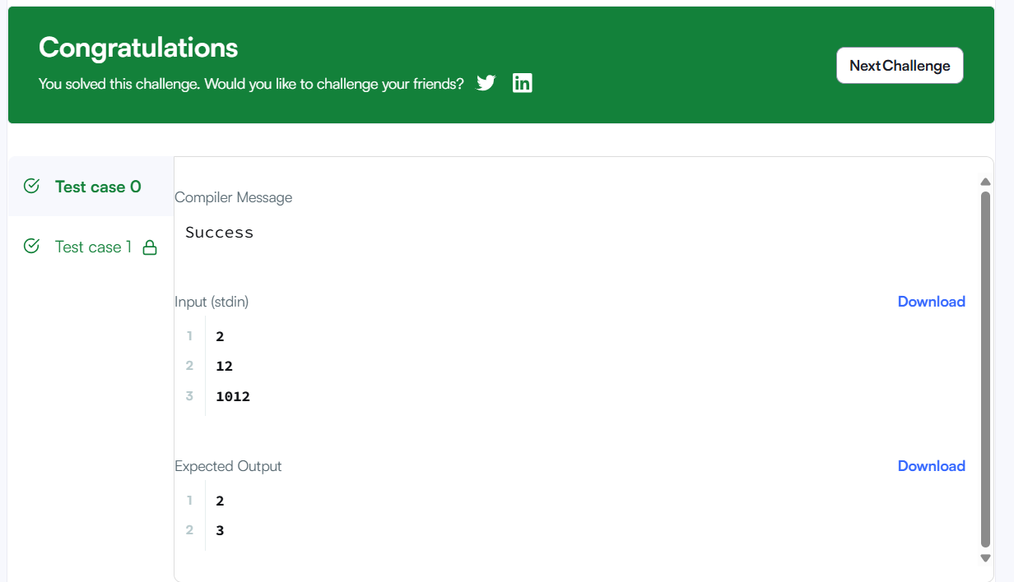
CODE:
int x = n; (LINE 26)
int count = 0;
while (temp > 0) {
int digi= x % 10;
if (digi != 0 && n % digi == 0) {
count++;
}
x /= 10;
}
return count;
LINK:
https://www.hackerrank.com/challenges/find-digits/problem

