SARTHAK MAKKAR — PORTFOLIO WEBSITE
Architecture + UX + Interaction Specification
Gaming / cyber-racing portfolio inspired by the supplied Wix reference template.
Purpose: hand this document to Antigravity as the durable source of truth for structure, content, interactions, and implementation constraints.
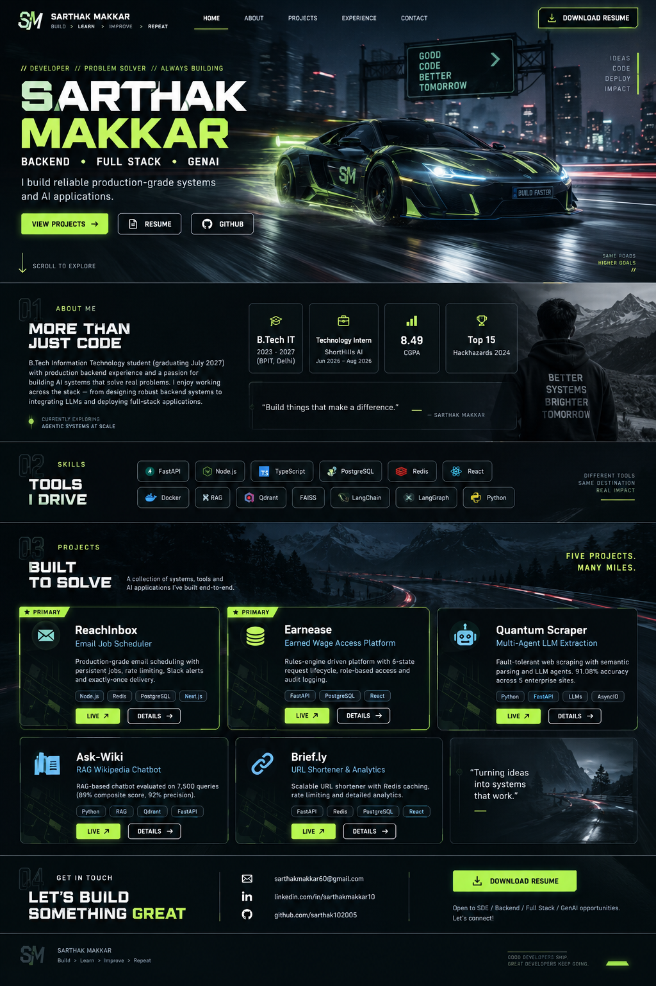
Figure 1. Target visual direction: cinematic car-driven hero, dark gaming UI, neon accents, project cards, and a focused CTA hierarchy. This is a generated visual specification, not a pixel-for-pixel copy of Wix.

1. Product Vision
Build a premium single-page developer portfolio that feels like an interactive game launch screen rather than a conventional resume website. The first viewport should create an immediate motion event: a high-performance car enters / crosses the hero scene while Sarthak Makkar's identity and role stack resolve into view. Scrolling then transitions from identity to proof: skills, experience, and five deployed projects, each with live links and concise technical context.
The design should borrow the supplied reference's energy, motion, and gaming vocabulary without reproducing proprietary copy, artwork, or exact layout. The portfolio must remain credible to recruiters and engineering interviewers: visual spectacle is the hook; architecture, metrics, and live demos are the evidence.

2. Source-of-Truth Content
The three provided resume variants overlap heavily. The portfolio should unify their common facts and expose all five distinct projects. The version whose primary projects are ReachInbox and Earnease is the canonical SDE resume destination.
Source variant | Primary emphasis | Distinct project emphasis | Use on site
SDE Resume A | Backend / Full Stack | ReachInbox, Earnease | Canonical resume + main portfolio narrative
SDE Resume B | Backend / Full Stack | Earnease, Brief.ly | Secondary SDE framing; use Brief.ly content
AI / GenAI Resume | Generative AI / Agentic Systems | Ask-Wiki, Quantum Scraper | AI-focused experience/project detail
Canonical personal facts: Sarthak Makkar; Delhi, India; sarthakmakkar60@gmail.com; +91 9468307819; LinkedIn linkedin.com/in/sarthakmakkar10; GitHub github.com/sarthak102005; B.Tech Information Technology at BPIT, 2023–2027, graduating July 2027; CGPA 8.495 / 8.49 depending on resume formatting; CBSE Class 12: 88%; Class 10: 93.2%; Hackhazards 2024 Top 15.
Important content rule: do not invent employers, awards, metrics, project capabilities, testimonials, client names, technologies, or job titles not present in the supplied resumes. Where two resume versions differ only in wording or rounding, prefer the SDE Resume A wording for the SDE view and the AI Resume wording for AI-oriented detail.

3. Five-Project Portfolio Content Model

ReachInbox — Email Job Scheduler
Portfolio role: Primary
Live: reach-inbox-topaz.vercel.app
Stack: Node.js, TypeScript, Express, BullMQ, Redis, PostgreSQL, Next.js, Tailwind, Google OAuth, Slack OAuth 2.0
Core proof: Persistent delayed-job scheduling; boot-time reconciliation; per-sender rate limiting with atomic Redis counters; idempotent exactly-once processing; live tracking; deployed on Render, Vercel, Neon PostgreSQL, Redis.

Earnease — Earned Wage Access Platform
Portfolio role: Primary
Live: earnease-seven.vercel.app
Stack: FastAPI, PostgreSQL, React, Framer Motion
Core proof: Two-tier eligibility rules engine; six-state lifecycle; append-only audit logging; Employee/HR RBAC; wage accrual engine; calendar-day rate limiting; bcrypt hardening.

Quantum Scraper — Multi-Agent LLM-Assisted Extraction Platform
Portfolio role: AI / Featured
Live: quantum-scraper-beryl.vercel.app
Stack: Python, AsyncIO, FastAPI, Google ADK, MCP, semantic DOM analysis, JSON-LD, LLM-assisted extraction, Docker, Oracle Cloud
Core proof: Fault-tolerant extraction combining semantic DOM, JSON-LD and LLM reasoning; confidence-driven validation; diagnostics and coverage reporting; 91.08% average accuracy across 5 enterprise manufacturer sites.

Ask-Wiki — RAG-Based Wikipedia Chatbot
Portfolio role: AI / Featured
Live: huggingface.co/spaces/sarthak1001/ai-wikipedia-rag
Stack: RAG, Sentence-Transformers, vector databases, RAGAS, DeepEval
Core proof: Fetch/chunk/embed Wikipedia content; retrieval-grounded responses; chunking/overlap strategy; model fallbacks; 7,500-query evaluation; 89% weighted composite score and 92% precision at the 500-query threshold.

Brief.ly — URL Shortener & Analytics
Portfolio role: Secondary SDE
Live: brief-ly-eight.vercel.app
Stack: FastAPI, PostgreSQL, Redis, React, Docker Compose
Core proof: Redis cache-aside redirects; per-user/per-IP rate limiting; demo JWT; denormalized click counter plus append-only event log; live Render/Vercel deployment.

4. Information Architecture
0. Persistent Header: Left: SM monogram + SARTHAK MAKKAR. Center/right: Home, About, Projects, Experience, Contact. Far right: DOWNLOAD RESUME. On mobile: compact logo + menu icon + persistent resume CTA.
1. Hero / Landing Sequence: Full viewport. Animated road / night city / car scene. Car movement is the dominant motion. Text enters in staggered sequence: eyebrow → Sarthak Makkar → BACKEND / FULL STACK / GENAI → one-line value statement → View Projects / Resume / GitHub. A subtle “Scroll to Explore” indicator lives near the lower-left.
2. About: Human-readable positioning statement, education, internship, CGPA and achievement metrics. Use compact stat cards so recruiter can scan in seconds.
3. Skills: Skill clusters rendered as chips / badges, grouped into Backend, Frontend, Core CS, and Applied AI / GenAI. Avoid turning the section into a dense keyword cloud.
4. Projects: Primary projects first: ReachInbox and Earnease. Then Quantum Scraper, Ask-Wiki and Brief.ly. Cards should support hover motion, live-link CTA, and “View Details” anchor/modal behavior.
5. Experience: ShortHills AI internship with three core proof points: Qdrant migration + chunking, multi-provider fallback, and Quantum Scraper delivery/accuracy.
6. Contact: Email, LinkedIn, GitHub, a concise availability statement, and a second resume CTA. Finish with the same gaming/circuit visual system from the hero.

5. Hero Motion Architecture
The hero is the signature interaction and should be scroll-linked rather than time-only. The preferred implementation is Framer Motion with a small amount of requestAnimationFrame-based smoothing only when needed. Avoid a heavy 3D engine unless visual testing proves the simpler implementation cannot achieve the target.
- Scene load: Dark background fades from near-black to the full road/city scene. Ambient fog/noise layers are static or very low motion for performance.
- Car entrance: Car starts slightly off-screen right or in a depth layer and translates across the road with a mild scale/parallax change. Motion blur is simulated with CSS / layered blur rather than expensive real-time post-processing.
- Identity reveal: As the car crosses a defined trigger point, the name and role lines reveal sequentially. The name uses a bold condensed display face; the role line uses a technical monospace / sans treatment.
- CTA reveal: Buttons fade/slide in after the identity block. View Projects should use an anchor scroll; Resume should open the canonical SDE PDF; GitHub opens the public profile.
- Scroll handoff: At ~80–100vh the hero locks or settles; the next section slides into a clean, darker information layout. Do not let the car animation continue so far that it becomes distracting during project reading.
Accessibility requirement: honor prefers-reduced-motion. In reduced-motion mode, replace the car translation with a simple fade/slow pan and preserve all content and controls.

6. Visual Design System
Palette: Near-black / charcoal base; cool gray text; restrained white; a single vivid neon-lime accent used for active states, buttons and key metrics. Optional cyan-blue secondary accent may be used sparingly for technology badges.
Typography: Display: condensed, heavyweight, slightly futuristic. Body: highly readable modern sans. Metadata / labels: compact mono or technical sans. Keep text contrast strong enough for normal reading.
Surfaces: Thin borders, low-opacity glass panels, subtle grid/noise textures, angular cuts / chamfers on buttons, and occasional diagonal separators. Avoid excessive card rounding; the visual language should feel engineered rather than playful.
Imagery: Hero uses a futuristic performance car on a wet night road with city lights. Supporting project imagery should be abstract system diagrams, product UI crops, terminal/code textures, or project-specific screenshots supplied later. Never fabricate screenshots that could be mistaken for the real product.
Motion: Every section has a small amount of purposeful motion: reveal, parallax, hover lift, number count-up, or line sweep. No continuous animations inside dense project text blocks.

7. Project Card & Detail Pattern
Each card should communicate three layers in under 8 seconds: what it is, why it is technically interesting, and where it can be tried.
- Project name + category
- One-sentence plain-English purpose
- 2–3 technical proof points
- Technology chips
- Metric or reliability claim when supported by the resume
- LIVE button linking to the deployment
- DETAILS button opening an on-page panel / modal with slightly longer architecture notes
Primary cards (ReachInbox and Earnease) get the strongest visual weight. Quantum Scraper and Ask-Wiki should visually communicate AI depth; Brief.ly should demonstrate classical backend engineering breadth.

8. Resume Routing Logic
All visible Resume / Download Resume CTAs on the SDE / default portfolio must route to the resume variant whose project section has ReachInbox and Earnease as the primary projects. In the source set this is the first SDE-oriented resume variant. Implement this as a stable route such as /resume/sde or a static asset such as /resume/sarthak-makkar-sde.pdf so the link remains predictable.
The AI resume variant should not replace the default resume. It can optionally be linked from an AI-focused project detail panel or future “AI Profile” route, but this is secondary to the requested portfolio flow.

9. Technical Architecture
Framework: Next.js (App Router) + TypeScript. Prefer a static-first / client-enhanced architecture so portfolio content renders quickly and SEO is strong.
Animation: Framer Motion for entrance, hover, scroll-linked transforms and reduced-motion handling. Use CSS transforms and opacity for GPU-friendly animation.
Styling: Tailwind CSS with a small token layer for colors, typography, spacing, borders and motion timing.
Content: Typed local data model, e.g. src/data/profile.ts and src/data/projects.ts. Keep content separate from UI components so facts can be updated without redesigning the page.
Routing: Single-page anchor navigation for the portfolio. Stable /resume/sde path for the canonical PDF. External project links open in a new tab with rel="noreferrer noopener".
Assets: Hero art and decorative textures in public/assets. Keep large image assets optimized (WebP/AVIF where practical). Use lazy loading for below-the-fold imagery.
Deployment: Vercel-ready. No backend is required for the initial portfolio unless a contact form is later added. If a contact form is added, prefer a serverless endpoint with spam protection rather than exposing credentials client-side.

10. Component Tree
app/layout.tsx
└── PortfolioPage
├── SiteHeader
│ ├── BrandMark
│ ├── DesktopNav / MobileNav
│ └── ResumeButton
├── HeroScene
│ ├── AmbientBackground
│ ├── RoadLayer
│ ├── CarMotionLayer
│ ├── HeroCopy
│ ├── HeroActions
│ └── ScrollPrompt
├── AboutSection
│ ├── AboutCopy
│ └── StatGrid
├── SkillsSection
│ └── SkillGroups
├── ProjectsSection
│ ├── FeaturedProjectGrid
│ │ ├── ProjectCard (ReachInbox)
│ │ └── ProjectCard (Earnease)
│ ├── AIProjectGrid
│ │ ├── ProjectCard (Quantum Scraper)
│ │ └── ProjectCard (Ask-Wiki)
│ └── AdditionalProjectCard (Brief.ly)
├── ExperienceSection
├── ContactSection
└── SiteFooter

11. Data Model
Use a schema-driven content model so Antigravity can build the UI from data instead of duplicating project markup.
type Project = {
slug: string;
name: string;
subtitle: string;
priority: "primary" | "featured" | "secondary";
category: "backend" | "fullstack" | "ai";
liveUrl: string;
stack: string[];
summary: string;
proofPoints: string[];
metric?: { label: string; value: string };
};
type ResumeVariant = {
slug: string;
label: string;
href: string;
primaryProjects: string[];
};

12. Interaction & Micro-UX Rules
- Header becomes slightly more opaque after leaving the hero; active nav item receives neon underline / indicator.
- Buttons have a sharp, technical hover state: border brightens, accent glow increases, arrow shifts 4–6 px, but no large scale jump.
- Project cards reveal a subtle background movement or diagonal scan line on hover; content stays readable and stable.
- External links clearly communicate that they leave the portfolio. Live buttons should be visually stronger than Details buttons.
- Contact details should be copyable text, not images. Email should be a mailto link, LinkedIn/GitHub should be standard anchors.
- All interactive elements keyboard reachable with visible focus states.

13. Responsive Behavior
Desktop ≥ 1200px: Full cinematic hero; 2–3 column project grid; generous negative space; car motion can be larger.
Tablet 768–1199px: Reduce car travel distance and background complexity; 2-column project cards; condensed header.
Mobile < 768px: Vertical hero composition, car as a centered or diagonal visual rather than a wide tracking motion; cards stacked; resume CTA remains prominent; no critical content is hidden behind hover-only interactions.
Reduced motion: Disable parallax and large translation. Replace with opacity/position fades while preserving hierarchy.

14. Performance, SEO & Accessibility
- Use next/image or optimized static assets for large imagery.
- Do not load a heavyweight 3D library, video, or shader stack unless a measured prototype proves it is necessary.
- Keep hero LCP asset optimized; preload only the critical hero visual.
- Use semantic landmarks: header, main, section, footer; one H1; logical H2s for major sections.
- Add descriptive alt text to meaningful images; decorative layers get empty alt text / aria-hidden.
- Use prefers-reduced-motion and preserve focus order.
- Add Open Graph/Twitter metadata, a concise SEO description, canonical URL placeholder, favicon/brand mark, and a simple sitemap if multi-route pages are added.

15. Acceptance Criteria
- The first viewport feels like a moving game intro, with the car visibly traveling through the scene and the identity content revealing as part of the motion sequence.
- All five projects appear in the portfolio and have working external links sourced from the resumes.
- ReachInbox and Earnease are clearly prioritized as the primary SDE projects.
- The Resume CTA reliably opens the SDE resume variant containing ReachInbox and Earnease as primary projects.
- Project descriptions preserve source claims and metrics; no unsupported claims are added.
- The site is responsive, keyboard navigable, performant, and usable under reduced-motion settings.
- The visual language is gaming/cyber-racing but still recruiter-friendly: content remains scannable and technical proof is easy to find.

16. Build Sequence for Antigravity
1. Create project scaffold, type-safe content model, design tokens, global layout, and route structure.
2. Build desktop hero with the car animation and scroll-triggered text sequence.
3. Build About, Skills, Experience and Projects from data models.
4. Implement resume routing and external project links.
5. Add responsive layouts and reduced-motion mode.
6. Optimize assets, typography, accessibility, SEO and Vercel deployment settings.
7. Run visual QA at 1440×900, 1280×800, 768×1024 and 390×844; fix overflow and motion issues before completion.

17. Source References Used
User-provided files: __Sarthak__Resume.pdf (SDE Resume A), Sarthak_Makkar_Resume_SDE.pdf (SDE Resume B), ___Resume_Sarthak.pdf (AI / GenAI Resume).
Web reference: Wix “Gaming Company (Playful)” template, template 3830. Wix describes it as a vibrant gaming-oriented template for gaming companies, game developers and esports teams; this portfolio spec uses the reference for general visual inspiration, motion energy and gaming presentation rather than reproducing it.

