Day-Ahead French Electricity Spot Price Forecasting
Design document — notebook to production
A 67-cell research notebook turned into a decoupled, tracked and servable system, and the eight defects that surfaced on the way.
Target | PRICE (EUR/MWH)
History | 2015-01-02 → 2020-06-30
Observations | 2,007 daily
Best backtest MAE | 8.68 EUR/MWh (XGBoost, tuned)
Registered model | french_spot_price_forecaster v1

Build status
What is implemented versus designed, as of the latest run. Low-level detail for each component is in INTERNALS.md; the AWS services are explained from first principles in AWS_S3_EC2.md, the container setup in DOCKER.md, and the test suite and pipelines in CI.md.
Component | Status | Where
Data ingestion, local and S3 | ✅ Built, both paths verified | INTERNALS.md §3
S3 write layer (forecast archive) | ✅ Built, round-trip verified | INTERNALS.md §3
Data contracts (3 pandera schemas) | ✅ Built | INTERNALS.md §3
Feature engineering | ✅ Built | INTERNALS.md §4
Exogenous cascade | ✅ Built | INTERNALS.md §5
Walk-forward backtest | ✅ Built | INTERNALS.md §6
Model registry, tuning | ✅ Built | INTERNALS.md §7
Served artifact (pyfunc bundle) | ✅ Built, registered v1 | INTERNALS.md §8
Analysis: leaderboard, SHAP | ✅ Built | INTERNALS.md §9
Training pipeline orchestration | ✅ Built | INTERNALS.md §10
FastAPI backend | ✅ Built, 4 endpoints tested | INTERNALS.md §11
MLflow tracking + registry | ✅ Built | INTERNALS.md §12
Containerisation (Dockerfile + compose) | ✅ Built and verified — 1.64 GB, healthy | `DOCKER.md`
Streamlit frontend | ✅ Built — 3 tabs, tested headlessly | INTERNALS.md §12
Test suite | ✅ Built — 53 tests, ~2 s, no data or credentials needed | `CI.md`
CI (GitHub Actions) | ✅ Built — tests on two dependency sets, image build + container smoke | `CI.md`
Image publish to ECR | ✅ Built, ⬜ awaiting OIDC role | CI.md, infra/iam/README.md
EC2 deployment | ⬜ Not deployed | AWS_S3_EC2.md Part 5

1. The problem, and why it is not load-and-predict
The system forecasts the daily wholesale electricity spot price on the French EPEX market from weather and market fundamentals. Input history runs from January 2015 to June 2020 at daily resolution: price, national demand, nuclear availability, and average temperature for Paris, Lyon, Bordeaux and Marseille.
The defining constraint sits in the forecast file. For the July 2020 horizon, only nuclear availability is populated — price, demand and all four temperature series are blank. Nuclear availability is genuinely known ahead of time because it is published as a maintenance schedule. Everything else the model wants as an input is unknowable at forecast time.
The consequence for the architecture
A conventional service loads a fitted model and calls predict() on features supplied in the request. Here the features do not exist yet. The service must first manufacture 20 of its 22 features from a single known input, through a chain of three subordinate models. That chain — not the price model — is the real subject of this design.

2. High-level design
Four services, deliberately separated. Streamlit is presentation only; it holds no model and performs no computation. FastAPI owns inference. MLflow owns the experiment record and the model registry. Each is independently containerised.
Implemented: FastAPI (/health, /model-info, /predict, /backtest-metrics) loads the registered bundle once at startup and serves forecasts; MLflow holds the tracked runs and version 1 of the model; Streamlit presents it in three tabs — Forecast, Model, Validation — holding no model and reaching inference only over HTTP.
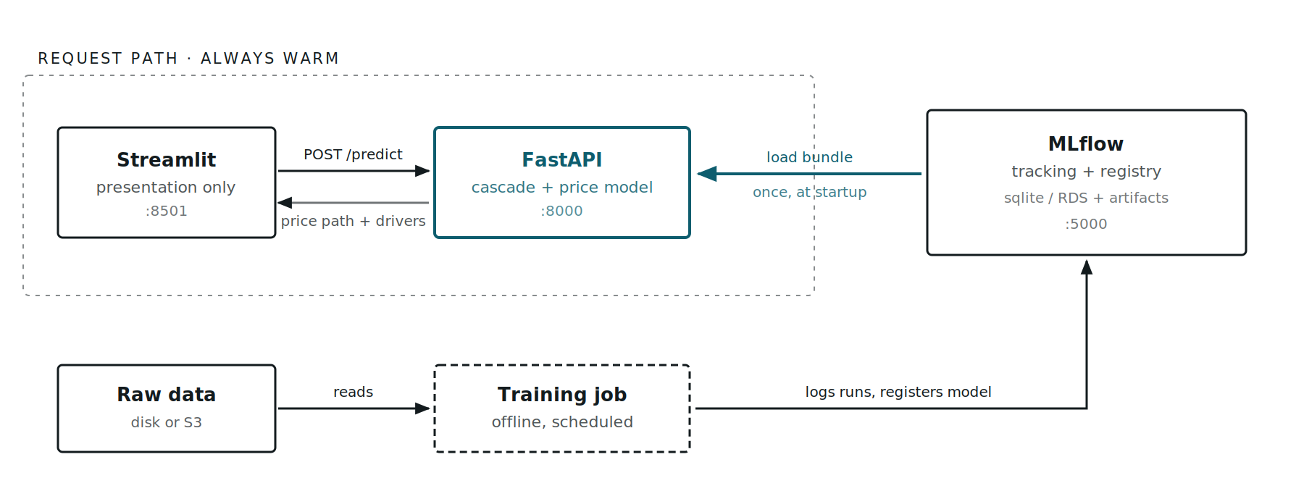
Service topology: Streamlit calls FastAPI over HTTP; FastAPI loads a fitted model bundle from the MLflow registry once at startup; the training job writes runs and models into MLflow and reads raw data from storage.
The teal path is what a forecast request actually touches. The model bundle crosses from MLflow into FastAPI exactly once, at process startup — no registry call and no model fitting happens inside a request. The dashed training job shares only the registry with the request path.
What changed from the notebook
The notebook's forecast function, forecast_holdout, refits the price model on the trailing 731 days every time it is called. Acceptable in a notebook; not in an API, where it would put a multi-second training loop inside a request handler and make two identical requests return different numbers. This is the single structural change the refactor turns on.
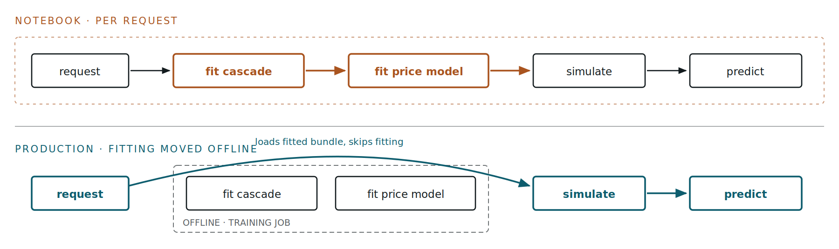
Comparison: in the notebook each forecast call refits the cascade and the price model before predicting. In production, fitting happens once offline and the request path only simulates and predicts.
The two amber boxes are the edges removed from the request path. They still run — once, in the offline training job — and their fitted state travels to the service inside the model bundle.

3. The exogenous cascade
This is the mechanism that makes the system work. Four stages turn one known input into a full design matrix, each stage consuming the previous stage's output.
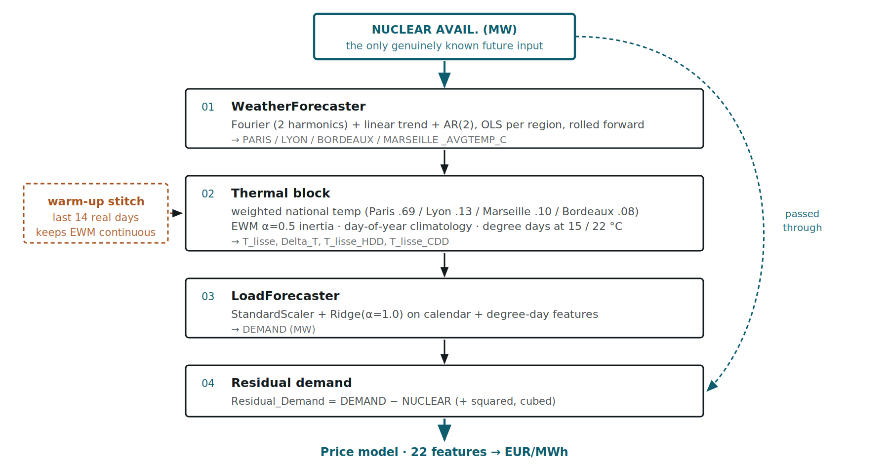
The four-stage exogenous cascade: nuclear availability is the only known input; stage one forecasts four regional temperatures with a Fourier plus AR(2) model; stage two builds national temperature, EWM thermal inertia and degree days using a 14-day warm-up stitch; stage three forecasts demand with a Ridge model; stage four computes residual demand.
Nuclear availability enters at the top and also bypasses directly to stage 4, where it is subtracted from simulated demand. The amber warm-up stitch is what stops the exponentially-weighted thermal inertia from restarting cold on the first forecast day.
Ordering matters and is enforced in code. Degree days are derived from T_lisse, the smoothed national temperature — a stage-2 output — so they cannot be computed before stage 2 runs. Getting this backwards was the most serious defect in the partially-migrated code (§8).

4. Low-level design
Module responsibilities
Module | Responsibility | Key exports
utils/config_loader.py | Loads YAML, resolves paths against a discovered project root, derives the feature list | load_config, get_feature_names
data/data_loader.py | Reads raw CSV from local disk or S3, switched by ENV | load_raw_dataset
data/schema.py | Three pandera contracts: raw, cleaned, forward-looking | RawDataSchema, ProcessedDataSchema, FutureExogenousSchema
`data/s3_store.py` | Writes forecasts, frames and artifacts to S3; date-partitioned archive | S3Store, forecast_key, artifact_key
data/preprocess.py | Dedupes dates, enforces a gap-free daily index, interpolates | preprocess_data, prepare_future_exogenous
features/build_features.py | Calendar flags, residual demand, degree days, national temperature | build_static_features, engineer_national_temperature
models/simulate_exogenous.py | The cascade, its three sub-models, the arcsinh target transform | ExogenousCascade, WeatherForecaster, LoadForecaster, RobustArcSinTransformer
models/backtest.py | Walk-forward fold preparation and evaluation, split apart | prepare_folds, evaluate_folds
models/registry.py | Benchmark candidates and their Optuna search spaces | build_model_registry, NaiveForecaster
models/train_tune.py | Optuna study with stagnation-based early stopping | tune_model
models/forecaster.py | The servable bundle and its MLflow pyfunc wrapper | PriceForecaster, PriceForecasterModel
analysis/evaluate.py | Leaderboard, per-regime breakdown, headless residual diagnostics | build_leaderboard, plot_residual_diagnostics
analysis/explainability.py | SHAP in both EUR/MWh and arcsinh space, with explainer routing | explain_predictions_shap
pipelines/train_pipeline.py | Six-stage orchestration and all MLflow logging | run_training_pipeline
`api/schemas.py` | Pydantic request/response contracts; validates the one real input | ForecastRequest, ForecastResponse
`api/model_loader.py` | Resolves the model URI and loads the bundle once | load_model, resolve_model_uri
`api/main.py` | Four HTTP endpoints; maps model errors to status codes | app

Data contracts
Three pandera schemas, because the training path and the inference path have genuinely different obligations. ProcessedDataSchema requires every column non-null — it gates model training. FutureExogenousSchema requires only nuclear availability and marks the rest Optional and nullable, because on the inference path those columns are supposed to be empty. Applying the training contract to the forecast file is what made the original predict path impossible.
Feature set
22 features in four blocks: 13 calendar and regime flags (including French summer vacation phases and Bastille Day bridge days), 2 degree days, 2 thermal state, 3 residual-demand polynomial terms, and the raw demand and nuclear levels.
The last group is collinear with the residual-demand block by construction, since Residual_Demand = DEMAND - NUCLEAR. A features.feature_set switch offers notebook (reproduces the original, collinear) and decorrelated (drops the raw levels). notebook is active.
Target transform
Prices in this market range from -10 to +126 EUR/MWh, so the target is MAD-scaled and passed through arcsinh, which is defined for negative values where a log transform is not. It is wrapped in TransformedTargetRegressor, which means the transform is fitted inside each fold on training data only — no statistic leaks across the fold boundary.
Configuration
One YAML file drives everything: paths, feature blocks, cascade constants, three named backtest schedules, hyperparameter bounds, MLflow wiring, and the model shortlist. Secrets stay in the environment. Nothing operational is hard-coded in Python.
feature_engineering:
hdd_cdd_reference: ["T_lisse"] # degree days from smoothed national temp
ewm_alpha: 0.5 # thermal inertia
temp_weights: {PARIS: 0.69, LYON: 0.13, MARSEILLE: 0.10, BORDEAUX: 0.08}

backtest:
active_schedule: "extended_summer"
train_window_days: 731 # 2-year rolling window
warmup_days: 14 # EWM warm-up stitch

models:
enabled: ["Baseline_Seasonal", "ElasticNet", "XGBoost"]
selection_metric: "mae"

forecast:
max_horizon_days: 31 # AR(2) decays to seasonal mean beyond this

5. Validation strategy
A random train/test split would be meaningless here. Validation is walk-forward: 12 folds, each testing one calendar month, each trained on the 731 days immediately preceding it. Critically, the cascade is refitted per fold, so a fold's test features are simulated from that fold's training window only — exactly as blind as production.
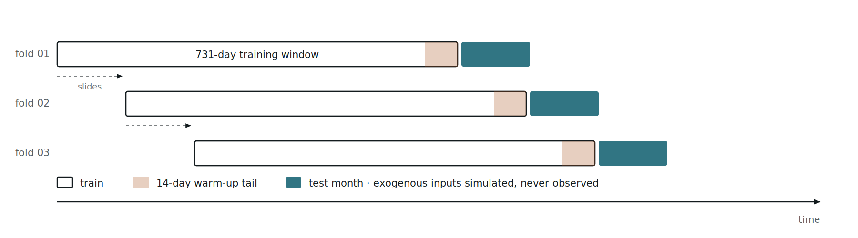
Walk-forward validation timeline: three successive folds each use a 731-day rolling training window ending the day before a one-month test period, with a 14-day warm-up tail seeding thermal inertia.
The window slides one month per fold. The amber tail is the last 14 days of each training window, reused to seed thermal inertia across the boundary — it is training data, not test data.
An efficiency change worth knowing about
The cascade depends only on the training window, never on the price model's hyperparameters. The notebook nonetheless refits it inside every Optuna trial: 50 trials x 12 folds of weather OLS and Ridge fitting, for byte-identical results. Fold preparation is now split from fold evaluation, so the cascade is fitted 12 times instead of 600 and each trial refits only the price model.

6. The served artifact
Because features are manufactured rather than supplied, the model artifact cannot be just a pickled regressor. PriceForecaster bundles six things, and all six are required to reproduce a forecast:
- The fitted WeatherForecaster coefficients, per region
- The day-of-year temperature climatology (t_norm_reference)
- The fitted Ridge LoadForecaster
- The fitted price model, including its arcsinh target transform
- The exact feature ordering the price model was trained on
- The 14-day warm-up tail of real history, and the training window bounds
Item 6 is what lets the service reject a horizon it cannot honestly serve: a request starting before train_end + 1 day, or longer than max_horizon_days, fails with an explanation rather than returning a number built on a cold EWM.
The bundle is logged as an mlflow.pyfunc model with code_paths=["src"], so the artifact carries its own source and a loading process needs nothing on its PYTHONPATH. Verified: it loads in a fresh interpreter from an unrelated working directory and predicts.
>>> m = mlflow.pyfunc.load_model("models:/french_spot_price_forecaster/1")
>>> m.predict(pd.DataFrame({"date": [...], "nuclear_avail": [...]}))

Date predicted_price T_lisse Delta_T Residual_Demand DEMAND (MW)
2020-07-01 33.813735 20.737027 -3.430928 17223.683868 46272.683868
2020-07-02 33.682746 21.152606 -2.539252 16767.610196 46233.610196
2020-07-03 33.348168 21.586594 -2.037861 16195.879552 46195.879552
2020-07-04 25.431980 21.949386 -1.671565 8998.934273 39998.934273 # Sat
2020-07-05 23.617528 22.223079 -1.802549 8651.396348 40151.396348 # Sun

>>> m.unwrap_python_model().model_info()
{'model_name': 'XGBoost', 'backtest_mae': 8.677,
'train_start': '2018-07-01', 'train_end': '2020-06-30', 'n_train_days': 731,
'max_horizon_days': 31, 'n_features': 22, 'best_params': {...}}

The response returns the simulated drivers alongside the price. A forecast that arrives with its assumed temperature, demand and residual demand can be interrogated; a bare number can only be trusted or ignored. The weekend drop on 4-5 July is the demand model behaving correctly, and it is visible precisely because those columns are exposed — residual demand nearly halves, and the price follows.
model_info() is what the API's /model-info endpoint returns, and it is the answer to "which model produced this number, trained on what, scoring what". Carrying provenance in the artifact rather than in a wiki is the difference between a forecast you can audit and one you merely have.

7. Results
All figures below are from a 12-fold walk-forward backtest on the extended_summer schedule, after a 50-trial Optuna sweep per tunable model. Selection is on mean fold MAE.
Model | Mean MAE | Mean RMSE | MAE sigma | Worst fold
XGBoost (registered) | 8.677 | 10.038 | 3.819 | 18.981
ElasticNet | 11.737 | 13.100 | 5.445 | 22.357
Baseline_Seasonal (naive) | 16.994 | 18.427 | 7.641 | 26.500

The migration reproduces the notebook independently. Tuned ElasticNet lands at 11.737 MAE against the notebook's 11.775 — the same model, re-tuned from scratch in the refactored pipeline, arriving at the same answer. That is the strongest available evidence that the port preserved the science.
XGBoost — which the notebook had commented out and never benchmarked — wins by 3.06 MAE, a 26% reduction in error. Its Optuna study early-stopped after 19 trials on max_depth=7, n_estimators=700, learning_rate=0.019, with subsample and colsample both near 1.0.
Where the models differ
A single mean hides regime failure, so folds are reported individually. XGBoost wins 9 of 12 folds.
Regime (test month) | Baseline | ElasticNet | XGBoost
Spring Transition (2018) | 8.35 | 8.50 | 7.67
Early Summer (2018) | 11.33 | 11.14 | 8.02
July Vacations (2018) | 16.65 | 16.23 | 9.24
August Industrial Trough (2018) | 26.16 | 19.56 | 18.98
Back to School / Autumn (2018) | 25.07 | 22.36 | 12.02
Spring Transition (2019) | 9.52 | 5.05 | 5.20
Early Summer (2019) | 13.17 | 12.68 | 9.27
July Vacations (2019) | 14.55 | 7.40 | 9.33
August Industrial Trough (2019) | 25.16 | 12.04 | 6.44
Back to School / Autumn (2019) | 26.50 | 12.22 | 5.56
COVID-19 Demand Collapse (2020) | 21.84 | 8.87 | 5.35
Lockdown Easing / Early Summer (2020) | 5.63 | 4.80 | 7.03

Two rows are worth dwelling on. The August Industrial Trough is where every model is weakest — 18.98 even for the winner, more than twice its average — so the French summer shutdown remains genuinely under-modelled despite the dedicated is_august_vacation flag. And during Lockdown Easing, the naive baseline (5.63) beats XGBoost (7.03). When prices sit flat near their year-ago level, a model with 22 features has more ways to be wrong than a model with none. Keeping the naive baseline in the registry is what makes both facts visible.
The year problem
SHAP attribution on the winning model surfaced something that changes how much you should trust these numbers.
Feature | Mean absolute SHAP (EUR/MWh)
year | 11.530
Residual_Demand | 4.788
NUCLEAR AVAIL. (MW) | 1.240
day_of_week | 0.981
DEMAND (MW) | 0.953
T_lisse | 0.863
sin_day_of_year | 0.771
cos_day_of_year | 0.571
Delta_T | 0.543
T_lisse_CDD | 0.493

Why this is fragile, and why it is not leakage
year contributes more than every physical fundamental combined — 11.53 against 4.79 for residual demand, the strongest real driver. Removing it costs XGBoost 9.08 to 13.85 MAE at default hyperparameters, so it is carrying real signal — but the reason is structural: each fold trains on 731 days, roughly 2 calendar years, and tests in the later one, so year is a near-perfect "recent price level" indicator.
It is not leakage; the calendar year is genuinely known in advance. The problem is generalisation. Across a January boundary, an unseen year value makes the tree saturate at its highest split while ElasticNet extrapolates its coefficient without bound. What year proxies is recent price level, which a trailing 30-day median price would capture honestly and extrapolate sanely. That substitution is the highest-value modelling change available, and it is deliberately not made yet — it changes results and is your call. year lives in features.calendar, so dropping it is a one-line config edit.

8. Defects found and fixed
The partially-migrated src/ tree had not been run end to end. Eight defects, two of which made the system non-functional — plus three more found later by the test suite and CI, listed at the end of this section.
Defect | Effect | Resolution
Degree days built from city columns, not T_lisse | Produced PARIS_AVGTEMP_C_HDD and never the T_lisse_HDD the model requires — hard KeyError | Added hdd_cdd_reference config key; explicit error if the source column is absent
Training schema applied to the forecast file | nullable=False rejected the deliberately-empty July input — predict path impossible | Added FutureExogenousSchema and prepare_future_exogenous
PROJECT_ROOT derived from __file__ | MLflow's code_paths shadows src, so a served process resolved config inside the artifact and raised FileNotFoundError | Resolution order: env var, then upward search from cwd, then module-relative
T_norm unmapped on 29 February | A 731-day window need not contain a leap day, silently yielding NaN for Delta_T | Day 366 falls back to day 365; unmapped days now raise
MLflow file store | Maintenance mode in MLflow 3.x, and it has never supported the model registry | Switched to sqlite:/// with a pinned artifact location
requirements.txt incomplete | Missing python-dotenv, PyYAML, optuna, shap, statsmodels — all imported | Pinned full dependency set across training and serving
AWS credentials unignored | .gitignore held only .env with no trailing newline; live keys one git add from a commit | Full .gitignore plus .env.example
Stale src/train.py and four empty modules | Referenced config["data"]["local_path"], which does not exist; registry, train_tune, evaluate, explainability were 0 bytes | All written; train.py reduced to a shim

Fidelity check. After the degree-day fix, the seasonal baseline reproduces the notebook fold-for-fold — fold 01 at MAE 8.35 / RMSE 10.33 and fold 02 at 11.33 / 13.52, matching the notebook output exactly. The migration preserves behaviour where behaviour was correct.
Three more, found by adding tests and CI
Listed separately because they were found by a different method — writing the checks in tests/ and verifying the CI steps locally, rather than by running the pipeline. Detail in CI.md.
Defect | Effect | Resolution
src/models/registry.py imported optuna at module scope | optuna is a training dependency absent from the slim serving image, but registry is on the serving path (NaiveForecaster lives there) — so a Baseline_Seasonal champion could not have been loaded by the `:serve` image at all. Latent: it only bites when the baseline wins. | Moved behind TYPE_CHECKING with from __future__ import annotations; it is used only in type positions
Container smoke test satisfied by the wrong process | A host uvicorn bound to 127.0.0.1:8000 wins over Docker's 0.0.0.0:8000 proxy for loopback traffic, so the check answered from the host and reported a model the container did not have | Publish the smoke container on port 18000; a test something else can satisfy is not a test
pd.Timedelta(days=N) deprecated | Emitted from inside pandas 2.3.3's own constructor under numpy 2.5.2 and documented to become an error — across five sites, all on the date arithmetic defining fold boundaries | pd.Timedelta(N, unit="D"): identical meaning, different code path

9. AWS — S3 implemented, EC2 outstanding
S3 is done and verified. The bucket was already provisioned with versioning enabled, all four public-access blocks on, and AES256 default encryption. What was missing was the code actually using it, and a way to write back. Both now exist:
Verified | Result
ENV=production read path | ✅ First [PROD] fetch — 2,007 and 31 rows, matching local exactly
Full pipeline sourced from S3 | ✅ Identical metrics to the local run (16.99 / 13.00 / 9.08 MAE)
S3 write layer (src/data/s3_store.py) | ✅ Wrote 8,256 B Parquet to forecasts/dt=2020-07-01/, read back identical
Forecast archive wired into the pipeline | ✅ Stage 6; inert locally, archives in production
Raw objects moved to raw/epex/{train,predict}/ | ✅ Copied, ETag-verified, root copies removed
Credentials via the boto3 chain, not explicit keys | ✅ No aws_access_key_id anywhere in src/
Dockerfile + docker-compose.yml | ✅ Built; container serves identical predictions, healthcheck healthy
MLflow artifact location portable across machines | ✅ S3 URI under ENV=production (was an absolute host path)

The forecast archive matters more than its size suggests: a forecast not stored on the day it is made cannot be reconstructed later, so the realised-accuracy record can only begin once it exists.
EC2 is not yet deployed, but the container is built and working. One image with four compose services (api, ui, mlflow, train) differing only by command, ports bound to loopback, and a healthcheck that asserts the model actually loaded. docker compose up api reports healthy and returns predictions identical to the host. Image size 1.64 GB after removing a 288 MB transitive GPU dependency.
Containerising surfaced two portability bugs that a host-only run could never have found — MLflow's absolute artifact paths and a container/host uid mismatch (CORRECTIONS.md findings 13-14). Both are now handled.
Remaining: launch an instance, attach an IAM role scoped to this one bucket, and put Nginx in front. AWS_S3_EC2.md explains both services from first principles and carries the model-interaction diagrams.
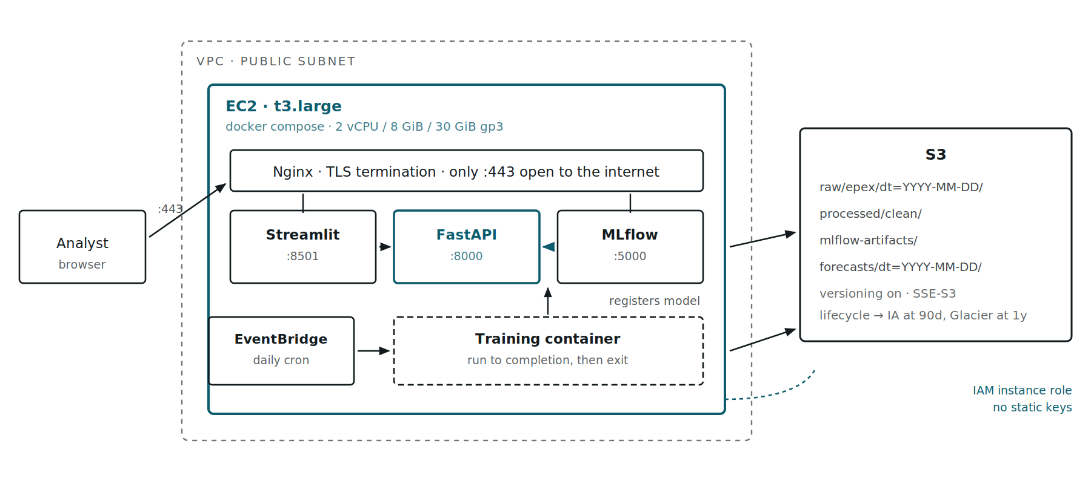
Target AWS topology: a single EC2 instance in a public subnet runs Streamlit, FastAPI and MLflow containers behind Nginx with only port 443 exposed; S3 holds raw, processed, artifact and forecast prefixes; EventBridge triggers the training container; S3 access uses an IAM instance role.
A single instance is right for this workload: one model, one analyst audience, a daily retrain measured in minutes. The teal path is the request path; everything else is scheduled or storage. Credentials come from an instance role, so the .env AWS keys disappear entirely in production.
S3 — what to set up
- Bucket layout with date partitions. Four prefixes as drawn. Partitioning raw arrivals by dt= makes a daily feed append-only, so a bad file affects one partition instead of overwriting history. Write forecasts/ on every run — that is your future accuracy-tracking dataset, and it cannot be reconstructed later.
- Versioning and encryption on from day one. Bucket versioning plus SSE-S3. Versioning is what makes a bad overwrite recoverable, and it cannot be applied retroactively to objects already clobbered.
- Lifecycle rules. Raw and forecast partitions to Standard-IA at 90 days, Glacier Instant at one year. MLflow artifacts hold SHAP plots and model bundles that are only read on investigation — same treatment. Block public access at the account level.
- Replace static keys with an instance role. data_loader.py currently passes explicit aws_access_key_id to boto3.client. On EC2, omit those arguments and let boto3 pick up the instance role — scoped to s3:GetObject and s3:PutObject on this bucket only. Static keys in .env then have no production role at all.
EC2 — deployment shape
t3.large (2 vCPU, 8 GiB) is the right starting point. The binding constraint is not serving — a forecast is a Ridge predict plus an XGBoost predict over 31 rows, single-digit milliseconds — it is the Optuna sweep, which is CPU-bound across 12 folds. If a nightly retrain runs long, move training to a scheduled c7i.xlarge that terminates on completion rather than paying for idle vCPUs all day.
- Split the container images. The current single DockerFile — note the casing — builds one image and runs the trainer. Split into Dockerfile.api, Dockerfile.ui and Dockerfile.train so the Streamlit image carries no XGBoost and the API image carries no Optuna or SHAP. Set PYTHONUNBUFFERED=1 in all three, or print output sits in a block buffer and CloudWatch shows nothing until the process exits.
- Move MLflow's backend off SQLite. SQLite on EBS is fine while one training job writes at a time. The moment the API, the MLflow UI and a training run share it, use RDS Postgres (db.t4g.micro) with --default-artifact-root s3://.../mlflow-artifacts/. This is also what makes the registry safe to promote against.
- Pin the API to a registry stage, not a run. Load models:/french_spot_price_forecaster@champion rather than a run-scoped URI, so promoting a model is a registry alias change and a container restart, not a rebuild. Keep the loaded bundle in module scope so it is fetched once per process.
- Lock the security group down. Inbound 443 from the internet, 22 from your IP only. Ports 8000, 8501 and 5000 stay on the Docker network and are never exposed — Nginx reverse-proxies to them. MLflow has no authentication of its own, so anything that reaches :5000 can delete your registry.
- Health checks and restart policy. restart: unless-stopped in compose, and a /health endpoint that asserts the model actually loaded rather than returning 200 unconditionally. A service that reports healthy with no model is worse than one that is plainly down.
Order of work
Build FastAPI and Streamlit locally against the SQLite store first — the artifact already loads and predicts, so nothing blocks this. Containerise second. Move to S3 and EC2 third, once there is a working system worth deploying. Introducing cloud infrastructure before the service exists means debugging two unknowns at once.

10. Open questions and known gaps
- The `year` feature — see §7. The single highest-value modelling decision outstanding, and a prerequisite for trusting this model beyond 2020.
- The `decorrelated` feature set is untested. The comparison run exceeded its time limit and was killed, so whether dropping the collinear DEMAND and NUCLEAR levels resolves the ElasticNet ConvergenceWarnings — and at what accuracy cost — remains unmeasured. The switch exists and is wired; only the measurement is missing.
- August is under-modelled. Every model posts its worst fold on the August industrial trough (18.98 MAE for the winner, against an 8.68 average). The single is_august_vacation month flag is too blunt for a shutdown whose depth varies year to year; residual demand during that month is the thing to look at.
- Weather forecast time index has a known drift. WeatherForecaster builds its training index over leap-day-stripped data but computes forecast offsets in calendar days, so t drifts by one or two days across a two-year window. Behaviour is preserved from the notebook deliberately; correcting it would silently move every number here.
- Test coverage is structural, not behavioural. The 53 tests in tests/ now pin the invariants that fail silently — cascade stage ordering, horizon bounds, fold disjointness, request unit validation, and graceful degradation with no model (see CI.md). What they deliberately do not cover is the training pipeline end to end, the S3 read/write paths, and the rendered Streamlit output; those need real data or real credentials and are verified by hand. Model accuracy is not unit-tested on purpose: pinning an MAE threshold tests a result, not a contract, and such a test fails for reasons that are not bugs.
- No drift monitoring. Writing forecasts/ to S3 is the enabling step; comparing them against settled prices as they arrive is what turns this into something you can trust unattended.

Appendix — reproducing this
# Clean and cache the training data
python -m src.data.preprocess

# Full run: benchmark, tune, select, register
python -m src.pipelines.train_pipeline

# Fast smoke test: default hyperparameters, no SHAP, no registration
python -m src.pipelines.train_pipeline --skip-tuning --skip-shap --no-register

# Inspect runs
mlflow ui --backend-store-uri sqlite:///mlflow.db

Diagram sources are kept as SVG alongside the rendered PNGs in docs/images/, so they stay editable. To regenerate this document as a Word file:
python scripts/md_to_docx.py docs/DESIGN.md docs/DESIGN.docx

