Docker in This Project
What Docker is, how it fits this system, the step-by-step approach that was actually taken, and the two portability bugs it exposed.
Companion to AWS_S3_EC2.md (where the containers will run), DESIGN.md (architecture) and INTERNALS.md (the code inside them).

1. Why Docker here
Docker packages an application together with its entire environment — the Python version, every library, the OS packages — into a single immutable artifact that runs identically anywhere.
The generic case for it is "works on my machine". The specific case for this project is sharper, and there are three reasons:
1. The model artifact is a cloudpickle of a live Python object. The PriceForecaster bundle contains a fitted ExogenousCascade, an XGBRegressor, and a RobustArcSinTransformer. Unpickling requires the same library versions that pickled it. A pandas or xgboost major bump breaks deserialisation. One image for training and serving makes that class of failure structurally impossible.
2. XGBoost has a native dependency most people discover the hard way. It needs libgomp1 (the OpenMP runtime) present at import. On a bare python:3.12-slim the import fails with an opaque shared-object error. Putting that apt package in the Dockerfile means it is never missing again.
3. A `t3.large` needs to be reproducible, not hand-configured. Anything done over SSH must be redone on the next instance. In an image, it is done once.
What it is NOT for here. Not scale, not orchestration, not microservices. One small always-on service and one scheduled batch job. Kubernetes would be theatre.

2. The five concepts you need
Concept | What it is | In this project
Image | An immutable filesystem snapshot + default command. Read-only | epex-forecaster:latest, 1.64 GB
Container | A running instance of an image. Disposable | four of them: api, ui, mlflow, train
Layer | One filesystem diff per Dockerfile instruction, cached | why COPY requirements.txt comes before COPY src/
Volume | A host directory mounted into a container. The only writable, surviving state | ./mlflow.db, ./mlartifacts, ./results
Network | A private DNS namespace between containers | the UI reaches the API at http://api:8000

The one rule that governs everything below:
The image is code. Everything mutable is a volume or S3. A container must be destroyable at any moment with nothing lost.

3. The architecture
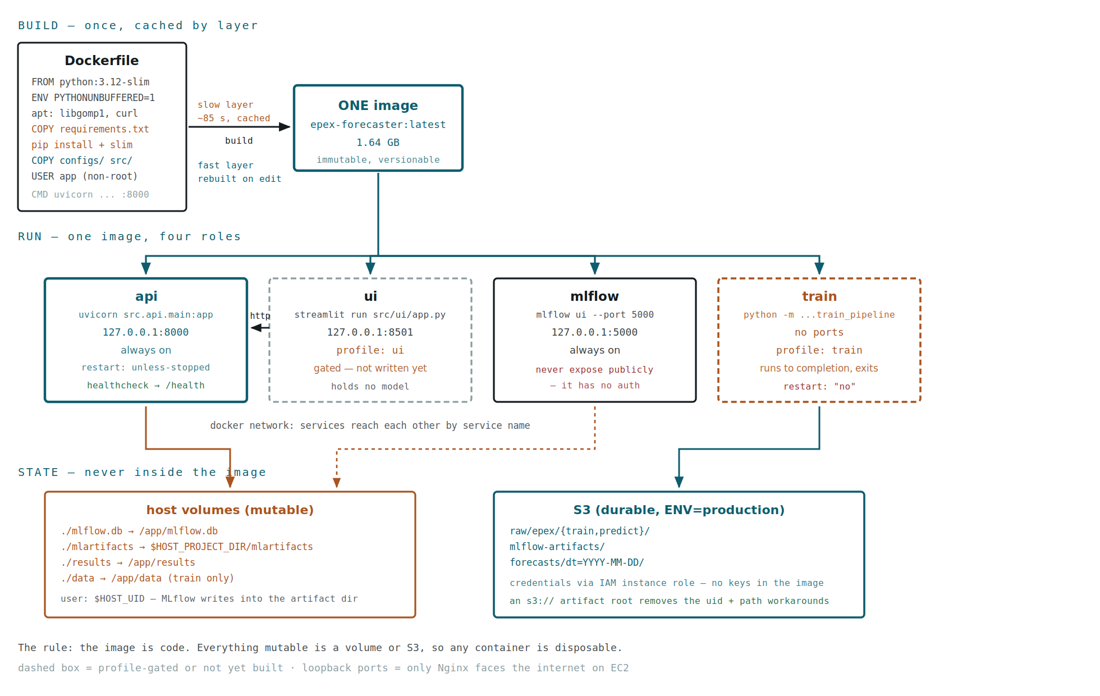
Docker architecture: one Dockerfile builds one image through cached layers; that single image runs as four containers chosen by command — api, ui, mlflow, train. Two are always on, two are profile-gated. Ports bind to loopback, host volumes hold mutable state, and S3 holds durable artifacts.
One image, four roles
This is the central design decision, and it is worth defending because the obvious alternative is one image per service.
epex-forecaster:latest
│
┌──────────────┬───────────┴────────────┬──────────────┐
▼ ▼ ▼ ▼
api ui mlflow train
uvicorn streamlit mlflow ui python -m
:8000 :8501 :5000 train_pipeline
always on profile: ui always on profile: train
exits when done

Option | Pros | Cons
One image, command per service ✅ | Training and serving can never diverge in library versions — the cloudpickle problem cannot occur. One build, one thing to push | Larger than any single service needs; the API carries optuna and shap it never calls
One image per service | Each is minimal; smaller pulls | Three Dockerfiles to keep in sync, and the versions can drift — which is exactly the failure the bundle is vulnerable to

The trade is deliberate: correctness over size, given the artifact format. The size cost is real and quantified in §7.
Two always-on, two gated
ui and train sit behind compose profiles, so docker compose up starts only api and mlflow.
- ui is gated because `src/ui/app.py` does not exist yet. Without the profile, docker compose up would fail on a service that was never written.
- train is gated because it is a batch job, not a service. It must be invoked deliberately: docker compose --profile train run --rm train.
Ports bind to loopback, not 0.0.0.0
ports:
- "127.0.0.1:8000:8000" not "8000:8000"

8000:8000 binds to every interface, which on EC2 means the public internet, security group permitting. Binding to 127.0.0.1 means only processes on the host — i.e. Nginx — can reach them.
This matters most for MLflow: it has no authentication of its own. Anything that can reach :5000 can delete the model registry.

4. The Dockerfile, decision by decision
FROM python:3.12-slim

slim over alpine: alpine uses musl libc, and scientific Python wheels are built for glibc — on alpine, numpy, scipy and xgboost compile from source, which is slow and fragile. slim keeps glibc and still drops ~700 MB versus the full image. 3.12 matches the development interpreter exactly.
ENV PYTHONUNBUFFERED=1 PYTHONDONTWRITEBYTECODE=1 PIP_NO_CACHE_DIR=1 PROJECT_ROOT=/app

Variable | Why
PYTHONUNBUFFERED=1 | Without it print() sits in a block buffer and container logs stay empty until the process exits — a hung training run looks identical to a silent one. This was observed for real earlier in the project
PYTHONDONTWRITEBYTECODE=1 | No .pyc in a layer that is discarded anyway
PIP_NO_CACHE_DIR=1 | pip's wheel cache would otherwise be baked into the image
PROJECT_ROOT=/app | config_loader resolves paths from this rather than __file__, because MLflow's code_paths shadows the src package (see INTERNALS.md §2)

RUN apt-get install -y --no-install-recommends libgomp1 curl && rm -rf /var/lib/apt/lists/*

libgomp1 is XGBoost's OpenMP runtime — non-optional. curl exists solely for the healthcheck. --no-install-recommends and deleting the apt lists in the same layer keeps them out of the image.
COPY requirements.txt .
RUN pip install ... && pip uninstall -y nvidia-nccl-cu13 && find ... -delete

Two separate ideas here, both important.
Layer ordering. Requirements are copied and installed before the source. Docker caches layers by content, so editing src/ invalidates only the last two layers and rebuilds in seconds. Copying source first would reinstall all 34 dependencies on every code change — 85 seconds, every time.
Same-layer cleanup. nvidia-nccl-cu13 arrives transitively via xgboost and weighs 288 MB, but is only used for multi-GPU collective operations. This project trains on CPU (tree_method="hist"), verified to work without it. It must be uninstalled in the same `RUN` — a later layer cannot delete bytes from an earlier one, it only adds a whiteout entry, and the image keeps both.
COPY configs/ ./configs/
COPY src/ ./src/

Only what runtime needs. data/, notebooks/, docs/, mlartifacts/ and .git/ are excluded by .dockerignore — see §5.
RUN useradd app && chown -R app:app /app
USER app

Non-root. Nothing here needs privileges, and a container that cannot write outside its own directories limits the blast radius of a compromised dependency. This choice interacts with volume permissions — see §6.
CMD ["uvicorn", "src.api.main:app", "--host", "0.0.0.0", "--port", "8000"]

--host 0.0.0.0 binds inside the container, which is required for the port mapping to reach it. The host-side restriction to loopback happens in compose. Two different bindings, easy to confuse.

5. .dockerignore — a 15 MB and a correctness win
The build context is everything sent to the daemon before the build starts.
 | Context size
Original .dockerignore (5 lines) | 15.2 MB
Rewritten | 0.1 MB

The worst offender was `mlartifacts/` at 13 MB, and that is a correctness problem as much as a size one: baking a stale copy of the model bundle into the image risks it shadowing the mounted volume. .git/, docs/, results/ and mlflow.db were also being shipped.
Also excluded, and non-negotiable: `.env`. Secrets must never enter an image layer — layers are distributable and docker history can expose them.

6. The step-by-step approach actually taken
Not the idealised order — the real one, including what went wrong.
STEP 1 Rename and write the Dockerfile
DockerFile -> Dockerfile (case matters to docker build)
+ PYTHONUNBUFFERED, libgomp1, non-root user, layer ordering

STEP 2 Write docker-compose.yml
four services from one image, differing only by command
ui + train behind profiles (ui isn't written yet)
ports -> 127.0.0.1 (not 0.0.0.0)
healthcheck -> /health (asserts the MODEL loaded)
train: restart "no" (a batch job must not retry forever)

STEP 3 Rewrite .dockerignore
15.2 MB -> 0.1 MB; exclude mlartifacts (stale-model hazard) and .env

STEP 4 Validate before building
docker compose config --quiet ✅ valid
docker compose config --services ✅ only api + mlflow by default
▲ cheap, catches YAML and interpolation errors in a second

STEP 5 Build
docker compose build api ✅ all layers
▲ libgomp1 worked; all 34 pinned deps installed as wheels,
nothing compiled from source

STEP 6 Smoke-test imports inside the container
docker run --rm ... python -c "import xgboost, mlflow, src.api.main"
▲ proves the environment before involving networking or volumes

STEP 7 Run it — and hit BUG 1
docker run ... -v ./mlartifacts:/app/mlartifacts
/health -> 503 "No such artifact: ''"
▲ MLflow recorded an ABSOLUTE HOST PATH in mlflow.db

STEP 8 Mount at the recorded host path — and hit BUG 2
-v ./mlartifacts:/home/<user>/<project>/mlartifacts
/health -> 503 "[Errno 13] Permission denied: registered_model_meta"
▲ host uid 1001 vs container uid 1000, and MLflow WRITES that file

STEP 9 Confirm the image is fine
docker run --user "$(id -u):$(id -g)" ...
/health -> ok, model_loaded=true
/predict -> 33.81 33.68 33.36 == identical to the host
▲ isolates "the image is good" from "the mounts are wrong"

STEP 10 Fix both properly, not with flags
config_loader._resolve_artifact_location() -> s3:// under ENV=production
compose: user "${HOST_UID}:${HOST_GID}" + mount at $HOST_PROJECT_DIR
▲ S3 is the real fix; the compose flags only rescue the LOCAL path

STEP 11 Run through compose
docker compose up -d api ✅ healthy
/predict ✅ identical predictions

STEP 12 Slim it
drop nvidia-nccl-cu13 in the install layer, prune tests/ and *.pyc
2.65 GB -> 1.64 GB, predictions unchanged, still healthy

The two bugs, and why containerising was worth it
Both are recorded in CORRECTIONS.md findings 13-15. Neither could have been found by running on the host, and both are real portability defects rather than Docker problems.
Bug 1 — MLflow bakes absolute paths. artifact_location is recorded on the experiment at creation time, and MLflow stores absolute paths thereafter:
mlflow.db -> /home/sarthakgupta/quantitave_forecasting/mlartifacts
container -> /home/sarthakgupta : No such file or directory
/app/mlartifacts : exists, but MLflow never looks there

Fix: artifact_location is now environment-aware and becomes s3://<bucket>/mlflow-artifacts under ENV=production — one URI that resolves identically from any machine, any user, with no mount.
Residual limitation: MLflow cannot relocate an existing experiment, so the S3 location applies to experiments created in production.
Bug 2 — uid mismatch on a bind mount. Host uid 1001, container app user 1000. And MLflow writes registered_model_meta into the artifact directory when loading a models:/ URI, so read permission is not enough.
Fix: compose passes user: "${HOST_UID}:${HOST_GID}". Note UID is readonly in bash, hence the HOST_ prefix. The S3 artifact root removes the need entirely — no bind mount, no uid mapping, no local write.
Both diagnosed themselves. The API starts unhealthy and reports the exact cause rather than crash-looping — the deliberate design choice in INTERNALS.md §11 paying for itself.

7. Verified state, and what is still open
Check | Result
Docker / Compose | 29.2.1 / v5.0.2
docker compose config | valid; only api + mlflow default
Build | all layers; libgomp1 present, XGBoost imports
34 pinned deps on python:3.12-slim | no wheel compiled from source
Runs as non-root | uid 1000 (or $HOST_UID)
docker compose up api | healthy
/predict in-container | 33.81 / 33.68 / 33.36 — identical to host
/predict error path | GW unit error → 422
Image size | 1.64 GB (from 2.65 GB)

Open: split requirements per service
The API image still carries training-only dependencies:
Package | Size | Pulled in by | API needs it?
llvmlite | 171 MB | numba ← shap | no
pyarrow | 149 MB | parquet I/O | yes
plotly | 39 MB | Streamlit UI | no
streamlit | 30 MB | UI service | no
statsmodels | ~30 MB | notebook EDA only | no
optuna | small | tuning | no

Splitting into requirements-base/api/train.txt would remove roughly 270 MB more from the serving image. This is the per-service-image recommendation in MLOPS.md step 10, and it matters for the AWS free tier where t3.micro ships an 8 GiB EBS volume by default.
The tension to be aware of: separate images reintroduce the version-drift risk that one image was chosen to eliminate. The safe form is a shared `requirements-base.txt` with pinned versions, plus thin per-service additions — never independently resolved dependency sets.

8. Command reference
# --- local, ENV=local -------------------------------------------------------
export HOST_PROJECT_DIR=$PWD HOST_UID=$(id -u) HOST_GID=$(id -g)

docker compose config --quiet # validate before building
docker compose build api # build (cached after the first run)
docker compose up -d api # start the API
docker compose ps # status, including health
docker compose logs -f api # follow logs
docker compose down # stop and remove

# --- ad-hoc -----------------------------------------------------------------
docker compose exec api bash # shell into a running container
docker run --rm epex-forecaster:latest python -c "import xgboost"
docker compose --profile train run --rm train # one training run, then exit
docker compose --profile ui up -d ui # once src/ui/app.py exists

# --- inspection -------------------------------------------------------------
docker images epex-forecaster
docker inspect --format '{{.State.Health.Status}}' <container>
docker run --rm epex-forecaster:latest \
du -sm /usr/local/lib/python3.12/site-packages/* | sort -rn | head

# --- housekeeping -----------------------------------------------------------
docker system df # what disk is being used
docker builder prune # drop the build cache

Two things that will bite you
- The proxy. In this environment curl localhost:8000 is intercepted by an HTTP proxy and returns 504. Use curl --noproxy '*' localhost:8000/.... Not a container problem, but it looks exactly like one.
- `docker compose up` with no `HOST_PROJECT_DIR` falls back to /app, the artifact mount lands in the wrong place, and the API starts unhealthy with No such artifact. Export the three variables, or set ENV=production and let S3 handle it.

9. The path to EC2
Docker is what makes the deployment in AWS_S3_EC2.md Part 5 step 6 a short job rather than an afternoon of SSH:
1. launch t3.large, Amazon Linux
2. install docker + compose plugin (via user-data, so it is reproducible)
3. attach an IAM role s3:GetObject / s3:PutObject, one bucket
4. clone the repo, set ENV=production
▲ artifact_location becomes s3:// — no volume mount, no uid mapping
5. docker compose up -d api mlflow
6. Nginx in front: :443 public, proxy to 127.0.0.1:8000 and :8501
7. security group: 443 from anywhere, 22 from your IP only

Two cautions carried over. The 12-month free tier is t2.micro/t3.micro with 1 GiB RAM — not enough for three containers plus a training run; either train locally and deploy only the API, or pay roughly $60/month for a t3.large. And bake the model into the image (or cache it on EBS) so MLflow is not a boot dependency: a running API survives MLflow being down, but a restarting one does not.

