D3 (Data-Driven Document)

* It is used to map data with data elements.

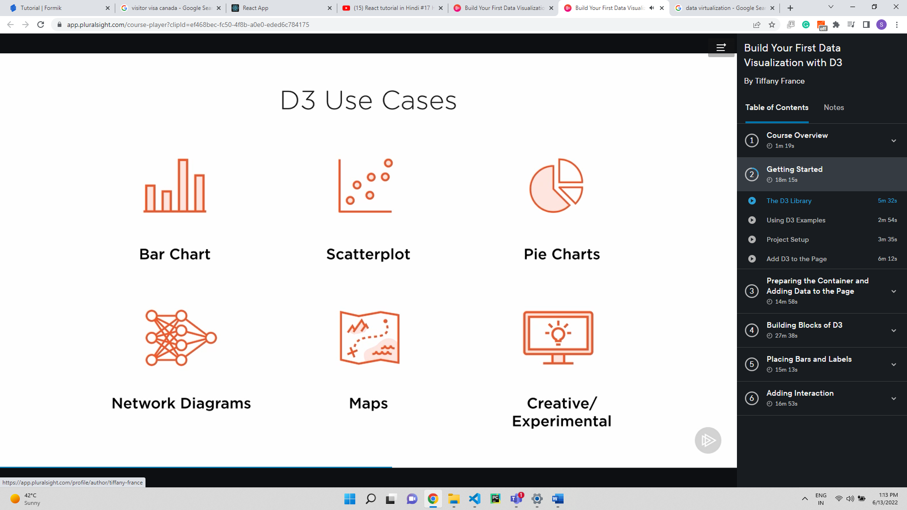

(SWG)=Scalable Vector Graphics.



