**Q.1**

<!DOCTYPE html>

<html lang="en">

<head>

<meta charset="UTF-8">

<meta name="viewport" content="width=device-width, initial-scale=1.0">

<title>Currency Converter</title>

<style>

/* CSS styles */

body {

font-family: Arial, sans-serif;

}

label {

margin-right: 10px;

}

select {

margin-left: 5px;

}

</style>

</head>

<body>

<div id="root"></div>

<script src="https://unpkg.com/react@17/umd/react.development.js"></script>

<script src="https://unpkg.com/react-dom@17/umd/react-dom.development.js"></script>

<script>

// ReactJS code

const { useState } = React;

function CurrencyConverter() {

const [amount, setAmount] = useState('');

const [fromCurrency, setFromCurrency] = useState('USD');

const [toCurrency, setToCurrency] = useState('EUR');

const exchangeRate = 0.85; // Example exchange rate (1 USD = 0.85 EUR)

const handleAmountChange = (event) => {

setAmount(event.target.value);

};

const handleFromCurrencyChange = (event) => {

setFromCurrency(event.target.value);

};

const handleToCurrencyChange = (event) => {

setToCurrency(event.target.value);

};

const convertCurrency = () => {

const convertedAmount = parseFloat(amount) * exchangeRate;

return isNaN(convertedAmount) ? '' : convertedAmount.toFixed(2);

};

return React.createElement(

'div',

null,

React.createElement('h1', null, 'Currency Converter'),

React.createElement(

'div',

null,

React.createElement(

'label',

null,

'Amount:',

React.createElement('input', { type: 'number', value: amount, onChange: handleAmountChange })

)

),

React.createElement(

'div',

null,

React.createElement(

'label',

null,

'From:',

React.createElement(

'select',

{ value: fromCurrency, onChange: handleFromCurrencyChange },

React.createElement('option', { value: 'USD' }, 'USD'),

React.createElement('option', { value: 'EUR' }, 'EUR')

)

)

),

React.createElement(

'div',

null,

React.createElement(

'label',

null,

'To:',

React.createElement(

'select',

{ value: toCurrency, onChange: handleToCurrencyChange },

React.createElement('option', { value: 'USD' }, 'USD'),

React.createElement('option', { value: 'EUR' }, 'EUR')

)

)

),

React.createElement(

'div',

null,

React.createElement('p', null, 'Converted Amount: ', convertCurrency())

)

);

}

ReactDOM.render(React.createElement(CurrencyConverter), document.getElementById('root'));

</script>

</body>

</html>

**Output:**

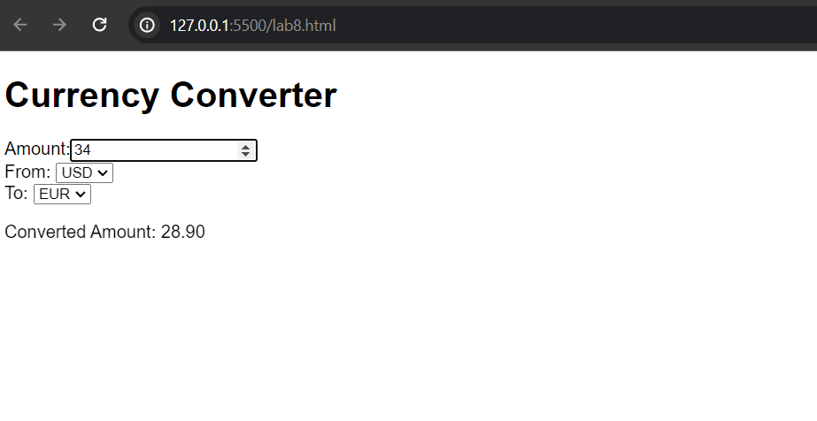

**Q.2**

<!DOCTYPE html>

<html lang="en">

<head>

<meta charset="UTF-8">

<meta name="viewport" content="width=device-width, initial-scale=1.0">

<title>Stopwatch</title>

<style>

/* CSS styles */

body {

font-family: Arial, sans-serif;

}

button {

margin-right: 10px;

}

</style>

</head>

<body>

<div id="root"></div>

<script src="https://unpkg.com/react@17/umd/react.development.js"></script>

<script src="https://unpkg.com/react-dom@17/umd/react-dom.development.js"></script>

<script src="https://cdnjs.cloudflare.com/ajax/libs/babel-standalone/6.26.0/babel.min.js"></script>

<script type="text/babel">

// ReactJS code

const { useState, useEffect } = React;

function Stopwatch() {

const [timer, setTimer] = useState(0);

const [isActive, setIsActive] = useState(false);

useEffect(() => {

let interval;

if (isActive) {

interval = setInterval(() => {

setTimer((prevTimer) => prevTimer + 1);

}, 1000);

} else {

clearInterval(interval);

}

return () => clearInterval(interval);

}, [isActive]);

const handleStart = () => {

setIsActive(true);

};

const handlePause = () => {

setIsActive(false);

};

const handleReset = () => {

setIsActive(false);

setTimer(0);

};

return (

<div>

<h1>Stopwatch</h1>

<div>

<p>{timer}s</p>

</div>

<div>

{!isActive ? (

<button onClick={handleStart}>Start</button>

) : (

<button onClick={handlePause}>Pause</button>

)}

<button onClick={handleReset}>Reset</button>

</div>

</div>

);

}

ReactDOM.render(<Stopwatch />, document.getElementById('root'));

</script>

</body>

</html>

**Output:**

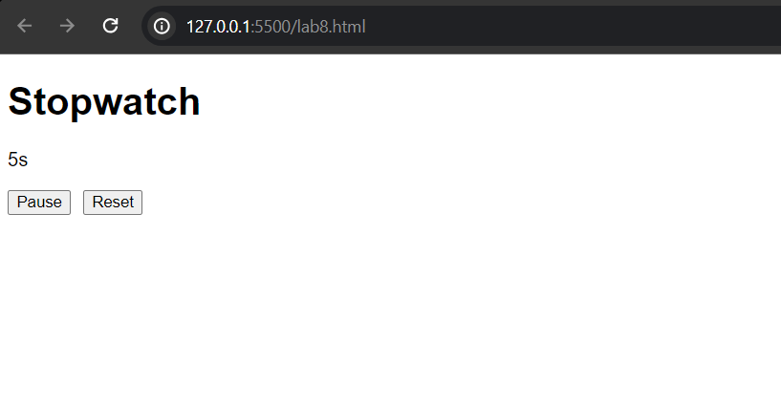

**Q.3**

<!DOCTYPE html>

<html>

<head>

<meta charset="UTF-8" />

<title>Simple Messaging App</title>

<style>

body {

font-family: Arial, sans-serif;

}

#conversations {

list-style-type: none;

padding: 0;

margin: 0;

}

#conversations li {

padding: 10px;

border-bottom: 1px solid #ddd;

cursor: pointer;

}

#conversations li:hover {

background-color: #f5f5f5;

}

#messages {

list-style-type: none;

padding: 0;

margin: 0;

height: 300px;

overflow-y: auto;

}

#messages li {

padding: 10px;

border-bottom: 1px solid #ddd;

}

#message-input {

width: 100%;

padding: 10px;

}

#send-button {

padding: 10px;

background-color: #4CAF50;

color: white;

border: none;

cursor: pointer;

}

#send-button:hover {

background-color: #45a049;

}

</style>

</head>

<body>

<h1>Simple Messaging App</h1>

<ul id="conversations"></ul>

<ul id="messages"></ul>

<input id="message-input" type="text" placeholder="Type a message..." />

<button id="send-button">Send</button>

<script src="https://unpkg.com/react@16.13.1/umd/react.development.js"></script>

<script src="https://unpkg.com/react-dom@16.13.1/umd/react-dom.development.js"></script>

<script src="https://unpkg.com/babel-standalone@6.26.0/babel.min.js"></script>

<script src="https://unpkg.com/push.js@1.0.12/push.min.js"></script>

<script type="text/babel">

class Conversation extends React.Component {

constructor(props) {

super(props);

this.state = {

messages: [],

};

this.sendMessage = this.sendMessage.bind(this);

}

componentDidMount() {

this.getMessages();

this.interval = setInterval(() => this.getMessages(), 1000);

}

componentWillUnmount() {

clearInterval(this.interval);

}

getMessages() {

fetch(`/api/conversations/${this.props.conversation.id}/messages`)

.then((response) => response.json())

.then((data) => {

this.setState({ messages: data });

});

}

sendMessage() {

const message = {

text: document.getElementById("message-input").value,

};

fetch(`/api/conversations/${this.props.conversation.id}/messages`, {

method: "POST",

headers: {

"Content-Type": "application/json",

},

body: JSON.stringify(message),

})

.then((response) => response.json())

.then((data) => {

this.getMessages();

document.getElementById("message-input").value = "";

Push.create("New message", {

body: data.text,

timeout: 4000,

});

});

}

render() {

return (

<div>

<h2>{this.props.conversation.name}</h2>

<ul id="messages">

{this.state.messages.map((message) => (

<li key={message.id}>{message.text}</li>

))}

</ul>

<input

id="message-input"

type="text"

placeholder="Type a message..."

onKeyPress={(event) => {

if (event.key === "Enter") {

this.sendMessage();

}

}}

/>

<button id="send-button" onClick={this.sendMessage}>

Send

</button>

</div>

);

}

}

class Conversations extends React.Component {

constructor(props) {

super(props);

this.state = {

conversations: [],

};

}

componentDidMount() {

fetch("/api/conversations")

.then((response) => response.json())

.then((data) => {

this.setState({ conversations: data });

});

}

render() {

return (

<ul id="conversations">

{this.state.conversations.map((conversation) => (

<li key={conversation.id} onClick={() => this.props.onSelect(conversation)}>

{conversation.name}

</li>

))}

</ul>

);

}

}

class App extends React.Component {

constructor(props) {

super(props);

this.state = {

selectedConversation: null,

};

this.onSelectConversation = this.onSelectConversation.bind(this);

}

onSelectConversation(conversation) {

this.setState({ selectedConversation: conversation });

}

render() {

return (

<div>

<Conversations onSelect={this.onSelectConversation} />

{this.state.selectedConversation && (

<Conversation conversation={this.state.selectedConversation} />

)}

</div>

);

}

}

ReactDOM.render(<App />, document.getElementById("root"));

</script>

</body>

</html>