**Web-Tech Lab 07**  
  
Name-Sarthak Kasaudhan  
Roll No.- 22mc3028  
  
T1. Develop prototype 3 continuing with the last lab. Confirm that the app now remembers

your list even after a page refresh.

HTML Code:  
  
<!DOCTYPE html>

<html lang="en">

<head>

<meta charset="UTF-8">

<meta name="viewport" content="width=device-width, initial-scale=1.0">

<title>Shopping List</title>

<link rel="stylesheet" href="styles.css">

</head>

<body>

<div class="container">

<h1>Shopping List</h1>

<input type="text" id="itemInput" placeholder="Add new item">

<button onclick="addItem()">Add Item</button>

<ul id="itemList"></ul>

</div>

<script src="script.js"></script>

</body>

</html>

CSS code:  
  
.container {

max-width: 600px;

margin: 50px auto;

padding: 0 20px;

}

h1 {

text-align: center;

}

input[type="text"] {

width: 70%;

padding: 8px;

margin-bottom: 10px;

}

button {

padding: 8px 15px;

background-color: #4CAF50;

color: white;

border: none;

cursor: pointer;

}

button:hover {

background-color: #45a049;

}

ul {

list-style-type: none;

padding: 0;

}

li {

margin-bottom: 5px;

padding: 8px;

background-color: #f2f2f2;

border-radius: 5px;

}

Javascript Code:  
script .js  
  
*// Function to add item to the list*

function addItem() {

var itemInput = document.getElementById('itemInput');

var itemValue = itemInput.value.trim();

if (itemValue !== '') {

var itemList = document.getElementById('itemList');

var listItem = document.createElement('li');

listItem.textContent = itemValue;

itemList.appendChild(listItem);

saveListToStorage(); *// Save list to localStorage*

itemInput.value = '';

} else {

alert('Please enter a valid item!');

}

}

*// Function to save the list to localStorage*

function saveListToStorage() {

var itemList = document.getElementById('itemList');

var items = [];

*// Get all list items*

for (var i = 0; i < itemList.children.length; i++) {

items.push(itemList.children[i].textContent);

}

*// Save items to localStorage*

localStorage.setItem('shoppingList', JSON.stringify(items));

}

*// Function to load the list from localStorage*

function loadListFromStorage() {

var itemList = document.getElementById('itemList');

var storedItems = localStorage.getItem('shoppingList');

if (storedItems) {

var items = JSON.parse(storedItems);

*// Add items to the list*

items.forEach(function(item) {

var listItem = document.createElement('li');

listItem.textContent = item;

itemList.appendChild(listItem);

});

}

}

*// Load list from localStorage when the page loads*

window.addEventListener('load', loadListFromStorage);

model.js  
  
var shoppingListModel = {

items: [],

addItem: function(item) {

this.items.push(item);

}

};

controller.js  
  
var shoppingListController = {

addItem: function() {

var itemInput = document.getElementById('itemInput');

var itemValue = itemInput.value.trim();

if (itemValue !== '') {

shoppingListModel.addItem(itemValue);

itemInput.value = '';

shoppingListView.displayItems();

} else {

alert('Please enter a valid item!');

}

},

init: function() {

this.setupEventListeners();

shoppingListView.displayItems();

},

setupEventListeners: function() {

var addButton = document.querySelector('button');

addButton.addEventListener('click', this.addItem);

var itemInput = document.getElementById('itemInput');

itemInput.addEventListener('keypress', function(event) {

if (event.key === 'Enter') {

shoppingListController.addItem();

}

});

}

};

shoppingListController.init();

view.js  
  
var shoppingListView = {

displayItems: function() {

var itemList = document.getElementById('itemList');

itemList.innerHTML = '';

shoppingListModel.items.forEach(function(item) {

var listItem = document.createElement('li');

listItem.textContent = item;

itemList.appendChild(listItem);

});

}

};

OUTPUT:-  
  
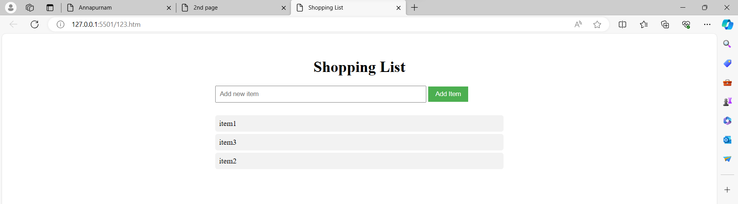  
  
  
  
  
  
  
T2. Create a local storage that saves the number of times you have accessed the page and

displays it.  
  
HTML code:-  
  
<!DOCTYPE html>

<html lang="en">

<head>

<meta charset="UTF-8">

<meta name="viewport" content="width=device-width, initial-scale=1.0">

<title>Page Access Counter</title>

<link rel="stylesheet" href="styles.css">

</head>

<body>

<h1>Page Access Counter</h1>

<p>You have accessed this page <span id="accessCount"></span> times.</p>

<button id="incrementButton">Increment Access Count</button>

<script src="script.js"></script>

</body>

</html>

CSS Code:-  
  
body {

font-family: Arial, sans-serif;

margin: 0;

padding: 0;

text-align: center;

}

h1 {

margin-top: 50px;

}

p {

font-size: 18px;

}

Javascript Code:-  
  
function updateAccessCount() {

if (typeof(Storage) !== "undefined") {

if (localStorage.pageAccessCount) {

localStorage.pageAccessCount = Number(localStorage.pageAccessCount) + 1;

} else {

localStorage.pageAccessCount = 1;

}

document.getElementById("accessCount").innerText = localStorage.pageAccessCount;

} else {

document.getElementById("accessCount").innerText = "Sorry, your browser does not support web storage...";

}

}

function initializeAccessCount() {

if (typeof(Storage) !== "undefined") {

if (!localStorage.pageAccessCount) {

localStorage.pageAccessCount = 0;

}

document.getElementById("accessCount").innerText = localStorage.pageAccessCount;

} else {

document.getElementById("accessCount").innerText = "Sorry, your browser does not support web storage...";

}

}

window.onload = initializeAccessCount;

document.getElementById("incrementButton").addEventListener("click", updateAccessCount);

OUTPUT:-

