Post-Tender Management System (End-to-End 360° Monitoring)
2. Stakeholder-wise Menu & Dashboard Design
2.1 Admin / Department Authority
Menu Structure
- Dashboard
- Tender → Awarded Tenders
- Work Orders
- Project Monitoring
- Inspections
- Finance Overview
- Vendors
- Reports & MIS
- Document Repository
- Audit & Compliance
- User Management
- Master Data
Dashboard KPIs
- Total Active Projects
- Projects On-Time vs Delayed
- Work Order Value vs Utilized
- Pending Inspections
- Pending Bills (RA / Final)
- Vendors with Repeated Delays
- Penalties / LD Applied

2.2 Project Management Unit (PMU)
Menu
- Dashboard
- My Projects
- Milestones & Gantt
- Progress Reports
- Delay & Escalations
- Inspections
- Communications
- Reports
KPIs
- % Physical Progress
- Milestone Slippage
- Delayed Tasks
- Inspection Defects
- Average Closure Time

2.3 Vendor / Contractor
Menu
- Dashboard
- Assigned Work Orders
- Progress Reporting
- Milestone Updates
- Document Uploads
- Bill Submission
- Queries & Clarifications
- Inspection Observations
KPIs
- Assigned Projects
- Completed Milestones
- Pending Submissions
- Bill Status (Submitted / Approved / Paid)
- Rework Count

2.4 Finance & Accounts
Menu
- Dashboard
- Budgets
- RA Bills
- Final Bills
- Payment Approvals
- Financial Reports
KPIs
- Budget vs Utilization
- Pending Payments
- Cost Overruns
- Average Payment Cycle Time

2.5 Inspection & Quality Team
Menu
- Dashboard
- Inspection Schedule
- Assigned Inspections
- Reports & Checklists
- Defect Tracking
KPIs
- Inspections Completed
- Defects Open vs Closed
- Average Rework Time
- Approval vs Rejection Ratio

3. Functional Modules – Forms, Fields & Workflow

3.1 Work Order Management
Key Forms
Work Order Creation
- Tender ID
- Vendor ID
- Work Order No
- Scope Description
- Start Date / End Date
- Total Value
- Payment Terms
- Milestones
- Penalty / LD Terms
Workflow
Tender Award
↓
Work Order Draft
↓
Authority Approval
↓
Vendor Digital Acceptance
↓
Project Activated

3.2 Vendor Work Execution Module
Forms
Progress Report
- Project ID
- Reporting Period
- % Completion
- Work Description
- Delay Reason (if any)
- Attachments (Images/Videos)
- Geo-tagged Evidence
Job Completion Report
- Milestone Reference
- Completion Date
- Supporting Documents
Workflow
Vendor Submission
↓
PMU Review
↓
Approve / Seek Clarification
↓
Auto Update Project Progress

3.3 Project Monitoring & 360° Tracking
Dashboard KPIs
- Planned vs Actual Progress
- Timeline Variance (Days)
- Pending Milestones
- Escalated Issues
Auto Alerts
- Milestone Due Tomorrow
- Delay Beyond Threshold
- No Progress Update X Days

3.4 Financial & Budget Tracking
Forms
Budget Allocation
- Project ID
- Approved Budget
- Head-wise Allocation
RA Bill Submission
- Bill No
- Period
- Claimed Amount
- Supporting Measurements
- GST/Taxes
Workflow
Vendor Bill Submission
↓
PMU Verification
↓
Inspection Clearance
↓
Finance Approval
↓
Payment Release

3.5 Inspection & Quality Assurance
Inspection Checklist Form
- Inspection Type (Planned / Random)
- Milestone Reference
- Checklist Items (Dynamic)
- Observation
- Status (Pass / Fail)
- Defect Severity
- Evidence Upload
Defect Workflow
Inspection → Defect Logged
↓
Vendor Rework
↓
Re-inspection
↓
Closure

3.6 Milestone & Timeline Management
Fields
- Milestone Name
- Planned Start / End Date
- Dependencies
- Weightage (%)
- Linked Payment %
Visualization
- Gantt Chart (React Gantt Library)
- Delay Impact Indicator

3.7 Document Management System (DMS)
Document Types
- Agreements
- Progress Reports
- Bills / Invoices
- Inspection Reports
- MOMs
Features
- Version Control
- Role-based Access
- Audit Logs
- Metadata Tagging

3.8 Communication & Collaboration
Modules
- Vendor Queries
- Clarifications
- Internal Notes
- Meeting Scheduler
- MOM Upload

3.9 Compliance & Audit Trail
Tracked Events
- Work Order Changes
- Milestone Date Changes
- Financial Approvals
- Inspection Rejections
- Penalty Applications
Reports
- Audit Log (User / Date / Action)
- LD Calculation Report
- Clause Compliance Matrix

4. Reporting & MIS
Standard Reports
- Project Status Report
- Vendor Performance Report
- Inspection Summary
- Financial Utilization Report
- Delay & Escalation Report
Export
- PDF
- Excel
- CSV

5. API Design – Sample Endpoints (.NET Core 8)
Authentication
POST /api/auth/login
POST /api/auth/refresh
Work Orders
GET /api/workorders
POST /api/workorders
PUT /api/workorders/{id}
GET /api/workorders/{id}
Projects & Milestones
GET /api/projects/{id}/milestones
POST /api/milestones
PUT /api/milestones/{id}
Progress Reports
POST /api/progress
GET /api/progress/project/{id}
Inspections
POST /api/inspections
GET /api/inspections/project/{id}
PUT /api/inspections/{id}/approve
Finance
POST /api/bills/ra
GET /api/bills/pending
PUT /api/bills/{id}/approve
Reports
GET /api/reports/project-status
GET /api/reports/financial-utilization

6. Database Design (PostgreSQL – High Level)
Core Tables
- users
- roles
- vendors
- tenders
- work_orders
- projects
- milestones
- progress_reports
- inspections
- inspection_defects
- bills
- payments
- documents
- audit_logs
- notifications

7. Technology Stack Summary
Layer | Technology
Frontend | React.js (Redux / RTK / Vite)
Backend | .NET Core 8 Web API
Auth | JWT / OAuth2
Database | PostgreSQL
GIS | PostGIS (Optional)
File Storage | Local / Azure Blob / S3
Reporting | RDLC / PDF Generator
Notifications | Email / SMS APIs

8. Key Advantages of This Design
✔ Role-based 360° Monitoring
✔ Strong audit & compliance readiness
✔ Tight physical vs financial integration
✔ Scalable microservice-ready backend
✔ Future-ready for mobile & GIS expansion

PART-A: ENTITY RELATIONSHIP (ER) DIAGRAM – LOGICAL DESIGN
1. Core Entities & Relationships
1.1 User & Access Control
USERS
- UserId (PK)
- Name
- Email
- Mobile
- RoleId (FK)
- Department
- IsActive

ROLES
- RoleId (PK)
- RoleName (Admin, PMU, Vendor, Finance, Inspector)

USER_ROLE_MAPPING (optional if many-to-many)
Relationships
- One Role → Many Users

1.2 Vendor & Tender Management
VENDORS
- VendorId (PK)
- VendorCode
- VendorName
- GSTNo
- PAN
- RegistrationDetails
- Status

TENDERS
- TenderId (PK)
- TenderNo
- TenderName
- Department
- EstimatedValue
- AwardDate
- Status
Relationships
- One Tender → One Vendor (Awarded)
- One Vendor → Many Tenders

1.3 Work Orders & Projects
WORK_ORDERS
- WorkOrderId (PK)
- TenderId (FK)
- VendorId (FK)
- WorkOrderNo
- IssueDate
- StartDate
- EndDate
- TotalValue
- AgreementDocId
- Status

PROJECTS
- ProjectId (PK)
- WorkOrderId (FK)
- ProjectName
- Location
- PlannedStart
- PlannedEnd
- ActualStart
- ActualEnd
- CurrentStatus
Relationships
- One Work Order → One Project
- One Vendor → Many Work Orders

1.4 Milestones & Dependencies
MILESTONES
- MilestoneId (PK)
- ProjectId (FK)
- MilestoneName
- PlannedStartDate
- PlannedEndDate
- Weightage
- PaymentPercentage
- Status

MILESTONE_DEPENDENCIES
- ParentMilestoneId (FK)
- ChildMilestoneId (FK)
Relationships
- One Project → Many Milestones

1.5 Progress Monitoring
PROGRESS_REPORTS
- ProgressId (PK)
- ProjectId (FK)
- MilestoneId (FK)
- ReportingPeriod
- PhysicalProgress%
- Remarks
- SubmittedBy
- SubmittedDate

1.6 Inspection & Quality
INSPECTIONS
- InspectionId (PK)
- ProjectId (FK)
- MilestoneId (FK)
- InspectorId (UserId)
- InspectionDate
- InspectionType
- Status

INSPECTION_DEFECTS
- DefectId (PK)
- InspectionId (FK)
- Description
- Severity
- Status
- ClosureDate

1.7 Finance & Billing
BUDGETS
- BudgetId (PK)
- ProjectId (FK)
- ApprovedAmount
- UtilizedAmount

BILLS
- BillId (PK)
- ProjectId (FK)
- VendorId (FK)
- BillType (RA/Final)
- ClaimedAmount
- ApprovedAmount
- Status
- SubmissionDate

PAYMENTS
- PaymentId (PK)
- BillId (FK)
- PaymentDate
- Amount
- VoucherNo

1.8 Documents, Communication & Audit
DOCUMENTS
- DocumentId (PK)
- EntityType
- EntityId
- FileName
- Version
- UploadedBy
- UploadedDate

COMMUNICATIONS
- CommId (PK)
- ProjectId (FK)
- SenderId
- ReceiverId
- Message
- Date

AUDIT_LOGS
- AuditId (PK)
- UserId
- Action
- EntityType
- EntityId
- Timestamp

PART-B: API SWAGGER STRUCTURE (.NET CORE 8)
2. Swagger Base Setup
OpenAPI: 3.0.1
Title: Post Tender Management API
Version: v1
Security:
- BearerAuth: []

3. Module-wise API Structure
3.1 Authentication
POST /api/auth/login
POST /api/auth/refresh-token
GET /api/auth/me

3.2 User & Role Management
GET /api/users
POST /api/users
PUT /api/users/{id}

GET /api/roles

3.3 Vendor & Tender
GET /api/vendors
POST /api/vendors

GET /api/tenders
POST /api/tenders

3.4 Work Order & Project
POST /api/workorders
GET /api/workorders/{id}
PUT /api/workorders/{id}

GET /api/projects/{id}
GET /api/projects/dashboard

3.5 Milestone & Gantt
POST /api/milestones
GET /api/milestones/project/{projectId}
PUT /api/milestones/{id}

3.6 Progress Reporting
POST /api/progress-reports
GET /api/progress-reports/project/{projectId}

3.7 Inspection & QA
POST /api/inspections
GET /api/inspections/project/{projectId}
POST /api/inspections/{id}/approve
POST /api/inspections/{id}/reject

3.8 Finance & Billing
POST /api/bills
GET /api/bills/pending
POST /api/bills/{id}/approve

POST /api/payments

3.9 Documents & DMS
POST /api/documents/upload
GET /api/documents/{entityType}/{entityId}

3.10 Dashboards & Reports
GET /api/dashboard/admin
GET /api/dashboard/vendor
GET /api/reports/project-status
GET /api/reports/financial-utilization

PART-C: PHASE-WISE DEVELOPMENT PLAN
Phase 1 – Foundation & Core Setup
Duration Focus: System Backbone
- User Authentication & Role Management
- Vendor & Tender Master
- Work Order Creation
- Project Setup
- Database Schema
- Audit Logs Framework
Deliverables
- Login & Role-based Menus
- Work Order Issuance Flow
- Admin Dashboard (Basic KPIs)

Phase 2 – Execution & Monitoring
Duration Focus: Core Value Delivery
- Vendor Dashboard
- Progress Reporting
- Milestones & Gantt
- Real-time Project Monitoring
- Alerts & Notifications
Deliverables
- 360° Project Tracking
- Delay Escalation
- Milestone Slip Detection

Phase 3 – Inspection & Quality Control
Duration Focus: Governance & Quality
- Inspection Scheduling
- Checklist Engine
- Defect Tracking
- Re-inspection Flow
Deliverables
- Quality Approval Workflow
- Defect Closure Reports

Phase 4 – Finance & Billing Integration
Duration Focus: Financial Control
- Budget Tracking
- RA & Final Bills
- Payment Approval
- Cost Overrun Alerts
Deliverables
- Finance Dashboard
- Budget vs Actual Reports

Phase 5 – DMS, Reports & Audit
Duration Focus: Compliance & Intelligence
- Document Management
- MIS Reports
- PDF / Excel Export
- Compliance Reports

Phase 6 – Optimization & Advanced Features
Optional / Future-Ready
- GIS Integration
- Mobile App
- AI Delay Prediction
- Vendor Performance Scoring
- ERP Integration

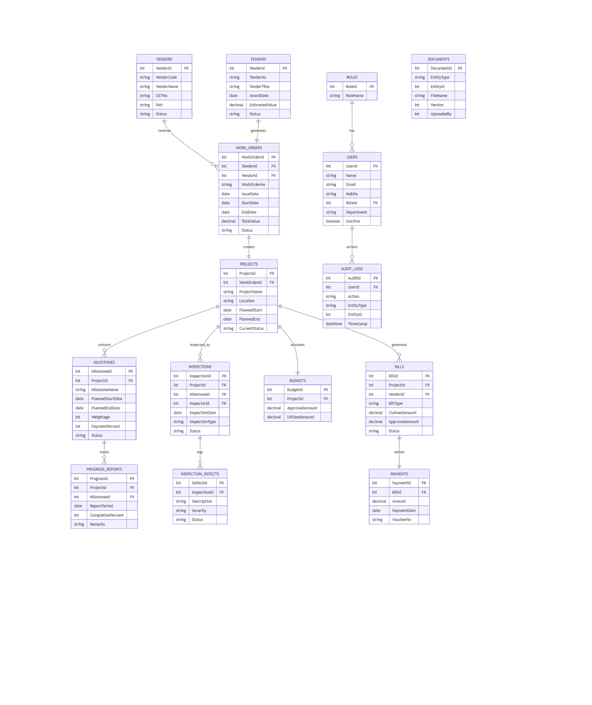
ER Diagram

Module-wise API Structure
Authentication
POST /api/auth/login
POST /api/auth/refresh-token
GET /api/auth/me
User & Role Management
GET /api/users
POST /api/users
PUT /api/users/{id}
GET /api/roles
Vendor & Tender
GET /api/vendors
POST /api/vendors
GET /api/tenders
POST /api/tenders
Work Order & Project
POST /api/workorders
GET /api/workorders/{id}
PUT /api/workorders/{id}
GET /api/projects/{id}
GET /api/projects/dashboard
Milestone & Gantt
POST /api/milestones
GET /api/milestones/project/{projectId}
PUT /api/milestones/{id}
Progress Reporting
POST /api/progress-reports
GET /api/progress-reports/project/{projectId}
Inspection & QA
POST /api/inspections
GET /api/inspections/project/{projectId}
POST /api/inspections/{id}/approve
POST /api/inspections/{id}/reject
Finance & Billing
POST /api/bills
GET /api/bills/pending
POST /api/bills/{id}/approve
POST /api/payments
Documents & DMS
POST /api/documents/upload
GET /api/documents/{entityType}/{entityId}
Dashboards & Reports
GET /api/dashboard/admin
GET /api/dashboard/vendor
GET /api/reports/project-status
GET /api/reports/financial-utilization

