Output Screen

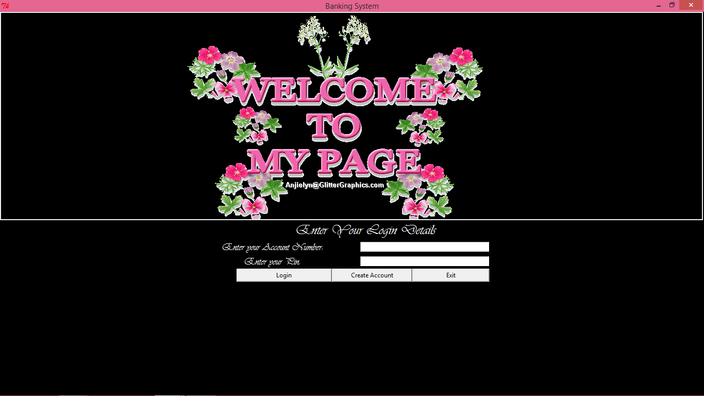

This is the first Window which we come across when we run the project .In this Window user is provided with 3 option:

1. Creating Of New Account
2. Login
3. Exit

1)Creating A New Account

To Start preparing a new account you just need to Click on the Create Account Button.

Which will lead you to the following Screen:

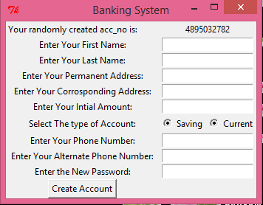

In this window your Account Number would be generated randomly by the computer itself. Since it is a Primary Key for the database so the Rights are not given to the user to choose a random user key.

Filling the Form:

Enter Your First Name: Here you have to enter your name in the Characters if there is any numeric Value then it will display a info box displaying message ‘The Name Must only Contain Alphabets’.

Enter Your Last name: Same here like the First name it would check whether you have entered a numeric value in between or not if there is it will display a error message.

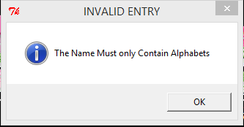

Enter the Permanent address: It will take your Permanent Address.

Enter the Corresponding Address: It will take your Corresponding Address.

Enter the Initial Amount: Enter the initial amount which is deposited in your Account.It will check whether the inputted value is Numerical or not. If not then it will display a message ‘The Amount should not Contain Alphabets’. 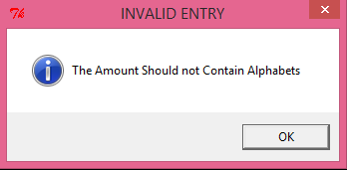

Enter the Phone Number & Alternate Phone Number: Enter Your Mobile Number it should be exactly of 10 Digits More then or less than that would lead to displaying of a message ‘Invalid Phone Number’. And if the Entry contains alphabets or any other non-numeric character it would display ‘The phone number should not contain Alphabets’.



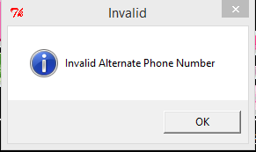

Enter the Password: This is the pin which would be used to access your Account to Withdraw or Deposit the Cash. The password length is limited to 6-30 characters less or more than that will display an error message.

Since these all the things are mandatory therefore if you leave any of the of the fields it would display an error message ‘All Fields Are Mandatory’.

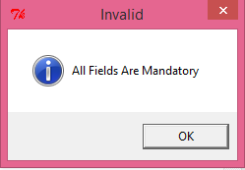

After The Successful Creation of the Account you would be lead to the Main window.

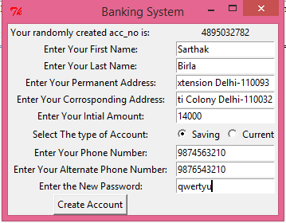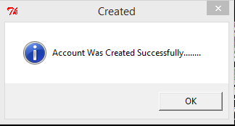

2) Login

Login Is Provided For Different Types of Users:

1. Administrator
2. Normal Users

For Administrator There is Default Password ‘**sarthak**’

To View Administrative Rights Type **Administrator** in Enter the Account Number And the Password in the pin.

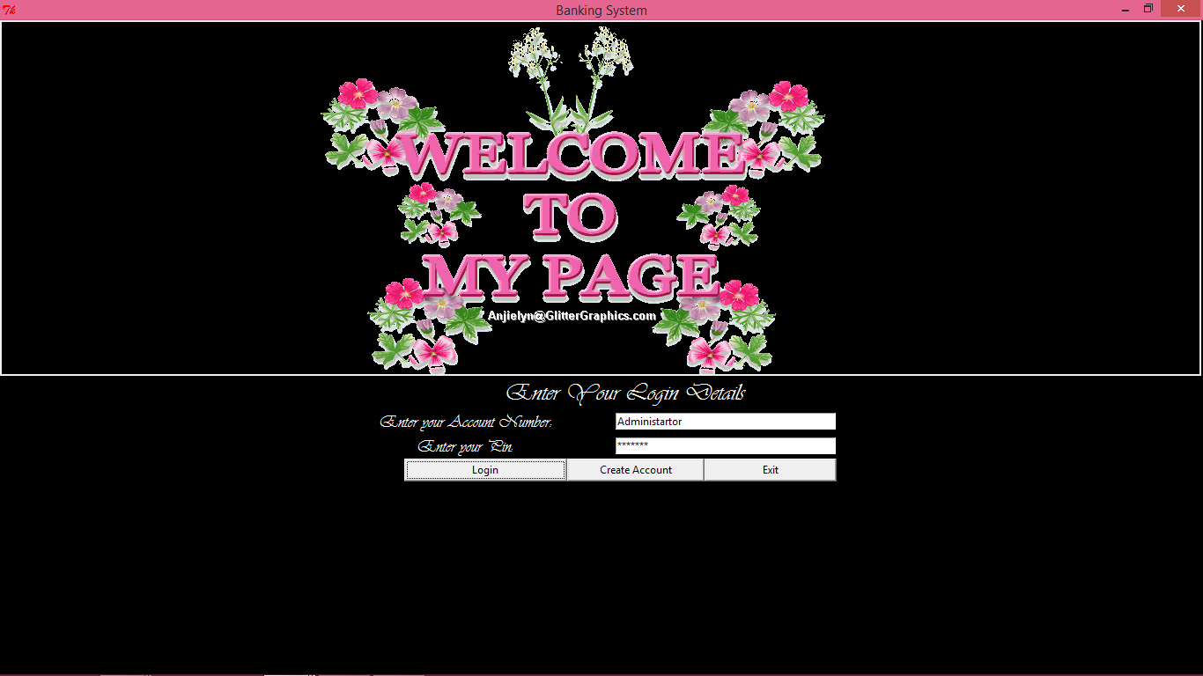

Click on the Login Button To sign in.

After it following small Dialog box Would appear:

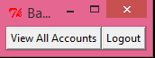

You can click on either of the Button On clicking logout you will directed back to the old window. And by clicking on the View all Accounts you will view all accounts Existed in the database.

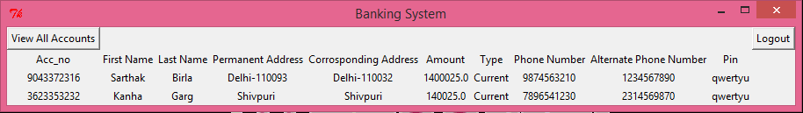

On clicking on ‘Logout’ you will be directed back to the main window.

Now for The Normal users,

You have to enter your Account number which is 10 digit long if you left any thing blank it will display a message



Now,

If you have not given 10 digit number properly it will display a message and pin properly it could display the following messages on the basis of the mistake committed

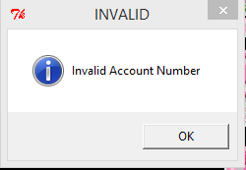

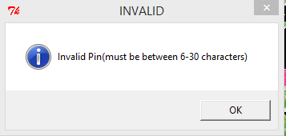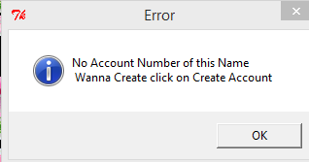

If you entered your information correctly u would be taken to the new dialog box which would appear somewhat like this:

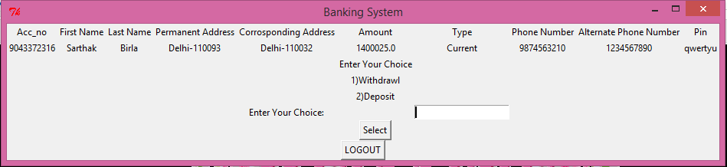

In this you can enter the the choice and amount and click on the WIthdaw/Deposit On the basis of your choice.

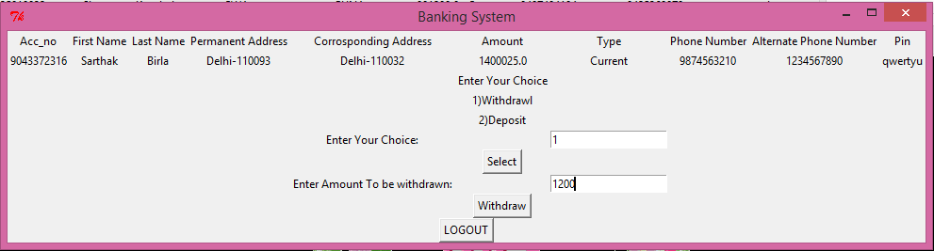

After that you will be immediately redirected to the page

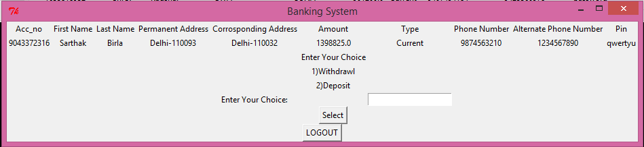

In this either u can continue by selecting either of the choice or redirecting back to the main screen by clicking on the logout.

3)EXIT

Exit Will Destroy your current Window And exit you from the Program.