VITyarthi | Open Source Software

The Open Source Audit
A Capstone Project for OSS NGMC Course
Course: Open Source Software | Unit Coverage: 1 – 5 Max Marks: 100

Student Name | Registration Number
Sarthak patil | 24BCY10017
Slot | Date of Submission
B22 | 31-03-26
Chosen Software | GIT

1. Introduction

Open source software (OSS) is playing a major part in the modern era of computer science.

By OSS, Development tools and Platforms like web servers, programming softwares and environments are built by collaboration and shared openly. Unlike proprietary software, open source allows users to study, modify, and distribute the code freely.

This project focuses on analyzing Git, a very much used distributed version control system. The aim is to understand its functions but also to know its origins, its licensing model, its legal or ethical applications and its role in the whole open source system.

Through this project, we want you to understand Linux which is demonstrated using shell scripts, which shows how open-source tools operate at the command-line. This helps in understanding both the technical and philosophical aspects of open-source software.

Proprietary software in Computer Science are licensed only by owner (may be an individual or a Co-operation) under terms and conditions. Users cannot access the source code, which does not give the ability to modify it. It will usually require payment for a license to use.

Part A — Origin and Philosophy

A1 - The Origin Story of Git
If you have spent any time around software development you have probably used Git without even thinking much about where it came from. It is just sort of there installed on every machine, assumed by every employer, embedded in every workflow. But the story of how Git actually came to exist is one of the more interesting moments in the history of software, and it says a lot about why free and open source software matters in a way that no amount of philosophical argument ever quite captures.

The World Before Git
To understand why Git exists you have to understand what version control actually is and why developers need it. When you are working on a software project, especially with other people, you are constantly making changes to files. Sometimes changes break things. Sometimes two people change the same file at the same time. Sometimes you need to go back to how the code looked three weeks ago. Version control systems are basically an organised undo history for an entire project, tracking every change, who made it, when, and why.
Before Git the dominant systems were CVS (Concurrent Versions System) and SVN
(Subversion). Both were centralised, there was one main server and everyone checked files out from it and checked them back in. This worked, but it had problems. If the server went down, nobody could work. If you wanted to make experimental changes you had to do it on the shared server which was risky for everyone. Performance was slow. Merging changes from different developers was painful.
The Linux Kernel project, the most complex collaborative software project in history, with thousands of developers spread across every continent it was using a proprietary tool called BitKeeper, owned by a company called BitMover. BitMover had given the Linux community a free licence to use the tool, but it was a favour not a right. The entire workflow of thousands of developers depended on this arrangement continuing.

The Trigger Event
In 2005, a developer named Andrew Tridgell attempted to reverse engineer BitKeeper's communication protocol, his goal was to understand how it worked well enough to build compatible tools. BitMover's response was swift and total: they revoked the free licence for the entire Linux development community. Overnight, thousands of developers had no version control system.
Linus Torvalds, the creator of the Linux Kernel, surveyed every existing alternative. CVS, SVN, and the others, he looked at all of them and found each one too slow, too limited, or architecturally wrong for what the Kernel project needed. Rather than compromise, he decided to build something from scratch. This is not as dramatic as it sounds coming from Linus who had written an entire operating system kernel as a student project.

\

The Build
Linus began writing Git on 3rd April 2005. His stated goals were clear: the system had to be fast, it had to be distributed (meaning every developer would hold a complete copy of the entire history of the project, not just the current state), and it had to be reliable enough to handle the Linux Kernel's scale. He announced the project publicly on 7th April 2005, just four days after starting. By June 2005 roughly two months after the first line of code, Git was already managing the Linux Kernel codebase. That timeline is remarkable.
The name is typical Linus. Git is British slang for a stupid or unpleasant person. Linus has said he names all his projects after himself: Linux, and now Git.

Why He Made It Free
This is perhaps the most important part of the story and the part most relevant to understanding open source philosophy. Linus had just been burned by depending on a proprietary tool that could be taken away at any time by its owner. The lesson was obvious and personal: if critical infrastructure is exclusive, it is fragile in a way that has nothing to do with technical quality. A business decision somewhere can destroy the work of thousands of people overnight.
He released Git under the GNU General Public Licence version 2, the same licence used by the Linux Kernel itself. Under GPL v2, nobody can ever take Git, modify it, and re-release it as exclusive software. The freedom is legally protected and permanent. The whole episode was essentially a live demonstration of exactly why free software matters.

The Impact
Today Git is used by over 100 million developers worldwide according to GitHub's own statistics. Every major technology company on earth: Google, Microsoft, Meta, Amazon, Netflix uses Git as the foundation of their development workflow. GitHub, which was built entirely on top of Git, was acquired by Microsoft in 2018 for 7.5 billion US dollars. There is something almost poetic about that last fact: Microsoft, a company that spent much of the 1990s and early 2000s actively fighting open source, paying 7.5 billion dollars for a platform built on a tool released under the GPL, without the BitKeeper incident in 2005, the entire modern landscape of collaborative software development would look completely different.

A2 - Licence Analysis:
What Is a Software Licence?
When someone writes software they automatically hold the copyright over it. That means by default nobody can legally use, copy, modify, or distribute it without explicit permission. A software licence is the document where the copyright holder grants those permissions — and specifies what conditions come with them. Without a licence, even software that has been published publicly is technically illegal to use. This is not theoretical, open source projects have faced legal challenges over exactly this issue.

Richard Stallman, who founded the GNU Project and essentially invented the philosophical framework behind free software, articulated what he called the Four Freedoms. These are worth understanding properly because they frame everything that follows.

The Four Freedoms
- Freedom 0 - The freedom to run the program for any purpose. You can use Git for personal projects, commercial products, government systems, military applications, anything. The licensor cannot restrict your use case.
- Freedom 1 -The freedom to study how the program works and modify it. This requires that the source code be available. You can download Git's entire codebase, read every line, understand exactly what it does, and change it for your own use.
- Freedom 2 -The freedom to redistribute copies. You can share Git with anyone, put it on a USB drive, host it on your own server, give it to a friend. Nobody can stop you.
- Freedom 3 - The freedom to distribute your modified versions. If you improve Git you can share those improvements. Under the GPL, however, those improvements must be shared under the same licence, this is the crucial condition.

Git's Licence: GPL v2
The GNU General Public Licence version 2 was written by Richard Stallman in 1991. It is one of the most widely used software licences in the world and it is the licence under which both the Linux Kernel and Git are distributed. The central concept is copyleft.
Copyleft is a clever legal mechanism. Normal copyright says you cannot copy this. Copyleft says you can copy this but any copy or modified version that you distribute must also be free under the same terms. This creates a kind of forward moving guarantee of freedom. If a company takes Git's source code, modifies it, and distributes that modified version, they must release their modifications under GPL v2. They cannot take the code, improve it, and sell it as a proprietary product. The freedom is contagious it spreads to any derivative work.

GPL v2 vs MIT: A Direct Comparison
The MIT Licence represents the opposite end of the open source spectrum. It is extremely permissive essentially saying do whatever you want with this. A company can take MIT-licenced code, modify it, incorporate it into a exclusive product, and sell it without ever releasing the changes. There is no copyleft requirement. The entire licence is about three sentences long.

A3 - Ethics of Open Source
Should All Software Be Open Source?
Open source Software is a way to share knowledge and technology and creates an atmosphere for users to analyze and think how technology should develop and evolve. We can say that it kind of represents the philosophy of shared knowledge. Open Source is not just about availability

of the source code in this way. It leads to collaboration, transparency between developers and users, and leads to collective problem-solving and development. But, deeply the ethics of open source and the answer of should all the software should be open source is not direct or straight forward.
If we think from the perspective of common people (users or developers) it is required that the software should be open source because it will provide accessibility for students and developers who may not be able to buy or afford the proprietary tools. This will lead to faster development, innovation, creativity and better quality software because different minds will work in collaboration. From this perspective, it feels ideal to be open source.
But if we see from the business perspective, companies invest their time and money into developing that software and there are a large number of developers involved in the project. So, it becomes necessary for a company to generate revenue from that service or product. So, companies make their products exclusive.
And there is also one important point that we should focus on and that is data security. Some applications deal with sensitive data and are even used for national security. So, if we make this open source, this will lead to misuse and exploitation. So, keeping the source code private is very necessary. By this we can say that not all software should and cannot be open source.
But at the same time we can make an argument that if companies cannot make their software opensource, then why can they build their products with open source softwares at the fundamental or root or base level. Like for example Red Hat, Google use Linux as a foundation for their products and services. On the top level, this seems unfair because these companies benefit from the work of the global community which contributed freely but make their product proprietary.
Although, this issue is more complex because many companies actually contribute to open source development by improving software, by fixing bugs and they even give funding for the development. Companies often sponsor and employ developers who contribute in building the open source projects.
By this we can say that, this is more of a collaboration instead of exploitation. While we can be concerned about imbalance, overall, both the community and the companies benefit.
There is a saying that we can talk about in this context and that is “standing on the shoulders of giants”.In the context of open source, modern innovations are being made on the work of previous contributors. In software development, this is more visible. Today, developers do not have to start from the beginning. They can build by the help of existing tools and frameworks.
But there can be an argument that developers heavily rely on existing solutions. But by removing the need to reinvent basic tools, developers can focus on solving more complex problems. This will lead to faster and more creative development of technology. In conclusion, we can say that this brings opportunities for collaboration and innovation but brings questions about fairness and security. So, I think people should not see this as a perfect solution but as a powerful approach. And I think, not all softwares should be open sourced, but it can be very effective for students and developers from a learning perspective.

Part B - The Linux Footprint of Git

B1. Installation Method
We can install Git using Advanced Package Tool (APT). It is a default package manager in Ubuntu based Linux distribution. It can be installed using the command: sudo apt install git Git is easily available by the official package repositories. It does not require manual compilation from source. The APT ensures that the software is properly configured and integrated into the system.

B2. Key Directories
We can get the location of the Git Executable by the “which git”command which will return /usr/bin/git. This is a directory which contains essential system binaries which can be accessed by all users.

Additional locations related to git can be found by “whereis git” command, which shows paths for binaries, source files and documentation.

Configuration files of git can exist at multiple levels. The system-wide config file is usually located at “/etc/gitconfig” while user-specific is stored in the home directory as “~/.gitconfig”. These config files are only get created when they are made by the user.
The “git config --list” command had not any output because there was no user-specificconfiguration.

It does not maintain logs in the /var/log directory or folder. Instead, it does its operations locally within repositories. It tracks changes using its own version control mechanisms internally.

B3. User and Group
Git runs in the present logged-in user. It can be verified by the “whoami” command. It does not run under a specific system user. It is important for security reasons as it prevents unauthorized access to system-level resources and maintains user level control.

B4. Service Management
Git is not a background service. It does not require starting or stopping. It is a command line tool which is executed when needed.
When checking its status using commands like: “systemctl status git”

This behaviour is expected because Git operates locally rather than a continuously running device.

B5. Update Model
Git updates are managed by the APT package manager. Because it is an open source model, the community improves by fixing Git bugs and releases updates. System package updates commands: “sudo apt update”/ “sudo apt upgrade” This checks that security patches and improvements are regularly delivered to the system.

Part C - The FOSS Ecosystem

C1. What Git Depends On
Git is made up of open source parts that it needs to run. These parts are libc6, libcurl, libexpat1, libpcre2-8-0 zlib1g, perl and ca-certificates. Each of these parts is taken care of by a group of developers. Is free for anyone to use. This creates a system where each project is built on top of projects and this makes everything work together really well.
The way Git is made is not a coincidence. It is because of the kind of licence Git has which is called GPL v2. Since Git has this licence it can only use parts that have a licence. Git cannot use parts that're not free for everyone to use because that would go against the rules of the GPL licence. The GPL licence makes sure that all the parts of Git stay open and free for anyone to use. This means that Git and all its parts are free and open and that is what makes it work well.

C2. What Git Has Enabled
If Git's origin story is interesting, its downstream impact is arguably more significant. Git did not just solve the Linux Kernel's problem in 2005, it created the infrastructure on which the entire modern open source world runs.

-GitHub
GitHub started in 2008. It made a website and a way for people to talk to each other using Git. GitHub added some things like pull requests, a way to track issues tools to review code, wikis and a news feed. This made it a lot easier for people to work on open source projects. Now you can just copy a project make some changes and ask the owners to look at your changes. You do not have to send emails to a group of people anymore.
GitHub has a lot of projects now. Over 330 million.. It has more than 100 million people who have accounts. Almost everyone who works on open source projects uses GitHub. It is, like a meeting place. GitHub is very important. This is why Microsoft bought GitHub in 2018 for 7.5 billion dollars. GitHub is a deal because it was built on top of Git. The GitHub platform is very valuable.

-GitLab
GitLab, which started in 2011 is a competitor to GitHub. What is really cool about GitLab is that it is source. This means companies can use GitLab on their servers. They have control over where their code is stored. They do not have to rely on someone to host their code. This is important for companies that have to be very careful about where their data's kept, like banks and government offices. For these companies GitLab is a choice because they can have a similar experience, to GitHub without actually using GitHub. Many big companies are now using GitLab because they like what GitHub offers. They do not want to have to depend on it.

The Open Source Audit | VITyarthiPage 10

-Modern DevOps and Continuous Integration
GitHub Actions and GitLab CI are completely based on Gits way of making commits and branches. So when a developer adds code automatic tests start running security checks are done and if everything is okay the code is sent to the production servers on its own. This whole process, which is now the norm in making software starts when someone uses git push. The automation happens because of the events that Git makes possible.
This means that in life a developer can add a new commit from their laptop and in just a few minutes that change is available to users all over the world. The underlying system, including Linux servers, containers and orchestration tools is all source. The process of deploying the code is controlled by Git. The fact that Git shows us what changed, when it changed and who made the change is what makes it safe to deploy code automatically. GitHub Actions and GitLab CI rely, on Git to make this happen.

-Git in the LAMP Stack and Beyond
The LAMP stack, which is Linux, Apache, MySQL, PHP is a popular way to build websites. Git is not actually part of this stack. It is a very important tool that helps manage everything in it. Developers write code in PHP. Use Git to keep track of it. When they want to put their code on the website they use Git to push it. If something goes wrong they can use Git to figure out which change caused the problem. Git keeps a record of all the changes. It is like a history book for the whole website.
Nowadays with cloud computing Git is more important. There are tools like Terraform and Ansible that help manage the servers and they use Git to store the settings. The idea of GitOps, which means Git is the source of truth, for everything even the servers is becoming very common. This means that Git is used to manage not the code but also the infrastructure of the website. The LAMP stack and Git are used together to build and manage websites and Git is the tool that helps keep everything running smoothly.

C3. Community and Governance
Git development is done in a way that really follows open source values. The Git project has been taken care of by a group of people with Junio C Hamano in charge since 2005. Linus handed Git over to Junio C Hamano soon after he created it and Junio C Hamano has been taking care of Git since.
When people want to make changes to Git they send their ideas to an email list at git@vger.kernel.org. Every single change, every discussion about whether to accept or reject a change and every decision about what Git should do is talked about openly on this list. Saved for anyone to read. There is no group making decisions without telling anyone. If you do not agree with a decision you can read the conversation that led to it. What matters is how good your idea is, not who you work for or who you know. Some big companies like Google, Microsoft and GitHub have people working for them who contribute to Git. Their ideas are reviewed in the same public way as everyone else's. No company is in charge of Git. What matters is the quality of the code.

Part D - Open Source vs Proprietary (Part D)

Open Source vs Proprietary: Direct Comparison
Perforce Helix Core is one of the oldest and most established proprietary version control systems. It is used heavily in the games industry and in aerospace, environments with large binary assets and strict change management requirements. It represents perhaps the strongest real-world alternative to Git for professional use.
Dimension | Open Source | Proprietary
Cost | Free | Thousands of dollars per year, per-user licensing
Security | Source code is open | Source code is closed
Support and  Reliability | Community support and updates | Company provides updates and support
Freedom to modify | Full freedom fork, modify, run your own version | Restricted
Community vs corporate control | Managed by open course community | By private company

Conclusion
The recommendation here is simple: for the overwhelming majority of software development contexts, Git is the correct choice. This is not a close call.
Git is used by every major technology company on earth. The Linux Kernel arguably the most complex collaborative software project in human history, with contributions from thousands of developers across every continent is managed with Git. GitHub has 100 million active developer accounts. The entire open source ecosystem is organised around Git. Any developer hired anywhere in the industry will be expected to use Git fluently. The community, the documentation, the tooling, and the integrations available to Git users are orders of magnitude beyond anything Perforce can offer.
Git is free in both senses of the word. It costs nothing and it grants you legal rights over the software itself. It is not possible for any company to take it away, change its terms, or lock it behind a paywall. The lesson of BitKeeper in 2005 is built into Git's licence.
Git's only genuine technical weakness is performance with large binary files. Video assets, game textures, compiled binaries Git was designed for source code (text files) and binary handling has always been awkward. Git LFS addresses this reasonably well but it is an extension, not a native feature. This is the one area where Perforce has a legitimate technical advantage.
For that specific use case a AAA game studio managing hundreds of gigabytes of art assets alongside source code, with strict change management and centralised control requirements Perforce may be the better tool. The games industry has historically preferred it for exactly these reasons. Unreal Engine's own repository management uses Perforce.

The Open Source Audit | VITyarthiPage 12

Shell Script Documentation

Script 1: System Identity Report
This script collects and displays basic Linux system information. It uses variables to store student and system data, and command substitution, the $() syntax to run commands and capture their output into variables. Commands used include uname -r to fetch the kernel version, uptime -p to show how long the system has been running, and date to display the current date and time. The script ends with a message stating which open-source licence covers the OS, directly connecting the technical output to the philosophy of free software.
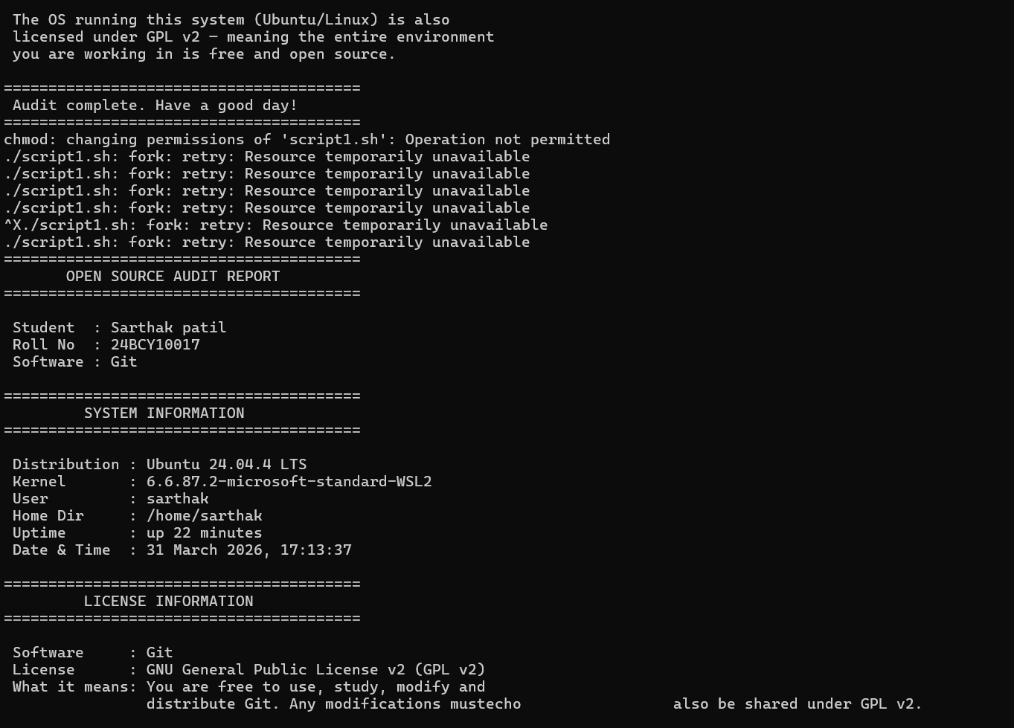

Script 2: FOSS Package Inspector
This script checks whether Git is installed on the system using dpkg -l piped through grep. If it is installed, it retrieves the version number, summary description, and installed size using dpkg-query. If it is not installed, it tells the user how to install it. A case statement which works like a cleaner version of multiple if-else checks prints a short philosophy note based on the package name. This directly connects the technical inspection to open source values.

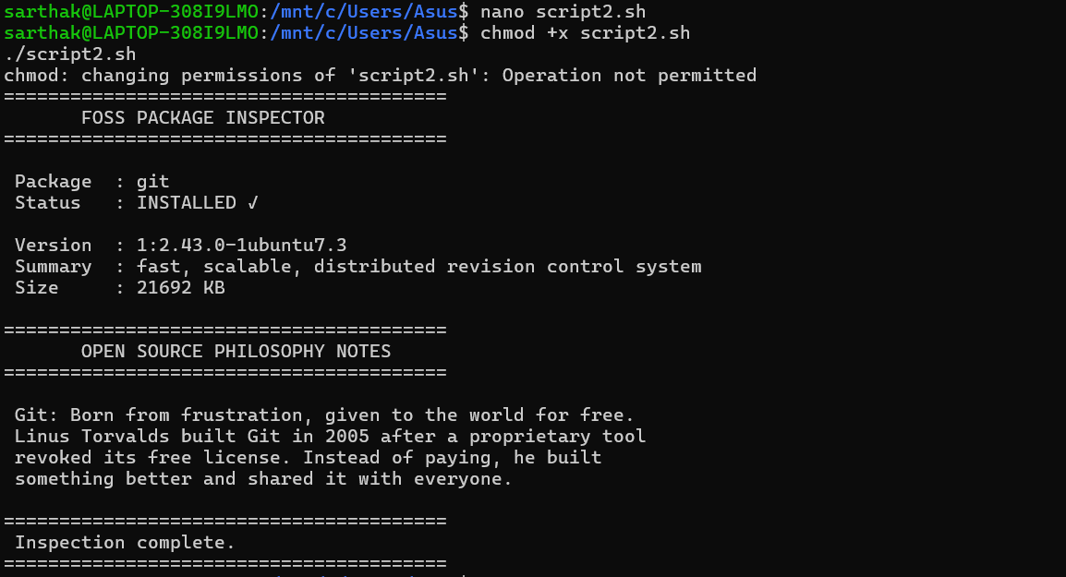

Script 3: Disk and Permission Auditor
This script uses a for loop to iterate through a predefined list of important system directories one at a time. For each directory it first checks whether it actually exists using the if [ -d "$DIR" ] condition. If it does exist, the script reports the directory's permissions and ownership using ls -ld and awk to extract the relevant columns, and reports disk usage using du -sh. The script also specifically checks the locations where Git stores its configuration files. This demonstrates how open source software is transparent every file it places on the system can be inspected.

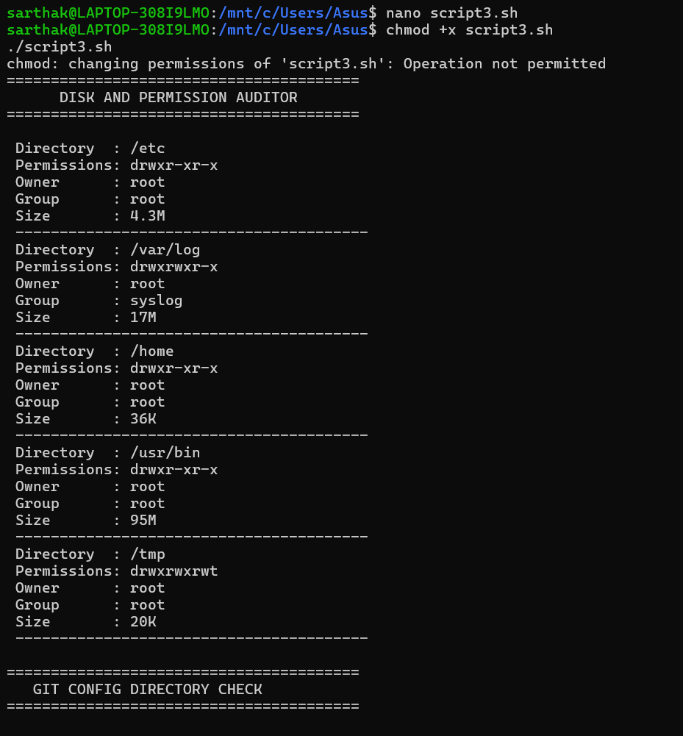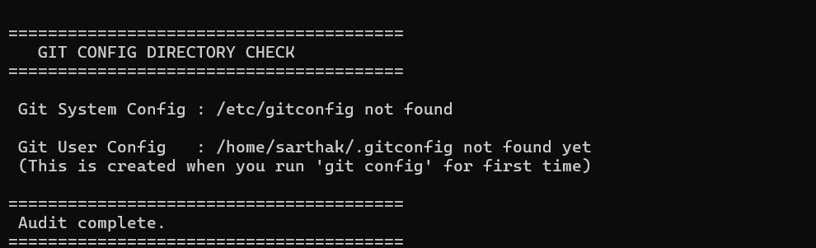

Script 4: Log File Analyzer
This script accepts a log file path as a command-line argument using $1, with a default fallback to /var/log/dpkg.log if no argument is provided. It uses a while IFS= read -r loop to process the file one line at a time. For each line, grep -iq checks whether the line contains the target keyword, case-insensitively. A counter variable increments each time a match is found. At the end the script prints the total match count and displays the last five matching lines using a combination of grep and tail. This demonstrates argument handling, loops, conditionals, and counter variables working together

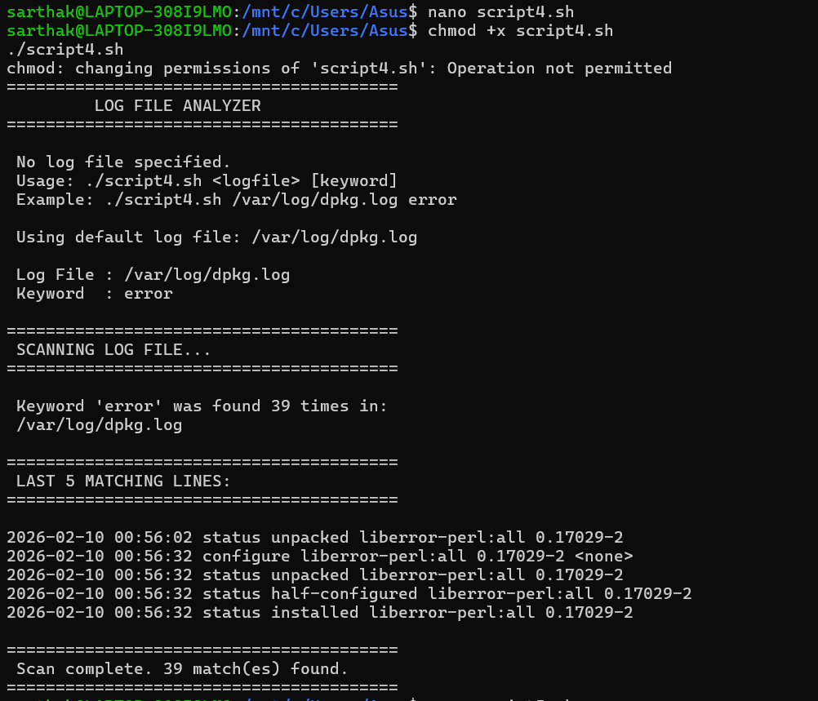

Script 5 — Open Source Manifesto Generator
This script uses read -p to ask the user three interactive questions and stores the answers in variables. It then demonstrates string concatenation — combining variable values with surrounding text to form complete sentences — to compose a personalised philosophy statement. The output is written to a file using > to create it and >> to append additional lines. The date command timestamps the manifesto. The file is saved as manifesto_$(whoami).txt and displayed using cat. This script is the most creative of the five and directly engages with the ideas discussed throughout the report.

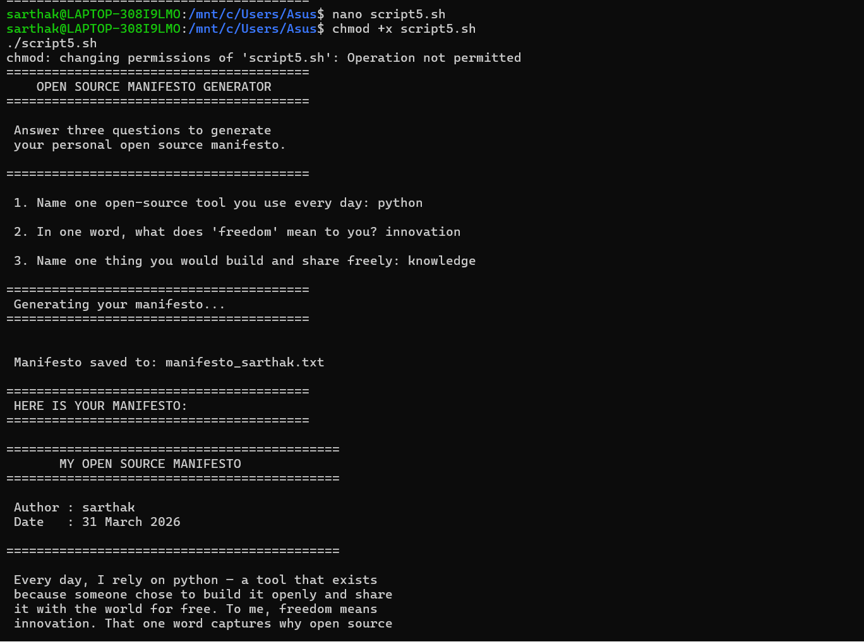

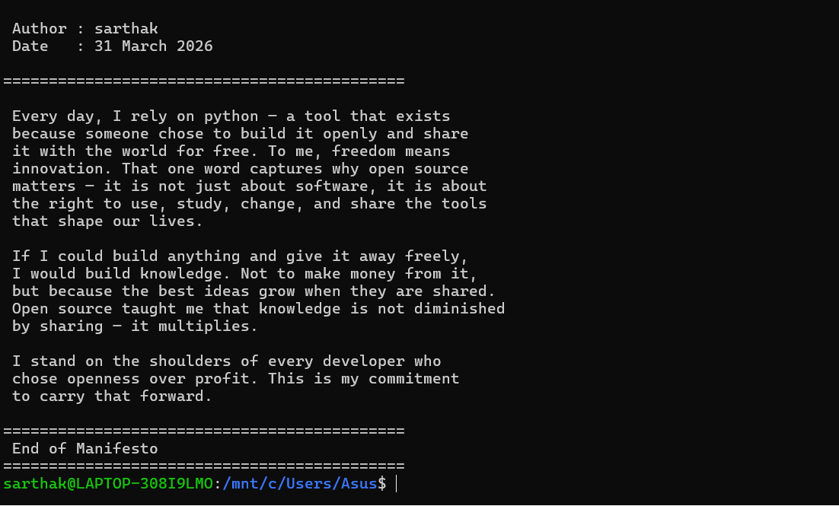

The Open Source Audit | VITyarthiPage 17

References

1). GIT Document==
https://git-scm.com/docs

2). General Public License v2 ==
https://www.gnu.org/licenses/old-licenses/gpl-2.0.en.html

3). Open Source Initiative ==
https://opensource.org/

