MINI PROJECT REPORT
LIBRARY MANAGEMENT SYSTEM
Unit 1: Product Engineering & Design Thinking
Submitted by: Sarthak Badakh
Class: SY- DSY (B)
PRN: 2126UMLM2513
Academic Year: 2026–2027

Acknowledgement
I express my sincere gratitude to my faculty members and institution for providing guidance and support in preparing this mini project. This report helped me understand the library domain, identify stakeholder needs, define requirements, design the system architecture, and prepare a roadmap for future development.

Abstract
The Library Management System is a proposed software platform designed to automate and simplify common library activities such as book cataloguing, member management, book searching, issuing, returning, fine calculation, notifications, and report generation. The system reduces manual paperwork, improves record accuracy, provides real-time book availability, and helps librarians manage library operations through a centralized interface.

Table of Contents
1. Introduction
2. Business Understanding
3. Problem Statement
4. Objectives
5. Design Thinking Approach
6. Stakeholder Analysis
7. User Personas
8. Requirements Specification
9. Product Vision and MVP
10. System Architecture
11. Database Design and ER Diagram
12. System Flowchart
13. Use Case Diagram
14. Modules
15. Technology Stack
16. Testing Strategy
17. Product Roadmap
18. Project Folder Structure
19. Expected Outcomes
20. Conclusion
21. Future Scope
22. References

1. Introduction
A library contains a large collection of books and learning resources that must be organised, tracked, and made available to students, faculty members, and other authorised users. In a manual system, librarians often maintain paper registers or separate spreadsheets for book records, issue and return transactions, and overdue fines.
The proposed Library Management System provides a centralized digital platform where users can search for books and view availability, while librarians can manage catalogues, issue books, accept returns, calculate fines, and generate reports.

1.1 Programming vs. Software Product Engineering
Programming / Coding | Software Product Engineering
Focuses mainly on writing executable code. | Covers the complete product lifecycle.
Solves individual functions or tasks. | Considers requirements, architecture, security, testing, deployment, and maintenance.
Success is often measured by whether code runs. | Success is measured through usability, reliability, performance, and user outcomes.

2. Business Understanding
The library domain includes the following major operations:
- Book acquisition and cataloguing: adding book details, authors, categories, ISBN, shelf location, and quantity.
- Membership management: registering students, faculty members, and staff with suitable borrowing permissions.
- Search and circulation: searching books, issuing books, calculating due dates, renewing loans, and processing returns.
- Fine management: calculating penalties for overdue books and recording payments when required.
- Reporting and administration: monitoring inventory, transactions, overdue books, and library usage.

2.1 Existing System Challenges
- Time-consuming manual search for books.
- Errors in paper-based issue and return records.
- Difficulty tracking overdue books and fines.
- No real-time visibility of available copies.
- Manual preparation of reports.
- Risk of misplaced, duplicated, or incomplete records.

3. Problem Statement
Library members experience delays in locating, reserving, borrowing, and returning books because of inefficient manual tracking. Librarians may also face difficulties in maintaining accurate inventory, tracking overdue books, calculating fines, and preparing reports. A centralized Library Management System is required to improve efficiency, accuracy, transparency, and user satisfaction.

4. Objectives
- Digitize book and member records.
- Provide quick book search and availability information.
- Automate issue, return, renewal, and due-date tracking.
- Calculate overdue fines using defined rules.
- Provide role-based access for students, librarians, and administrators.
- Generate basic reports for inventory and transactions.
- Maintain secure, consistent, and easily accessible records.

5. Design Thinking Approach
Design Thinking is a human-centred, iterative approach used to understand user problems before implementing a solution. The five stages applied to this project are:
Stage | Application in this Project
Empathize | Understand the problems faced by students, faculty, librarians, and administrators.
Define | Formulate the main problem related to manual searching, circulation, and reporting.
Ideate | Generate ideas such as online search, barcode scanning, notifications, and dashboards.
Prototype | Prepare wireframes for login, search, issue/return, and admin screens.
Test | Collect feedback from potential users and improve the proposed design.

5.1 IBM Design Thinking
- Focus on user outcomes: enable users to find and borrow books with minimum effort.
- Restless reinvention: continuously improve the system using feedback, usage data, and testing.
- Diverse empowered teams: encourage collaboration among developers, designers, testers, librarians, and administrators.

5.2 IBM Loop
The IBM Loop used for continuous improvement is Observe → Reflect → Make.
- Observe: study user interactions, delays, errors, and operational problems.
- Reflect: analyse feedback, metrics, and priorities.
- Make: implement design or software improvements and test them again.

6. Stakeholder Analysis
Stakeholder | Responsibilities / Expectations
Students | Search books, check availability, view due dates, and check fines.
Faculty Members | Borrow academic resources and view their transactions.
Librarian | Manage books, issue and return books, track fines, and maintain inventory.
Library Administrator | Monitor performance, review reports, and manage access.
IT / Support Team | Maintain application availability, security, backups, and technical support.

7. User Personas
Persona | Goals | Pain Points | Required Features
Student | Find books quickly and avoid fines. | Long queues and uncertain availability. | Search portal, due-date alerts, transaction history.
Librarian | Process transactions accurately and quickly. | Manual entries and inventory mismatch. | Catalog management, issue/return interface, fine tracker.
Administrator | Monitor usage and generate reports. | Reports take time and lack real-time data. | Dashboard, audit logs, exportable reports.

8. Requirements Specification

8.1 Functional Requirements
ID | Requirement | Description
FR-01 | Authentication | The system shall provide secure login and role-based access for students, faculty, librarians, and administrators.
FR-02 | User Management | The system shall allow authorised staff to add, update, deactivate, and view member records.
FR-03 | Book Management | The system shall support adding, editing, deleting, and viewing book details.
FR-04 | Search | Users shall search books by title, author, category, ISBN, or keyword.
FR-05 | Issue Book | The system shall issue an available book and calculate its due date.
FR-06 | Return Book | The system shall record returns and update available quantity.
FR-07 | Fine Calculation | The system shall calculate overdue fines according to configured rules.
FR-08 | Notifications | The system may send due-date and overdue reminders.
FR-09 | Reports | The system shall generate basic inventory, transaction, and overdue reports.

8.2 Non-Functional Requirements
Category | Requirement
Security | Passwords must be hashed; access must be role-based; communication should use HTTPS.
Performance | Common search and dashboard operations should respond quickly under expected load.
Usability | Interfaces should be simple, responsive, and easy for first-time users.
Reliability | Transactions should be stored consistently and backed up regularly.
Maintainability | The codebase should be modular and documented.
Scalability | The design should allow additional users, branches, and books in future.

9. Product Vision and MVP
Product Vision: To deliver a secure, user-friendly, and automated Library Management System that reduces manual administrative work, improves book circulation, and provides a reliable digital catalogue for academic communities.

9.1 Minimum Viable Product (MVP)
- Login and role-based access.
- Book catalogue and search.
- Book availability status.
- Basic issue and return transaction management.
- Automated fine calculation.
- Basic administrative reports.

9.2 Deferred / Future Features
- Barcode or QR-based self-checkout.
- Mobile application.
- Online reservations and waitlists.
- Email/SMS/push notifications.
- AI-based book recommendations.
- Multi-branch library support.
- Advanced analytics and cloud scaling.

10. System Architecture
The proposed system follows a three-tier architecture. The presentation layer provides interfaces for users, the application layer contains business logic and APIs, and the data layer stores persistent information in a relational database.
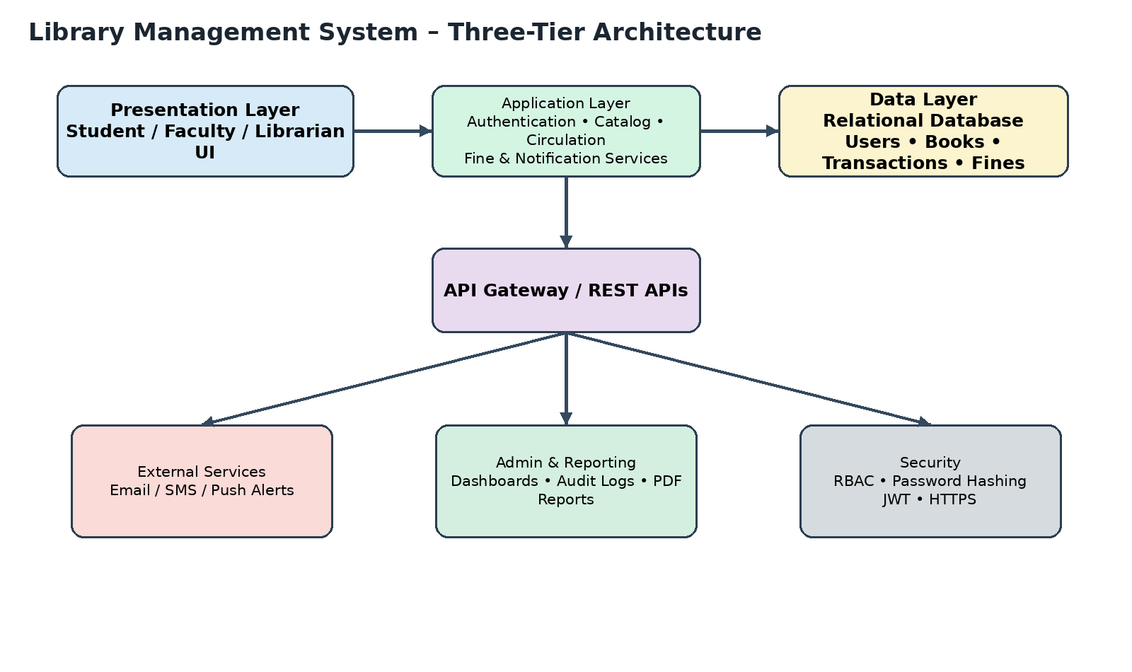
Figure 1: Proposed three-tier architecture of the Library Management System.

10.1 Architecture Components
Layer | Components | Purpose
Presentation Layer | Web or mobile UI | Allows students, faculty, librarians, and administrators to interact with the system.
Application Layer | Authentication, catalogue, circulation, fine, notification, reporting services | Processes requests and applies business rules.
Data Layer | Relational database and ORM models | Stores users, books, transactions, fines, and audit records.
Security Layer | RBAC, password hashing, JWT, HTTPS | Protects user accounts and sensitive operations.
External Services | Email/SMS service, optional barcode scanner | Supports reminders and faster circulation.

11. Database Design and ER Diagram
A relational database is suitable because library transactions require consistency and relationships between users, books, loans, and fines. Primary keys uniquely identify records, while foreign keys connect related entities.
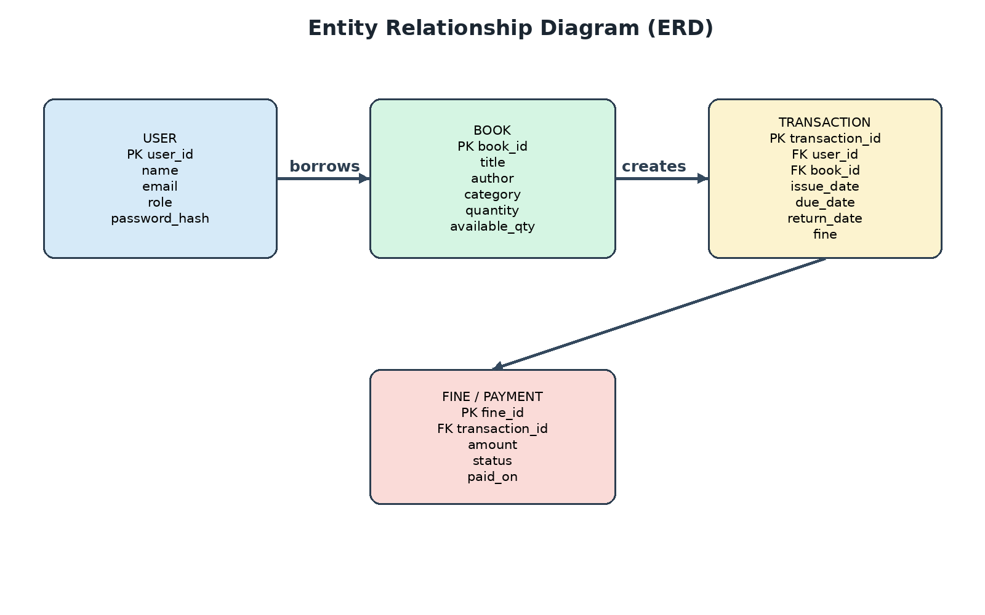
Figure 2: Entity Relationship Diagram for the core library database.

11.1 Main Entities
- User: stores user identity, email, role, and authentication details.
- Book: stores title, author, category, ISBN, quantity, and availability.
- Transaction: records issue date, due date, return date, user, and book.
- Fine: stores overdue amount, payment status, and payment date.

12. System Flowchart
The following flow describes a typical issue and return process. The system first authenticates the user, searches the catalogue, checks availability, and then updates the transaction and inventory records.
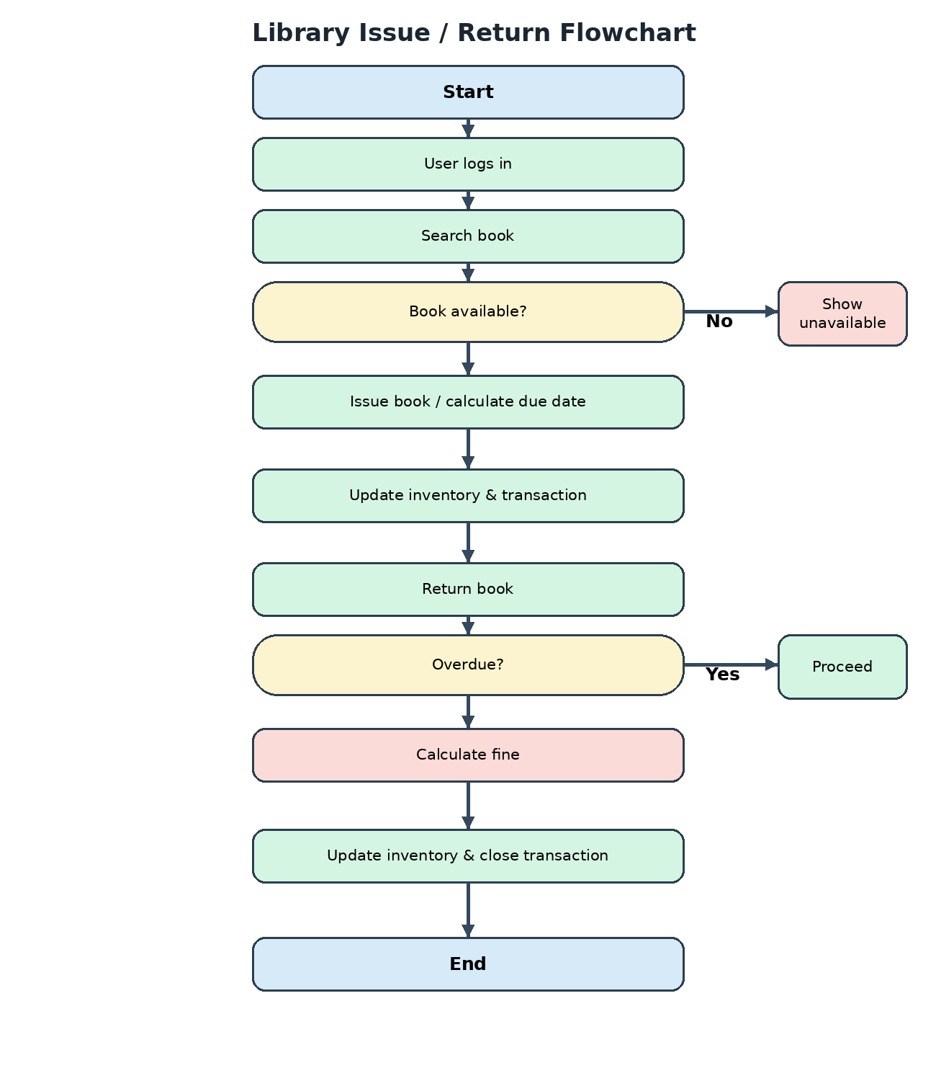
Figure 3: Flowchart for book search, issue, return, and fine processing.

13. Use Case Diagram
The use case diagram shows how different actors interact with the Library Management System.
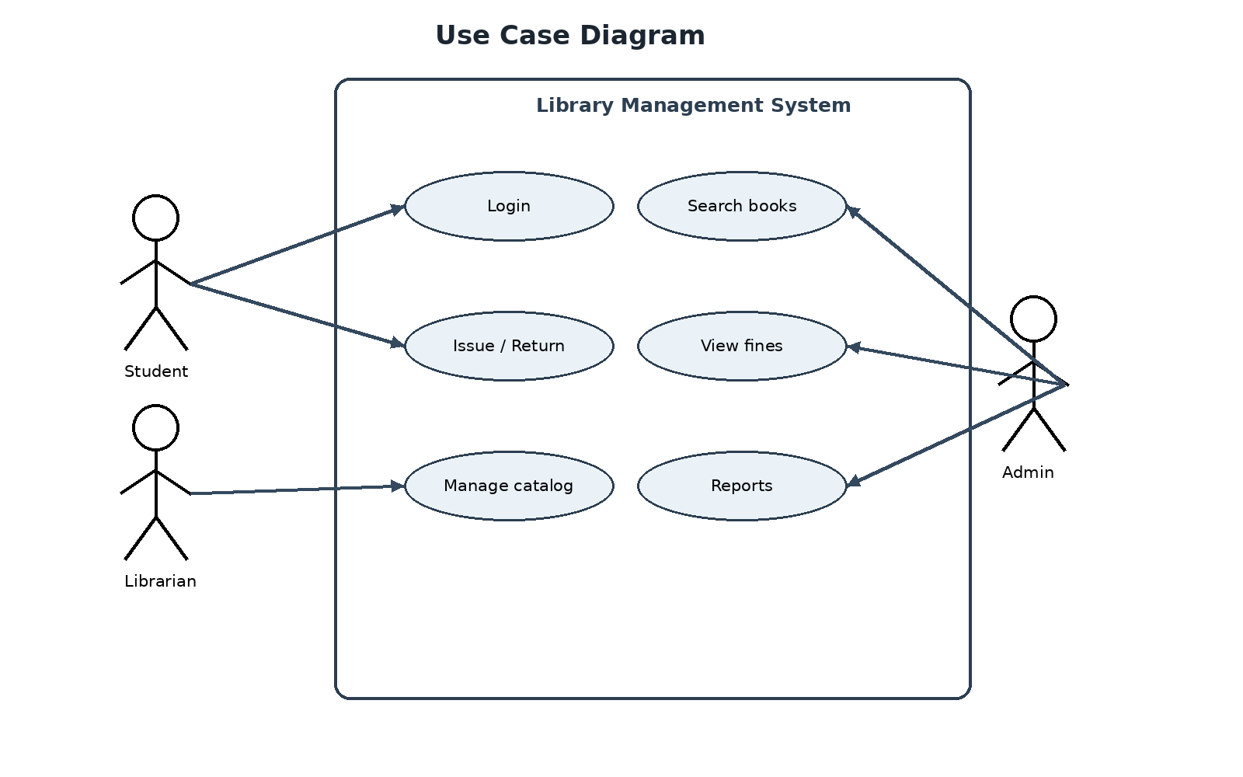
Figure 4: Use case diagram showing major actors and system functions.

14. Major System Modules
Module | Description
Authentication Module | Login, logout, password protection, role-based access, and session management.
User Management Module | Member registration, profile updates, role assignment, and account status.
Book Catalogue Module | Book CRUD operations, category management, shelf details, and stock tracking.
Search Module | Keyword-based search, filtering, sorting, and availability display.
Circulation Module | Issue, return, renewal, due-date calculation, and transaction history.
Fine Module | Overdue calculation, fine status, and payment recording.
Notification Module | Due-date reminders, overdue alerts, and system messages.
Reporting Module | Inventory reports, issued books, overdue books, and user activity.
Administration Module | Dashboard, audit logs, system configuration, and access control.

15. Suggested Technology Stack
Layer | Suggested Technologies | Reason
Frontend | HTML, CSS, JavaScript / React | Build responsive and interactive interfaces.
Backend | Node.js + Express or Python FastAPI | Develop REST APIs and business logic.
Database | PostgreSQL or MySQL | Store structured data with relationships and constraints.
Authentication | JWT, bcrypt or Argon2 | Secure login and role-based access.
Version Control | Git and GitHub | Track changes and collaborate.
Testing | Postman, unit testing framework | Validate APIs and application behaviour.
Deployment | Docker and a cloud hosting service | Provide consistent deployment and portability.

16. Testing Strategy
Testing Type | Purpose | Example
Unit Testing | Test individual functions. | Fine calculation and due-date logic.
Integration Testing | Test communication between modules. | Issue transaction updates both book and transaction tables.
System Testing | Test the complete application. | Student searches and issues an available book.
Usability Testing | Check ease of use. | Observe whether users can locate a book quickly.
Security Testing | Check access restrictions. | Student cannot access admin functions.
Performance Testing | Check response under load. | Search remains responsive for multiple users.

17. Product Roadmap
Phase | Activities | Deliverables
Phase 1: Domain Analysis | Understand library operations and stakeholders. | Problem statement, personas, BRD.
Phase 2: Design Thinking | Empathize, define, ideate, prototype, test. | Wireframes, feedback, design report.
Phase 3: Planning | Prepare backlog, requirements, and architecture. | FRS, NFRS, MVP, architecture.
Phase 4: Development | Build frontend, backend, database, and core modules. | Working MVP.
Phase 5: Testing | Perform unit, integration, usability, and security testing. | Test report and bug fixes.
Phase 6: Deployment | Containerize, deploy, monitor, and collect feedback. | Deployed system and improvement backlog.

18. Project Folder Structure
A modular repository structure can be used for the project:
library-management-system/
├── frontend/
│ ├── src/
│ ├── components/
│ ├── pages/
│ └── services/
├── backend/
│ ├── routes/
│ ├── controllers/
│ ├── services/
│ ├── models/
│ └── middleware/
├── database/
│ ├── schema/
│ └── migrations/
├── tests/
├── docs/
│ ├── diagrams/
│ └── requirements/
├── docker/
├── .github/
│ └── workflows/
└── README.md

19. Expected Outcomes
- Reduced time required to search and locate books.
- Improved accuracy of issue, return, and inventory records.
- Faster circulation processing and shorter queues.
- Better visibility of overdue books and fines.
- Centralized reports for librarians and administrators.
- Improved user experience through self-service search and transaction history.

20. Conclusion
The Library Management System is a practical software product idea that addresses common operational challenges in academic libraries. By applying business understanding, design thinking, stakeholder analysis, requirements engineering, architecture design, and MVP planning, the project establishes a strong foundation for future implementation. The proposed solution can be developed incrementally using Agile practices and improved through continuous user feedback.

21. Future Scope
- Mobile application for students and librarians.
- Barcode and QR code scanning.
- Online reservation and waitlist management.
- Email, SMS, and push notifications.
- AI-based recommendations and demand forecasting.
- Multi-library and multi-campus support.
- Cloud deployment with monitoring and automated backups.

22. References
- Unit 1 Mini Project Guide: Library Management Platform – Product Engineering & Design Thinking.
- Classroom notes and faculty guidance on Design Thinking, IBM Design Thinking, requirements engineering, and system architecture.
- Official documentation of the selected frontend framework, backend framework, and database system (to be added during implementation).

Appendix A: Submission Checklist
- Cover page and certificate completed.
- Problem statement and objectives included.
- Design Thinking stages documented.
- Stakeholder matrix and personas included.
- Functional and non-functional requirements included.
- MVP and roadmap defined.
- Architecture, ERD, flowchart, and use case diagram inserted.
- Technology stack and folder structure documented.
- Testing strategy and future scope added.

