DEVOPS MINI-PROJECT -2

Agile Project Planning Report
Scrum-Based Planning and Complete Agile Documentation

Student Record and Academic Management Platform (SRAMP)

Submitted by | Sarthak Badakh
Subject | DevOps
Unit | Unit 2 – Agile Mini-Project
Class | SY-B
PRN | 2126UMLM2513
Table of Contents
1. Introduction 3
2. Business Problem and Product Discovery Review 4
3. Agile Product Vision 6
4. Scrum Team Structure and Roles 8
5. Epic Documentation 10
6. User Story Repository 11
7. Acceptance Criteria Document 12
8. Prioritized Product Backlog 15
9. Story Point Estimation 16
10. Sprint Planning and Sprint Backlogs 18
11. Scrum Board 20
12. Scrum Ceremonies 21
13. Burndown Chart and Velocity 22
14. Agile Framework Comparison 23
15. Project Timeline and Release Roadmap 24
16. DevOps Integration with Agile 25
17. Risk Register, Conclusion and Deliverables 25
List of Figures
Figure 1: Agile product vision board for SRAMP 7
Figure 2: Scrum framework: backlog, sprint, increment and feedback loop 8
Figure 3: Scrum team structure of SRAMP 9
Figure 4: Epic map of SRAMP with features 10
Figure 5: Product backlog composition by epic and priority 16
Figure 6: Distribution of story points by value and by epic 17
Figure 7: Scrum board snapshot – Sprint 3, day 6 (illustrative) 20
Figure 8: Sprint 1 burndown (left) and release burndown for 138 story points (right) 22
Figure 9: Planned versus completed story points per sprint 23
Figure 10: Framework suitability scoring for SRAMP 24
Figure 11: Project timeline and release roadmap (12 weeks) 24
Figure 12: DevOps pipeline supporting every sprint 25

1. Introduction

1.1 Purpose of this Document
This report is the Agile Project Planning Report for the Unit 2 DevOps mini-project. It converts the product discovery work of Unit 1 (vision, stakeholders, requirements, personas, MVP and roadmap) into Agile delivery artefacts for the Student Record and Academic Management Platform (SRAMP): a secure, web-based application that lets an educational institution manage student records, courses, attendance, marks, notifications and reports.
The document follows the Scrum framework. It defines the Agile product vision, the Scrum team and roles, epics, user stories with acceptance criteria, a prioritised product backlog, story-point estimates, sprint plans, a Scrum board, ceremony records, a burndown chart, a comparison of Agile frameworks and a release roadmap. Together these form the complete Agile documentation required for Unit 2.

1.2 Project at a Glance
Table 1: Project summary
Item | Details
Project name | Student Record and Academic Management Platform (SRAMP)
Domain | Education / academic administration (web-based information system)
Methodology | Agile – Scrum framework with Kanban-style visual board
Sprint length | 2 weeks (10 working days)
Project duration | 12 weeks – 6 sprints and 3 planned releases
Team size | 4 members (Product Owner, Scrum Master, 2 Developers)
Product backlog | 7 epics + technical enablers, 32 user stories, 138 story points
Planned velocity | 23 story points per sprint (average)
Tools (planned) | Git/GitHub, GitHub Projects (Scrum board), GitHub Actions (CI/CD), Docker, Jira-style backlog sheet

1.3 Mapping of Unit 2 Activities to this Report
Table 2: Unit 2 activities and where they are documented
# | Unit 2 Activity | Section
1 | Study the business problem and product vision | Section 2
2 | Define the Agile product vision | Section 3
3 | Identify Scrum roles | Section 4
4 | Identify project epics | Section 5
5 | Develop user stories | Section 6
6 | Define acceptance criteria | Section 7
7 | Prepare the product backlog | Section 8
8 | Estimate story points | Section 9
9 | Sprint planning | Section 10
10 | Scrum board development | Section 11
11 | Simulate Scrum ceremonies (incl. review and retrospective reports) | Sections 12 and 13
12 | Compare Agile frameworks | Section 14
– | Timeline, release roadmap, DevOps integration, risks, checklist | Sections 15 – 17

1.4 Why Agile for SRAMP?
Academic requirements change frequently: grading schemes differ between departments, attendance rules are revised and reports are requested in new formats. A plan-driven (waterfall) approach would lock these decisions too early. Agile delivery with short sprints allows the team to release a working increment every two weeks, collect feedback from faculty and administrative staff, and re-prioritise the backlog. The four Agile Manifesto values are applied as follows:
- Individuals and interactions – daily Scrum, pair work between developer and tester, open communication with the Product Owner.
- Working software – every sprint ends with a demonstrable, tested increment instead of long design documents.
- Customer collaboration – faculty and staff representatives review each increment in the Sprint Review.
- Responding to change – the Product Backlog is re-ordered every sprint as new needs appear.

2. Business Problem and Product Discovery Review
Before planning the work, the team reviewed the Product Discovery artefacts created in Unit 1 and adapted them to SRAMP. This section summarises that review so that every later Agile artefact can be traced back to a business need.

2.1 Business Problem
Many institutions still keep student information in paper files, scattered spreadsheets and separate departmental registers. Updating one record means updating it in several places, attendance is totalled by hand at the end of the month, and result sheets take days to prepare. Students cannot see their own attendance or marks until a notice is displayed, and management cannot see institution-wide trends.
Table 3: Manual process challenges and the platform response
Manual challenge | SRAMP solution | Expected outcome
Duplicate and inconsistent student records | Single centralised database with validation and unique roll numbers | Record accuracy of 95% or more
Paper attendance registers totalled manually | Digital attendance entry with automatic percentage calculation | Attendance entry in under 2 minutes per lecture
Marks compiled in spreadsheets; grading errors | Marks entry with automatic grade and SGPA calculation | Result preparation time reduced by about 70%
No early warning for low attendance | Automated alerts by email and in-app notification | Fewer students falling below 75% attendance
Reports prepared on request, taking days | On-demand reports exportable as PDF/CSV | Reports generated in seconds

2.2 Product Vision and Mission
Product Vision Statement
"To deliver a secure, user-friendly and scalable web-based Student Record and Academic Management Platform that helps educational institutions manage student records, attendance, academic performance, course registration and reporting efficiently."

Mission Statement
"To simplify academic administration by giving staff accurate and fast digital tools, giving faculty reliable data for teaching decisions, and giving students transparent access to their own academic progress."

2.3 Stakeholders
Table 4: Stakeholder analysis
Stakeholder | Who | Interest / expectation | Influence
Institution management | Principal, Dean, HoD | Accurate institution-level reports; compliance; low cost | High
Faculty | Teachers, course coordinators | Quick attendance and marks entry; class-level insight | High
Administrative and exam staff | Admission office, exam cell | Easy record maintenance; fast result generation | High
Students | All enrolled students | Transparent view of attendance, marks and notices | Medium
Development and DevOps team | Product Owner, Scrum Master, developers | Clear requirements; stable CI/CD pipeline | High
IT / security administrator | Institute IT department | Data protection, backups, access control | Medium

2.4 Business Requirements
Table 5: Business requirements
ID | Business requirement | Epic
BR-01 | Maintain a single, accurate digital record for every student from admission to graduation. | E1
BR-02 | Reduce staff time spent on attendance entry, mark compilation and result preparation. | E3, E4
BR-03 | Allow only authorised persons to view or change academic data. | E5
BR-04 | Keep students and faculty informed about attendance, examinations and results. | E6
BR-05 | Provide management with timely reports to support academic decisions. | E7
BR-06 | Support course registration and the assignment of students to courses. | E2

2.5 Functional Requirements
Table 6: Functional requirements (FRS)
ID | Functional requirement | Epic
FR-01 | Register, view, search, update and delete student records with unique roll numbers. | E1
FR-02 | Create and update courses; assign students to courses individually or in bulk. | E2
FR-03 | Record attendance per course and lecture date; view attendance course-wise. | E3
FR-04 | Enter and update marks; calculate grades and SGPA; generate result sheets. | E4
FR-05 | Login, logout, password reset and role-based access control (Admin, Faculty, Student, Staff). | E5
FR-06 | Send attendance alerts, examination notifications and result notifications. | E6
FR-07 | Generate student, attendance, performance and course reports with PDF/CSV export. | E7
FR-08 | Maintain an audit log of changes to student records, attendance and marks. | E1, E3, E4

2.6 Non-Functional Requirements
Table 7: Non-functional requirements (NFRS)
ID | Category | Requirement
NFR-01 | Security | Passwords hashed with bcrypt/Argon2; JWT sessions; HTTPS; protection against SQL injection and XSS.
NFR-02 | Performance | Search and list pages respond in under 2 seconds with 200 concurrent users.
NFR-03 | Availability | Target uptime of 99% during academic hours; daily automated database backups.
NFR-04 | Scalability | Containerised deployment so that the application can scale horizontally.
NFR-05 | Usability | Responsive interface; every main task reachable in 3 clicks; basic accessibility support.
NFR-06 | Maintainability | Modular code, automated tests with at least 70% coverage, Infrastructure as Code.
NFR-07 | Privacy | Student data accessible only by role; audit logging; compliance with institutional data policy.

2.7 User Personas
Table 8: User personas
Persona | Goals | Pain points | Key features used
Aarav (Student, 2nd-year) | Check attendance and marks; avoid shortage of attendance | Learns of low attendance too late; waits for notice-board results | Student dashboard, attendance view, alerts, results
Prof. Mehta (Faculty) | Mark attendance quickly; enter marks accurately | Paper registers; manual totals; repeated data entry | Attendance recording, marks entry, course reports
Mrs. Sunita (Administrative Officer) | Keep student records correct and up to date | Duplicate files; slow searches; frequent corrections | Student CRUD, search, student reports
Dr. Verma (Head of Department) | Monitor department performance and attendance trends | No consolidated data; reports take days | Analytics dashboard, performance and attendance reports

2.8 Minimum Viable Product and Product Roadmap
The MVP (Release 1) contains the smallest set of features that gives real value to the institution: secure login with role-based access, student management with search, course creation and student assignment, and attendance recording with basic reports. Marks, notifications and advanced reporting follow in later releases.
Table 9: Enterprise engineering roadmap and the position of Unit 2
Phase | Activity | Status
1 | Domain analysis and problem understanding | Completed (Unit 1)
2 | Design thinking, personas and prototyping | Completed (Unit 1)
3 | Agile sprint planning and backlog management | This report (Unit 2)
4 | Core application development (backend and frontend) | Planned – Sprints 1 to 6
5 | DevOps automation: CI/CD pipelines and containerisation | Planned – from Sprint 1
6 | Infrastructure automation (Terraform, Ansible) | Upcoming units
7 | Production deployment and monitoring (Kubernetes, Prometheus, Grafana) | Upcoming units

3. Agile Product Vision
In Agile, the product vision is a short, shared description of why the product exists and what success looks like. It guides every backlog decision. The vision below refines the Unit 1 vision from an Agile perspective.
Agile Product Vision
"Develop a secure and user-friendly Student Record and Academic Management Platform that enables educational institutions to efficiently manage student records, attendance, academic performance, course registration and reporting through a scalable web-based application."
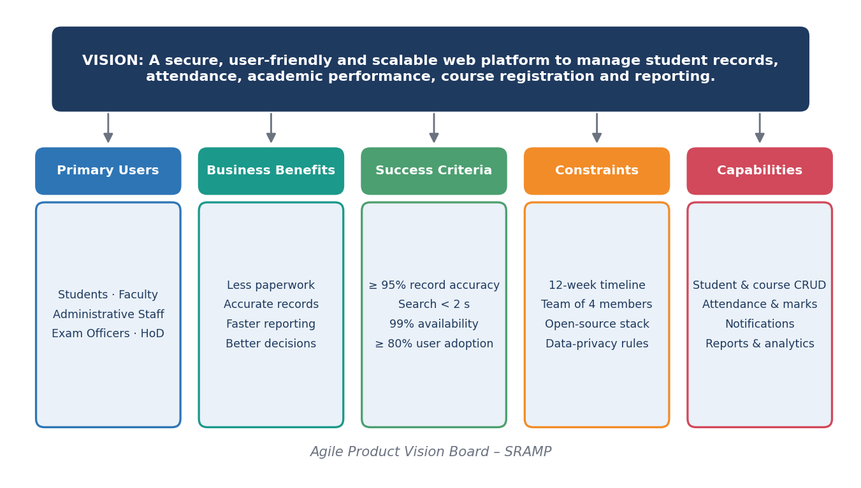
Figure 1: Agile product vision board for SRAMP

3.1 Product Objective and Primary Users
The objective is to replace paper registers and disconnected spreadsheets with one reliable system that is simple enough for faculty to use between lectures and strong enough for management to trust. Primary users are administrators, administrative/exam staff, faculty members, students and heads of department.

3.2 Business Benefits
- Less manual paperwork and re-entry of data; fewer errors.
- Faster attendance, grading and result processing.
- Early identification of students with low attendance or weak performance.
- Real-time reports that support management decisions.
- Secure, auditable handling of student information.

3.3 Measurable Success Criteria
Table 10: Success criteria and how they are measured
Success criterion | Target | How it is measured
Record accuracy | 95% or more records without correction | Sample audit after Release 1
Search response time | Under 2 seconds | Automated performance test in CI
Attendance entry time | Under 2 minutes per lecture | Observation during Sprint Review demo
User adoption | 80% of faculty use the system within one month | Login statistics
Sprint predictability | Completed points within ±15% of plan | Velocity chart
Code quality | 70% test coverage; no failed build merged | CI pipeline report

3.4 Project Constraints
- Time: 12 weeks (six two-week sprints).
- Team: four members with part-time availability alongside classes.
- Technology: open-source stack; free-tier CI/CD and hosting.
- Data privacy: student data must be protected; only dummy data is used during development.
- Scope: no third-party payment, biometric attendance or mobile native app in the first release.

3.5 Expected Software Capabilities
SRAMP will provide: student record management; course creation and enrolment; attendance recording and tracking; marks entry, grading and result sheets; secure authentication with role-based access; email and in-app notifications; and reports and analytics. These capabilities are decomposed into epics in Section 5.

3.6 Alignment with Stakeholder Expectations
Table 11: Stakeholder expectations versus vision elements
Stakeholder | Expectation | Addressed by
Management | Reliable, consolidated reports | Epic 7 – Reporting; analytics dashboard
Faculty | Fast attendance and marks entry | Epics 3 and 4; simple UI (NFR-05)
Students | Visibility of own progress | Student profile, attendance view, notifications
Administrative staff | Accurate records and quick search | Epic 1 – Student Management
IT / security | Controlled access and auditability | Epic 5; NFR-01 and NFR-07

4. Scrum Team Structure and Roles

4.1 Scrum Framework Overview
Scrum is a lightweight framework in which a small, cross-functional team delivers a potentially shippable product increment in fixed-length sprints. The Product Owner maintains a prioritised Product Backlog; in Sprint Planning the team pulls the top items into a Sprint Backlog, builds them with a Daily Scrum for coordination, shows the result in the Sprint Review and improves its way of working in the Sprint Retrospective.
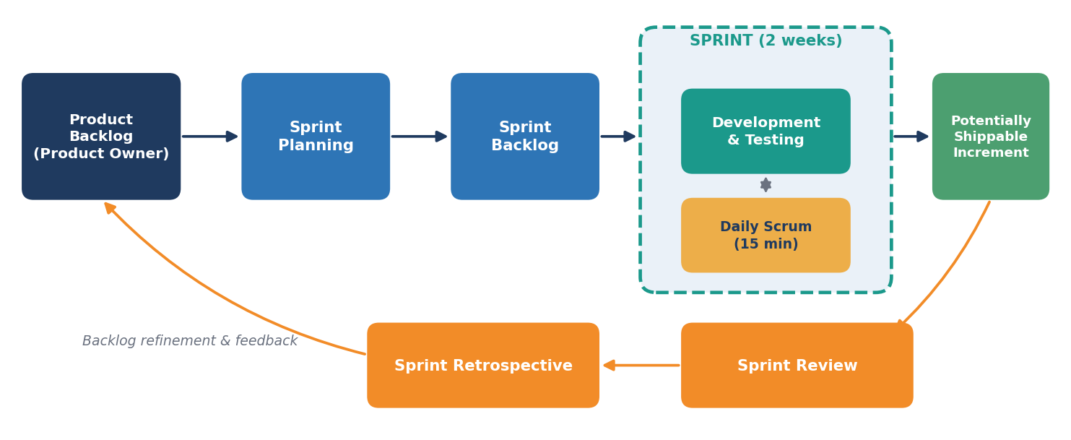
Figure 2: Scrum framework: backlog, sprint, increment and feedback loop

4.2 Scrum Team Structure
The Scrum Team of SRAMP has four members. Because the team is small, members hold more than one technical "hat" (for example, the Scrum Master also owns the CI/CD pipeline), but the three Scrum accountabilities remain clearly separated.
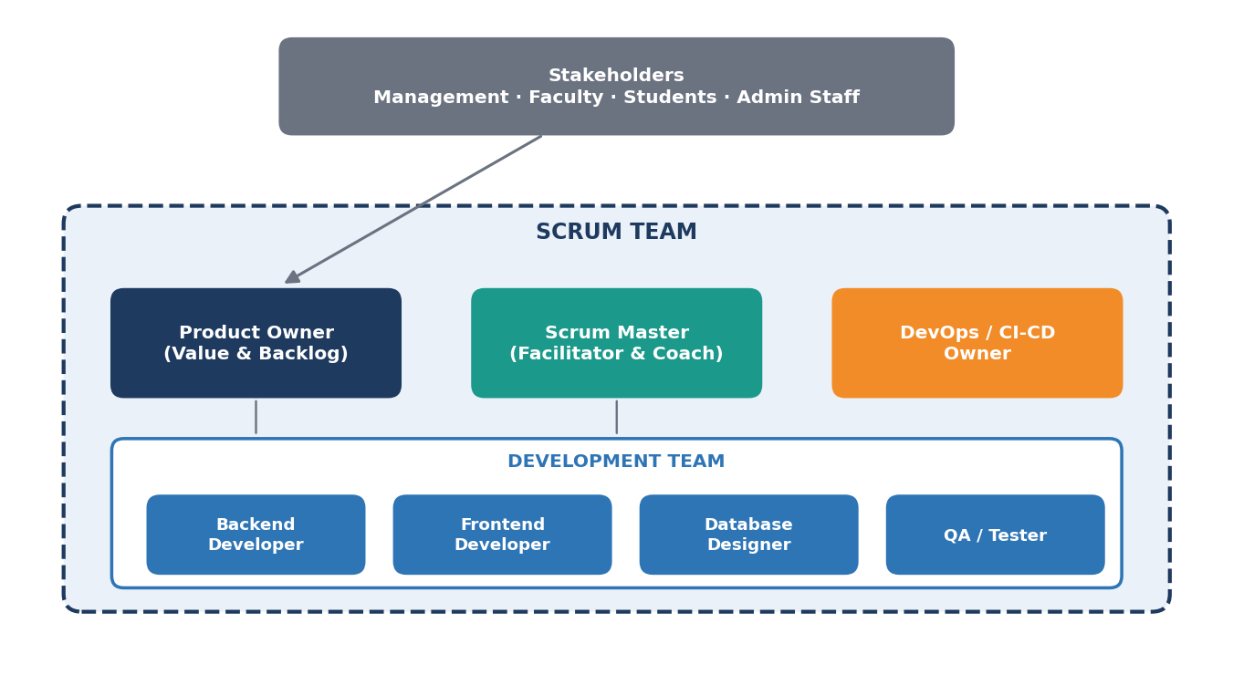
Figure 3: Scrum team structure of SRAMP
Table 12: Team members and role assignment
Member | Scrum role | Technical responsibility
Member 1 (Sarthak) | Product Owner | Requirements, backlog ordering, acceptance of stories
Member 2 | Scrum Master | Facilitation of ceremonies; DevOps and CI/CD pipeline
Member 3 | Developer | Backend APIs, database design, authentication
Member 4 | Developer | Frontend UI, test cases and quality assurance

4.3 Roles and Responsibilities
Table 13: Scrum roles and responsibilities
Role | Responsibilities | Key outputs
Product Owner | - Defines product requirements and the product vision.  - Prioritises the Product Backlog.  - Represents stakeholder interests.  - Accepts or rejects completed work. | Product Backlog, acceptance decisions, release goals
Scrum Master | - Facilitates Scrum ceremonies.  - Removes project impediments.  - Ensures Agile practices are followed.  - Supports team collaboration and self-organisation. | Sprint calendar, impediment log, retrospective actions
Development Team | - Designs the application.  - Writes and reviews code.  - Tests the software and fixes defects.  - Prepares documentation and demonstrates completed features. | Working, tested increment; documentation; demo

4.4 Responsibility Matrix
Table 14: R = Responsible, A = Accountable, C = Consulted, I = Informed
Activity | Product Owner | Scrum Master | Dev Team
Define product vision | A/R | C | C
Maintain Product Backlog | A/R | C | C
Write acceptance criteria | A/R | I | C
Estimate story points | C | C | A/R
Sprint Planning | R | A (facilitates) | R
Daily Scrum | I | C | A/R
Build, test and integrate | I | I | A/R
Sprint Review | A | R | R
Sprint Retrospective | R | A (facilitates) | R
Remove impediments | C | A/R | C

4.5 Team Working Agreement
- Sprints are two weeks long; scope of a running sprint is not changed without the Product Owner and the team agreeing.
- Daily Scrum at a fixed time, maximum 15 minutes.
- A story is "Done" only when it satisfies its acceptance criteria and the Definition of Done (Section 7).
- Every change goes through a pull request with at least one review.
- Impediments are raised immediately and tracked by the Scrum Master.

5. Epic Documentation
An epic is a large body of work that can be broken down into user stories. SRAMP is organised into seven functional epics, plus a small set of technical enabler stories (repository, CI/CD, UI shell and deployment) that support the DevOps objective of the course.
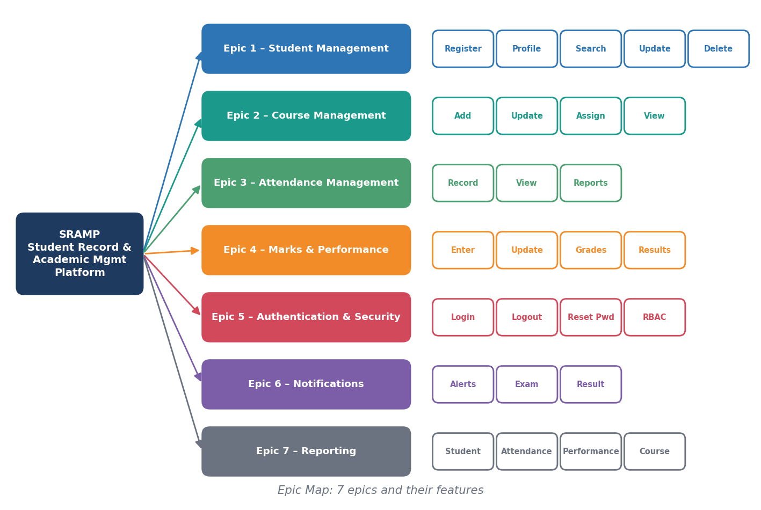
Figure 4: Epic map of SRAMP with features
Table 15: Epic document – purpose, scope and value
Epic | Purpose | In scope | Out of scope | Stories / Points
Epic 1 – Student Management | Maintain accurate digital student records. | Registration, profile management, search, update, deletion. | Admission workflow and fee management. | 5 / 19
Epic 2 – Course Management | Manage the courses offered and who is enrolled in them. | Add and update course, assign students, view course details. | Timetable generation. | 4 / 12
Epic 3 – Attendance Management | Track lecture attendance reliably. | Record attendance, view attendance, attendance reports. | Biometric or RFID capture. | 3 / 16
Epic 4 – Marks & Academic Performance | Record academic performance and publish results. | Enter and update marks, calculate grades and SGPA, result sheets. | Question-paper or exam-hall management. | 4 / 21
Epic 5 – Authentication & Security | Protect the system and its data. | Login, logout, password reset, role-based access control. | Single sign-on with external providers. | 5 / 22
Epic 6 – Notifications | Keep users informed in time. | Attendance alerts, examination and result notifications (email, in-app). | SMS and mobile push notifications. | 3 / 11
Epic 7 – Reporting | Support decisions with data. | Student, attendance, performance and course reports; analytics dashboard. | Predictive analytics. | 5 / 26

The three technical enabler stories (US-01, US-05 and US-32) add 11 points. In total the backlog holds 32 stories and 138 story points.

6. User Story Repository
Each epic is broken into user stories using the Agile format "As a <role>, I want <goal> so that <benefit>". Good stories follow the INVEST principle – Independent, Negotiable, Valuable, Estimable, Small and Testable. The repository below lists all stories; acceptance criteria are given in Section 7.
Example
As a Faculty Member, I want to record student attendance so that attendance records remain accurate and updated. (US-16)

Table 16: User story repository
ID | Epic | User story | Pts
US-01 | TE | As a Development Team member, I want a version-controlled repository with an automated build pipeline so that every commit is compiled and tested automatically. | 3
US-02 | E5 | As an Administrator, I want to create user accounts for students, faculty and staff so that only authorised persons can access the platform. | 3
US-03 | E5 | As a Registered User, I want to log in with my credentials so that I can securely access features meant for my role. | 5
US-04 | E5 | As a Logged-in User, I want to log out of the system so that my session cannot be misused on a shared computer. | 1
US-05 | TE | As an End User, I want a consistent layout with menu and dashboard placeholder so that I can navigate the application easily. | 3
US-06 | E5 | As an Administrator, I want to assign roles with specific permissions so that users see and change only the data they are permitted to. | 8
US-07 | E1 | As an Administrative Staff, I want to register a new student with personal and academic details so that the institution has a complete and accurate student record. | 5
US-08 | E1 | As a Student, I want to view my profile and request corrections so that my personal data stays accurate. | 3
US-09 | E1 | As a Faculty Member, I want to search students by name, roll number, department or year so that I can find a record in seconds. | 5
US-10 | E1 | As an Administrative Staff, I want to edit an existing student record so that outdated information is corrected. | 3
US-11 | E1 | As an Administrator, I want to remove a student record that is no longer required so that the database stays clean and compliant. | 3
US-12 | E5 | As a Registered User, I want to reset a forgotten password via email so that I regain access without contacting the administrator. | 5
US-13 | E2 | As an Administrator, I want to create a course with code, title, credits and semester so that students can be enrolled in it. | 3
US-14 | E2 | As an Administrator, I want to modify course details so that timetable or syllabus changes are reflected. | 2
US-15 | E2 | As an Administrator, I want to enrol students into a course individually or in bulk so that they appear in attendance and marks sheets. | 5
US-16 | E3 | As a Faculty Member, I want to record student attendance for a lecture so that attendance records remain accurate and updated. | 8
US-17 | E3 | As a Student, I want to view my attendance course-wise so that I can keep it above the required percentage. | 3
US-18 | E3 | As a Faculty Member, I want to generate attendance reports for a course and date range so that I can identify irregular students. | 5
US-19 | E2 | As a Student, I want to view the details of courses I am enrolled in so that I know the syllabus, faculty and schedule. | 2
US-20 | E4 | As a Faculty Member, I want to enter internal and examination marks so that student performance is recorded. | 5
US-21 | E4 | As a Faculty Member, I want to correct marks before result publication so that errors do not reach the final result. | 3
US-22 | E4 | As an Examination Officer, I want grades to be calculated automatically from marks so that grading is consistent and error-free. | 5
US-23 | E4 | As an Examination Officer, I want to generate result sheets for a class so that results can be published and archived. | 8
US-24 | E6 | As a Student, I want to be alerted when my attendance falls below the threshold so that I can take corrective action. | 5
US-25 | E6 | As a Student, I want to receive notifications about exam schedules so that I do not miss an examination. | 3
US-26 | E6 | As a Student, I want to be notified when my result is published so that I can view my result promptly. | 3
US-27 | E7 | As an Administrative Staff, I want to generate a consolidated report for a student so that I have a complete academic summary. | 5
US-28 | E7 | As a Head of Department, I want to view class and department performance reports so that I can evaluate teaching outcomes. | 5
US-29 | E7 | As a Head of Department, I want an institution-level attendance summary so that I can monitor attendance trends. | 5
US-30 | E7 | As a Faculty Member, I want a report on enrolment and results for my course so that I can review course effectiveness. | 3
US-31 | E7 | As a Head of Department, I want a dashboard with academic analytics so that decisions are supported by data. | 8
US-32 | TE | As a DevOps Engineer, I want to package and deploy the application through a CD pipeline so that releases are repeatable and low risk. | 5

7. Acceptance Criteria Document
Acceptance criteria are measurable conditions that must be true for a story to be accepted by the Product Owner. They remove ambiguity, drive test-case design and give a clear definition of "Done" for every feature.
Definition of Done (applies to every story)
1. Code is reviewed through a pull request and merged to the develop branch.
2. All acceptance criteria are met and verified by a tester.
3. Unit tests are written and pass; CI pipeline is green.
4. No open high-severity defects; basic security checks are satisfied.
5. Documentation (README / API notes) is updated and the feature is demonstrated to the Product Owner.

Table 17: Acceptance criteria for all user stories
ID | User story | Acceptance criteria
US-01 | Repository and CI Pipeline Setup | - Git repository is created with a branching strategy (main, develop, feature/*).  - README and folder structure are committed.  - CI pipeline runs build and unit tests on every push.  - A failed build blocks merging to the develop branch.
US-02 | User Registration | - Registration form validates name, email, role and password.  - Duplicate email addresses are rejected with a clear message.  - Passwords are stored as salted hashes.  - Newly created account appears in the user list.
US-03 | User Login | - Login page loads successfully.  - Registered users can log in.  - Invalid credentials display an appropriate error message.  - Successful login redirects to the dashboard.  - Session management functions correctly (timeout after inactivity).
US-04 | User Logout | - Logout option is visible on every page.  - Session token is invalidated on logout.  - User is redirected to the login page.  - Back button does not restore the session.
US-05 | Basic UI and Navigation Shell | - Responsive layout works on desktop and tablet widths.  - Navigation menu shows items according to the user role.  - Common header, footer and error pages are available.
US-06 | Role-Based Access Control | - Roles Admin, Faculty, Student and Staff are defined.  - Each API endpoint checks the role before responding.  - Unauthorised access returns HTTP 403 and is logged.  - Admin can change a user's role.
US-07 | Student Registration | - Form captures name, roll number, department, year, contact and guardian details.  - Mandatory fields and formats are validated.  - Roll number must be unique.  - Student record is saved and a confirmation is shown.
US-08 | Student Profile Management | - Student can view own profile only.  - Profile page shows courses, attendance summary and marks summary.  - Profile photo and contact details can be updated.  - Changes to sensitive fields require staff approval.
US-09 | Student Search | - Search supports partial and case-insensitive matches.  - Filters for department, year and course are available.  - Results are paginated and returned within 2 seconds.  - A 'no records found' message is shown for empty results.
US-10 | Student Update | - Existing values are pre-filled in the form.  - Validation rules match the registration form.  - An audit entry stores who changed what and when.  - Updated data is visible immediately.
US-11 | Student Deletion | - A confirmation prompt is displayed before deletion.  - Deletion is a soft delete so history can be restored.  - Linked attendance and marks are archived, not orphaned.  - Only the Admin role can delete.
US-12 | Password Reset | - Reset link is emailed to the registered address.  - Link expires after 30 minutes and works once.  - New password must satisfy the password policy.  - Confirmation email is sent after reset.
US-13 | Add Course | - Course code is unique.  - Credits, semester and department are mandatory.  - A faculty member can be assigned as instructor.  - Course appears in the course list after saving.
US-14 | Update Course | - Existing details are editable except the course code.  - Changes are validated and saved.  - Enrolled students see the updated details.
US-15 | Assign Students to Course | - Students can be selected by department and year.  - A student cannot be enrolled twice in the same course.  - Bulk assignment via CSV upload is supported.  - Enrolment count is shown on the course page.
US-16 | Record Attendance | - Faculty can select a course.  - Faculty can select a lecture date.  - Faculty can mark each student present or absent.  - Attendance records are saved successfully.  - Attendance for the same lecture cannot be duplicated.
US-17 | View Attendance | - Student sees attendance percentage per course.  - Lecture-wise present/absent list is available.  - Courses below 75% are highlighted.
US-18 | Attendance Reports | - Report can be filtered by course, date range and student.  - Report can be exported as PDF and CSV.  - Report is generated within 5 seconds for one semester.
US-19 | View Course Details | - Course page shows code, title, credits, faculty and schedule.  - Only enrolled courses are listed for a student.  - Page loads within 2 seconds.
US-20 | Enter Marks | - Marks can be entered per student and per assessment.  - Marks cannot exceed the maximum marks.  - Entries can be saved as draft and then submitted.  - Only the assigned faculty can enter marks.
US-21 | Update Marks | - Marks are editable only before publication.  - Every change is logged with reason and timestamp.  - Recalculated totals are shown immediately.
US-22 | Calculate Grades | - Grade scale is configurable by the Admin.  - Grade and grade points are computed for every student.  - SGPA is calculated per semester.  - Edge cases (absent, withheld) are handled.
US-23 | Generate Result Sheets | - Result sheet lists subject-wise marks, grades and SGPA.  - Sheet is exportable as PDF with the institution header.  - Individual and consolidated sheets can be generated.  - Only published results are visible to students.
US-24 | Attendance Alerts | - Threshold is configurable (default 75%).  - Email alert is sent automatically.  - In-app notification is displayed.  - An alert is not repeated more than once a week.
US-25 | Examination Notifications | - Admin can publish an exam schedule.  - Enrolled students receive in-app and email notification.  - Notification shows date, time and venue.
US-26 | Result Notifications | - Notification is triggered upon result publication.  - Notification contains a link to the result sheet.  - Notification is sent only to the concerned students.
US-27 | Student Reports | - Report includes profile, attendance and marks.  - Report can be exported as PDF.  - Access is limited to authorised roles.
US-28 | Performance Reports | - Pass percentage, average and topper list are displayed.  - Reports can be filtered by course and semester.  - Graphical charts accompany the tabular data.
US-29 | Attendance Summary Report | - Summary is grouped by department and year.  - Low-attendance students are listed.  - Report is exportable in PDF and CSV.
US-30 | Course Reports | - Report shows enrolment, attendance average and result distribution.  - Report is generated for a selected semester.
US-31 | Academic Analytics Dashboard | - Dashboard shows attendance and performance trends.  - Charts refresh with the latest data.  - Dashboard loads within 3 seconds.
US-32 | Containerised Deployment and Release Pipeline | - Application is packaged as a Docker image.  - Pipeline deploys to staging automatically and to production after approval.  - Health checks and basic monitoring are configured.  - Rollback to the previous version is possible.

8. Prioritized Product Backlog
All user stories are consolidated into one Product Backlog, ordered by priority. Ordering considers business value, user importance, technical dependencies and implementation complexity. For example, login and RBAC are ranked first because every other feature depends on them, while the analytics dashboard has high effort and lower urgency and is therefore ranked last.
Table 18: Prioritisation model (weighted scoring)
Criterion | Weight | Question asked
Business value | 40% | How much does this story contribute to the stated business requirements?
User importance | 25% | How many users need it and how often?
Technical dependency | 20% | Do other stories depend on it (for example login before attendance)?
Implementation complexity | 15% | Is it cheap enough to deliver early? (lower effort scores higher)

Table 19: Prioritised product backlog (rank 1 = highest)
Rank | ID | Epic | User story | Priority | Pts | Sprint
1 | US-01 | Technical Enablers | Repository and CI Pipeline Setup | High | 3 | S1
2 | US-02 | Authentication & Security | User Registration | High | 3 | S1
3 | US-03 | Authentication & Security | User Login | High | 5 | S1
4 | US-05 | Technical Enablers | Basic UI and Navigation Shell | High | 3 | S1
5 | US-06 | Authentication & Security | Role-Based Access Control | High | 8 | S1
6 | US-07 | Student Management | Student Registration | High | 5 | S2
7 | US-08 | Student Management | Student Profile Management | High | 3 | S2
8 | US-09 | Student Management | Student Search | High | 5 | S2
9 | US-10 | Student Management | Student Update | High | 3 | S2
10 | US-16 | Attendance Management | Record Attendance | High | 8 | S3
11 | US-17 | Attendance Management | View Attendance | High | 3 | S3
12 | US-20 | Marks & Academic Performance | Enter Marks | High | 5 | S4
13 | US-22 | Marks & Academic Performance | Calculate Grades | High | 5 | S4
14 | US-04 | Authentication & Security | User Logout | Medium | 1 | S1
15 | US-11 | Student Management | Student Deletion | Medium | 3 | S2
16 | US-12 | Authentication & Security | Password Reset | Medium | 5 | S2
17 | US-13 | Course Management | Add Course | Medium | 3 | S3
18 | US-14 | Course Management | Update Course | Medium | 2 | S3
19 | US-15 | Course Management | Assign Students to Course | Medium | 5 | S3
20 | US-18 | Attendance Management | Attendance Reports | Medium | 5 | S3
21 | US-19 | Course Management | View Course Details | Medium | 2 | S4
22 | US-21 | Marks & Academic Performance | Update Marks | Medium | 3 | S4
23 | US-23 | Marks & Academic Performance | Generate Result Sheets | Medium | 8 | S4
24 | US-24 | Notifications | Attendance Alerts | Medium | 5 | S5
25 | US-26 | Notifications | Result Notifications | Medium | 3 | S5
26 | US-27 | Reporting | Student Reports | Medium | 5 | S5
27 | US-28 | Reporting | Performance Reports | Medium | 5 | S5
28 | US-29 | Reporting | Attendance Summary Report | Medium | 5 | S6
29 | US-32 | Technical Enablers | Containerised Deployment and Release Pipeline | Medium | 5 | S6
30 | US-25 | Notifications | Examination Notifications | Low | 3 | S5
31 | US-30 | Reporting | Course Reports | Low | 3 | S6
32 | US-31 | Reporting | Academic Analytics Dashboard | Low | 8 | S6

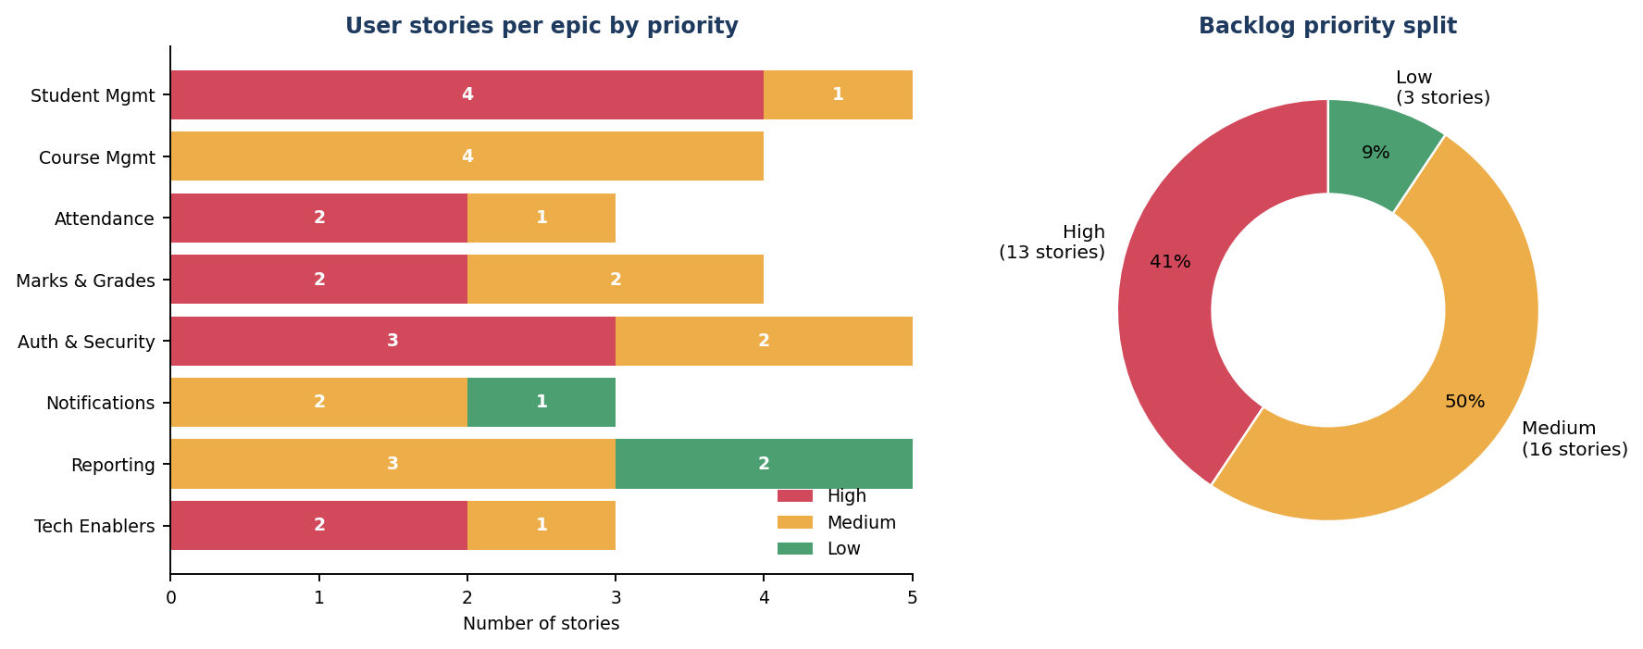
Figure 5: Product backlog composition by epic and priority
High-priority stories form the foundation (authentication, student management and attendance recording). Medium stories complete the academic workflow, and low-priority stories such as the analytics dashboard are scheduled last, supporting incremental delivery: the system is usable after Release 1 even though many features are still to come.

9. Story Point Estimation
Story points measure the relative effort, complexity and uncertainty of a story rather than hours. The team uses a modified Fibonacci scale and estimates collaboratively with Planning Poker, so that the whole team shares one understanding of each story.
Table 20: Estimation scale
Story points | Complexity | Typical example in SRAMP
1 | Very easy | Logout
2 | Easy | Update course, view course details
3 | Moderate | Profile management, add course, view attendance
5 | Difficult | Login, search student, assign students to course
8 | Very difficult | RBAC, record attendance, result sheets, analytics dashboard
13 | Highly complex | Not used: any 13-point story is split before entering a sprint

9.1 Planning Poker Sessions
Each estimator privately selects a card, all cards are revealed together, and the highest and lowest estimators explain their reasoning. The round is repeated until the team converges. Sample sessions are shown below.
Table 21: Planning Poker results (selected stories)
Story | Backend | Frontend | QA | SM | Round 1 spread | Agreed | Reason for discussion
US-04 Logout | 1 | 1 | 1 | 2 | 1 – 2 | 1 | Session invalidation is simple
US-03 Login | 3 | 5 | 5 | 8 | 3 – 8 | 5 | JWT, error handling and redirect added
US-09 Search Student | 5 | 3 | 5 | 5 | 3 – 5 | 5 | Filters and pagination in backend
US-06 RBAC | 8 | 5 | 13 | 8 | 5 – 13 | 8 | Permission checks on every endpoint
US-16 Record Attendance | 5 | 8 | 8 | 13 | 5 – 13 | 8 | Duplicate-lecture rule and bulk marking
US-31 Analytics Dashboard | 8 | 13 | 8 | 8 | 8 – 13 | 8 | Charts reuse existing report queries
Round-1 votes are shown; every story reached consensus in round 2.

9.2 Story Point Estimation Sheet
Table 22: Estimation sheet – stories grouped by story points
Points | Complexity | Stories | Count | Total
1 | Very easy | 04 | 1 | 1
2 | Easy | 14, 19 | 2 | 4
3 | Moderate | 01, 02, 05, 08, 10, 11, 13, 17, 21, 25, 26, 30 | 12 | 36
5 | Difficult | 03, 07, 09, 12, 15, 18, 20, 22, 24, 27, 28, 29, 32 | 13 | 65
8 | Very difficult | 06, 16, 23, 31 | 4 | 32
13 | Highly complex | – | 0 | 0
 | Total |  | 32 | 138
Story IDs are shown without the "US-" prefix. The per-story estimate also appears in the backlog (Section 8).
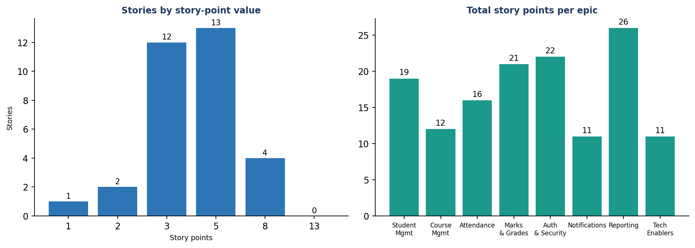
Figure 6: Distribution of story points by value and by epic

10. Sprint Planning and Sprint Backlogs
The backlog of 138 points is organised into six sprints. The planned velocity is about 23 points per sprint, which is realistic for four part-time members. Each sprint has a goal, a sprint backlog and expected deliverables; sprint goals follow the dependency order of the product (foundation, then core records, then academic features, then communication and reporting).

Sprint 1 – Develop user authentication and project setup
Item | Details
Duration / planned points | Weeks 1–2 | 23 story points | 6 stories
Sprint goal | Develop user authentication and project setup.
Activities | - Repository initialisation and CI pipeline.  - User registration, login and logout.  - Role-based access control.  - Basic user interface and navigation shell.  - Testing of authentication flows.
Sprint backlog | - US-01 Repository and CI Pipeline Setup (3)  - US-02 User Registration (3)  - US-03 User Login (5)  - US-04 User Logout (1)  - US-05 Basic UI and Navigation Shell (3)  - US-06 Role-Based Access Control (8)
Expected deliverable | Running application with secure login for all roles; green CI pipeline.

Sprint 2 – Develop the Student Management module
Item | Details
Duration / planned points | Weeks 3–4 | 24 story points | 6 stories
Sprint goal | Develop the Student Management module.
Activities | - Add Student and student profile.  - Search Student with filters.  - Update and delete (soft delete) Student.  - Password reset by email.  - Carry-over of any unfinished Sprint 1 work.
Sprint backlog | - US-07 Student Registration (5)  - US-08 Student Profile Management (3)  - US-09 Student Search (5)  - US-10 Student Update (3)  - US-11 Student Deletion (3)  - US-12 Password Reset (5)
Expected deliverable | Complete student CRUD and search; password reset.

Sprint 3 – Develop Course and Attendance Management (MVP complete)
Item | Details
Duration / planned points | Weeks 5–6 | 26 story points | 6 stories
Sprint goal | Develop Course and Attendance Management (MVP complete).
Activities | - Add and update Course.  - Assign courses and enrol students.  - Record and view attendance.  - Attendance reports.  - MVP regression test and demo.
Sprint backlog | - US-13 Add Course (3)  - US-14 Update Course (2)  - US-15 Assign Students to Course (5)  - US-16 Record Attendance (8)  - US-17 View Attendance (3)  - US-18 Attendance Reports (5)
Expected deliverable | Release 1 – MVP: authentication, students, courses and attendance.

Sprint 4 – Develop Marks and Academic Performance
Item | Details
Duration / planned points | Weeks 7–8 | 23 story points | 5 stories
Sprint goal | Develop Marks and Academic Performance.
Activities | - View course details.  - Enter and update marks.  - Calculate grades and SGPA.  - Generate result sheets.  - Carry-over of Sprint 3 story US-14.
Sprint backlog | - US-19 View Course Details (2)  - US-20 Enter Marks (5)  - US-21 Update Marks (3)  - US-22 Calculate Grades (5)  - US-23 Generate Result Sheets (8)
Expected deliverable | Release 2 – marks, grading and result sheets.

Sprint 5 – Develop Notifications and core reports
Item | Details
Duration / planned points | Weeks 9–10 | 21 story points | 5 stories
Sprint goal | Develop Notifications and core reports.
Activities | - Attendance alerts.  - Examination and result notifications.  - Student reports.  - Performance reports.
Sprint backlog | - US-24 Attendance Alerts (5)  - US-25 Examination Notifications (3)  - US-26 Result Notifications (3)  - US-27 Student Reports (5)  - US-28 Performance Reports (5)
Expected deliverable | Automated notifications; student and performance reports.

Sprint 6 – Analytics, hardening and final release
Item | Details
Duration / planned points | Weeks 11–12 | 21 story points | 4 stories
Sprint goal | Analytics, hardening and final release.
Activities | - Attendance summary and course reports.  - Academic analytics dashboard.  - Containerised deployment and release pipeline.  - Performance, security and regression testing.
Sprint backlog | - US-29 Attendance Summary Report (5)  - US-30 Course Reports (3)  - US-31 Academic Analytics Dashboard (8)  - US-32 Containerised Deployment and Release Pipeline (5)
Expected deliverable | Release 3 – final product, deployed and monitored.

11. Scrum Board
The Scrum board makes the work visible. SRAMP uses a five-column board (GitHub Projects), updated during the Daily Scrum. A card moves left to right: Product Backlog → To Do → In Progress → Testing → Completed. A story reaches Completed only when it satisfies its acceptance criteria and the Definition of Done.
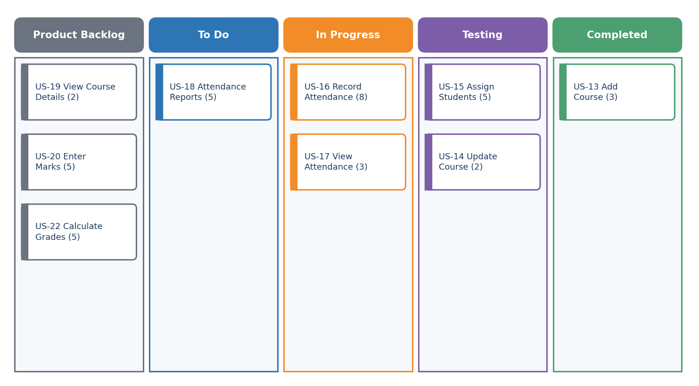
Figure 7: Scrum board snapshot – Sprint 3, day 6 (illustrative)
Table 23: Board columns and rules
Column | Meaning | Work-in-progress rule
Product Backlog | Prioritised stories not yet selected for the sprint | Top 10 items are refined and estimated
To Do | Stories committed in Sprint Planning and not started | Pulled in priority order
In Progress | Stories currently being developed | Maximum 2 stories per developer
Testing | Development finished; verification against acceptance criteria | Tester picks the oldest card first
Completed | Done as per Definition of Done and accepted by the Product Owner | Counted in velocity and burndown

In the snapshot above, Sprint 3 has 26 points committed: 3 points are Completed, 7 are in Testing, 11 are In Progress and 5 are still To Do. The three cards in the Product Backlog column are the next candidates for Sprint 4.

12. Scrum Ceremonies
Note on the sample data
The ceremony records, burndown and velocity figures in Sections 12 and 13 are an illustrative simulation prepared for this academic mini-project. They demonstrate how Scrum artefacts are produced and read; they are not measurements from a production team.

Table 24: Scrum events and time-boxes (2-week sprint)
Event | Time-box | Purpose | Output
Sprint Planning | Up to 4 hours | Select stories, estimate and agree the Sprint Goal | Sprint Backlog
Daily Scrum | 15 minutes | Synchronise and plan the next 24 hours | Updated board
Sprint Review | 1.5 hours | Demonstrate the increment and collect feedback | Review report; updated backlog
Sprint Retrospective | 1 hour | Inspect the way of working and improve | Retrospective report; action items

12.1 Sprint Planning (Sprint 3 example)
- Select user stories: the Product Owner presented the top backlog items; the team selected US-13 to US-18 (course and attendance stories).
- Estimate effort: estimates were confirmed by Planning Poker; the total of 26 points was compared with the average velocity of 23 and accepted because Sprint 2 had completed 27.
- Define the Sprint Goal: "Develop Course and Attendance Management so that Release 1 (MVP) can be demonstrated."
- Tasking: each story was split into tasks (API, UI, tests) and assigned during the meeting.

12.2 Daily Scrum (Sprint 3, day 4)
Each member answers three questions: What did I complete yesterday? What will I do today? What challenges am I facing?
Table 25: Daily Scrum record
Member | Yesterday | Today | Challenges
Product Owner | Clarified attendance rules (75% threshold) with faculty | Review US-13 and US-15 in Testing | Waiting for sample course data from the department
Scrum Master | Fixed CI cache problem; updated board | Set up staging deployment of Sprint 3 build | Slow pipeline on large test suite
Developer (backend) | Completed Add Course API and tests | Start Assign Students API | Duplicate enrolment rule needs a DB constraint
Developer (frontend/QA) | Built course form; wrote test cases for US-13 | Build attendance sheet UI (US-16) | Needs final API contract for attendance

12.3 Sprint Review Report (Sprint 3)
Table 26: Sprint Review report
Item | Details
Sprint goal | Develop Course and Attendance Management (MVP complete).
Planned / completed | 26 points planned; 24 points completed (92%).
Features demonstrated | - Add course and assign students (single and CSV bulk).  - Record attendance for a lecture and prevent duplicate entry.  - View attendance with course-wise percentage.  - Attendance report export to PDF/CSV.
Stakeholder feedback | - Faculty asked for a "mark all present" shortcut.  - Add the lecture topic to the attendance sheet.  - Highlight attendance below 75% in red.
Accepted by Product Owner | US-13, US-15, US-16, US-17, US-18 accepted.
Not accepted / carry-over | US-14 Update Course (2 points): validation defect found in testing; moved to Sprint 4.
Backlog changes | New story added: "Mark all present" shortcut (2 points, Medium) – to be estimated in Sprint 4 planning.

12.4 Sprint Retrospective Report (Sprint 3)
Table 27: Sprint Retrospective report
What went well | Challenges | Improvements (action items)
- Early API contract reduced rework.  - Planning Poker produced accurate estimates.  - CI caught two regression bugs before review.  - Daily Scrum stayed within 15 minutes. | - Test data arrived late.  - One story failed in testing at the end of the sprint.  - Pipeline run time increased to 12 minutes. | - Prepare test data in a shared seed script – Developer, Sprint 4.  - Test stories as soon as they reach Testing, not at sprint end – QA.  - Cache dependencies in CI – Scrum Master.  - Refine next-sprint stories one week earlier – Product Owner.

13. Burndown Chart and Velocity
A burndown chart plots the work remaining against time. The ideal line falls steadily to zero; the actual line shows real progress. A flat segment means no story was completed that day, because points are burned down only when a story is Done.
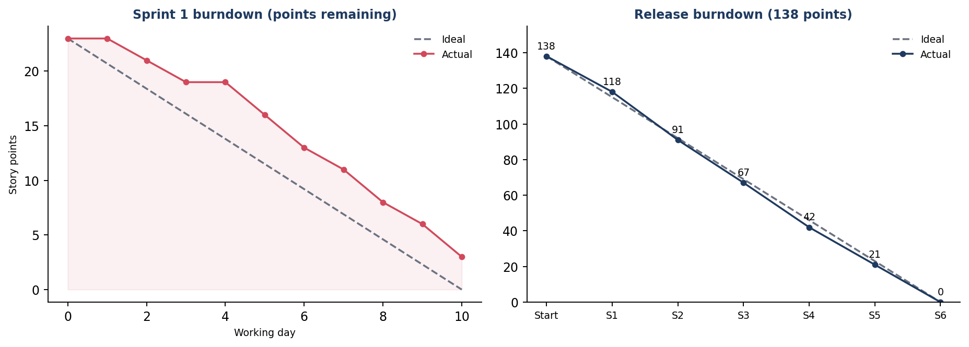
Figure 8: Sprint 1 burndown (left) and release burndown for 138 story points (right)
In Sprint 1 the actual line stays above the ideal line during the first week because the CI pipeline and repository setup took longer than estimated, then recovers; US-05 (3 points) is carried to Sprint 2. The release burndown ends at zero after Sprint 6, so the full backlog is delivered in 12 weeks.
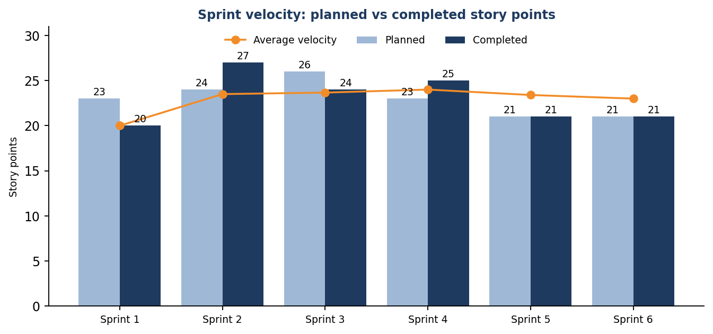
Figure 9: Planned versus completed story points per sprint
Table 28: Sprint summary
Sprint | Planned | Completed | Carry-over / catch-up | Remaining after sprint
Sprint 1 | 23 | 20 | US-05 (3) carried to S2 | 118
Sprint 2 | 24 | 27 | Includes 3-point carry-over from S1 | 91
Sprint 3 | 26 | 24 | US-14 (2) carried to S4 | 67
Sprint 4 | 23 | 25 | Includes 2-point carry-over from S3 | 42
Sprint 5 | 21 | 21 | – | 21
Sprint 6 | 21 | 21 | – | 0

The average velocity of 23 points per sprint matches the plan. Velocity is used only for forecasting; it is not a measure of individual performance.

14. Agile Framework Comparison
Several Agile frameworks exist, differing in team size, rules and scale. The frameworks introduced in the syllabus are compared below for the needs of SRAMP: a single product, a small team and a fixed 12-week duration.
Table 29: Comparison of Agile frameworks
Framework | Core idea | Best suited for | Fit for SRAMP
Scrum | Time-boxed sprints, defined roles, events and artefacts | One team (3–9 people) building a product iteratively | Excellent – matches size and need for regular feedback
Kanban | Visualise flow, limit work in progress, continuous delivery | Support, maintenance and variable-priority work | Good for the board; no sprint cadence or planning structure
Extreme Programming (XP) | Engineering practices: TDD, pair programming, CI, refactoring | Teams needing high technical quality | Use its practices (CI, tests, reviews) inside Scrum
Lean Development | Eliminate waste, deliver fast, empower the team | Cost- and waste-sensitive organisations | Useful principles; lacks concrete ceremonies
LeSS | Scrum scaled to many teams with one Product Owner | 2–8 teams on one product | Overkill for one team
SAFe | Enterprise-scale framework with release trains and portfolio layers | Large organisations with many teams | Too heavy for a four-member project
Scrum@Scale | Network of Scrum teams with scaled Scrum Master and Product Owner cycles | Scaling Scrum across many teams | Not required at this size

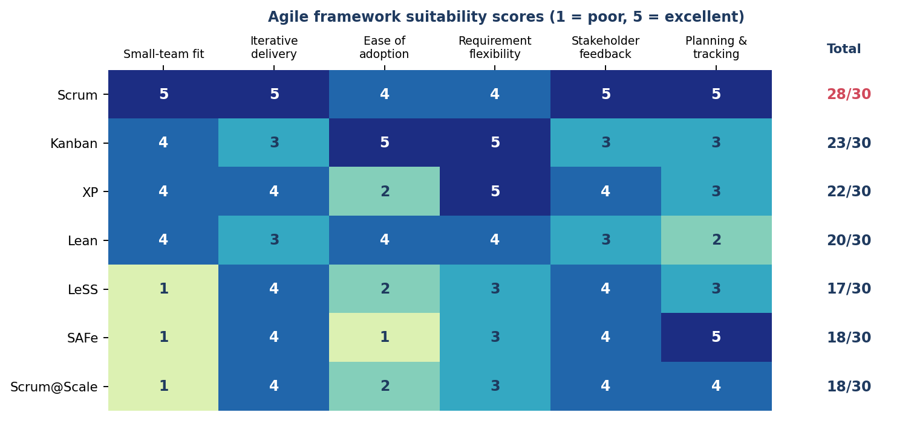
Figure 10: Framework suitability scoring for SRAMP
Recommendation: Scrum, enriched with Kanban visualisation and XP engineering practices
Why Scrum: SRAMP has one product, one small team and requirements that need frequent stakeholder feedback. Two-week sprints give a working increment and a review point every fortnight.
Why not a scaled framework: LeSS, SAFe and Scrum@Scale coordinate many teams; with four members they add overhead without benefit.
What is borrowed: Kanban's work-in-progress limits and board for visibility; XP's continuous integration, automated testing and code review, which also support the DevOps pipeline of this course.

15. Project Timeline and Release Roadmap
The roadmap shows when each epic is delivered and when the three planned releases occur. Release 1 (MVP) is ready at the end of Week 6, giving stakeholders early value and an opportunity to correct direction.
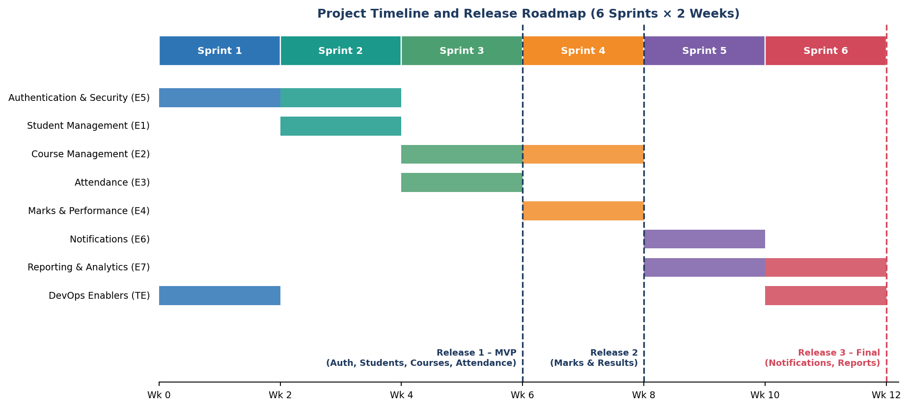
Figure 11: Project timeline and release roadmap (12 weeks)
Table 30: Release plan
Release | End of | Contents | Success check
Release 1 – MVP | Sprint 3 (Week 6) | Login and RBAC, student management and search, courses, attendance and attendance reports | Pilot with one department; faculty can record attendance
Release 2 | Sprint 4 (Week 8) | Marks entry, grade/SGPA calculation, result sheets, course detail view | Exam cell generates a sample result sheet
Release 3 – Final | Sprint 6 (Week 12) | Notifications, student/performance/attendance/course reports, analytics dashboard, containerised deployment | All acceptance criteria met; deployment pipeline works

16. DevOps Integration with Agile
Agile decides what is built in each sprint; DevOps decides how it is built, tested and delivered safely and repeatedly. Because every sprint must end with a potentially shippable increment, the CI/CD pipeline is set up in Sprint 1 (US-01) and extended throughout the project.
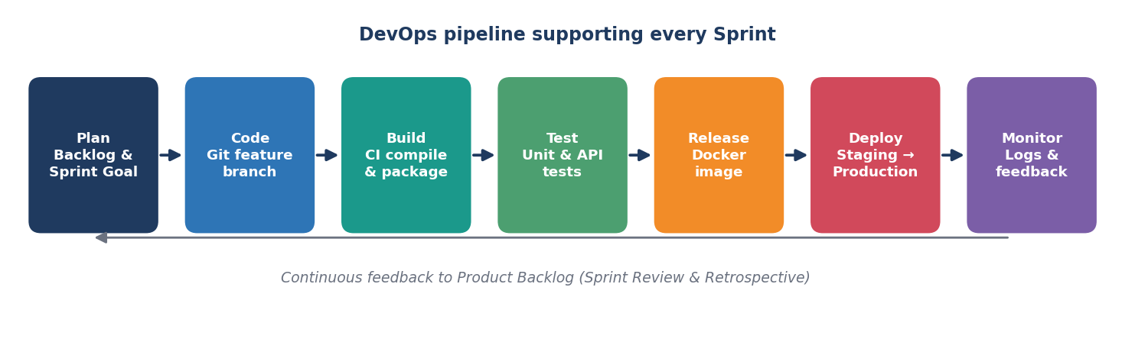
Figure 12: DevOps pipeline supporting every sprint
Table 31: Scrum events and the corresponding DevOps practices
Scrum element | DevOps practice
Sprint Planning | Stories linked to GitHub issues; feature branches created per story
Daily Scrum | Pipeline status and failed builds are discussed first
Development | Pull requests, code review, automated unit and API tests on every push
Definition of Done | Green pipeline, test coverage report and security scan before merge
Sprint Review | Increment deployed automatically to a staging environment for the demo
Retrospective | Pipeline metrics (build time, failure rate) reviewed for improvement
Release | Docker image built and tagged; production deployment after Product Owner approval; rollback available

Branching follows a simple model: short-lived feature branches (named feature/story-id) are merged into the develop branch through pull requests; develop is merged into main at the end of each release. Later units extend this foundation with Terraform, Ansible, Kubernetes and monitoring.

17. Risk Register, Conclusion and Deliverables

17.1 Risk Register
Table 32: Project risks and mitigation
ID | Risk | Probability | Impact | Mitigation
R1 | Requirements change late in the project | Medium | High | Short sprints; backlog refinement each sprint; PO available to the team
R2 | Team member unavailable due to exams or illness | Medium | Medium | Cross-training; buffer of 10% in sprint capacity
R3 | Complex stories (RBAC, result sheets) underestimated | Medium | High | Planning Poker; split stories larger than 8 points; spike if needed
R4 | Security or privacy weakness in student data | Low | High | Role checks, hashing, HTTPS, dummy data in development, security review
R5 | Email notification service unreliable | Medium | Low | Queue with retry; in-app notification as fallback
R6 | CI/CD pipeline failures block delivery | Low | Medium | Pipeline owned by Scrum Master; simple, documented configuration

17.2 Conclusion
This report has translated the product discovery of SRAMP into a complete Agile plan: a measurable product vision, a Scrum team with clear roles, seven epics, 32 user stories with acceptance criteria, a prioritised and estimated backlog of 138 story points, six sprint plans, a Scrum board, ceremony records, burndown tracking, a justified framework choice (Scrum with Kanban and XP practices) and a 12-week release roadmap. The plan is deliberately aligned with the DevOps pipeline so that each sprint produces a tested, deployable increment. The next step is to begin Sprint 1 by initialising the repository and CI pipeline.

