def pangram(str1):
for i in str1:
if i in "abcdefghijklmnopqrstuvwxyz":
return True

str1="The quick brown fox jumps over the lazy dog"
pangram(str1)
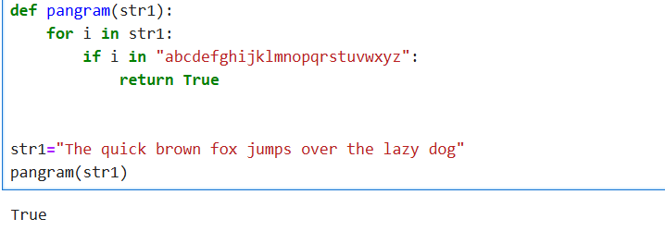

num = int(input("enter a number :"))
total = 0

while num>0:
rem = num%10
total+=rem
num=num//10

print(total)

a = int(input("enter a number"))
b = int(input("enter a number"))
c = int(input("enter a number "))

ls1 = sorted(list([a,b,c]))
print(ls1)
def perfect_num(n):
totall = 0

for i in range(1, n // 2 + 1):
if n % i == 0:
totall += i

if totall == n:
print(f"{n} is a perfect number")
else:
print(f"{n} is not a perfect number")

perfect_num(6)
perfect_num(28)
perfect_num(12)
