Project Requirement and Specification on

**Online Auction System**

CSE VI Semester Mini Project

2020-21



**Submitted By**

Himanshu Negi

University Roll: 2015167

Section: DS

Department on Computer Science and Engineering

About Project

The project “Online auction management system” is a smart management system for conducting auctions online securely and with ease. The project itself has been created on a Python framework called ‘Django’ that provides an easy MVT implementation for creating applications. The project also integrates a recommender system that can be used to provide similar item recommendations to the people based on their interaction with the website, hence providing an easy, flexible, and taste-based experience to the users.

The project has been made modular to meet the client’s requirements and hence make changes to the code whenever necessary.

Requirements

* Web Interface
  + Web Browser and an internet connection
  + Runnable at [this link](http://bot7037.pythonanywhere.com/)
* Local Environment
  + Python 3.x
  + Virtual environment setup
  + Django 4.x
  + Web Browser
  + Runnable at localhost:3000

Modules of the Project

* User console
  + Setup new item for auction
  + Update item description
  + Set bidding amount
  + Remove items
* Admin console
  + View the database
  + Interact with database directly
  + Remove and insert new items without the user console interaction
  + View all users currently registered
  + Add/Remove users
  + Grant/Revoke permissions from users

Backend Architecture

The database consists of 3 noticeable tables

Users

|  |  |
| --- | --- |
| Attribute | Type |
| Username | Varchar |
| Password | Password |
| First Name | Varchar |
| Last Name | Varchar |
| Email Address | Email |
| Active User | Boolean |
| Staff Status | Boolean |
| Superuser Status | Boolean |

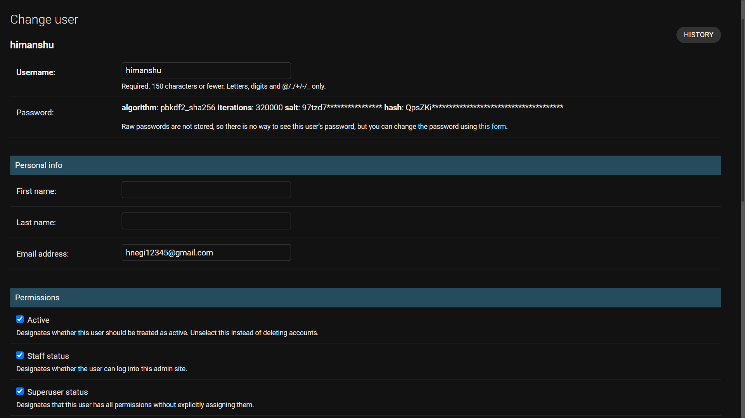

Auctions

|  |  |
| --- | --- |
| Attribute | Type |
| Author | Varchar |
| Title | Varchar |
| Description | Varchar |
| Image | File |
| Min Value | Integer |
| Date Added | DateTime |
| Is Active | Boolean |
| Winner | <Users> Item |
| Final Value | Integer |

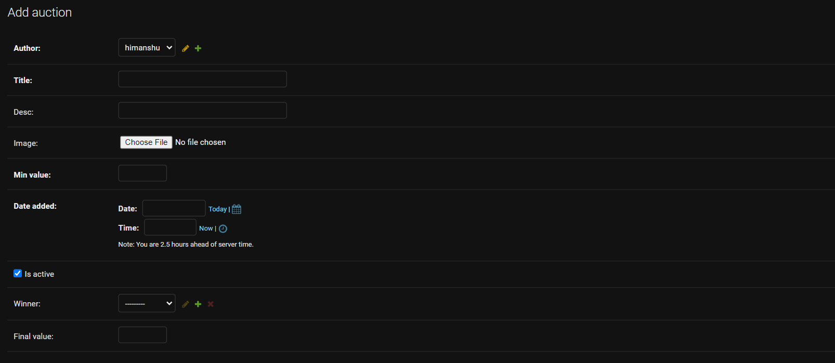

Bids

|  |  |
| --- | --- |
| Attribute | Type |
| Bidder | <User> Item |
| Auction | <Auction> Item |
| Amount | Integer |
| When | DateTime |

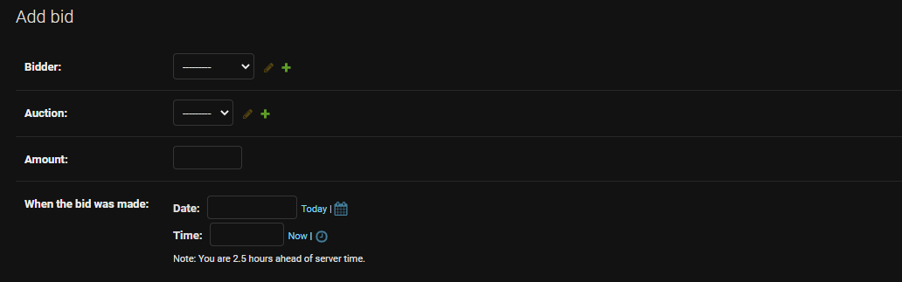

**Database Design**

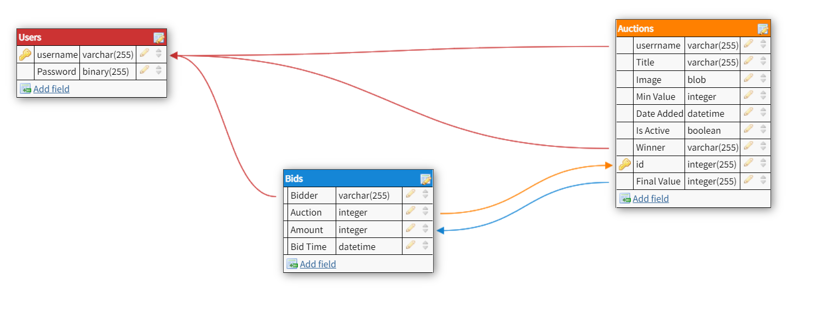

References

<https://docs.djangoproject.com/en/4.0/>

<https://app.sqldbm.com/>