Made by Raju
Date 21-08-25

APB_UART
Design: cmsdk_apb_uart.v
Testbench: apb_uart_tb.sv

1. Project Overview
The project involves the verification of a UART module interfaced with an APB bus. The goal is to ensure correct communication between the APB master and the UART module, proper baud rate generation, and overall functional coverage.
Key Components:
- DUT (Design Under Test): cmsdk_apb_uart.v
- Testbench: apb_uart_tb.sv
- Interfaces:
  - APB interface (master-slave communication)
  - UART TX/RX interface

2. Issues Faced During Verification (Cleaned)

Issue 1: Register Address Configuration
Problem: Register addresses were misaligned ([11:2] vs byte addresses).
Solution: Use word-aligned addresses with localparam for each register:
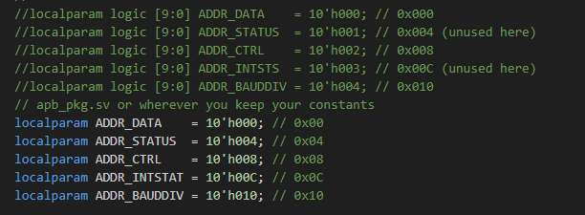

Issue 2: BAUDTICK Not Toggling
Problem: The baud rate clock (BAUDTICK) did not toggle.
Solution:
- Ensure BAUDDIV is written correctly via APB after reset.
- Verify the system clock driving the UART is active.
- Check that no reset or gating logic prevents BAUDTICK toggling.

Issue 3: Synchronization between APB Agent and UART Agent
Problem: APB write could happen while UART TX/RX was in progress, causing race conditions.
Solution: Implement handshaking or wait mechanisms between the agents:
@(posedge apb_pready); // Wait for APB transaction to complete

Issue 4: Simulation Hanging
Problem: Testbench stalled during some test cases.
Solution:
- Initialize all signals properly.
- Ensure sequences/tasks complete and do not block indefinitely.
- Apply a proper reset at simulation start:
initial begin
reset_n = 0;
#100 reset_n = 1;
end

Issue 5: Unable to See All Signals
Problem: Some DUT or TB signals were not visible in the waveform viewer.
Solution:
- Enable hierarchical logging in .do file:
- Adding the switch : -voptargs=+acc tb_name
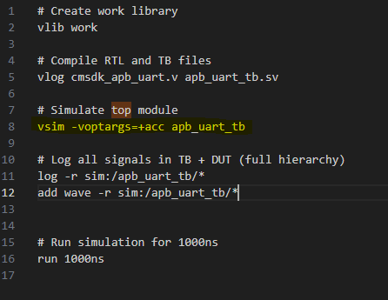

Issue 6: Incorrect Reset Behaviour
Problem: UART did not initialize correctly on reset.
Solution:
- Ensure active-low or active-high reset matches DUT.
- Reset all registers to default values as per specification.

Issue 7: Incorrect APB Timing/Protocol
Problem: APB transactions failed due to incorrect PSEL, PENABLE, or PWRITE sequence.
Solution:
- Follow APB timing diagram strictly:
1. Assert PSEL
2. Assert PENABLE
3. Apply PWRITE/PADDR/PWDATA
4. Wait for PREADY
5. Deassert PSEL/PENABLE
- Add checks in the APB driver to enforce correct handshaking.

Issue 8: Data Corruption during RX/TX
Problem: Received data did not match transmitted data.
Solution:
- Ensure TX and RX clocks are synchronized or use proper asynchronous handling.
- Verify baud rates match between transmitting and receiving ends.

Issue 9: APB Transactions during Clock Domain Crossing
Problem: APB writes occurred when UART logic was in a different clock domain, causing metastability.
Solution:
- Synchronize signals using multi-flop synchronizers.
- Use proper handshake mechanisms for safe clock domain crossing.

