UART – APB design Verification plan

Title
UART – APB design Verification plan
File Name
cmsdk_apb_uart.v
Author
Raju Gupta
Created On
04-08-2025

- DUT Overview

Description
This document describes the implementation and verification of a simplified UART RTL design based on the AMBA APB interface. The module cmsdk_apb_uart implements a serial communication interface that supports:
- 8-bit UART transmission and reception
- Programmable baud rate via a 20-bit baud divider register BAUDIV
- Generation and clearing of multiple interrupts: TXINT, RXINT, TXOVRINT, RXOVRINT, and UARTINT
- High-speed test mode operation for simulation acceleration
- Compliance with APB3 register protocol for integration in AMBA-based SoCs
- TX and RX logic managed by FSMs with tick-based state transitions

5

2. Interface Overview

APB Interface Signals
Inputs:
- PCLK: Clock signal for APB operations
- PRESETn: Active-low reset
- PSEL: APB peripheral select
- PENABLE: APB enable phase
- PWRITE: Indicates write (1) or read (0)
- PADDR[11:2]: Register address (word-aligned)
- PWDATA[31:0]: Write data from APB master

Outputs:
- PRDATA[31:0]: Data read from UART registers

UART Serial Interface Signals
Input:
- RXD: UART receive data line (serial input)
Outputs:
- TXD: UART transmit data line (serial output)
- TXINT: Transmit interrupt (TX buffer ready)
- RXINT: Receive interrupt (byte received)
- TXOVRINT: TX overrun interrupt
- RXOVRINT: RX overrun interrupt
- UARTINT: Combined interrupt signal (logical OR of all UART interrupts)
Note: RXD input is passed through a double flip-flop synchronizer in the DUT. Monitors should account for one PCLK cycle latency when validating RX state transitions.

3. Internal Architecture

FSMs
Two finite state machines (FSMs) control UART transmission and reception:
- Transmit FSM
- States: IDLE, START, DATA0–DATA7, STOP
- Transitions: Driven by TX enable, baud tick, and TX buffer status
- Receive FSM
- States: IDLE, START DETECT, DATA0–DATA7, STOP
- Transitions: Based on RXD edge detection and tick count sampling

Registers and Logic
- reg_tx_buf, reg_rx_buf: 8-bit transmit and receive buffers
- reg_ctrl[6:0]: Control register (TX/RX enable, INT enable, test mode)
- reg_status[3:0]: Status register (TXFULL, RXFULL, overruns)
- reg_baud_div[19:0]: Baud rate divider register
- reg_baud_cntr_i/f: Integer and fractional tick counters
- tx_shift_buf: 8-bit shift register for serial TX
- rx_sample_buf: Captures incoming RXD bits for assembly
- tx_state, rx_state: FSM state registers
- reg_tx_overrun, reg_rx_overrun: Error flags for TX and RX buffer overruns

Protocol Compliance

Supported Features
- Full-duplex 8-bit UART communication (TX and RX)
- Standard UART 1 start bit + 8 data bits + 1 stop bit format
- Configurable baud rate using 20-bit BAUDDIV register
- APB3-compliant register interface
- Individual interrupt generation: TXINT, RXINT, TXOVRINT, RXOVRINT
- Combined interrupt output: UARTINT
- High-speed test mode for simulation acceleration

Unsupported Features
- Parity bit and framing configuration
- Hardware flow control (RTS/CTS)
- Break condition and loopback modes
- FIFO buffering or DMA integration (not implemented in RTL)

4. Verification Objectives
- Verify full APB register access including read/write/INTCLEAR behavior
- Validate UART TX and RX logic for both functional and timing correctness
- Verify UART interrupt logic under normal and corner-case scenarios
- Test overruns and framing error conditions with assertions
- Validate baud tick timing under normal and high-speed mode
- Confirm FSM transitions and state legality in TX and RX datapaths
- Achieve 100% functional, code, and FSM coverage
- Integrate assertions for protocol rule checks
- Ensure reusability in subsystem/full-chip environment
- Validate baud rate configuration using BAUDDIV = PCLK / Baud
- Ensure system can handle UART interrupt timing at high speeds (e.g., 115200 baud)

5. Verification Environment Components
- APB Agent: Drives and sequences APB read/write transactions to configure the UART registers.
- UART Driver: Sends serial data to the DUT by driving RXD with valid UART frames.
- UART Monitor: Observes TXD to reconstruct and check transmitted UART bytes.
- Register Model (RAL): Maintains a mirrored view of UART registers and verifies APB accesses.
- Scoreboard: Compares expected and actual data from TXD, RX buffer, and registers.
- Virtual Sequencer: Coordinates APB and UART sequences to ensure proper flow.
- Coverage Collector: Tracks functional, code, FSM, and toggle coverage for completeness.
- Clock/Reset Generator: Provides PCLK and PRESETn signals to the DUT and interfaces.

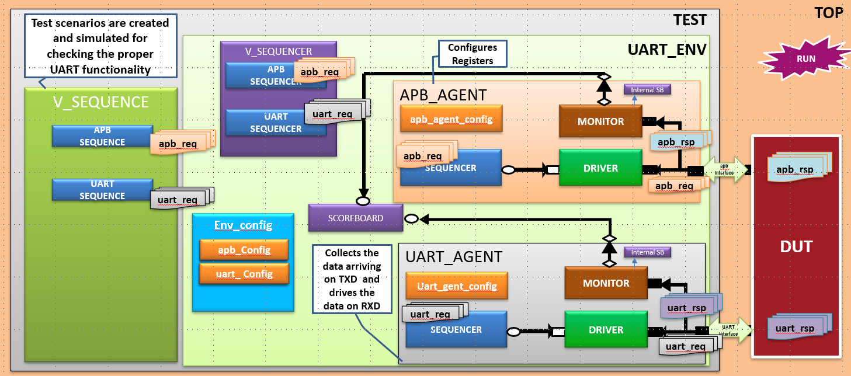

6. Functional Testcases
TC No. | Testcase Name | Description
TC01 | UART Soft Reset | Apply reset and check all internal registers and outputs
TC02 | Basic TX Transmission | Write 1 byte to TX buffer. Ensure TXD outputs start bit, 8 data bits (LSB first), and stop bit.
TC03 | Basic RX Reception | Send a UART frame (start + 8 data bits + stop) on RXD and verify RX buffer gets updated.
TC04 | Transmit Buffer Full Handling | Write multiple bytes to TX buffer until tx_buf_full is asserted.
TC05 | Receive Buffer Full Handling | Send two back-to-back UART frames without reading the first. Verify rx_buf_full and overrun.
TC06 | TX Overrun Interrupt | Write to TX buffer when it’s full. Confirm TXOVRINT is raised.
TC07 | RX Overrun Interrupt | Simulate RX overrun by sending two frames quickly. Verify RXOVRINT.
TC08 | Interrupt Enable/Disable | Enable/disable TXINT and RXINT via control reg. Verify only enabled interrupts are triggered.
TC09 | INTCLEAR Operation | Write to INTCLEAR register. Confirm TXINT/RXINT/OVRINT are cleared.
TC10 | Status Register Read | Check status register bits (tx_buf_full, rx_buf_full, etc.) match internal states.
TC11 | Baud Rate Programming (Integer only) | Write a valid baud divider value (≥ 16) and verify reload_i pulses every N cycles.
TC12 | Baud Rate Less than 16 (Illegal) | Write divider < 16 and ensure assertion or error response (as per OVL).
TC13 | Baud Rate Change During Idle | Change baud divider when TX is idle. Ensure proper reload without glitch.
TC14 | Baud Rate Change During TX | Try to change baud divider mid-transmission. Ensure it is blocked or handled cleanly.
TC15 | Read RX Buffer | Send a UART byte and read from RX register. Ensure correct value and rx_buf_full clears.
TC16 | TXINT Trigger Test | Fill TX buffer, then check TXINT is raised only when the buffer is emptied (as per spec).
TC17 | RXINT Trigger Test | Send data and verify RXINT gets raised after valid byte is received.
TC18 | High-Speed Test Mode | Enable high-speed mode (reg_ctrl[6]) and verify TX state changes in 1 cycle.
TC19 | Illegal TX/RX States Check (FSM) | Force illegal FSM states (rx_state=0xB-0xF, tx_state=0xC-0xF) and verify assertions.
TC20 | INTCLEAR Byte-Wise Write | Write only bit [1] or bit [0] of INTCLEAR and confirm selective interrupt clearing.

7. Assertions
Description: Ensures correct UART protocol operation using SystemVerilog Assertions (SVA)
- TXD Idle Check
  - Property Name: txd_idle
  - Description: TXD must be high during idle and after reset.

- RX Start Bit Detect
  - Property Name: rxd_startbit_detect
  - Description: RXD must be low to initiate start bit detection.

- TX Tick Timing
  - Property Name: tx_bit_tick_count
  - Description: Each TX bit must last exactly 16 baud ticks (unless in high-speed mode).

- RXINT Assertion
  - Property Name: rxint_enable_check
  - Description: RXINT must assert only when RX is enabled and byte is received.

- BAUDDIV Minimum Check
  - Property Name: baud_div_min_check
  - Description: BAUDDIV must be ≥ 16 when UART is active.

8. Coverage

Functional Coverage
The verification plan includes coverpoints for:
- Baud rate divider (BAUDDIV) values, including valid range and illegal configurations.
- TX buffer operations, including data values, full conditions, and TXINT/TXOVRINT generation.
- RX behavior: start bit detection, valid data reception, stop bit, framing errors, and RXINT/RXOVRINT.
- Control register (reg_ctrl) fields: TX/RX enable, interrupt enable, and test mode activation.
- INTCLEAR register access: individual interrupt clear actions.
- Status register flags: TXFULL, RXFULL, and overrun flags read by software.

Code Coverage
- Line and condition coverage of all RTL modules.
- FSM state and transition coverage for TX and RX state machines.
- Toggle coverage of control and data signals (TXD, RXD, INTs, buffer flags).
9. Additional parameters
- PCLK = 50 MHz, Baud Rate = 115200 bps
- BAUDDIV = 27, calculated as:
      - BAUDDIV = PCLK / (16 × Baud Rate)
      - BAUDDIV = 50,000,000 / (16 × 115200) ≈ 27
- 1 character = 10 bits → ~4340 PCLK cycles per character

