Lab6
Q1

#include <stdio.h>
#include <stdlib.h>
#include <string.h>
int curr = 0;
char str[100];

void S();
void T();
void TPrime();

void invalid()
{
printf("-----------------ERROR!----------------\n");
exit(0);
}

void valid()
{
printf("----------------SUCCESS!---------------\n");
exit(0);
}

/*
S→a | > | ( T )
T→ST'
T' -> ,ST' | epsi
*/

void S(){
if(str[curr] == 'a' || str[curr] == '>'){
curr++;
return;
}
else if(str[curr] == '('){
curr++;
T();
if(str[curr] == ')'){
curr++;
return;
}
else
invalid();
}
else
invalid();
}

void T(){
S();
TPrime();
}

void TPrime(){
if(str[curr] == ','){
curr++;
S();
TPrime();
}
return;
}

int main(){
printf("EnterString : \n");
scanf("%s",str);
S();
if(str[curr] == '$') valid();
else invalid();
return 0;
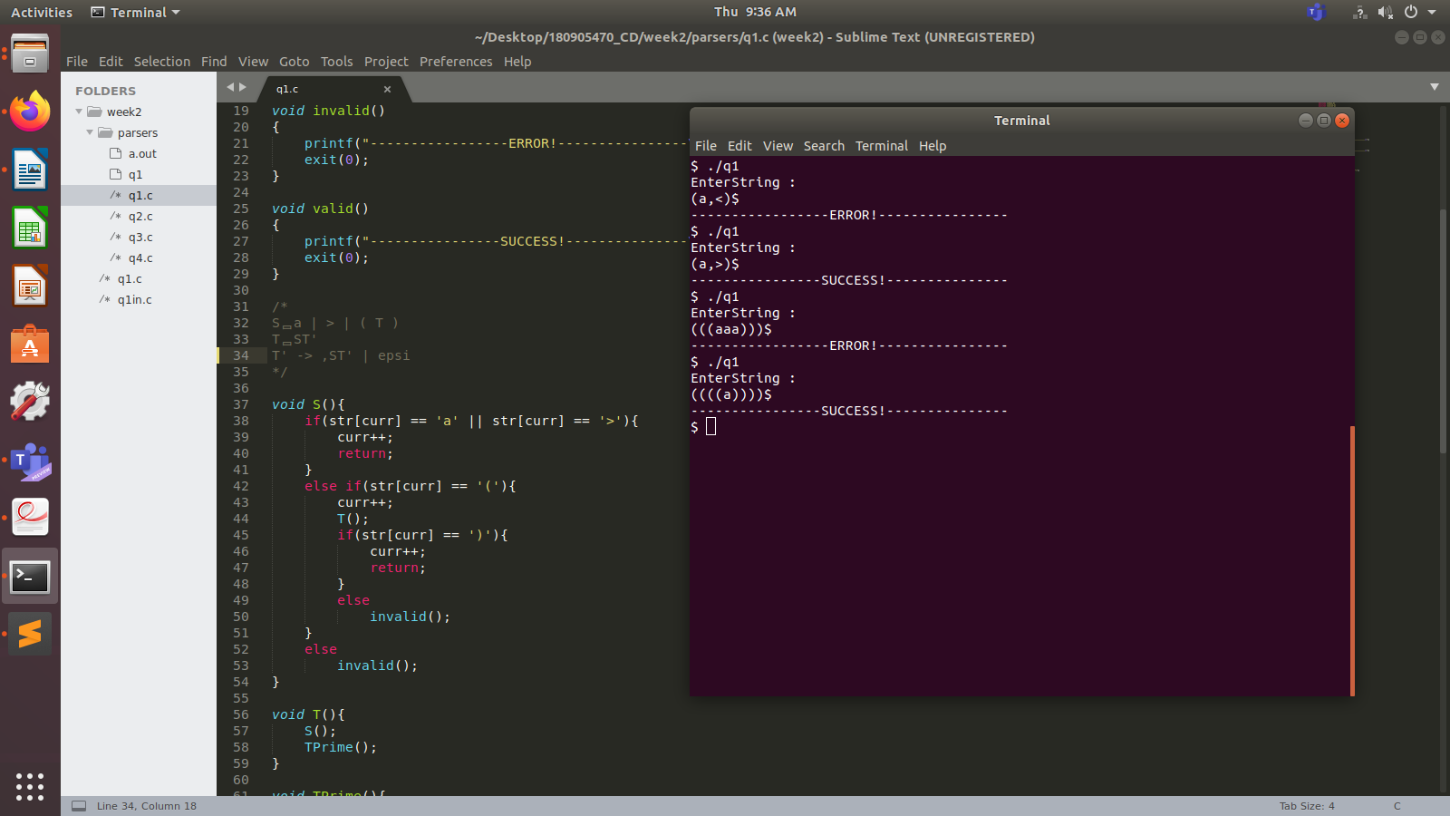
}

Q2
#include <stdio.h>
#include <stdlib.h>
#include <string.h>
int curr = 0;
char str[100];

void S();
void U();
void V();
void W();

void invalid()
{
printf("-----------------ERROR!----------------\n");
exit(0);
}

void valid()
{
printf("----------------SUCCESS!---------------\n");
exit(0);
}

/*
S→UVW
U →(S) | aSb | d
V → aV | ε
W → cW | ε
*/

void S(){
U();
V();
W();
}

void U(){
if(str[curr] == '('){
curr++;
S();
if(str[curr] == ')'){
curr++;
return;
}
else invalid();
}
else if(str[curr] == 'd') {
curr++;
return;
}
else if(str[curr] == 'a'){
curr++;
S();
if(str[curr] == 'b'){
curr++;
return;
}
else invalid();
}
else invalid();
}

void V(){
if(str[curr] == 'a'){
curr++;
V();
}
return;
}

void W(){
if(str[curr] == 'c'){
curr++;
W();
}
return;
}

int main(){
printf("EnterString : \n");
scanf("%s",str);
S();
if(str[curr] == '$') valid();
else invalid();
return 0;
}

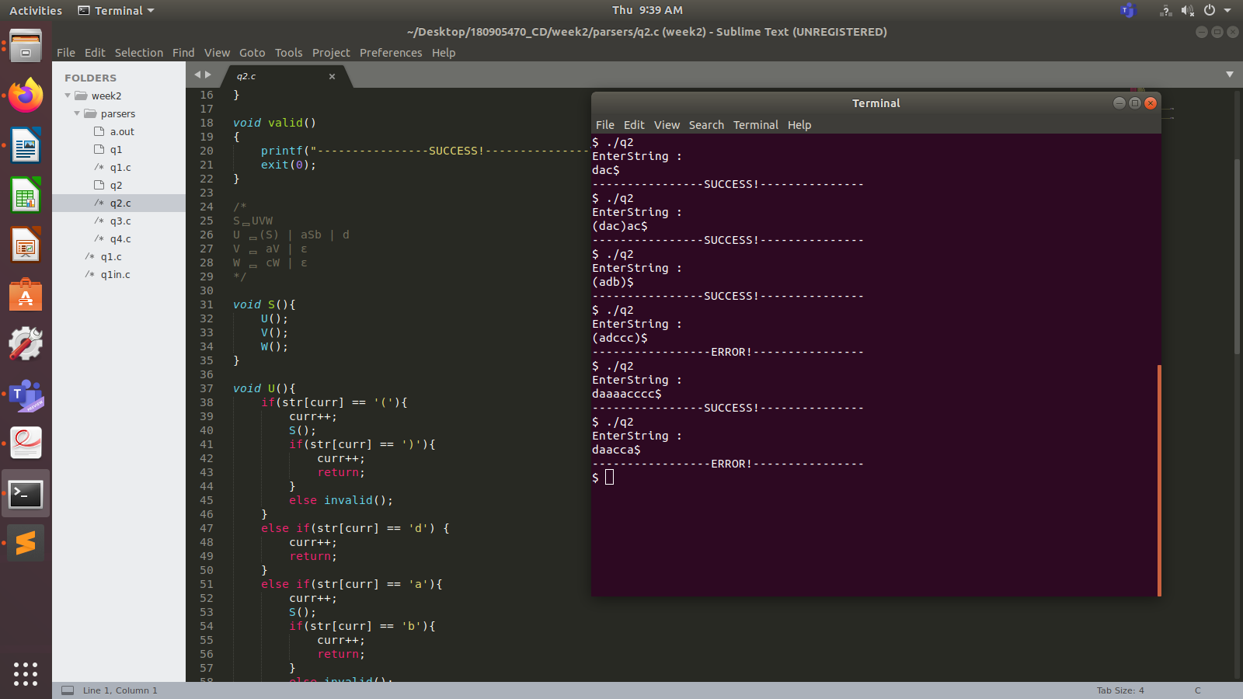

Q3
#include <stdio.h>
#include <stdlib.h>
#include <string.h>
int curr = 0;
char str[100];

void S();
void A();
void B();
void APrime();

void invalid()
{
printf("-----------------ERROR!----------------\n");
exit(0);
}

void valid()
{
printf("----------------SUCCESS!---------------\n");
exit(0);
}

/*
S→aAcBe
A-> bA'
A' -> bA' |ε
B→d
*/

void S(){
if(str[curr] == 'a'){
curr++;
A();
if(str[curr] == 'c'){
curr++;
B();
if(str[curr]=='e'){
curr++;
return;
}
else invalid();
}
else invalid();
}
else invalid();
}

void A(){
if(str[curr] == 'b'){
curr++;
APrime();
return;
}
else invalid();
}

void APrime(){
if(str[curr] == 'b'){
curr++;
APrime();
}
return;
}

void B(){
if(str[curr] == 'd'){
curr++;
return;
}
else invalid();
}

int main(){
printf("EnterString : \n");
scanf("%s",str);
S();
if(str[curr] == '$') valid();
else invalid();
return 0;
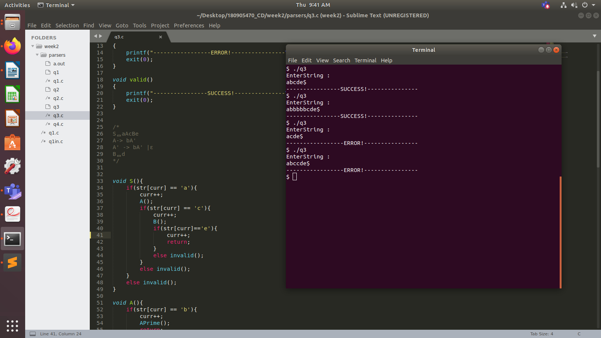
}

Q4
#include <stdio.h>
#include <stdlib.h>
#include <string.h>
int curr = 0;
char str[100];

void S();
void L();
void LPrime();

void invalid()
{
printf("-----------------ERROR!----------------\n");
exit(0);
}

void valid()
{
printf("----------------SUCCESS!---------------\n");
exit(0);
}

/*
S →(L) | a
L → SL'
L' -> ,SL' | epsilon
*/

void S(){
if(str[curr] == '('){
curr++;
L();
if(str[curr] == ')'){
curr++;
return;
}
else
invalid();
}
else if(str[curr] = 's'){
curr++;
return;
}
else
invalid();
}

void L(){
S();
LPrime();
}

void LPrime(){
if(str[curr] == ','){
curr++;
S();
LPrime();
}
return;
}

int main(){
printf("EnterString : \n");
scanf("%s",str);
S();
if(str[curr] == '$') valid();
else invalid();
return 0;



