Q1
#include <unistd.h>
#include <stdlib.h>
#include <sys/stat.h>
#include <sys/types.h>
#include <string.h>
#include <stdio.h>
#include <dirent.h>
#include <time.h>
void printdir(char *dir, int depth)
{
DIR *dp;
struct dirent *entry;
struct stat statbuf;
if((dp = opendir(dir)) == NULL){
fprintf(stderr, "Cannot Open Directory%s\n", dir);
return;
}
chdir(dir);
while((entry = readdir(dp)) != NULL){
lstat(entry -> d_name, &statbuf);

if(S_ISDIR(statbuf.st_mode)){
if(strcmp(".", entry -> d_name) ==0 || strcmp("..",entry -> d_name) ==0) continue;
printf("%*s%s \n",depth,"", entry-> d_name );
// printdir(entry -> d_name, depth+4);
}
else
printf("%*s%s\n", depth,"", entry-> d_name);

printf((statbuf.st_mode & S_IRUSR) ? "r" : "-");
printf((statbuf.st_mode & S_IWUSR) ? "w" : "-");
printf((statbuf.st_mode & S_IXUSR) ? "x" : "-");
printf((statbuf.st_mode & S_IRGRP) ? "r" : "-");
printf((statbuf.st_mode & S_IWGRP) ? "w" : "-");
printf((statbuf.st_mode & S_IXGRP) ? "x" : "-");
printf((statbuf.st_mode & S_IROTH) ? "r" : "-");
printf((statbuf.st_mode & S_IWOTH) ? "w" : "-");
printf((statbuf.st_mode & S_IXOTH) ? "x" : "-");
printf("\tLast modified time: %s", ctime(&statbuf.st_mtime));
}
chdir("..");
closedir(dp);
return;
}

int main(int argc, char const *argv[])
{
printdir(".",0);
return 0;
}

Sample I/O

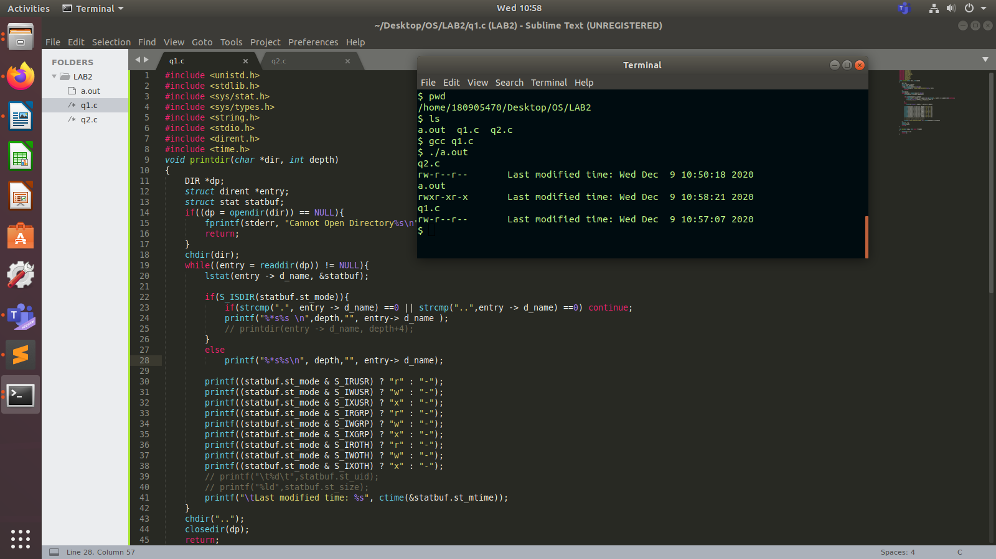

Q2
#include <unistd.h>
#include <stdlib.h>
#include <sys/stat.h>
#include <sys/types.h>
#include <string.h>
#include <stdio.h>
#include <dirent.h>
#include <time.h>
void printdir(char *dir, int depth)
{
DIR *dp;
struct dirent *entry;
struct stat statbuf;
if((dp = opendir(dir)) == NULL){
fprintf(stderr, "Cannot Open Directory%s\n", dir);
return;
}
chdir(dir);
while((entry = readdir(dp)) != NULL){
lstat(entry -> d_name, &statbuf);

if(S_ISDIR(statbuf.st_mode)){
if(strcmp(".", entry -> d_name) ==0 || strcmp("..",entry -> d_name) ==0) continue;
printf("%*s%s \n",depth,"", entry-> d_name );
printdir(entry -> d_name, depth+4);
}

else printf("%*s%s\n", depth,"", entry-> d_name);

printf("%*s",depth,"");
// printf((statbuf.st_mode & S_IRUSR) ? "r" : "-");
// printf((statbuf.st_mode & S_IWUSR) ? "w" : "-");
// printf((statbuf.st_mode & S_IXUSR) ? "x" : "-");
// printf((statbuf.st_mode & S_IRGRP) ? "r" : "-");
// printf((statbuf.st_mode & S_IWGRP) ? "w" : "-");
// printf((statbuf.st_mode & S_IXGRP) ? "x" : "-");
// printf((statbuf.st_mode & S_IROTH) ? "r" : "-");
// printf((statbuf.st_mode & S_IWOTH) ? "w" : "-");
// printf((statbuf.st_mode & S_IXOTH) ? "x" : "-");
// printf("\tLast modified time: %s", ctime(&statbuf.st_mtime));
}
chdir("..");
closedir(dp);
return;
}

int main(int argc, char const *argv[])
{
printdir(".",0);
return 0;
}
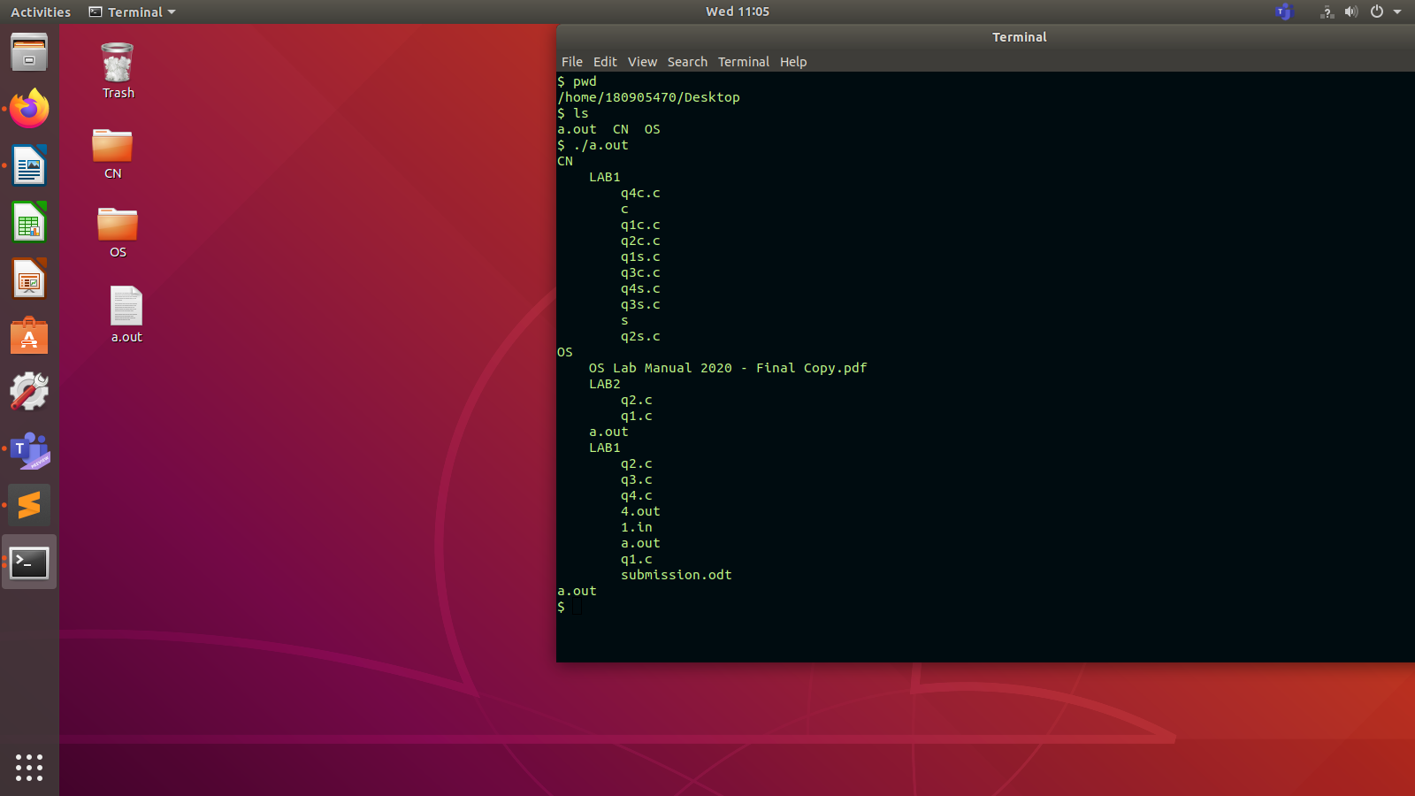
Q3

apt list –installed
* apt is a command-line interface for the package management system. It was introduced in Ubuntu 14.04 and combines the most commonly used commands from apt-get and apt-cache including an option to list installed packages.

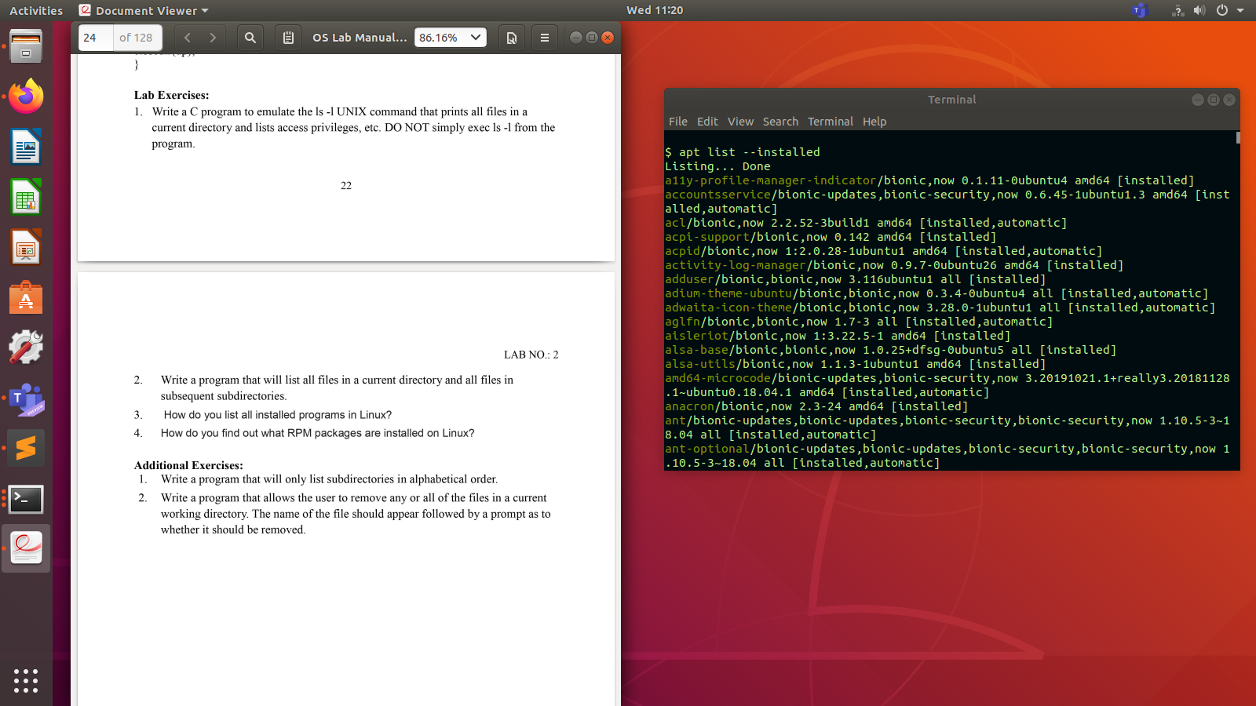
Q4

rpm -qa

[ Lists all packages installed by rpm ]

Each RPM package is stored in a file with an rpmextension. Package files usually follow a naming convention with the following structure:
name-version-release.architecture.rpm
The rpmcommand provides for most user interactions with the RPM system. You can query if a packageis installed with a command such as the following:$ rpm -qa xinetdxinetd-2.3.14-40

