Q1
#include <sys/types.h>
#include <sys/stat.h>
#include <unistd.h>
#include <stdio.h>

int main(int argc, char const *argv[])
{
struct stat sb;
int ret;
if (argc < 2)
{
fprintf(stderr, "file name not mentioned%s\n",argv[0] );
return 1;
}
ret = stat(argv[1],&sb);
if(ret){
perror("stat");
return 1;
}
printf("Inode Number : %ld", sb.st_ino);

return 0;
}
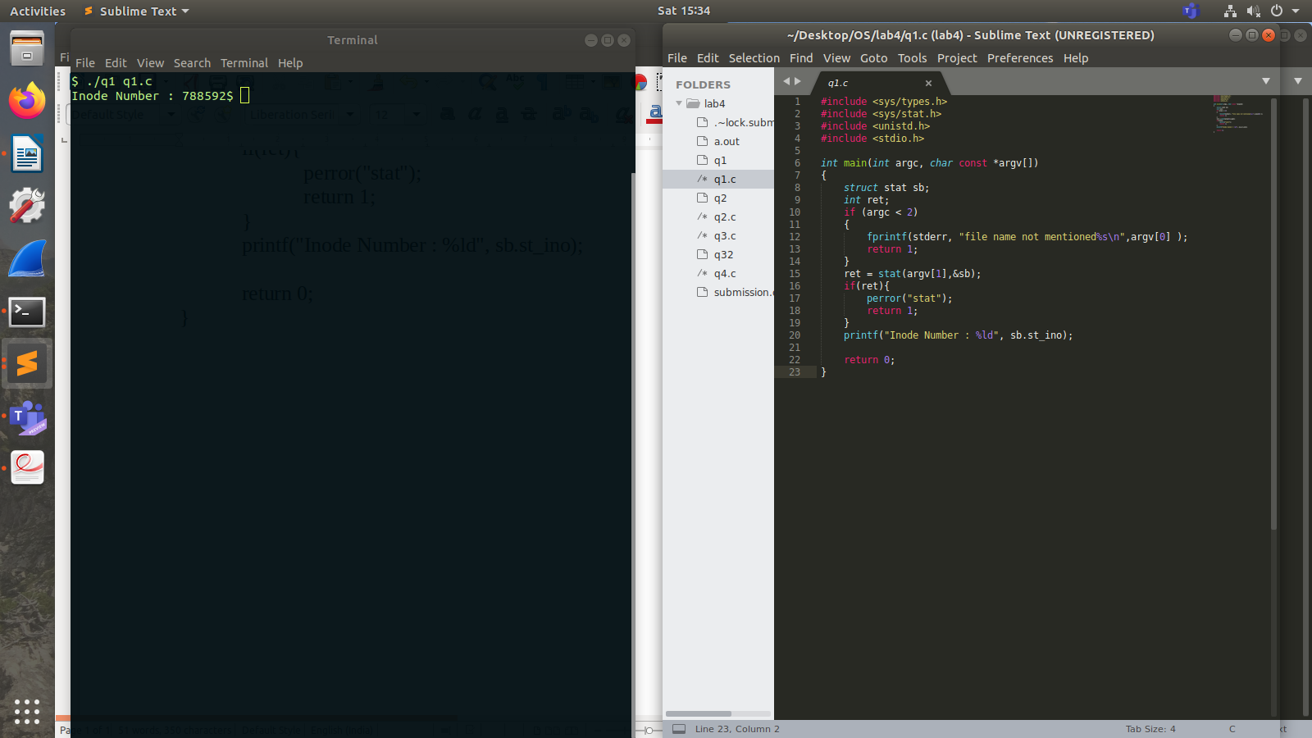

Q2
#include <sys/types.h>
#include <sys/stat.h>
#include <unistd.h>
#include <stdio.h>

int main(int argc, char const *argv[])
{
struct stat sb;
int ret;
if (argc < 2)
{
fprintf(stderr, "file name not mentioned%s\n",argv[0] );
return 1;
}
ret = stat(argv[1],&sb);
if(ret){
perror("stat");
return 1;
}
printf("ID pf device containing file : %ld\n", sb.st_dev);
printf("Inode Number : %ld\n", sb.st_ino);
printf("Permissions : %d\n", sb.st_mode);
printf("Number of Hard Links : %ld\n", sb.st_nlink);
printf("User ID of owner : %d\n", sb.st_uid);
printf("Group ID of owner : %d\n", sb.st_gid);
printf("Device ID : %ld\n", sb.st_rdev);
printf("Total Size : %ld\n", sb.st_size);
printf("Block Size : %ldbytes\n", sb.st_blksize);
printf("Number of Blocks allocated : %ld\n", sb.st_blocks);
printf("Last Access Time : %ld\n", sb.st_atime);
printf("Last Modification Time : %ld\n", sb.st_mtime);
printf("Last Status Change Time : %ld\n", sb.st_ctime);

return 0;
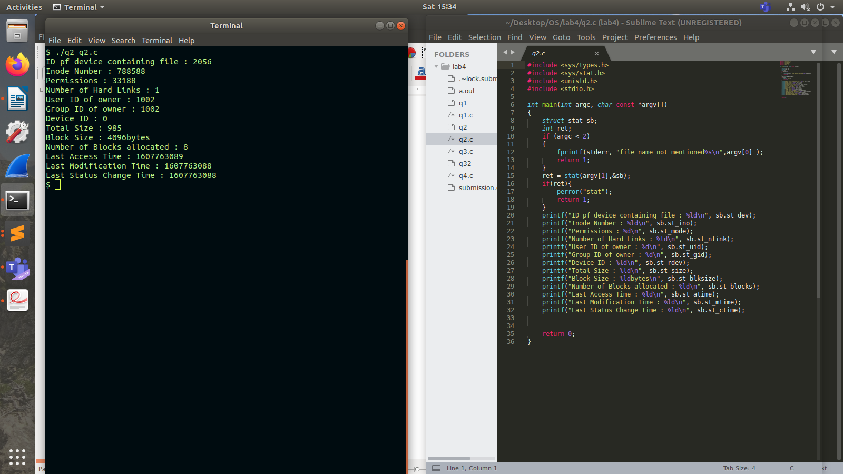
}
Q3
#include <sys/types.h>
#include <sys/stat.h>
#include <unistd.h>
#include <stdio.h>

int main(int argc, char const *argv[])
{
struct stat sb;
int ret;
if (argc < 2)
{
fprintf(stderr, "file name not mentioned%s\n",argv[0] );
return 1;
}

ret = stat("./q3.c",&sb);
if(ret){
perror("stat");
return 1;
}

printf("Number of Hard Links : %ld\n", sb.st_nlink);
printf("Path right now\n /home/Desktop/180905470/OS/lab4/q3.c\n");

int ret2 = link("./q3.c", argv[1]);

if(ret2) perror("link");
else printf("Linking Succes\n");

int ret3 = stat("./q3.c",&sb);
printf("No. of Hard Links : %ld\n",sb.st_nlink );

int unl = unlink("./q3.c");
if(unl == 0) printf("Unlinking Successs\n");

int ret4 = stat(argv[1],&sb);
printf("Path right now\n /home/Desktop/180905470/OS/lab4/%s\n",argv[1]);

printf("Number of Hard Links : %ld\n", sb.st_nlink);

return 0;
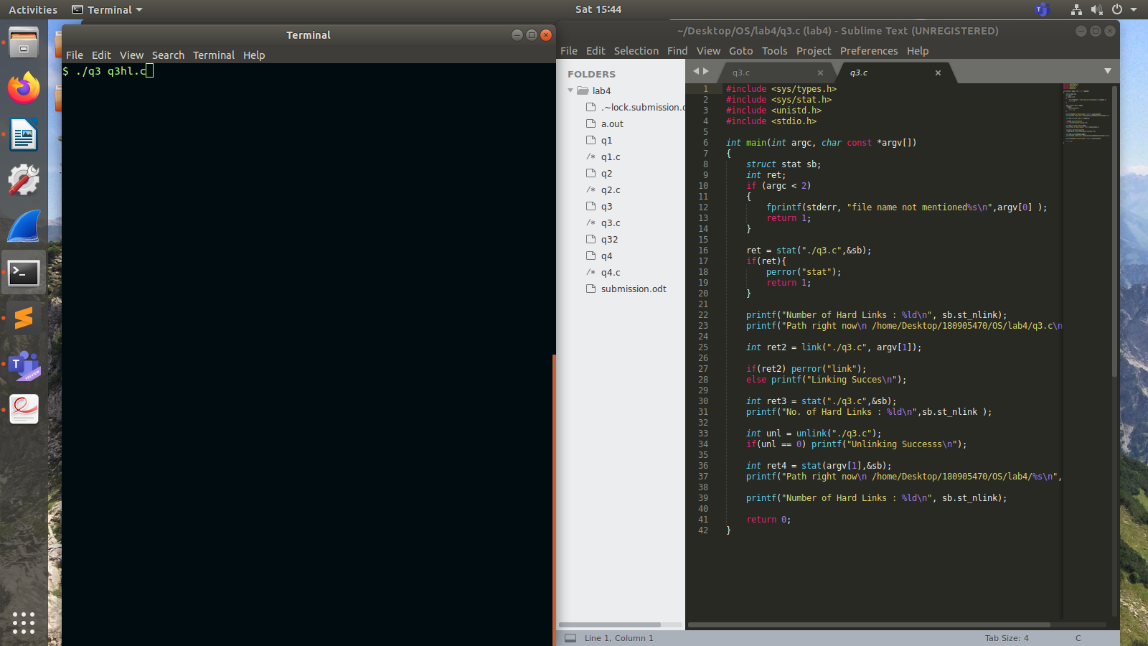
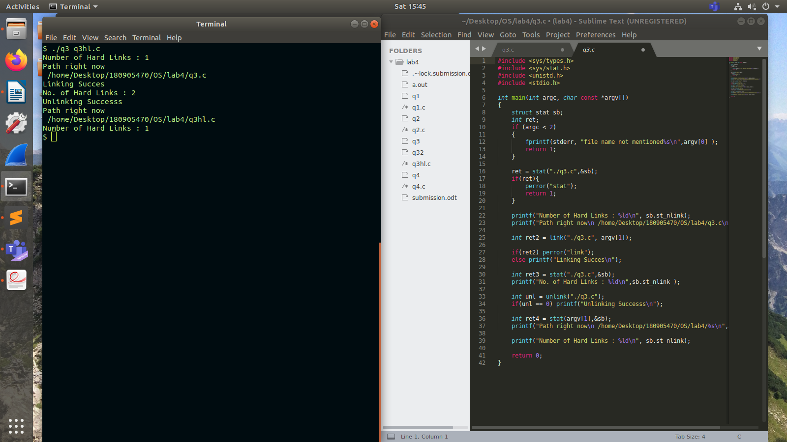
}

Q4
#include <sys/types.h>
#include <sys/stat.h>
#include <unistd.h>
#include <stdio.h>

int main(int argc, char const *argv[])
{
struct stat sb;
int ret;
if (argc < 2)
{
fprintf(stderr, "file name not mentioned%s\n",argv[0] );
return 1;
}

ret = stat("./q4.c",&sb);
if(ret){
perror("stat");
return 1;
}

printf("Number of Hard Links : %ld\n", sb.st_nlink);
printf("Path right now\n /home/Desktop/180905470/OS/lab4/q3.c\n");

int ret2 = symlink("./q4.c", argv[1]);

if(ret2) perror("link");
else printf("Linking Succes\n");

int ret3 = stat("./q4.c",&sb);
printf("No. of Hard Links : %ld\n",sb.st_nlink );

int unl = unlink("./q4.c");
if(unl == 0) printf("Unlinking Successs\n");

int ret4 = stat(argv[1],&sb);
printf("Path right now\n /home/Desktop/180905470/OS/lab4/%s\n",argv[1]);

printf("Number of Hard Links : %ld\n", sb.st_nlink);

return 0;
}

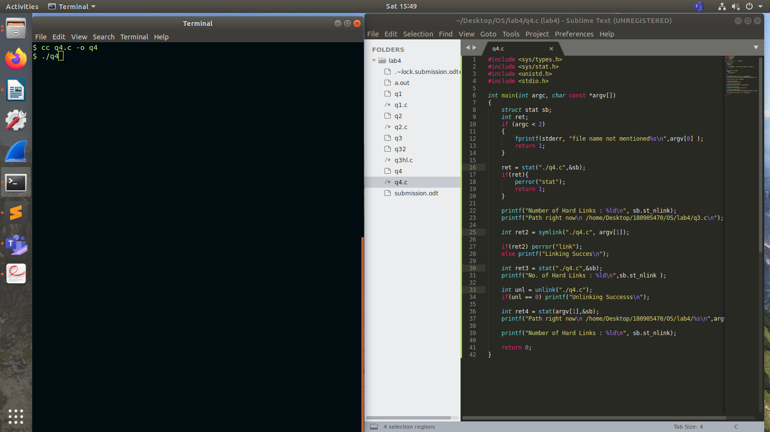
Before executing

After Executing

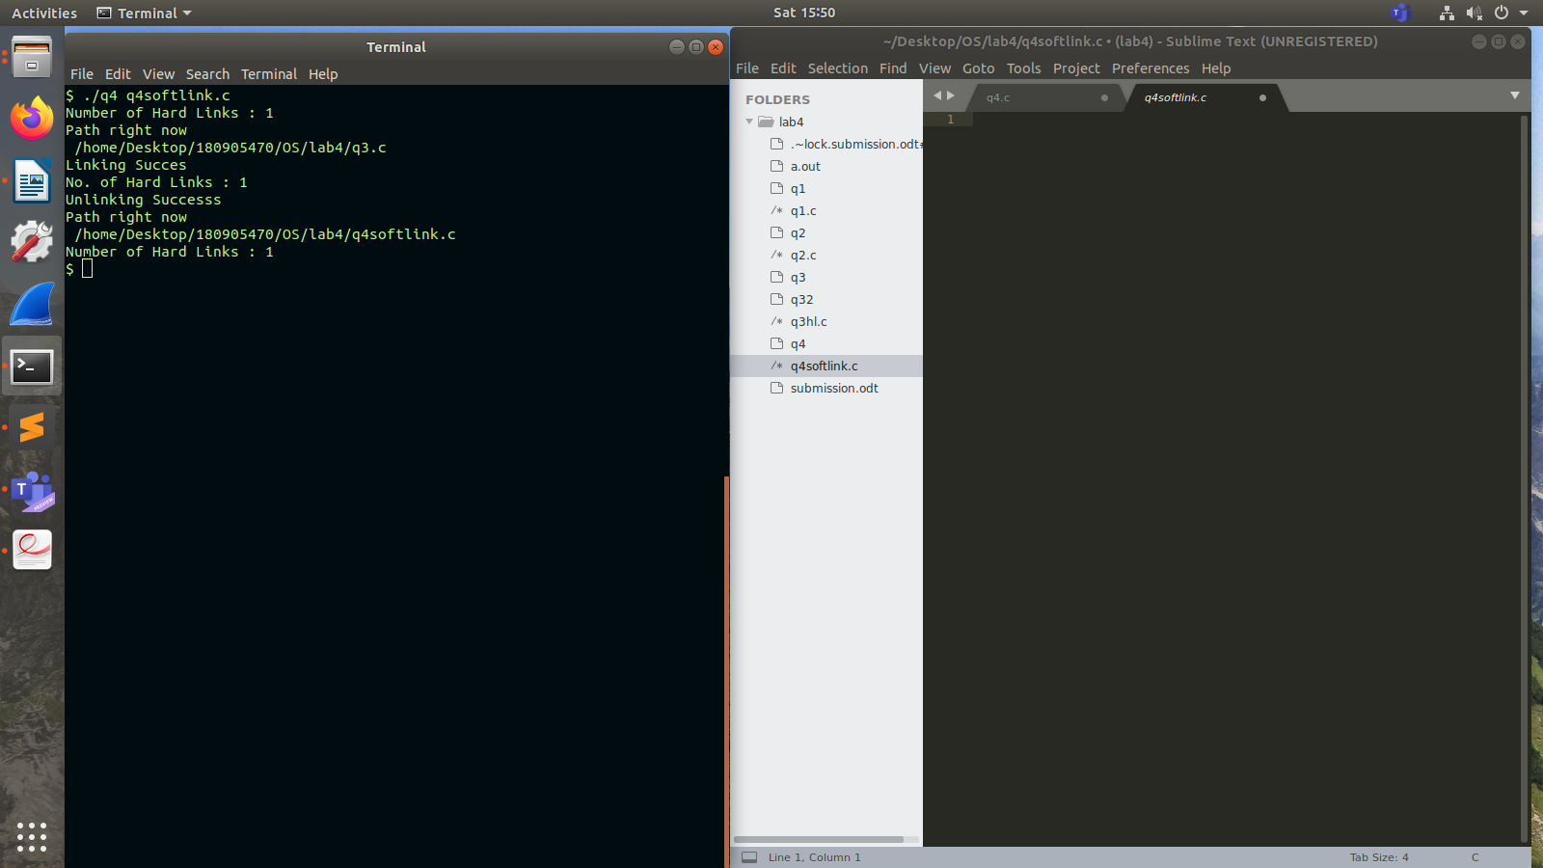
as file q4.c gets unlinked, the new file q4softlink.c also gets blanked, unline in q3hl.c which still contains the content of q3.

