Q1
Producer

#include<sys/types.h>
#include<sys/stat.h>
#include<unistd.h>
#include<stdlib.h>
#include<stdio.h>
#include<limits.h>
#include<fcntl.h>
#include<string.h>

#define FIFO_NAME "/tmp/my_fifo"
#define BUFFER_SIZE PIPE_BUF
#define TEN_MEG (1024 * 1024 * 10)

int main(int argc, char const *argv[])
{
int pipe_fd;
int res;
int open_mode = O_WRONLY;
int bytes_sent = 0;
int buffer;

if(access(FIFO_NAME, F_OK) == -1){
printf("pipe does not exist\n");
res = mkfifo(FIFO_NAME, 0777);
if(res != 0){
fprintf(stderr, "could not create fifo %s\n", FIFO_NAME);
exit(EXIT_FAILURE);
}
}

printf("Process %d opening FIFO O_WRONLY\n", getpid());
pipe_fd = open(FIFO_NAME, open_mode);
printf("Process %d result %d\n", getpid(), pipe_fd);

if(pipe_fd != -1){
while(bytes_sent < 4*sizeof(int)){
printf("\nEnter an integer: ");
scanf("%d", &buffer);
res = write(pipe_fd, &buffer, sizeof(int));
if(res == -1){
fprintf(stderr, "Write error on pipe\n");
exit(EXIT_FAILURE);
}
bytes_sent += res;
}
(void)close(pipe_fd);
}
else
exit(EXIT_FAILURE);

printf("Process %d finished\n", getpid());
exit(EXIT_SUCCESS);
return 0;
}

Consumer
#include<sys/types.h>
#include<sys/stat.h>
#include<unistd.h>
#include<stdlib.h>
#include<stdio.h>
#include<limits.h>
#include<fcntl.h>
#include<string.h>

#define FIFO_NAME "/tmp/my_fifo"
#define BUFFER_SIZE PIPE_BUF

int main(int argc, char const *argv[])
{
int pipe_fd;
int res;
int open_mode = O_RDONLY;
int bytes_read = 0;
int buffer;

printf("Process %d opening FIFO O_RDONLY\n", getpid());
pipe_fd = open(FIFO_NAME, open_mode);
printf("Process %d result %d\n", getpid(), pipe_fd);

int count = 0;
if(pipe_fd != -1){
do{
res = read(pipe_fd, &buffer, sizeof(int));
printf("\nInteger read is: %d, of size: %d\n", buffer, res);
bytes_read += res;
count++;
}while(bytes_read < 4 * sizeof(int));
(void)close(pipe_fd);
}
else
exit(EXIT_FAILURE);

printf("Process %d finished, %d bytes read\n", getpid(), bytes_read);
exit(EXIT_SUCCESS);
return 0;
}

Sample Output

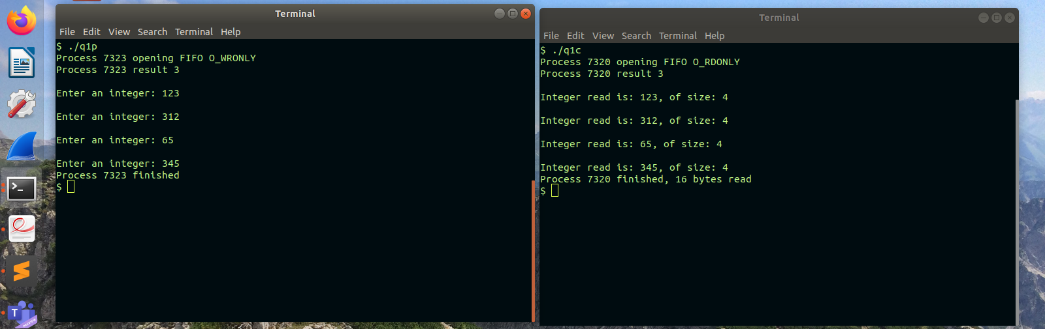

Q2

#include<unistd.h>
#include<stdio.h>
#include<sys/wait.h>
#include<assert.h>
#include<stdlib.h>
#include<string.h>
int main(int argc, char const *argv[])
{
int pfd[2];
pid_t cpid;
char buf;

//Creating a pipe
if(pipe(pfd) == -1){
perror("pipe");
exit(EXIT_FAILURE);
}

cpid = fork();
if(cpid == -1){
perror("fork");
exit(EXIT_FAILURE);
}

if(cpid == 0){
//Take a no as input and send it to the parent

close(pfd[0]);
int x;
printf("Enter a no: ");
scanf("%d", &x);

//writing to a pipe
write(pfd[1], &x, sizeof(int));
close(pfd[1]); //Reader sees this as EOF and stops reading
exit(EXIT_SUCCESS);
}
else
{
close(pfd[1]);
int y;

//Reading from a pipe
read(pfd[0], &y, sizeof(int));
close(pfd[0]);
printf("\nGot the no: %d, from the child!", y);
wait(NULL);
}
return 0;
}

Sample IO
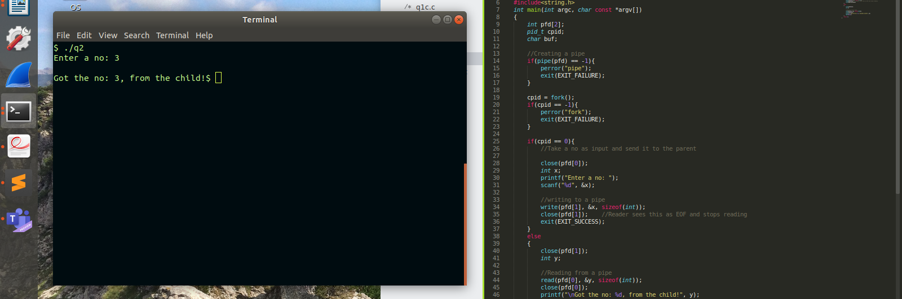

Q4
#include <stdio.h>
#include <stdlib.h>

int main()
{
FILE *fptr;
int num;
int num1=0;
fptr = fopen("demo.bin","wb+");

printf("Enter 4 integers: \n");

for(int i=1;i<=4;i++)
{
scanf("%d",&num);
fwrite(&num, sizeof(int), 1, fptr);
}

printf("Write finished!! \n");
fclose(fptr);

fptr = fopen("demo.bin","rb");

for(int i=1;i<=4;i++)
{
fread(&num1, sizeof(int), 1, fptr);
printf("%d\n",num1);
}
printf("Read finished!! \n");
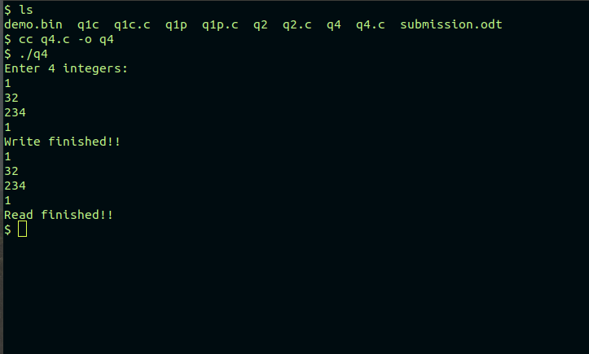
}

Q3

Process1

#include<sys/types.h>
#include<sys/stat.h>
#include<unistd.h>
#include<stdlib.h>
#include<stdio.h>
#include<limits.h>
#include<fcntl.h>
#include<string.h>

#define FIFO_NAME "/tmp/my_fifo"
#define BUFFER_SIZE PIPE_BUF

int main(int argc, char const *argv[])
{
//This program will first write and then read
char buffer[1024];
memset(buffer, '\0', sizeof(buffer));
int res, pipe_fd;

if(access(FIFO_NAME, F_OK) == -1){
printf("pipe does not exist\n");
res = mkfifo(FIFO_NAME, 0777);
if(res != 0){
fprintf(stderr, "could not create fifo %s\n", FIFO_NAME);
exit(EXIT_FAILURE);
}
}

//step 1: write to the pipe
printf("Process %d opening FIFO O_WRONLY\n", getpid());
pipe_fd = open(FIFO_NAME, O_WRONLY);

printf("Input: ");
fgets(buffer, 1024, stdin);

write(pipe_fd, buffer, strlen(buffer)+1);
close(pipe_fd);

//step 2: Read from the pipe
printf("\nProcess %d opening FIFO O_RDONLY\n", getpid());
pipe_fd = open(FIFO_NAME, O_RDONLY);

memset(buffer, '\0', sizeof(buffer));
read(pipe_fd, buffer, 1024);
close(pipe_fd);

printf("Output: Process %d reads -> %s\n", getpid(), buffer);

return 0;
}

Process 2

#include<sys/types.h>
#include<sys/stat.h>
#include<unistd.h>
#include<stdlib.h>
#include<stdio.h>
#include<limits.h>
#include<fcntl.h>
#include<string.h>

#define FIFO_NAME "/tmp/my_fifo"
#define BUFFER_SIZE PIPE_BUF

int main(int argc, char const *argv[])
{
//This program will first read and then write
char buffer[1024];
int res, pipe_fd;

if(access(FIFO_NAME, F_OK) == -1){
printf("pipe does not exist\n");
res = mkfifo(FIFO_NAME, 0777);
if(res != 0){
fprintf(stderr, "could not create fifo %s\n", FIFO_NAME);
exit(EXIT_FAILURE);
}
}

//step 1: Read from the pipe
printf("Process %d opening FIFO O_RDONLY\n", getpid());
pipe_fd = open(FIFO_NAME, O_RDONLY);

memset(buffer, '\0', sizeof(buffer));
read(pipe_fd, buffer, 1024);
close(pipe_fd);

printf("Output: Process %d reads -> %s\n", getpid(), buffer);

//step 2: write to the pipe
printf("Process %d opening FIFO O_WRONLY\n", getpid());
pipe_fd = open(FIFO_NAME, O_WRONLY);

printf("Input: ");
memset(buffer, '\0', sizeof(buffer));
fgets(buffer, 1024, stdin);

write(pipe_fd, buffer, strlen(buffer)+1);
close(pipe_fd);

return 0;
}

