CD LAB 2 Aniruddha Amit Dutta
180905488
Q1.
#include<stdio.h>
#include<stdlib.h>

int main(){
FILE *fa, *fb;
char ca, cb;
fa = fopen("HelloWorld.c", "r");
if(fa == NULL){
printf("Cannot open file \n");
exit(0);
}
fb = fopen("q1out.c", "w");
ca = getc(fa);
while (ca != EOF){
if(ca==' '){
putc(ca,fb);
while(ca==' ')
ca = getc(fa);
}
if (ca=='/'){
cb = getc(fa);
if (cb == '/'){
while(ca != '\n')
ca = getc(fa);
}
else if (cb == '*'){
do{
while(ca != '*')
ca = getc(fa);
ca = getc(fa);
}while (ca != '/');
}
else{
putc(ca,fb);
putc(cb,fb);
}
}
else putc(ca,fb);
ca = getc(fa);
}
fclose(fa);
fclose(fb);
return 0;
}
input file -
[HelloWorld.c]
#include <stdio.h>
#define ll long long
// remove it
int main(){
printf("Hello World");
return 0;
}

output file-
[q1out.c]
#include <stdio.h>
#define ll long long
int main(){
printf("Hello World");
return 0;
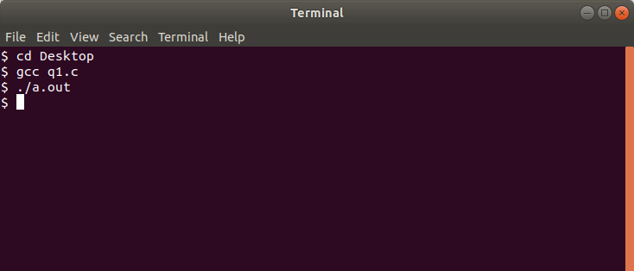
}

Q2
#include<stdio.h>
#include<stdlib.h>
#include <stdbool.h>

char temp[100];

bool is_include(){
char s[] = "#include";
for(int i=0;i<8;++i){
if(s[i]!=temp[i]){
return false;
}
}
return true;
}

bool is_define(){
char s[] = "#define";
for(int i=0;i<7;++i){
if(s[i]!=temp[i]){
return false;
}
}
return true;
}

void eraseComment(){
FILE *fa, *fb;
char ca, cb;
fa = fopen("HelloWorld.c", "r");
if(fa == NULL){
printf("Cannot open file \n");
exit(0);
}
fb = fopen("q1out.c", "w");
ca = getc(fa);
while (ca != EOF){
if(ca==' '){
putc(ca,fb);
while(ca==' ')
ca = getc(fa);
}
if (ca=='/'){
cb = getc(fa);
if (cb == '/'){
while(ca != '\n')
ca = getc(fa);
}
else if (cb == '*'){
do{
while(ca != '*')
ca = getc(fa);
ca = getc(fa);
}while (ca != '/');
}
else{
putc(ca,fb);
putc(cb,fb);
}
}
else putc(ca,fb);
ca = getc(fa);
}
fclose(fa);
fclose(fb);
}

int main(){
eraseComment();

FILE *fa, *fb;
char ca, cb;
fa = fopen("q1out.c", "r");
if(fa == NULL){
printf("Cannot open file \n");
exit(0);
}
fb = fopen("q2out.c", "w");
ca = getc(fa);
while (ca != EOF){
if(ca=='#'){
// putc(ca,fb);
int x=0;
while(ca!='\n'){

// ca = getc(fa);
temp[x++] = ca;
temp[x] = '\0';
ca = getc(fa);
}
printf(" bool = %d \n",is_include() );
if(!is_include() && !is_define() ){
for(int k=0;k<x;++k){
putc(temp[k],fb);
}
}

}

else putc(ca,fb);
ca = getc(fa);
}
fclose(fa);
fclose(fb);

return 0;
}
input file -
[HelloWorld.c]
#include <stdio.h>
#define ll long long
// remove it
int main(){
printf("Hello World");
return 0;
}
output file-
[q2out.c]
int main(){
printf("Hello World");
return 0;
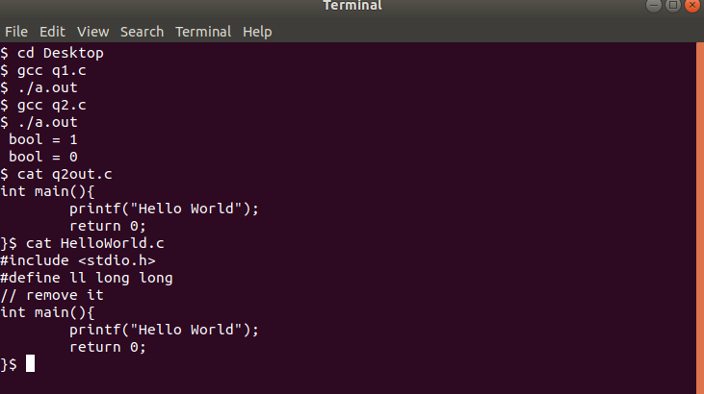
}

Q3
#include<stdio.h>
#include<stdlib.h>
#include <stdbool.h>
#include <ctype.h>
#include <string.h>

char temp[100],word[100];

char keywords[10][10] ={{"IF"},{"ELSE"},{"INT"},{"MAIN"},{"RETURN"},{"PRINTF"}};

bool is_keyword(){
// printf(" %s \n", word );
for(int i=0;i<5;++i){
if( strcmp(word,keywords[i])==0 ){
return true;
}
}
return false;
}

bool is_include(){
char s[] = "#include";
for(int i=0;i<8;++i){
if(s[i]!=temp[i]){
return false;
}
}
return true;
}

bool is_define(){
char s[] = "#define";
for(int i=0;i<7;++i){
if(s[i]!=temp[i]){
return false;
}
}
return true;
}

void eraseComment(){
FILE *fa, *fb;
char ca, cb;
fa = fopen("HelloWorld.c", "r");
if(fa == NULL){
printf("Cannot open file \n");
exit(0);
}
fb = fopen("q1out.c", "w");
ca = getc(fa);
while (ca != EOF){
if(ca==' '){
putc(ca,fb);
while(ca==' ')
ca = getc(fa);
}
if (ca=='/'){
cb = getc(fa);
if (cb == '/'){
while(ca != '\n')
ca = getc(fa);
}
else if (cb == '*'){
do{
while(ca != '*')
ca = getc(fa);
ca = getc(fa);
}while (ca != '/');
}
else{
putc(ca,fb);
putc(cb,fb);
}
}
else putc(ca,fb);
ca = getc(fa);
}
fclose(fa);
fclose(fb);
}

void erasePreprocessor(){
eraseComment();

FILE *fa, *fb;
char ca, cb;
fa = fopen("q1out.c", "r");
if(fa == NULL){
printf("Cannot open file \n");
exit(0);
}
fb = fopen("q2out.c", "w");
ca = getc(fa);
while (ca != EOF){
if(ca=='#'){
// putc(ca,fb);
int x=0;
while(ca!='\n'){

// ca = getc(fa);
temp[x++] = ca;
temp[x] = '\0';
ca = getc(fa);
}
printf(" bool = %d \n",is_include() );
if(!is_include() && !is_define() ){
for(int k=0;k<x;++k){
putc(temp[k],fb);
}
}

}

else putc(ca,fb);
ca = getc(fa);
}
fclose(fa);
fclose(fb);
}

int main(){
erasePreprocessor();
FILE *fa, *fb;
char ca, cb;
fa = fopen("HelloWorld.c", "r");
if(fa == NULL){
printf("Cannot open file \n");
exit(0);
}
fb = fopen("q3out.c", "w");
ca = getc(fa);
int x=0;
while (ca != EOF){

if( isalpha(ca) ){
word[x++] = (char)toupper(ca);
word[x] = '\0';
ca = getc(fa);
continue;
}

else{
// printf(" bool key = %d \n",is_keyword() );
if( is_keyword() ){
// printf(" %s \n", word);
for(int k=0; k<x;++k){
putc(word[k],fb);
}
putc('\n',fb);
}
x=0;
ca = getc(fa);
}
}
}
Terminal -

