1)
n = int(input('Enter Nmber'))

for i in range(1,n+1):
if n % i == 0:
print(i)
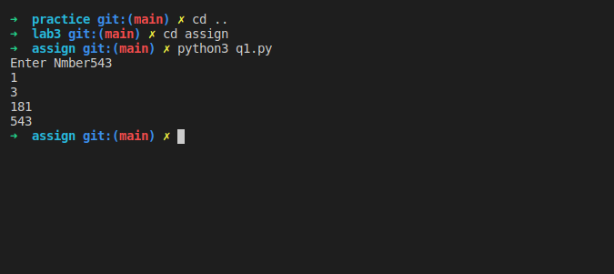

2)
import numpy as np
arr = np.array([[1,2,4], [ 3,5,21], [2,53,5]])
print(arr.shape)

print('rows:')
print(arr.sum(axis = 1))
print('Columns:')
print(arr.sum(axis = 0))

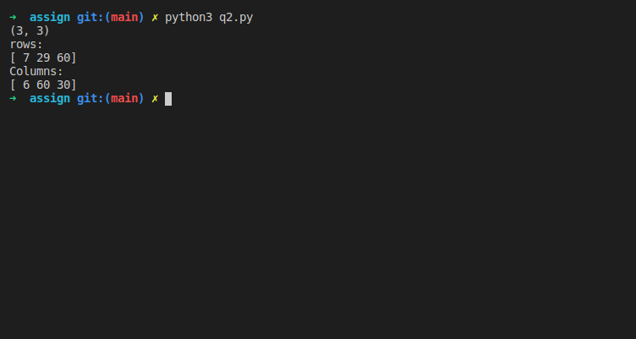

Q3
import numpy as np

aList = [23.4,21.2,54.5]
arr = np.array(aList)
print(arr)

aTuple = (34,234,23,5)
arr2 = np.array(aTuple)
print(arr2)

arr3 = np.zeros((3,4))
print(arr3)

arr4 = np.arange(0,20,5)
print(arr4)

arr5 = arr3.reshape((2,2,3))
print(arr5)

arr = np.array([[1,2,4], [ 3,5,21], [2,53,5]])

print(arr.max(axis=1))
print(arr.max(axis=0))
print(arr.sum(axis=1))
print(arr.sum(axis=0))
print(arr.min(axis=1))
print(arr.min(axis=0))

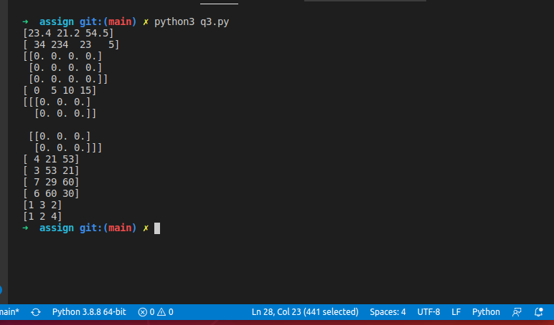

4)
import numpy as np
arr = np.array([[1,2,4], [ 3,5,21], [2,53,5]])

print(np.transpose(arr))
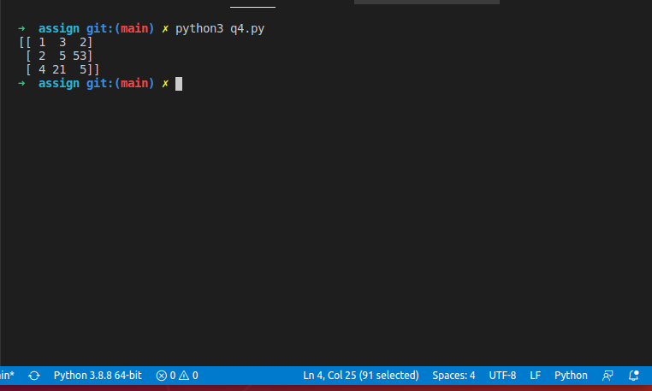

5)
import numpy as np

arr = np.array([[1,2,4], [ 3,5,21], [2,53,5]])
arr2 = np.array([[9,5,6], [ 4,25,1], [2,5,51]])

print(arr+arr2)
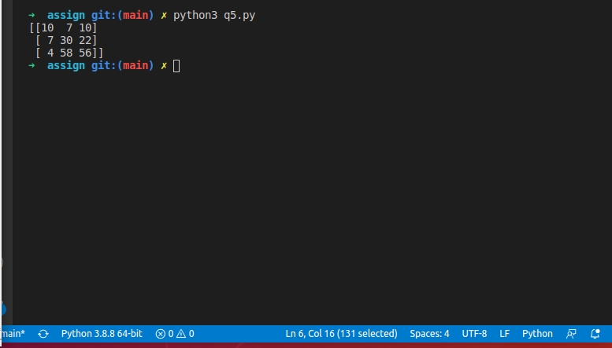

Q6
import numpy as np

arr = np.array([[1,2,4], [ 3,5,21], [2,53,5]])
arr2 = np.array([[9,5,6], [ 4,25,1], [2,5,51]])

print(arr*arr2)
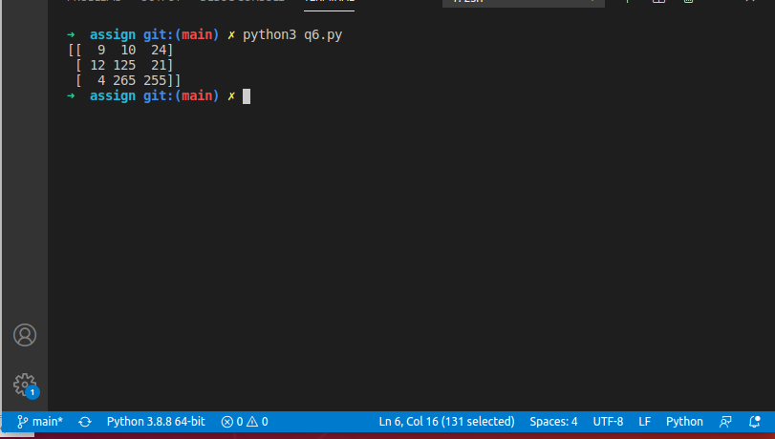

Learning

import numpy as np
import random as rd

A = np.array([2,5,10])
print(A.dtype)

B = np.array ([2.4,10.6,5.2])
print(B.dtype)

A=np.array([(3,4,5),(12,6,1)])

print(np.ones((3,3)))
print(A)

print(np.linspace(0,2,9))

print(rd.choice([1,2,3,4,5]))
print(rd.choice('dsada'))
print(rd.randrange(25,80))
print(rd.randrange(25,80,2))
print(rd.random())
print(rd.uniform(5,10))
print(rd.shuffle([1,2,3,4,5,7]))

for i in range(5):
rd.seed(10)
print(rd.randint(1, 1000))
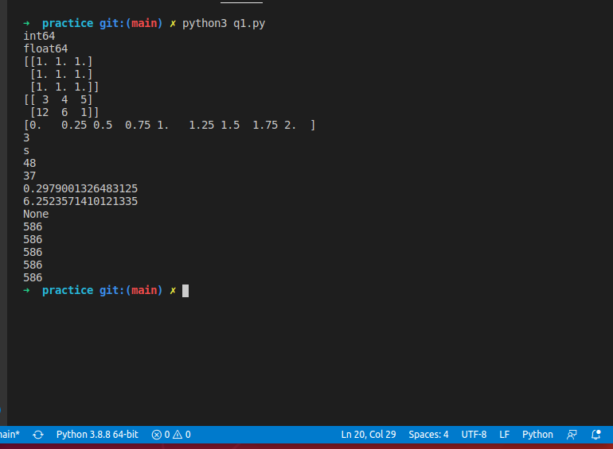

import numpy as np

#Dimensional Array (Matrix)
a=np.arange(15).reshape(3,5)
print(a)
print(a.shape)
print(a.size)
print(a.T) #transpose

print("-------------------------------")

#Dimensional Array
c=np.arange(24).reshape(2,3,4)
print(c)
print(c.shape)
print(c[1,:,:])
print(c[:,:,2])

print("-------------------------------")

#Array operations
a = np.array( [20,30,40,50] )
print(a)
b = np.arange( 4 )
print(b)
c = a-b
print(c)
print(b**2)
print(10*np.sin(a))
print(a<35)

print("-------------------------------")

#Matrix operations
A = np.array( [[1,1],[0,1]] )
B = np.array( [[2,0],[3,4]] )
print(A*B)
print(A.dot(B))
print(np.dot(A, B))
C = np.arange(12).reshape(3,4)
print(C)
print(C.sum(axis=0))
print(C.sum(axis=1))

print("-------------------------------")

#Indexing, Slicing & Iterating Array
x = np.arange(10)**3
print(x)
print("**********")
print(x[2:5])
print("**********")
print(x[0:6:2])
print("**********")
y=np.array([[ 0, 1, 2, 3],[10, 11, 12, 13],[20, 21, 22, 23],[30, 31, 32, 33],[40, 41, 42, 43]])
print(y[2,3])
print("**********")
print(y[:5,1])
print("**********")
print(y[-1,:])
print("**********")
print(y[:,-1])
print("**********")
for row in y:
print(row)
print("**********")
for element in y.flat:
print(element)
print("-------------------------------")
#Changing the shape of a matrix
print(y.ravel())
B1=y.reshape(4,5)
print(B1)

