Q1

n = 1
while n != -1:
n = int(input("Enter 1 for +, 2 for -, 3 for *. 4 for /, -1 to exit \n"))
if n == -1:
exit(0)
a = int(input("Enter first no.\n"))
b = int(input("Enter second no.\n"))

if n == 1:
print(a+b)
elif n == 2:
print(a-b)
elif n == 3:
print(a*b)
elif n==4:
try:
c = a/b
except ZeroDivisionError:
c = 0
print(c)

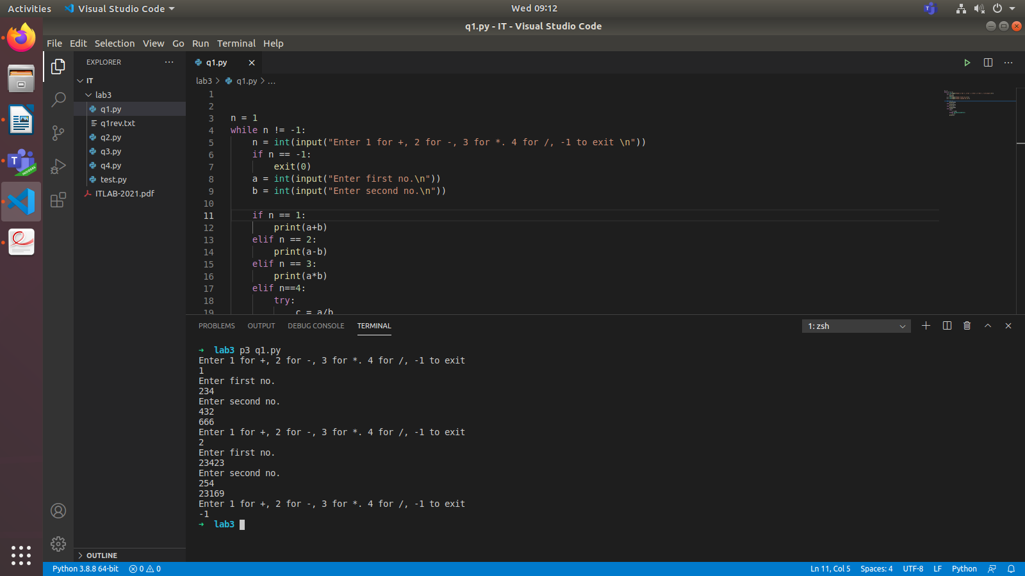

Q2
import sys

inp = open("q1.py",'r')
out = open("q1rev.txt",'w')

# for line in inp:
# print(line)

text = inp.read()
# print(text)

out.write(text[::-1])

inp.close()
out.close()
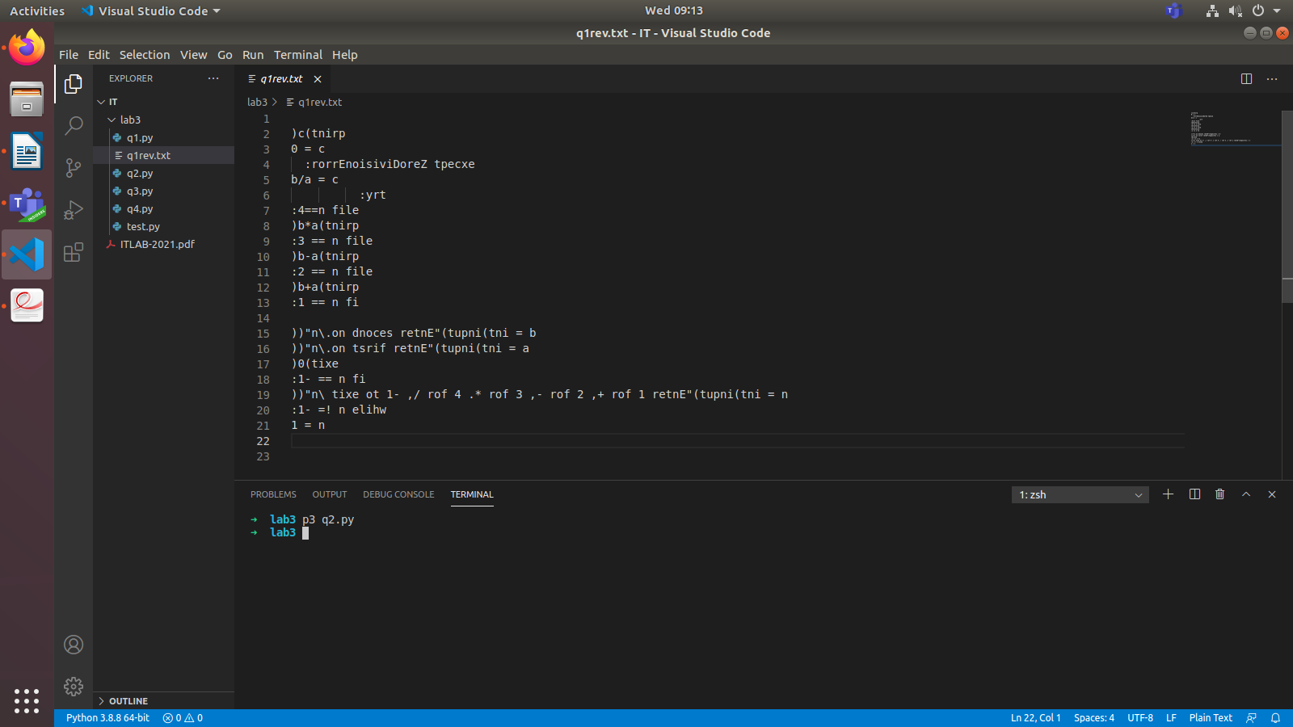

Q3
arr = [1,2,3,5,6,7,8,9]
l = 0
u = len(arr)

def binary(l,u,toFind):
m = ( l+u)//2
if(l > u ):
print('noFound ' )
elif arr[m] == toFind:
print('Found at ' + str(m))
elif arr[m] < toFind:
binary(m+1,u,toFind)
else:
binary(l,m-1,toFind)

binary(l,u,7)
binary(l,u,4)

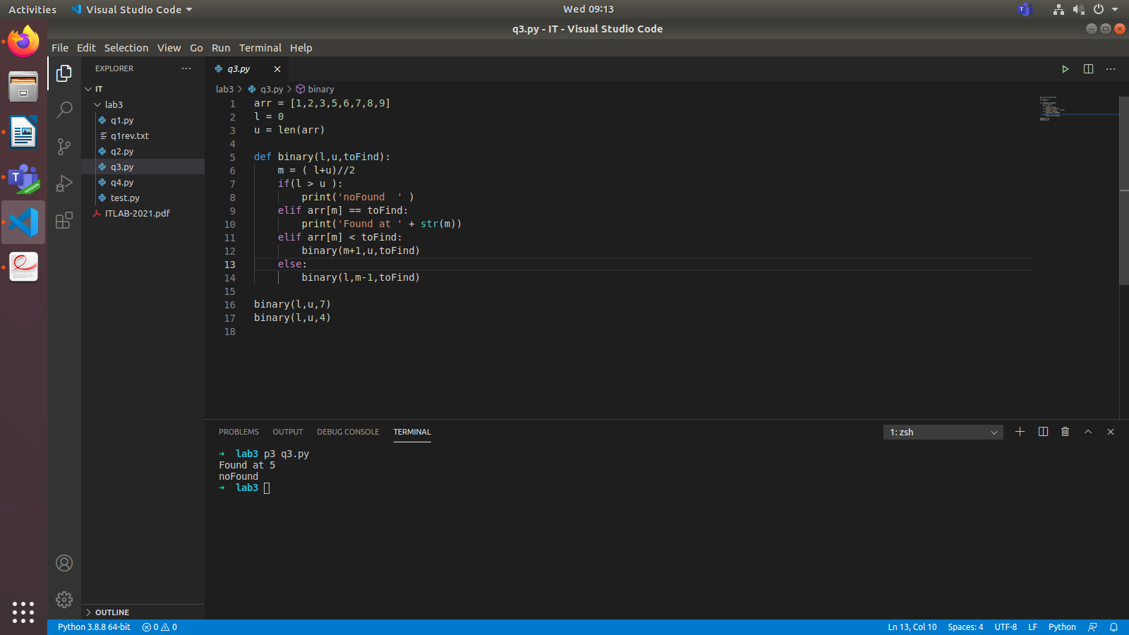

Q4
sentence = input()
words = sentence.split()
words.sort()
for word in words:
print(word)

