Q1

#include <stdio.h>
#include "mpi.h"

int main(int argc, char *argv[]) {
int rank,size,fact=1,factsum, i;

MPI_Init(&argc, &argv);

MPI_Comm_rank(MPI_COMM_WORLD, &rank);
MPI_Comm_size(MPI_COMM_WORLD, &size);

for(i = 1; i <= rank; i++ , fact*=i);

// MPI_Reduce(&fact, &factsum, 1, MPI_INT, MPI_SUM, 0, MPI_COMM_WORLD);
// !rank && printf("Sum of fact : %d\n",factsum );
int error_code,len_error_string,error_class;
MPI_Errhandler_set(MPI_COMM_WORLD,MPI_ERRORS_RETURN);
error_code=MPI_Comm_rank(MPI_COM_WORLD,&rank);
if(error_code!=MPI_SUCCESS)
{
MPI_Error_class(error_code,&error_class);
MPI_Error_string(error_class,error_string,&len_error_string);
printf("%s\n",error_string);
}

MPI_Scan(&fact, &factsum, 1, MPI_INT, MPI_SUM, MPI_COMM_WORLD); //automatically stores everything in the last process
rank == size-1 && printf("Sum of fact : %d\n",factsum );

MPI_Finalize();
return 0;
}

// To run
/*
mpicc q.c -o q
mpirun -np [arg] ./1

*/

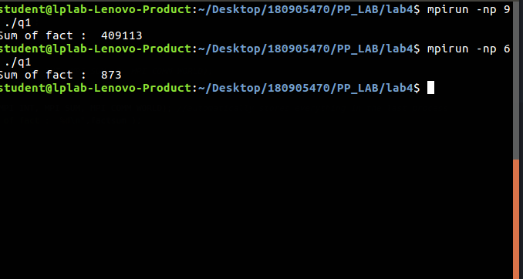

Q2
#include <stdio.h>
#include <math.h>
#include "mpi.h"

int main(int argc, char *argv[]) {
int rank,size;
float fact,factsum=0,rect=0;

MPI_Init(&argc, &argv);

MPI_Comm_rank(MPI_COMM_WORLD, &rank);
MPI_Comm_size(MPI_COMM_WORLD, &size);

// fact = 4 * (atan(rank+1) - atan(rank));
float x = (rank+0.5)/size;
float x2 = x*x;
rect = (4/(1+x2))*(1/(float)size);

int error_code,len_error_string,error_class;
MPI_Errhandler_set(MPI_COMM_WORLD,MPI_ERRORS_RETURN);
error_code=MPI_Comm_rank(MPI_COM_WORLD,&rank);
if(error_code!=MPI_SUCCESS)
{
MPI_Error_class(error_code,&error_class);
MPI_Error_string(error_class,error_string,&len_error_string);
printf("%s\n",error_string);
}

MPI_Scan(&rect, &factsum, 1, MPI_FLOAT, MPI_SUM, MPI_COMM_WORLD); //automatically stores everything in the last process
rank == size-1 && printf("Area : %f\n",factsum );

MPI_Finalize();
return 0;
}

// To run
/*
mpicc q.c -o q
mpirun -np [arg] ./1

*/

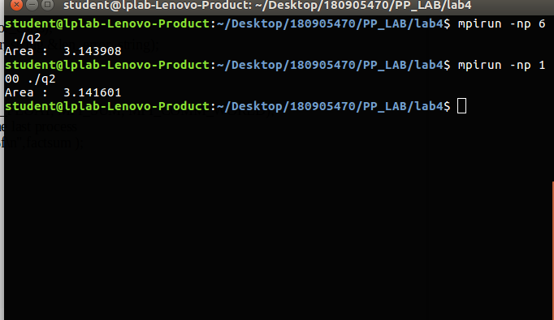

Q3
#include <stdio.h>
#include "mpi.h"

int main(int argc, char *argv[]) {
int rank,size,i,j,a[3][3],b[3],key,count,countsum;

MPI_Init(&argc, &argv);

MPI_Comm_rank(MPI_COMM_WORLD, &rank);
MPI_Comm_size(MPI_COMM_WORLD, &size);

if(rank==0){
printf(" Enter values in 3x3 matrix:\n");
for(int i=0;i<3;++i){
for(int j=0;j<3;++j){
scanf("%d",&a[i][j]);
}
}
printf(" Enter ele to search:\n");
scanf("%d",&key);
}
int error_code,len_error_string,error_class;
MPI_Errhandler_set(MPI_COMM_WORLD,MPI_ERRORS_RETURN);
error_code=MPI_Comm_rank(MPI_COM_WORLD,&rank);
if(error_code!=MPI_SUCCESS)
{
MPI_Error_class(error_code,&error_class);
MPI_Error_string(error_class,error_string,&len_error_string);
printf("%s\n",error_string);
}

MPI_Bcast(&key, 1, MPI_INT, 0, MPI_COMM_WORLD);
MPI_Scatter(a,3,MPI_INT,b,3,MPI_INT,0,MPI_COMM_WORLD);

for(int i=0;i<3;++i){
key == b[i] && count++;
}

MPI_Reduce(&count,&countsum,1,MPI_INT,MPI_SUM,0,MPI_COMM_WORLD );

if(rank==0){
printf("total no of occurances of %d = %d",key,countsum);
}

MPI_Finalize();
return 0;
}

// To run
/*
mpicc q.c -o q
mpirun -np [arg] ./1

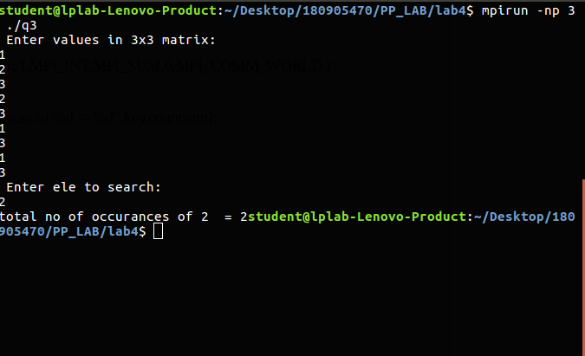
*/

Q4
#include "mpi.h"
#include <stdio.h>
#include <string.h>

int main (int argc, char* argv[]) {

int rank, size;
int i = 0, j;
int k = 0, fac = 1, ans[1000], sum = 0;
int n, a[100][100], b[100];

MPI_Init(&argc, &argv);
MPI_Comm_rank(MPI_COMM_WORLD, &rank);
MPI_Comm_size(MPI_COMM_WORLD, &size);

int error_code,len_error_string,error_class;
MPI_Errhandler_set(MPI_COMM_WORLD,MPI_ERRORS_RETURN);
error_code=MPI_Comm_rank(MPI_COM_WORLD,&rank);
if(error_code!=MPI_SUCCESS)
{
MPI_Error_class(error_code,&error_class);
MPI_Error_string(error_class,error_string,&len_error_string);
printf("%s\n",error_string);
}

if (rank == 0) {
printf("Enter the elements of i/p matrix \n");
for (i = 0; i < 4; i++) {
for (j = 0; j < 4; j++) {
scanf("%d", &a[i][j]);
}
}
}

MPI_Scatter(a, 100, MPI_INT, b, 100, MPI_INT, 0, MPI_COMM_WORLD);
MPI_Scan(b, ans, 4, MPI_INT, MPI_SUM, MPI_COMM_WORLD);

for (i = 0; i < 4; i++) printf("%d ", ans[i]);
printf("\n");

MPI_Finalize();

return 0;

}

