PROJECT REPORT
ON
“VEHICLE PARKING SYSTEM”
Submitted to
Sant Gadge Baba Amravati University
Amravati
In partial fulfillment of the requirement of

M.Sc.(Computer Software) Final Year Examination

Submitted by
Prajwal Bhanudasrao Harne.

Under the guidance of
Miss. S. A. Kakade

(Department of Computer Science)



DEPARTMENT OF COMPUTER SCIENCE
Shri Shivaji Education Society Amravati’s
SHRI SHIVAJI SCIENCE COLLEGE
Amravati.
2019-2020
Shri Shivaji Education Society Amravati’s
Department of Computer Science
Shri Shivaji Science College, Amravati

CERTIFICATE

This is to certify that the project report entitled "Vehicle Parking System" is carried out and developed by Mr. Prajwal Bhanudasrao Harne in partial fulfillment of the M.Sc. (Final Year) and submitted to Sant Gadge Baba Amravati University , Amravati under my guidance and supervision.
.
To the best of my knowledge the matter presented in this project has not been presented
earlier for similar degree/diploma.

Place: Amravati Project Guide
Date:
Miss .S. A. Kakade

Head
Department of Computer Science

External Examiner Internal Examiner

DECLARATION

To,
The Principal
Shri Shivaji Science College,
Amravati.

Respected Sir,
I the undersigned, hereby declare that the project work entitled "Vehicle Parking System" submitted to Sant Gadge Baba Amravati University , Amravati is my independent work . This is my original work and has not been submitted anywhere for any degree/diploma. The system presented herein has not been duplicated from any other source.

I understand that any such copying is liable to be punished in any way the University authority may deem fit.
Thanking You.

Place: Amravati Yours Sincerely
Date: Prajwal B. Harne

ACKNOWLEDGEMENT

We wish to express our sincere thanks to many persons who helped us to develop our original project work.
At first, We express our sincere thanks Principal Dr. V.G.Thakare, Science College, Nagpur for providing the infrastructure and facilities without which it would have been impossible to complete this hard task.

In foremost this are to, Dr. H. M .Deshmukh, Head of Department of computer science who has aided as in completing this project report.

We are thankful to Prof. M. M .Bhonde for their constant inspiration and guidance throughout the course of this project work.

Our foremost thanks are to Miss. S. A .Kakade, who has guided us in completing this project report, We take the opportunity to express our deep sense of gratitude and whole hearted thanks for his inspiration and guidance throughout the course of this project.

We express our gratitude to all members of teaching and non- teaching staff of the Department of Computer Science for their co-operation during the course. Finally we thank our friends and specially who helped us in our endeavors.

Place: Amravati Name of projectee
Date Prajwal B. Harne.

INDEX
Sr. No. | Name Of Topics | Page No.
1. | INTRODUCTION  Project Overview  Existing System  Need of System  Proposed system
2. | REQUIREMENTS AND ANALYSIS  2.1 Problem Definition  2.2 Requirements Specification  2.3 Planning and Scheduling  2.4 Software and Hardware Requirements  2.5 Feasibility study  2.5.1 Economic  2.5.2 Technical  2.5.3 Operational
3. | DATA FLOW DIAGRAM
4. | SYSTEM DESIGN
5. | TESTING  5.1 Testing Approach  5.2 Implementation  5.2.1 Unit Testing  5.2.2 Integrated Testing  5.2.3 System testing
6. | ADVANTAGES & DISADVANTAGES
7. | FUTURE SCOPE
8. | CONCLUSION
9. | REFERENCES

ABSTRACT

The main aim of this project is to reduce the traffic in the parking place. Normally we can see in the multiplexes, cinema halls, large industries, and function halls there is problem they have to go and search which line is empty and which line having place to park the vehicle, for parking then they need workers for parking in correct position it is the money consumed process. So to avoid this problem Car Parking Information System project is implemented.
In this Electronics and communications project we have to use the equipments of microcontroller, Infrared transmitters and infrared receivers for each and every parking slot, IR receivers should be connect to the microcontroller.
Here we are using infrared communication because it can support LOS (line of sight communication), and while enter into gate for parking there is the display to get the information regarding which line is empty. This information gives the microcontroller.
The microcontroller first give the information to the IR transmitter then it gives to the IR receiver then this information show on the display, so by this process the parking is easy process. So the traffic can be reduced in the parking place of the theatres, multiplex, and in large industries and in commercial places.
Also we are collecting an information about a vehicle where it is parking in a slot and this software checks the check-in and check-out information about any vehicle.

1. INTRODUCUTION

1.1 Project Overview :

This project is for collecting a parking information of vehicles. In that the number of vehicles can park at the particular location for that purpose we design this software.
If there any vehicle wants to park, then software can check the remain slots where are available a space and we can check-in that vehicle at that particular slot and also an check-out that particular vehicle from that slot.
Motive of this project is for collect a data of visited vehicles and proper information about check-in and check-out of particular vehicle. Parking helps one of the biggest problems on driving in urban areas; finding empty parking spaces and controlling illegal parking.
This project is developed using Html, CSS and Java Script. As per Html and CSS is a front of the software and Java Script is Back end of the project. Where Java Script is contain a data from local storage of the system in this software.

1.2 Existing System :

This software contain an information about particular vehicle where that vehicle wants to park in a particular available slot. It helps to find a place for our vehicle for parking.
Another benefit of this software is that we can check-in or check-out a vehicle where that particular vehicle are at that slot or not available. So easily can find a place for our vehicle and also with security of that check-in and check-out options.
In this software can search a vehicle by owner name or vehicle number and it will show that it is check-in or check-out.
This software contain a information about vehicle in form of owner name , vehicle number , check-in date , check-out date , search box, etc where all data can store in a local storage of a system and also can access data from local storage using Java script.

1.3 Need Of System :
Collect a information about any vehicle which wants to park in a parking location.
To insure that how many vehicle visits.
Also checks that vehicle is check-in or check-out.
This software contain a information about vehicle and check-in and check-out.

1.4 Proposed System :
To save paperwork and benefit of this software is that to contain a information in data.
The data is easily accessable
To save check-in and check-out information (for security purpose).
Time saving and fastly accessable.

2. REQUIREMENT AND ANALYSIS

2.1 Problem definition :
The purpose of this application is to automate the existing manual system by the help of computerized equipments and full-fledged computer software, fulfilling the customers requirements, so that their information can be stored for a longer period with easy accessing and manipulation of the same. The required software and hardware are easily available and easy to work with.

2.2 Requirement Specification :
The introduction of the requirement specification states the goals and objectives of the software, describing it in context of the computer based system.
The Requirement Specification is produced at the culmination of the analysis task. The function and performance allocated to software as part of the system engineering are refined by establishing a complete information description, a detailed functional and behavioral description, an indication of performance requirements and design constraints, appropriate validation criteria and other data pertinent to requirements.

Information Description :
It provides detailed description of the problem that the software must solve. Information content, flow and structure are documented. Hardware, Software and Human interfaces are described for external system elements and internal software functions.
2.3 Planning and Scheduling :
Planning :
For a successful software project, the following steps can be followed:
Select a project Identifying project’s aims and objectives. Understanding requirements and specification. Methods of analysis, design and implementation. Testing Techniques and Documentation .

Project Milestones
Deliverables
Budget Allocation
Resource Allocation Hardware Software Previous Relevant Project Information Digital Library
Project Estimates Cost Time Size of Code Duration
Risk Management Risk Avoidance Risk Detection Scheduling:
An elementary Gantt chart or Timeline Chart for the development plan is given below:

 | August |  |  |  | September |  |  |  | October
Requirement
Gathering
Analysis
Design
Coding
Testing
Implement
 | W1 | W2 | W3 | W4 | W1 | W2 | W3 | W4 | W1 | W2 | W3 | W4

W’s are week of the month, for i =1, 2, 3, 4.

2.4 Hardware and Software Requirements :

Hardware Requirement :
Minimum RAM : 500 MB
Hard Disk : 40 GB
Processor : Intel Pentium 4
Keyboard : Standard
Monitor : 15/17 inch (color)

Software Requirement :
Front End : HTML, CSS, Java Script
Back End : Local Storage of a System.
Operating System : Windows 10 Professional (DOS)

2.5 Feasibility Study :
Feasibility study is the phase in which the analyst checks that the student system is feasible for the University or institution. This entails identification, description & evaluation of the system. Feasibility study is done to select the best system that meets the performance requirement.
If the feasibility study is to serve as a decision document, it must answer key questions.
Is there a new and better way to do the job that will benefit the user?
What are the costs and saving of the alternatives?
What is recommended?

2.5.1. Economic Feasibility :
The system being developed is economic with respect to University perspective. It is effective in the sense that has eliminated the paper work completely. The system is also time effective coz the calculations are automated. The output obtained contains fewer errors and are highly accurate as the data is required.

2.5.2. Technical Feasibility :
The technical requirement for the system is economic and it does not use any other additional hardware and software. The system is technically feasible; it is providing us required output.

3. DATAFLOW DIAGRAM

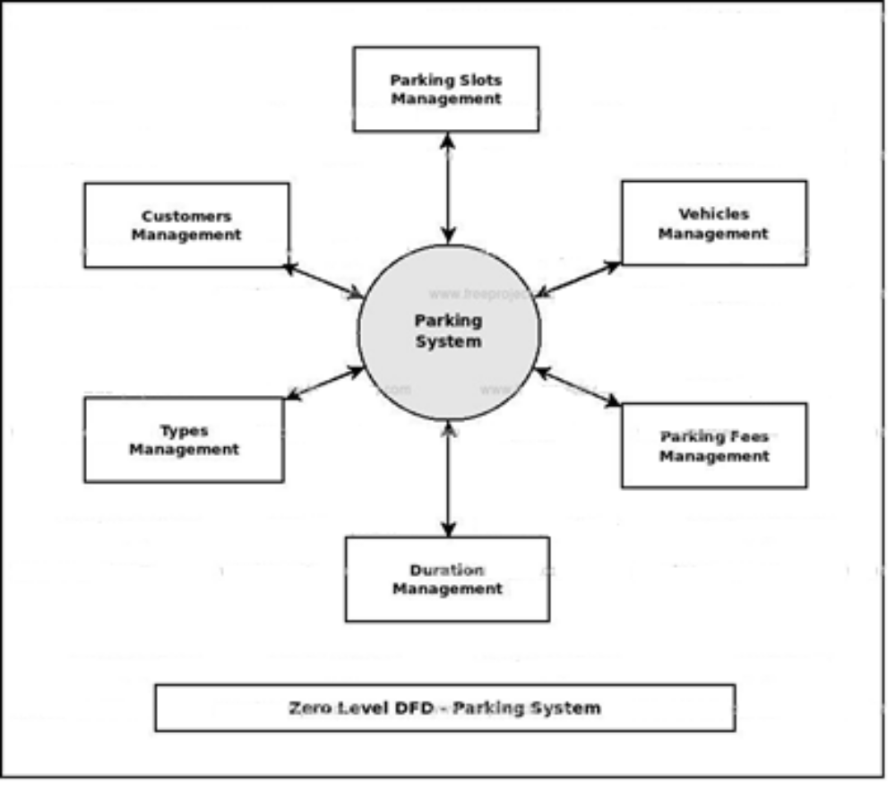

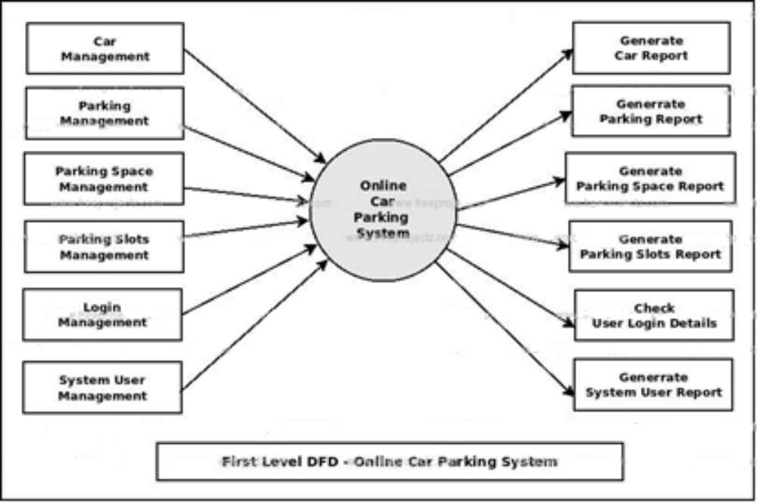

4. SYSTEM DESIGN
4.1 Login Page :
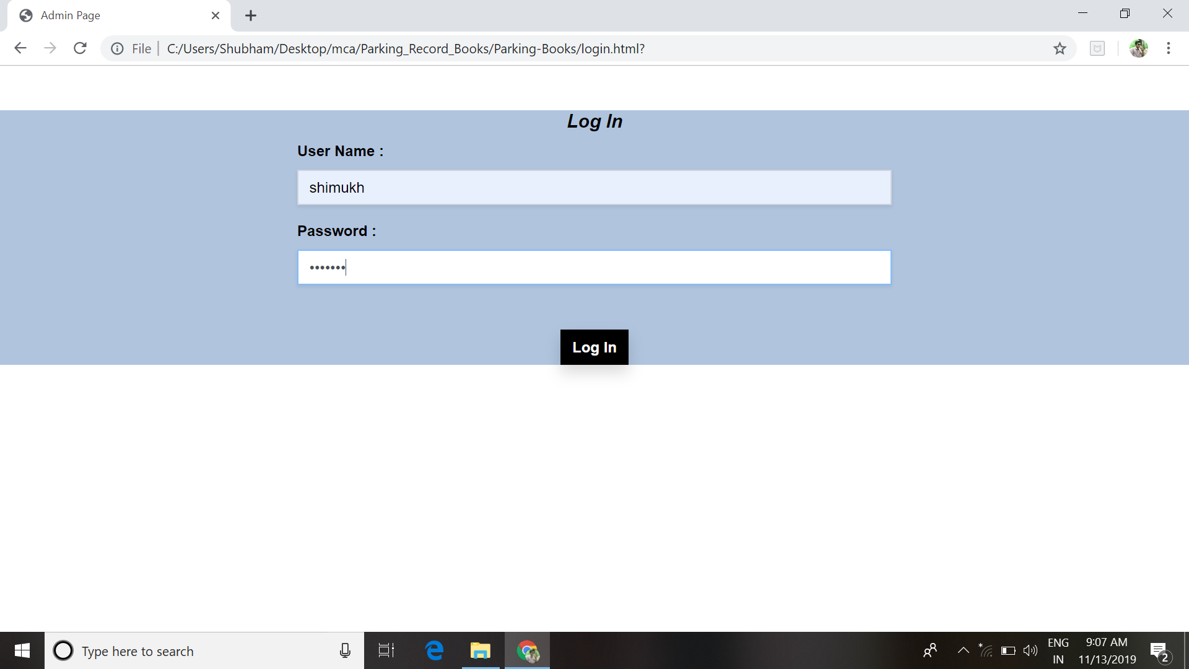
<!DOCTYPE html>
<html lang="en">
<head>
<meta charset="UTF-8">
<meta name="viewport" content="width=device-width, initial-scale=1.0">
<meta http-equiv="X-UA-Compatible" content="ie=edge">
<link rel="stylesheet" href="./CSS/bootstrap.min.css">
<link rel="stylesheet" href="./CSS/style.css">
<title>Admin Page</title>
</head>
<div class="form-container mt-5">
<form class="w-50 mx-auto" id="Form">
<h5 class="text-center" style="color: black;"><b><i>Log In </i></b></h5>
<div class="form-group">
<label for="owner" style="color: black;"><B> User Name : </B></label>
<input type="text" class="form-control rounded-0 shadow-sm" id="userName" placeholder="Enter User Name">
</div>
<div class="form-group">
<label for="car" style="color: black;"><b>Password :</b></label>
<input type="password" class="form-control rounded-0 shadow-sm" id="pass" placeholder="Enter a Password">
</div>
<button type="submit" class="btn mx-auto d-block mt-5 rounded-0 shadow" id="btnOne" onclick="myfun()"><b> Log In </b></button>
<script src="./JS/core.js"></script>
<script src="./JS/login.js"></script>
</body>
</html>

4.2 Data Entry Page :
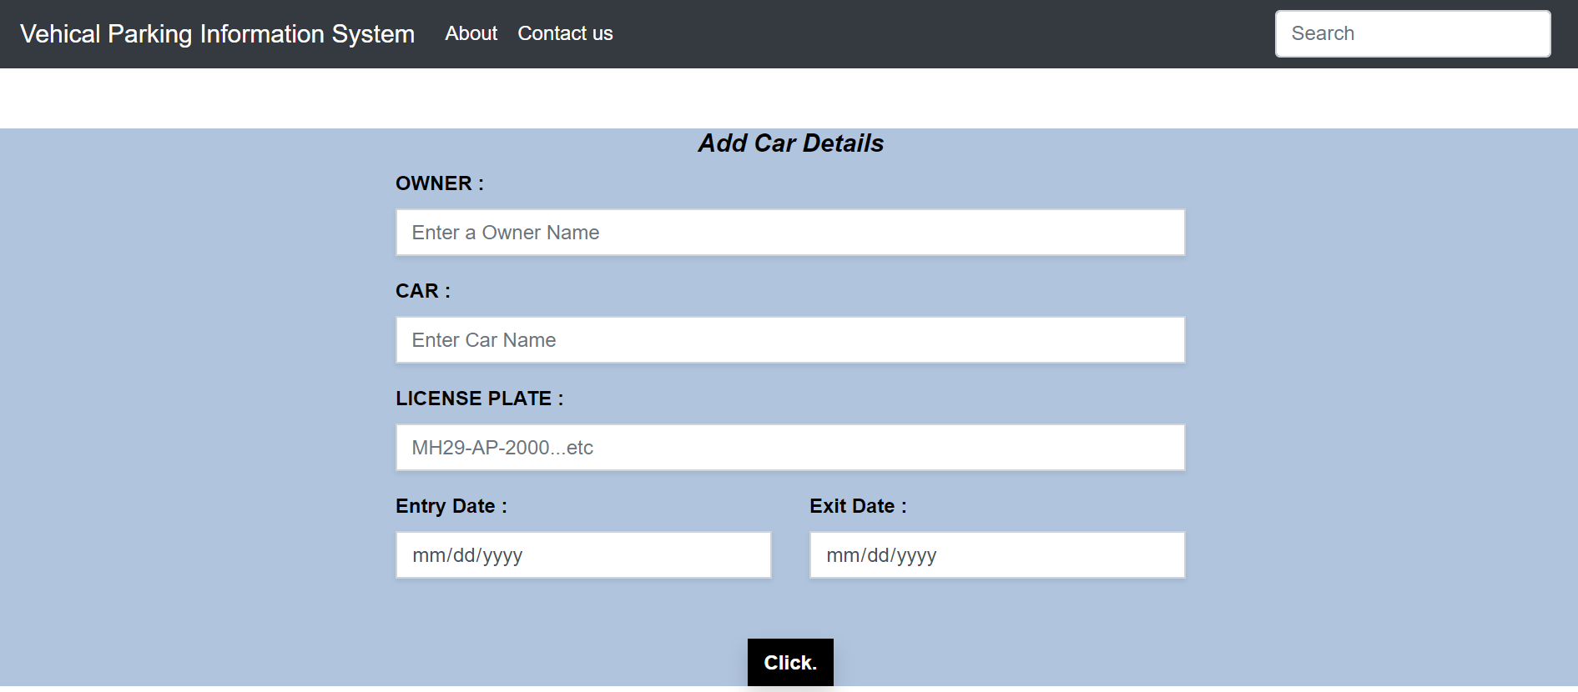
<!DOCTYPE html>
<html lang="en">

<head>
<meta charset="UTF-8">
<meta name="viewport" content="width=device-width, initial-scale=1.0">
<meta http-equiv="X-UA-Compatible" content="ie=edge">
<link rel="stylesheet" href="./CSS/bootstrap.min.css">
<link rel="stylesheet" href="./CSS/style.css">
<title>Parking Information System</title>
</head>
<nav class="navbar navbar-expand-lg navbar-dark bg-dark">
<a class="navbar-brand" href="#">Vehical Parking Information System</a>
<button class="navbar-toggler" type="button" data-toggle="collapse" data-target="#navbarSupportedContent"
aria-controls="navbarSupportedContent" aria-expanded="false" aria-label="Toggle navigation">
<span class="navbar-toggler-icon"></span>
</button>

<div class="collapse navbar-collapse" id="navbarSupportedContent">
<ul class="navbar-nav mr-auto">
<li class="nav-item active">
<a class="nav-link" href="about.html"> About <span class="sr-only">(current)</span></a>
</li>
<li class="nav-item active">
<a class="nav-link" href="contactUs.html"> Contact us <span class="sr-only">(current)</span></a>
</li>

</ul>
<form class="form-inline my-2 my-lg-0">
<input class="form-control mr-sm-2" id="searchInput" type="search" placeholder="Search"
aria-label="Search">
</form>
</div>
</nav>

<div class="form-container mt-5">
<form class="w-50 mx-auto" id="entryForm">
<h5 class="text-center" style="color: black;"><b><i>Add Car Details </i></b></h5>
<div class="form-group">
<label for="owner" style="color: black;"><B> OWNER : </B></label>
<input type="text" class="form-control rounded-0 shadow-sm" id="owner" placeholder="Enter a Owner Name">
</div>
<div class="form-group">
<label for="car" style="color: black;"><b>CAR :</b></label>
<input type="text" class="form-control rounded-0 shadow-sm" id="car" placeholder="Enter Car Name">
</div>
<div class="form-group">
<label for="licensePlate" style="color: black;"><b> LICENSE PLATE :</b></label>
<input type="text" class="form-control rounded-0 shadow-sm" id="licensePlate" placeholder="MH29-AP-2000...etc">
</div>
<div class="row">
<div class="col-6">
<label for="entryDate" style="color: black;"><B> Entry Date :</B></label>
<input type="date" class="form-control rounded-0 shadow-sm" id="entryDate">
</div>
<div class="col-6">
<label for="exitDate" style="color: black;"><B>Exit Date :</B></label>
<input type="date" class="form-control rounded-0 shadow-sm" id="exitDate">
</div>
</div>
<button type="submit" class="btn mx-auto d-block mt-5 rounded-0 shadow" id="btnOne"><b> Click. </b></button>
</form>
</div>
<script src="./JS/core.js"></script>
</body>
</html>

4.3 Data in Table Format :
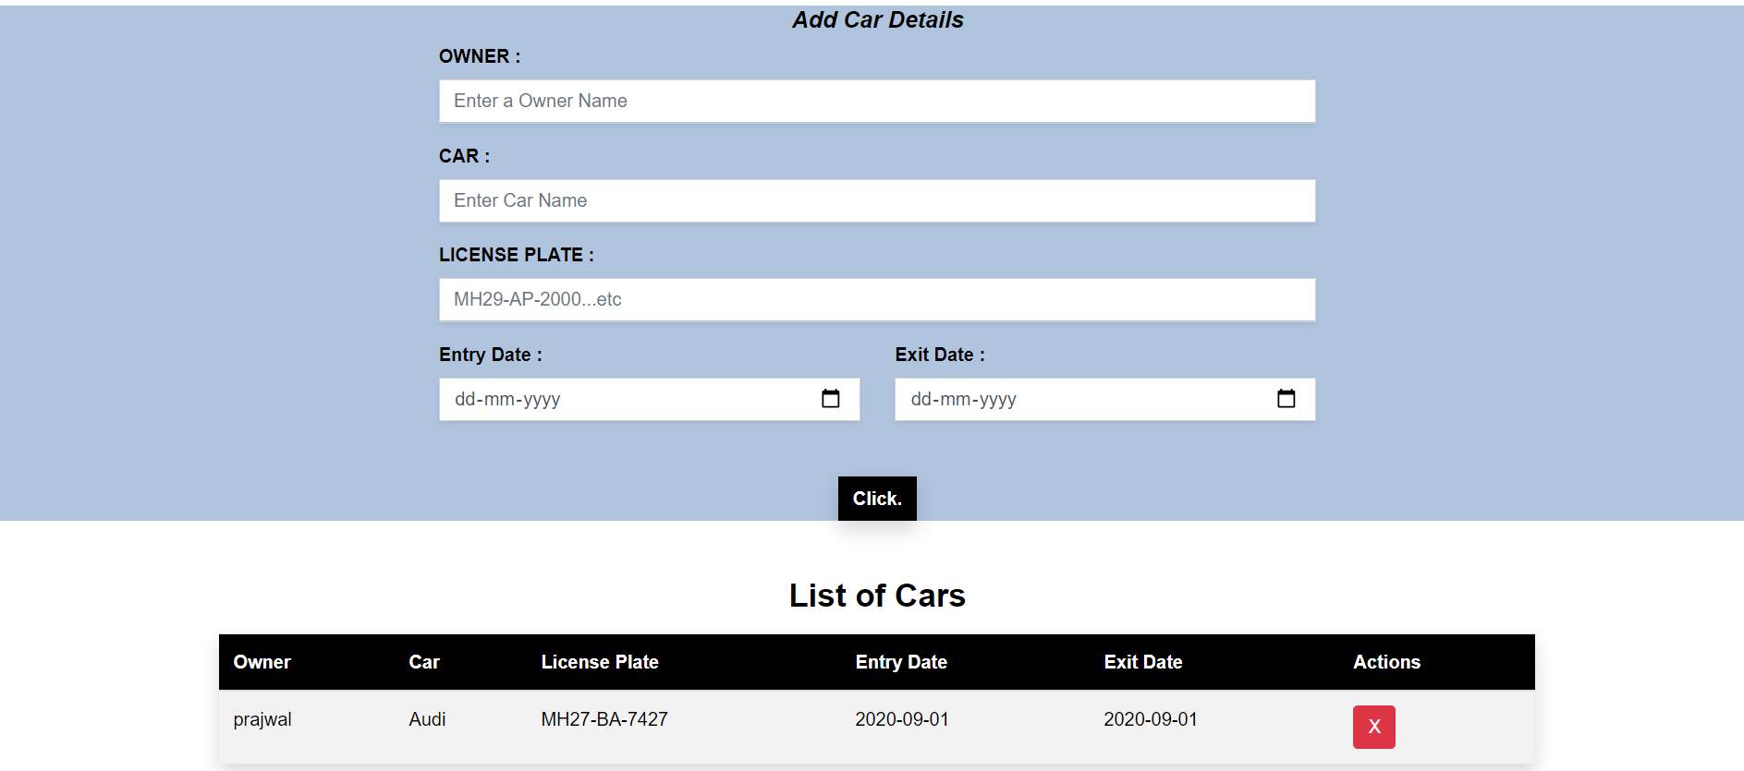
<div class="table-container mt-5 mb-5 w-75 mx-auto" >
<h3 class="text-center mb-3" style="color: black;"><b>List of Cars</b> </h3>
<table class="table table-striped shadow " id="parkingTable">
<thead class="text-darkblack" id="tableHead">
<tr>
<th scope="col">Owner</th>
<th scope="col">Car</th>
<th scope="col">License Plate</th>
<th scope="col">Entry Date</th>
<th scope="col">Exit Date</th>
<th scope="col">Actions</th>
</tr>
</thead>
<tbody id="tableBody" style="color:black;">

</tbody>
</table>
</div>

5. TESTING

5.1. Testing Approach :

Software Testing is a critical element of software quality assurance and represents the ultimate review of application, design and coding. The aim of testing process is to identify all defects existing in a software product. Testing provides a practical way of reducing defects in a system and increasing the user’s confidence in a developed system.

Testing Objective :

• Testing is a process of executing a program with a program with the intent of finding of error.
• A good test case is one of that has a high probability of finding an as yet undiscovered error.
• A successful test is one that uncover as a yet undiscovered error.

5.2. Implementation :
Once the system is tested satisfactorily with the test data, the implementation has to be done. The application is a newly developed system which will remove completely the already existing manual system.

5.2.1. Unit Testing :
In unit testing we tested different modules of system isolation. To test a program we provide set of inputs to program and observe whether it behaves as expected in unit testing we user white box approach to develop the test cases.
Unit testing focuses verification efforts on the smaller unit of software design. Using the detailed design description as a guide, important control paths are tested to uncover errors within the boundary of the module. The relative complexity of the test and the error detected as a result is limited by the constraint scope established for unit testing. The unit test is always while box oriented, and the step can be conducted in parallel for multiple modules.

5.2.2. Integrated Testing :
With unit testing the modules may function properly, but at times they may have inadvertent affect on another, sub function, when combined, may not produce the desired major functions; individually acceptable impression may be signed to unacceptable levels then global data structure may present problems.
Integration testing is a systematic technique for constructing the program structure while at the same time conducting tests to uncover errors associated with interfacing. The objective is to take unit tested modules and build a program structure that has been dictated by the design.

5.2.3. System Testing :
In system testing the software engineer should anticipate potential interfacing problems such as:
• Design error-handling paths that all information coming from other elements of the system.
• Conduct a series of tests that simulate bad data or potential errors at the software interfaces.
• Record the results of the test to use as a proof for future reference.
• Participate into planning and design of the system test to ensure that the software is adequately tested.

6. ADAVANTAGES AND DISADVANTAGES
Advantages of Vehicle Parking System :
1. Versatile
Another great benefit about parking management systems is its versatility. It is very easy for authorities and vehicle owners to use it. It is also very flexible and does not cause any inconvenience to its users. Additionally, you can adjust the settings depending on the number of vehicle traffic.

2. Easy to Manage
Because parking management systems are organised in a structured manner, it is very easy to manage as well as control and regulate. Parking management systems are also user-friendly, and the parking staff won’t have any difficulties handling the system.

3. Easy to Maintain
Maintaining your parking management system is fairly easy. Gemini Parking Solutions offer maintenance around the clock. If any part of the system becomes defective, it can easily be fixed, and your operations will continue in no time.

4. Cost-effective
Another advantage that you obtain from having an effective parking management system is the cost. Because it runs on low manpower, you save more money. Parking management systems also help you save more time, and vehicles move at a faster speed which lessens the cost of wasted fuel. Another feature of parking management system is that you can control the lights, ventilation and other services that require electricity. If that area has little to no vehicle traffic, you may easily switch it off to conserve electricity.

5. Increased Protection
With its technologically advanced security features, parking management systems can give you upgraded security, safety and privacy. Parking management systems prevent unauthorised access to your parking lots, as a result, car owners will have increased confidence that their cars are well protected.

Disadvantages of Vehicle Parking System :

It is difficult to maintain a whole a database with an images and information.
Data can be unwanted authorized access by third party.
If operating system have problem it cause error in accessing data through this software
It may be a bit confusing for unfamiliar users.

Limitations :
In summer, preferred for shaded parking spaces
Stop planting tress because of the extra cost of cleaning parking a lot

7. FUTURE SCOPE

We can add printer in future.
We can give more advance software for Vehicle Parking System including more facilities
We will host the platform on online servers to make it accessible worldwide
Integrate multiple load balancers to distribute the loads of the system
Create the master and slave database structure to reduce the overload of the database queries
Implement the backup mechanism for taking backup of codebase and database on regular basis on different servers

8. CONCLUSION

The project entitled is done in an effective manner is an efficient, time saving and easy way to report, view and control the version of file. All the operation is done efficiently. To use one, Start by Admin Login to a portal of the Vehicle parking system.
The portal shows that the information about any vehicle can fill up and it will store in a local storage. It is helpful for security that vehicle shows check-in or check-out.
This software is done using Java Script, HTML and CSS. This software is time reducing. Easy to simple and handle. Paperwork reduce and store information in a table format.

9. REFERNCES

We have refer to the following sources for assistance

1. https://nodemcu.readthedocs.io/en/master/
2. https://www.elprocus.com/infrared-ir-sensor-circuit-and-working/
3. https://electronicsofthings.com/expert-opinion/smart-city-solutions-smart-parking-lots/

