BEEE LAB EVALUATION:

QUE: Design a DJ system that produces a. Red light when a button is pressed during day. b. Green Light when a button is pressed during night.

CIRCUIT DIG:

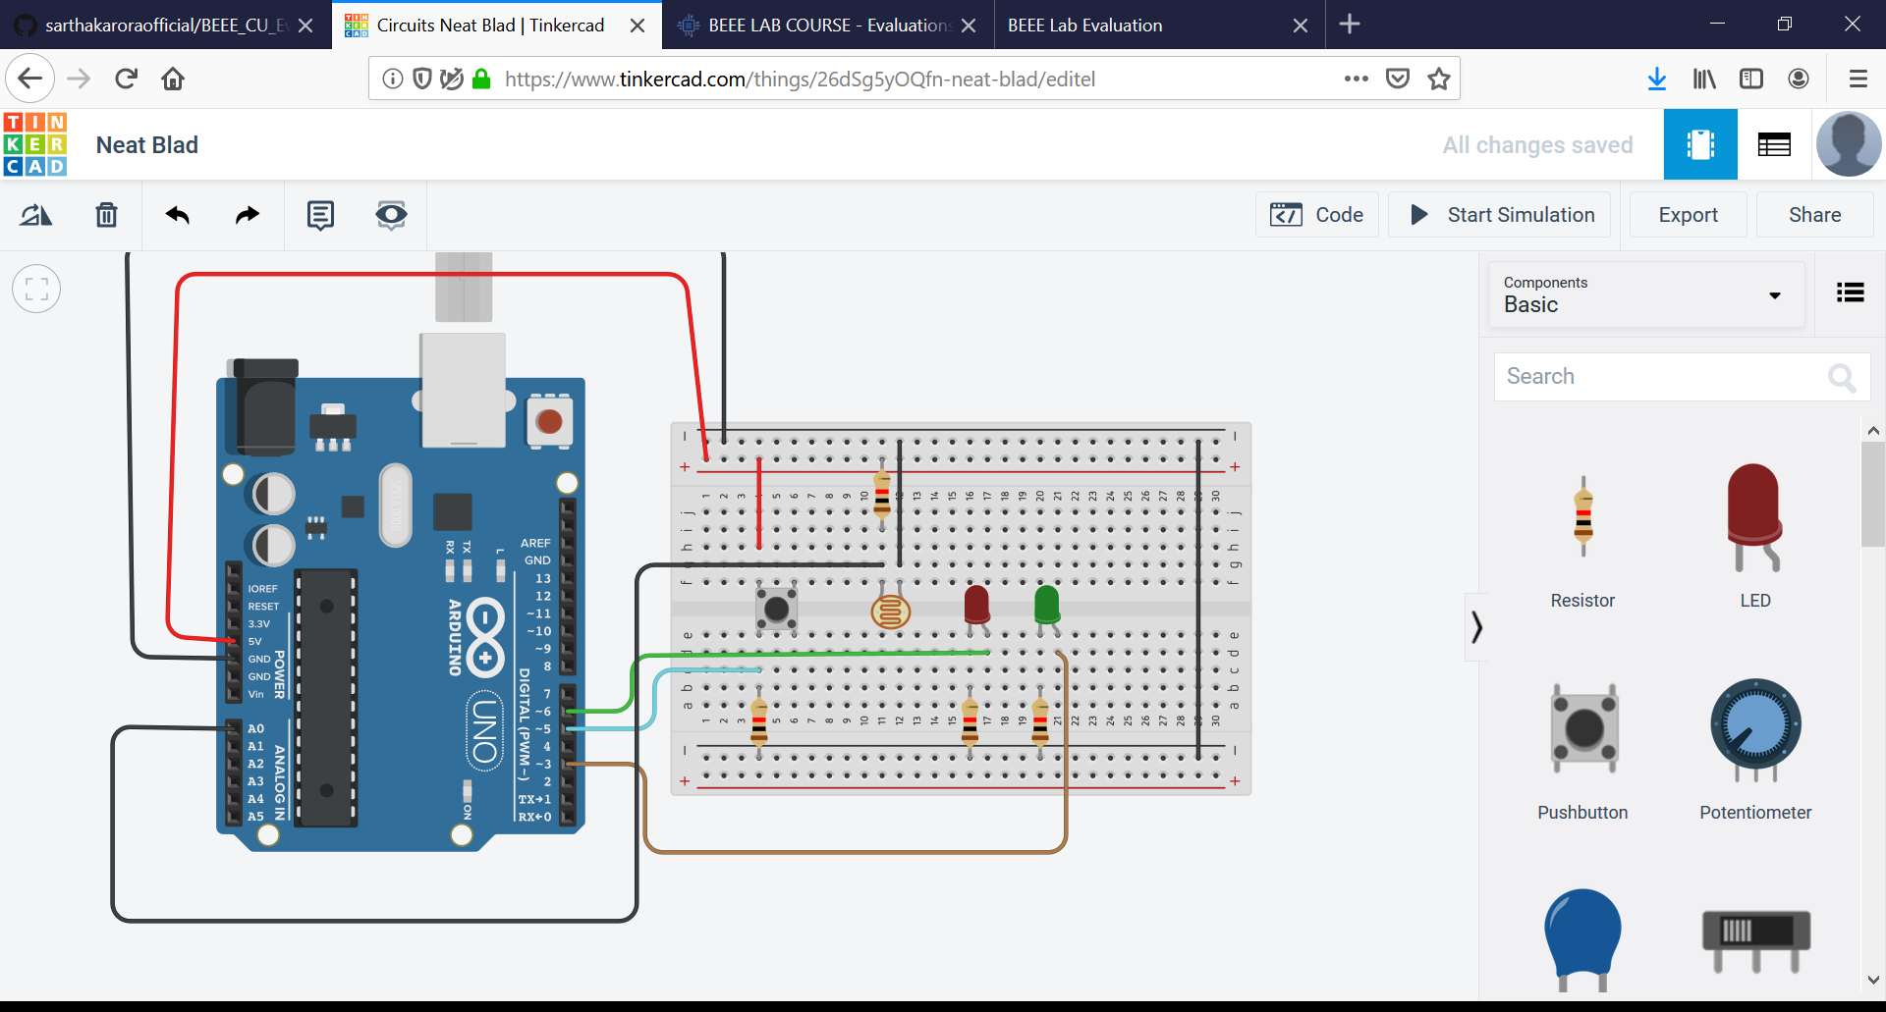

**THEORY:**

CONCEPT USED: Basic knowledge of connection of wires ,understanding the working of Arduino board and all the components of it. Basic knowledge of breadboard and coding for the working of Arduino connections of LED wire and arduino board.basic knowledge of electrical equipment is neccesory. Moreover basic understanding of simultaneously glowing LEDs and the series of glowing .

LEARNING &OBSERVATIONS:

Learning: Working of Arduino Board and working with breadboard .Making correct connections to make circuit work properly.

Observations: Red LED is blinking during Day time and Green LED is blinking during the dark because of the photo resistor.

PROBLEMS &TROUBLESHOOTING:

Problems faced during the conduction of the experiment were programming the Arduino UNO Board with different methods of coding and implementing different loops. Wrong connections . Trouble shooting can only be done by learning and implementing different codes.

PRECAUTIONS:

* Don’t use damaged equipments.
* Make the correct connections.
* Select correct port while working with Arduino.
* Using safety measures.

LEARNING OUTCOMES: Through conduction of this experiment I have learned how to program the Arduino board with different methods using programing and what set of instructions need to be passes. This experiment helps me in basic understanding of the coding and functionality .