
APPLICATION OF MACHINE LEARNING FOR PREDICTON ON DATASETS

Solid State Physics Laboratory, DRDO, Timarpur, Delhi

TRAINING IN-CHARGE: SURINDER LOI, TECHNICAL OFFICER ‘b’
28th May – 15th july
SARTHAK bABBAR | cOMPUTER SCIENCE
Jaypee Institute of Information Technology

TABLE OF CONTENT
- ABSTRACT
- ACKNOWLEDGEMENT
- OBJECTIVE
- REQUIREMENT ANALYSIS
  - HARDWARE & SOFTWARE REQUIREMENT
    - HARDWARE REQUIREMENTS
    - SOFTWARE REUIREMENTS
4.2 FEASIBILITY STUDY
4.3 PRODUCT FUNCTIONS
4.4 USE-CASE DIAGRAMS
- SYSTEM DESIGN
5.1.FLOW CHART
  - ACTIVITY DIAGRAMS
    - STUDENT PERFORMANCE PREDICTION
    - IBM EMPLOYEE ATTRITION
- DATABASE DESCRIPTION
- CODING
- TESTING & RESULTS
- CONCLUSION
- REFERENCES

- ABSTRACT

Machine learning is the science of getting computers to act without being explicitly programmed. Practical applications such as self-driving cars and speech recognition it has helped technology reach its culmination point. In this project we exploit machine learning for prediction and analysis of two different scenarios. The first scenario involves prediction of student performance in the final exam. In the second case we predict attrition of employees from a dataset fabricated by IBM engineers.

ACKNOWLEDGEMENT

I would like to place on record my deep sense of gratitude to Mr. Surinder Loi, Technical Officer ‘B’, SSPL, DRDO, India for his generous guidance, help and useful suggestions.

I also wish to extend my thanks to my colleagues for their insightful comments and constructive suggestions to improve the quality of this project work.

- OBJECTIVES
- Analyse student performance dataset and use machine learning techniques to predict student’s final marks based on various parameters. Determine which parameters have a strong correlation with final marks and which parameters are irrelevant. Predictions made from machine learning should be within a reasonable error percentage.
- Analyse IBM fabricated dataset on employees to uncover the factors that lead to employee attrition. Parameters irrelevant to attrition must be found and removed from the dataset for improved accuracy. The software should predict whether the employee would be attrited or not. The predictions of the software must be within a reasonable accuracy.

- REQUIREMENT ANALYSIS
  - HARDWARE & SOFTWARE REQUIREMENT
    - HARDWARE REQUIREMENTS
- 32- or 64-bit computer.
- Camera for car images
- Storage Space
- For Anaconda—Minimum 3 GB disk space to download and install.
- Space for web browser and other software.
- Internet connection to download software

    - SOFTWARE REUIREMENTS
- Web browser: To download python and other libraries.
- Python installed.
- Packages like Anaconda which is a popular python data science platform.
- A text editor.
- Suitable Operating system that supports python like Windows, macOS or Linux.

  - FEASIBILITY STUDY
- Technical Feasibility
- Dataset for both problem sets is readily available online, ready to be processed.
- An average computing system would suffice for analysing both datasets since both datasets are fairly small:
  - 396 rows and 32 features for student performance dataset
  - 1471 rows and 34 features for IBM employee dataset
- Time to analyse these datasets will also be fairly less due to the size of the dataset
- No special technical equipment required.
- Fairly quick to add more data for better training.
- Extremely quick to make new predictions once the model is trained.

- Operational Feasibility
- Student Performance Dataset:
  - Features found having correlation with student’s final marks must be paid extra attention for improvement in results.
  - These results would also be released to students so that they can focus on important features to improve their results.
  - College must provide resources to help improve these factors.

  - PRODUCT FUNCTIONS
STUDENT PERFORMANCE DATASET :
- The dataset must be rid of irrelevant features.
- Dataset must be visualized and analysed for patterns.
- The model should predict student final marks.
- The predictions must be within a reasonable error percentage.
IBM EMPLOYEE DATASET :
1.The dataset must be rid of irrelevant features.
2. Dataset must be visualized and analysed for patterns.
3. The model should predict whether employee is attritioned or not.
4. The predictions must be within a reasonable error percentage.
  - USE CASE DIAGRAM
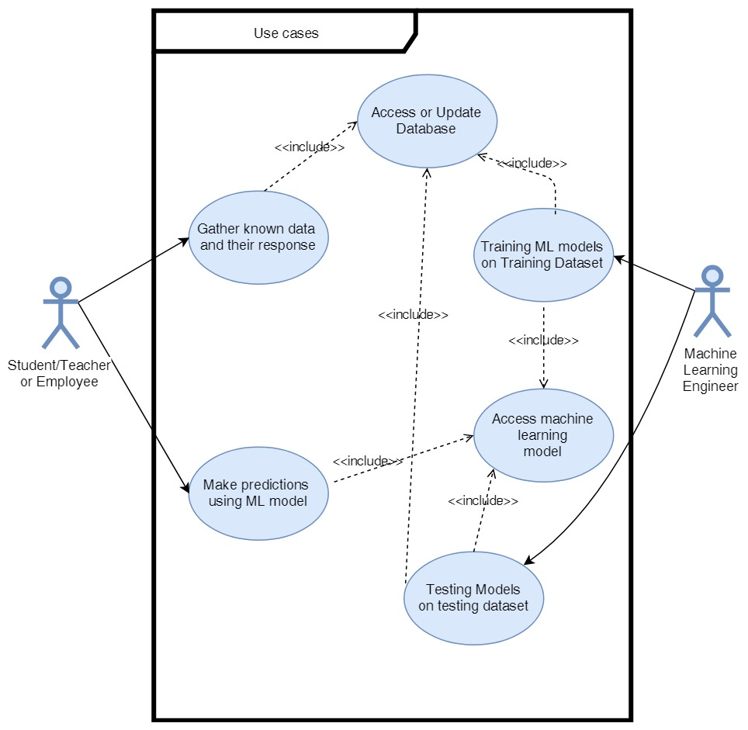

- SYSTEM DESIGN
    - FLOW CHART( BOTH DATASETS)
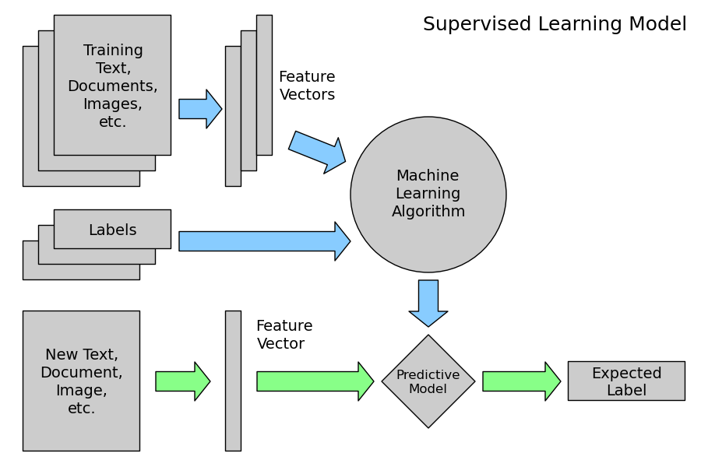

    - ACTIVITY DIAGRAM
      - STUDENT PERFORMANCE PREDICTION
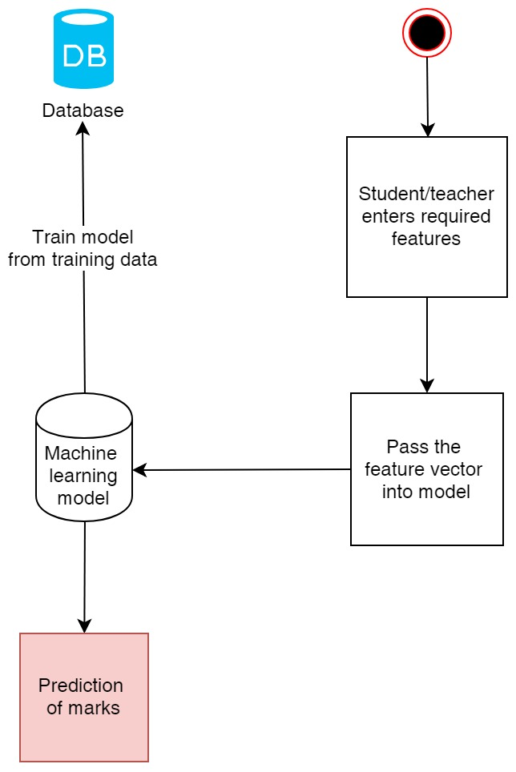

      - IBM DATASET – PREDICTION OF EMPLOYEE ATTRITION

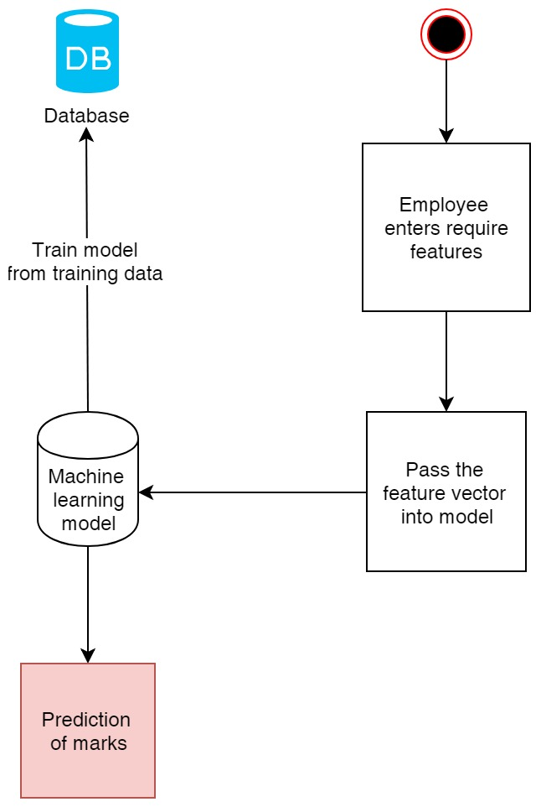
- DATABASE DESCRIPTION
  - STUDENT PERFORMANCE DATASET
This dataset has data of 395 students distributed over 33 features including the label.
Source : https://archive.ics.uci.edu/ml/datasets/student+performance
Information on the features :
1 school – student’s school (binary: “GP” – Gabriel Pereira or “MS” – Mousinho da Silveira)
2 sex – student’s sex (binary: “F” – female or “M” – male)
3 age – student’s age (numeric: from 15 to 22)
4 address – student’s home address type (binary: “U” – urban or “R” – rural)
5 famsize – family size (binary: “LE3” – less or equal to 3 or “GT3” – greater than 3)
6 Pstatus – parent’s cohabitation status (binary: “T” – living together or “A” – apart)
7 Medu – mother’s education (numeric: 0 – none, 1 – primary education (4th grade), 2 – 5th to 9th grade, 3 – secondary education or 4 – higher education)
8 Fedu – father’s education (numeric: 0 – none, 1 – primary education (4th grade), 2 – 5th to 9th grade, 3 – secondary education or 4 – higher education)
9 Mjob – mother’s job (nominal: “teacher”, “health” care related, civil “services” (e.g. administrative or police), “at_home” or “other”)
10 Fjob – father’s job (nominal: “teacher”, “health” care related, civil “services” (e.g. administrative or police), “at_home” or “other”)
11 reason – reason to choose this school (nominal: close to “home”, school “reputation”, “course” preference or “other”)
12 guardian – student’s guardian (nominal: “mother”, “father” or “other”)
13 traveltime – home to school travel time (numeric: 1 - <15 min., 2 – 15 to 30 min., 3 – 30 min. to 1 hour, or 4 - >1 hour)
14 studytime – weekly study time (numeric: 1 - <2 hours, 2 – 2 to 5 hours, 3 – 5 to 10 hours, or 4 - >10 hours)
15 failures – number of past class failures (numeric: n if 1<=n<3, else 4)
16 schoolsup – extra educational support (binary: yes or no)
17 famsup – family educational support (binary: yes or no)
18 paid – extra paid classes within the course subject (Math or Portuguese) (binary: yes or no)
19 activities – extra-curricular activities (binary: yes or no)
20 nursery – attended nursery school (binary: yes or no)
21 higher – wants to take higher education (binary: yes or no)
22 internet – Internet access at home (binary: yes or no)
23 romantic – with a romantic relationship (binary: yes or no)
24 famrel – quality of family relationships (numeric: from 1 – very bad to 5 – excellent)
25 freetime – free time after school (numeric: from 1 – very low to 5 – very high)
26 goout – going out with friends (numeric: from 1 – very low to 5 – very high)
27 Dalc – workday alcohol consumption (numeric: from 1 – very low to 5 – very high)
28 Walc – weekend alcohol consumption (numeric: from 1 – very low to 5 – very high)
29 health – current health status (numeric: from 1 – very bad to 5 – very good)
30 absences – number of school absences (numeric: from 0 to 93)
31 G1 – first period grade (numeric: from 0 to 20)
32 G2 – second period grade (numeric: from 0 to 20)
33 G3 – final grade (numeric: from 0 to 20, output target)
Features having values in form of strings were converted to numbers.

  - IBM EMPLOYEE ATTRITION DATASET
This dataset has data of 1470 employees spread over 35 features including label. This is a fictional dataset created by IBM scientists.
Source : https://www.ibm.com/communities/analytics/watson-analytics-blog/hr-employee-attrition/

- CODING
  - Student Performance Dataset
All coding was done in Spyder software in Python 3 language.
- Extra-Trees Based Feature Selection: We use Extra-Trees Classifier for ranking features of the dataset and to exclude irrelevant features.
CODE :
from sklearn.ensemble import ExtraTreesClassifier
import pandas as pd
import numpy as np
url = "dataset_1.csv"
dataset = pd.read_csv(url)
dataset=dataset.dropna(axis=1,how='any')
X=dataset
y=np.array([6,6,10,15,10,15,11,6,19,15,9,12,14,11,16,14,14,10,5,10,15,15,16,12,8,8,11,15,11,11,12,17,16,12,15,6,18,15,11,13,11,12,18,11,9,6,11,20,14,7,13,13,10,11,13,10,15,15,9,16,11,11,9,9,10,15,12,6,8,16,15,10,5,14,11,10,10,11,10,5,12,11,6,15,10,8,6,14,10,7,8,18,6,10,14,10,15,10,14,8,5,17,14,6,18,11,8,18,13,16,19,10,13,19,9,16,14,13,8,13,15,15,13,13,8,12,11,9,0,18,0,0,12,11,0,0,0,0,12,15,0,9,11,13,0,11,0,11,0,10,0,14,10,0,12,8,13,10,15,12,0,7,0,10,7,12,10,16,0,14,0,16,10,0,9,9,11,6,9,11,8,12,17,8,12,11,11,15,9,10,13,9,8,10,14,15,16,10,18,10,16,10,10,6,11,9,7,13,10,7,8,13,14,8,10,15,4,8,8,10,6,0,17,13,14,7,15,12,9,12,14,11,9,13,6,10,13,12,11,0,12,12,0,12,0,18,13,8,5,15,8,10,8,8,12,8,13,11,14,0,18,8,12,9,0,17,10,11,10,0,9,14,11,14,10,12,9,9,8,10,8,10,12,10,11,11,19,12,14,15,11,15,13,18,14,11,0,8,14,16,11,10,14,18,13,12,18,8,12,10,0,13,11,11,13,11,0,9,10,11,13,9,11,15,15,11,16,10,9,14,8,14,0,0,0,15,13,0,17,10,11,0,15,0,10,14,16,9,15,13,8,13,8,8,11,9,13,11,10,16,13,12,10,15,12,10,13,0,10,11,9,12,11,5,19,10,15,10,15,10,14,7,10,0,5,10,6,0,8,0,9,16,7,10,9])
print(X.shape)
clf = ExtraTreesClassifier()
clf = clf.fit(X, y)
print(clf.feature_importances_)
np.savetxt('treebased.csv',clf.feature_importances_, delimiter=',')

- SMOTE : Synthetic minority oversampling technique for balancing the dataset.
CODE :
import pandas as pd
import numpy as np
from imblearn.over_sampling import SMOTE
from sklearn import preprocessing
df= pd.read_csv("dataset_1.csv")
df=df.dropna(axis=0,how='any')
print(df.shape)
X=np.array(df.drop(['G3'],1))
y=np.array(df['G3'])
sm = SMOTE()
X_resampled,y_resampled = sm.fit_sample(X, y)
print(X_resampled.shape)
np.savetxt('smotex.csv',X_resampled, delimiter=',')
np.savetxt('smotey.csv',y_resampled, delimiter=',')

- Linear Regression : Code for evaluation of Linear Regression Model – Mean absolute error and Coefficient of determination – R²
CODE :
import pandas as pd
import numpy as np
from sklearn.linear_model import LinearRegression
from sklearn.metrics import mean_absolute_error
from pandas.plotting import scatter_matrix
from sklearn import preprocessing,cross_validation
#Smote Marks
#df= pd.read_csv("smotexy.csv")
#without 0 marks
df= pd.read_csv("dataset_1.csv")
#with 0 marks
#df= pd.read_csv("dataset_2.csv")
#df=df[['sex','age','address','famsize','Pstatus','Medu','Fedu','Mjob','Fjob','reason','guardian','traveltime','studytime','failures','schoolsup','famsup','paid','activities','nursery','higher','internet','romantic','famrel','freetime','goout','Dalc','Walc','health','absences','G1','G2','G3']]
#df=df[['sex','age','address','famsize','Pstatus','G1','G2','G3']]
print(df.shape)
X=np.array(df.drop(['G3'],1))
X=preprocessing.scale(X)
y=np.array(df['G3'])
X_train, X_test, y_train, y_test = cross_validation.train_test_split(X,y, test_size=0.2)
clf=LinearRegression()
clf.fit(X_train,y_train)
y_pred = clf.predict(X_test)
print("Mean absolute Error is",mean_absolute_error(y_test,y_pred) )
reg=LinearRegression()
reg.fit(X,y)
r2 = reg.score(X, y)
print("Full R2 score is",r2)
- Visualizing Predictions for particular students stored in a csv file :
CODE :
import pandas as pd
import numpy as np
from sklearn import preprocessing, cross_validation, svm
from sklearn.linear_model import LinearRegression
import matplotlib.pyplot as plt
from matplotlib import style
import datetime
from sklearn.metrics import mean_squared_error
from sklearn.metrics import r2_score

style.use('ggplot')

df= pd.read_csv("dataset_1.csv")
dp=pd.read_csv("predict.csv")
#df=df[['sex','age','address','famsize','Pstatus','Medu','Fedu','Mjob','Fjob','reason','guardian','traveltime','studytime','failures','schoolsup','famsup','paid','activities','nursery','higher','internet','romantic','famrel','freetime','goout','Dalc','Walc','health','absences','G1','G2','G3']]

print(df.shape)

df=df.dropna(axis=0,how='any')
print(df.shape)
X=np.array(df.drop(['G3'],1))
X_predict=np.array(dp.drop(['G3'],1))
X_predict=preprocessing.scale(X_predict)
X=preprocessing.scale(X)

y=np.array(df['G3'])
g2=np.array(df['G2'])
g2_predict=np.array(dp['G2'])
clf=LinearRegression()
clf.fit(X,y)

y_pred = clf.predict(X_predict)

np.savetxt('predictions.csv',y_pred, delimiter=',')

plt.scatter(g2, y, color='black')
plt.scatter(g2_predict,y_pred,color='blue',lw=3)
plt.legend(loc=4)
plt.xlabel('2nd Term Marks')
plt.ylabel('Final Marks')
plt.show()

- SVM : Support Vector Machines for Prediction
CODE :
import pandas as pd
import numpy as np
from sklearn import preprocessing, cross_validation, svm
from sklearn.linear_model import LinearRegression
import matplotlib.pyplot as plt
from matplotlib import style
import datetime
from sklearn.metrics import mean_squared_error
from sklearn.metrics import r2_score
from sklearn.metrics import mean_absolute_error
style.use('ggplot')
df= pd.read_csv("smotexy.csv")
#without 0 marks
#df= pd.read_csv("dataset_1.csv")
#with 0 marks
#df= pd.read_csv("dataset_2.csv")
#df=df[['sex','age','address','famsize','Pstatus','Medu','Fedu','Mjob','Fjob','reason','guardian','traveltime','studytime','failures','schoolsup','famsup','paid','activities','nursery','higher','internet','romantic','famrel','freetime','goout','Dalc','Walc','health','absences','G1','G2','G3']]
print(df.shape)
X=np.array(df.drop(['G3'],1))
X=preprocessing.scale(X)
y=np.array(df['G3'])
X_train, X_test, y_train, y_test = cross_validation.train_test_split(X,y, test_size=0.2)
clf=svm.SVC()
clf.fit(X_train,y_train)
y_pred = clf.predict(X_test)
print("Mean absolute Error is",mean_absolute_error(y_test,y_pred) )
reg=svm.SVC()
reg.fit(X,y)
r2 = reg.score(X, y)
print("Full R2 score is",r2)

- KNN : K- Nearest – Neighbors
CODE :

import pandas as pd
import numpy as np
from sklearn import preprocessing, cross_validation, svm , neighbors
from sklearn.linear_model import LinearRegression
import matplotlib.pyplot as plt
from matplotlib import style
import datetime
from sklearn.metrics import mean_squared_error
from sklearn.metrics import r2_score
from sklearn.metrics import mean_absolute_error
style.use('ggplot')
df= pd.read_csv("smotexy.csv")
#without 0 marks
#df= pd.read_csv("dataset_1.csv")
#with 0 marks
#df= pd.read_csv("dataset_2.csv")
#df=df[['sex','age','address','famsize','Pstatus','Medu','Fedu','Mjob','Fjob','reason','guardian','traveltime','studytime','failures','schoolsup','famsup','paid','activities','nursery','higher','internet','romantic','famrel','freetime','goout','Dalc','Walc','health','absences','G1','G2','G3']]
print(df.shape)
X=np.array(df.drop(['G3'],1))
X=preprocessing.scale(X)
y=np.array(df['G3'])
X_train, X_test, y_train, y_test = cross_validation.train_test_split(X,y, test_size=0.2)
clf=neighbors.KNeighborsClassifier()
clf.fit(X_train,y_train)
y_pred = clf.predict(X_test)
print("Mean absolute Error is",mean_absolute_error(y_test,y_pred) )
reg=svm.SVC()
reg.fit(X,y)
r2 = reg.score(X, y)
print("Full R2 score is",r2)

  - IBM EMPLOYEE DATASET
- SVM : SUPPORT VECTOR MACHINES
CODE :
import numpy as np
import pandas as pd
import matplotlib.pyplot as plt
from sklearn import preprocessing, cross_validation, svm
from sklearn.metrics import accuracy_score
df= pd.read_csv("ibm.csv")
dummy_fields = ['BusinessTravel', 'Department', 'EducationField', 'JobRole', 'MaritalStatus']
for each in dummy_fields:
dummies = pd.get_dummies(df[each], prefix=each, drop_first=False)
df = pd.concat([df, dummies], axis=1)
fields_to_drop = ['BusinessTravel', 'Department', 'EducationField', 'JobRole', 'MaritalStatus']
df = df.drop(fields_to_drop, axis=1)
X= np.array(df.drop(['Attrition'],1))
X=preprocessing.scale(X)
y=np.array(df['Attrition'])
X_train, X_test, y_train, y_test = cross_validation.train_test_split(X,y, test_size=0.2)
clf=svm.SVC()
clf.fit(X_train,y_train)
print(clf.score(X_test,y_test))

- KNN – K-NEAREST NEIGHBORS (From Scratch)
CODE :
import numpy as np
import warnings
from collections import Counter
import pandas as pd
import random
def k_nearest_neighbors(data,predict,k=3):
if len(data) >=k:
warnings.warn('K is set to a value less than total voting groups!')
distances=[]
for group in data:
for features in data[group]:
euclidean_distance= np.linalg.norm(np.array(features) - np.array(predict))
distances.append([euclidean_distance, group])
votes=[i[1] for i in sorted(distances)[:k]]
#contains sorted classes since we are calculating i[1] which is class and i[0] is distance
#print(Counter(votes).most_common(1))
votes_result = Counter(votes).most_common(1)[0][0]
confidence = Counter(votes).most_common(1)[0][1]/k
#print(votes_result,confidence)
return votes_result,confidence
accuracies = []
for i in range(10):
df=pd.read_csv('ibm.csv')
df.replace('?',-99999,inplace=True)
#df.drop(['id'],1,inplace=True)
full_data=df.astype(float).values.tolist()
random.shuffle(full_data)
test_size=0.4
train_set = {1:[] , 0:[]}
test_set={1:[] , 0:[]}
train_data=full_data[:-int(test_size*len(full_data))]
test_data=full_data[-int(test_size*len(full_data)):]
#i[-1] is the last column
for i in train_data:
train_set[i[-1]].append(i[:-1])
for i in test_data:
test_set[i[-1]].append(i[:-1])
correct=0
total=0

for group in test_set:
for data in test_set[group]:
vote,confidence = k_nearest_neighbors(train_set,data,k=5)
if group == vote:
correct+=1
#else:
#print(confidence)
total+=1
#print('Accuracy :', correct/total)
accuracies.append(correct/total)
print(sum(accuracies)/len(accuracies))

- EXTRA-TREE BASED FEATURE SELECTION :
CODE :
from sklearn.ensemble import ExtraTreesClassifier
import pandas as pd
import numpy as np
from sklearn import preprocessing
url = "ibm.csv"
df = pd.read_csv(url)
X=np.array(df.drop(['Attrition'],1))
y=np.array(df['Attrition'])
print(X.shape)
X=preprocessing.scale(X)
clf = ExtraTreesClassifier()
clf = clf.fit(X, y)
print(clf.feature_importances_)
np.savetxt('treebased.csv',clf.feature_importances_, delimiter=',')
- NEURAL NETWORK CODE :
import numpy as np
import pandas as pd
import matplotlib.pyplot as plt
from sklearn import cross_validation,preprocessing
from my_answers import NeuralNetwork
def MSE(y, Y):
return np.mean((y-Y)**2)
data_path = 'ibm.csv'
df = pd.read_csv(data_path)
#print(df.head())
dummy_fields = ['Department', 'EducationField', 'JobRole', 'MaritalStatus']
for each in dummy_fields:
dummies = pd.get_dummies(df[each], prefix=each, drop_first=False)
df = pd.concat([df, dummies], axis=1)
fields_to_drop = ['Department', 'EducationField', 'JobRole', 'MaritalStatus']
data = df.drop(fields_to_drop, axis=1)
#print(data.shape)
X= np.array(data.drop(['Attrition'],1))
X=preprocessing.scale(X)
y=np.array(data['Attrition'])
X_train, test_features, y_train, test_targets = cross_validation.train_test_split(X,y, test_size=0.2)
train_features,val_features, train_targets, val_targets = cross_validation.train_test_split(X_train,y_train,test_size=0.2)
import sys
from my_answers import iterations, learning_rate, hidden_nodes, output_nodes
N_i = train_features.shape[1]
network = NeuralNetwork(N_i, hidden_nodes, output_nodes, learning_rate)
losses = {'train':[], 'validation':[]}
for ii in range(iterations):
# Go through a random batch of 128 records from the training data set
X, y = train_features, train_targets
network.train(X, y)
# Printing out the training progress
train_loss = MSE(network.run(train_features).T, train_targets)
val_loss = MSE(network.run(val_features).T, val_targets)
sys.stdout.write("\rProgress: {:2.1f}".format(100 * ii/float(iterations)) \
+ "% ... Training loss: " + str(train_loss)[:5] \
+ " ... Validation loss: " + str(val_loss)[:5])
sys.stdout.flush()
losses['train'].append(train_loss)
losses['validation'].append(val_loss)
plt.plot(losses['train'], label='Training loss')
plt.plot(losses['validation'], label='Validation loss')
plt.legend()
_ = plt.ylim()
from sklearn.metrics import accuracy_score
from sklearn.metrics import mean_absolute_error
predictions = network.run(test_features)
mae=mean_absolute_error(test_targets,predictions)
print(mae)
np.savetxt('predictions.csv', predictions , delimiter=',')
np.savetxt('actual.csv', test_targets , delimiter=',')
for i in range(len(predictions)):
if(predictions[i][0] >= 0.5):
predictions[i][0] = 1
else:
predictions[i][0] = 0

accuracy_score(test_targets,predictions)
  - Neural Network Class :
import numpy as np
class NeuralNetwork(object):
def __init__(self, input_nodes, hidden_nodes, output_nodes, learning_rate):
# Set number of nodes in input, hidden and output layers.
self.input_nodes = input_nodes
self.hidden_nodes = hidden_nodes
self.output_nodes = output_nodes
# Initialize weights
self.weights_input_to_hidden = np.random.normal(0.0, self.input_nodes**-0.5, (self.input_nodes, self.hidden_nodes)) self.weights_hidden_to_output = np.random.normal(0.0, self.input_nodes**-0.5, (self.hidden_nodes,self.output_nodes))
self.lr = learning_rate
#### TODO: Set self.activation_function to your implemented sigmoid function ####
#
# Note: in Python, you can define a function with a lambda expression,
# as shown below.
#self.activation_function = lambda x : # Replace 0 with your sigmoid calculation.
### If the lambda code above is not something you're familiar with,
# You can uncomment out the following three lines and put your
# implementation there instead.
#
def sigmoid(x):
return 1/(1+np.exp(-x))
self.activation_function = sigmoid
def train(self, features, targets):
''' Train the network on batch of features and targets.
Arguments
---------
features: 2D array, each row is one data record, each column is a feature
targets: 1D array of target values
'''
n_records = features.shape[0]
delta_weights_i_h = np.zeros(self.weights_input_to_hidden.shape)
delta_weights_h_o = np.zeros(self.weights_hidden_to_output.shape)
for X, y in zip(features, targets):
final_outputs, hidden_outputs = self.forward_pass_train(X) # Implement the forward pass function below
# Implement the backproagation function below
delta_weights_i_h, delta_weights_h_o = self.backpropagation(final_outputs, hidden_outputs, X, y,
delta_weights_i_h, delta_weights_h_o)
self.update_weights(delta_weights_i_h, delta_weights_h_o, n_records)
def forward_pass_train(self, X):
''' Implement forward pass here
Arguments
---------
X: features batch
'''
#### Implement the forward pass here ####
### Forward pass ###
# TODO: Hidden layer - Replace these values with your calculations.
hidden_inputs = np.dot(X,self.weights_input_to_hidden)
hidden_outputs = self.activation_function(hidden_inputs)
# TODO: Output layer - Replace these values with your calculations.
final_inputs = np.dot(hidden_outputs,self.weights_hidden_to_output)
final_outputs = final_inputs
return final_outputs, hidden_outputs
def backpropagation(self, final_outputs, hidden_outputs, X, y, delta_weights_i_h, delta_weights_h_o):
#### Implement the backward pass here ####
### Backward pass ###
# TODO: Output error - Replace this value with your calculations.
error = y-final_outputs
# TODO: Backpropagated error terms - Replace these values with your calculations.
output_error_term = error
# TODO: Calculate the hidden layer's contribution to the error
hidden_error = np.dot(self.weights_hidden_to_output,output_error_term)
#print(hidden_error)
hidden_error_term = hidden_error * hidden_outputs * (1-hidden_outputs)
# Weight step (input to hidden)
delta_weights_i_h = delta_weights_i_h + hidden_error_term*X[:,None]
# Weight step (hidden to output)
delta_weights_h_o += output_error_term*hidden_outputs[:,None]
return delta_weights_i_h, delta_weights_h_o
def update_weights(self, delta_weights_i_h, delta_weights_h_o, n_records):
self.weights_hidden_to_output += (self.lr*delta_weights_h_o)/(n_records)
self.weights_input_to_hidden += (self.lr*delta_weights_i_h)/(n_records)
def run(self, features):
#### Implement the forward pass here ####
# TODO: Hidden layer - replace these values with the appropriate calculations.
hidden_inputs = np.dot(features,self.weights_input_to_hidden)
hidden_outputs = self.activation_function(hidden_inputs)
# TODO: Output layer - Replace these values with the appropriate calculations.
final_inputs = np.dot(hidden_outputs,self.weights_hidden_to_output)
final_outputs = final_inputs
return final_outputs
#########################################################
#hyperparameters
##########################################################
iterations = 2500
learning_rate = 0.06
hidden_nodes = 20
output_nodes = 1

- TESTING
  - STUDENT PERFORMANCE PREDICTION
    - Extra-Tree based Feature Selection:
This algorithm helps in ranking the features. It assigns an importance value in exponential form which can then help us to rank all the features as follows :
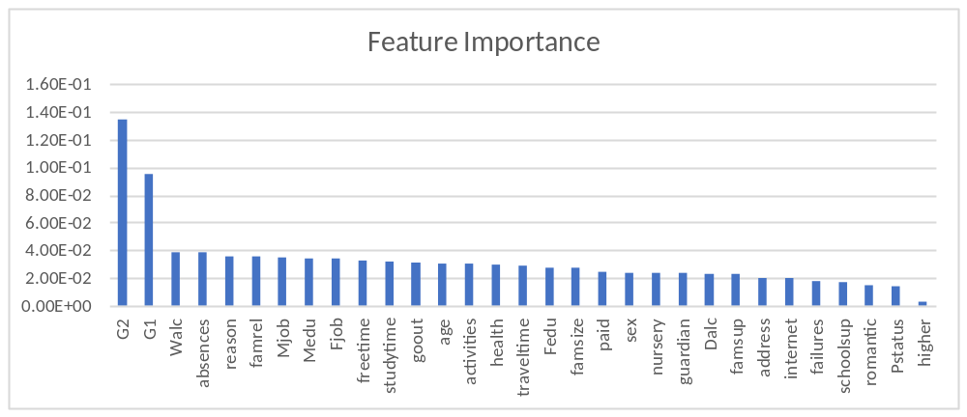
As we can see student marks in first and second term turn out to be the most important for predicting final marks.The other features have about the same importances.
Visualizing the correlation between 2nd term and final term marks and 1st term and final term marks reveal a strong correlation between them:
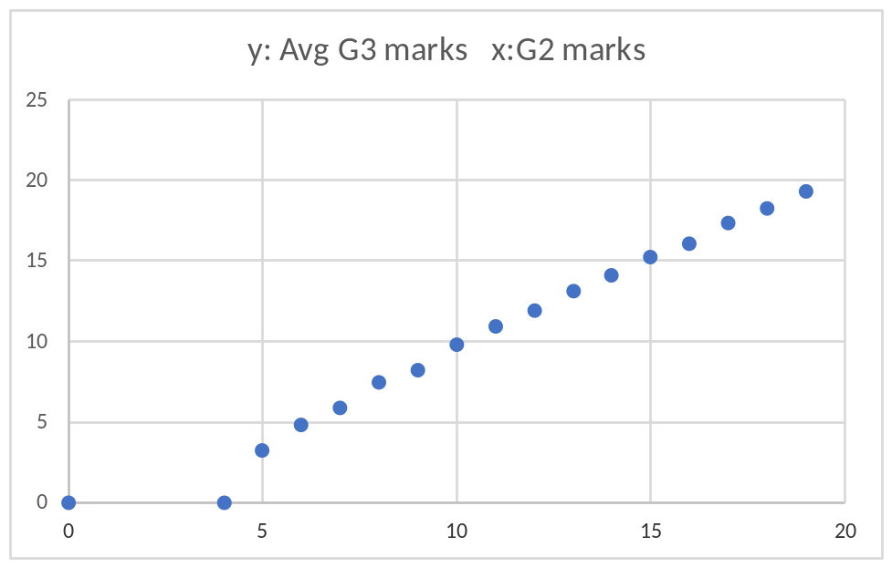
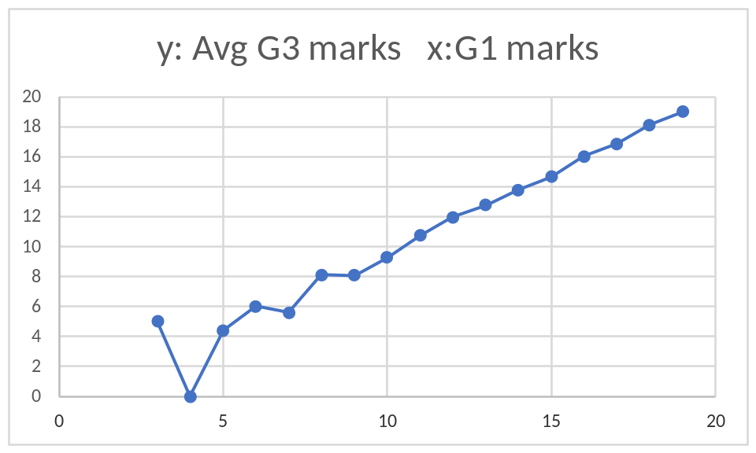

    - BALANCING DATASET WITH SMOTE
This is our initial dataset with number of students for each marks. One of the biggest problem here is an imbalance of the number of students for each marks.This could create a strong bias in our machine learning model which could lead to poor results.
Another problem here is the number of students with 0 marks.There are no features that could possibly predict 0 marks.Students who scored 0 could have had sudden medical/family emergencies or simply their marks could be unavailable so they were entered as 0.Students with 0 marks should be treated as an exception which could not be predicted by any of the features(can be seen in the graphs above) and should be removed from the dataset.Each machine learning model was tested with and without 0 marks.
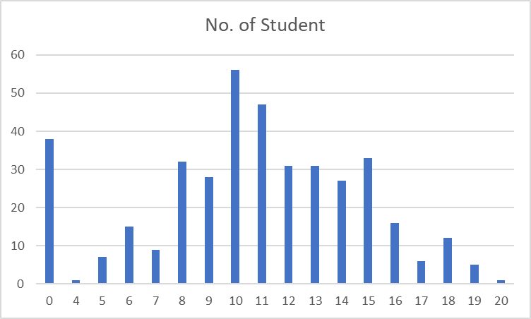
To solve the problem of imbalance we use SMOTE which generates new samples like oversampling, except for that fact that it generates new samples in the vicinity of existing samples instead of copying existing samples.The new generated dataset had balanced no. of students for each marks as shown.
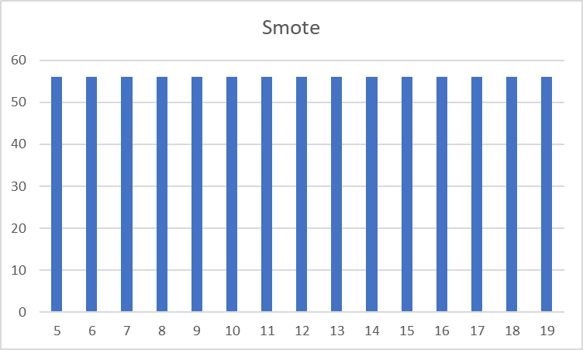
Note : students with 0 marks were removed for SMOTE for reasons explained above.
How smote generate new sample can be seen in the below scatter plot.The plot is 2nd term marks against final term marks before and after smote.

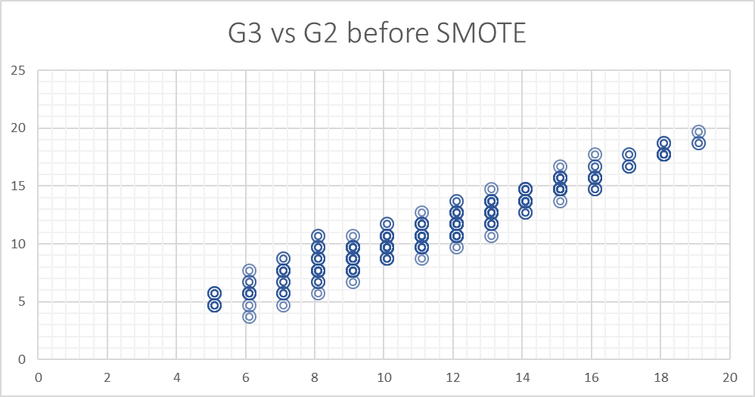

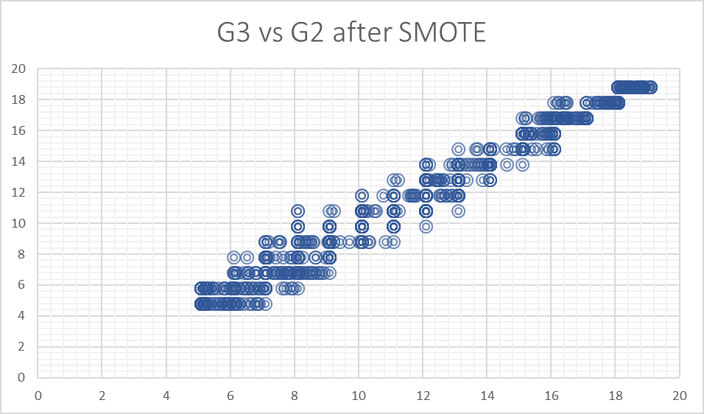
See how the second graph is more dense because of the new samples generated amongst the existing samples.
    - TESTING MODELS ON ORIGINAL DATASETS
Testing Size = 20% Training Size = 80%
Score can be between 0 and 1. The bigger score , the better.
Mean absolute error can be between 0 and 20. The lower the mean absolute error the better.
Model Name &  Evaluation Metric | Linear Regression  Coefficient of Determination(R²⁾ | SVM  Mean Accuracy | KNN  Mean Accuracy
Evaluation Metric Score  (Averaged over 5 observations) | 0.824 | 0.728 | 0.36
Mean Absolute Error  (Averaged over 5 observations) | 1.36 | 2.35 | 3.35

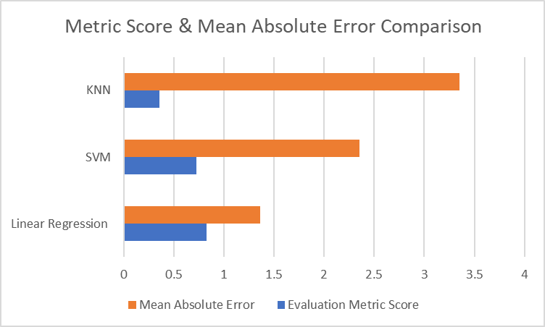
    - TESTING MODELS WITH NO STUDENTS HAVING 0 MARKS
Students having 0 marks cannot be explained by any of the features present. The student may be absent for emergencies, medically unfit etc. Including students having 0 marks in our dataset will eventually bring down our accuracy.This hypothesis was confirmed with increased accuracies :
Testing Size = 20% Training Size = 80%
Score can be between 0 and 1. The bigger score , the better.
Mean absolute error can be between 0 and 20. The lower the mean absolute error the better.

Model Name &  Evaluation Metric | Linear Regression  Coefficient of Determination(R²⁾ | SVM  Mean Accuracy | KNN  Mean Accuracy
Evaluation Metric Score  (Averaged over 5 observations) | 0.93 | 0.754 | 0.42
Mean Absolute Error  (Averaged over 5 observations) | 0.64 | 1.67 | 2.24

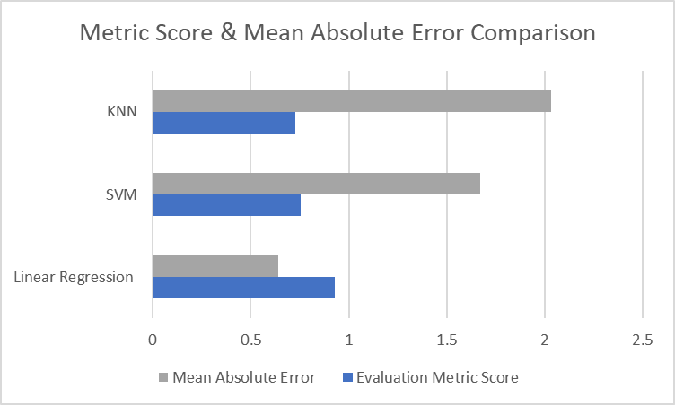

    - TESTING MODELS WITH SMOTE DATASET
SMOTE dataset makes the dataset less biased as explained in methodology section.Improvements over the normal dataset is expected.
Model Name &  Evaluation Metric | Linear Regression  Coefficient of Determination(R²⁾ | SVM  Mean Accuracy | KNN  Mean Accuracy
Evaluation Metric Score  (Averaged over 5 observations) | 0.97 | 0.96 | 0.80
Mean Absolute Error  (Averaged over 5 observations) | 0.53 | 0.43 | 0.99

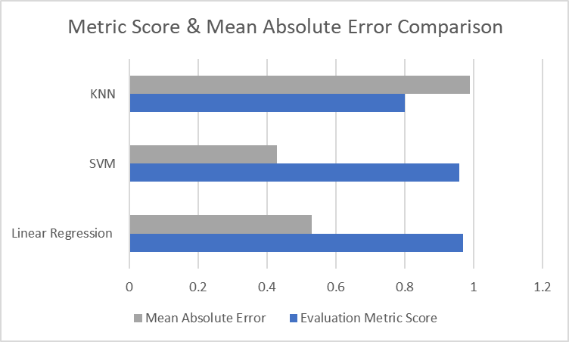

    - COMPARISON OF METRIC SCORES
Comparison of all datasets across different models is shown below.The bigger the metric score, the better.As we can see Linear Regression has the best score as expected.However, we cant compare the scores of LR with SVM and KNN directly since LR uses a coefficient of determination for metric evaluation while SVM and KNN use mean accuracy.
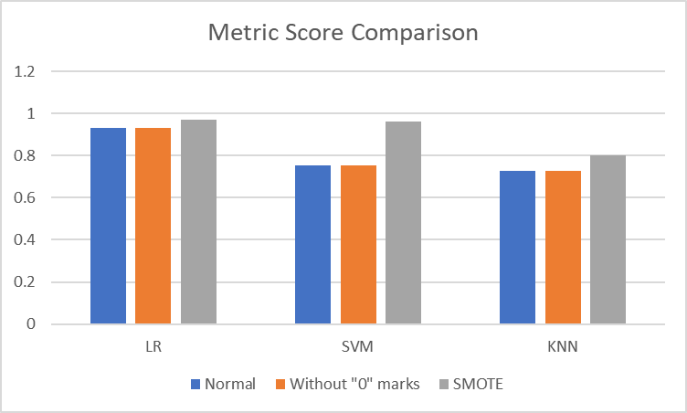

    - COMPARISON OF MEAN ABSOLUTE ERROR
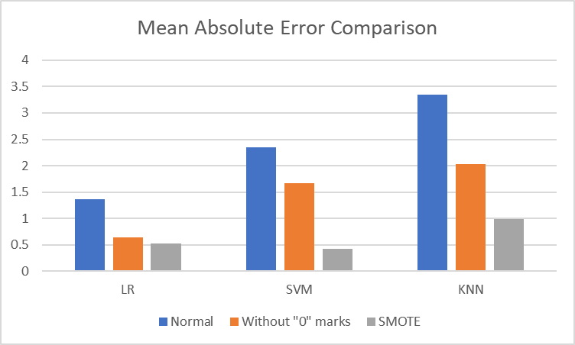
As we can see here, SVM performs the best, under SMOTE dataset as it has the least absolute error.Mean Absolute Error is a better comparison method since we can compare the performance of LR with KNN and SVM directly. This result is an unusual one since SVM is used for classification problems, but it outperformed LR even in a regression problem.
- VISUALISING DIFFERENCE :
Difference in prediction and actual marks for a testing set of 72 students visualized for Linear Regression :
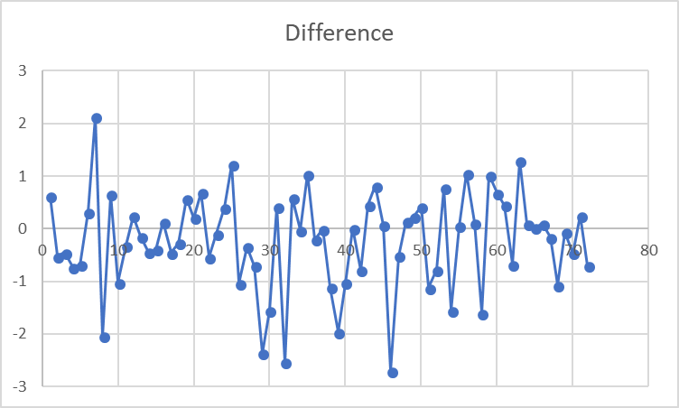
- VISUALIZING PREDICTIONS
The following graph shows the predictions for 15 students with respect to the second term marks of all students.The black dot shows the training data while the blue dots show the predicted data.
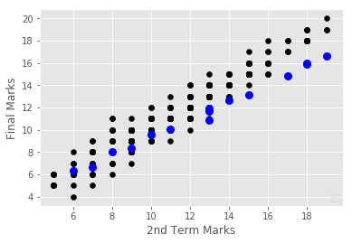
The data looks very sparse since majority of the data points are overlapping.
  - IBM DATASET : PREDICTION OF EMPLOYEE ATTRITION
    - TREE BASED FEATURE SELECTION
Since the dataset has many features, its always beneficial to exclude some less important features.
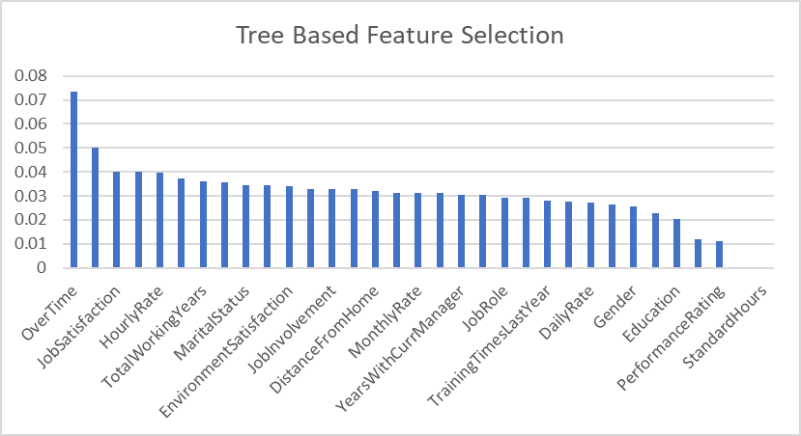
However tree based feature selection showed that all features are almost equally important.
    - VISUALIZING OUR DATA
The following figure shows the distribution of attrition across all the salaries.
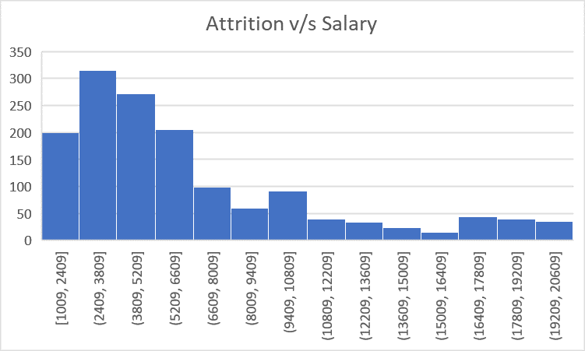
As we can see most of the attrition occurs amongst the lower salaries which is an interesting observation.
Attrition Distribution :
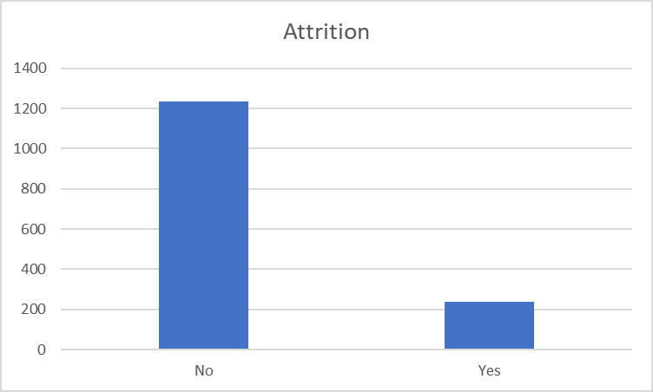
As you can see that a very small portion of the employees are actually attritioned.These makes our machine learning models to be more biased to predicting that employee will be attritioned.Removing this bias can help improve our predictions.
    - BALANCING THE DATASET WITH SMOTE
Visualizing the data after balancing it with smote :
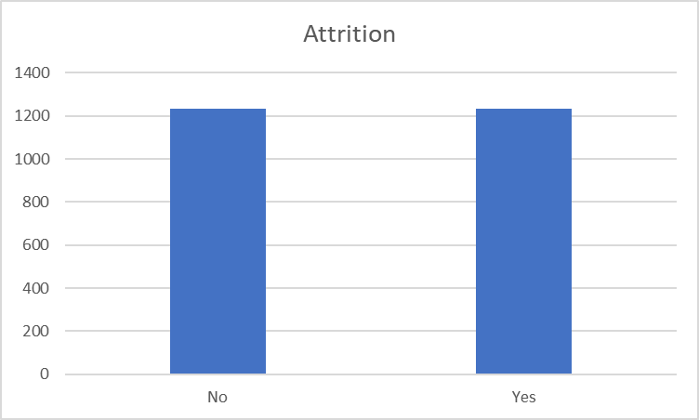
As we can see both the classes have equal number of instances, 1233 to be exact.
    - NEURAL NETWORK : VALIDATION V/S TRAINING LOSS
Validation loss helps us to verify how accurate the neural network is during training.If we train the network too much it can get over specific to the training set and the validation loss will start increasing.We have to set our parameters : iterations, hidden nodes, output nodes,learning rate.After testing out different values of parameters , the following were chosen :
iterations = 2500
learning_rate = 0.06
hidden_nodes = 20
output_nodes = 1
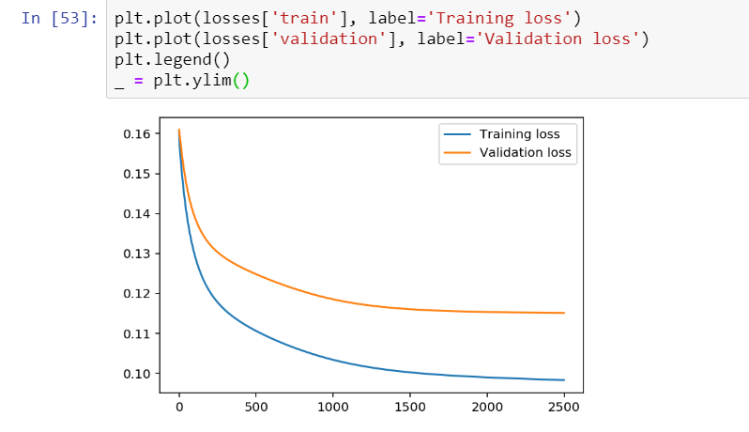
As you can see both the validation and training loss reduce as the number of iterations increase.

    - TESTING MODELS ON ORIGINAL DATASET
We have used mean accuracy as an evaluation score.
Model Name | NEURAL NETWORK | SVM | KNN
Evaluation Metric Score  (Averaged over 5 observations) | 86.59 | 86.39 | 82.24%

    - TESTING MODELS WITH SMOTE DATASET
We have used mean accuracy as an evaluation score.
Model Name | NEURAL NETWORK | SVM  (Averaged over 5 observations) | KNN  (Averaged over 5 observations)
Evaluation Metric Score | 78.7% | 89.55 | 75.23%

Although accuracies of neural network and knn have reduced, these models are more realistic since they are training for both “Yes” and “No” equally. The earlier model seemed to be better although it was not. Most of the data in the testing set was for “No” to attrition and the model was predicting “No” all the time.The only time it was wrong when the dataset was of “Yes” to attrition and that was very rare, hence the great accuracies

- CONCLUSION
Machine learning models for both the datasets have been implemented with reasonable accuracies for prediction.Techniques like SMOTE were applied on the dataset to help make the dataset less biased.Tree-based feature extraction was used to study the important features in the dataset and get rid of the irrelevant ones.Some unusual results were found, SVM which is a model used for categorization outperformed Linear Regression in terms of mean absolute error,in our regression problem, predicting the performance of students.A Neural network with one hidden layer was implemented for our IBM Attrition prediction.Its performance was compared with SVM and KNN.SVM performed the best under the SMOTE dataset with an mean accuracy of 89.55.

- REFERENCES
Student Performance Dataset : https://archive.ics.uci.edu/ml/datasets/student+performance
IBM dataset : https://www.ibm.com/communities/analytics/watson-analytics-blog/hr-employee-attrition/
SMOTE : https://jair.org/index.php/jair/article/view/10302

