### **SCGJ/Safai Karamchari -App**

### **Create Data Base**

1. Copy *“DbScript/createTableMaster.sql”* directory of source code to server on AWS.
2. Copy the content of *createTableMaster.sql* to MySql workbench window.
3. Execute it with the button shown in image below.

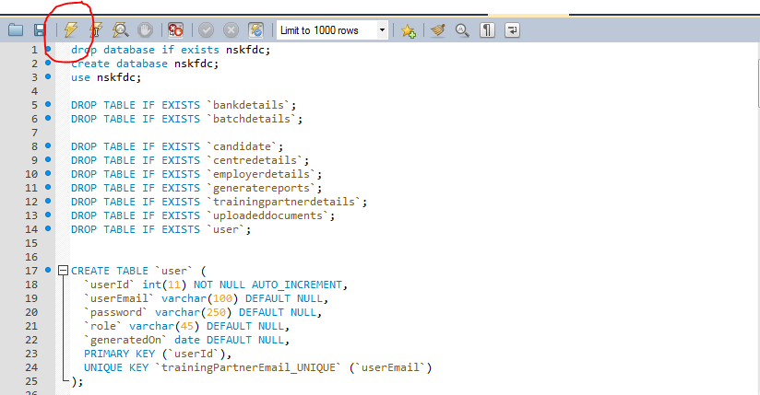

### **Create Database users**

1. Copy from *“DbScript/ DbScript.sql”* directory of source code to server on AWS.
2. Copy the content of *“DbScript.sql”* to MySql workbench window.
3. Execute it with the button shown in image below.

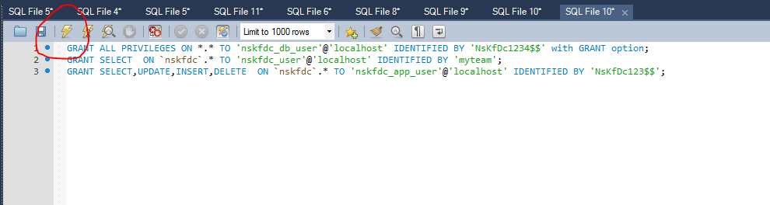

### **Create SCGJ users for Application**

1. Copy from *“DbScript/ insertScgjUsers.sql”* directory of source code to server on AWS.
2. Copy the content of “*insertScgjUsers.sql*” to MySql workbench window.
3. Execute it with the button shown in image below.

### **Create Directories**

1. To save Documents uploaded by Training partner *“ C:/TrainingPartner.NSKFDC/UploadedDocuments/* ”
2. To save Master Sheets uploaded by Training Partner

“C:/TrainingPartner.NSKFDC/UploadedDocuments/Master Sheets”

1. To save images for Final batch report to pick from

*“C:/nskfdc/report/images/”*

### **System variable**

1. Create an environment variable with name

NSKFDC_REPORT_IMAGE_PATH

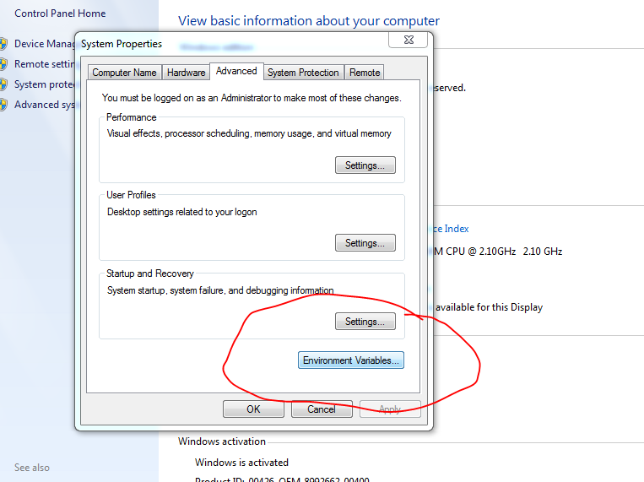

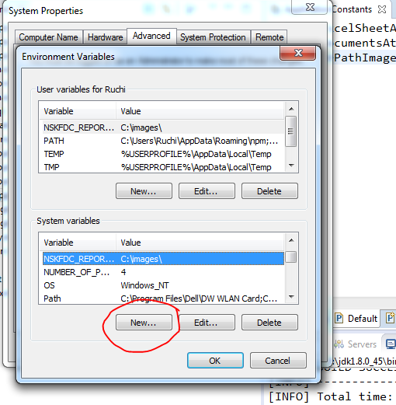

1. Set the value of variable to the path

*C:/nskfdc/report/images/*

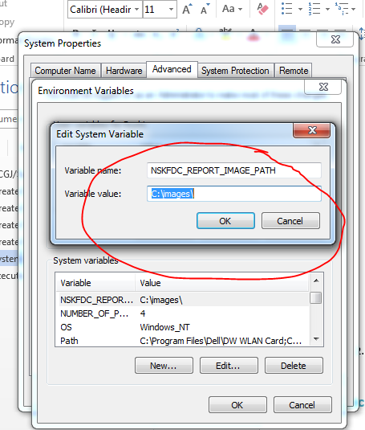

### **Copy static images**

1. Copy scgj log provided with the build without changing the name
2. Copy nskfdc logo provided with the build

### **Execute Jar**

1. Copy Jar to a location on server
2. Run command prompt as an administrator
3. Write following command in command prompt

java -Dspring.profiles.active=prod –jar <path of jar>.

Example - java -Dspring.profiles.active=prod –jar D:\SCGJ.SDMS\name-of-jar.jar

