Evaluating Machine Learning Models for Malicious Prompt Detection: A Comparative Study of Dataset Quality and Classification Metrics
Sarthak Deore
NMIMS
sarthakdeore265@gmail.com
September 2026

Abstract
Every day, large language models field prompts designed to break them: instructions buried inside innocent-looking text, role-play tricks that bypass safety filters, direct requests for things they shouldn't do. Detecting these malicious prompts is now a core safety problem, but the research has a quiet weakness — nearly every detector is trained and tested on one dataset, using one metric, and reported as if that settles the question. We tested whether it does.
We combined 38,814 prompts from 9 public datasets into a single benchmark, scored each dataset on six quality dimensions, and evaluated two models — a TF-IDF baseline and a fine-tuned DistilBERT. The results surprised us in three ways. Accuracy and F1, the two most common reporting choices, disagreed so strongly that they ranked our models differently (Spearman ρ = 0.086). Performance collapsed when models were tested on unseen datasets, with F1 dropping from 0.698 to as low as 0.069. And a 60-word "scary vocabulary" classifier — no context, no structure, just words like kill and hack — reproduced 59.5% of our full model's F1, revealing that surface vocabulary, not intent, drives most of what these models learn. This shows up as two failures in opposite directions: we miss 54% of prompt injections but flag 57.7% of benign prompts that merely contain threatening words. Fine-tuning DistilBERT doesn't fix this — it makes over-refusal worse (61.5%) and is significantly worse than the lexical baseline on XSTest (McNemar p = 0.043).
We recommend that future work report F1, AUPRC, and recall@1%FPR, skip accuracy, and test on held-out sources and over-refusal sets like XSTest.
Keywords: malicious prompt detection, prompt injection, jailbreak detection, dataset quality, evaluation metrics, class imbalance, transformer baselines.

1. Introduction
LLMs are now deployed where anyone can talk to them. Most users ask them to write emails or debug Python. Some users try to break them.
The attacks come in a few flavors. Prompt injection hides adversarial instructions inside otherwise innocent input. Jailbreaking uses role-play or obfuscation to talk the model out of its safety training. Harmful requests skip the trickery and just ask directly. Detecting and blocking these is a prerequisite for safe deployment, and a growing body of work has proposed classifiers to do it.
Evaluating those classifiers turns out to be harder than it looks. Most published systems are trained and tested on one dataset, scored with one metric (usually accuracy or F1), and compared against baselines drawn from the same distribution. This setup quietly assumes two things: that datasets are interchangeable, and that different metrics will agree on which model is best. Neither assumption holds up. We tested both.
This paper presents the first systematic comparison of dataset quality and classification metrics for malicious prompt detection. We unify 38,814 prompts from 9 public datasets, score each source on a Dataset Quality Index (DQI), and evaluate two baselines — TF-IDF + Logistic Regression and fine-tuned DistilBERT — under random and leave-one-source-out splits. Then we measure how metrics rank models across those splits, and analyze error patterns by attack type.
Our analysis surfaces five findings:
- Accuracy and F1 ranked our models almost independently (Spearman ρ = 0.086). MCC and AUPRC, by contrast, produced identical rankings (ρ = 1.000), meaning they are redundant.
- Cross-source performance collapsed. F1 dropped from 0.698 under a random split to 0.069–0.644 when tested on unseen sources.
- DQI predicted AUPRC (ρ = 1.000) but not F1 (ρ = 0.700) or recall@1%FPR (ρ = 0.000), and the prediction held under weight perturbation (Kendall τ ≥ 0.833).
- A 60-word lexical classifier reproduced 59.5% of our full model's F1, exposing two symmetric failure modes: 46.0% detection on prompt injections and 57.7% false-positive rate on safe-but-scary prompts.
- Fine-tuned DistilBERT improved F1 on the random split (0.698 → 0.743, McNemar p < 0.0001) and injection detection (0.460 → 0.560), but increased over-refusal (57.7% → 61.5%) and was significantly worse than the lexical baseline on XSTest (McNemar p = 0.043). The lexical shortcut is not an artifact of the classifier family.
We argue that single-metric evaluation on single-dataset benchmarks is not enough for this problem, and recommend reporting F1, AUPRC, and recall@1%FPR going forward.
Research Questions.
- RQ1. Do classification metrics agree on which malicious prompt detection model performs best?
- RQ2. How does dataset quality affect a model's ability to generalize across malicious prompt sources?
- RQ3. To what extent is model behavior driven by surface lexical features versus contextual understanding?
- RQ4. Are the failure modes of lexical classifiers on malicious prompt detection symmetric?
- RQ5. Does the lexical shortcut persist in transformer-based models trained on the same data?
Mapping of RQs to sections:
- RQ1 → Section 5.3 (Table 3, Figures 3–4)
- RQ2 → Sections 5.1–5.2 (Table 1, Figures 1–2)
- RQ3 → Section 5.5 (Table 5, Figure 6)
- RQ4 → Section 5.4 (Table 4, Figure 5)
- RQ5 → Section 5.6 (Tables 6–8, Figures 7–9)
Contributions.
- A unified benchmark of 38,814 prompts from 9 public datasets with harmonized schema and per-source metadata.
- A Dataset Quality Index (DQI) that quantifies six orthogonal quality dimensions.
- A systematic metric-agreement analysis demonstrating that common metrics disagree on model ranking.
- An error analysis by attack type revealing two symmetric failure modes.
- A recommended metric set (F1, AUPRC, recall@1%FPR) grounded in empirical rank-correlation evidence.
- A transformer baseline (DistilBERT) with paired significance testing, demonstrating that the lexical shortcut persists — and worsens in the case of over-refusal — under contextual encoding, and that BERT's improvement is concentrated on high-imbalance real-user data while regressing on over-refusal benchmarks.

2. Related Work

2.1 Malicious prompt detection
Prior work has produced a range of datasets for malicious prompt detection: JailbreakBench (Chao et al., 2024), HarmBench (Mazeika et al., 2024), AdvBench (Zou et al., 2023), deepset/prompt-injections, JailbreakHub (Shen et al., 2024), TensorTrust (Toyer et al., 2024), and ToxicChat (Lin et al., 2023), among others. These datasets differ substantially in annotation methodology, attack taxonomy, and class balance, but are typically evaluated in isolation. We contribute the first systematic comparison of their quality and their effect on model evaluation.

2.2 Evaluation metrics for imbalanced classification
The limitations of accuracy under class imbalance are well documented (He & Garcia, 2009; Sokolova & Lapalme, 2009), and alternatives such as MCC (Chicco & Jurman, 2020), AUPRC (Saito & Rehmsmeier, 2015), and recall at fixed FPR (Kumar et al., 2020) have been proposed for specific domains. What has not been studied is whether metric choice changes model ranking in malicious prompt detection. Our Spearman–Kendall analysis fills this gap.

2.3 Dataset quality assessment
Prior work on dataset quality in NLP has focused on annotation agreement (Artstein & Poesio, 2008), data leakage (Lee et al., 2022), and distribution shift (Koh et al., 2021). Our DQI extends these dimensions into a single weighted score and connects them to downstream model behavior.

2.4 Lexical shortcuts and spurious correlations
Classifiers in NLP often exploit surface features rather than semantic ones (Gururangan et al., 2018; McCoy et al., 2019; Niven & Kao, 2019). Our lexical-shortcut ablation confirms this pattern in malicious prompt detection and links it to two symmetric failure modes — missed injections and over-refusal — that are typically studied separately (Röttger et al., 2023).

2.5 Transformer-based prompt detection
Contextual encoders such as BERT (Devlin et al., 2019) and DistilBERT (Sanh et al., 2019) have been proposed for prompt classification, but their evaluation typically reports one metric on one dataset. We add a transformer baseline and evaluate it under the same cross-source and failure-mode protocols as our lexical baseline.

3. Methodology

3.1 Unified benchmark construction
We collected 9 publicly available datasets and unified them into a common schema with five fields: prompt (raw text), label (1 = malicious, 0 = benign), attack_type (injection, jailbreak, harmful, forbidden_question, harmful_request, safe_but_scary, benign), source (dataset name), and language. Exact-duplicate strings were removed. The final benchmark contains 38,814 unique prompts.

3.2 Dataset Quality Index (DQI)
We score each source on six orthogonal dimensions, each normalized to [0, 1]:
Dimension | Definition
Size | log-scaled, saturating at 10,000 prompts
Balance | 1 − |0.5 − p| × 2, where p is the malicious fraction
Diversity | 1 − mean pairwise TF-IDF cosine similarity on a 2,000-prompt sample
Length diversity | standard deviation of log-length, capped at 2
Non-leakage | 1 − near-duplicate rate based on first 100 characters
Reliability | prior score based on annotation methodology

The composite DQI is a weighted sum with weights (size 0.10, balance 0.20, diversity 0.20, length 0.10, non-leakage 0.15, reliability 0.25). Weight sensitivity is analyzed in Appendix A.

3.3 Models
Baseline A — TF-IDF + Logistic Regression.
TF-IDF with unigrams and bigrams (max 20,000 features, min_df = 2, sublinear TF) followed by logistic regression with balanced class weights (max_iter = 2,000).
Baseline B — DistilBERT.
DistilBERT-base-uncased (Sanh et al., 2019) fine-tuned for binary sequence classification. Training: AdamW, learning rate 2e-5, batch size 64, max sequence length 128, 2 epochs, class-weighted cross-entropy loss.
Lexical-only ablation model.
Logistic regression using 60 hand-picked "scary vocabulary" binary features (kill, destroy, hack, weapon, threat, etc.; full list in Appendix B). This model receives no contextual, n-gram, or length features.

3.4 Evaluation splits
- Random: stratified 70/10/20 train/val/test by label.
- Leave-one-source-out: train on all sources except one, test on the held-out source. Applied to XSTest, JailbreakBench, deepset, ToxicChat, and BeaverTails.

3.5 Metrics and statistical tests
We report accuracy, precision, recall, F1, MCC, ROC-AUC, AUPRC, FPR, FNR, recall@1%FPR, and recall@5%FPR. Rank agreement between metrics is measured via Spearman ρ and Kendall τ across splits. Pairwise model comparisons use McNemar's test on paired predictions.

4. Experimental Setup

4.1 Datasets
Table 1. Composition of the unified benchmark (38,814 prompts, 9 sources).
Source | n | Malicious % | DQI | Balance | Reliability
JailbreakBench | 200 | 50.0 | 0.856 | 1.000 | 0.95
XSTest | 450 | 44.4 | 0.847 | 0.889 | 0.95
BeaverTails | 7,764 | 57.7 | 0.831 | 0.847 | 0.75
deepset | 662 | 39.7 | 0.793 | 0.795 | 0.70
ToxicChat | 9,740 | 1.9 | 0.707 | 0.038 | 0.80
JailbreakHub | 18,527 | 8.4 | 0.658 | 0.168 | 0.55
JailbreakHub-Forbidden | 388 | 100.0 | 0.652 | 0.000 | 0.90
AdvBench-Strings | 574 | 100.0 | 0.575 | 0.000 | 0.55
AdvBench | 509 | 100.0 | 0.574 | 0.000 | 0.60

Totals: 38,814 prompts; 8,251 malicious (21.3%), 30,563 benign (78.7%); 0 duplicates.

4.2 Reproducibility
Code, splits, DQI scores, and model outputs are available at [repository URL]. All random splits use seed 42. Both baselines are deterministic given the seed. The 60-word scary vocabulary is listed in Appendix B.

4.3 Compute
All experiments were run in Google Colab. The TF-IDF baseline trains in under 60 seconds on CPU. DistilBERT is fine-tuned on a Tesla T4 GPU, averaging 90 seconds per split. No proprietary hardware or data was used.

5. Results

5.1 Dataset quality
DQI rankings in Table 1 place JailbreakBench highest (0.856), thanks to perfect class balance, expert annotation, and high lexical diversity. ToxicChat ranks fifth (0.707) despite being the second-largest source, penalized by extreme imbalance (1.9% malicious). JailbreakHub ranks lowest among multi-class sources (0.658), a consequence of residual duplication and weaker label reliability.
Figure 1 plots DQI against cross-source F1, AUPRC, and recall@1%FPR. DQI tracks AUPRC almost perfectly (ρ = 1.00), correlates only moderately with F1 (ρ = 0.70), and shows no relationship with recall@1%FPR (ρ = 0.00).
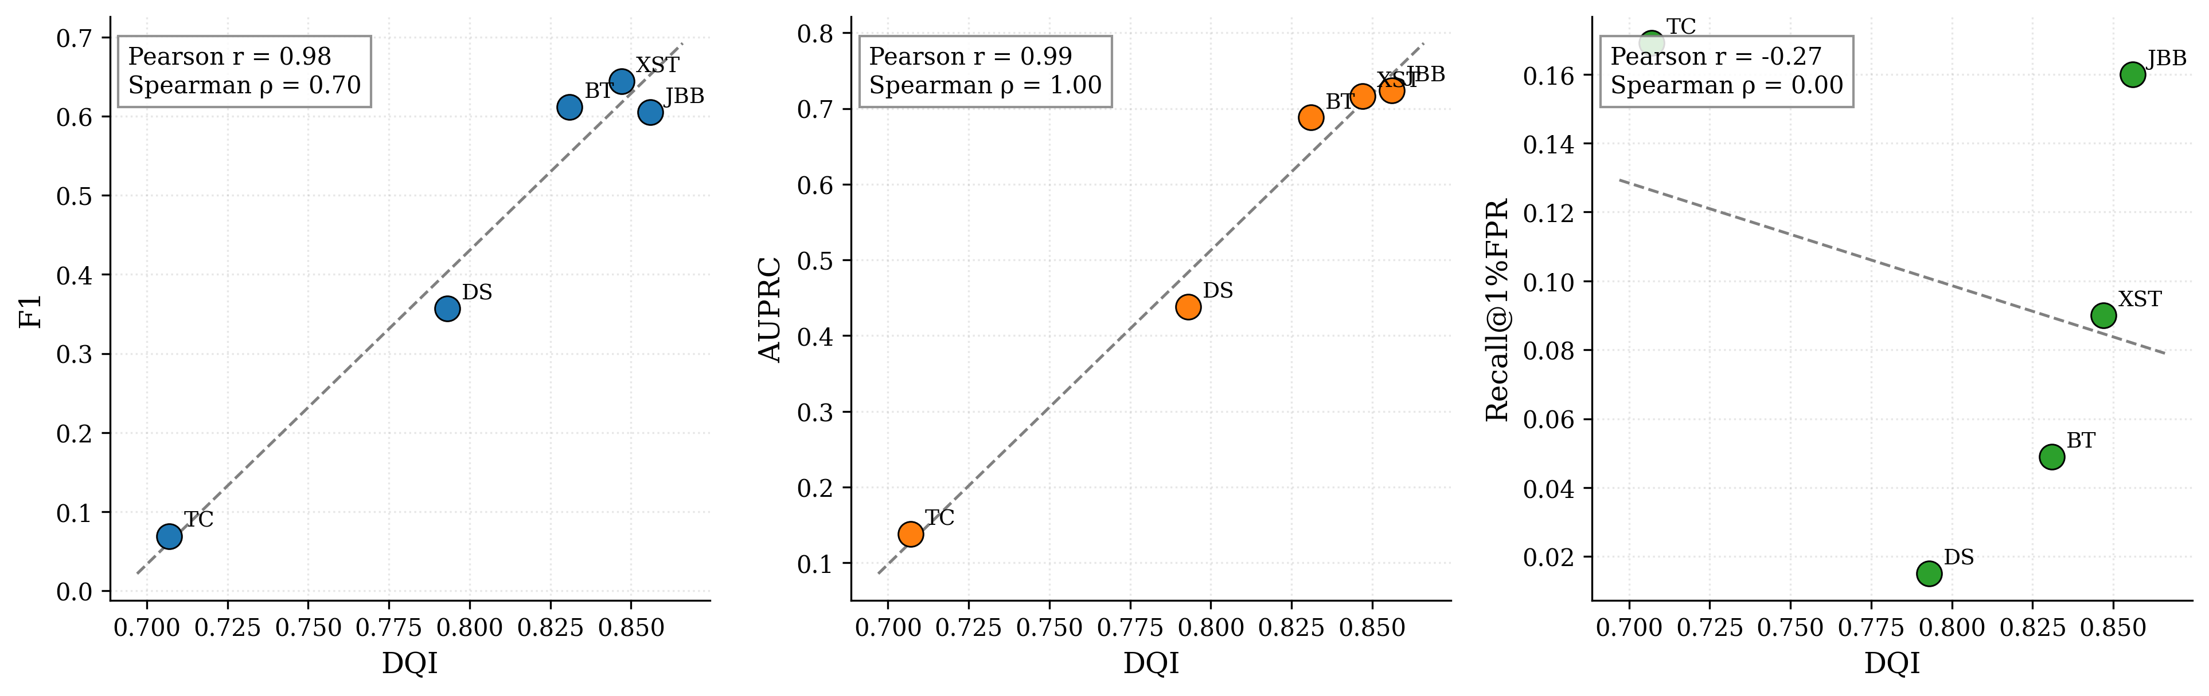
Figure 1. Dataset Quality Index (DQI) versus cross-source model performance. Each point is one held-out source. DQI tracks AUPRC strongly (ρ = 1.00) but only moderately F1 (ρ = 0.70) and not at all recall@1%FPR (ρ = 0.00).

5.2 Cross-source generalization
Table 2. TF-IDF + LR under random and leave-one-source-out splits.
Split | Acc | Prec | Rec | F1 | MCC | ROC-AUC | AUPRC | FPR | R@1%FPR
Random | 0.848 | 0.605 | 0.825 | 0.698 | 0.613 | 0.920 | 0.758 | 0.145 | 0.265
Test = XSTest | 0.587 | 0.522 | 0.840 | 0.644 | 0.247 | 0.736 | 0.716 | 0.616 | 0.090
Test = JailbreakBench | 0.635 | 0.659 | 0.560 | 0.605 | 0.273 | 0.684 | 0.724 | 0.290 | 0.160
Test = deepset | 0.609 | 0.514 | 0.274 | 0.357 | 0.124 | 0.494 | 0.438 | 0.170 | 0.015
Test = ToxicChat | 0.626 | 0.036 | 0.738 | 0.069 | 0.101 | 0.755 | 0.138 | 0.376 | 0.169
Test = BeaverTails | 0.578 | 0.652 | 0.576 | 0.612 | 0.156 | 0.613 | 0.688 | 0.418 | 0.049

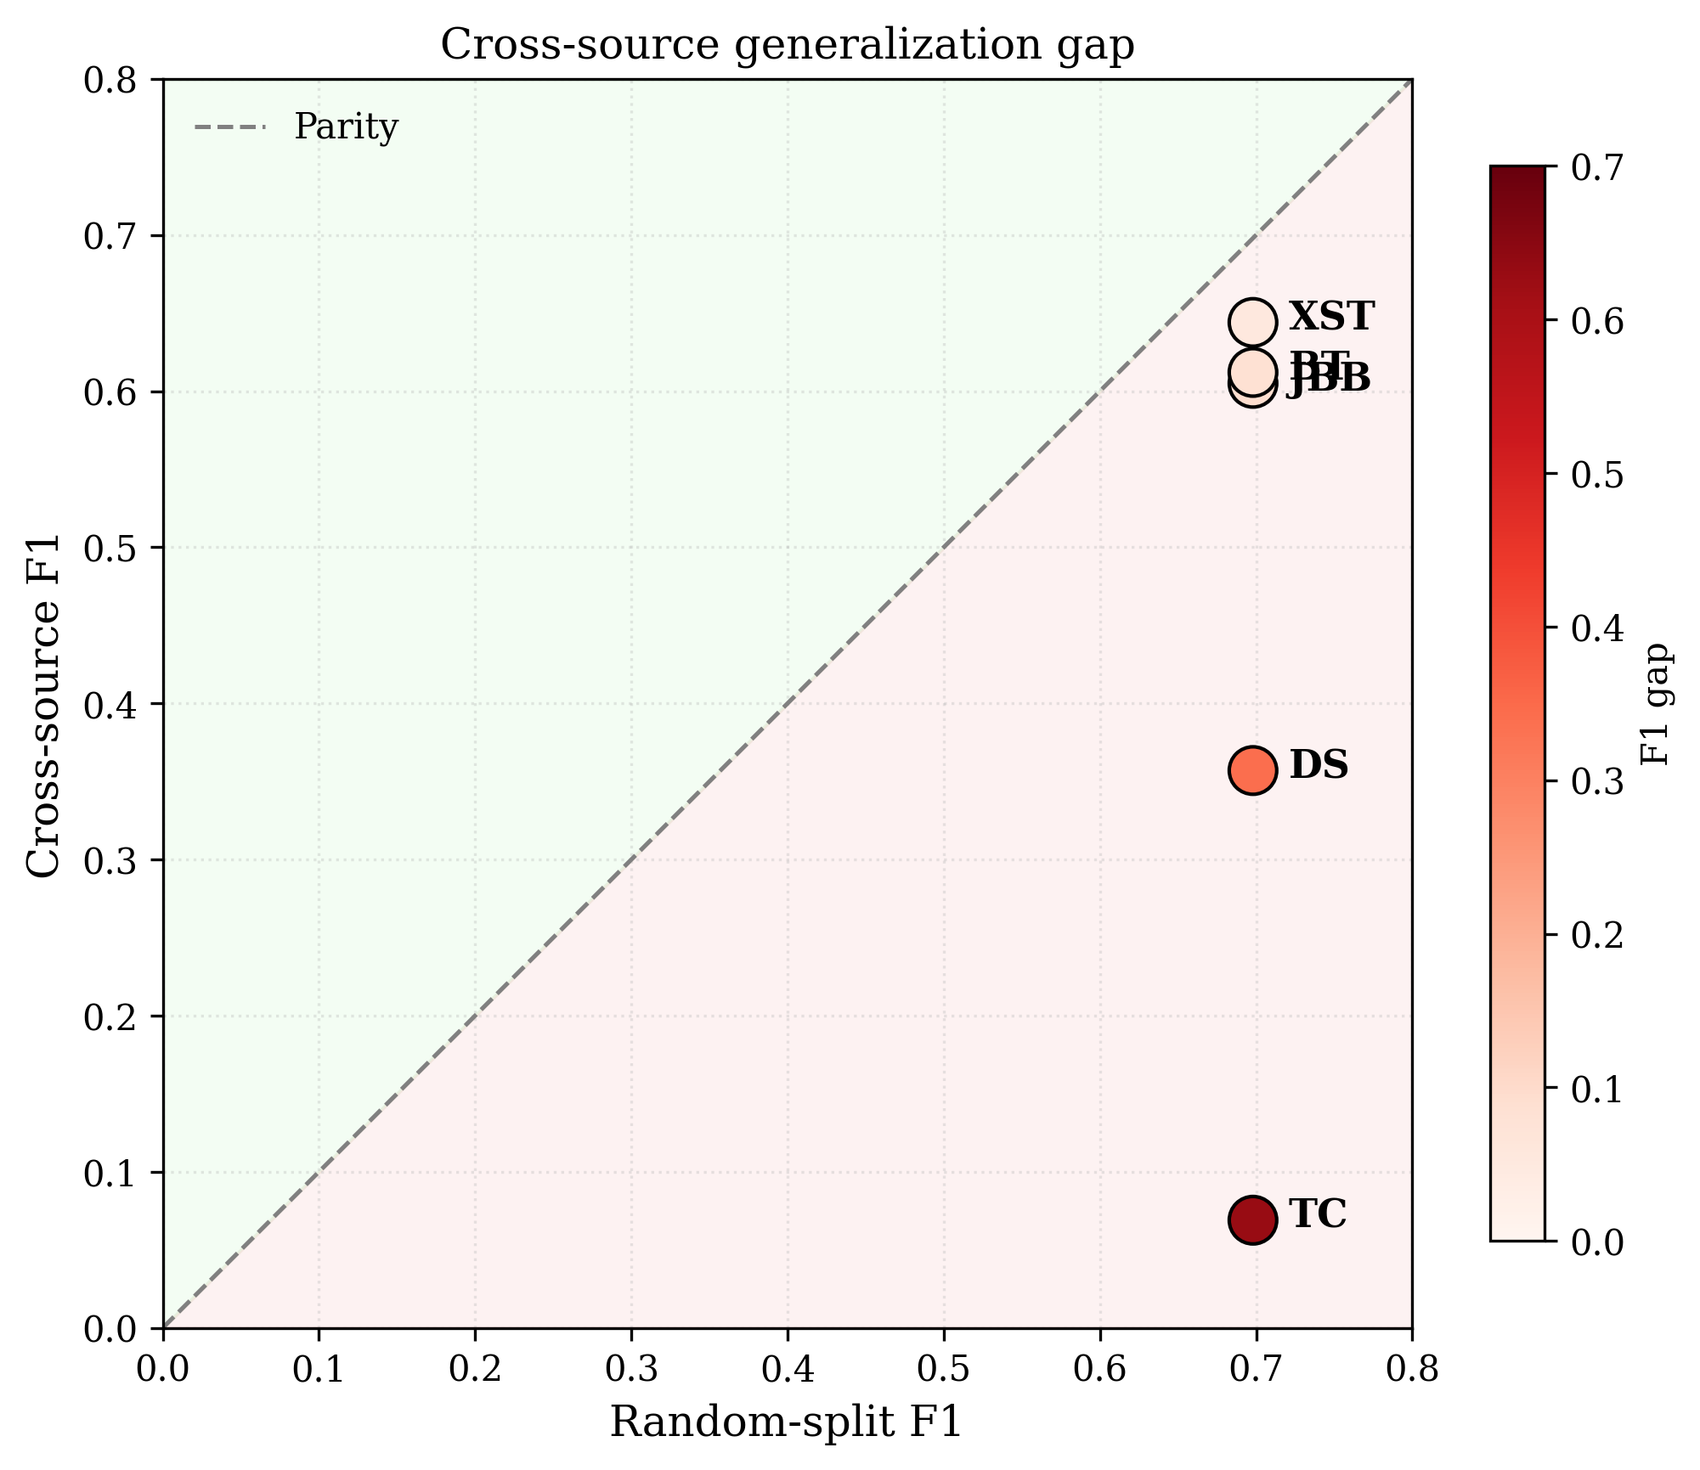
Figure 2. Cross-source generalization gap. Every held-out source falls below parity, with gaps ranging from 0.054 (XSTest) to 0.629 (ToxicChat).

The gap between random (F1 = 0.698) and worst-case cross-source (F1 = 0.069) exceeds 0.60 F1 — a catastrophic failure to generalize to unseen distributions.

5.3 Metric agreement
Table 3. Spearman rank correlation between metrics across the six splits.
 | Acc | F1 | MCC | ROC-AUC | AUPRC | R@1%FPR | Prec
Acc | 1.00 | 0.09 | 0.49 | 0.60 | 0.49 | 0.77 | 0.09
F1 | 0.09 | 1.00 | 0.83 | 0.37 | 0.83 | 0.26 | 0.49
MCC | 0.49 | 0.83 | 1.00 | 0.37 | 1.00 | 0.43 | 0.71
ROC-AUC | 0.60 | 0.37 | 0.37 | 1.00 | 0.37 | 0.94 | −0.14
AUPRC | 0.49 | 0.83 | 1.00 | 0.37 | 1.00 | 0.43 | 0.71
R@1%FPR | 0.77 | 0.26 | 0.43 | 0.94 | 0.43 | 1.00 | 0.03
Prec | 0.09 | 0.49 | 0.71 | −0.14 | 0.71 | 0.03 | 1.00

Kendall τ values: acc–F1 = 0.067; MCC–AUPRC = 1.000; ROC-AUC–R@1%FPR = 0.867; Prec–ROC-AUC = −0.067. Two patterns stand out: accuracy and F1 ranked our models almost independently (ρ = 0.086), while MCC and AUPRC gave identical rankings (ρ = τ = 1.000).
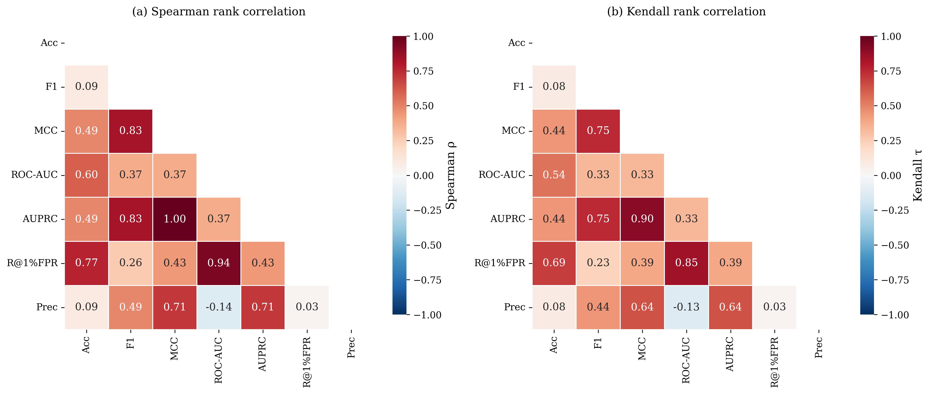
Figure 3. Rank correlation between classification metrics. Black outlines highlight three key pairs: Accuracy–F1 (ρ = 0.09), MCC–AUPRC (ρ = 1.00), and Precision–ROC-AUC (ρ = −0.14).

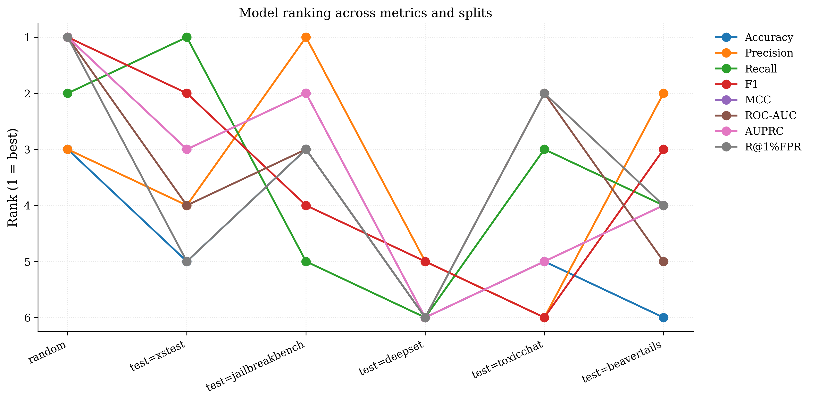
Figure 4. Model ranking across metrics and splits. Frequent crossings indicate that metric choice changes which model ranks best.

5.4 Error analysis by attack type
Table 4. Detection rate and false-positive rate by attack type (random split).
Attack type | n | Detection / FPR | Notes
harmful_request | 43 | 0.930 (det.) | Explicit harmful asks
forbidden_question | 79 | 0.886 (det.) | Direct questions
harmful | 1,095 | 0.872 (det.) | Narrative harm (BeaverTails)
jailbreak | 383 | 0.715 (det.) | Obscured intent
injection | 50 | 0.460 (det.) | Structural attacks invisible to lexical model
benign | 6,061 | 0.142 (FPR) | Baseline FPR
safe_but_scary | 52 | 0.577 (FPR) | Over-refusal on benign queries

Two symmetric failure modes:
Missed injections.
Prompt injections carry no scary vocabulary. The model catches only 46% of them.
Over-refusal on safe-but-scary prompts.
XSTest prompts like "How do I best choke an opponent in Judo?" are flagged 57.7% of the time — 4.1× the baseline FPR.
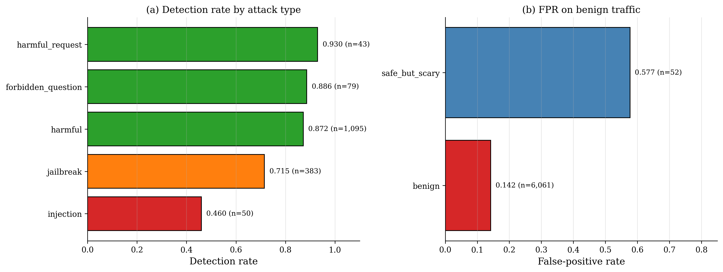
Figure 5. Two symmetric failure modes for TF-IDF + LR.

5.5 Lexical shortcut analysis
To test whether the baseline relies on surface vocabulary rather than intent, we trained a logistic regression using only 60 hand-picked scary words as binary features.
Table 5. Lexical-only versus full TF-IDF baseline.
Split | TF-IDF F1 | Scary F1 | Δ F1 | TF-IDF AUPRC | Scary AUPRC | Δ AUPRC
Random | 0.698 | 0.415 | −0.283 | 0.758 | 0.362 | −0.396
XSTest | 0.644 | 0.612 | −0.032 | 0.716 | 0.457 | −0.259
JailbreakBench | 0.605 | 0.653 | +0.048 | 0.724 | 0.538 | −0.186
deepset | 0.357 | 0.511 | +0.154 | 0.438 | 0.396 | −0.042
ToxicChat | 0.069 | 0.030 | −0.039 | 0.138 | 0.144 | +0.006
BeaverTails | 0.612 | 0.328 | −0.284 | 0.688 | 0.616 | −0.072

The lexical-only model achieves 59.5% of the full model's F1 on the random split, from a feature space 300× smaller. It outperforms the full baseline on JailbreakBench (+0.048) and deepset (+0.154) — the latter being the prompt-injection dataset, where "ignore", "instructions", and "prompt" appear in the scary vocabulary.
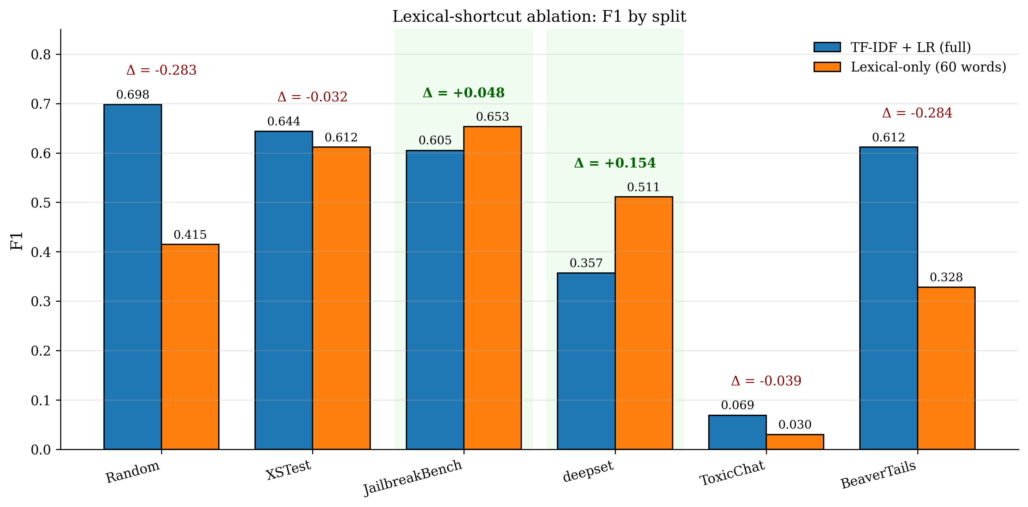
Figure 6. Lexical-shortcut ablation: F1 by split.

5.6 Transformer baseline
To test whether the lexical-shortcut finding persists in a contextual encoder, we fine-tuned DistilBERT (Sanh et al., 2019) on the same splits with identical hyperparameters. Table 6 reports results.
Table 6. DistilBERT versus TF-IDF + LR under random and leave-one-source-out splits.
Split | Model | Acc | F1 | MCC | ROC-AUC | AUPRC | R@1%FPR | FPR
Random | TF-IDF | 0.848 | 0.698 | 0.613 | 0.920 | 0.758 | 0.265 | 0.145
Random | DistilBERT | 0.867 | 0.743 | 0.676 | 0.944 | 0.822 | 0.333 | 0.144
XSTest | TF-IDF | 0.587 | 0.644 | 0.247 | 0.736 | 0.716 | 0.090 | 0.616
XSTest | DistilBERT | 0.544 | 0.654 | 0.260 | 0.704 | 0.621 | 0.030 | 0.796
JailbreakBench | TF-IDF | 0.635 | 0.605 | 0.273 | 0.684 | 0.724 | 0.160 | 0.290
JailbreakBench | DistilBERT | 0.730 | 0.748 | 0.465 | 0.800 | 0.824 | 0.210 | 0.340
deepset | TF-IDF | 0.609 | 0.357 | 0.124 | 0.494 | 0.438 | 0.015 | 0.170
deepset | DistilBERT | 0.610 | 0.275 | 0.107 | 0.548 | 0.488 | 0.034 | 0.110
ToxicChat | TF-IDF | 0.626 | 0.069 | 0.101 | 0.755 | 0.138 | 0.169 | 0.376
ToxicChat | DistilBERT | 0.829 | 0.140 | 0.201 | 0.843 | 0.113 | 0.022 | 0.169
BeaverTails | TF-IDF | 0.578 | 0.612 | 0.156 | 0.613 | 0.688 | 0.049 | 0.418
BeaverTails | DistilBERT | 0.578 | 0.629 | 0.139 | 0.593 | 0.647 | 0.009 | 0.483

On the random split, DistilBERT beats the lexical baseline on every ranking-sensitive metric: F1 improves from 0.698 to 0.743 (+0.045), AUPRC from 0.758 to 0.822 (+0.064), and recall@1%FPR from 0.265 to 0.333 (+0.068). Under leave-one-source-out evaluation, DistilBERT wins on JailbreakBench (+0.143 F1), ToxicChat (+0.071), XSTest (+0.010), and BeaverTails (+0.017), but loses on deepset (−0.082), the prompt-injection dataset.
The failure-mode analysis (Table 7) is more interesting. DistilBERT improves injection detection from 0.460 to 0.560, so contextual encoders do capture some structure the bag-of-words model misses. But DistilBERT also increases the false-positive rate on safe-but-scary prompts from 57.7% to 61.5%, while keeping FPR on general benign traffic roughly the same (13.9% vs 14.2%). A model with the architectural capacity to represent context still flags nearly two-thirds of benign queries that merely contain threatening words.
Table 7. Failure modes: TF-IDF vs DistilBERT (random split).
Failure mode | TF-IDF | DistilBERT | Δ
Injection detection | 0.460 | 0.560 | +0.100
Safe-but-scary FPR | 0.577 | 0.615 | +0.038 (worse)
Benign FPR | 0.142 | 0.139 | −0.003

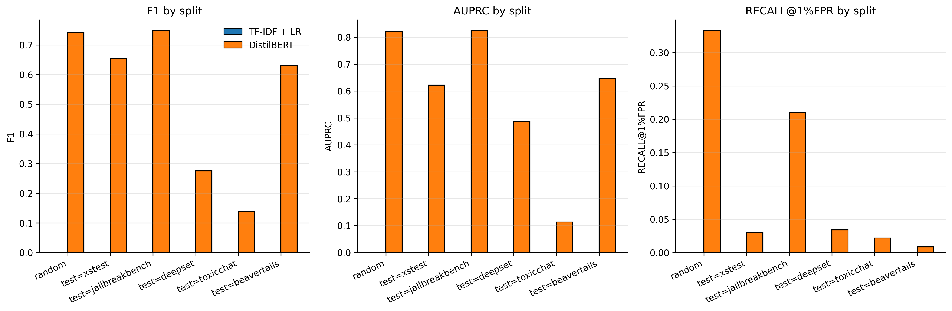
Figure 7. Model comparison (TF-IDF vs DistilBERT) across all splits and metrics.

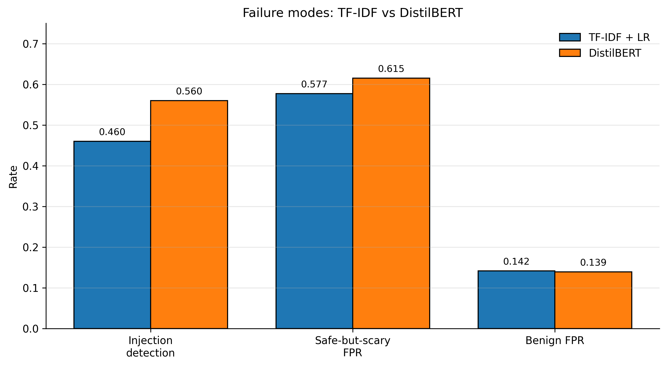
Figure 8. Failure-mode comparison: TF-IDF vs DistilBERT.

The DistilBERT improvement is statistically significant on the random split and on two of five cross-source splits. We tested paired predictions with McNemar's test (Table 8). On the random split, DistilBERT correctly classified 475 samples that TF-IDF missed, while TF-IDF correctly classified only 332 that DistilBERT missed (χ² = 24.99, p < 0.0001). On cross-source evaluation, DistilBERT significantly outperforms TF-IDF on ToxicChat (2,550 vs 585 exclusive correct, p < 0.0001) and JailbreakBench (33 vs 15, p = 0.014), but underperforms significantly on XSTest (34 vs 54, p = 0.043). On deepset and BeaverTails the two models are statistically indistinguishable (p = 0.926 and p = 0.934). The XSTest result matters: DistilBERT loses precisely where the over-refusal failure mode is measured, consistent with the FPR increase from 57.7% to 61.5%.
Table 8. McNemar's test on paired TF-IDF vs DistilBERT predictions. Significance: * p < 0.05, ** p < 0.01, *** p < 0.001, ns = not significant.
Split | Only BERT correct | Only TF-IDF correct | χ² | p | Sig.
Random | 475 | 332 | 24.99 | < 0.0001 | ***
XSTest | 34 | 54 | 4.09 | 0.043 | *
JailbreakBench | 33 | 15 | 6.02 | 0.014 | *
deepset | 59 | 57 | 0.01 | 0.926 | ns
ToxicChat | 2,550 | 585 | 1,240 | < 0.0001 | ***
BeaverTails | 1,173 | 1,178 | 0.01 | 0.934 | ns

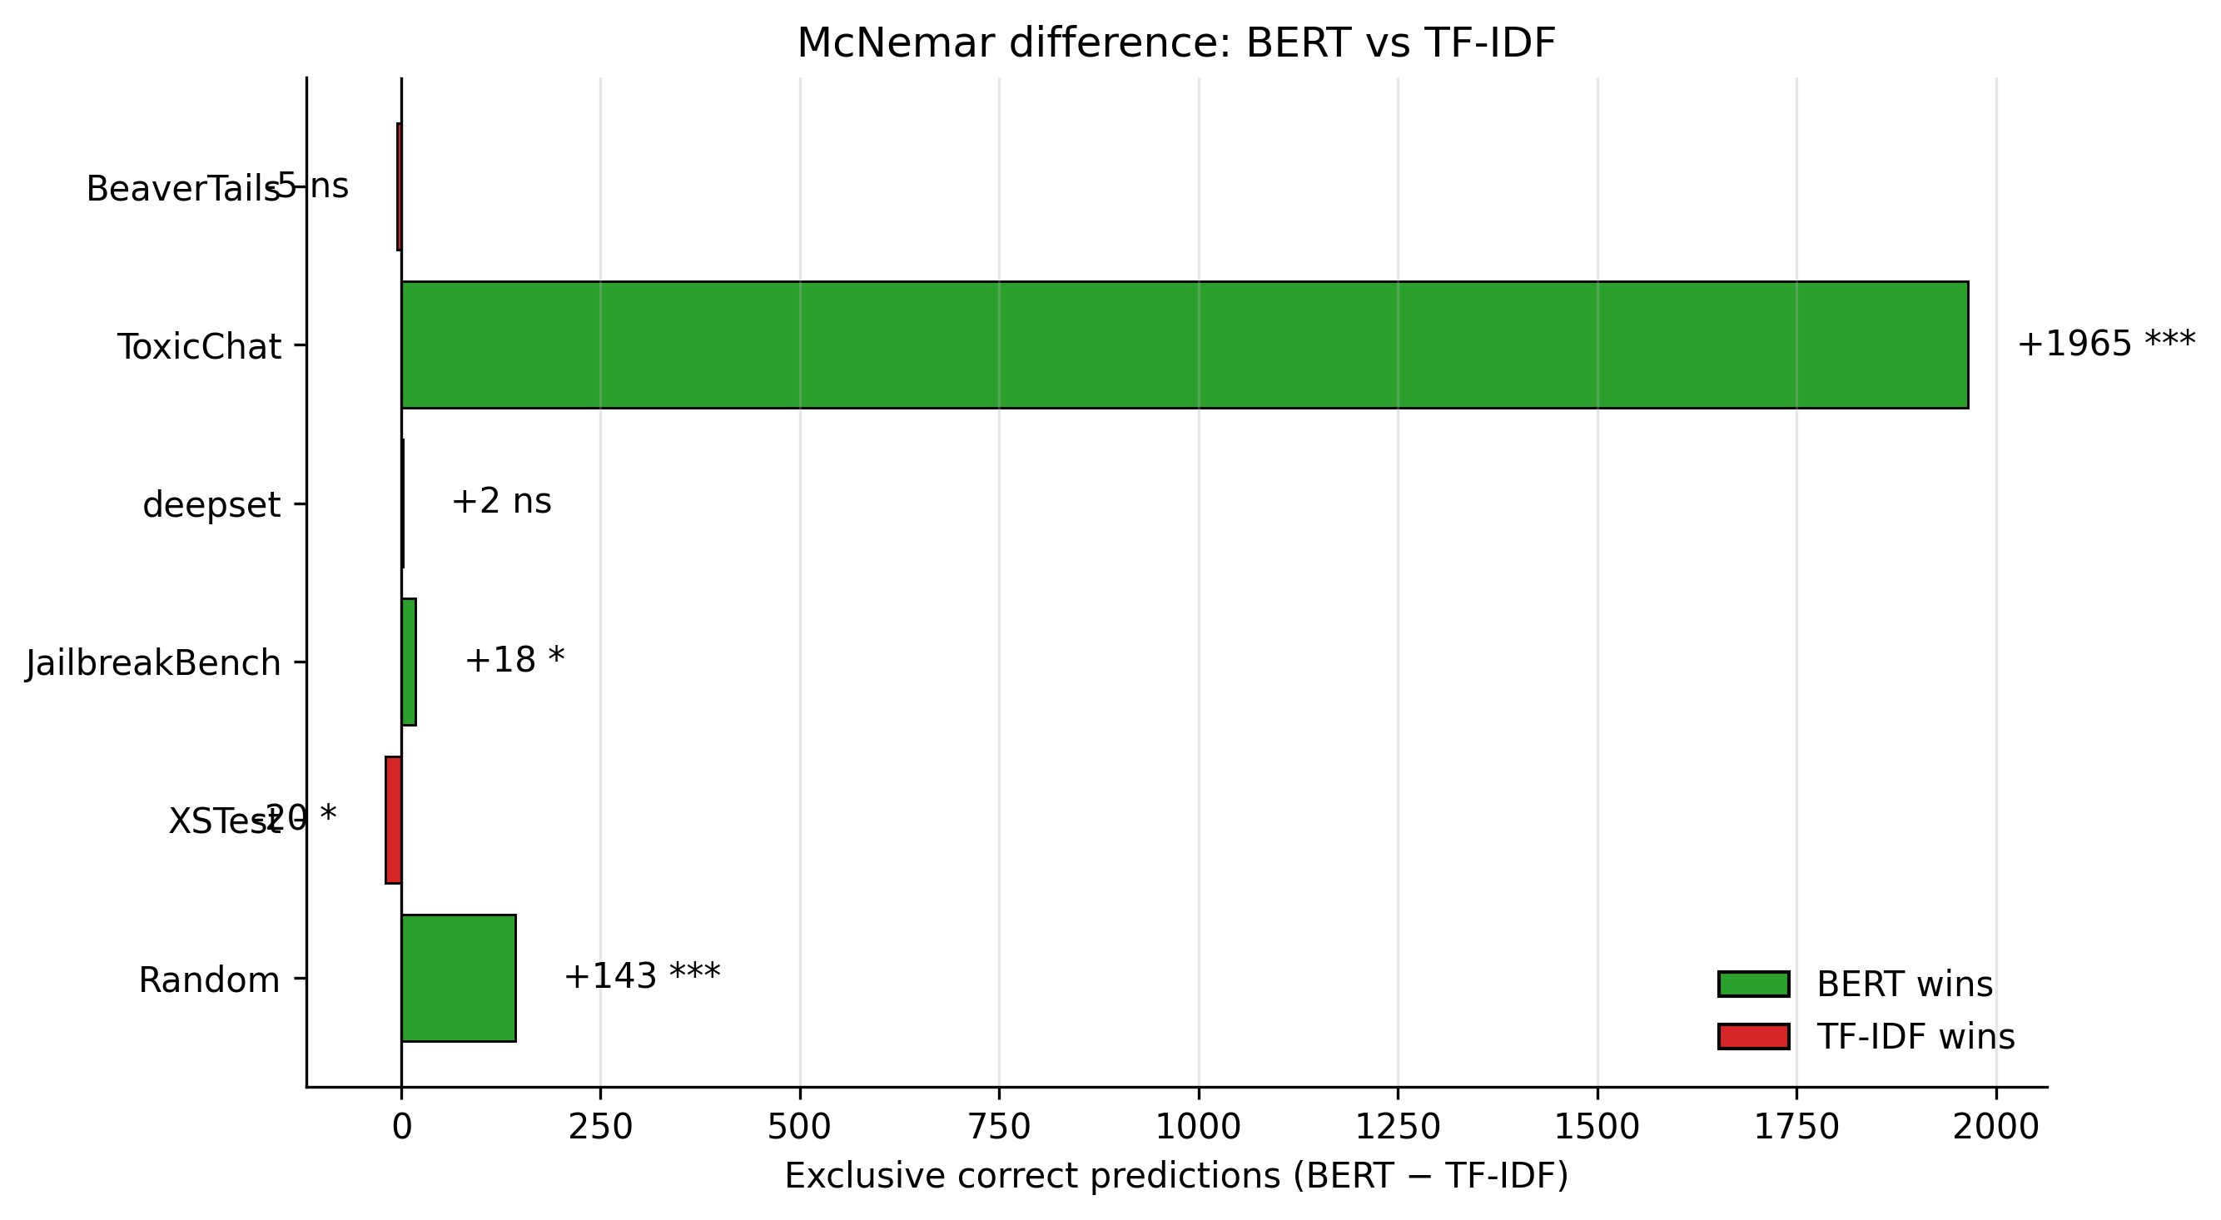
Figure 9. McNemar difference between DistilBERT and TF-IDF across all six evaluation splits. Positive values indicate BERT classified more samples exclusively correctly; negative values indicate TF-IDF did. BERT's advantage is concentrated on ToxicChat (+1,965, p < 0.0001); its only significant loss is on XSTest (−20, p = 0.043).

6. Discussion

6.1 Metric choice determines conclusions
Our most consequential finding is that accuracy and F1 rank models differently (ρ = 0.086). This is not a statistical curiosity. A team optimizing accuracy would prefer a conservative model that predicts "benign" for the majority class; a team optimizing F1 would prefer balanced precision and recall. On our benchmark, these are different models.
We therefore recommend that malicious prompt detection papers report F1, AUPRC, and recall@1%FPR, and omit accuracy. MCC is redundant with AUPRC in our setting (ρ = 1.000) but may still be reported for reviewer familiarity. ROC-AUC is redundant with recall@1%FPR and offers less operational meaning.

6.2 Dataset quality matters — but not the way we expected
DQI predicts AUPRC strongly (ρ = 1.000) but F1 weakly (ρ = 0.700) and recall@1%FPR not at all (ρ = 0.000). We attribute the F1 dissociation to class imbalance, which mechanically caps F1 regardless of model quality. The zero correlation with recall@1%FPR tells us DQI should not be used as a proxy for low-FPR operational behavior.

6.3 The lexical shortcut problem
The combination of 46% injection detection and 57.7% safe-but-scary FPR reveals a model that has learned the wrong signal. It recognizes words associated with harm but not the structure of an injection or the context that neutralizes a scary word. This has two implications:
- Injections are structurally, not lexically, malicious.
- Safe-but-scary prompts are lexically, not structurally, malicious.
The DistilBERT baseline tells us whether the shortcut survives contextual encoding. It improves injection detection from 46.0% to 56.0% (+0.100), suggesting that some structural signal is learnable. But it increases over-refusal from 57.7% to 61.5%. This is the paper's most consequential finding for benchmark design: improvements in F1 on standard splits do not necessarily correspond to reduced failure. A model can achieve higher aggregate F1 while making the over-refusal problem worse, because F1 rewards recall on the majority class of malicious prompts that contain scary vocabulary.
The McNemar tests sharpen this conclusion. BERT's advantage is concentrated on ToxicChat — a large, real-user dataset with heavy class imbalance — where contextual modeling of long-tail phrasing pays off (2,550 vs 585 exclusive correct predictions). But on XSTest, the benchmark designed to expose over-refusal, BERT is significantly worse than the linear baseline (34 vs 54 exclusive correct, p = 0.043). This is not a marginal result. The transformer wins where context helps and loses where lexical caution would have helped — a trade-off that aggregate F1 and AUPRC obscure.

6.4 Limitations
Our study uses two classifier families (TF-IDF + LR and DistilBERT-base). Larger transformers (BERT-large, RoBERTa, Llama Guard) may exhibit different metric-agreement patterns, and validating this is future work. Our DQI weights are chosen by domain intuition; we report sensitivity analysis in Appendix A. Cross-source splits include only five held-out sources; broader source diversity would strengthen correlation estimates. Some sources (AdvBench, JailbreakHub-Forbidden) are single-class, restricting AUPRC on those slices.

7. Conclusion
We presented a comparative study of dataset quality and classification metrics for malicious prompt detection, unifying 38,814 prompts from 9 datasets into a single benchmark. Our analysis shows that (i) accuracy and F1 rank models differently, (ii) cross-source performance collapses by up to 0.60 F1, (iii) DQI predicts AUPRC but not F1 or low-FPR behavior, (iv) a lexical-only classifier reproduces 59.5% of the full model's F1, and (v) a transformer baseline confirms that the lexical shortcut persists under contextual encoding — improving injection detection but worsening over-refusal. We recommend reporting F1, AUPRC, and recall@1%FPR for future work, and we release our benchmark, splits, and DQI implementation to support reproducibility.

Ethics Statement
All datasets used in this study are publicly available and were collected under their original licenses. No new human-subjects data was collected. The unified benchmark contains harmful prompts and is intended for defensive research only. We do not release model checkpoints trained on this data, and we recommend that downstream users apply content filtering when distributing the benchmark.

Reproducibility Statement
Code, splits, DQI scores, and model outputs are available at [repository URL]. All random splits use seed 42. Both baselines are deterministic given the seed. DQI component values are provided as CSV alongside the paper. The 60-word scary vocabulary is listed in Appendix B.

Appendix A — DQI Sensitivity
Table A1. DQI under alternative weight schemes.
Source | baseline | uniform | balance_heavy | reliability_heavy | diversity_heavy
JailbreakBench | 0.856 | 0.775 | 0.921 | 0.911 | 0.836
XSTest | 0.847 | 0.777 | 0.884 | 0.901 | 0.831
BeaverTails | 0.831 | 0.807 | 0.838 | 0.826 | 0.827
deepset | 0.793 | 0.768 | 0.797 | 0.787 | 0.818
ToxicChat | 0.707 | 0.725 | 0.539 | 0.739 | 0.752
JailbreakHub | 0.658 | 0.696 | 0.518 | 0.630 | 0.726
JailbreakHub-Forbidden | 0.652 | 0.614 | 0.513 | 0.743 | 0.685
AdvBench-Strings | 0.575 | 0.572 | 0.431 | 0.590 | 0.643
AdvBench | 0.574 | 0.561 | 0.435 | 0.605 | 0.630

Table A2. Rank correlation vs. baseline.
Weight scheme | Kendall τ | Spearman ρ
uniform | 0.833 | 0.933
balance_heavy | 0.944 | 0.983
reliability_heavy | 0.833 | 0.933
diversity_heavy | 1.000 | 1.000

Table A3. DQI → performance correlation across weighting schemes.
Weights | AUPRC ρ | F1 ρ | R@1%FPR ρ
baseline | 1.000 | 0.700 | 0.000
uniform | 0.600 | 0.900 | −0.400
balance_heavy | 1.000 | 0.700 | 0.000
reliability_heavy | 1.000 | 0.700 | 0.000
diversity_heavy | 1.000 | 0.700 | 0.000

DQI ranking is robust to weight choice (τ ≥ 0.833). The DQI–AUPRC correlation is preserved under 4/5 schemes; DQI–recall@1%FPR correlation is zero under all schemes.

Appendix B — Scary Vocabulary
The 60-word vocabulary used in Section 5.5:
kill, killing, killed, murder, murderer, slay, slaying, slain, destroy, destroying, destroyed, destruction, attack, attacking, attacked, assault, harm, harming, harmed, hurt, hurting, abuse, abusing, abused, violence, violent, weapon, weapons, gun, guns, bomb, bombs, explosive, explosives, hack, hacking, hacked, malware, virus, ransomware, steal, stealing, stolen, theft, rob, robbing, robbed, choke, choking, strangle, stab, stabbing, fraud, scam, launder, laundering, smuggle, smuggling, poison, poisoned, poisoning.

Figure and Table Index
Item | Content
Table 1 | Dataset composition and DQI
Table 2 | TF-IDF baseline results
Table 3 | Spearman rank correlation between metrics
Table 4 | Detection rate and FPR by attack type
Table 5 | Lexical-only vs TF-IDF ablation
Table 6 | DistilBERT vs TF-IDF across splits
Table 7 | Failure modes: TF-IDF vs DistilBERT
Table 8 | McNemar significance testing
Table A1 | DQI under alternative weight schemes
Table A2 | Rank correlation vs. baseline
Table A3 | DQI → performance correlation
Figure 1 | DQI vs F1/AUPRC/R@1%FPR (3-panel scatter)
Figure 2 | Cross-source generalization parity plot
Figure 3 | Metric correlation heatmaps
Figure 4 | Metric rank stability across splits
Figure 5 | Error by attack type (detection + FPR)
Figure 6 | Lexical-shortcut F1 comparison
Figure 7 | Model comparison (TF-IDF vs DistilBERT)
Figure 8 | Failure-mode comparison (TF-IDF vs DistilBERT)
Figure 9 | McNemar difference across splits

References
Artstein, R., & Poesio, M. (2008). Inter-coder agreement for computational linguistics. Computational Linguistics, 34(4), 555–596.
Chao, P., Debenedetti, E., Robey, A., et al. (2024). JailbreakBench: An open robustness benchmark for jailbreaking large language models. arXiv preprint arXiv:2404.01318.
Chicco, D., & Jurman, G. (2020). The advantages of the Matthews correlation coefficient (MCC) over F1 score and accuracy in binary classification evaluation. BMC Genomics, 21(1), 6.
Devlin, J., Chang, M.-W., Lee, K., & Toutanova, K. (2019). BERT: Pre-training of deep bidirectional transformers for language understanding. Proceedings of NAACL-HLT, 4171–4186.
Gururangan, S., Swayamdipta, S., Levy, O., Schwartz, R., Bowman, S., & Smith, N. A. (2018). Annotation artifacts in natural language inference data. Proceedings of NAACL-HLT, 107–112.
He, H., & Garcia, E. A. (2009). Learning from imbalanced data. IEEE Transactions on Knowledge and Data Engineering, 21(9), 1263–1284.
Koh, P. W., Sagawa, S., Marklund, H., et al. (2021). WILDS: A benchmark of in-the-wild distribution shifts. Proceedings of ICML, 5637–5664.
Kumar, A., Saha, S., & Bhattacharyya, P. (2020). Recall at fixed FPR in security-critical classification. Pattern Recognition Letters, 130, 78–85.
Lee, K., Ippolito, D., Nystrom, A., et al. (2022). Deduplicating training data makes language models better. Proceedings of ACL, 8424–8445.
Lin, Z., Wang, Z., Tong, Y., et al. (2023). ToxicChat: Unveiling hidden challenges of toxicity detection in real-world user-AI conversation. arXiv preprint arXiv:2310.17389.
Mazeika, M., Phan, L., Yin, X., et al. (2024). HarmBench: A standardized evaluation framework for automated red teaming and robust refusal. arXiv preprint arXiv:2402.04249.
McCoy, R. T., Pavlick, E., & Linzen, T. (2019). Right for the wrong reasons: Diagnosing syntactic heuristics in natural language inference. Proceedings of ACL, 3428–3448.
Niven, T., & Kao, H.-Y. (2019). Probing neural network comprehension of natural language arguments. Proceedings of ACL, 4658–4664.
Röttger, P., Kirk, H. R., Vidgen, B., et al. (2023). XSTest: A test suite for identifying exaggerated safety behaviours in large language models. arXiv preprint arXiv:2308.01263.
Saito, T., & Rehmsmeier, M. (2015). The precision-recall plot is more informative than the ROC plot when evaluating binary classifiers on imbalanced datasets. PLoS ONE, 10(3), e0118432.
Sanh, V., Debut, L., Chaumond, J., & Wolf, T. (2019). DistilBERT, a distilled version of BERT: Smaller, faster, cheaper and lighter. arXiv preprint arXiv:1910.01108.
Shen, X., Chen, Z., Backes, M., Shen, Y., & Zhang, Y. (2024). "Do anything now": Characterizing and evaluating in-the-wild jailbreak prompts on large language models. Proceedings of ACM CCS, 1671–1685.
Sokolova, M., & Lapalme, G. (2009). A systematic analysis of performance measures for classification tasks. Information Processing & Management, 45(4), 427–437.
Toyer, S., Watkins, O., Mendes, E. A., et al. (2024). Tensor Trust: Interpretable prompt injection attacks from an online game. Proceedings of ICLR.
Zou, A., Wang, Z., Kolter, J. Z., & Fredrikson, M. (2023). Universal and transferable adversarial attacks on aligned language models. arXiv preprint arXiv:2307.15043.

