Assignment No:- 8
Title: Design and Implement a Solution Using Word Embeddings to Tackle a Practical Real-Time Problem
Problem Statement:
Real-Time customer support ticket classification using word embeddings, organizations receive a large number of text-based customer queries every day, making manual classification slow and inefficient. Traditional keyword-based systems often fail to understand the context or semantic similarity between words. Therefore, there is a need for an automated system that uses word embeddings to understand the meaning of text and accurately classify customer queries in real time.
Objective:
The main objectives of this project are:
- To understand how word embeddings represent words in vector form.
- To build a system that automatically classifies customer queries.
- To improve the accuracy of text understanding compared to keyword matching.
- To demonstrate a practical real-time application of NLP using embeddings.
Outcomes:
After implementing this solution:
- Customer queries will be automatically categorized.
- The system will reduce manual effort for support teams.
- Queries will be routed to the correct department faster.
- The system will understand semantic similarity between different wordings.

Theory

1. Word Embeddings
Word embeddings are numerical vector representations of words used in Natural Language Processing (NLP). They map words into a continuous vector space where words with similar meanings are placed closer together. Unlike traditional text representation methods, word embeddings capture semantic relationships between words.
For example, the words “payment” and “transaction” will have similar vector representations because they are used in similar contexts.
Example representation:
Word | Vector Representation
payment | [0.23, 0.91, -0.45, ...]
transaction | [0.25, 0.89, -0.40, ...]
Words with similar meanings have similar vectors.

2. Word2Vec
Word2Vec is a popular technique used to generate word embeddings. It uses a shallow neural network to learn word relationships from large text datasets.
There are two main architectures:
Continuous Bag of Words (CBOW)
CBOW predicts a target word based on surrounding context words.
Skip-Gram
Skip-Gram predicts surrounding context words given a target word.
Both models help in learning meaningful vector representations of words.

3. Semantic Similarity
Word embeddings capture semantic similarity between words. This means words that appear in similar contexts will have similar vector representations.
For example:
- king – queen
- payment – transaction
- login – authentication
This property helps machines understand the meaning of text rather than just matching keywords.
4. Sentence Embeddings
In many NLP tasks, entire sentences need to be represented as vectors. Sentence embeddings are created by combining word embeddings of all words in the sentence.
A common method is averaging the word vectors in a sentence to obtain a single vector representation.

5. Cosine Similarity
Cosine similarity is used to measure the similarity between two vectors. It calculates the cosine of the angle between two vectors.
Formula:
Similarity(A,B)=A⋅B∣∣A∣∣×∣∣B∣∣ ​
The result ranges from -1 to 1:
- 1 → very similar
- 0 → unrelated
- -1 → opposite
Cosine similarity helps determine how closely two words or sentences are related.

5. Workflow of the System
- Collect customer queries
- Preprocess the text
- Convert words into vectors using word embeddings
- Aggregate vectors into sentence embeddings
- Train a classifier
- Predict category for new queries
Pseudocode
Input: Customer Query Dataset
Step 1: Load dataset
Step 2: Preprocess text
- Convert to lowercase
- Remove punctuation
- Remove stopwords
Step 3: Load pre-trained Word2Vec model
Step 4: Convert each word into vector representation
Step 5: Generate sentence embedding
sentence_vector = average(word_vectors)
Step 6: Train classification model
model = Train(SVM / Logistic Regression)
Step 7: For new query
preprocess(query)
convert to embedding
predicted_category = model.predict()
Output: Category of query

Example:

Input Queries
1. "I forgot my password and cannot login"
2. "My payment failed but money was deducted"
3. "Application crashes when opening profile"

Word Embedding Representation:
Example vector:
login → [0.12, -0.44, 0.67, ...]
password → [0.21, -0.33, 0.59, ...]
payment → [0.87, 0.12, -0.43, ...]

Output Classification:
Query | Category
Forgot password | Account Issue
Payment failed | Billing Issue
App crashes | Technical Issue

Link: https://github.com/sarthakdeshmukh212/NLP/

Results:

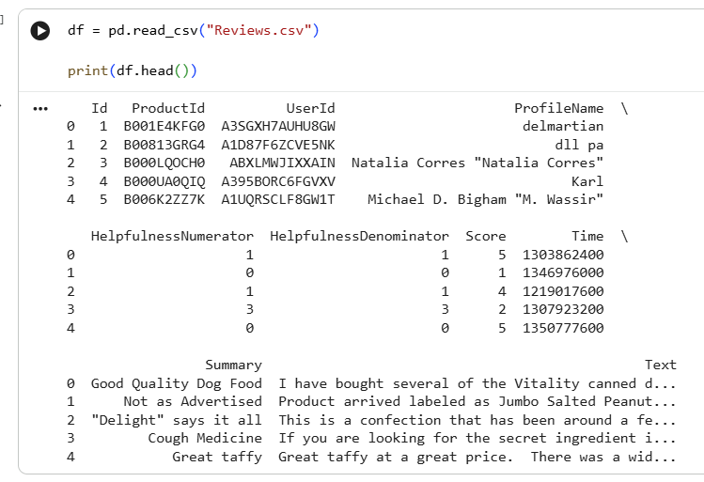

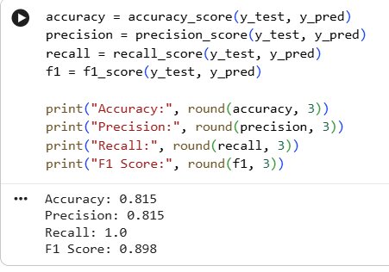

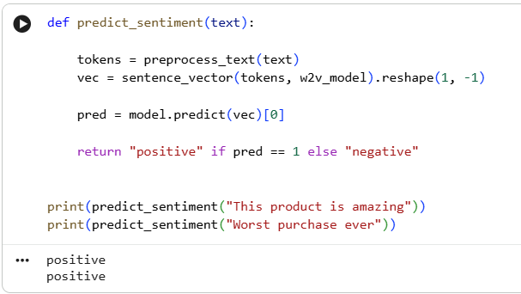

Conclusion:
Word embeddings provide a powerful way to represent textual data by capturing semantic meaning between words. In this project, word embeddings were used to build a real-time customer support ticket classification system.
The system improves efficiency by automatically categorizing customer queries and routing them to the appropriate department. Compared to traditional keyword-based methods, embedding-based systems understand context better and provide more accurate results.
This demonstrates how Natural Language Processing and word embeddings can solve practical real-world problems in real-time applications.

