Assignment No. 10

Problem Statement: Design and implement a solution using word embeddings to tackle a practical, real-time problem.

Objective:
- To study the concept of word embeddings and distributed word representations.
- To understand vector space representation of words using models like Word2Vec/GloVe/FastText.
- To implement a real-time semantic similarity system using pre-trained embeddings.
- To build an intent classification or semantic search system using cosine similarity.
- To analyze how embeddings capture contextual meaning compared to traditional bag-of-words models.

Outcomes:
- Understand how word embeddings capture semantic relationships.
- Gain practical experience in implementing Word2Vec/GloVe embeddings.
- Implement cosine similarity for semantic comparison.
- Build a real-time NLP solution for semantic search or chatbot intent detection.
- Analyze contextual similarity between words and sentences.

Theory

1. Word Embeddings
Word embeddings are dense vector representations of words in a continuous vector space where semantically similar words are placed close together.
Traditional methods like Bag of Words (BoW) create sparse vectors and ignore context, while word embeddings capture semantic meaning.
Popular Word Embedding Models:
- Word2Vec (CBOW and Skip-gram)
- GloVe (Global Vectors)
- FastText

Word2Vec Architecture
Two main architectures:
- CBOW (Continuous Bag of Words)
Predicts target word from context words.
- Skip-Gram
Predicts surrounding words from target word.

Mathematical Representation
Each word is represented as a vector:
$w_{i} ∈ R^{d}$
Where:
- d = embedding dimension
- $w_{i}$ = vector representation of word

Cosine Similarity Formula
Used to measure similarity between two word vectors:
$Cosine Similarity = \frac{A . B}{\left|\left|A\right|\right| \left|\left|B\right|\right|}$
Where:
- A,B = word vectors
- $\left|\left|A\right|\right|$= magnitude of vector A
Value range:
- 1 → Highly similar
- 0 → Unrelated
- -1 → Opposite

2. Real-Time Problem: Semantic Search System
Problem Statement:
Traditional keyword search fails to understand context.
Example:
- Query: “best laptop for coding”
- Document: “Top programming notebooks for developers”
Keyword search → low match
Embedding search → high semantic similarity
Word embeddings solve this by comparing vector similarity instead of exact word matching.

3. Sentence Embedding
Since embeddings are word-level, sentence embeddings can be computed using:
Average Embedding:
$S = \frac{1}{n} \sum_{i=1}^{n}{}w_{i}$
Where:
- n = number of words
- $w_{i}$ = word embedding

Pseudocode:
Algorithm SemanticSearchUsingWordEmbeddings

Input: User query sentence Q
Dataset of sentences D
Output: Most semantically similar sentence(s)

Step 1: Load pre-trained word embeddings
model ← LoadEmbeddingModel("Word2Vec")

Step 2: Preprocess text
Q_clean ← Preprocess(Q)
D_clean ← Preprocess(D)

Step 3: Convert words to vectors
For each word in Q_clean:
Retrieve embedding vector
Q_vector ← Average(word vectors)

Step 4: Convert dataset sentences to vectors
For each sentence in D_clean:
Convert to word vectors
Compute average vector
Store as sentence embedding

Step 5: Compute cosine similarity
For each sentence vector in dataset:
similarity ← CosineSimilarity(Q_vector, sentence_vector)

Step 6: Rank sentences
Sort sentences based on similarity score

Step 7: Display top matching result
Print("Most Relevant Result:", TopSentence)

Step 8: Comment on result
Print("Word embeddings capture contextual similarity beyond exact word matching.")

End Algorithm

Experimental Analysis
Method | Context Awareness | Accuracy | Limitation
Bag of Words | No | Low | Ignores semantics
TF-IDF | Partial | Medium | No contextual understanding
Word Embeddings | Yes | High | Requires training data

Link: https://github.com/sarthakdeshmukh212/NLP/

Result:
sentences = [
"Best laptop for coding",
"Top programming laptops for developers",
"Affordable smartphones with good battery",
"Best phones for gaming",
"How to reset password",
"Steps to change account password"
]

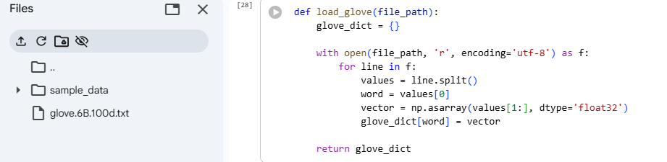
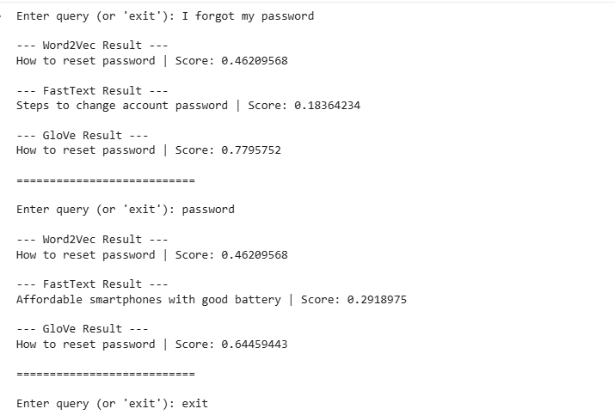

Conclusion
Word embeddings provide a powerful way to capture semantic relationships between words. By representing words in a continuous vector space and using cosine similarity, we can build real-time intelligent systems like semantic search engines and intent classification systems.
This lab demonstrates how distributed representations significantly outperform traditional keyword-based approaches in understanding contextual meaning.

