# Lab 01 – Modifying Navigation

## Overview

In this module you will be modifying how users navigate a Dynamics CRM instance by customizing the SiteMap.

There are different ways that you can edit the SiteMap. You could manually edit the SiteMap XML to reflect the changes desired, but oftentimes a 3rd party tool can make that process much easier. To demonstrate this process, you will be using a community tool to assist you in modifying the SiteMap XML.

## What you will learn

* How to modify CRM Navigation
* How to add a new Area to CRM
* How to add new Groups to an Area
* How to add new Sub Areas
* How to add a link to an external site to the navigation

## What you need to complete this lab

* CRM Online Trial Instance

# Exercise 1 – Download and Connect

In this exercise, you will use an online tool that will allow you to easily edit the SiteMap.

### Task 1: Connect to XRM.Tools

In this task you will use an online tool to see your current SiteMap setup.

1. Go to <http://xrm.tools> and click Sign in.

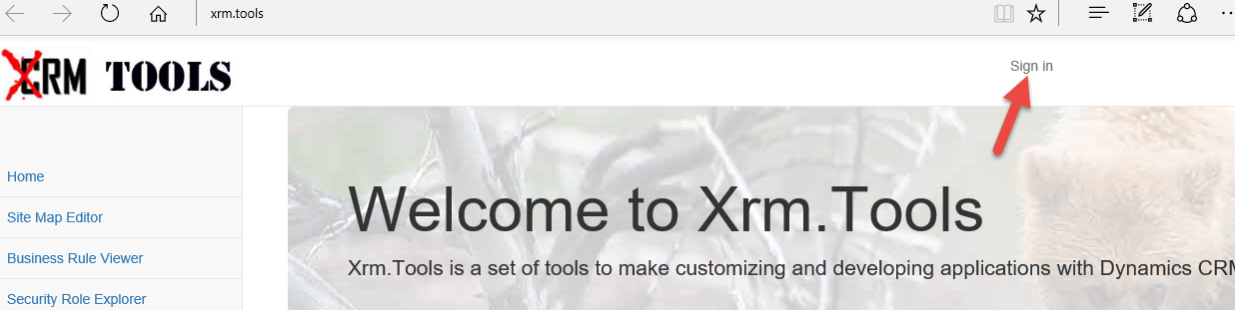

1. Provide your Dynamics CRM admin credentials and click Sign in.  
   **Note:** Remember, this tool works only with CRMOnline.

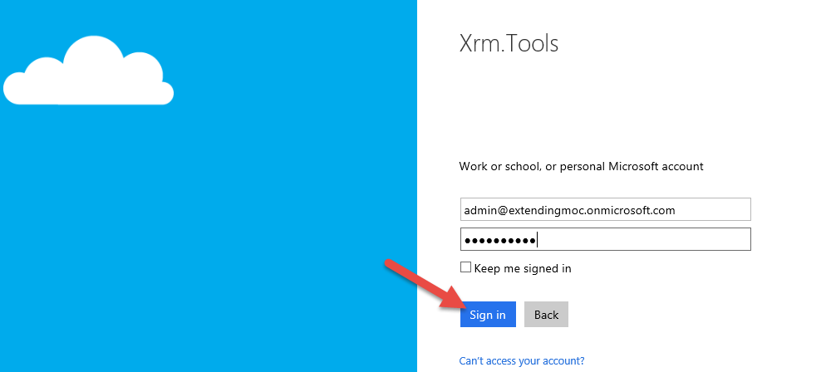

1. Read and click Accept if you accept the terms.

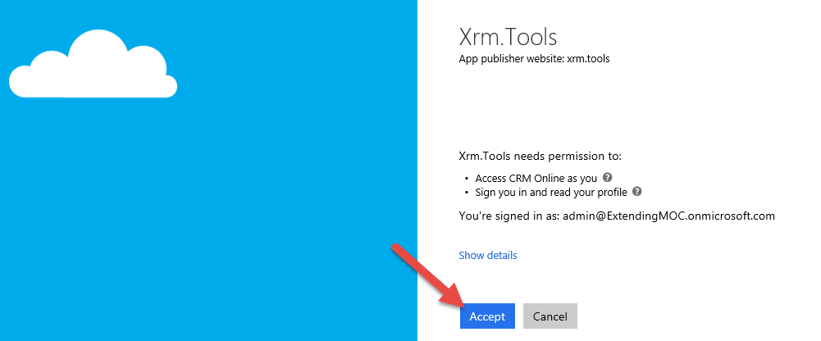

1. Click Sitemap Editor.

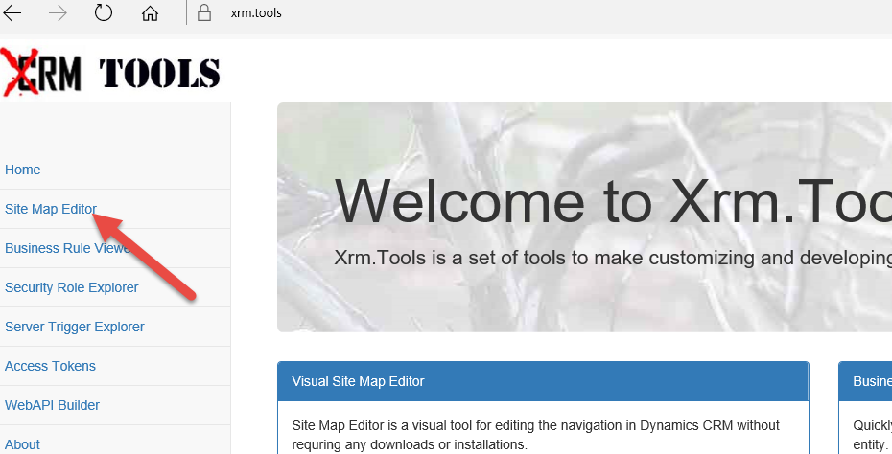

1. Click on the Dynamics CRM organization you want to see.

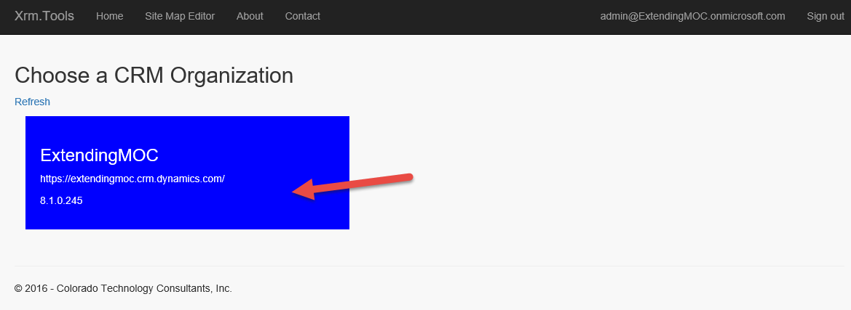

1. The tool will now display the top level of your current Sitemap areas.

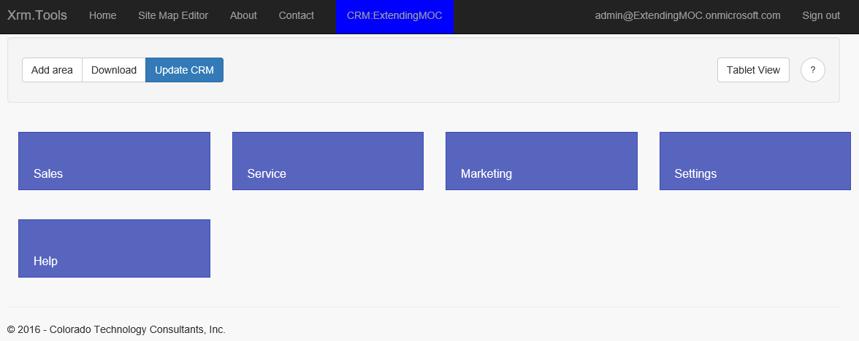

1. Click on the Sales area.

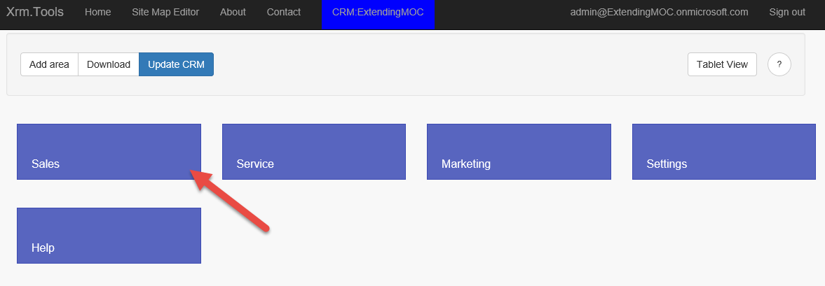

1. The tool will now load the groups and sub groups for the selected area.

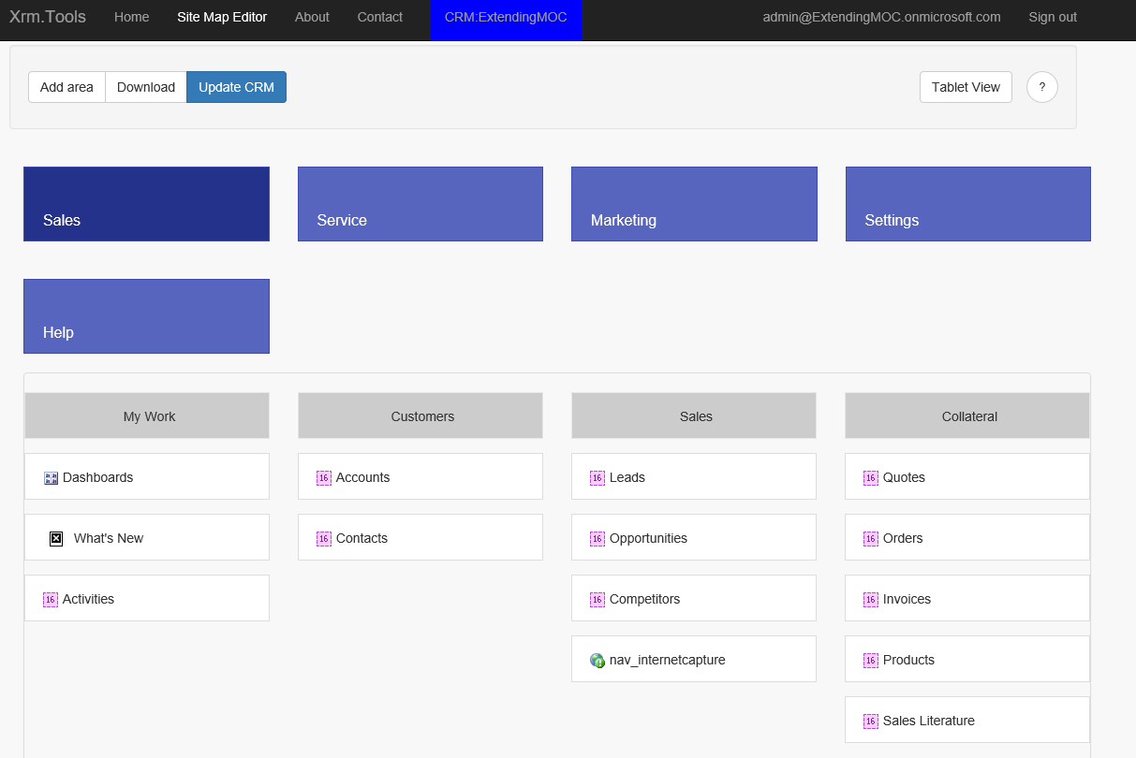

1. If you hover over an area, group or sub group, small triangle icon will come into view.

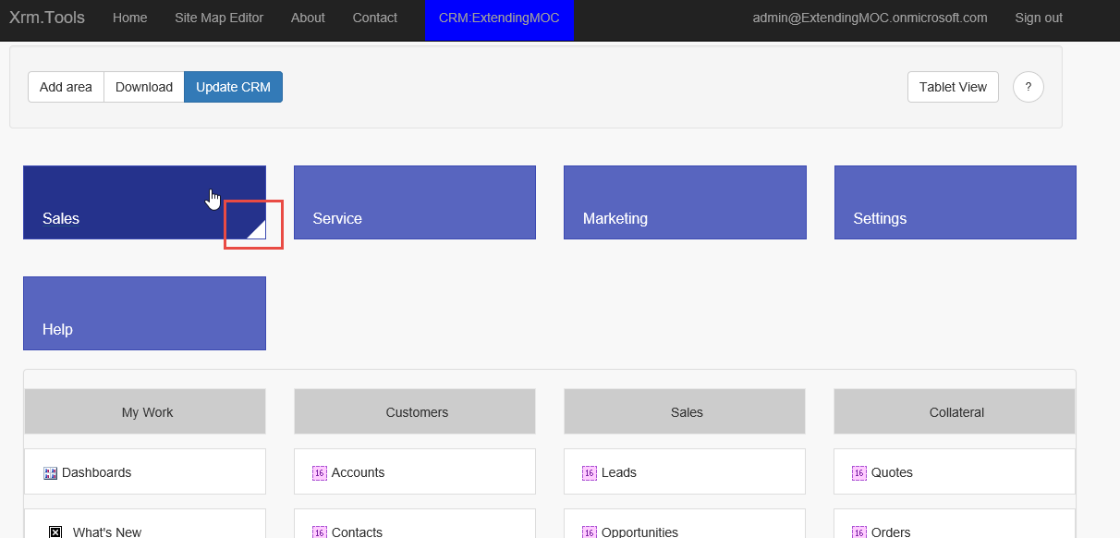

1. When you click on the triangle, a menu will come to view. You can add group, edit or remove.

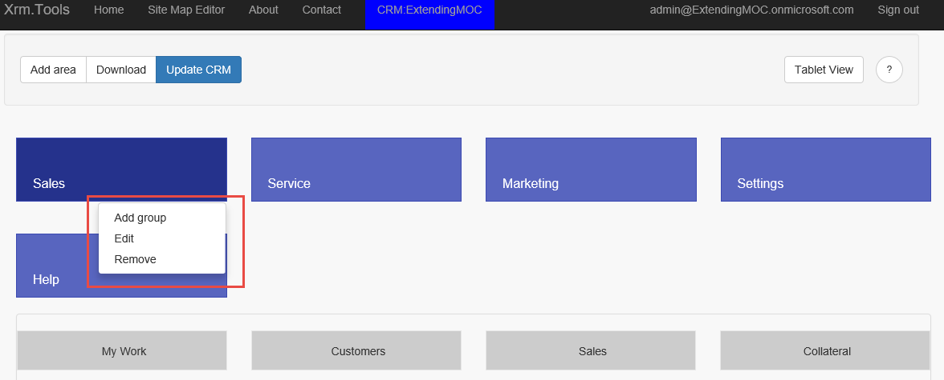

# Exercise 2 – Add new Area, Group and Subarea(s)

In this exercise you will be customizing CRM navigation by creating a new Area labeled Events. From this Area you should be able to view and create Event Listings and Accounts. You should also be able to access the external Microsoft Events page from your deployment.

Once completed, you would like to the Events area to reflect the structure that is outlined below:

Site Map

* Sales
* Events *(New Area)*
  + *Event Info (New Group)*
    - Accounts
    - Event Listing (New Custom Entity)
  + Public Sites *(New Group)*
    - Microsoft Events (Link to https://msevents.microsoft.com)
* Service
* Marketing

### Task 1: Create the Event Listing Entity

In this task you will create an entity to represent Event Listings. Because we are not using this for anything other than adding it to navigation we will not be adding any additional fields to it.

1. Go to your Dynamics CRM Organization, navigate to Settings | Solutions and click New.

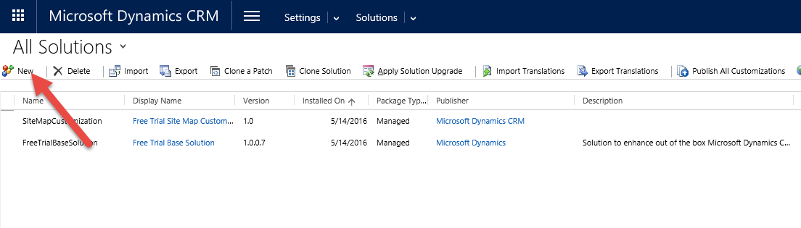

1. Enter Extending MOC for Display name and click the Publisher lookup.

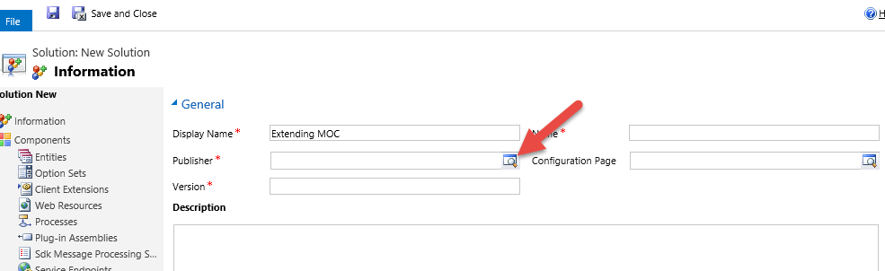

1. Click Look Up More Records.

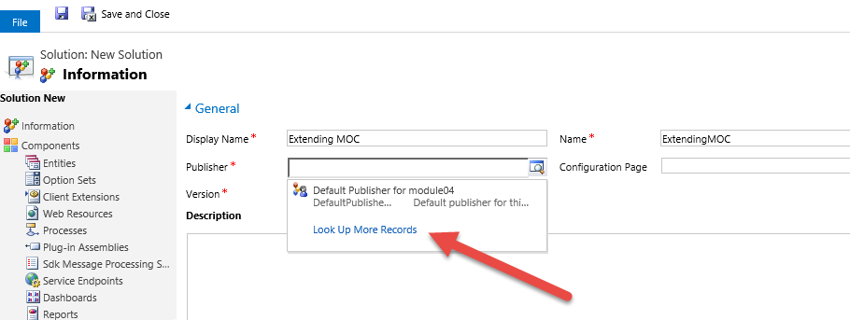

1. Click New.

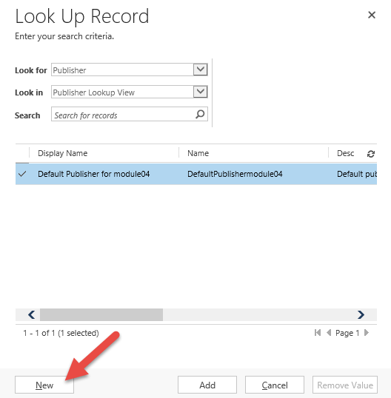

1. Enter MOC for Display Name, moc for Prefix and click Save and Close.

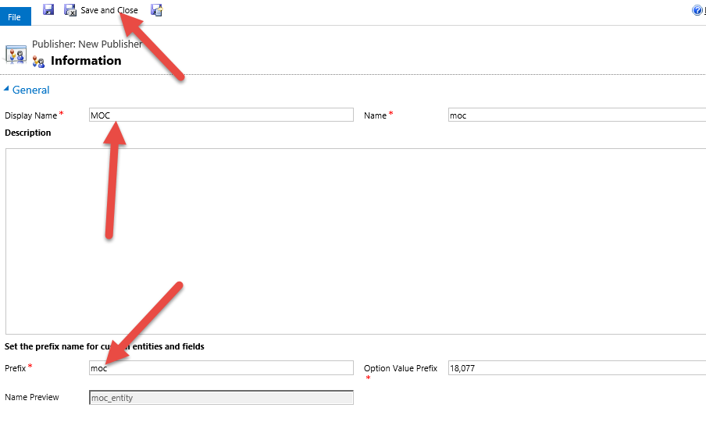

1. Click Add.

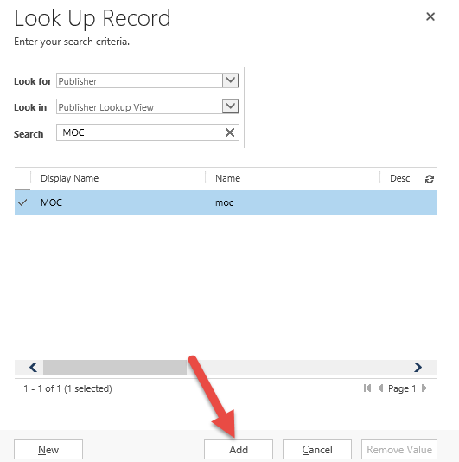

1. Enter 1 for version and click Save.

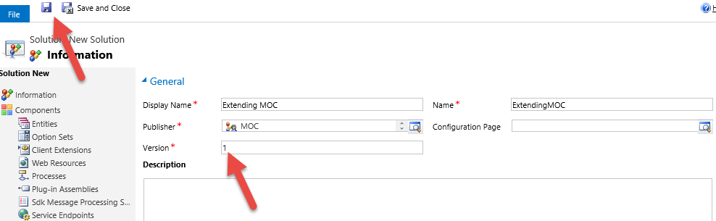

1. Select Entities and click New.

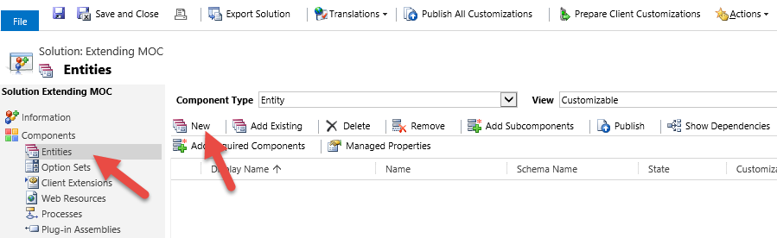

1. Enter Event Listing for Display Name, Event Listings for Plural Name, moc_eventlisting for Name, select Organization for Ownership, and click Save and Close. Leave other items, including data type, to the defaults already defined.

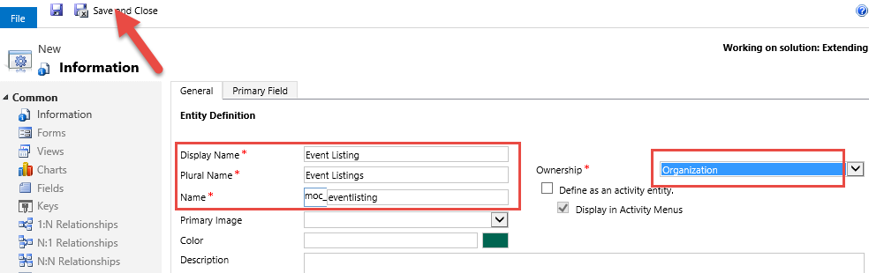

1. Publish All Customizations.

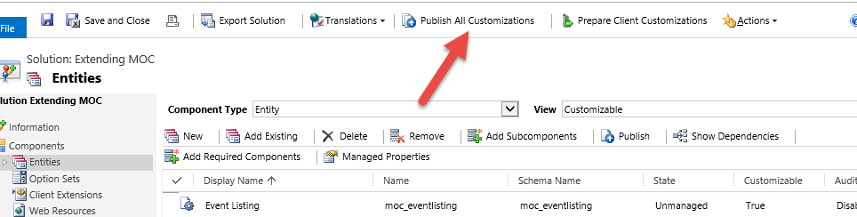

1. Close the Solution Explorer. As a reminder, we are only making this entity to learn about the site map, there is not a need at this time to build out more of the entity details.

### Task 2: Add Event Info Area

In this task you will use the SiteMap Editor to add a new SiteMap Area called Events to Dynamics CRM.

1. Go back to xrm.tools and click Add Area. 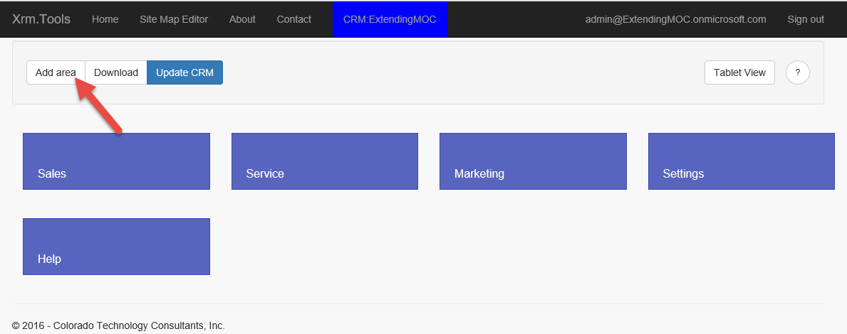
2. Enter EA for Id, Events for Title and click Save.  
   **Note:** This ID field is simply a short-hand for you to reference. You might use solutionprefix_name or as we do here abbreviations (EA is for Events Area. PSG for Public Sites Group and so on)

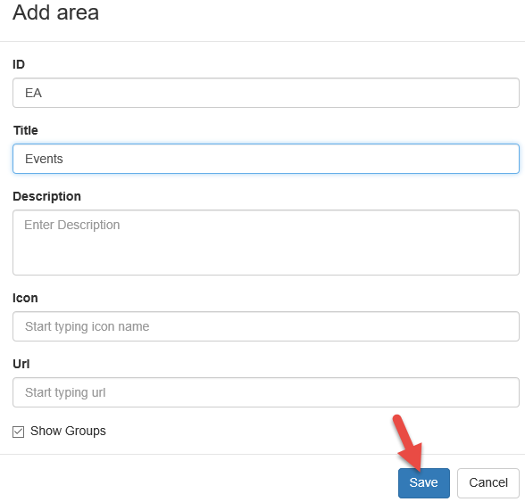

1. New area will be added. Click Update CRM and wait for update to complete.

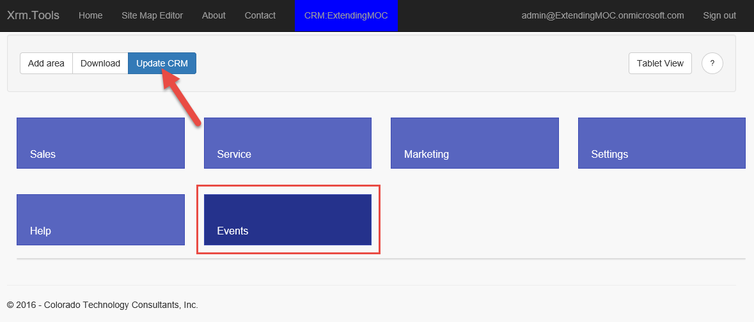

1. Go to your Dynamics CRM organization. Refresh the page, and click on the menu button. Notice that the Dynamics CRM SiteMap will not show the new Events Area yet, this is because it does not have Groups and SubAreas defined.

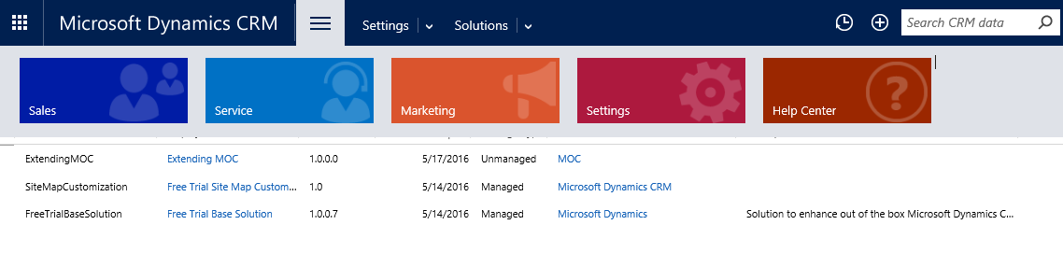

### Task 3: Add Groups

In this task you will add two new Groups called Event Info and Public Sites to the Events Area.

1. Go back to the xrm.tools and hover over the Events area. Small triangle will appear.

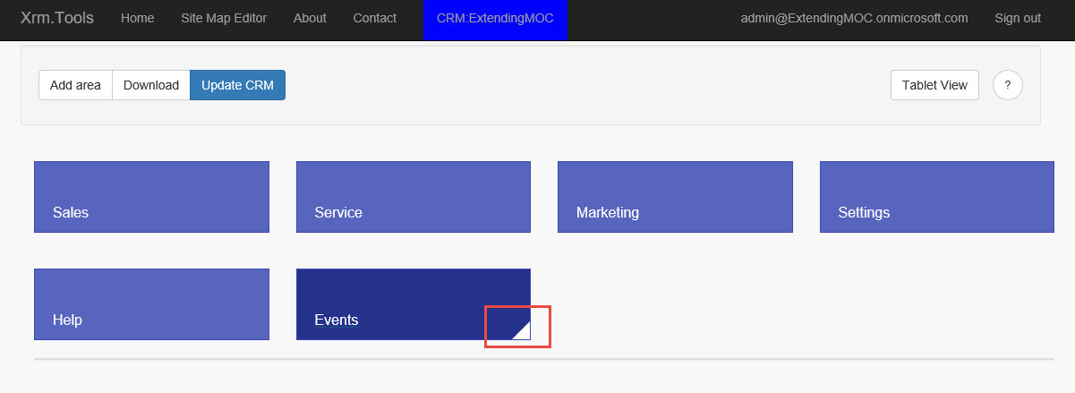

1. Click on the triangle and select Add Group.

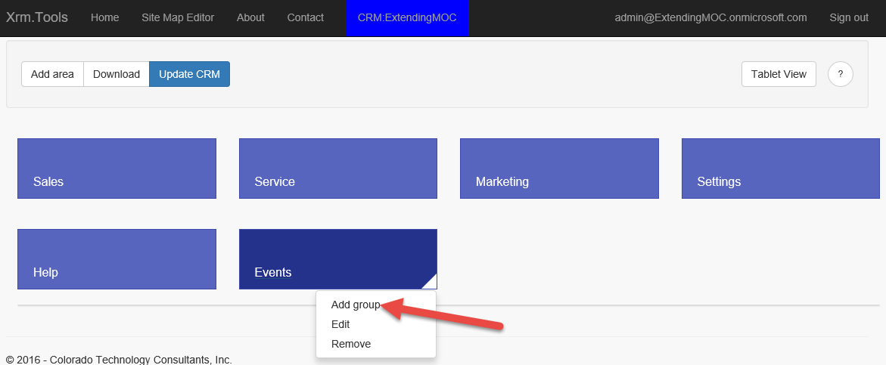

1. Enter EIG for Id, Event Info for Title, and click Save.

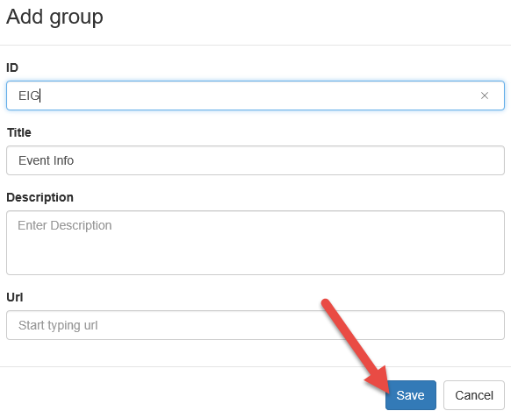

1. Hover over the Events area and click Add Group.

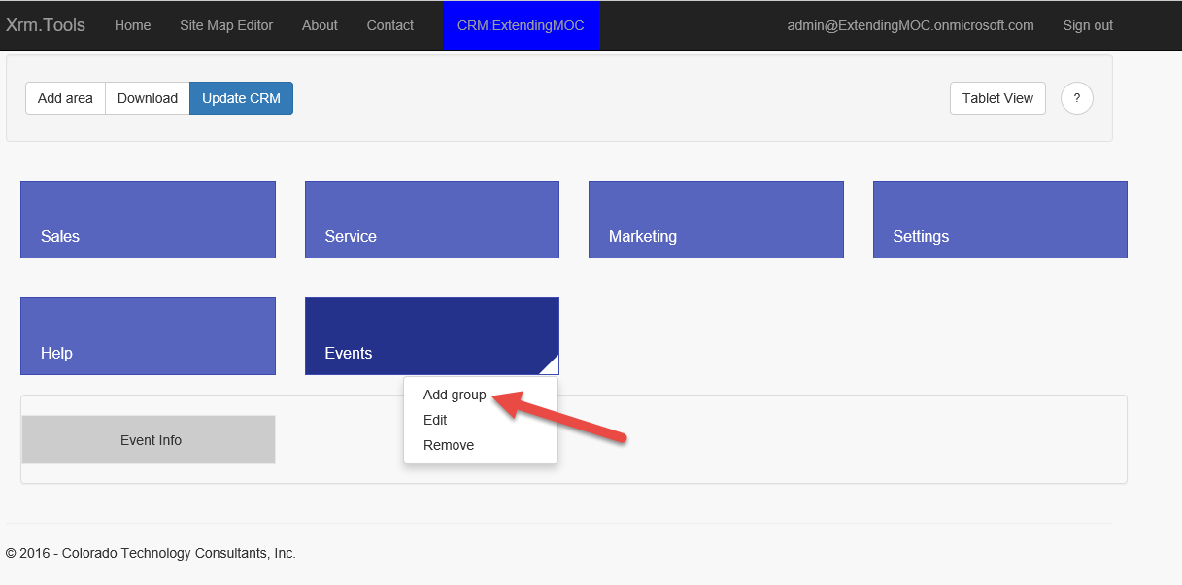

1. Enter PSG for ID, Public Sites for Title and click Save.

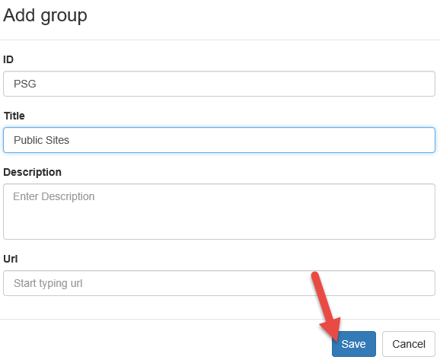

1. You will now have two groups under the Events are. Click Update CRM.

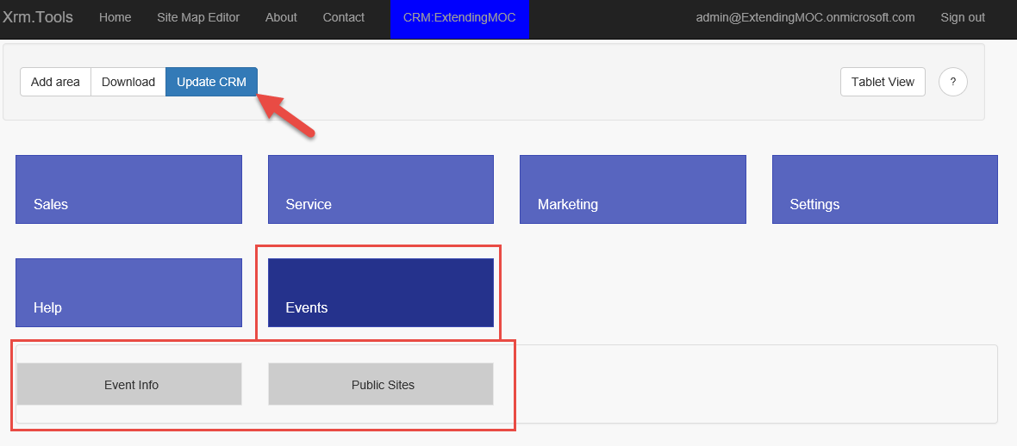

1. Go back into your Dynamics CRM organization. Refresh the page and click on the menu button. The Dynamics CRM SiteMap still does not display the Events Area, this is because none of the Groups defined contain any SubAreas.

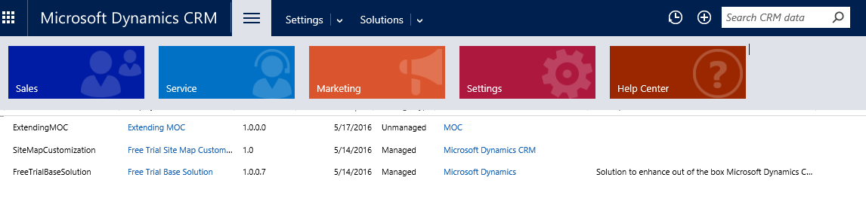

### Task 4: Add Subareas to the Events Info Group

In this task, you add two SubAreas called Accounts and Event Listings to the Event Info group.

1. Go to xrm.tools, hover over the Event Info group, and click add Item.

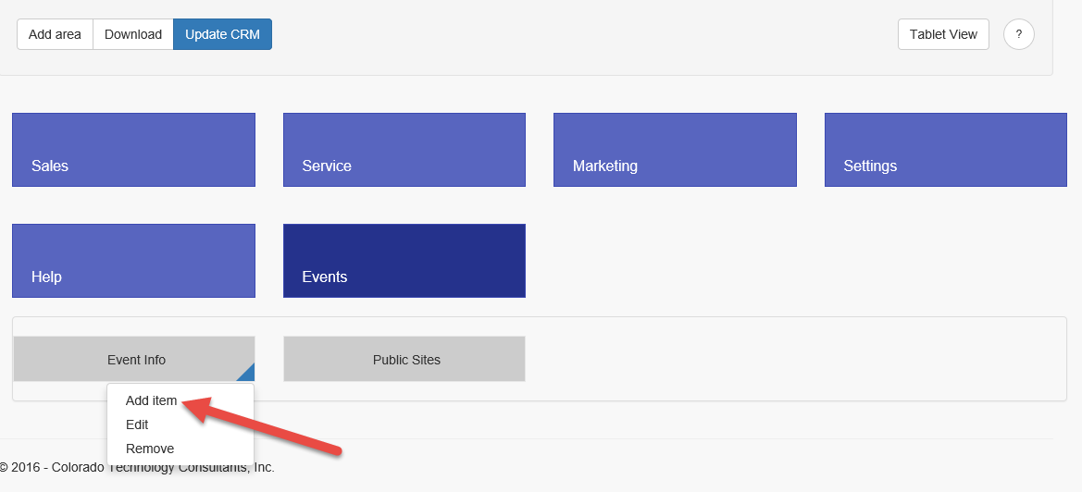

1. Enter EISA for ID, Event Listings for Title, moc_eventlisting for Entity, and click Save.

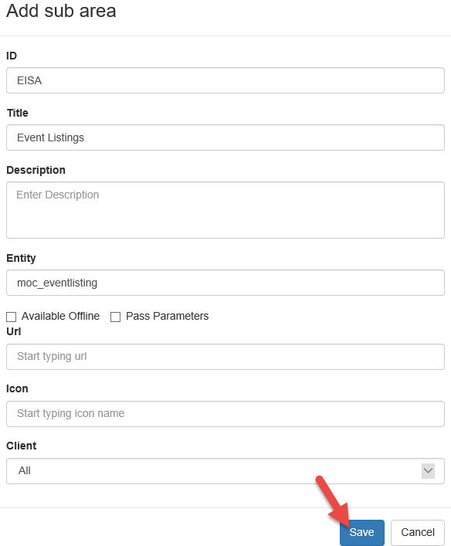

1. Click Add Item again.

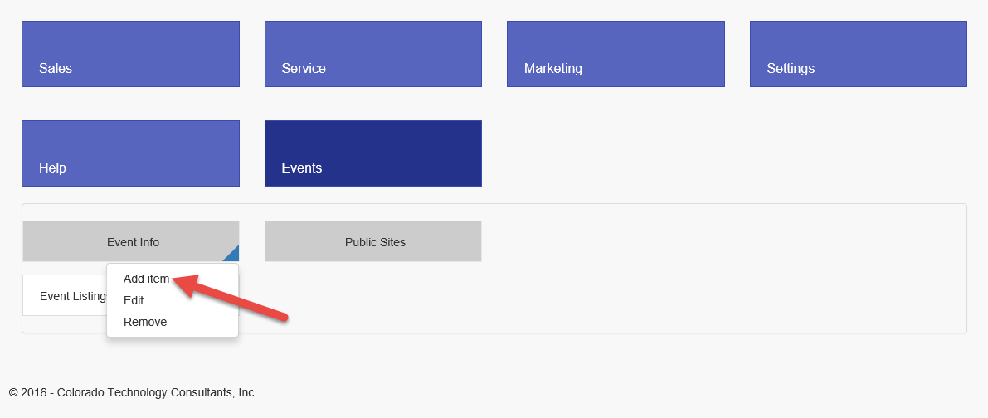

1. Enter ACC for ID, Accounts for Title, select account for Entity, and click Save.

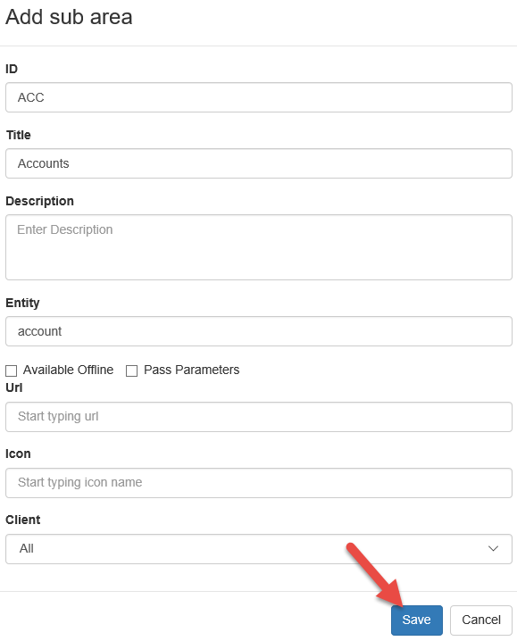

1. The Event Info group will now have two items. Click Update CRM.

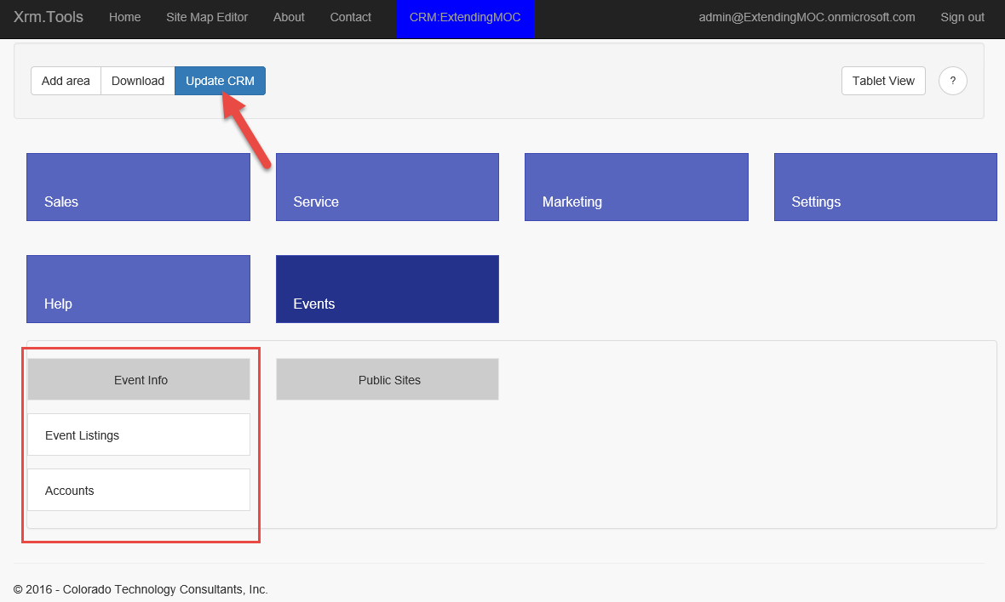

1. In your Dynamics CRM organization, refresh the page and click on the menu button. Dynamics CRM SiteMap will now display the Events Area because at least one Group has a SubArea defined.

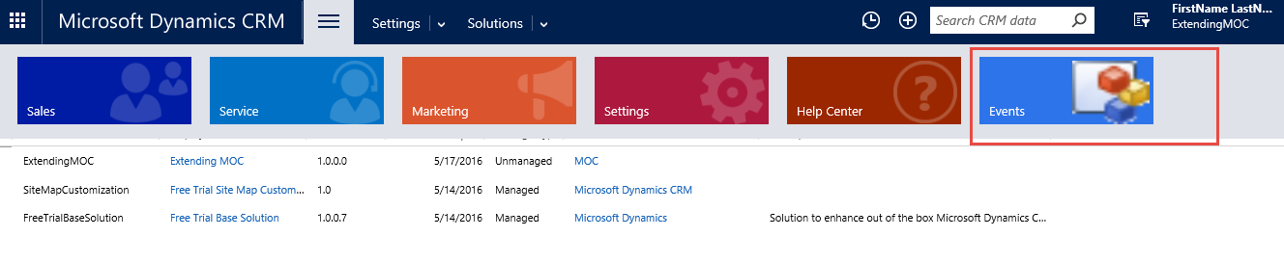

1. Select Events. Notice that only the Event Info Group (with Accounts and Event Listings SubAreas) is displayed because it is the only group that contains at least one defined SubArea.

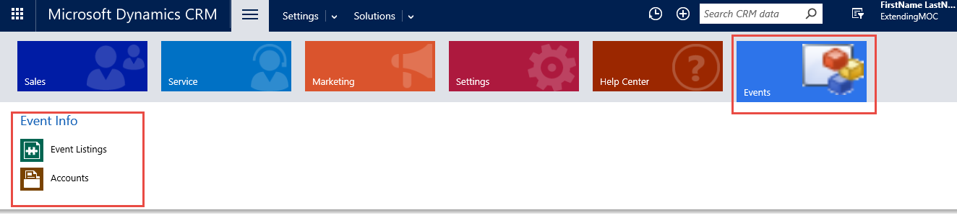

### Task 5: Add a Microsoft Events SubArea to the Public Sites Group

In this task you will add SubArea to the Public Sites Group.

1. Go back to xrm.tools, hover over Public Sites and click Add Item.

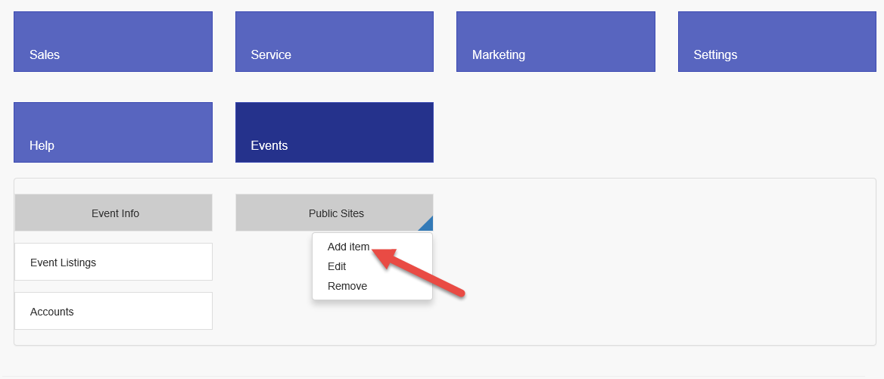

1. Enter MESA for Id, Microsoft Events FOR Title, enter <https://msevents.microsoft.com> for Url and click Save.

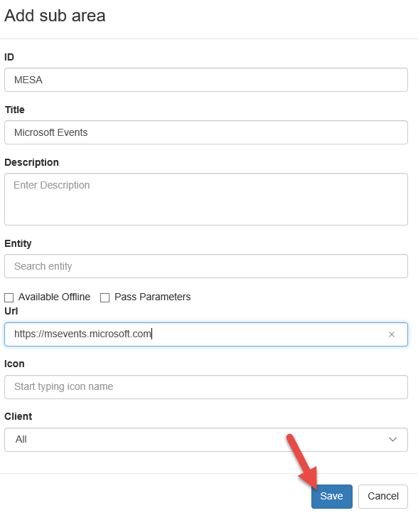

1. Click Update CRM and wait for update to complete.

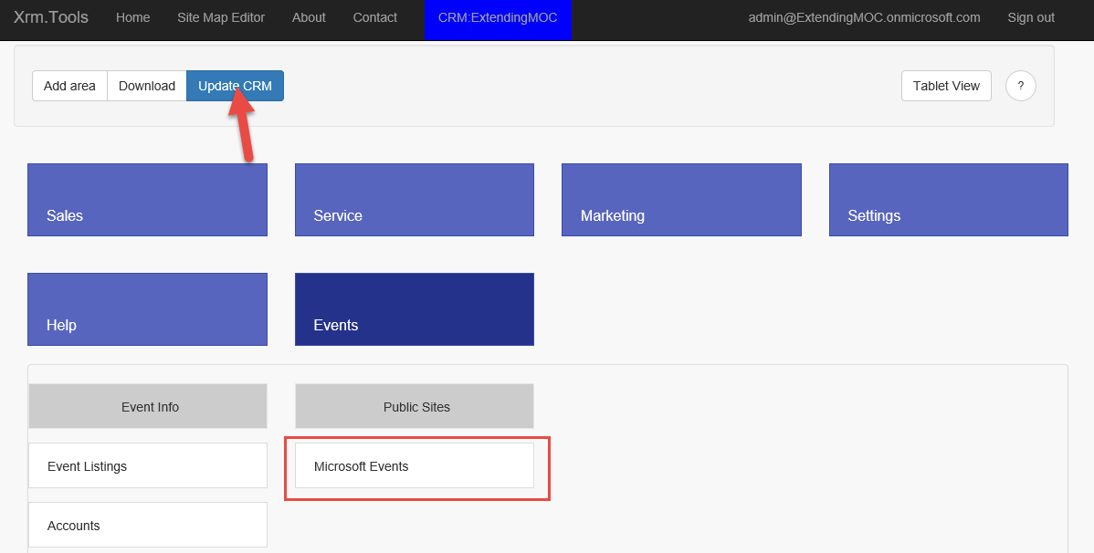

1. Back in your Dynamics CRM organization refresh the page, click on the menu button, and click Events. Both the Event Info and Public Sites groups are listed with as well as the defined SubAreas for each on.

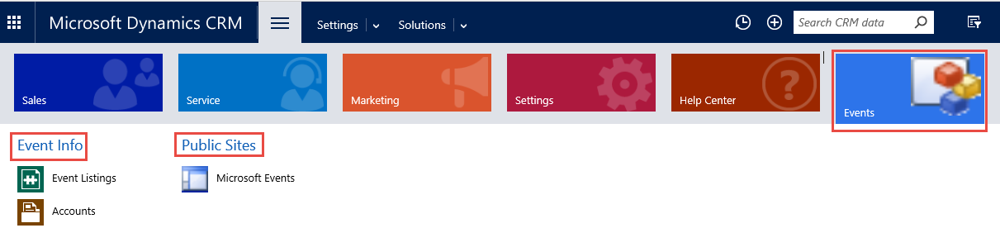

### Task 5: Order Sitemap Areas

In this task you add reorder SiteMap Areas.

1. Go to the XrmToolBox, drag Event and drop it between Sales and Service.

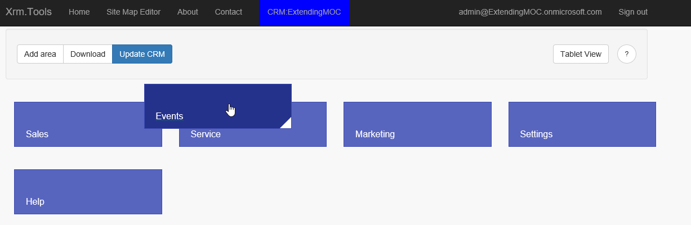

1. Event will now be moved after Sales.

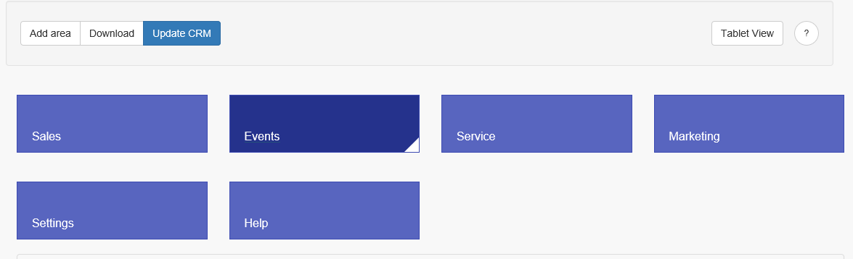

1. Move Public Sites, just above the Event Info.

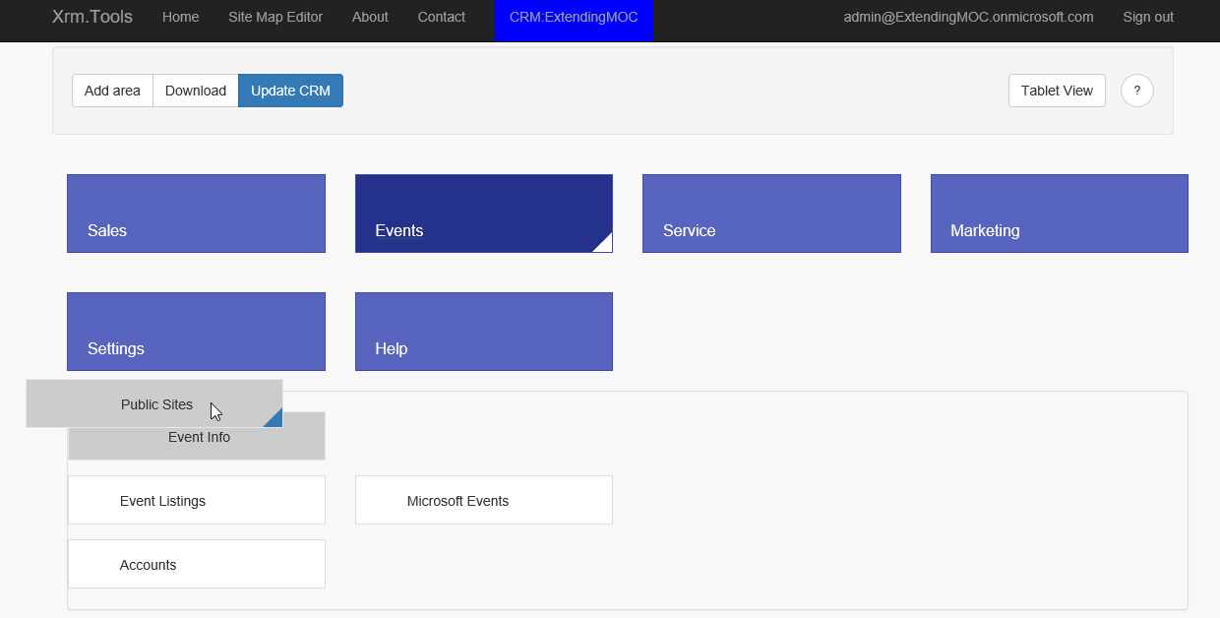

1. Public Sites will now be the first group.

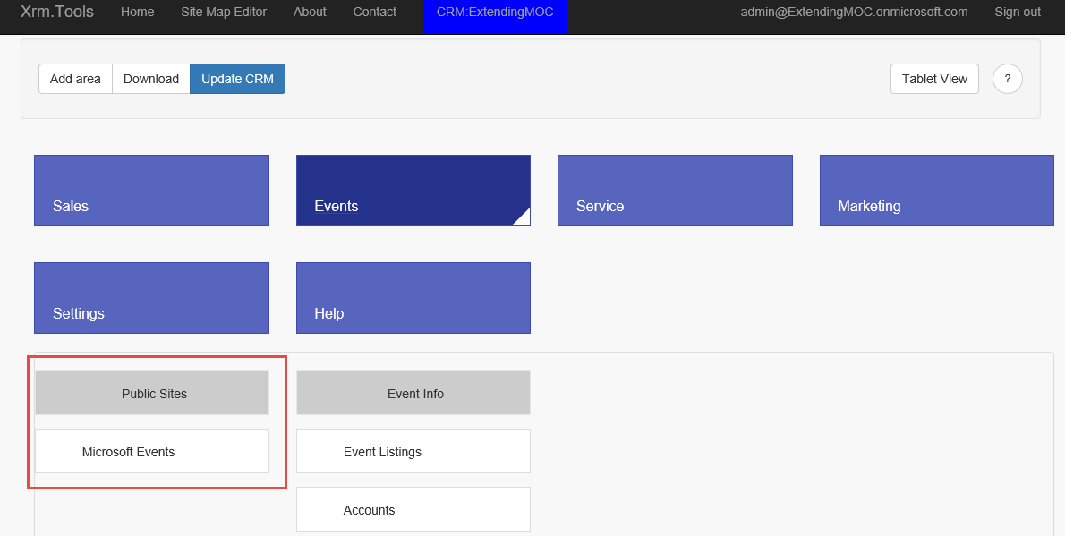

1. Move Accounts before Event Listings.

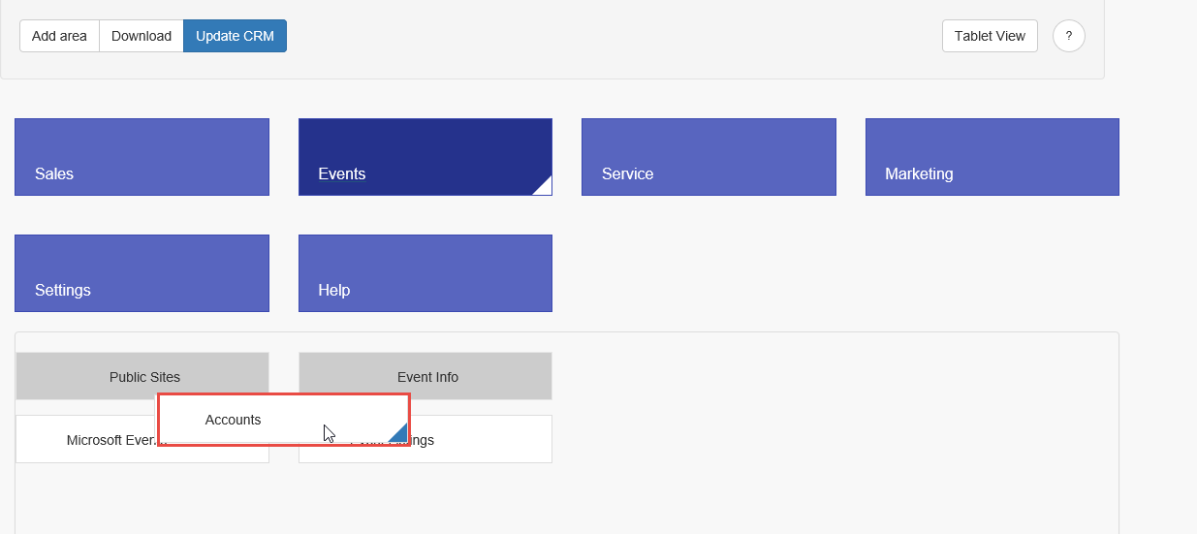

1. Accounts will now be the first item of Event Info. Click Update CRM.

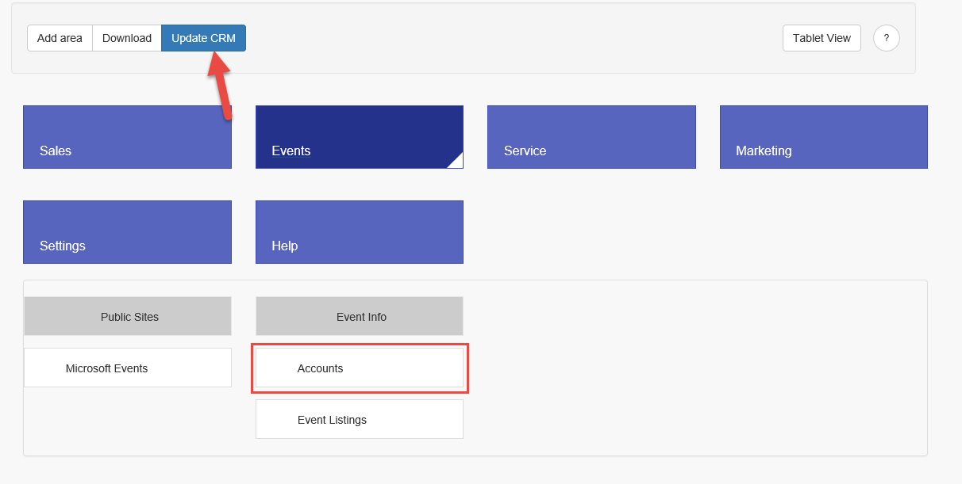

1. Go to your Dynamics CRM organization, refresh the page, and click on the menu button. Events should now appear second in the menu.

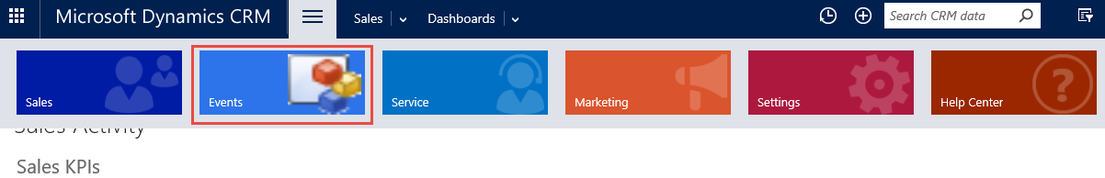

1. Click on Events. Public Sites will now be the first Group, and Accounts will be the first item in the Event Info group.

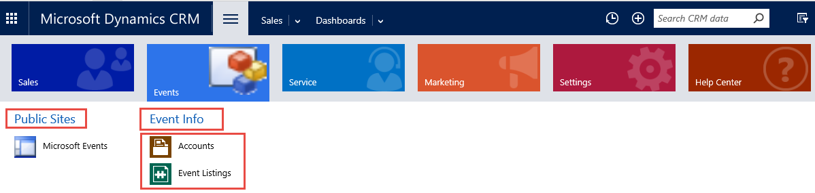

1. Click on Microsoft Events.

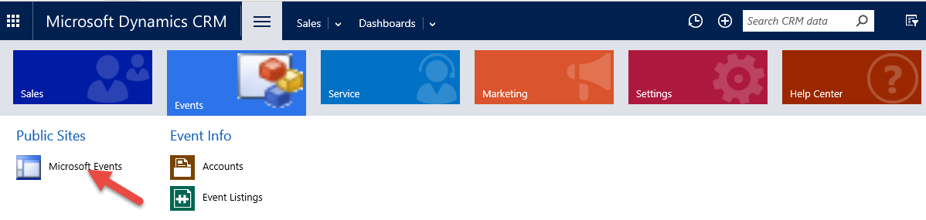

1. The external web page will be loaded.

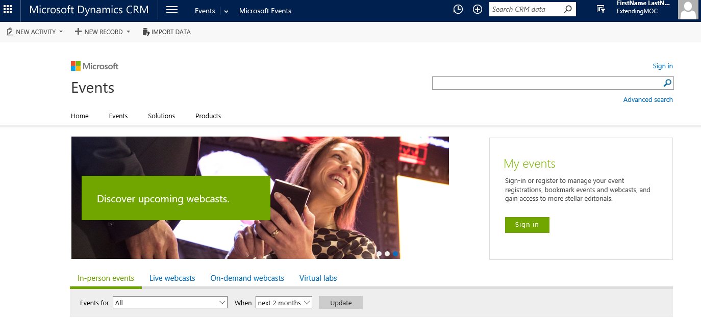

1. Click menu | Events and click Event Listings.

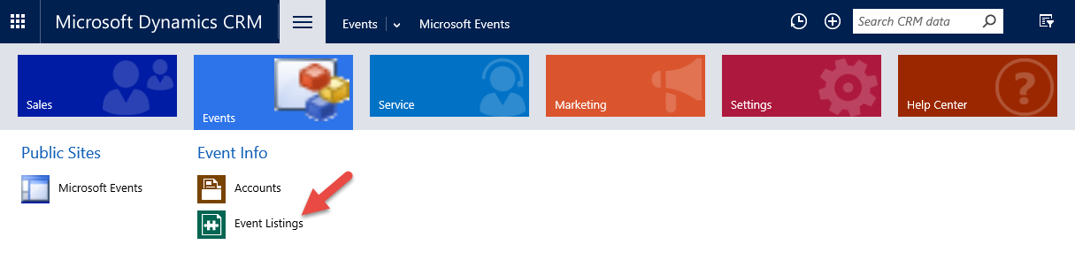

1. Event Listings will be loaded.