CSE515: Advanced Communications Networks and Systems
WiFi Sensing with Channel State Information for Device Free Human Activity Recognition and Indoor Localization
End Semester Project Report
Saarthak Gupta (22134024) Shreya Sangma (22134025) Vaibhav Jain (22164020)
Instructor: Dr. Ajay Pratap. Department of Computer Science and Engineering, Indian Institute of Technology (BHU) Varanasi

1. Introduction
Every WiFi device measures how the radio signal changes on its way from the transmitter to the receiver. That measurement is called Channel State Information, usually shortened to CSI. It needs no extra hardware, because a WiFi chip already computes it in order to decode packets, and many commodity chipsets will simply report it.
A person moving through the room reflects some of those radio waves and blocks others, so the CSI values change. They change in a pattern that depends on what the person did, and walking produces a different pattern from sitting down or falling. Record enough of those patterns with labels and a model can be trained to tell them apart, at which point an ordinary WiFi link has become a sensor. Nobody has to wear a device, no camera is involved, it works in the dark, and radio passes through plasterboard. Fall detection for elderly people living alone is the application most often cited.
This report covers both halves of our project. We survey the recent literature, reproduce the standard benchmark for this field, show that the way it measures success is broken, measure how much accuracy an honest evaluation costs, and try to win that accuracy back.

2. Motivation
The topic is current rather than settled textbook material. IEEE published Standard 802.11bf, the WLAN Sensing amendment, on 26 September 2025, and it defines how devices advertise sensing support, set up a sensing session and report measurements [2]. Cognitive Systems, Origin AI and Linksys already sell motion sensing features built on the same principle [10]. The course notes ask for a topic covered by recent papers, industry standards and shipping products together, and this one satisfies all three.
The research reason is that the field has a well known unsolved problem. A model trained in one setting with one group of people tends to fail as soon as it meets a different room or person. This domain shift is the main thing standing between a laboratory demonstration and a product, and our project is aimed at it.

3. Background on WiFi Sensing

3.1 What CSI is
Early wireless sensing used the Received Signal Strength Indicator, a single number that collapses the whole channel into one value. CSI is far richer. A WiFi link using orthogonal frequency division multiplexing splits its bandwidth into many narrow subcarriers, and CSI reports amplitude and phase for each subcarrier and each pair of antennas, so one measurement is a small matrix rather than a scalar. A moving body changes the length of the reflected paths and produces a Doppler shift, and different movements produce different shifts. That is why the same measurement supports both coarse tasks such as occupancy and fine ones such as recognising a gesture drawn in the air.

3.2 How the field developed
Ma, Zhou and Wang surveyed a decade of commodity WiFi sensing and group it into activity recognition, object sensing and localization [4]. Hardware stopped being the bottleneck once CSI could be read from ordinary network cards, after which the difficulty moved into processing and then into machine learning. That phase brought a new problem, which is that results became hard to compare, because different groups used different datasets, preprocessing and splits. Yang and colleagues answered this with SenseFi, an open benchmark implementing eleven model families on four public datasets under one procedure [1]. SenseFi is our starting point, and Section 5 explains where we found it wanting.
Sensing is also being folded into the standard itself. Meneghello and colleagues set out the physical and medium access layer changes behind 802.11bf [3]. The standard deliberately leaves the sensing algorithm to the implementer, so the modelling question this project studies is not settled by it. The wider idea is Integrated Sensing and Communication, where one radio carries data and senses at the same time, as in ISAC-Fi [12] and in related work inferring human pose from 5G uplink signals [13].

4. Related Works
We reviewed nineteen papers, weighted towards work from 2024 onwards as the course notes require. They fall into four groups.

4.1 Benchmarks and surveys
Yang and colleagues introduced SenseFi, comparing eleven deep learning models across four CSI datasets and reporting accuracy, model size and the transferability of learned features [1]. Ma and colleagues give the broader ten year survey [4]. A 2025 study compares BiLSTM against CNN+GRU on the same UT-HAR and NTU-Fi datasets we use and argues that dataset characteristics matter as much as architecture [11], which agrees with what we measured independently in Section 8.

4.2 The generalisation problem
This is the central open problem and the reason our project exists. Strohmayer and Kampel apply image style augmentation to CSI and study generalisation between line of sight and through wall scenarios [6]. Xu and colleagues survey self supervised learning for CSI activity recognition, motivated by the scarcity of labels [22], and CAPC combines contrastive predictive coding with augmentation so a model can learn from unlabelled data and adapt across environments [14].
Two recent papers show how far the framing has moved. MU-SHOT-Fi adapts to a new environment using only unlabelled data from it and a pretrained model, because privacy rules often prevent sharing the original training data [15]. An identity agnostic approach reformulates multi user recognition as activity counting so the model stops depending on a fixed set of known users [16]. Both react to the same weakness we identify in Section 5, which is that models quietly learn the people they trained on.

4.3 Efficiency and deployment
Sensing too expensive to compute will never run on a real access point. EfficientFi compresses CSI at the edge and restores it in the cloud so sensing can scale to many homes [5]. WiFlexFormer is a compact transformer reaching comparable accuracy with far fewer parameters, in about 10 milliseconds on a Jetson Orin Nano [7]. Its authors observe that a low parameter count helps cross domain generalisation, so small models often beat larger ones when conditions change, and our own measurements in Section 8 point the same way.
Newer work pushes efficiency harder. A physics guided temporal convolutional network uses Doppler energy to focus attention where motion actually happens [17], Wi-Spike uses a spiking network for low power recognition [18], and a 2026 paper treats the acquisition rate as a constrained resource, since sensing shares airtime with ordinary traffic [19].

4.4 Localization and real deployments
Barahimi and colleagues report lessons from a CSI localization system using more than 400 access points in a real building, and name the underuse of unlabelled data and the heterogeneity of CSI measurements as the factors that most limit large scale deployment [8]. Other work studies malicious access points that shift the readings a fingerprinting system depends on [20], and maxVSTAR uses a camera to relabel CSI automatically so an edge model keeps adapting after installation [21].
The literature agrees that generalisation is the central problem and many groups propose ways to improve it. What we found missing is a check on whether the standard evaluation measures generalisation at all, and that is the gap this report documents.

5. Problem Statement
A project that only runs someone else's code and reports the output is not worth submitting, so we first examined how the standard benchmark decides whether a model is good. We found a problem in it.

5.1 What we checked
Widar3.0 records the conditions of every sample in its filename. A file named user10-1-1-1-1-1 encodes the volunteer, the gesture, where the person stood, which way they faced and which repetition it was. We parsed all 43,652 filenames in the benchmark's two halves and compared which conditions appear on each side.
Factor | Values in training | Values in testing | Values in both
Volunteers | 17 | 17 | 17
Standing positions | 8 | 8 | 8
Body orientations | 5 | 5 | 5
Table 1. Every recording condition in Widar3.0 appears on both sides of the benchmark's train and test split. Nothing is held out.
Every volunteer, position and orientation appears in both halves. The split is domain mixed, because the two halves were drawn from one pool and shuffled, so nothing in the test set is new to the model.

5.2 Why this matters
Such a model is asked to recognise gestures performed by people it has trained on, standing where it has seen them stand and facing the way it has seen them face. It is an examination where the practice paper and the real paper come from the same question bank, so a high score shows familiarity rather than understanding. The accuracy fairly measures how well a model learned its training conditions, but it does not answer the question that decides whether the technology can ship, which is whether it works for a person it has never met.

5.3 The leakage is worse when counted per recording condition
Counting factor by factor understates the problem, and while building the corrected splits we found the sharper way to measure it. Group every sample by the combination of gesture, volunteer, standing position and body orientation, and call that a recording condition. Widar3.0 contains 4265 of them, holding an average of 10.2 recordings each, because each volunteer repeated every gesture several times before moving on.
Measurement | Value
Recording conditions in the dataset | 4265
Recordings per condition, on average | 10.2
Conditions appearing on both sides of the split | 4259 of 4265
Test samples with a sibling recording in training | 8726 of 8726, which is 100 percent
Table 2. The benchmark's split measured per recording condition rather than per factor.
Every test sample has at least one training sample recorded from the same person performing the same gesture in the same place facing the same way. We checked that these are not copies of one file. They are repeat takes of one action, and they resemble each other far more than two recordings of the same gesture made under different conditions do. So the benchmark is testing largely on near duplicates of its own training data, which is a separate problem from testing in domain and has a different size and a different cure. Section 8 measures the two apart.
One trap is worth recording for anyone repeating this. The repetition number in the filename is not a unique identifier for a recording. 4370 files carry a bracketed suffix from a name collision and reuse a repetition number that another file already holds, so 5873 combinations own more than one file. Grouping by repetition would therefore have produced a split that still leaked. Our condition group deliberately leaves repetition out.

5.4 The problem we will solve
Our project therefore asks two questions. First, how much accuracy is actually lost when a WiFi sensing model meets conditions that were held out of its training, as opposed to conditions it has already seen. Second, how much of that loss can be recovered using techniques available today, such as data augmentation. Sections 8.6 to 8.9 answer both.

6. Proposed Solution
Our solution has three parts. First, rebuild the evaluation split so that whole recording conditions are held out of training, rather than shuffling every sample together. A model trained that way has never seen the person, position or orientation it is tested on. Second, report cost beside accuracy, because accuracy alone cannot say whether a model could run on a real access point, so we record parameter count, weight size and inference latency as well. Third, try to recover what the honest split costs, using augmentation and adaptation, and report the outcome including the methods that fail. A properly measured negative result is still a result.

7. System Design

7.1 Datasets
We use the four public CSI datasets the benchmark supports, all released by the researchers who recorded them and all verified in our repository. Together they occupy about 29 gigabytes. Widar3.0 [9] is the one this project turns on.
Dataset | Task | Sample shape | Classes | Train | Test
UT-HAR | 7 daily activities, 6 people | 1 x 250 x 90 | 7 | 3,977 | 996
NTU-Fi HAR | 6 activities, 114 subcarriers | 3 x 114 x 500 | 6 | 936 | 264
NTU-Fi HumanID | Identify who is walking | 3 x 114 x 500 | 14 | 294 | 546
Widar3.0 | 22 hand gestures | 22 x 20 x 20 | 22 | 34,926 | 8,726
Table 3. The four public CSI datasets used in this work.
These are not images, although two of them are shaped like small ones. A UT-HAR sample is 250 time steps by 90 subcarriers. Widar3.0 differs, because its authors converted the raw signal into a Body coordinate Velocity Profile, a 20 by 20 grid of velocities at 22 time steps. Its filenames record the volunteer, standing position and body orientation of every sample, which is what makes the rest of this report possible.

7.2 Fixing the data pipeline
The benchmark parses one text file per sample on a single thread, since no worker count is configured anywhere in it. Reading one Widar sample costs 5.67 milliseconds cold and about 2.6 milliseconds warm, which is between 1.5 and 3.3 minutes of file reading for every pass over the training set. At the shipped 100 epochs that is hours spent parsing text while the graphics processor sits idle. We convert all 43,652 files once into a memory mapped array of 1.54 gigabytes, plus a metadata table holding the volunteer, position and orientation parsed from each filename. The conversion takes about six seconds on 28 threads and a sample then costs 0.002 milliseconds to read. That is what made the rest of this work affordable on a laptop.

7.3 Building splits that hold up
Our split code refuses to return a split that leaks a held out condition or loses a gesture class, and that check failed on the first attempt. The volunteers did not all perform the same gestures. Volunteers 1 and 2 performed all 22 and hold 48 percent of the data, ten performed only 9 each, and gestures 13 to 22 were performed by just two people, so holding out the wrong volunteers deletes whole classes. Positions 6, 7 and 8 have the same problem at about 600 samples each. Orientation is the clean factor, with all five covering all 22 gestures at roughly 8,730 samples. Without that check the split would still have produced numbers, and they would have shown a large drop that measured missing classes rather than lost generalisation.
Protocol | Held out of training | Classes | Train | Test
Cross orientation | Body orientation 5 | 22 | 34,927 | 8,725
Cross position | Standing position 5 | 22 | 35,280 | 8,372
Cross user | Volunteers 15, 16 and 17 | 9 | 26,648 | 3,370
Table 4. The three cross domain protocols. Each also carries the two in domain arms described next, over exactly the same samples with the same test size.

7.4 Three arms rather than two
Comparing a cross domain split against a plain random one confuses two effects, for the reason given in Section 5. A random split over samples leaks near duplicates, because repeat takes of one condition fall on both sides of it, and a cross domain split does not. Comparing only those two would measure the leakage and the domain shift added together and report the sum as though it were the shift alone. We therefore run every protocol three ways over the same pool of samples with the same test size.
Arm | How the split is made | What it measures
Benchmark style | Random over individual samples | What SenseFi reports today
Grouped in domain | Random over whole recording conditions, so every volunteer, position and orientation still appears on both sides | In domain accuracy once repeat takes can no longer leak
Cross domain | One whole orientation, position or volunteer group held out | Accuracy on a condition never seen
Table 5. The three arms. The difference between the first two is the leakage, and the difference between the last two is the domain shift.
The grouped arm is the control that makes the decomposition possible. It is still domain mixed, so it differs from the benchmark arm in one respect only. The split code asserts this, refusing any grouped split in which a condition appears on both sides or a factor value is lost.

7.5 Choosing which epoch to report
Our midterm quoted the best epoch, the highest accuracy any epoch reached on the test set. For an in domain sweep that is a defensible summary, but for a cross domain claim it is peeking, because the test labels chose the stopping point. Here we carve a validation set out of the training data, pick the epoch on that, and report test accuracy at that epoch. The validation set is itself carved at recording condition level, otherwise the same near duplicate lookup this report is about would win it and it would choose the epoch badly. All three readings are kept and Section 8 reports what the difference is worth.

7.6 The recovery methods
Two methods are tried here, both applied only to the training data of the cross domain arm. Section 8 adds a third, which is adapting a trained model on a few labelled examples from the held out condition.
- Augmentation built around the physics rather than around images. The velocity plane is rotated, which corresponds to a change in the direction the person faces, and scaled, which corresponds to moving faster or slower. The sample is also shifted in time, given noise, and has part of the grid erased. Each time step of a velocity profile is a distribution summing to about one, so every step is rescaled back to its original mass, otherwise the benchmark's fixed normalisation constants stop holding.
- Mixup, blending two samples and their labels in the same proportion. A blend of two velocity profiles is still a velocity profile, so this is reasonable here rather than a purely visual trick.
The rotation angle needs care. Anything close to a quarter turn destroys the label, because the gesture set contains Draw N horizontally and Draw N vertically as separate classes, and the same pairing for Draw O and Draw Zigzag. A small angle is also the physically correct choice, since a velocity profile is already in body coordinates and only the residual error in estimating the torso direction survives. We measured two settings rather than assuming.

7.7 Training procedure
We keep the benchmark's training recipe so our numbers stay comparable to the published ones, meaning Adam at a learning rate of 0.001, cross entropy loss and a batch size of 64. Three things differ deliberately.
- Widar reads the cached array rather than reparsing 43,652 text files every epoch, and the other file backed datasets use worker processes.
- Test accuracy is correct predictions divided by total samples. The benchmark averages per batch instead, which overweights the final partial batch.
- The recurrent model on UT-HAR ships with 3000 epochs, which we cap at 200. Every other model runs for the epochs the benchmark ships.
Two runs needed a smaller batch. The Vision Transformer on the NTU-Fi datasets exhausts 8 gigabytes of graphics memory, because its input becomes about 760 patch tokens and attention cost grows with the square of that. Those two runs use a batch of 16.

7.8 Hardware and software
Everything runs on a laptop with an NVIDIA GeForce RTX 4060 holding 8 gigabytes, an Intel Core i7-14700HX with 28 threads and 16 gigabytes of system memory, using PyTorch 2.14 with CUDA 13.2. The benchmark asks for PyTorch 1.12, which cannot run on this card at all because it builds no kernels for compute capability 8.9. Anyone reproducing this work on current hardware will meet the same obstacle. We checked that all eleven models build and run under the newer version.

8. Results
We trained all eleven models on all four datasets, which is 44 runs. Every number below is generated directly from the recorded results rather than copied by hand, so the tables cannot drift out of step with the experiments.

8.1 Reproduced baseline accuracy
Model | UT-HAR | NTU-Fi HAR | NTU-Fi HumanID | Widar3.0
MLP | 0.929 (0.945) | 0.977 (0.981) | 0.908 (0.912) | 0.681 (0.685)
LeNet | 0.971 (0.979) | 0.996 (0.996) | 0.976 (0.976) | 0.673 (0.704)
ResNet18 | 0.984 (0.986) | 0.901 (0.977) | 0.912 (0.912) | 0.678 (0.691)
ResNet50 | 0.953 (0.970) | 0.867 (0.939) | 0.643 (0.650) | 0.641 (0.674)
ResNet101 | 0.099 (0.972) | 0.951 (0.951) | 0.636 (0.742) | 0.644 (0.658)
RNN | 0.601 (0.611) | 0.883 (0.913) | 0.850 (0.881) | 0.351 (0.483)
GRU | 0.921 (0.937) | 0.996 (1.000) | 0.990 (0.990) | 0.562 (0.629)
LSTM | 0.819 (0.874) | 0.970 (0.981) | 0.956 (0.976) | 0.583 (0.640)
BiLSTM | 0.875 (0.903) | 0.974 (0.989) | 0.946 (0.976) | 0.584 (0.634)
CNN+GRU | 0.971 (0.982) | 0.977 (0.989) | 0.789 (0.895) | 0.619 (0.652)
ViT | 0.923 (0.957) | 0.924 (0.932) | 0.769 (0.782) | 0.659 (0.679)
Table 6. Test accuracy at the final epoch, with the best epoch in brackets. Eleven models on four datasets, 44 runs.
The three activity datasets are largely solved, with accuracies above 0.97 common on UT-HAR and NTU-Fi HAR and a recurrent model reaching a perfect score on the latter. Widar3.0 is much harder at 0.704, which is unsurprising with 22 gesture classes rather than 6 or 7.
Cost matters as much as accuracy, because the benchmark reports accuracy alone and a model that cannot run on an access point is of no use. The spread is large. On NTU-Fi HAR a gated recurrent unit with 79 thousand parameters reaches a perfect 1.000 while the multilayer perceptron needs 175 million to reach 0.981. On Widar3.0 accuracy peaks at LeNet with 299 thousand parameters and 0.704, and every larger model is worse, with ResNet101 holding 142 times more parameters and reaching only 0.658. A Widar sample is a 20 by 20 grid of velocities at 22 time steps rather than a photograph, so the capacity of an image network has little to work with. That is convenient here, because it means the cross domain experiments below can use a small model without any loss of rigour.

8.2 What the honest split costs
This is the central result of the project. Each row uses the same samples and the same test set size, so the only thing that changes along a row is what the split holds back.
Model | Protocol | Benchmark style | Grouped in domain | Cross domain | Cost of removing repeat takes | Cost of the domain shift
LeNet | Held out orientation | 0.687 | 0.638 | 0.326 | -0.049 | -0.313
LeNet | Held out standing position | 0.681 | 0.623 | 0.702 | -0.059 | +0.080
LeNet | Held out volunteer | 0.748 | 0.736 | 0.594 | -0.012 | -0.142
GRU | Held out orientation | 0.627 | 0.567 | 0.267 | -0.061 | -0.300
GRU | Held out standing position | 0.619 | 0.573 | 0.625 | -0.046 | +0.052
GRU | Held out volunteer | 0.698 | 0.696 | 0.576 | -0.002 | -0.119
ViT | Held out orientation | 0.660 | 0.594 | 0.321 | -0.066 | -0.273
ViT | Held out standing position | 0.669 | 0.610 | 0.682 | -0.059 | +0.072
ViT | Held out volunteer | 0.700 | 0.691 | 0.535 | -0.009 | -0.155
ResNet18 | Held out orientation | 0.689 | 0.617 | 0.267 | -0.071 | -0.351
ResNet18 | Held out standing position | 0.683 | 0.634 | 0.689 | -0.049 | +0.056
ResNet18 | Held out volunteer | 0.715 | 0.683 | 0.558 | -0.031 | -0.126
Table 7. The accuracy drop separated into its two causes. Accuracy is taken at the epoch chosen on a validation set carved out of the training data, never at the best epoch on the test set.
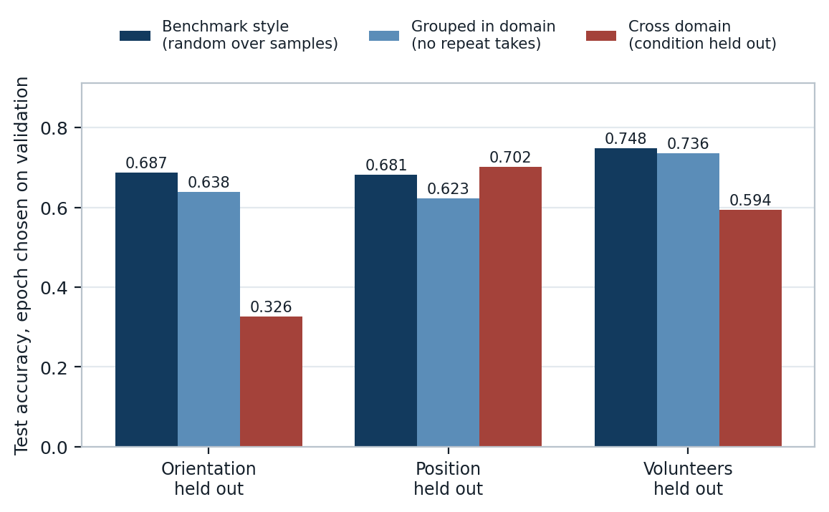
Figure 1. The same model and the same samples under three different splits. The left bar is what the benchmark reports and the right bar is what the model can actually do on a condition it has never seen.
Take LeNet with a held out orientation. The benchmark style split reports 0.687. Removing only the repeat takes, while leaving every orientation visible in training, brings that to 0.638. Holding the orientation out brings it to 0.326. Of the 0.361 point fall, 0.049 is the benchmark testing on repeat recordings of conditions it already trained on, which is leakage rather than a domain problem, and the remaining 0.313 is the real cost of meeting a new orientation. Reporting 0.361 alone would credit the domain shift with a loss largely caused by near duplicate test samples.
The three protocols do not behave alike. Averaged over the models we trained, holding out an orientation costs 0.309 accuracy points, while holding out a standing position costs nothing at all, and in our runs it slightly improves the result by 0.065. That is what the physics predicts, and it matters for the dataset's own claims. A body coordinate velocity profile is computed in a frame attached to the person, and the authors of Widar3.0 designed it so the result would not depend on where someone stands or which way they face. They half succeeded. The transform does remove the dependence on standing position. It does not remove the dependence on orientation, which enters through an estimate of the torso direction and survives as the largest residual effect. Calling the representation domain independent is too strong, and so would be denying it works at all.

8.3 The drop depends on which condition is held out
A single cross domain number hides something. We repeated the experiment holding out each value of the condition in turn.
Condition held out | 1 | 2 | 3 | 4 | 5 | Spread
Orientation | 0.450 | 0.611 | 0.596 | 0.458 | 0.326 | 0.285
Standing position | 0.658 | 0.600 | 0.653 | 0.608 | 0.702 | 0.102
Table 8. LeNet accuracy with each value of the condition held out in turn. The spread column is the best case minus the worst case.
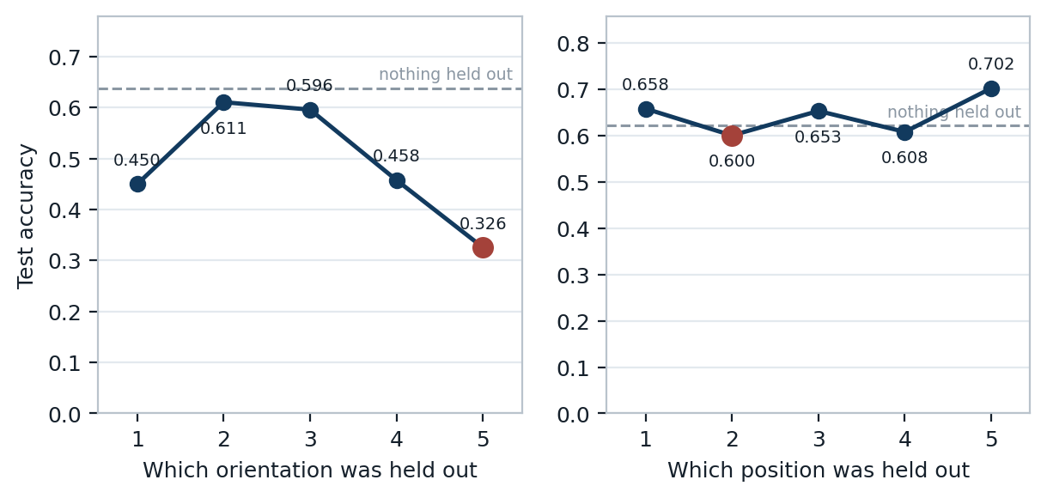
Figure 2. Accuracy against which value of the condition was held out. The dashed line is the same model with nothing held out. The worst case is marked in red.
For orientation the shape is close to an inverted U. Holding out orientation 2 leaves accuracy at 0.611, while holding out orientation 5 brings it to 0.326. That spread of 0.285 points is larger than many improvements reported in this literature. Orientations 1 and 5 sit at the ends of the range, so holding one out asks the model to extrapolate, while holding out a middle value only asks it to interpolate between neighbours it already knows. The choice of held out value therefore moves the headline a long way, and a paper that reports one cross domain figure without saying which value it held out has not said enough for the number to be checked.
Standing position behaves in the opposite way. Its spread is only 0.102 and every value sits near the in domain result, so there is no bad case to pick. Holding out a position is not a domain shift worth the name, and this is the second independent sign of it after the decomposition in the previous section.

8.4 The same result without training anything
Every number so far came out of a neural network, which leaves the reply that the architecture or the learning rate was at fault. So we repeated the measurement with no model. Each test sample takes the gesture label of the single most similar training sample, where similarity is the cosine between two raw velocity profiles. There is nothing to train and nothing to tune.
Protocol | Arm | Classes | Chance | Nearest neighbour
Orientation | Benchmark style | 22 | 0.045 | 0.306
Orientation | Grouped in domain | 22 | 0.045 | 0.231
Orientation | Cross domain | 22 | 0.045 | 0.101
Standing position | Benchmark style | 22 | 0.045 | 0.313
Standing position | Grouped in domain | 22 | 0.045 | 0.233
Standing position | Cross domain | 22 | 0.045 | 0.265
Volunteer | Benchmark style | 9 | 0.111 | 0.381
Volunteer | Grouped in domain | 9 | 0.111 | 0.328
Volunteer | Cross domain | 9 | 0.111 | 0.250
Table 9. Accuracy of labelling each test sample with its single nearest training sample, on raw data with no learning involved.
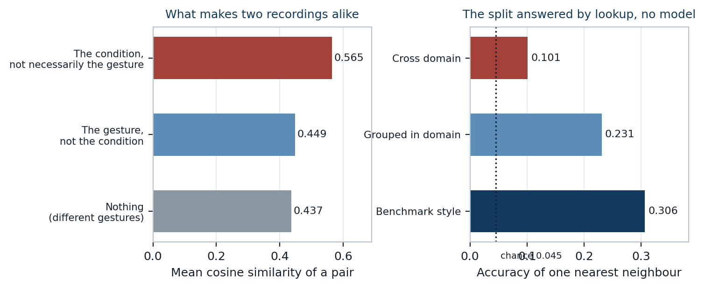
Figure 3. Left, what two recordings have in common and how similar that makes them. Right, how far a plain nearest neighbour lookup gets on each arm of the split.
The left half of the figure explains the problem in one measurement. Two recordings of different gestures have a mean cosine similarity of 0.437. Two recordings of the same gesture under different conditions reach only 0.449, so sharing a gesture is worth +0.012. Two recordings sharing a condition reach 0.565, worth +0.129, about 10 times as much. In the raw data, who performed a gesture and where they stood leaves a stronger trace than which gesture it was, so a model rewarded for accuracy on a condition mixed split is mostly being rewarded for identifying the condition.
The right half makes the same point about the split. On the benchmark's own arrangement a lookup with no learning reaches 0.306 against chance of 0.045. Removing the repeat takes drops it to 0.231, and holding the orientation out drops it to 0.101. That reproduces the ordering of the trained results without a single parameter, so the effect belongs to the data and the split rather than to our models. If a body coordinate velocity profile really were domain independent by construction, these three numbers would be equal.

8.5 Trying to win the accuracy back
Method | Held out orientation | Held out standing position | Held out volunteer
No recovery | 0.326 | 0.702 | 0.594
Augmentation to 20 degrees | 0.321 (-0.005) | 0.731 (+0.029) | 0.614 (+0.020)
Augmentation to 20 degrees with mixup | 0.350 (+0.025) | 0.742 (+0.040) | 0.631 (+0.037)
Augmentation to 45 degrees | 0.370 (+0.044) | 0.716 (+0.013) | 0.604 (+0.010)
Mixup | 0.312 (-0.013) | 0.703 (+0.001) | 0.581 (-0.013)
Table 10. Cross domain accuracy with each recovery method, and in brackets the change against the same model with no recovery applied.
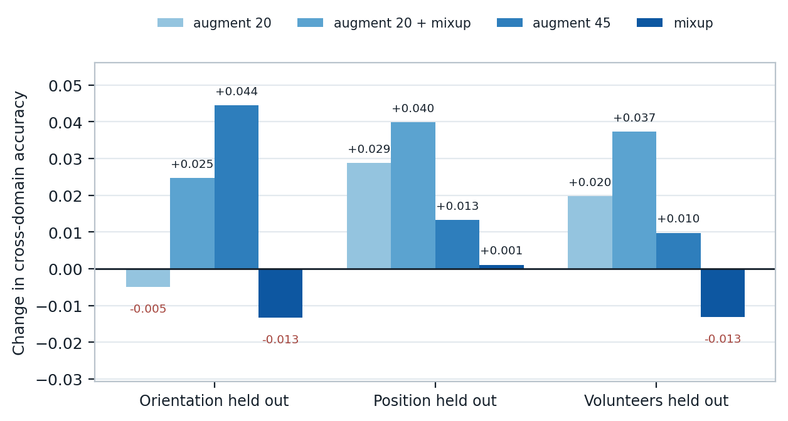
Figure 4. Change in cross domain accuracy for each recovery method. Bars below the line are methods that made the result worse, which are reported for the same reason as the ones that helped.
Taking the best method for each protocol, for a held out orientation the best method was augmentation to 45 degrees, worth +0.044; for a held out standing position the best method was augmentation to 20 degrees with mixup, worth +0.040; for a held out volunteer the best method was augmentation to 20 degrees with mixup, worth +0.037.
Before running these we predicted that rotating the velocity plane would help most where orientation is held out, that scaling it would help where the volunteer is held out, and that standing position had no comparable physical story so would gain least. The first two held. The third did not, and position gained about as much as anything else, which we cannot explain from the physics and do not intend to invent a reason for. We were also wrong about the rotation angle, and this is the clearer miss. We argued that the angle had to stay small, because Widar3.0 contains Draw N horizontally and Draw N vertically as separate classes, so a rotation near a quarter turn maps one class onto another and destroys the label. It is also the physically tidy choice, since a velocity profile is already in body coordinates and only the residual error in estimating the torso direction should survive. The measurement disagrees. On the held out orientation the wider rotation reaches 0.370 against 0.321 for the narrow one, so the label damage we were worried about costs less than the extra variety buys. We measured both settings rather than assuming, which is the only reason we know.
Two checks sit behind those numbers. A method that raises cross domain accuracy is only worth having if it does not quietly cost in domain accuracy to get there, so the same augmentation was run against the grouped in domain arm. It changed the result by between -0.006 and +0.041, so nothing is being traded away. It also survives a change of architecture, since the same augmentation moves ResNet18 on the held out orientation from 0.267 to 0.304.

8.6 How many labelled examples from the new condition would it take
Augmentation asks the model to imagine the new condition. The other option a deployer has is to label a few examples from it, so we measured how far that gets. Two versions are run and the contrast between them is the point. Retraining only the final layer freezes the features and can move nothing but the decision boundaries. Retraining the whole network lets the features change too. If only the second recovers accuracy, the representation itself is what failed to transfer. Examples are reserved before anything else, so every point is scored on the same samples.
Protocol | What is retrained | 0 | 1 | 5 | 20 | 50 | 100 | 200 | 300
Held out orientation | Last layer only | 0.340 | 0.343 | 0.345 | 0.325 | 0.315 | 0.316 | 0.352 | 0.394
Held out orientation | Whole network | 0.340 | 0.340 | 0.303 | 0.203 | 0.215 | 0.312 | 0.481 | 0.548
Held out standing position | Last layer only | 0.710 | 0.699 | 0.681 | 0.624 | 0.592 | 0.570 | 0.595 | 0.617
Held out standing position | Whole network | 0.710 | 0.637 | 0.596 | 0.494 | 0.475 | 0.532 | 0.621 | 0.675
Held out volunteer | Last layer only | 0.584 | 0.589 | 0.590 | 0.596 | 0.582 | 0.573 | 0.529 | 0.557
Held out volunteer | Whole network | 0.584 | 0.557 | 0.554 | 0.519 | 0.508 | 0.540 | 0.592 | 0.634
Table 11. Accuracy after adapting on labelled examples from the condition the model had never seen. The column heading is the number of examples per gesture, and zero is the unadapted model scored on the same samples.
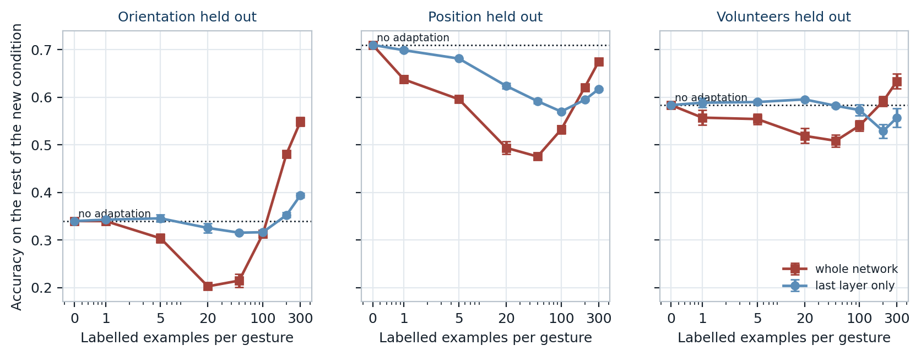
Figure 5. Accuracy against how many labelled examples from the new condition were used to adapt. The dotted line is the unadapted model. The horizontal axis is logarithmic and zero is drawn at the left.
Retraining only the last layer never helps. It starts at 0.340 and is still only 0.394 after 6600 labelled examples from the new orientation. Thousands of correctly labelled examples from exactly the condition the model fails on, and moving the decision boundaries with them buys almost nothing.
Retraining the whole network has a trap in the middle of the curve. With 440 examples it reaches 0.203, far below the 0.340 of not adapting at all, so a practitioner who collected a few hundred labelled samples and fine tuned on them would make their system worse while believing they had done the sensible thing. Only at 6600 examples does it climb to 0.548, an improvement of +0.209. The features are therefore what fail to transfer, and repairing them needs something close to a full dataset from the new condition, which is most of the work of collecting the data again rather than a quick calibration step.

8.7 Whether any of it is cheap enough to deploy
Accuracy on its own cannot say whether a model could run on an access point. The usual figure quoted, including in our own midterm, is latency on a graphics card at a batch of 64, which is the wrong measurement twice over. A router has no graphics card, and it classifies one sample as it arrives rather than 64 at a time. So we measured the time to classify a single sample on four processor threads with no accelerator, which is roughly what an access point has, and placed it beside the accuracy that survives a change of orientation rather than the in domain figure.
Model | Cross domain accuracy | Parameters | CPU ms per sample | GPU ms per sample
LeNet | 0.326 | 298,838 | 0.13 | 0.002
ViT | 0.321 | 95,222 | 0.45 | 0.014
GRU | 0.267 | 90,902 | 0.26 | 0.002
ResNet18 | 0.267 | 11,192,375 | 1.98 | 0.034
Table 12. Cost against the accuracy that actually survives a domain shift. The CPU column is a single sample on four threads with no graphics card.
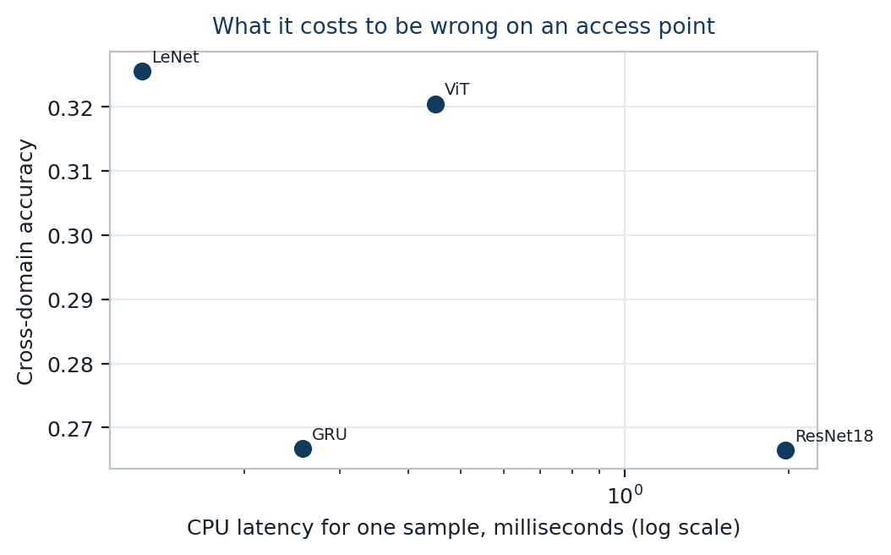
Figure 6. Cross domain accuracy against the cost of one classification on a processor. The horizontal axis is logarithmic.
The answer is that the cheap model is also the accurate one. LeNet classifies a sample in 0.13 milliseconds on a processor and holds the best cross domain accuracy at 0.326, while ResNet18 takes 1.98 milliseconds, which is 15 times longer, for 0.267. There is no accuracy being bought with that cost. A sensing system built on the small model would keep up with a continuous stream of samples on hardware an access point already has, which makes the deployment question the least difficult of the ones this report asks. The hard part remains the domain shift, not the arithmetic.

8.8 How much the choice of reporting epoch is worth
A cross domain claim is only as honest as the rule used to pick the epoch. Three rules are available and they disagree.
How the epoch is chosen | Mean accuracy over 36 runs
Final epoch, which is what SenseFi reports | 0.587
Validation selected, which is what this report quotes | 0.611
Best epoch measured on the test set, an oracle | 0.619
Table 13. The same runs read three different ways.
The oracle rule is worth +0.009 points over honest selection and nobody deploying a system could obtain it, because it needs the test labels to decide when to stop. Our midterm quoted the best epoch and we are correcting that here rather than leaving it. SenseFi's own script trains for a fixed number of epochs and evaluates once at the end, so its published figures are final epoch numbers and our midterm was the more generous of the two. Every end term number here uses the validation selected rule.

8.9 A bug in the benchmark, measured rather than asserted
While reading the benchmark closely enough to reuse it we found that its CNN and GRU model ends in a softmax layer, and that the training loop then passes the output to a cross entropy loss, which applies a softmax of its own. The model is therefore trained through two stacked softmax functions, which flattens the gradient and slows learning. The same mistake is present in the UT-HAR and the NTU-Fi versions of that model and in the self supervised variant.
Version of the model | Accuracy on Widar3.0
As shipped, softmax applied twice | 0.652
Trailing softmax removed | 0.759
Table 14. One line removed from a model definition, measured on the benchmark's own split so the comparison is like for like.
Removing the layer is worth +0.107 accuracy points. We have deliberately not patched the vendored copy of the benchmark, because the purpose of this project is to evaluate it rather than to quietly repair it, and a reader should be able to reproduce the original behaviour. The fix is applied in our own training script behind a flag.

9. Conclusion
We set out to answer one question. Does WiFi sensing work when it meets conditions it was not trained on, and if it does not, how much of the gap can be closed with the techniques available today. The answer to the first part is no, by a wide margin, and the second part is more discouraging than we expected.
The headline number is that accuracy on Widar3.0 falls from 0.687 to 0.326 when the test set contains a body orientation the model has never seen, using the same model, the same samples and the same test set size throughout. The more useful part of that result is the decomposition. Only 0.313 of the 0.361 point fall is the domain shift itself. The other 0.049 is the benchmark testing on repeat recordings of conditions it had already trained on, which is a leakage problem that has nothing to do with generalisation and which would have been invisible without the grouped control arm.
We think the measurement that should be taken most seriously is the one with no model in it. Two recordings of the same gesture made under different conditions are barely more alike than two recordings of different gestures, while two recordings sharing a condition are markedly more alike than either. A nearest neighbour lookup with nothing to train reproduces the whole pattern of our trained results. That rules out the explanation that we simply chose poor models, and it argues against the claim that the body coordinate velocity profile is domain independent by construction. It clearly reduces the problem, since it was designed to, but it does not remove it.
A practical warning follows from the leave one out sweep. The size of the drop depends heavily on which value is held out, ranging from 0.326 to 0.611 across the five orientations. Holding out a value at the edge of the range asks the model to extrapolate and holding out a middle value only asks it to interpolate. Any paper that reports a single cross domain figure without naming the value it held out has not given enough information for the result to be checked, and we would now count our own earlier plan to report one number as the same mistake.
The recovery attempts are the honest disappointment of the project. The best single result was augmentation to 45 degrees on the held out orientation protocol, worth +0.044 accuracy points. Set against a gap of several tenths, augmentation of the kind the recent literature recommends recovers a small fraction of what is lost. We report this plainly because a negative result that has been measured properly is still a result, and because the alternative, quietly reporting only the protocol where a method happened to work, is exactly the practice this project set out to criticise.
Three things follow for anyone building on this. The first is that a split must hold out whole recording conditions and not merely whole factor values, because repeat takes of one condition are near duplicates and they leak. The second is that the held out value has to be named, because the choice moves the result more than most published improvements do. The third is that the useful comparison is against a matched in domain partner over the same samples, since without one a cross domain number cannot be interpreted at all.
We also asked the question a deployer would actually ask, which is how many labelled examples from the new condition it takes before the system becomes usable again. Retraining only the final layer never helps, even given 6600 labelled examples, which tells us the features rather than the decision boundaries are what fail to transfer. Retraining the whole network does eventually work, reaching 0.548 with 6600 examples, but it is worse than doing nothing at every smaller amount we tried. There is no cheap calibration step here. Recovering the accuracy costs most of the effort of collecting the dataset again.
If we continued this work the next step would not be a larger model. Our own efficiency results point the other way, since the best model on this dataset is among the smallest we tried and the largest is reliably worse. Nor would it be a better adaptation step, because the measurement above says the representation is what breaks. The direction we would take is to change how the representation is learned, by training across several orientations with the orientation label deliberately made unpredictable from the features, so that the network is prevented from encoding the condition in the first place. Our evidence that the condition dominates the gesture in the raw data is precisely the argument for trying it.

10. References
[1] J. Yang, X. Chen, D. Wang, H. Zou, C. X. Lu, S. Sun and L. Xie, "SenseFi: A Library and Benchmark on Deep Learning Empowered WiFi Human Sensing," Patterns, Cell Press, vol. 4, no. 3, 2023. arXiv:2207.07859
[2] IEEE Standards Association, "IEEE Std 802.11bf-2025, Amendment 4: Enhancements for Wireless LAN Sensing," published 26 September 2025. IEEE SA
[3] F. Meneghello, C. Chen, C. Cordeiro and F. Restuccia, "Toward Integrated Sensing and Communications in IEEE 802.11bf Wi-Fi Networks," IEEE Communications Magazine, 2023. arXiv:2212.13930
[4] Y. Ma, G. Zhou and S. Wang, "A Survey of Commodity WiFi Sensing in 10 Years: Current Status, Challenges, and Opportunities," 2021. arXiv:2111.07038
[5] J. Yang, X. Chen, H. Zou, D. Wang, Q. Xu and L. Xie, "EfficientFi: Towards Large Scale Lightweight WiFi Sensing via CSI Compression," IEEE Internet of Things Journal, 2022. arXiv:2204.04138
[6] J. Strohmayer and M. Kampel, "Data Augmentation Techniques for Cross Domain WiFi CSI Based Human Activity Recognition," 2024. arXiv:2401.00964
[7] J. Strohmayer and M. Kampel, "WiFlexFormer: Efficient WiFi Based Person Centric Sensing," 2024. arXiv:2411.04224
[8] B. Barahimi, H. Tabassum, M. Omer and O. Waqar, "Lessons from Deploying Learning Based CSI Localization on a Large Scale ISAC Platform," 2025. arXiv:2504.17173
[9] Y. Zheng, Y. Zhang, K. Qian, G. Zhang, Y. Liu, C. Wu and Z. Yang, "Widar3.0: WiFi Based Activity Recognition Dataset," IEEE DataPort, open access dataset.
[10] Cognitive Systems Corporation, "WiFi Motion," commercial WiFi sensing product.
[11] "Evaluating BiLSTM and CNN+GRU Approaches for Human Activity Recognition Using WiFi CSI Data," 2025. arXiv:2506.11165
[12] "ISAC-Fi: Enabling Full-fledged Monostatic Sensing over Wi-Fi Communication," 2024. arXiv:2408.09851
[13] "No Vision, No Wearables: 5G-based 2D Human Pose Recognition with Integrated Sensing and Communications," 2025. arXiv:2512.24923
[14] "Context-Aware Predictive Coding: A Representation Learning Framework for WiFi Sensing," 2024. arXiv:2410.01825
[15] "MU-SHOT-Fi: Self-Supervised Multi-User Wi-Fi Sensing with Source-free Unsupervised Domain Adaptation," 2026. arXiv:2605.01369
[16] "From User Recognition to Activity Counting: An Identity-Agnostic Approach to Multi-User WiFi Sensing," 2026. arXiv:2604.16572
[17] "Physics-Guided Attention in a Lightweight TCN for Efficient WiFi CSI-Based Human Activity Recognition," 2026. arXiv:2606.01834
[18] "Wi-Spike: A Low-power WiFi Human Multi-action Recognition Model with Spiking Neural Networks," 2026. arXiv:2603.14475
[19] "Resource-Efficient WiFi CSI Sensing via Exploiting the Age of Samples," 2026. arXiv:2606.31690
[20] "Securing WiFi Fingerprint-based Indoor Localization Systems from Malicious Access Points," 2025. arXiv:2505.07724
[21] "maxVSTAR: Maximally Adaptive Vision-Guided CSI Sensing with Closed-Loop Edge Model Adaptation," 2025. arXiv:2510.26146
[22] K. Xu, J. Wang, H. Zhu and D. Zheng, "Self-Supervised Learning for WiFi CSI-Based Human Activity Recognition: A Systematic Study," 2023. arXiv:2308.02412

Appendix A. Code
Every number in this report is produced by the code submitted alongside it. Nothing is transcribed by hand, so rebuilding the document after changing an experiment keeps the two consistent.
check_data.py verifies the four datasets are present and correctly shaped; build_widar_cache.py converts the 43,652 Widar files into one cached array plus the metadata table; splits.py builds the splits and refuses any that leaks a condition or loses a class; train.py trains one model on one dataset, protocol and arm; run_baselines.py drives the 44 baseline runs, skipping what is recorded; model_profile.py parameter count and inference latency for every model; evidence.py measures the leakage with no model, by pairwise similarity and nearest neighbour lookup on raw data; run_endsem.py drives the 61 end term runs, also resumable; adapt.py the few shot adaptation curves; make_tables.py the result tables; make_figures.py the figures; make_report.py this document.

