CSE515: Advanced Communications Networks and Systems
WiFi Sensing with Channel State Information for Device Free Human Activity Recognition and Indoor Localization
Midterm Project Report
Saarthak Gupta (22134024) Shreya Sangma (22134025) Vaibhav Jain (22164020)
Instructor: Dr. Ajay Pratap. Department of Computer Science and Engineering, Indian Institute of Technology (BHU) Varanasi

1. Introduction
Every WiFi device measures how the radio signal changes on its way from the transmitter to the receiver. That measurement is called Channel State Information, usually shortened to CSI. It needs no extra hardware, because a WiFi chip already computes it in order to decode packets, and many commodity chipsets will simply report it.
A person moving through the room reflects some of those radio waves and blocks others, so the CSI values change. They change in a pattern that depends on what the person did, and walking produces a different pattern from sitting down or falling. Record enough of those patterns with labels and a model can be trained to tell them apart, at which point an ordinary WiFi link has become a sensor. Nobody has to wear a device, no camera is involved, it works in the dark, and radio passes through plasterboard. Fall detection for elderly people living alone is the application most often cited.
This report covers the first half of our project. We survey the recent literature, reproduce the standard benchmark for this field on four public datasets, and report a problem we found in how that benchmark measures success. The second half will act on that problem.

2. Motivation
The topic is current rather than settled textbook material. IEEE published Standard 802.11bf, the WLAN Sensing amendment, on 26 September 2025, and it defines how devices advertise sensing support, set up a sensing session and report measurements [2]. Cognitive Systems, Origin AI and Linksys already sell motion sensing features built on the same principle [10]. The course notes ask for a topic covered by recent papers, industry standards and shipping products together, and this one satisfies all three.
The research reason is that the field has a well known unsolved problem. A model trained in one setting with one group of people tends to fail as soon as it meets a different room or person. This domain shift is the main thing standing between a laboratory demonstration and a product, and our project is aimed at it.

3. Background on WiFi Sensing

3.1 What CSI is
Early wireless sensing used the Received Signal Strength Indicator, a single number that collapses the whole channel into one value. CSI is far richer. A WiFi link using orthogonal frequency division multiplexing splits its bandwidth into many narrow subcarriers, and CSI reports amplitude and phase for each subcarrier and each pair of antennas, so one measurement is a small matrix rather than a scalar. A moving body changes the length of the reflected paths and produces a Doppler shift, and different movements produce different shifts. That is why the same measurement supports both coarse tasks such as occupancy and fine ones such as recognising a gesture drawn in the air.

3.2 How the field developed
Ma, Zhou and Wang surveyed a decade of commodity WiFi sensing and group it into activity recognition, object sensing and localization [4]. Hardware stopped being the bottleneck once CSI could be read from ordinary network cards, after which the difficulty moved into processing and then into machine learning. That phase brought a new problem, which is that results became hard to compare, because different groups used different datasets, preprocessing and splits. Yang and colleagues answered this with SenseFi, an open benchmark implementing eleven model families on four public datasets under one procedure [1]. SenseFi is our starting point, and Section 5 explains where we found it wanting.
Sensing is also being folded into the standard itself. Meneghello and colleagues set out the physical and medium access layer changes behind 802.11bf [3]. The standard deliberately leaves the sensing algorithm to the implementer, so the modelling question this project studies is not settled by it. The wider idea is Integrated Sensing and Communication, where one radio carries data and senses at the same time, as in ISAC-Fi [12] and in related work inferring human pose from 5G uplink signals [13].

4. Related Works
We reviewed nineteen papers, weighted towards work from 2024 onwards as the course notes require. They fall into four groups.

4.1 Benchmarks and surveys
Yang and colleagues introduced SenseFi, comparing eleven deep learning models across four CSI datasets and reporting accuracy, model size and the transferability of learned features [1]. Ma and colleagues give the broader ten year survey [4]. A 2025 study compares BiLSTM against CNN+GRU on the same UT-HAR and NTU-Fi datasets we use and argues that dataset characteristics matter as much as architecture [11], which agrees with what we measured independently in Section 8.

4.2 The generalisation problem
This is the central open problem and the reason our project exists. Strohmayer and Kampel apply image style augmentation to CSI and study generalisation between line of sight and through wall scenarios [6]. Xu and colleagues survey self supervised learning for CSI activity recognition, motivated by the scarcity of labels [22], and CAPC combines contrastive predictive coding with augmentation so a model can learn from unlabelled data and adapt across environments [14].
Two recent papers show how far the framing has moved. MU-SHOT-Fi adapts to a new environment using only unlabelled data from it and a pretrained model, because privacy rules often prevent sharing the original training data [15]. An identity agnostic approach reformulates multi user recognition as activity counting so the model stops depending on a fixed set of known users [16]. Both react to the same weakness we identify in Section 5, which is that models quietly learn the people they trained on.

4.3 Efficiency and deployment
Sensing too expensive to compute will never run on a real access point. EfficientFi compresses CSI at the edge and restores it in the cloud so sensing can scale to many homes [5]. WiFlexFormer is a compact transformer reaching comparable accuracy with far fewer parameters, in about 10 milliseconds on a Jetson Orin Nano [7]. Its authors observe that a low parameter count helps cross domain generalisation, so small models often beat larger ones when conditions change, and our own measurements in Section 8 point the same way.
Newer work pushes efficiency harder. A physics guided temporal convolutional network uses Doppler energy to focus attention where motion actually happens [17], Wi-Spike uses a spiking network for low power recognition [18], and a 2026 paper treats the acquisition rate as a constrained resource, since sensing shares airtime with ordinary traffic [19].

4.4 Localization and real deployments
Barahimi and colleagues report lessons from a CSI localization system using more than 400 access points in a real building, and name the underuse of unlabelled data and the heterogeneity of CSI measurements as the factors that most limit large scale deployment [8]. Other work studies malicious access points that shift the readings a fingerprinting system depends on [20], and maxVSTAR uses a camera to relabel CSI automatically so an edge model keeps adapting after installation [21].
The literature agrees that generalisation is the central problem and many groups propose ways to improve it. What we found missing is a check on whether the standard evaluation measures generalisation at all, and that is the gap this report documents.

5. Problem Statement
A project that only runs someone else's code and reports the output is not worth submitting, so we first examined how the standard benchmark decides whether a model is good. We found a problem in it.

5.1 What we checked
Widar3.0 records the conditions of every sample in its filename. A file named user10-1-1-1-1-1 encodes the volunteer, the gesture, where the person stood, which way they faced and which repetition it was. We parsed all 43,652 filenames in the benchmark's two halves and compared which conditions appear on each side.
Factor | Values in training | Values in testing | Values in both
Volunteers | 17 | 17 | 17
Standing positions | 8 | 8 | 8
Body orientations | 5 | 5 | 5
Table 1. Every recording condition in Widar3.0 appears on both sides of the benchmark's train and test split. Nothing is held out.
Every volunteer, position and orientation appears in both halves. The split is domain mixed, because the two halves were drawn from one pool and shuffled, so nothing in the test set is new to the model.
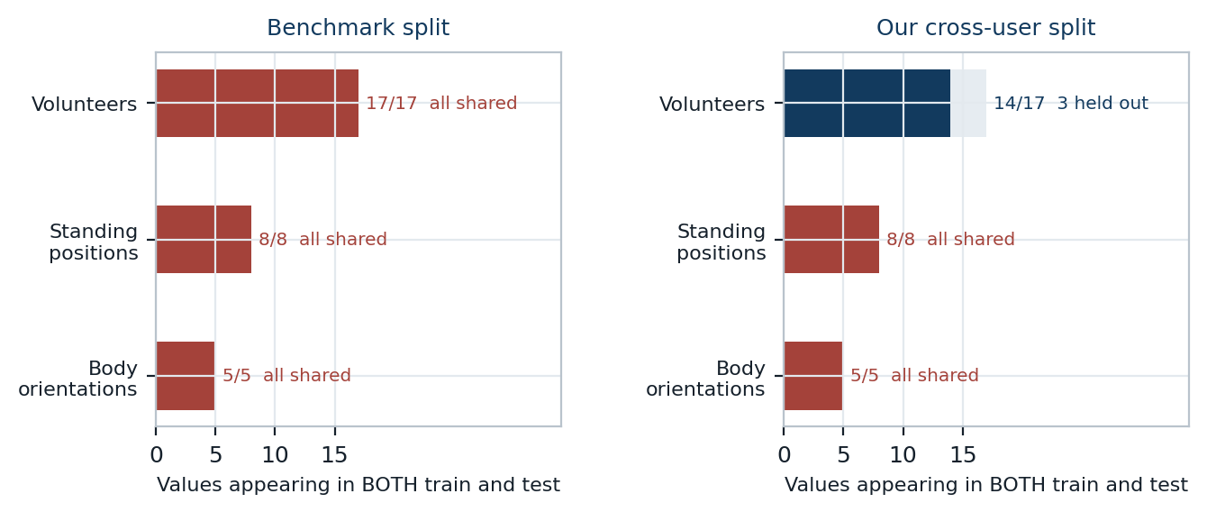
Figure 1. The benchmark's split holds nothing back, so the model is tested on people, positions and orientations it has already trained on. Our cross-user split holds three volunteers out entirely.

5.2 Why this matters
Such a model is asked to recognise gestures performed by people it has trained on, standing where it has seen them stand and facing the way it has seen them face. It is an examination where the practice paper and the real paper come from the same question bank, so a high score shows familiarity rather than understanding. The accuracy fairly measures how well a model learned its training conditions, but it does not answer the question that decides whether the technology can ship, which is whether it works for a person it has never met.

5.3 The problem we will solve
Our project therefore asks two questions. First, how much accuracy is actually lost when a WiFi sensing model meets conditions that were held out of its training, as opposed to conditions it has already seen. Second, how much of that loss can be recovered using techniques available today, such as data augmentation. The midterm work reported here builds everything needed to answer them. The end term work will answer them.

6. Proposed Solution
Our solution has three parts. The first two are complete and are reported here. The third is the end term work.

6.1 Rebuild the evaluation split honestly
Instead of shuffling all the samples together, we hold entire recording conditions out of training, so a model has never seen the people, positions or orientations it is tested on. Building these splits needed care, because the dataset is not evenly balanced, and Section 7 explains what we found.

6.2 Measure cost as well as accuracy
The benchmark reports accuracy and nothing else, which cannot say whether a model could ever run on a real access point. We also record the parameter count, the weight size and the inference latency of every model, and report them beside the accuracy.

6.3 Recover the lost accuracy, and check the cost
In the end term we will apply data augmentation to the cross domain splits and measure how much of the lost accuracy it wins back, reporting this honestly including anything that fails to help. We will then check whether a small model retains most of the accuracy of a large one, which decides whether any of it is deployable.

7. System Design

7.1 Datasets
We use the four public CSI datasets the benchmark supports, all released by the researchers who recorded them and all verified in our repository. Together they occupy about 29 gigabytes. Widar3.0 [9] is the one this project turns on.
Dataset | Task | Sample shape | Classes | Train | Test
UT-HAR | 7 daily activities, 6 people | 1 x 250 x 90 | 7 | 3,977 | 996
NTU-Fi HAR | 6 activities, 114 subcarriers | 3 x 114 x 500 | 6 | 936 | 264
NTU-Fi HumanID | Identify who is walking | 3 x 114 x 500 | 14 | 294 | 546
Widar3.0 | 22 hand gestures | 22 x 20 x 20 | 22 | 34,926 | 8,726
Table 2. The four public CSI datasets used in this work.
These are not images, although two of them are shaped like small ones. A UT-HAR sample is 250 time steps by 90 subcarriers. Widar3.0 differs, because its authors converted the raw signal into a Body coordinate Velocity Profile, a 20 by 20 grid of velocities at 22 time steps. Its filenames record the volunteer, standing position and body orientation of every sample, which is what makes the rest of this report possible.

7.2 Fixing the data pipeline
The benchmark parses one text file per sample on a single thread, since no worker count is configured anywhere in it. Reading one Widar sample costs 5.67 milliseconds cold and about 2.6 milliseconds warm, which is between 1.5 and 3.3 minutes of file reading for every pass over the training set. At the shipped 100 epochs that is hours spent parsing text while the graphics processor sits idle. We convert all 43,652 files once into a memory mapped array of 1.54 gigabytes, plus a metadata table holding the volunteer, position and orientation parsed from each filename. The conversion takes about six seconds on 28 threads and a sample then costs 0.002 milliseconds to read. That is what made the rest of this work affordable on a laptop.

7.3 Building splits that hold up
Our split code refuses to return a split that leaks a held out condition or loses a gesture class, and that check failed on the first attempt. The volunteers did not all perform the same gestures. Volunteers 1 and 2 performed all 22 and hold 48 percent of the data, ten performed only 9 each, and gestures 13 to 22 were performed by just two people, so holding out the wrong volunteers deletes whole classes. Positions 6, 7 and 8 have the same problem at about 600 samples each. Orientation is the clean factor, with all five covering all 22 gestures at roughly 8,730 samples. Without that check the split would still have produced numbers, and they would have shown a large drop that measured missing classes rather than lost generalisation.
Protocol | Held out of training | Classes | Train | Test
Cross orientation | Body orientation 5 | 22 | 34,927 | 8,725
Cross position | Standing position 5 | 22 | 35,280 | 8,372
Cross user | Volunteers 15, 16 and 17 | 9 | 26,648 | 3,370
Table 3. The three cross domain protocols. Each one also carries a matched in domain split, which is a random split over exactly the same samples with the same test size, so that the only thing that changes between the two is whether the test conditions were seen during training.

7.4 Training procedure
We keep the benchmark's training recipe so our numbers stay comparable to the published ones, meaning Adam at a learning rate of 0.001, cross entropy loss and a batch size of 64. Three things differ deliberately.
- Widar reads the cached array rather than reparsing 43,652 text files every epoch, and the other file backed datasets use worker processes.
- Test accuracy is correct predictions divided by total samples. The benchmark averages per batch instead, which overweights the final partial batch.
- Two configurations ship with epoch counts far out of line with the rest, the recurrent model on UT-HAR at 3000 and the same model on Widar3.0 at 500. We cap both at 200, so those two runs see less training than the benchmark intends. Every other model runs for the epochs the benchmark ships.
Two runs needed a smaller batch. The Vision Transformer on the NTU-Fi datasets exhausts 8 gigabytes of graphics memory, because its input becomes about 760 patch tokens and attention cost grows with the square of that. Those two runs use a batch of 16.

7.5 Hardware and software
Everything runs on a laptop with an NVIDIA GeForce RTX 4060 holding 8 gigabytes, an Intel Core i7-14700HX with 28 threads and 16 gigabytes of system memory, using PyTorch 2.14 with CUDA 13.2. The benchmark asks for PyTorch 1.12, which cannot run on this card at all because it builds no kernels for compute capability 8.9. Anyone reproducing this work on current hardware will meet the same obstacle. We checked that all eleven models build and run under the newer version.

8. Results
We trained all eleven models on all four datasets, which is 44 runs. Every number below is generated directly from the recorded results rather than copied by hand, so the tables cannot drift out of step with the experiments.

8.1 Reproduced baseline accuracy
Model | UT-HAR | NTU-Fi HAR | NTU-Fi HumanID | Widar3.0
MLP | 0.929 (0.945) | 0.977 (0.981) | 0.908 (0.912) | 0.681 (0.685)
LeNet | 0.971 (0.979) | 0.996 (0.996) | 0.976 (0.976) | 0.673 (0.704)
ResNet18 | 0.984 (0.986) | 0.901 (0.977) | 0.912 (0.912) | 0.678 (0.691)
ResNet50 | 0.953 (0.970) | 0.867 (0.939) | 0.643 (0.650) | 0.641 (0.674)
ResNet101 | 0.099 (0.972) | 0.951 (0.951) | 0.636 (0.742) | 0.644 (0.658)
RNN | 0.601 (0.611) | 0.883 (0.913) | 0.850 (0.881) | 0.351 (0.483)
GRU | 0.921 (0.937) | 0.996 (1.000) | 0.990 (0.990) | 0.562 (0.629)
LSTM | 0.819 (0.874) | 0.970 (0.981) | 0.956 (0.976) | 0.583 (0.640)
BiLSTM | 0.875 (0.903) | 0.974 (0.989) | 0.946 (0.976) | 0.584 (0.634)
CNN+GRU | 0.971 (0.982) | 0.977 (0.989) | 0.789 (0.895) | 0.619 (0.652)
ViT | 0.923 (0.957) | 0.924 (0.932) | 0.769 (0.782) | 0.659 (0.679)
Table 4. Test accuracy at the final epoch, with the best epoch in brackets. Eleven models on four datasets, 44 runs.
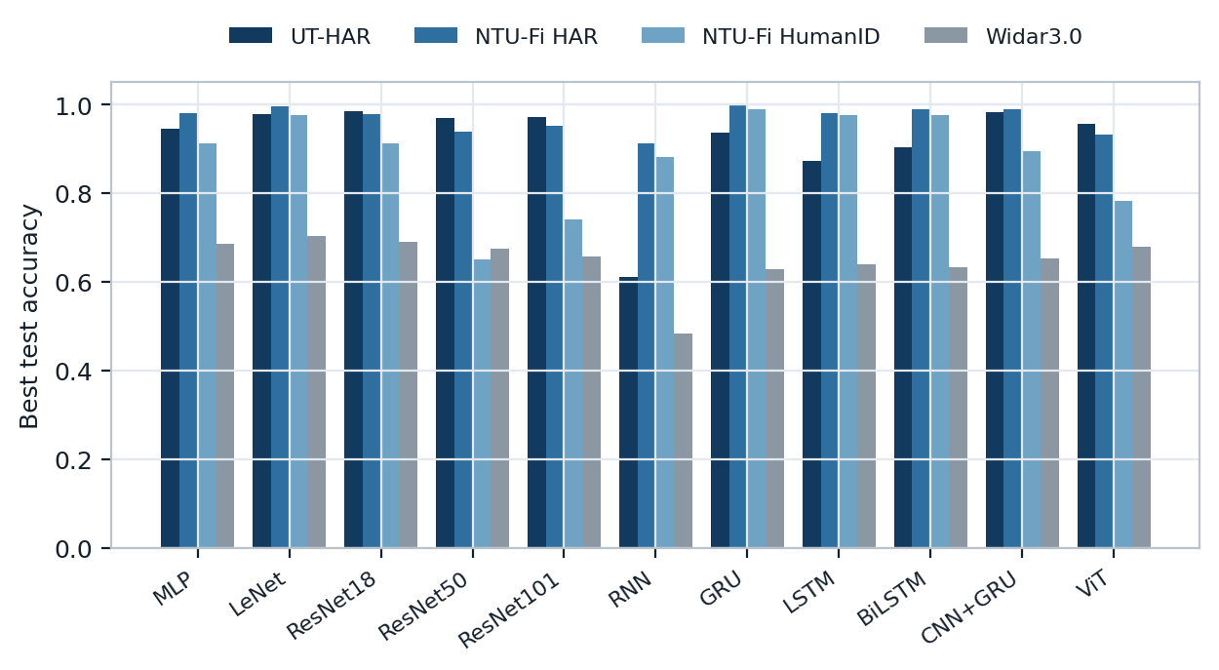
Figure 2. Best test accuracy for every model on every dataset. Widar3.0 is markedly harder than the other three.
The three activity datasets are largely solved, with accuracies above 0.97 common on UT-HAR and NTU-Fi HAR and a recurrent model reaching a perfect score on the latter. Widar3.0 is much harder at 0.704, which is unsurprising with 22 gesture classes rather than 6 or 7.

8.2 The training recipe is unstable
Recording both the final epoch and the best epoch exposed something the benchmark cannot see. 10 of the 44 runs ended below their own best epoch by more than five accuracy points. The extreme case is ResNet101 on UT-HAR, which reached 0.972 at its best epoch and then collapsed to 0.099 by the last one, which is below the 0.143 that random guessing would give on seven classes.
This matters because the benchmark evaluates only after the final epoch, so its published figure for a model is whatever that last epoch happened to produce. The recipe has no learning rate schedule and no early stopping to prevent a late collapse. The single worst collapse is a deep residual network, but counting the affected runs rather than their size tells a different story, because 6 of the 10 are recurrent models against 4 residual ones. The problem belongs to the recipe rather than to one family of architecture. For the rest of this report we quote best epoch accuracy, with one caveat stated plainly. It is the highest accuracy any epoch reached on the test set, so the test set chose the stopping point, which is something no deployed system could do. It is an optimistic reading rather than a fair one, and it makes our figures more generous than the benchmark's own, which are final epoch numbers. We print both columns throughout so the difference stays visible, and the end term work will choose the epoch on a validation set carved out of the training data.

8.3 Cost against accuracy
The benchmark reports accuracy alone. Once parameter count and inference latency are placed beside it, the picture changes considerably.
Model | Accuracy | Gap to best | Parameters | Weights MB | GPU ms | CPU ms
LeNet | 0.704 | +0.000 | 298,838 | 1.2 | 0.002 | 0.13
ResNet18 | 0.691 | +0.014 | 11,192,375 | 44.8 | 0.034 | 1.98
MLP | 0.685 | +0.019 | 9,146,262 | 36.6 | 0.004 | 0.33
ViT | 0.679 | +0.026 | 95,222 | 0.4 | 0.014 | 0.45
ResNet50 | 0.674 | +0.031 | 23,583,287 | 94.3 | 0.105 | 4.67
ResNet101 | 0.658 | +0.047 | 42,601,527 | 170.4 | 0.238 | 8.76
CNN+GRU | 0.652 | +0.052 | 92,238 | 0.4 | 0.005 | 0.52
LSTM | 0.640 | +0.064 | 120,726 | 0.5 | 0.002 | 0.12
BiLSTM | 0.634 | +0.071 | 240,022 | 1.0 | 0.003 | 0.23
GRU | 0.629 | +0.076 | 90,902 | 0.4 | 0.002 | 0.26
RNN | 0.483 | +0.221 | 31,254 | 0.1 | 0.002 | 0.12
Table 5. Accuracy against cost on Widar3.0, ordered by accuracy. The GPU column is one sample within a batch of 64 on the graphics card. The CPU column is a single sample on four processor threads with no graphics card, which is the situation an access point is in.
The two columns answer different questions and the second is the one that decides deployability. A router has no graphics card and it classifies one sample as it arrives rather than 64 at a time, so the processor figure is the one to read. The graphics card figure cannot separate the small models at all. Seven of the eleven sit between 0.001 and 0.005 milliseconds there, which is too close to tell apart, while on a processor those same seven spread from 0.12 to 0.52 milliseconds, a factor of four. We report the graphics card column here because it is what the literature usually quotes, and the end term work uses the processor column instead.
On NTU-Fi HAR a gated recurrent unit with 79 thousand parameters and 0.3 megabytes of weights reaches a perfect 1.000, while the multilayer perceptron needs 175 million parameters and 701 megabytes to reach 0.981. That is roughly 2,200 times the size for a worse result, and every residual network there is beaten by models a hundred times smaller.

8.4 On Widar3.0, the best model size is a small one
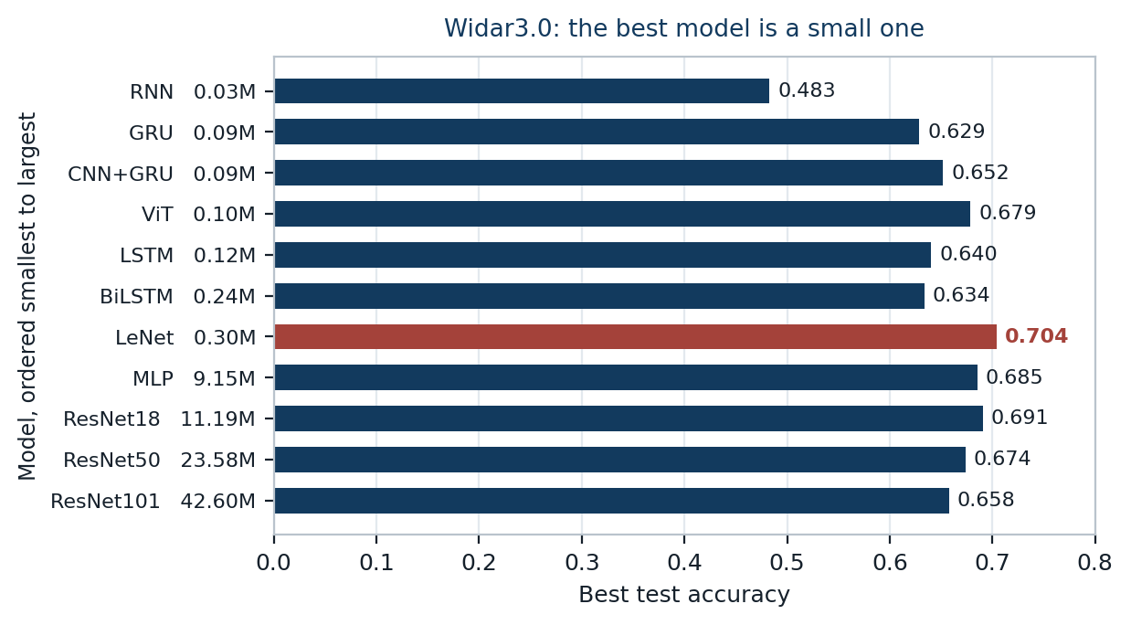
Figure 3. Accuracy on Widar3.0 with the models ordered from smallest to largest. LeNet is the most accurate and every larger model is worse. Below LeNet the ordering does not follow size.
The pattern on Widar3.0 is stronger, though it is not simply that smaller is better, and the figure shows two different things above and below the peak. Above it the trend is clean. Accuracy peaks at LeNet with 299 thousand parameters and 0.704, and all four larger models rank below it, falling further the larger they get. ResNet101 holds 142 times more parameters than LeNet and took 67 minutes against LeNet's 5, yet reaches only 0.658. Below the peak there is no such trend. The Vision Transformer at 95 thousand parameters reaches 0.679 while LSTM and BiLSTM, both larger, manage 0.640 and 0.634, so among the small models architecture decides the result and size does not.
Two cautions apply to the ends of that figure. The smallest model, a plain recurrent network at 31 thousand parameters, is also the one whose epoch count we capped, so its 0.483 reflects 200 of the 500 epochs the benchmark ships for it and should not be read as the cost of being small. At the other end the nearest comparisons are tight, since LeNet beats ResNet18 by 0.013, and every figure here is a single run with no repeat seeds, so a gap that small is not something we would defend. The gap from LeNet to ResNet101 is 0.046 and the ordering of the four larger models is consistent, which is the part of the result the end term work relies on.
The likely explanation is a mismatch between architecture and data. A Widar sample is a 20 by 20 grid of velocities at 22 time steps, not a photograph, and residual networks were designed for large natural images with deep hierarchies of visual structure. That capacity has little to work with here. The authors of WiFlexFormer make the same observation, that a low parameter count helps rather than hurts in this domain [7].
The whole sweep of 44 runs cost 293 minutes of graphics processor time on the laptop described above, of which 181 minutes were Widar3.0. That is small enough to repeat whenever a result is questioned, which is the point of having fixed the data pipeline first.

9. Conclusion
This report covers the first half of our project. We surveyed the recent literature, rebuilt the data pipeline so experiments are affordable, reproduced the benchmark across 44 runs and found three things.
First, the benchmark's Widar3.0 split holds nothing back. All 17 volunteers, all 8 standing positions and all 5 orientations appear in both halves, so the reported accuracy measures how well a model learned its training conditions rather than whether it would work for a new person in a new place. Because Widar3.0 records those conditions in its filenames a correct split can be built, and we have built three.
Second, the training recipe is unstable. Ten of the 44 runs ended materially below their own best epoch and one collapsed from 0.972 to 0.099. Since the benchmark evaluates only after the final epoch, its published numbers inherit that instability.
Third, larger models are not better here, and on Widar3.0 every model larger than the best one is worse, falling further the larger it gets. The best model there is 142 times smaller than the largest and 13 times faster to train, which means the expensive cross domain experiments planned for the end term can use a small model without any loss of rigour. Among the models smaller than the best one, size predicts nothing and architecture decides the result.
The end term work follows directly. We will train on the three cross domain protocols, measure how far accuracy falls against the matched in domain baselines, and try to recover the loss with data augmentation, reporting the outcome honestly including anything that does not help.

10. References
[1] J. Yang, X. Chen, D. Wang, H. Zou, C. X. Lu, S. Sun and L. Xie, "SenseFi: A Library and Benchmark on Deep Learning Empowered WiFi Human Sensing," Patterns, Cell Press, vol. 4, no. 3, 2023. arXiv:2207.07859
[2] IEEE Standards Association, "IEEE Std 802.11bf-2025, Amendment 4: Enhancements for Wireless LAN Sensing," published 26 September 2025. IEEE SA
[3] F. Meneghello, C. Chen, C. Cordeiro and F. Restuccia, "Toward Integrated Sensing and Communications in IEEE 802.11bf Wi-Fi Networks," IEEE Communications Magazine, 2023. arXiv:2212.13930
[4] Y. Ma, G. Zhou and S. Wang, "A Survey of Commodity WiFi Sensing in 10 Years: Current Status, Challenges, and Opportunities," 2021. arXiv:2111.07038
[5] J. Yang, X. Chen, H. Zou, D. Wang, Q. Xu and L. Xie, "EfficientFi: Towards Large Scale Lightweight WiFi Sensing via CSI Compression," IEEE Internet of Things Journal, 2022. arXiv:2204.04138
[6] J. Strohmayer and M. Kampel, "Data Augmentation Techniques for Cross Domain WiFi CSI Based Human Activity Recognition," 2024. arXiv:2401.00964
[7] J. Strohmayer and M. Kampel, "WiFlexFormer: Efficient WiFi Based Person Centric Sensing," 2024. arXiv:2411.04224
[8] B. Barahimi, H. Tabassum, M. Omer and O. Waqar, "Lessons from Deploying Learning Based CSI Localization on a Large Scale ISAC Platform," 2025. arXiv:2504.17173
[9] Y. Zheng, Y. Zhang, K. Qian, G. Zhang, Y. Liu, C. Wu and Z. Yang, "Widar3.0: WiFi Based Activity Recognition Dataset," IEEE DataPort, open access dataset.
[10] Cognitive Systems Corporation, "WiFi Motion," commercial WiFi sensing product.
[11] "Evaluating BiLSTM and CNN+GRU Approaches for Human Activity Recognition Using WiFi CSI Data," 2025. arXiv:2506.11165
[12] "ISAC-Fi: Enabling Full-fledged Monostatic Sensing over Wi-Fi Communication," 2024. arXiv:2408.09851
[13] "No Vision, No Wearables: 5G-based 2D Human Pose Recognition with Integrated Sensing and Communications," 2025. arXiv:2512.24923
[14] "Context-Aware Predictive Coding: A Representation Learning Framework for WiFi Sensing," 2024. arXiv:2410.01825
[15] "MU-SHOT-Fi: Self-Supervised Multi-User Wi-Fi Sensing with Source-free Unsupervised Domain Adaptation," 2026. arXiv:2605.01369
[16] "From User Recognition to Activity Counting: An Identity-Agnostic Approach to Multi-User WiFi Sensing," 2026. arXiv:2604.16572
[17] "Physics-Guided Attention in a Lightweight TCN for Efficient WiFi CSI-Based Human Activity Recognition," 2026. arXiv:2606.01834
[18] "Wi-Spike: A Low-power WiFi Human Multi-action Recognition Model with Spiking Neural Networks," 2026. arXiv:2603.14475
[19] "Resource-Efficient WiFi CSI Sensing via Exploiting the Age of Samples," 2026. arXiv:2606.31690
[20] "Securing WiFi Fingerprint-based Indoor Localization Systems from Malicious Access Points," 2025. arXiv:2505.07724
[21] "maxVSTAR: Maximally Adaptive Vision-Guided CSI Sensing with Closed-Loop Edge Model Adaptation," 2025. arXiv:2510.26146
[22] K. Xu, J. Wang, H. Zhu and D. Zheng, "Self-Supervised Learning for WiFi CSI-Based Human Activity Recognition: A Systematic Study," 2023. arXiv:2308.02412

Appendix A. Code
Every number in this report is produced by the code submitted alongside it. Nothing is transcribed by hand, so rebuilding the document after changing an experiment keeps the two consistent.
check_data.py verifies the four datasets are present and correctly shaped; build_widar_cache.py converts the 43,652 Widar files into one cached array plus the metadata table; splits.py builds the splits and refuses any that leaks a condition or loses a class; train.py trains one model on one dataset, protocol and arm; run_baselines.py drives the 44 baseline runs, skipping what is recorded; model_profile.py parameter count and inference latency for every model; make_tables.py the result tables; make_figures.py the figures; make_report.py this document.

