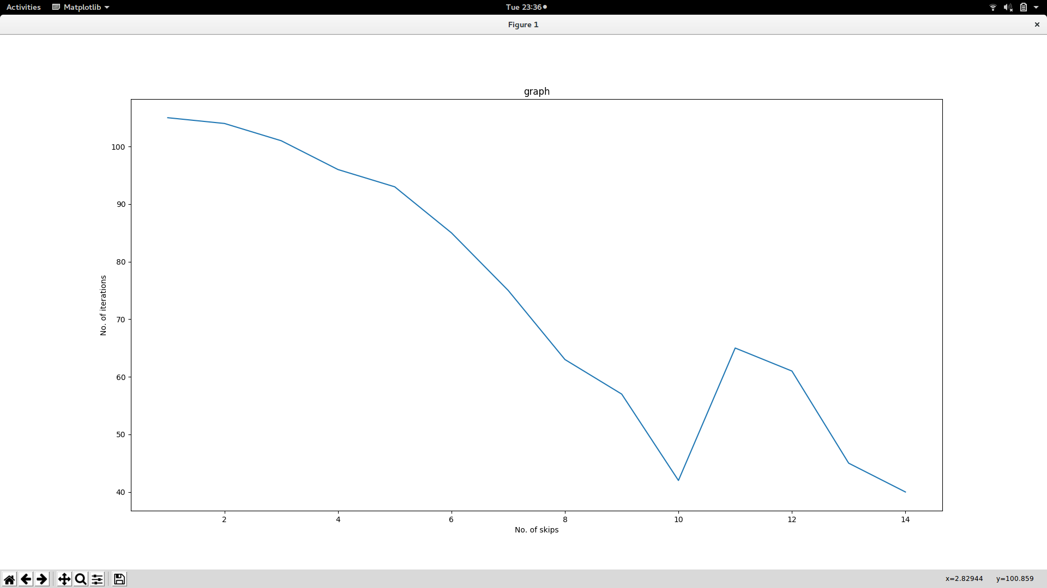
In this case as we are increasing the number of skips the no. Of iterations are decreasing till some value.

