CAPSTONE PROJECT REPORT
Project Title: EcoTrace (SDG 13 - Climate Action)
GitHub Repository: https://github.com/sarthakghag39-glitch/EcoTrace.git

1. Selected SDG and Reason for Selection
Selected SDG: SDG 13 - Climate Action.
Focus Area: SDG 13 focuses on taking urgent action to combat climate change and its devastating impacts. It emphasizes building resilience to climate-related hazards, integrating climate measures into national policies, and improving education, awareness, and capacity on climate mitigation and adaptation.
Importance of the Issue: Climate change is one of the greatest challenges of our era, affecting every continent, disrupting economies, and threatening lives. Carbon dioxide emissions and other greenhouse gases have reached record levels. Without conscious individual and systemic action, global average temperatures are projected to rise beyond critical thresholds, leading to extreme weather events, sea-level rise, ecosystem collapse, food security threats, and displacement of vulnerable populations.

2. Problem Statement
What is the problem? Most individuals lack clear visibility into how their daily routines (commuting, diet, energy usage, and waste generation) impact the global climate. There is a disconnect between everyday lifestyle choices and their carbon footprint. Furthermore, people often feel overwhelmed by the scale of climate change and lack localized, actionable goals and tracking mechanisms to transition to sustainable habits.
Where does this problem exist? This is a global issue, but it is highly prevalent in urban environments and developed regions where high-consumption lifestyles dominate transport, household power, and food systems.
Who is affected? While individuals in high-emission areas contribute the most, the consequences affect everyone globally. Coastal communities suffer from rising sea levels, agricultural sectors face crop failure, wildlife habitats are destroyed, and future generations will inherit a highly volatile biosphere.
Why is it serious and what happens if not solved? If individual habits do not pivot towards carbon reduction, the cumulative effect will accelerate global warming. Unchecked climate change will lead to irreversible ecosystem tipping points, extreme droughts, global resource wars, and massive economic instability.

3. Proposed Solution
What EcoTrace is: EcoTrace is a premium, full-stack web application that gamifies individual carbon footprint tracking. It acts as a personal ecology companion, letting users calculate their carbon emissions, set realistic reduction goals, complete daily eco-friendly challenges, and see community standings.
How the system works: Users register and sign in securely. They use the Carbon Calculator to log activities. The system processes inputs using standard carbon conversion algorithms and instantly displays categorized carbon breakdown charts (Transportation, Energy, Food, Waste). Users can also sign up for daily challenges (like taking public transit or avoiding single-use plastics) to earn XP points, leveling up their eco-citizen profile. A real-time leaderboard displays public standings to drive healthy competition.
How it helps solve the problem: EcoTrace makes invisible carbon emissions visible. By breaking down carbon output by category, users immediately identify their biggest environmental impacts. Gamifying the habits with points, levels, and streaks turns a daunting global task into a fun, daily habit-forming routine.
Who will use the application: EcoTrace is targeted at students, conscious households, corporate teams, and anyone looking to actively measure and offset their footprint.

4. Project Features
Carbon Footprint Calculator: Users input travel distances, household electricity usage, diet types, and waste levels. The backend runs algorithms translating these to kilograms of CO2 equivalents (kg CO2e) for instant user awareness.
Visual Dashboard Analytics: Utilizes Chart.js on the frontend to render dynamic, interactive charts. It displays historical logging trends and an itemized category breakdown to highlight areas that require reduction.
Daily Quest & Achievement System: Generates daily action items (quests) that users check off when completed. Doing so awards points/XP, increments streaks, and updates user levels, reinforcing positive climate habits.
Community Leaderboard: Displays the top eco-citizens sorted by level and points. This public comparison motivates users to continue logging, saving carbon, and leveling up their sustainable profiles.
Secure JWT Authentication: Keeps data isolated and secure. Passwords are hashed using bcryptjs on the backend, and JWT tokens handle secure session storage on the client side.
AI Eco-Coach (Google Gemini Integration): Integrates the Google Gemini 2.5 Flash API to analyze the user's carbon footprint in real-time. The AI Eco-Coach generates context-aware, customized carbon reduction advice based on the user's specific emissions. To ensure high availability and stability, the backend features a robust fallback rule-based engine that activates automatically if the API key is missing or calls fail. The frontend delivers a responsive typing animation effect when displaying the AI insights.

5. Project Architecture & File Structure
The application is modularized into distinct client and server directories to ensure high maintainability:
• server.js: The entry point for the backend. Hosts the Node.js Express server, serves the static public site, defines secure REST API endpoints, handles password validation/generation, and issues JWT tokens.
• database/db.js: The data engine helper. Reads/writes to the JSON database, handles user table queries, appends carbon footprint logs, manages quest progress, and calculates leaderboards.
• database/data/db.json: The physical storage medium. Holds structured schemas for Users, Footprint logs, and Active daily quests.
• public/index.html: The Single Page UI. Designed with glassmorphic slate styling, containing tabs for Dashboard, Calculator, Daily Quests, and Leaderboards.
• public/styles.css: The visual theme. Controls the slate-light theme, glassmorphic transparency panels, responsive grids, transitions, and hover-state animations.
• public/app.js: The frontend logic controller. Handles API fetches, manages local session storage, updates DOM elements dynamically, and coordinates Chart.js datasets.

6. Technology Stack
The application is built using the following stack:
Layer | Technologies Used | Purpose
Frontend | HTML5, CSS3, Vanilla JS, Chart.js | Interactive, light-themed glassmorphic user dashboard.
Backend | Node.js, Express.js | REST API for handling auth, calculation, logs, and leaderboard.
Database | Custom JSON database (db.js) | File-based document store for user data and quest details.
Authentication | JSON Web Tokens (JWT), bcryptjs | Password hashing and token-based state authorization.
AI Integration | Google Gemini 2.5 Flash, @google/genai, dotenv | Generates personalized eco-coaching advice based on carbon metrics.

7. System Screenshots (Proof of Work)
Below are actual screenshots of the functional EcoTrace system in action, demonstrating its visual layouts and live operations:

Figure 1: EcoTrace Homepage & Landing Section (Before Authentication)
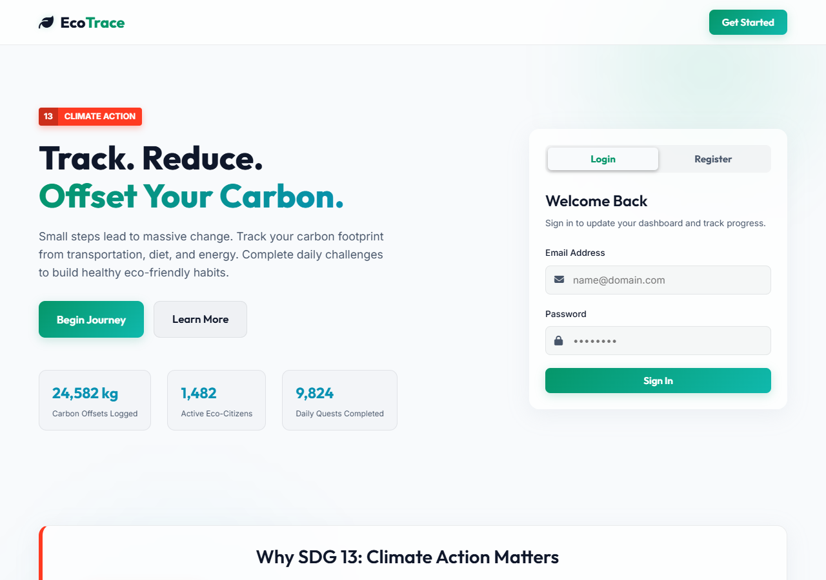

Figure 2: EcoTrace User Dashboard Overview (Initial State)
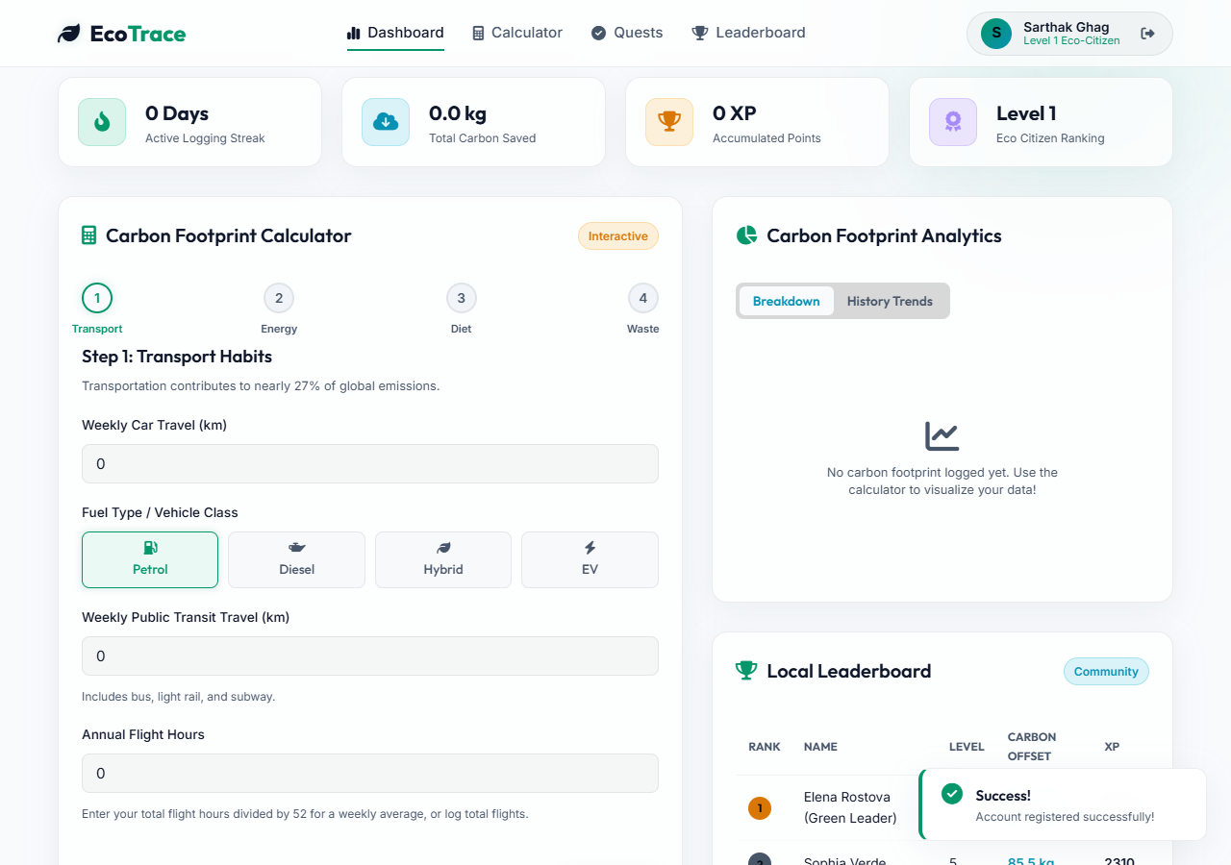

Figure 3: Carbon Footprint Calculator Multi-Step Wizard
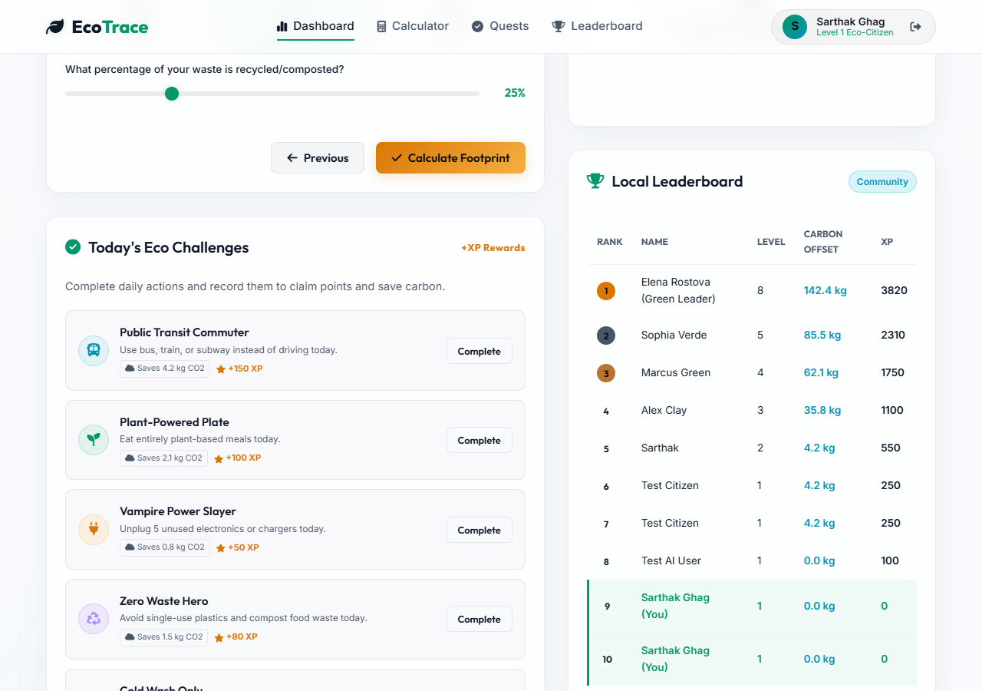

Figure 4: Analytical Carbon Charts & Live Leaderboard (With Logged Data)
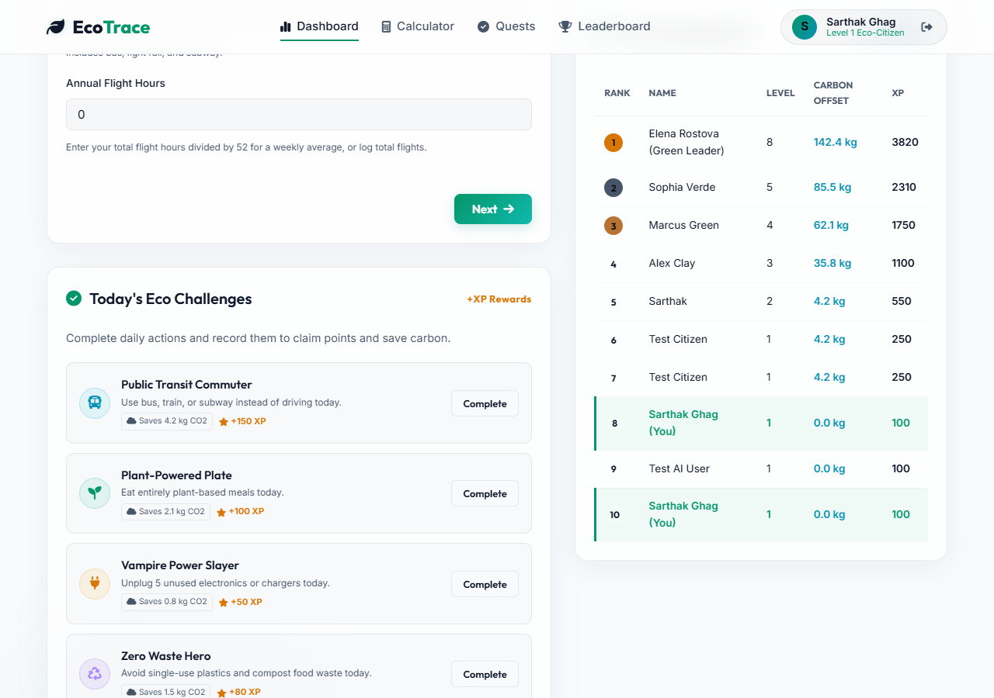

Figure 5: AI Eco-Coach Insights Panel (Live Gemini AI Recommendations)
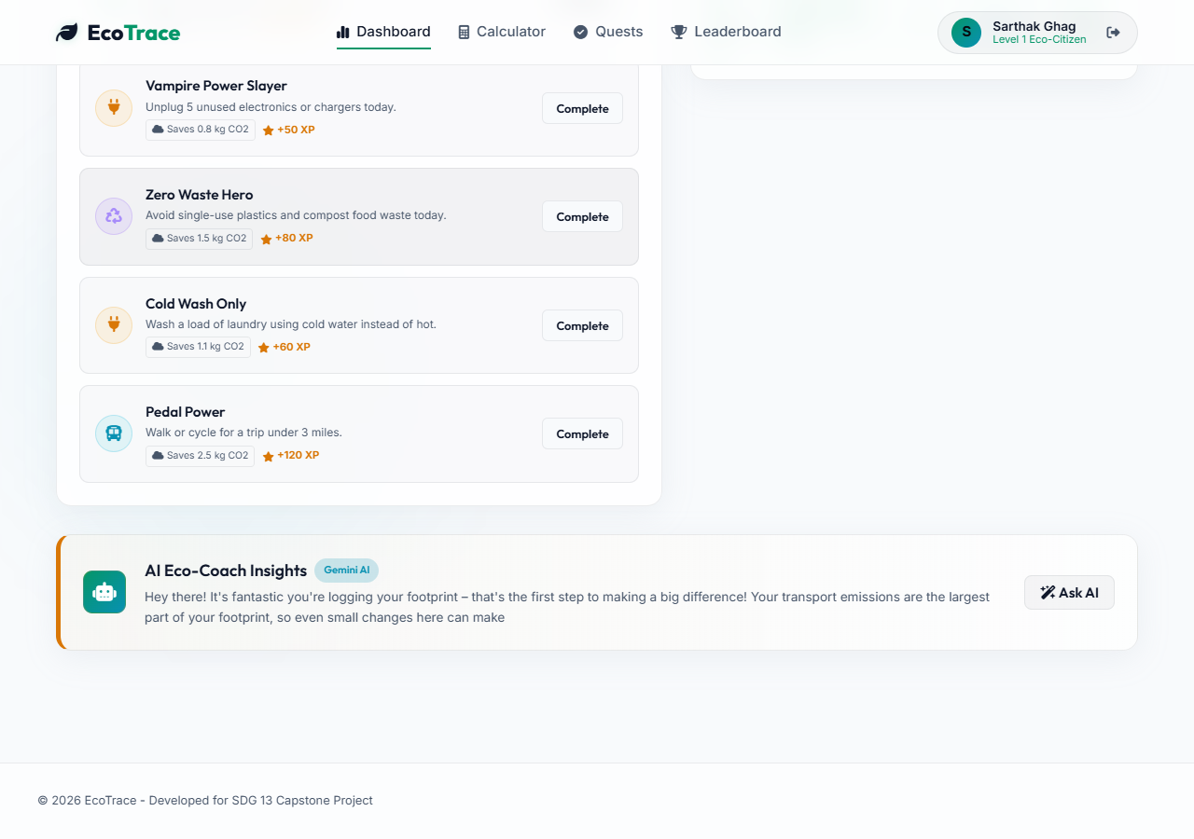

8. Future Scope
Mobile Application (iOS/Android): Developing dedicated mobile apps to support push notifications for daily quests and quick-log widgets.
Smart IoT & Utility Integration: Integrating directly with home smart meters or smart vehicle APIs to automatically import electricity and travel data without manual user logs.
Advanced Machine Learning Models: Moving from general LLM guidance to training specialized localized machine learning models that can integrate with local weather patterns and utility grids to offer predictive carbon reduction steps.

