Create a web page containing tabs: Home, Details

Page should be reloaded when any tab is clicked.

Home Page:

1. It should contain a list displaying name and image in tile format.

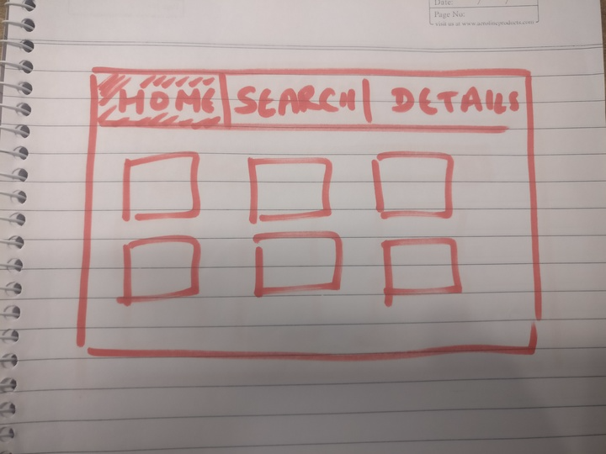

Search Page:

1. It should contain a search bar with a cross icon( only visible when there is some text)
2. When we type search string on search bar list should be filtered accordingly.
3. If we click on cross search filter should be removed

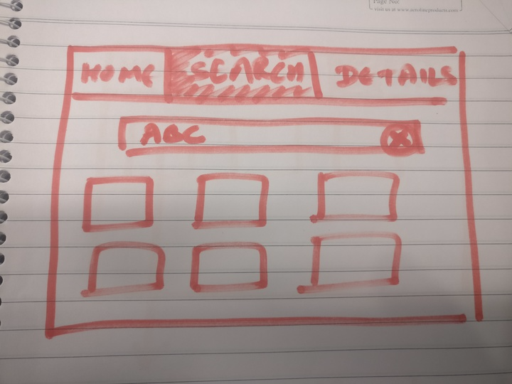

Details

1. When we click on any tile details open up in modal window containing an edit button.
2. When user clicks on edit button details can be edited and contain SAVE and CANCEL buttons.
3. If user clicks on Save button, the details are written to server.
4. If user clicks on Cancel button, the editing page is closed and user goes back to details page and changes are not saved.

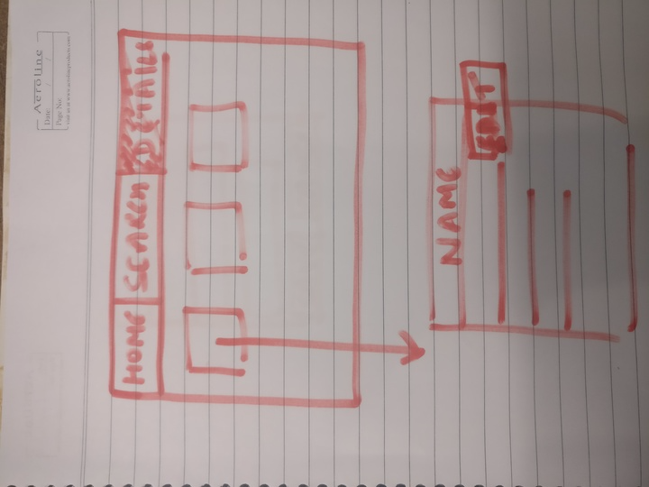

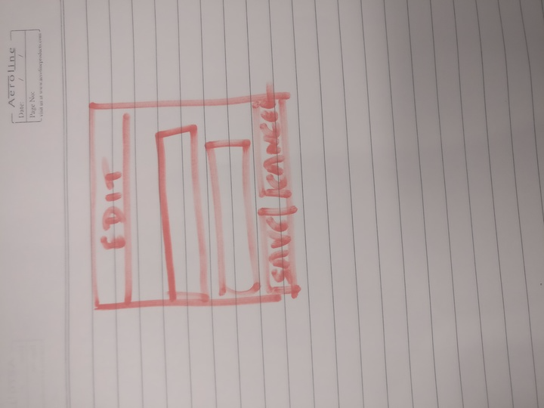

Pre requisites

1. Webpack-(dev/production) - minify JS and CSS
2. Node Express / Http server
3. No jquery
4. Grunt eslint
5. Bootstrap can be used only for css.
6. Create a json file for data and pass through ajax to local server
7. Try responsive layout ( not necessary )
8. All submissions should be on github and should not be uploaded in zip format