**STANDARD OPERATING PROCEDURE**

**Step1:-** If you are a new user then Click **Sign Up** and add your details otherwise fill the required details and Click on **Sign In** button.

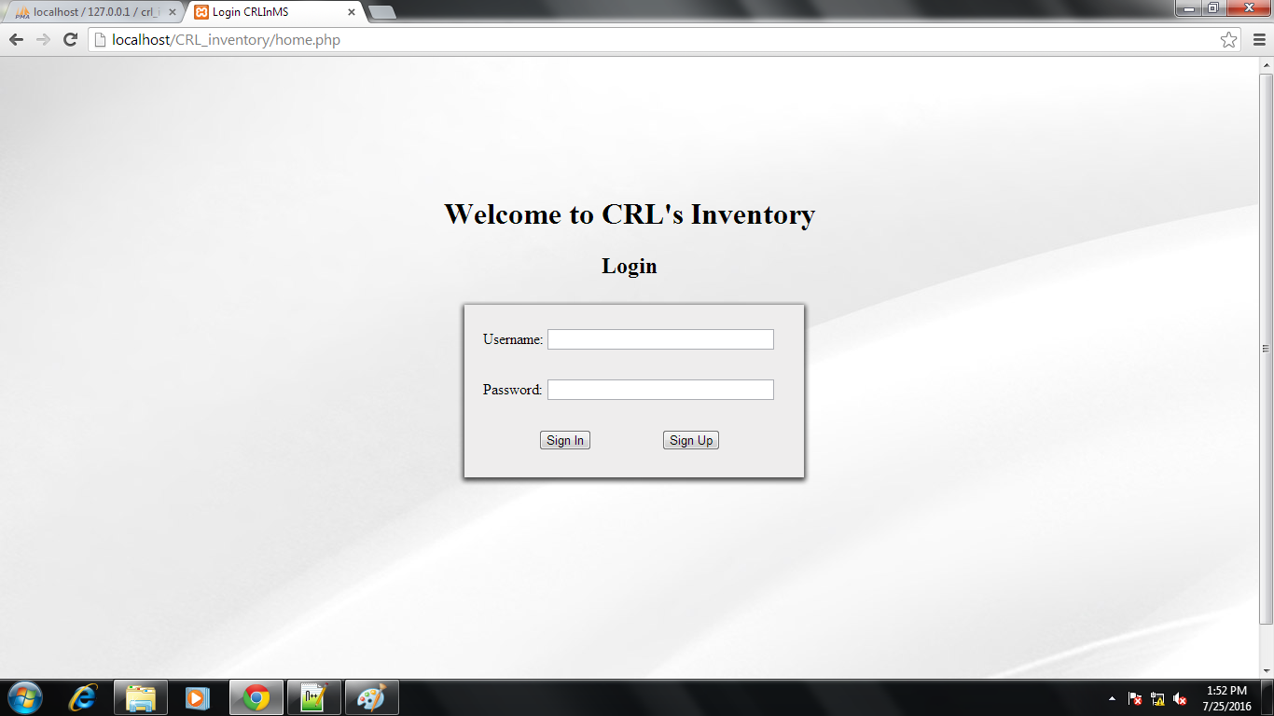

**Step2:-** If you press the Sign Up button the following page will appear. Fill your details correctly and after that click on Create button to get registered.

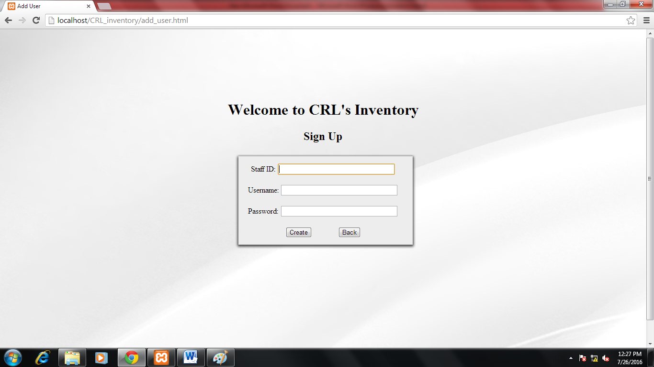

After Clicking the **Create** button you are registered as a new user and then you will redirected to the main Login page where this time you have to Sign In after filling the required details.

**Step3:-** After Signing In user will see the dashboard where all the items present in the inventory is listed.

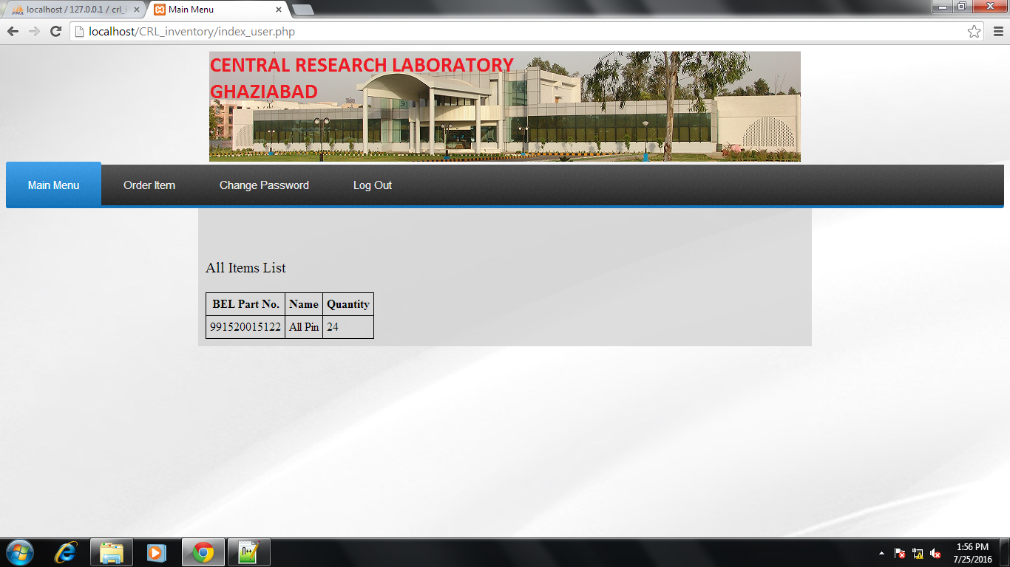

**Step4:-** For placing an order click on the **Order Item** option to order the item you want.

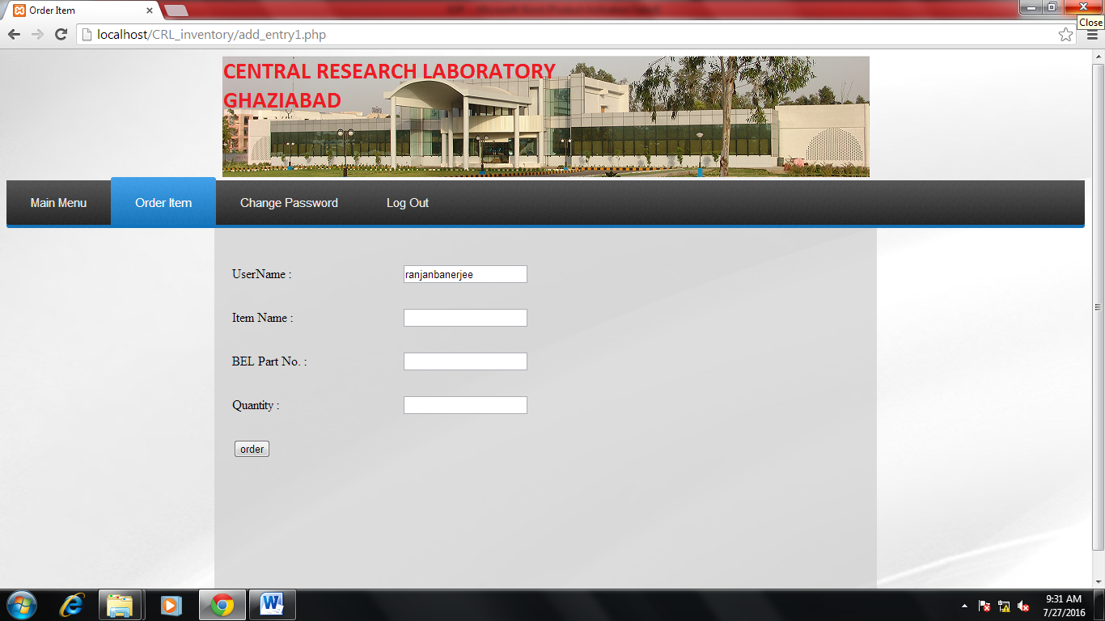

In this Option you have to fill the details of the item you want to order. Details of the item can be seen from Main Menu option. After filling up the details, click on the **Order** button and your order is placed.

**Step5:-** If any user wants to change the password of his/her account then he/she can change the password from the Change Password Option.

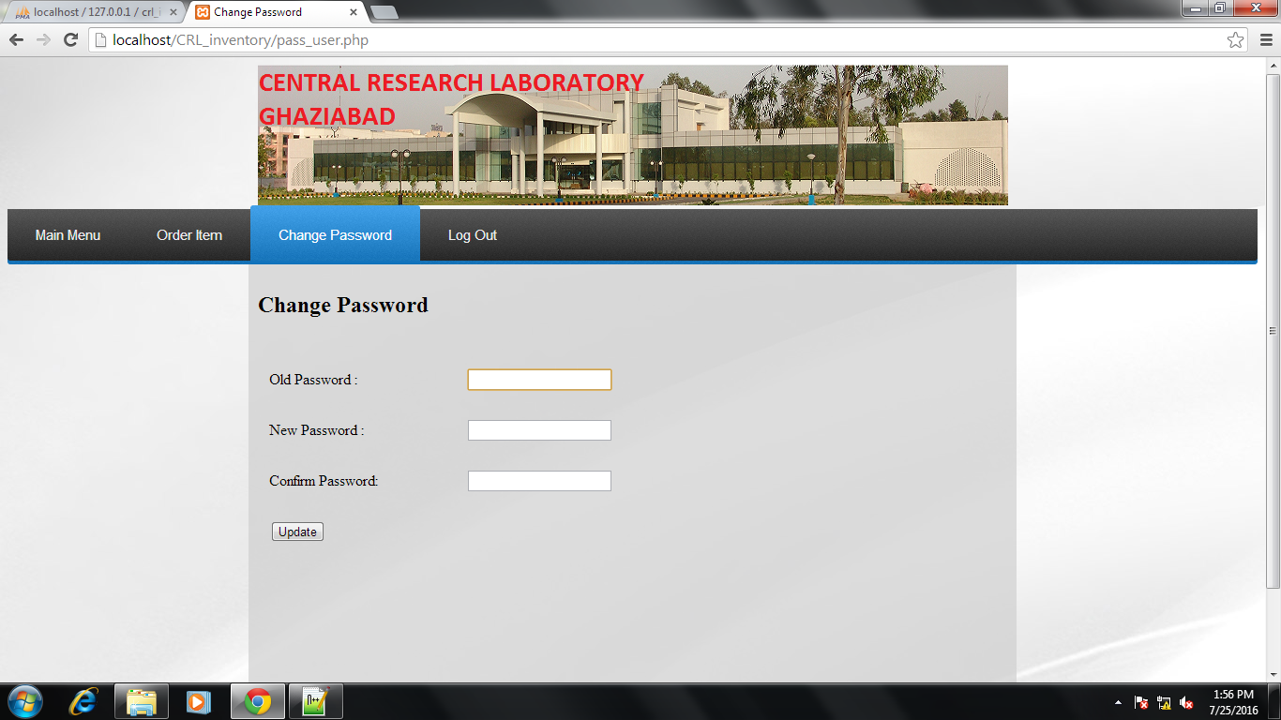

In this you have to fill the Old password then your new password twice and then click on **update** button and your password is updated successfully.

**Step6:-** Next option is Log Out option. It is used for Logging out from the inventory account.