**PROJECT TOPIC: EVENT RECOGNITION USING MACHINE LEARNING**

**Group No.:**27

**Project Group Members:**

1. Nitika Garg (C-48/161500365.) **3.** Prateek Verma(C-52/161500405)
2. Sarthak Agarwal (C-58/161500574)

**Project Supervisor:** Mr. Sandeep Kumar Rathore, Asstt. Professor

**Objective:** The main objective of the project “Event Recognition using Machine Learning” is to find out the interaction between entities referred as objects and humans to find out the event taking place. This helps us in several applications like human monitoring, defense surveillance, etc. The objective is to find a human skeleton and by monitoring its posture and movements taking along the object which it is interacting with to finally conclude the event taking place.

**Tools required:**

* **Hardware Requirements:**
* Processor (64 bit), Quad-core and above
* RAM (8 GB)
* Hard disk (100 GB)
* Graphical Processing Unit (min. 4 GB)
* Webcam
* **Software Requirements:**
* Python (version 3.7 and above)
* OpenCV (version 3.4.1 and above)
* Sklearn
* Tensorflow and Keras
* Numpy and Scipy
* Pathlib

**Abstract:** There is an increasing consensus that a human-like understanding of human behavior is a major challenge for autonomous systems, like self-driving cars in urban areas. In the future, autonomous systems and human beings will co-exist in shared public spaces. Reliably inferring the world state with series sensor technology is still a challenge. One area that we consider very important is the detection of human actions. This area is still an open field and there are no systems that can be used productively in a stable and reliable manner. In areas where autonomous systems have to interact with people, it is very important that they have information about what people are exactly doing in their immediate environment. This is especially true if a direct interaction with the human being is to take place. Since human actions are highly dynamic, it is not only important to predict the actions correctly but also in real-time..

**Outcome:**

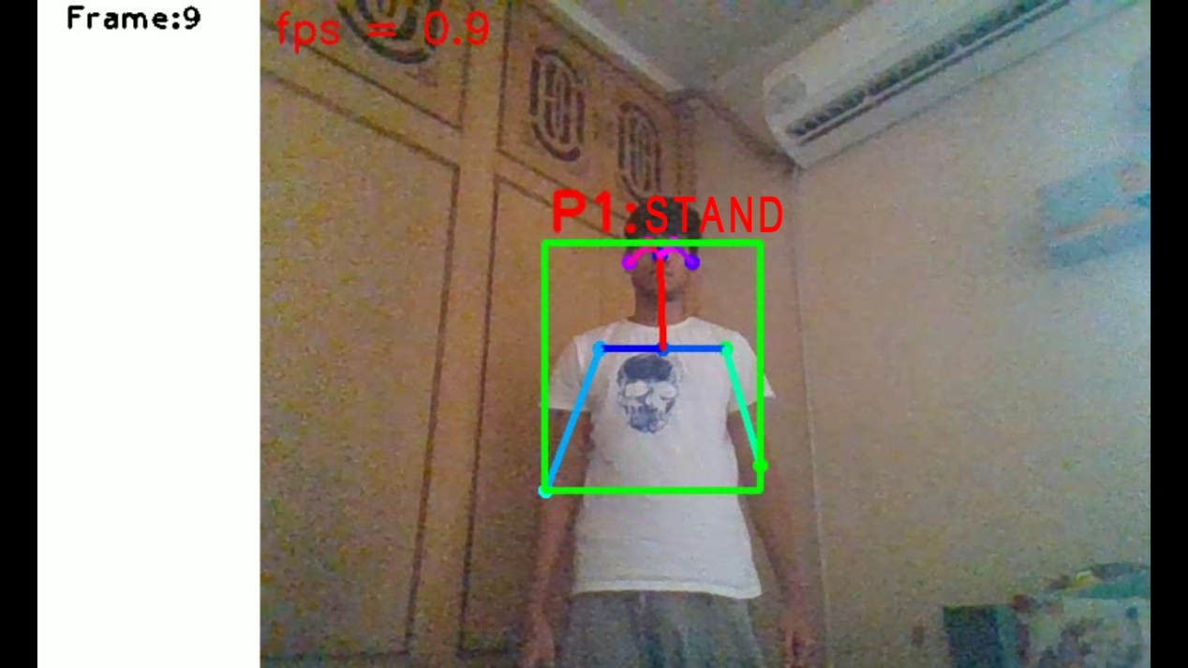

Figure 1 Webcam showing the lab event of "STAND"

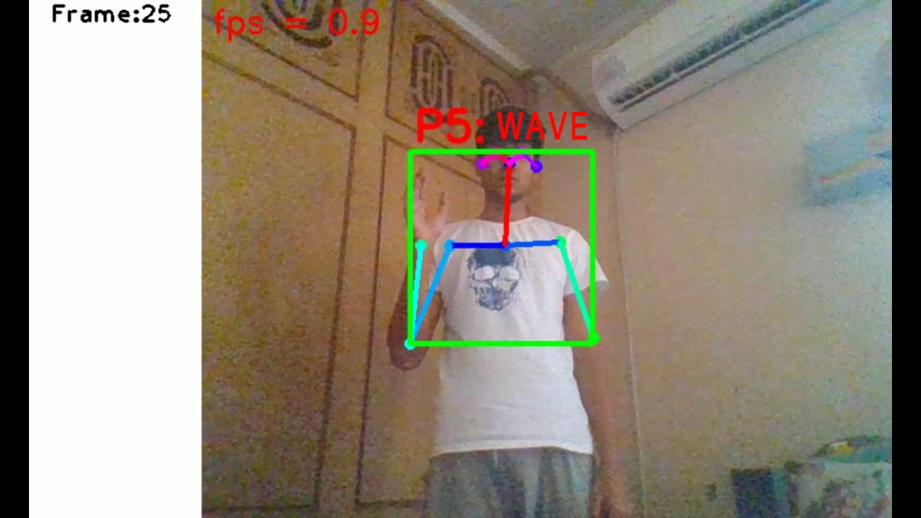

Figure 2 Webcam showing the lab event of "WAVE"