Customer Analytics & RFM Action Dashboard
Data Analytics / Generative AI Internship Project

1. Executive Summary
This project develops a business-oriented analytics dashboard for an online retail dataset. The objective is to move from raw transaction records to measurable KPIs, customer insights, risk/opportunity identification and practical actions. The project emphasizes actionable analytics rather than unnecessary model complexity.

2. Problem Statement
Retail transaction data contains information about invoices, products, quantities, dates, prices, customers and countries. A business needs a compact analytics solution that can identify revenue trends, high-value customer groups, weak engagement segments and actions that can be tested to improve retention and revenue.

3. Dataset
The project uses the UCI Machine Learning Repository Online Retail dataset (Dataset ID 352). The UCI repository describes it as transactional data from a UK-based registered non-store online retailer, covering transactions from 01/12/2010 to 09/12/2011. The dataset contains invoice, product, quantity, invoice date, unit price, customer and country information.
Dataset source: https://archive.ics.uci.edu/dataset/352/online+retail

4. Objectives
- Clean and prepare transaction data for analysis.
- Calculate executive KPIs such as revenue, customers, transactions and average order value.
- Identify monthly revenue trends and top-performing countries/products.
- Perform customer-level RFM analysis.
- Identify high-value and at-risk customer segments.
- Translate findings into business actions.
- Provide an interactive Streamlit dashboard that can be reviewed locally or hosted.

5. Methodology
The analytical flow is:
Data → Information → Insight → Opportunity/Risk → Action
Cleaning removes unusable records and cancellation invoices for revenue analysis. Revenue is calculated as Quantity × UnitPrice. Customer-level RFM measures are then calculated from the cleaned transaction history. Customers are segmented using rank-based RFM scores.

6. Dashboard Pages
- Executive Overview — KPI cards, monthly revenue trend, top countries and top products.
- Customer & Product Analysis — RFM segment size, segment revenue and customer-level metrics.
- Risk & Action — at-risk and champion customer counts, priority customers and recommended actions.

7. RFM Segments and Actions
Segment | Business Meaning | Suggested Action
Champions | High-value, recent and frequent customers. | Reward loyalty, early access and referrals.
Loyal Customers | Repeat customers with strong engagement. | Cross-sell relevant products and loyalty incentives.
Potential Loyalists | Customers with room to develop repeat behavior. | Personalized offers and repeat-purchase reminders.
At Risk | Previously valuable/frequent customers with weak recency. | Win-back campaigns and targeted offers.
Hibernating | Low recent activity and weaker engagement. | Low-cost reactivation campaigns.

8. UI / Output Preview
The following is an interface preview. It is intentionally labeled as a UI preview rather than a claim about final computed values. The live application populates KPI values and charts from the UCI dataset when it is run.
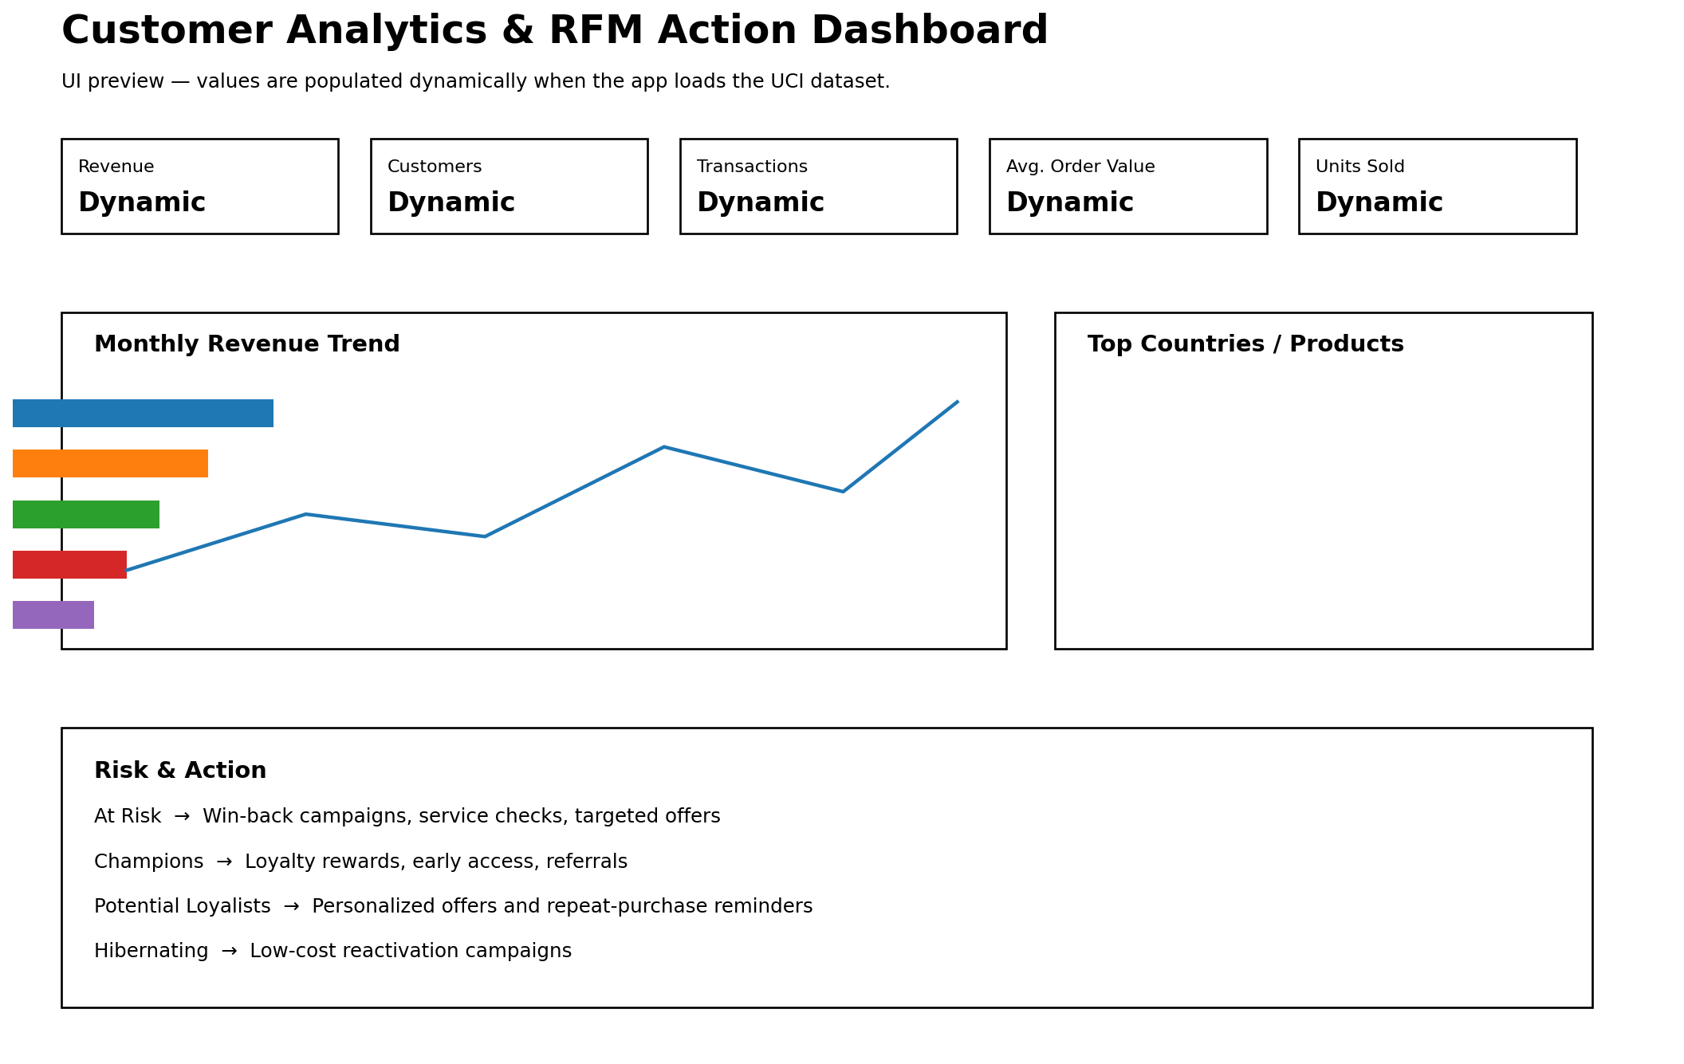

9. Technical Implementation
- Python for data processing and application logic.
- Pandas and NumPy for cleaning and analytics.
- Plotly for interactive charts.
- Streamlit for the dashboard interface.
- ucimlrepo for loading the public UCI dataset.
- RFM segmentation for customer-level descriptive analysis.

10. Files in the Submission
- customer_analytics_rfm.py — main Python application.
- requirements.txt — project dependencies.
- README.md — project overview, dataset source, setup and usage.
- Customer_Analytics_Project_Report.docx — project report with methodology and UI preview.

11. Limitations and Responsible Interpretation
The dataset is historical and represents one online retailer, so its patterns should not be treated as current market-wide behavior. RFM segments are descriptive groups and do not prove that an action will cause a particular business outcome. Recommendations should be tested before being treated as proven improvements.

12. Submission Checklist
- Verify that the dataset is different from the exact dataset used in the internship masterclass.
- Run the dashboard locally and check all three tabs.
- Check that requirements.txt installs successfully.
- Create a GitHub repository and upload the four required project files.
- Submit the GitHub repository link according to the internship instructions.

