Software Requirements Specification

For

SMART PARKING MANAGEMENT SYSTEM

06-11-2024

Prepared by

Specialization | SAP ID | Name
AI-ML | 500110213 | Shreeya Jaiswal
AI-ML | 500112316 | Sarthak Jain
AI-ML | 500112368 | Vansh Grover



School Of Computer Science
UNIVERSITY OF PETROLEUM & ENERGY STUDIES,
DEHRADUN- 248007. Uttarakhand
Table of Contents
Topic
Table of Content
Revision History
1 | Introduction
 | 1.1 Purpose of the Project
 | 1.2 Target Beneficiary
 | 1.3 Project Scope
 | 1.4 References
2 | Project Description
 | 2.1 Reference Algorithm
 | 2.2 Data/ Data structure
 | 2.3 SWOT Analysis
 | 2.4 Project Features
 | 2.5 User Classes and Characteristics
 | 2.6 Design and Implementation Constraints
 | 2.7 Design diagrams
 | 2.8 Assumption and Dependencies
3 | System Requirements
 | 3.1 User Interface
 | 3.2 Software Interface
 | 3.3 Database Interface
 | 3.4 Protocols
4 | Non-functional Requirements
 | 4.1 Performance requirements
 | 4.2 Security requirements
 | 4.3 Software Quality Attributes
5 | Other Requirements
Appendix A: Glossary
Appendix B: Analysis Model
Appendix C: Issues List

Revision History

Date | Change | Reason for Changes | Mentor Signature

1 | INTRODUCTION
 | 1.1 Purpose of the Project | The purpose of this project is to develop a Smart Parking System that optimizes parking space utilization in urban environments by using real-time image processing to identify and display available parking slots. The system aims to enhance parking efficiency by providing clear indicators (lights and screens) for free or occupied spaces, reducing the time drivers spend searching for parking. By offering an open-source solution, this project enables cost-effective deployment in locations like shopping malls, airports, hospitals, and office complexes, making parking management more efficient and accessible to all.
 | 1.2 Target Beneficiary | Drivers, Facility Managers, Municipalities and City Planners, Businesses
 | 1.3 Project Scope | The Smart Parking System is designed for urban environments, particularly high-traffic areas such as shopping malls, airports, hospitals, office complexes, and event venues. This software solution uses real-time image processing and visual indicators to identify and display available parking slots, helping drivers locate spaces efficiently and reducing congestion within parking areas.  Benefits:  - Reduces search time for parking, improving user convenience.  - Decreases congestion within parking facilities, enhancing traffic flow.  - Supports smart city initiatives by reducing carbon emissions and optimizing space utilization.  Objectives and Goals:  - To implement an automated parking slot detection system using image processing to determine slot occupancy.  - To enable visual indicators (lights and screens) to signal free and occupied slots to drivers in real-time.  - To provide a cost-effective, open-source solution adaptable to different facilities and ease integration with potential mobile navigation apps.  Requirements:  - Real-time Image Processing: Detect car presence in slots and distinguish between free and occupied spots.  - Visual Indicators: Send signals to change lights above each parking slot to green or red based on availability.  - Display Screens: Show the number of available parking spots in each section of the facility.  Deliverables:  - Software Application: A backend logic in C++ for processing images, detecting car presence, and signaling indicators.  - User Interface: A frontend interface to display real-time parking data and slot availability.  - Documentation: Detailed instructions, including setup and configuration, to guide users on system operation and potential mobile integration options.
 | 1.4 References | - OpenCV Documentation: https://docs.opencv.org/ - Reference for image processing and contour detection techniques.  - Agile Methodology Guide: https://www.agilealliance.org/agile101/ - Reference for Agile development practices used in the project.  - IEEE SRS Standards: https://ieeexplore.ieee.org/document/7205746 - Guidelines followed for structuring this SRS document.  - C++ Documentation: https://en.cppreference.com/w/ - Reference for C++ programming concepts and libraries used in the project.  - Smart Parking System Papers: https://olgarose.github.io/ParkingLot/
2 | PROJECT DESCRIPTION
 | 2.1 Reference Algorithm | Contour Detection Algorithm:  - Purpose: This algorithm identifies the boundaries of parked cars within each parking slot, distinguishing between occupied and free slots.  - Methodology: Using OpenCV’s contour detection, the system identifies closed boundaries in each video frame. It calculates the intersection area between detected contours and predefined parking slot polygons, marking a slot as “occupied” if a significant portion is covered.  - Data Structures Used: Arrays to store parking slot coordinates, contours for detecting objects in each slot, and Boolean flags to record occupancy status.
 | 2.2 Characteristic of Data | The dataset for the Smart Parking System includes parking spot coordinates, video feed for car detection, and occupancy status of parking spots.  Primary Data Sources:  - Video Feed: Real-time footage from cameras in parking areas is processed for vehicle detection.  - Parking Spot Coordinates: Coordinates of each parking spot are manually marked and saved in a YAML file.  Secondary Data Sources:  - Parking Lot Layout: Predefined parking layouts or maps are used for reference.  - Vehicle Detection: External car detection data (if applicable) may supplement the system's real-time detection.  Sampling Techniques:  - Manual Sampling: Coordinates for parking spots are manually selected through a GUI.  - Video Sampling: Frames from video feeds are analyzed at regular intervals for motion detection.  Statistical Methods  - Intersection Area Calculation: Used to determine if a parking spot is occupied by a vehicle.  - Moment Calculations: Used to calculate the center of parking spots for visualization.  - Motion Detection: Frame difference and thresholding techniques are used to detect vehicle movement.
 | 2.3 SWOT Analysis | Strengths  - Open Source: The project is designed to be open source, encouraging community contributions and fostering innovation.  - Scalability: The system can be scaled to accommodate more parking spaces and integrate additional features as demand grows.  - Filling a Vital Need: The solution addresses a significant issue in urban areas, helping to reduce the time spent searching for parking and improving overall parking efficiency.  - User-Friendly Interface: The application is designed with a focus on usability, making it accessible for all users, including those with limited technical skills.  Weaknesses  - Dependency on Data Quality: The system's performance is heavily reliant on the quality and accuracy of the input data from video feeds and parking spot coordinates.  - Initial Setup Cost: There may be substantial upfront costs for hardware and installation, which could be a barrier for some users or organizations.  - Maintenance Requirements: Ongoing maintenance is necessary to ensure the system continues to function effectively, which may require dedicated resources.  Opportunities  - Mobile App Integration: Developing a mobile application can enhance user experience by providing real-time updates on parking availability and allowing reservations.  - Potential Partnerships: Collaborating with local municipalities or private parking facilities can expand the system's reach and functionality.  - Navigation Feature Integration: Adding navigation features can guide users to the nearest available parking spots, improving convenience and efficiency.  Threats  - Competition: The market may have established players with similar solutions, posing a challenge for user adoption and market penetration.  - Integration Challenges: Integrating with existing systems and technologies may present technical difficulties and require additional resources.  - Technological Limitations: Potential limitations in technology, such as camera resolution or processing power, may affect the system's reliability and performance.
 | 2.4 Project Features | Parking Spot Detection:  - The system uses image processing techniques (like contour detection in C++) to identify available parking spots in a parking lot. It detects whether a spot is occupied or free and marks it accordingly with colored rectangles (red for occupied, green for free) on the system’s display.  Parking Spot Selection and Mapping:  - Users or administrators can manually select parking spots through a graphical interface. Once spots are selected, the system creates a visual map with labeled spots, helping both parking lot administrators and users to track the status of each spot in real-time.  Parking Spot Availability Signaling:  - Using a light signaling system, the system can trigger the lights above parking spaces to show if a spot is free or occupied. Red lights indicate occupied spots, while green lights show available spots.  Parking Spot Reservation (Future Integration):  - Users will be able to reserve parking spots in advance via a mobile app. This feature will help to reduce the time spent searching for an available spot and improve the efficiency of parking lot usage.  Navigation to Nearest Free Spot (Future Integration):  - The system will integrate with a navigation app, guiding users to the nearest free parking spot. This feature will minimize the time spent searching for an open space and improve user convenience.  Real-Time Parking Lot Data:  - The system will display real-time data on available and occupied parking spots. This data can be used by both parking lot operators and users to make informed decisions.
 | 2.5 User Classes and Characteristics | End Users (Parking Customers):  - Characteristics: General public seeking parking spaces, varying tech proficiency.  - Needs: Easy access to available spots, simple reservation interface, real-time notifications.  Administrators (Parking Facility Managers):  - Characteristics: Responsible for managing parking operations, may have technical backgrounds.  - Needs: Monitoring tools for occupancy, management of space configurations, access to analytics.  Application Developers:  - Characteristics: Software developers maintaining and updating the system.  - Needs: Documentation and APIs for feature integration, access to system architecture.  City Planners and Urban Developers:  - Characteristics: Professionals involved in urban planning and smart city initiatives.  - Needs: Data on parking utilization, insights on traffic impact for planning decisions.  Investors and Stakeholders:  - Characteristics: Individuals or organizations interested in project funding and support.  - Needs: Information on project viability, benefits, and potential returns on investment.
 | 2.6 Design and Implementation Constraints | Hardware Boundary Conditions:  - Timing Requirements: Real-time processing of video feeds must be completed within 100 milliseconds to ensure timely updates of parking availability.  - Memory Requirements: The system should operate with a minimum of 4 GB RAM to handle video processing and data storage efficiently.  - Processing Power: High processing power is required, with recommended hardware such as an NVIDIA RTX 4070 or equivalent GPU for fast execution of image processing tasks.  Interfaces to Other Applications:  - The system will interface with a mobile application for end-users to check parking availability and reserve spots.  - Integration with existing city traffic management systems for data sharing and enhanced functionalities.  Specific Technologies and Tools:  - Image Processing: OpenCV library for C++ will be used for image analysis and contour detection.  - Development Environment: Visual Studio or similar IDE for C++ development.  Parallel Operations:  - The system must support concurrent processing of multiple video feeds from different parking locations to monitor multiple areas simultaneously.  Language Requirements:  - The backend will be developed in C++, with potential for integration with a frontend developed in JavaScript or Python for web-based functionalities.
 | 2.7 Design diagrams | USE CASE DIAGRAM  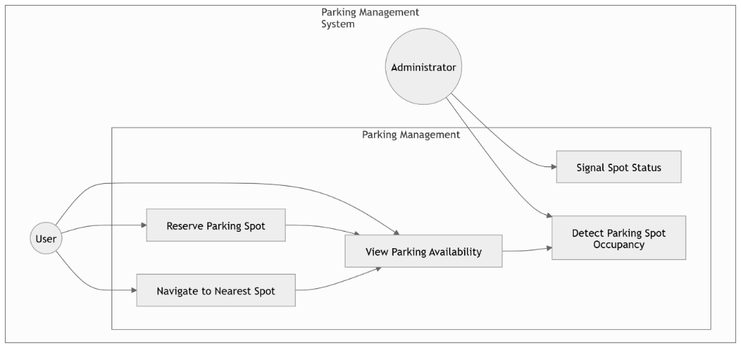  STATE DIAGRAM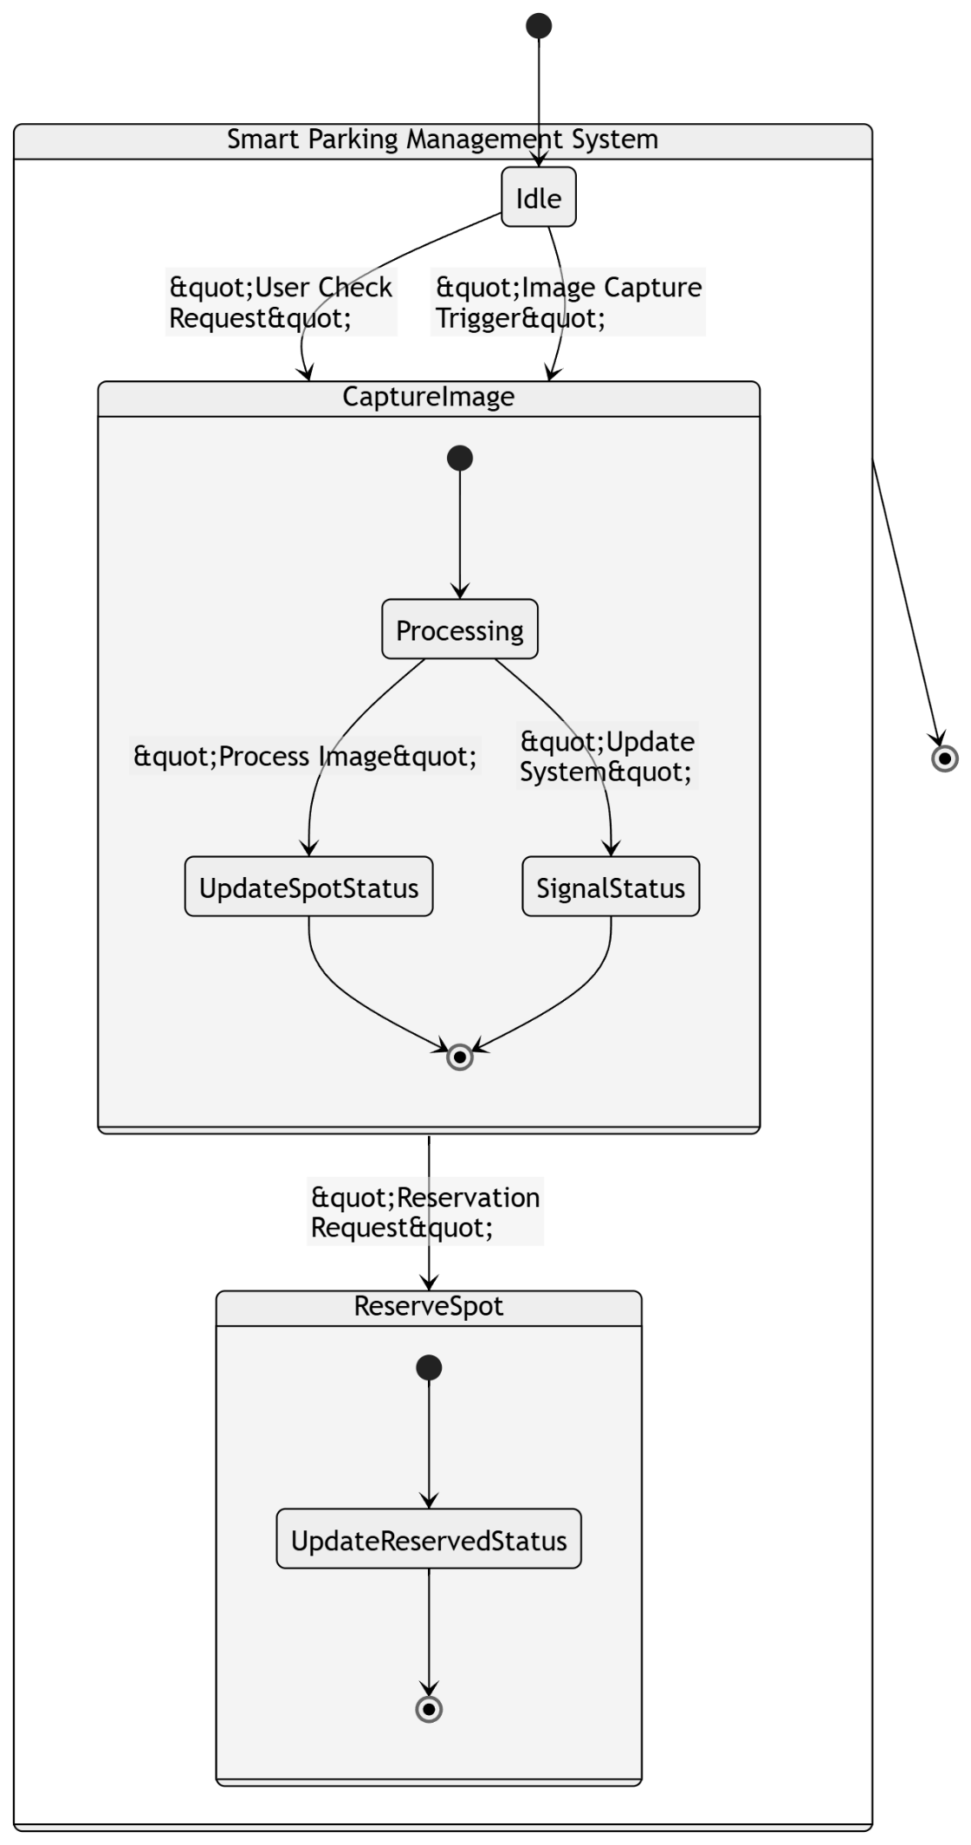  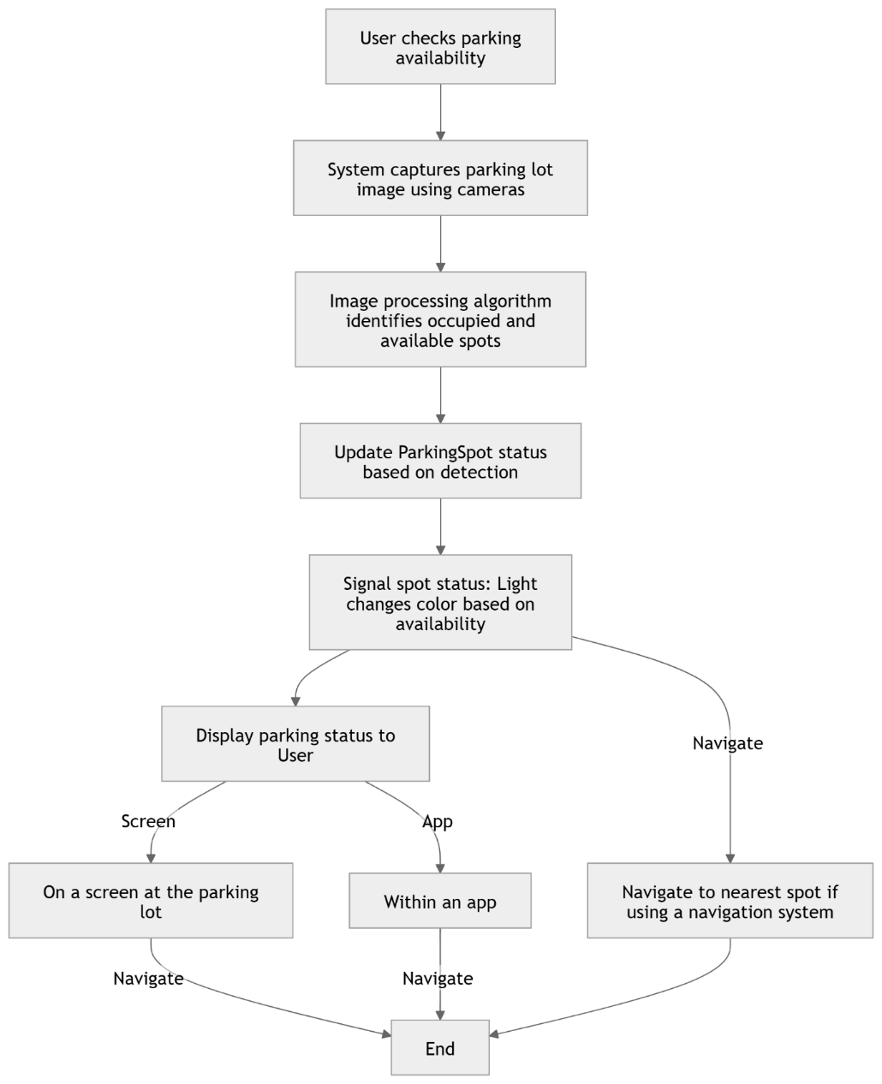  ACTIVITY DIAGRAM  DATA FLOW DIAGRAM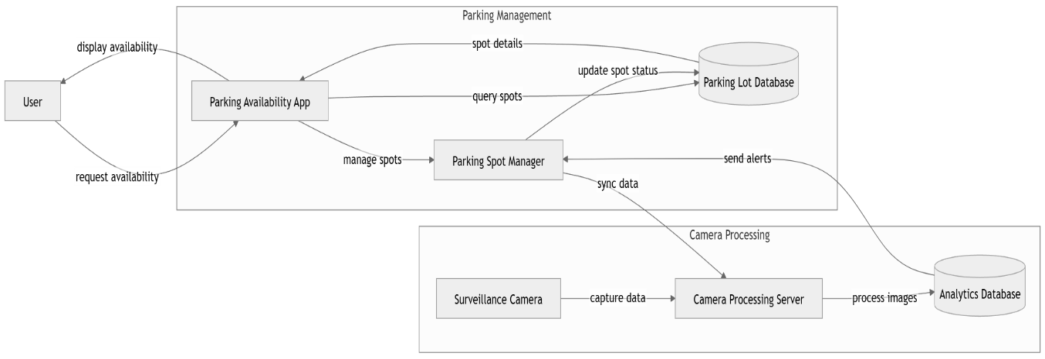  CLASS DIAGRAM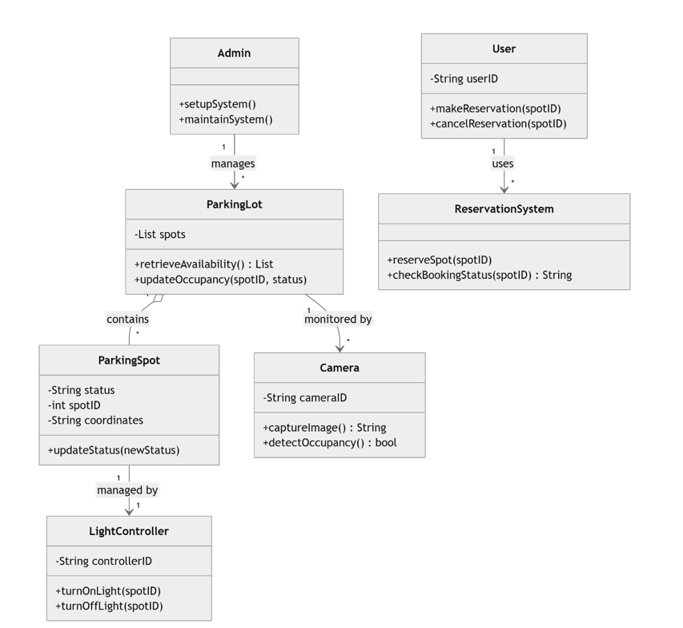SEQUENCE DIAGRAM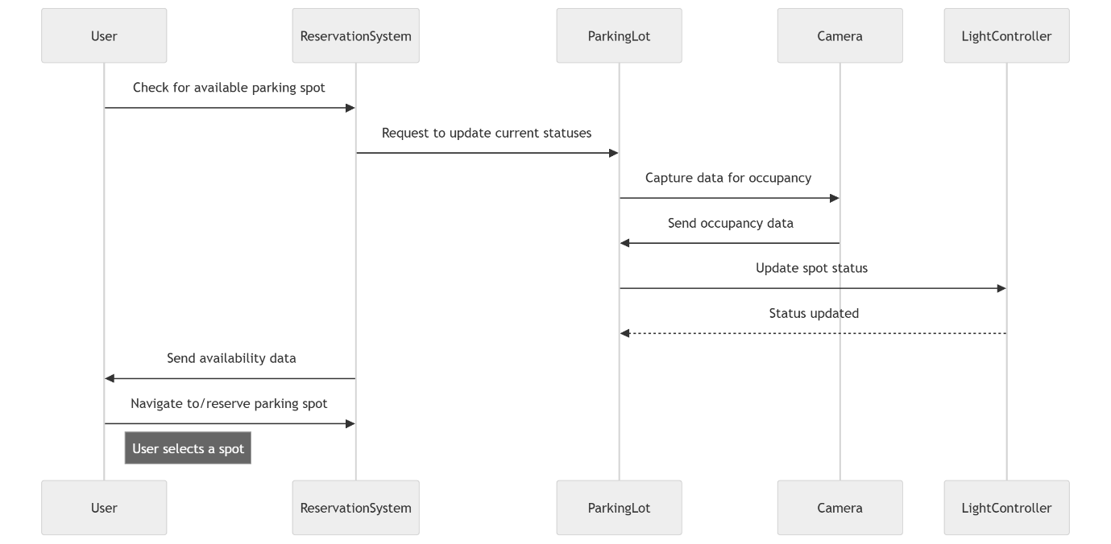
 | 2.8 Assumption and Dependencies | Assumptions:  - Consistent Power Supply: It is assumed that the parking facility has a reliable and continuous power supply to maintain uninterrupted monitoring and signaling operations.  - High-Quality Camera Feeds: The system assumes that the video feed provided by cameras will be of sufficient resolution (HD or higher) to ensure accurate image processing and detection.  - User Adoption: The success of the system partially depends on end-users downloading and using the accompanying mobile application to reserve spots and view parking availability.  - Regular Maintenance: It is assumed that the system, including the cameras and lights, will receive regular maintenance to avoid hardware-related issues and maintain optimal performance.  - Internet Connectivity: Reliable internet connectivity is assumed to ensure real-time data transfer between the parking system and user applications.  Dependencies:  - Hardware Compatibility: The project depends on compatible hardware (e.g., cameras, sensors, lights) that can interface seamlessly with the software.  - Data Privacy Regulations: Compliance with data privacy laws and regulations, such as GDPR, will be necessary for handling user data within the system and mobile application.  - Third-Party Software Libraries: The project relies on OpenC  - V for image processing, which could impact the project if the library is updated or no longer supported.
3 | SYSTEM REQUIREMENTS
 | 3.1 User Interface | Desktop/Administrator Dashboard:  - Real-Time Monitoring Panel: Displays live camera feeds with marked parking spots to indicate occupancy status (green for free, red for occupied).  - Slot Management Interface: Allows administrators to configure or adjust parking slot boundaries and identifiers.  - Analytics Dashboard: Provides insights on parking occupancy trends, average stay duration, and other useful statistics.  - Settings and Controls: An interface to adjust camera and light settings, system notifications, and real-time alerts.  Parking Lot Entrance Display:  - Digital Display Board: Shows total available parking slots and sections with free spots, assisting users as they enter the facility.
 | 3.2 Software Interface | Module Connections:  - Image Processing Module to Occupancy Detection Module: The image processing module processes live camera feeds to identify parking slot boundaries and car presence. It then sends real-time data on occupied and available slots to the occupancy detection module.  - Occupancy Detection to Signaling Module: Once the occupancy status is determined, the signaling module receives instructions to update slot lights (green for free, red for occupied) accordingly.  - Administrator Dashboard and Data Module: The occupancy data is also transmitted to the administrator dashboard for live monitoring and analytics. The data module stores historical data on parking usage patterns and occupancy trends.  Required Services and Communication:  - Real-Time Data Processing: Continuous analysis of camera feeds is required to ensure accurate, real-time occupancy detection.  - Signal Transmission for Lights: The signaling module must communicate quickly with physical lights, updating their color based on slot availability status.  - Data Storage: All processed data, including parking slot statuses and historical trends, must be stored for further analytics, reporting, and trend analysis.  Detailed API Protocols:  - Occupancy Data API: Provides a structured response with occupancy status for each parking slot, updated periodically or upon user request.  - Signaling Control API: Accepts POST requests to update individual slot lights, adjusting based on occupancy detection module output.
 | 3.3 Database Interface | The Smart Parking System uses YAML files as the primary data storage format. YAML is chosen for its simplicity, readability, and ease of use, making it an effective option for configuration and static data storage in this project.  Key Data Storage Features:  File Structure:  - Parking_Spots.yaml: Stores information about each parking spot's coordinates and basic settings.  Operations:  - Configuration Loading: The system reads the YAML file to load the parking spot locations and configurations at runtime.  - Storage Simplicity: YAML files provide an easy way to update configurations without a complex database setup, suitable for projects with a static dataset.
 | 3.4 Protocols | The Smart Parking System employs communication protocols to manage data transfer between the backend system and the visual indicators (LED lights) positioned over parking spots. Key protocols and requirements include:  Data Transfer Protocol:  - Purpose: Transmits signals to turn LED indicators red (occupied) or green (available) based on real-time image processing results.  - Requirements: Low-latency, reliable communication to ensure immediate updates to the visual indicators.  Synchronization Mechanism:  - Objective: Ensures consistent state across the system, particularly when multiple parking spots are updated simultaneously.  - Approach: Lightweight polling or periodic updates to maintain synchronization without significant performance impact.  Security Considerations:  - Data Integrity: Ensures that signals for LED indicators are accurate, reducing the risk of erroneous or manipulated parking availability data.  - Encryption: If extended for remote access or integration with mobile apps, encryption may be applied to secure communication channels and prevent unauthorized access.  Data Transfer Rate:  - Requirement: Moderate transfer rate sufficient to handle frequent updates in response to vehicle movement while prioritizing low delay.
4 | NON-FUNCTIONAL REQUIREMENTS
 | 4.1 Performance requirements | The Smart Parking System must meet specific performance criteria to ensure smooth operation and a reliable user experience, especially under varying conditions. Key performance requirements include:  Real-Time Processing:  - Image Processing Speed: The system should process each camera frame within 100 milliseconds to maintain real-time occupancy detection.  - Response Time: LED indicators should update within 200 milliseconds of a change in parking occupancy status, providing immediate feedback to users.  System Scalability:  - Load Handling: The system should efficiently manage up to 200 parking spots within a single location without degradation in processing speed or response time.  - Expansion Capability: The software architecture should allow the addition of new parking sections with minimal impact on performance.  Resource Utilization:  - Processing Power: For optimal performance, a high-performance GPU (e.g., NVIDIA RTX 4070 or similar) is recommended to handle the image processing tasks at scale.  - Memory Requirements: The system should operate within a memory footprint of 4 GB, especially for large parking lots, to ensure stability and responsiveness.  Reliability and Uptime:  - System Availability: The system should maintain 99.9% uptime to ensure continuous operation in busy areas.  - Error Recovery: In the event of a crash, the system should auto-restart within 30 seconds to minimize downtime and data inconsistency.  Data Throughput:  - Network Requirements: The system should support high-throughput data exchange for LED signals, maintaining smooth communication even during peak usage times.
 | 4.2 Security requirements | The Smart Parking System must ensure the security and privacy of user data and system integrity. Security measures are implemented to prevent unauthorized access, maintain data confidentiality, and meet regulatory compliance. Key security requirements include:  Authentication and Access Control:  - User Authentication: Only authorized personnel should have access to the system controls, such as adding or modifying parking slots and managing hardware (LEDs, cameras).  - Access Levels: Define multiple access levels for administrators, maintenance staff, and general users, with permissions restricted to relevant functions.  Data Encryption and Privacy:  - Encryption: Any data transmitted between system components, such as occupancy status and LED signal updates, should be encrypted to prevent interception by unauthorized parties.  - Privacy Compliance: Ensure compliance with relevant data protection regulations, such as GDPR, to protect any personal information that may be collected or stored.  Verification and Validation:  - System Integrity Checks: Regularly verify system components, such as camera feeds and LED indicators, to detect and prevent tampering.  - Data Validation: Validate image processing data inputs to reduce false positives in occupancy detection, enhancing accuracy.  Compliance with External Policies:  - Regulatory Standards: Adhere to standards such as ISO/IEC 27001 for information security management, especially for systems integrated with sensitive data.  - Incident Response: Establish protocols for quick response to security breaches, including user notifications and recovery processes to restore secure operations.
 | 4.3 Software Quality Attributes | Adaptability:  - The system must accommodate various parking lot layouts and sizes, allowing for easy integration of new features, such as mobile app connectivity for real-time updates.  Availability:  - The system should aim for 99.9% uptime, ensuring continuous monitoring of parking spaces with quick recovery protocols in case of hardware failure.  Correctness:  - Accurate occupancy detection is crucial. The backend algorithms must reliably identify parking space availability under varying conditions, ensuring high precision in reporting.  Flexibility:  - Users should be able to adjust parameters easily, such as detection thresholds, to optimize performance based on specific environments.  Interoperability:  - The system must integrate seamlessly with third-party technologies, supporting standard communication protocols for real-time updates and navigation assistance.  Maintainability:  - The software architecture should be modular, allowing for straightforward maintenance and updates to the backend code with minimal operational disruption.  Portability:  - The system should be deployable on various hardware platforms, optimized to function efficiently on both high-end (e.g., RTX 4070) and lower-end systems.  Reliability:  - Consistent and accurate parking status reporting is essential, ensuring that users can trust the system's information.  Reusability:  - Components, especially image processing algorithms, should be designed for reuse in other projects, facilitating the development of future smart solutions.  Robustness:  - The system should perform effectively in diverse environmental conditions, maintaining detection accuracy in varying lighting and weather.  Testability:  - The design should support comprehensive testing of individual components, ensuring reliable integration into the overall system.  Usability:  - The user interface must be intuitive, with clear visual signals for parking availability and straightforward navigation features for end-users.
5 | Other Requirements | Training Requirements:  - Training sessions should be conducted for end-users and system administrators to ensure proper utilization of the system and its features.  Compliance Standards:  - The system must adhere to local regulations and standards regarding data privacy and security, especially those related to user information and monitoring technologies.  Integration with Existing Infrastructure:  - The solution must be designed to work alongside existing parking management systems, ensuring smooth transitions and interoperability.
Appendix A: Glossary |  | - API (Application Programming Interface): A set of protocols and tools for building software applications that allows different programs to communicate with each other.  - Contour Detection: A technique used in image processing to identify and outline shapes or objects within an image, commonly used for detecting parking spaces and vehicles.  - DBMS (Database Management System): Software used to store, manage, and retrieve data in a structured format; in this project, YAML files are used instead of a traditional DBMS.  - GUI (Graphical User Interface): A visual way for users to interact with the software using graphical elements such as buttons, icons, and windows.  - Open Source: Software that is made available to the public with its source code, allowing users to modify, distribute, and use it freely.  - Parking Spot: A designated area in a parking facility for parking vehicles.  - Real-time Processing: The capability of a system to process data and provide immediate results as events occur, essential for monitoring parking space occupancy.  - YAML (YAML Ain't Markup Language): A human-readable data serialization format used for configuration files and data exchange between languages with different data structures.  - Vehicle Detection: The process of identifying and locating vehicles within a designated area, typically using computer vision techniques.  - Smart Parking Management System: A technology-based solution designed to optimize parking space utilization, providing real-time information on available parking slots and enhancing user experience.
Appendix B: Analysis Model |  | Use Case Diagrams  Use case diagrams are used to represent the interactions between users (actors) and the system. In this project, key use cases include:  User Interaction:  - View Available Parking Spots: Users can see the real-time availability of parking spots.  - Reserve a Parking Spot: Users can book a parking space in advance.  - Receive Directions: Users can obtain navigation assistance to the nearest available parking spot.  Sequence Diagrams  - Sequence diagrams illustrate how objects interact in a particular scenario of a use case, detailing the sequence of messages exchanged.  - Example: The sequence of events when a user reserves a parking spot, which includes:  - User selects a parking spot from the available options.  - System verifies availability.  - Confirmation sent to the user.  Class Diagrams  - Class diagrams depict the static structure of the system by showing the system's classes, attributes, methods, and relationships among objects.  Key Classes:  - ParkingSpot: Attributes include location, status (occupied/free), and methods to check availability.  - User: Attributes include user ID, contact information, and methods for booking and viewing spots.  - Reservation: Attributes include reservation ID, user details, and assigned parking spot.  Data Flow Diagrams (DFD)  - Data flow diagrams are used to visualize how data moves through the system, including inputs, outputs, and processes.  - Displays how data is input by users and processed by the system to display parking availability.  - Shows interaction between the user interface, processing components, and output display.  Activity Diagrams  - Activity diagrams illustrate the dynamic aspects of the system, showcasing the flow of control or data from activity to activity.  - Example: The process flow for monitoring parking space occupancy, including:  - Capturing video input.  - Detecting vehicles using image processing.  - Updating the status of parking spots.

