

**MINOR PROJECT SYNOPSIS**

**EPIDEMIC BREAKOUT PREDICTION**

**AND VISUALISATION**

**Made By:-**

**Sarthak Kapoor (15103103)**

**Utkarsh Tripathi (15103225)**

**Abstract**

We all know the importance of General Public Health.

There have been numerous epidemic breakouts in the world. These have been catastrophic in nature for everyone no matter which country. This costs us our most valued resource that is Human Life.

With our project we aim to predict the next epidemic breakout in the world.

We are going to collect our data from various sources on the internet. After pre-processing data or getting important details extracted from data we will make proper analysis of various factors playing role in the breakout of an epidemic and then will make a model trained on this dataset so that for future events we could predict the breakout of any epidemic on the basis of location, climate, temperature, average monthly rainfall, total number of positive cases, and other data points.

We will make an Android as well as an iOS App, where our model will predict the next epidemic breakout and visualise it on a map.

With this we’ll be able to prepare ourselves better for the incoming catastrophe.

**Basic Flowchart of Inner Working of Project**

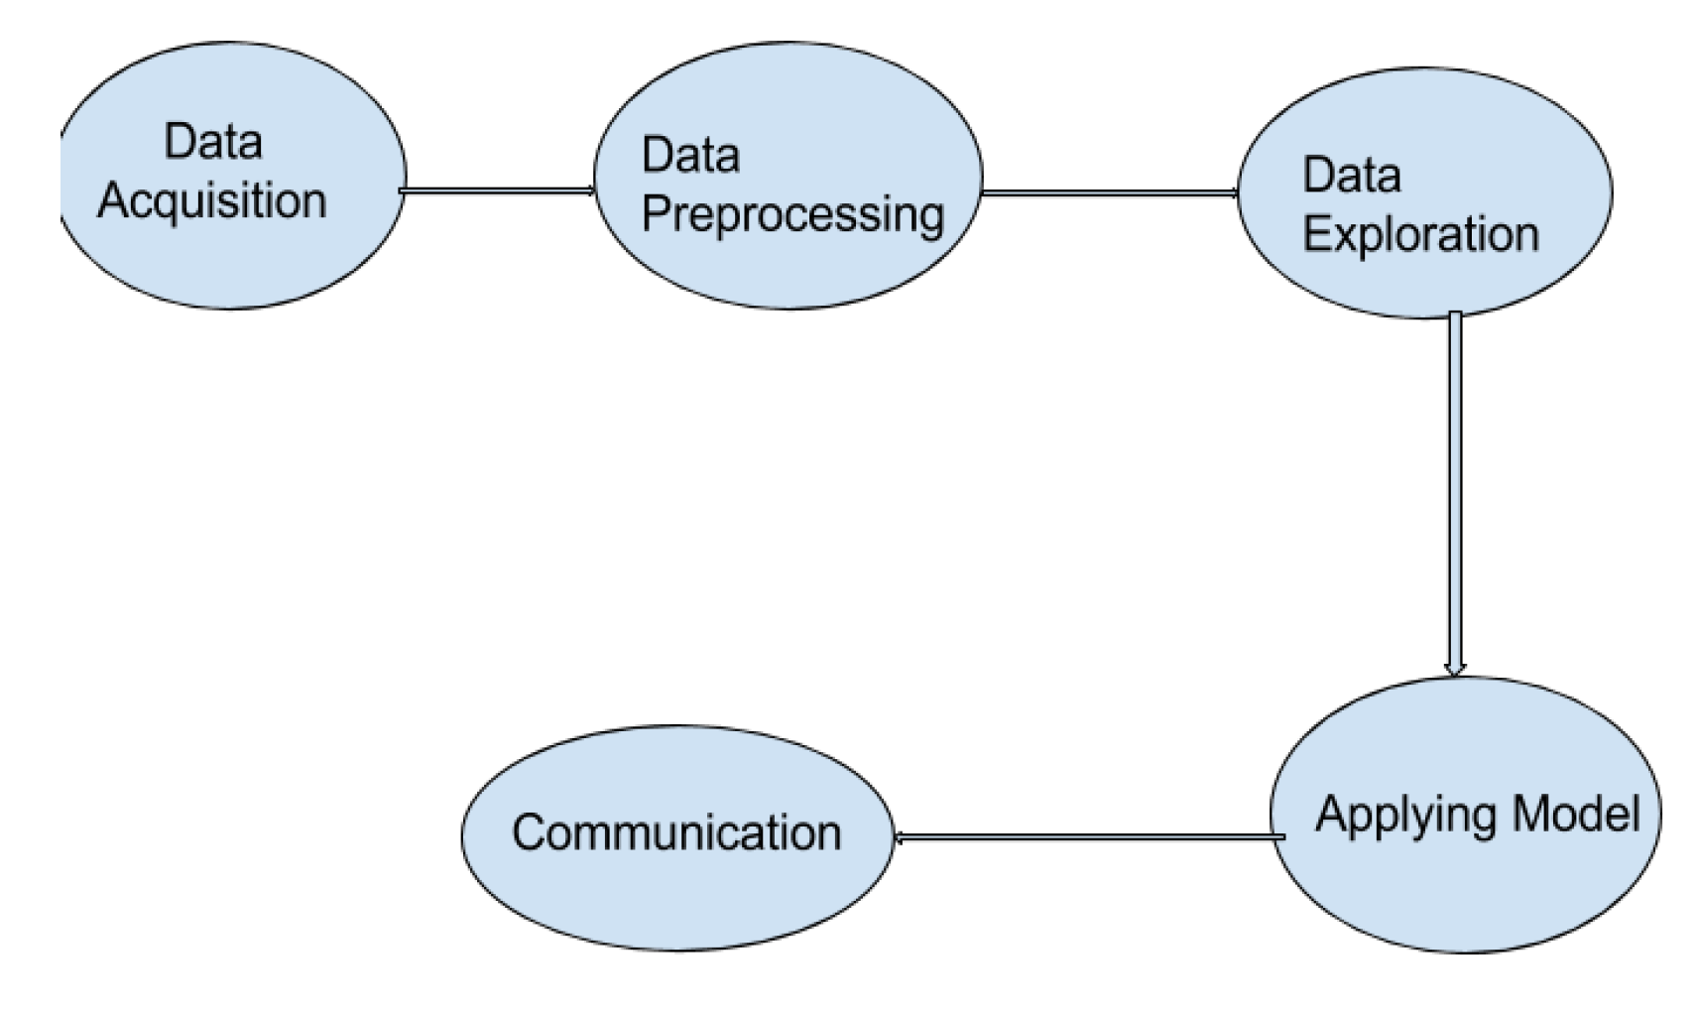

**Working Flowchart of project**

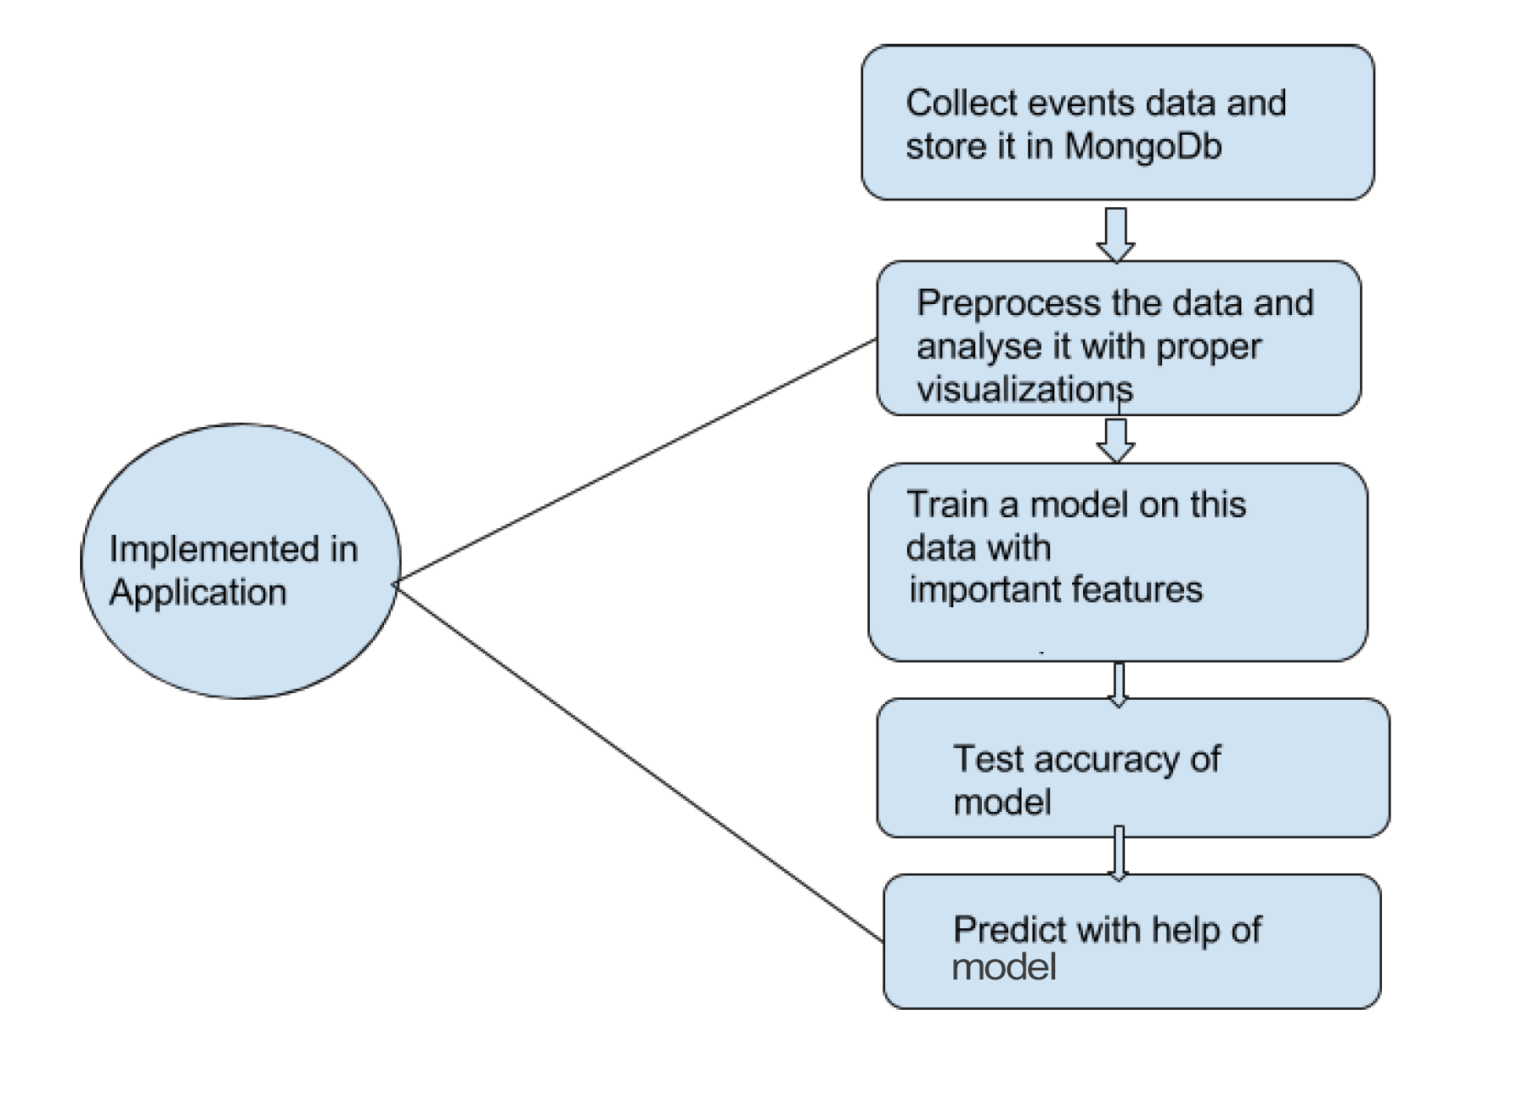

**References**

1.https://www.stat.berkeley.edu/~breiman/randomforest2001.pdf

2. https://github.com/d3/d3/wiki/Tutorials

3. A Survey of Prediction Using Social Media, Sheng Yu and Subhash Kak.

4. http://facebook-sdk.readthedocs.io/en/latest/api.html

5. https://developers.facebook.com/docs/graph-api/reference/event/

6. https://docs.mongodb.com/

7. Qualitative Data Analysis, Elizabeth H.Bradley, Leslie A.Curry, Kelly, J.Devers.

8. Using Neural Network Analysis to Evaluate Buyer-Seller Relationships, Barry Wray, Adrian Palmer, David Bejou.

9. https://rpubs.com/

10. https://www.rdocumentation.org/

11. https://devcenter.heroku.com/categories/reference

12.Improved marketing decision making in a customer churn prediction context using generalized additive models. KristofCoussement, Dries F.Benoit, DirkVan den Poe.