PROJECT REPORT
Insurance Project

Name: SARTHAK SINGH
Roll Number: 2306219
Batch/Programme: 2023-2027 | B.Tech - Information Technology
College : Kalinga Institute of Industrial Technology, Bhubaneswar ( KIIT-DU )
Tool Used: Microsoft Power BI
Topic: Insurance Data Analysis Dashboard
Purpose: Identify high-risk policyholders, track claims trends, and analyze policy adjustments.
1. Problem Statement
Large amounts of consumer and claim data are produced by insurance firms. Extracting insights becomes challenging in the absence of appropriate visualisation. The goal of this project is to create an interactive Power BI dashboard for the analysis of consumer behaviour, insurance performance, and claim patterns.

2. Solution & Features
The project includes an interactive dashboard with multiple pages:
- Overview: Key KPIs like Total Premium, Total Claims, Claim Ratio
- Customer Analysis: Age, gender, and regional distribution
- Claims Analysis: Claim amount, status, and policy-wise breakdown
- Risk Analysis: Identification of high-risk customers and policies
3. Dataset Description
Customer demographics, policy details, premium amounts, and claim information are among the insurance-related data included in the dataset. For analytical purposes, it is a synthetic dataset.

4. Technology Stack
- Power BI Desktop
- Power Query
- DAX (Data Analysis Expressions)
- CSV Dataset
- Key Measures (DAX)
- Total Claims (SUM(Claims_Frequency))
- Average Claims per Policyholder (AVERAGE(Claims_Frequency))
- Claim Severity Distribution (Low/Medium/High)
- Claims Adjustment Impact (SUM(Claims_Adjustment))
- Claim Ratio = Total Claims / Total Premium

Average Claim Amount = DIVIDE(SUM(‘synthetic_insurance_data'[Claims_Adjustment]), SUM(‘synthetic_insurance_data'[Claims_Frequency]), 0)
- Scatter Plot: Premium Amount vs. Claims Frequency

6. Key Insights
Some areas make more money from premiums than others. Higher claim ratios are found in some policy types.
Demographics of customers affect how they make claims.
Risk locations are indicated by a high claim ratio.

Visuals:
- Bar Chart: Claims Frequency by Age Group or Region
- Heatmap: Claim Severity by Region
- KPI Cards: Total Claims, Average Claim Amount

RESULTS :

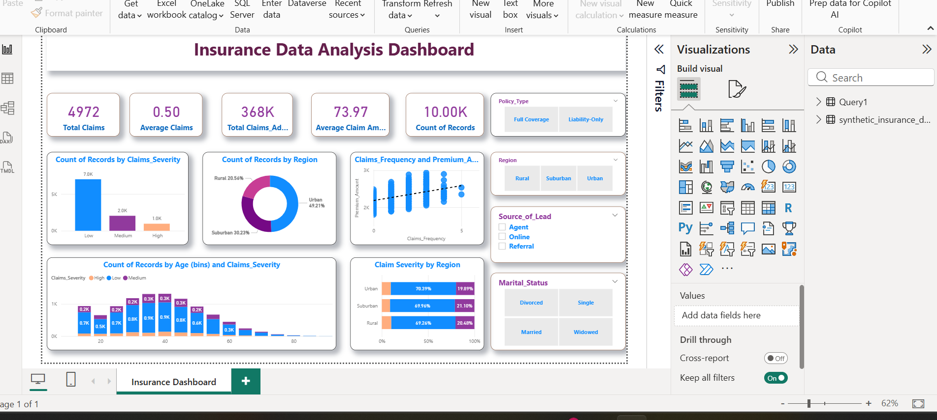

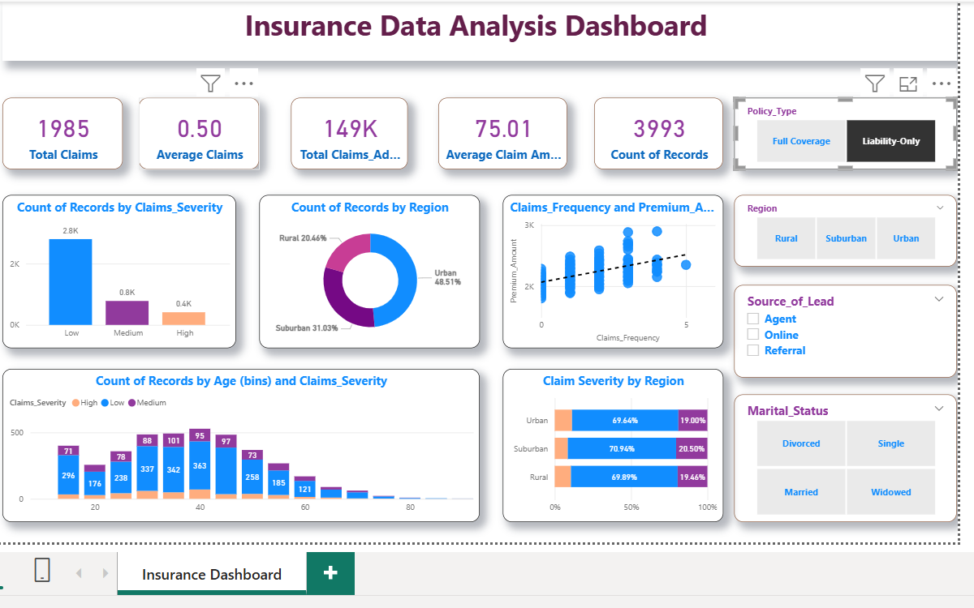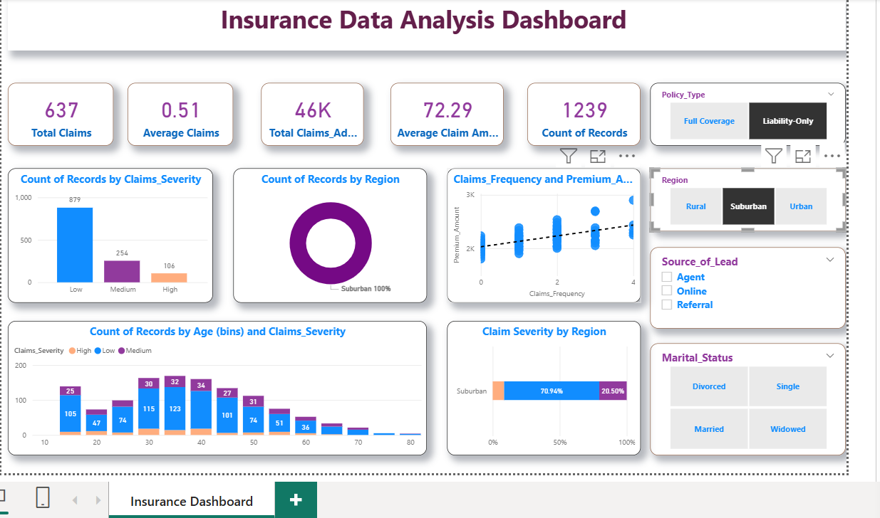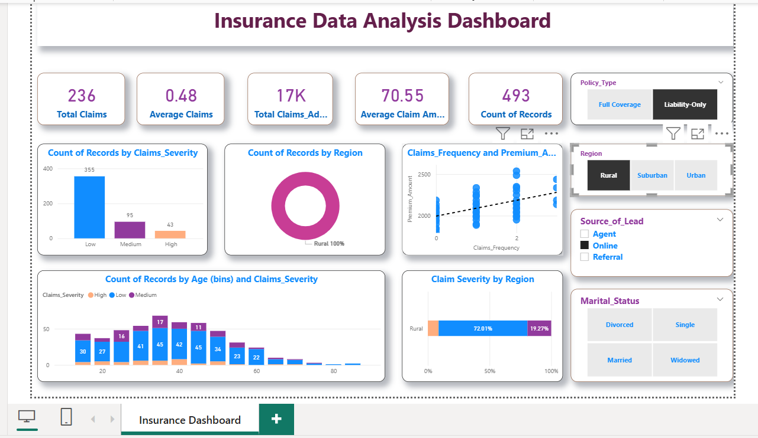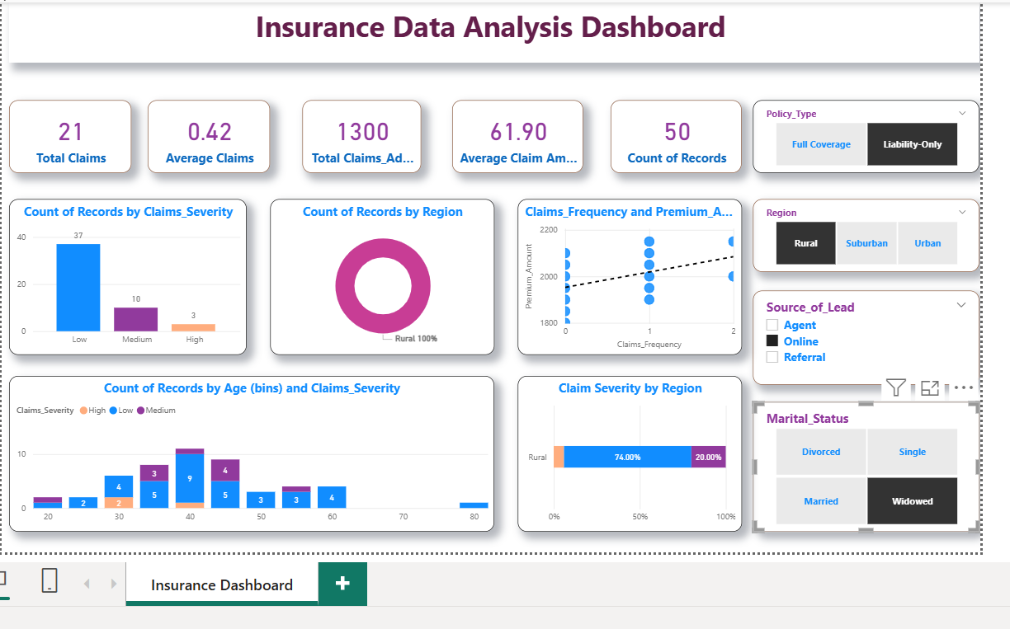

7. Unique Points
- Interactive dashboard with filters
- Multi-page analysis
- Business-focused insights
- Clean and simple design
8. Future Improvements
- Add predictive analytics
- Use real-time data
- Integrate machine learning models
9. Conclusion
This project serves as an example of how Power BI can turn unprocessed insurance data into insightful knowledge. It facilitates improved performance, risk analysis, and decision-making.

BY:
Name : Sarthak Singh
Roll No.: 2306219
Session : 2023-2027
Branch : B.Tech I.T. 3rd year
College : Kalinga Institute Of Industrial Technology, Bhubaneswar (KIIT-DU)

