LOGISTICS DATA PREPROCESSING AND DATA QUALITY ANALYSIS
Week 2 Internship Assignment

Objective:
To perform a data preprocessing pipeline for a logistics dataset, including data collection simulation, data cleaning, missing-value analysis, duplicate checking, outlier detection, normalization, validation, and documentation of the methodology using Python.
Technology Used:
- Python 3.13.9
- Pandas
- Matplotlib
- Visual Studio Code
Dataset:
Delivery Logistics Dataset
Prepared By:
Sarthak Manwatkar

1. Introduction
Data preprocessing is an important step before performing any data analysis. In a logistics environment, the quality of data can directly affect the accuracy of analysis and the decisions made from it. For example, incorrect delivery times, duplicate records, missing values, or unusual observations can lead to misleading conclusions.
For this week's task, I worked with a logistics delivery dataset and performed a basic data preprocessing pipeline using Python. I first explored the dataset to understand its structure and identify possible data-quality issues. I then checked for missing values and duplicate records, investigated the format of the delivery-time fields, detected statistical outliers, and applied Min-Max normalization to the selected numerical variables.
During the process, I did not remove unusual records automatically. Instead, I inspected the results and considered whether the observations could represent genuine logistics situations. This helped me understand that an unusual value is not necessarily an incorrect value.
The main purpose of this exercise was not only to clean the dataset, but also to understand how and why different preprocessing techniques are used in a real data-analysis workflow.

2. Dataset and Data Collection Simulation
For this task, I used the Delivery Logistics dataset provided for the preprocessing exercise. The dataset contains information about deliveries, delivery partners, vehicles, weather conditions, delivery time, distance, package weight, ratings, and delivery cost.
Before starting the cleaning process, I loaded the dataset into Python using the Pandas library. I then checked the number of records, column names, data types, and the overall structure of the dataset. This initial inspection helped me understand what type of information was available and where preprocessing might be required.
The dataset contains 25,000 records and 15 variables.
The main variables include:
- Delivery ID
- Delivery Partner
- Package Type
- Vehicle Type
- Delivery Mode
- Region
- Weather Condition
- Distance
- Package Weight
- Delivery Time
- Expected Time
- Delay Status
- Delivery Status
- Delivery Rating
- Delivery Cost
I treated this stage as a data collection simulation, where the dataset represents information that could be collected from a logistics delivery system. In a real logistics environment, similar information could come from delivery records, vehicle tracking systems, order management systems, and customer feedback.
Initial Dataset Characteristics
Characteristic | Result
Number of records | 25,000
Number of variables | 15
Complete duplicate rows | 0
Missing values | 0

3. Initial Data Quality Assessment
After loading the dataset, I performed an initial quality check before making any changes to the data. My main purpose at this stage was to understand whether the dataset contained missing values, duplicate records, or data types that could cause problems during analysis.
I used Pandas to check the structure of the dataset, its data types, and the number of missing values in each column.
The initial check gave the following results:
- Total records: 25,000
- Total variables: 15
- Missing values: 0
- Complete duplicate rows: 0
Although the dataset did not contain missing values or completely duplicated rows, the data-type check showed that delivery_time_hours and expected_time_hours were stored as object values instead of numerical values. This needed further investigation because these columns represent delivery times and should be usable for numerical calculations.
I also noticed that the delivery_id field contained repeated IDs. Therefore, I did not immediately delete these records. Instead, I treated this as a data-quality issue that needed to be investigated separately.

4. Missing Value Analysis
Missing values can create problems during data analysis because calculations may become incomplete or biased if important information is unavailable. Therefore, checking for missing values was one of the first cleaning steps I performed.
I used the Pandas isnull() function to check every column in the dataset.
The result showed that there were no missing values in any of the 15 columns. Therefore, I did not use techniques such as mean, median, or mode imputation.
Result
Check | Result
Total records checked | 25,000
Columns checked | 15
Total missing values | 0
Imputation required | No
Decision
Since no missing values were present, I decided not to modify or artificially fill any values. This helped preserve the original information in the dataset.
What I learned
This step showed me that data preprocessing does not always mean changing the data. Sometimes the correct decision is to check for a particular problem, confirm that it does not exist, and leave the data unchanged.

5. Duplicate Records and Delivery ID Investigation
After checking missing values, I checked the dataset for duplicate records. I performed two separate checks because a completely duplicated row and a repeated delivery ID are not necessarily the same problem.
First, I checked for completely duplicated rows using Pandas. The result was 0 complete duplicate rows.
I then checked the delivery_id column separately. This showed 498 duplicate delivery IDs, while the dataset contained 24,502 unique delivery IDs.
Results
Check | Result
Total records | 25,000
Complete duplicate rows | 0
Duplicate delivery IDs | 498
Unique delivery IDs | 24,502
How I handled the issue
I did not delete the 498 records automatically. A repeated ID does not necessarily mean that the entire delivery record is duplicated. Removing these records without investigation could result in loss of useful information.
For this preprocessing exercise, I treated delivery_id mainly as an identifier, rather than a variable used for numerical analysis. I documented the repeated IDs as a data-quality issue that should be investigated further if this were a real production logistics database.
What I learned
This check helped me understand that duplicate detection needs to be done carefully. A dataset can have no completely duplicated rows while still having repeated identifiers. Therefore, simply using a duplicate-row check is not always enough to determine whether records should be removed.

6. Data Type and Format Cleaning
During the initial inspection, I noticed that the delivery_time_hours and expected_time_hours columns were stored as object data types instead of numerical values.
When I inspected the values, they appeared in a timestamp-like format such as:
1970-01-01 00:00:00.000000008
This format was not suitable for directly performing numerical calculations such as averages, comparisons, and outlier detection.
I investigated the values and found that the final numerical component represented the hour value. I therefore converted these columns into numerical hour values using Pandas.
For example:
Before Cleaning | After Cleaning
1970-01-01 00:00:00.000000008 | 8
1970-01-01 00:00:00.000000003 | 3
1970-01-01 00:00:00.000000016 | 16
1970-01-01 00:00:00.000000002 | 2
After conversion, both columns became integer data types and could be used for numerical analysis.
Why I performed this cleaning
If I had left these values in their original format, calculations involving delivery time could produce incorrect or unusable results. Converting them into numerical hours made the data more consistent and suitable for the next preprocessing steps

7. Outlier Detection and Handling
After correcting the data types, I checked the numerical columns for unusual observations. Outliers are values that are considerably different from the majority of the observations. In logistics data, an unusual value does not automatically mean that the data is wrong. For example, a delivery taking longer than usual could be caused by a long-distance route, traffic, or other operational conditions.
For this analysis, I used the Interquartile Range (IQR) method to identify potential outliers.
The IQR is calculated as:
IQR = Q3 − Q1
An observation was considered a potential outlier if it was below:
Q1 − 1.5 × IQR
or above:
Q3 + 1.5 × IQR
Outlier Detection Results
Numerical Variable | Number of Potential Outliers
Distance (km) | 0
Package Weight (kg) | 0
Delivery Time (hours) | 203
Delivery Cost | 0
The IQR method identified 203 potential outliers in delivery time. I then inspected sample records from these observations instead of immediately deleting them.
The unusual delivery times were generally associated with relatively long-distance deliveries and, in many cases, delayed deliveries. Some records were also marked as delivered without delay. Based on this inspection, I could not conclude that these values were data-entry errors.
Decision
I decided to retain the 203 observations rather than remove them automatically.
My reason was that statistical outliers are not necessarily incorrect data. Removing them could hide genuine cases of longer delivery times and could affect future logistics analysis.
What I learned
This step taught me that outlier detection should be followed by investigation and a reasoned decision. A preprocessing process should not simply remove every value that falls outside a statistical limit.

8. Data Normalization
After cleaning and checking the numerical data, I applied Min-Max normalization to the selected numerical variables.
The main reason for using normalization was that the numerical columns had very different ranges. For example, delivery cost was measured in hundreds or thousands, while delivery rating was between 1 and 5. Using these variables together in some future analytical or machine-learning techniques could cause variables with larger numerical ranges to have more influence.
I used the Min-Max normalization technique, which converts values to a range between 0 and 1.
The formula used was:
Normalized Value = (Value − Minimum Value) / (Maximum Value − Minimum Value)
I applied this technique to:
- distance_km
- package_weight_kg
- delivery_time_hours
- expected_time_hours
- delivery_rating
- delivery_cost
I kept the original dataset unchanged and created a separate normalized copy called normalized_data. This allowed me to compare the original and transformed values.
Example of the Result
Original Delivery Cost | Normalized Delivery Cost
1632.7206 | 1.000000
640.1700 | 0.354251
1448.1700 | 0.879932
1486.5700 | 0.904915
1394.5600 | 0.845054
391.4500 | 0.192435
The normalized numerical variables were successfully converted to a range from 0 to 1.
Before and After Visualization
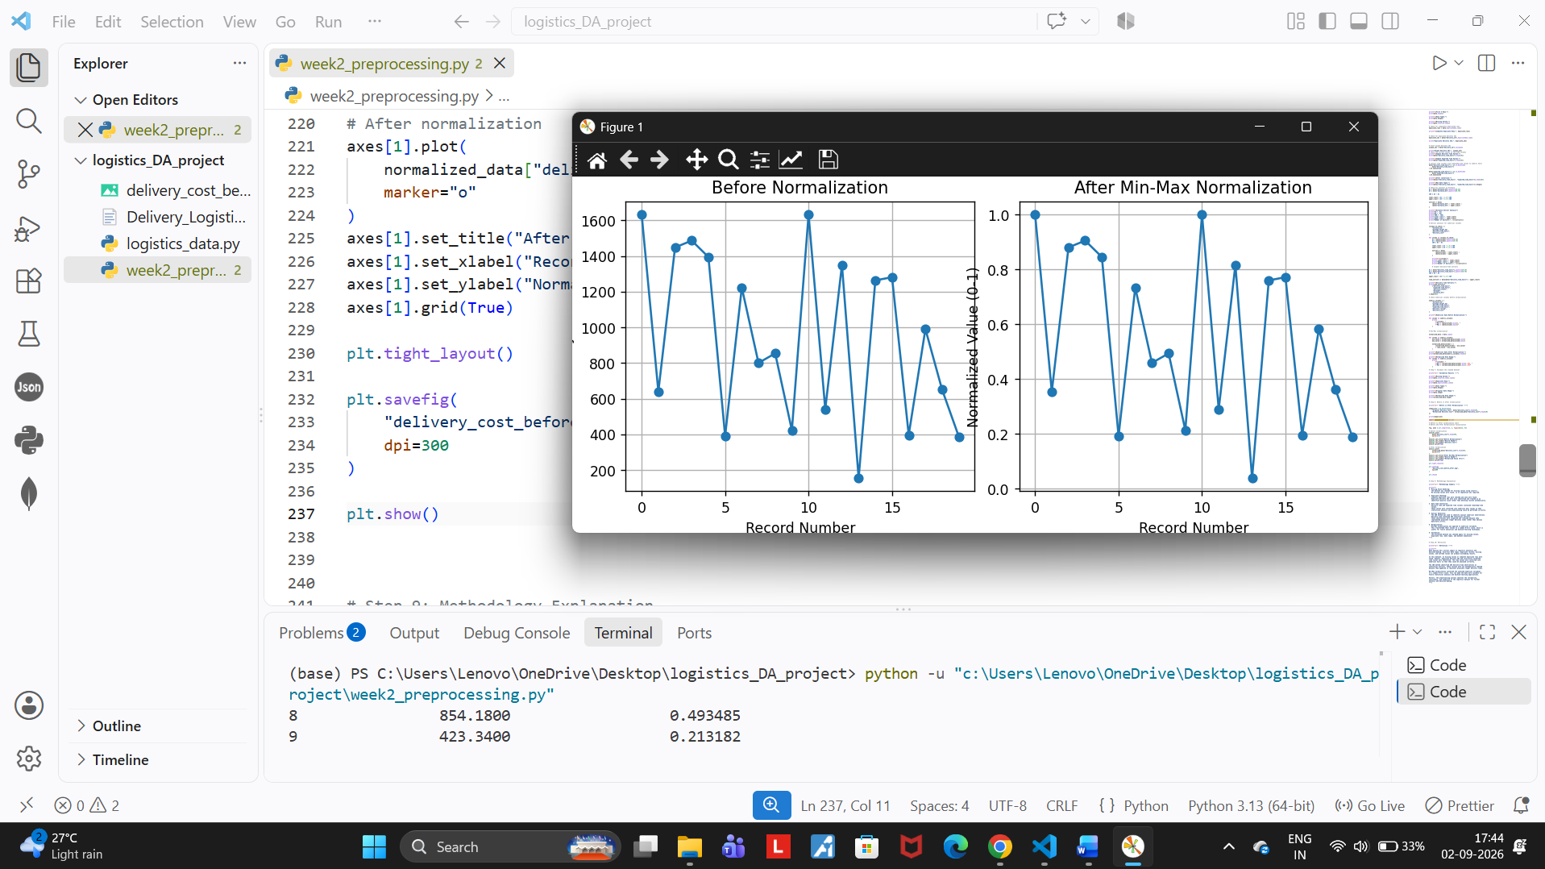

9. Validation of the Preprocessed Dataset
After completing the cleaning, data-type conversion, outlier investigation, and normalization steps, I performed a final validation check. The purpose of this step was to make sure that the preprocessing process had not accidentally changed the structure of the dataset or introduced new problems.
The validation produced the following results:
Validation Check | Result
Original dataset size | 25,000 × 15
Normalized dataset size | 25,000 × 15
Missing values | 0
Complete duplicate rows | 0
delivery_time_hours data type | int32
expected_time_hours data type | int32
The dataset retained all 25,000 records and 15 variables after preprocessing. No missing values or complete duplicate rows were introduced during the process.
I also confirmed that the two delivery-time columns were successfully converted from object values into integer values, making them suitable for numerical analysis.
Validation of Normalization
The normalized numerical variables were checked to confirm that their minimum and maximum values were within the expected 0–1 range.
The results showed:
- Distance: 0–1
- Package Weight: 0–1
- Delivery Time: 0–1
- Expected Time: 0–1
- Delivery Rating: 0–1
- Delivery Cost: 0–1
This confirmed that the Min-Max normalization was applied successfully.
What I learned
The validation step gave me confidence that the preprocessing pipeline worked as intended. It also showed me why validation is important: cleaning the data is not enough; the final dataset should always be checked after processing.
10. Methodology Summary
During this preprocessing exercise, I followed a step-by-step approach rather than making changes to the dataset without checking the data first. Each technique was selected according to the type of issue identified during the initial inspection.
Data Quality Issue / Task | Technique Used | Why I Used It | Result / Decision
Missing values | isnull() check | To identify incomplete records | 0 missing values found
Complete duplicates | duplicated() | To identify repeated records | 0 complete duplicate rows
Repeated delivery IDs | Duplicate ID check | To identify identifier-related issues | 498 repeated IDs identified and documented
Incorrect time format | Pandas datetime conversion | To make delivery times usable for numerical analysis | Converted to numerical hours
Unusual numerical values | IQR method | To identify statistical outliers | 203 delivery-time outliers identified
Outlier handling | Record inspection | To avoid deleting potentially valid observations | Outliers retained
Different numerical scales | Min-Max normalization | To bring selected variables to a common scale | Values converted to 0–1
Final quality check | Validation | To confirm preprocessing did not introduce problems | Dataset remained 25,000 × 15
Overall Methodology
The overall process followed this sequence:
Dataset → Initial Inspection → Missing Value Check → Duplicate Check → Data-Type Cleaning → Outlier Detection → Outlier Investigation → Normalization → Validation
I found this step-by-step approach useful because each stage was based on the results of the previous stage. For example, I did not perform missing-value imputation because the dataset contained no missing values, and I did not remove the delivery-time outliers because they could represent valid logistics situations.
What I learned
The main lesson from this process was that data preprocessing requires judgement as well as technical methods. Python can identify potential problems, but the analyst still needs to understand the data and decide what should actually be changed.

11. Reflection and Learning
This preprocessing task helped me understand that data analysis does not start directly with making graphs or calculating results. Before analyzing the data, it is important to understand whether the data is reliable and suitable for the intended purpose.
While working on this dataset, I found that there were no missing values and no completely duplicated rows. However, I found repeated delivery IDs and unusual formatting in the delivery-time columns. This showed me that a dataset can look complete at first but still contain issues that need further investigation.
The outlier analysis was also an important learning experience. The IQR method identified 203 delivery-time observations as potential outliers. Instead of deleting them immediately, I inspected the observations and considered whether they could represent genuine longer deliveries. I decided to retain them because there was not enough evidence to classify them as errors.
I also learned how Min-Max normalization can bring numerical variables with very different ranges to a common 0–1 scale. This makes the data more suitable for certain future analytical and machine-learning techniques.
Overall, this exercise improved my understanding of the complete preprocessing process. I learned that good data preparation is not only about using Python functions; it also requires understanding the data, checking the results, and making logical decisions based on those results.

12. Python Code Documentation
Python was used throughout the preprocessing process because it provides useful libraries for working with structured datasets. I mainly used Pandas for data loading, cleaning, transformation, and validation, and Matplotlib for creating the before-and-after normalization visualization.
12.1 Loading and Inspecting the Dataset
import pandas as pd

data = pd.read_csv("Delivery_Logistics.csv")

print("Dataset Shape:", data.shape)
print(data.columns.tolist())
print(data.dtypes)
print(data.isnull().sum())
This code was used to load the dataset and perform the initial inspection. It helped me understand the size, structure, data types, and missing values before making any changes.
12.2 Checking Duplicate Records
duplicate_rows = data.duplicated().sum()
duplicate_ids = data["delivery_id"].duplicated().sum()

print("Complete Duplicate Rows:", duplicate_rows)
print("Duplicate Delivery IDs:", duplicate_ids)
I used two separate checks because a repeated delivery ID does not necessarily mean that the entire row is duplicated.
12.3 Converting Delivery-Time Values
data["delivery_time_hours"] = pd.to_datetime(
data["delivery_time_hours"]
).dt.nanosecond

data["expected_time_hours"] = pd.to_datetime(
data["expected_time_hours"]
).dt.nanosecond
This converted the timestamp-like values into numerical hour values so that the columns could be used for numerical analysis.
12.4 Detecting Outliers Using IQR
Q1 = data[column].quantile(0.25)
Q3 = data[column].quantile(0.75)

IQR = Q3 - Q1

lower_limit = Q1 - 1.5 * IQR
upper_limit = Q3 + 1.5 * IQR
I used the IQR method to identify observations that were statistically unusual. The identified observations were then inspected before deciding whether they should be removed or retained.
12.5 Min-Max Normalization
normalized_data[column] = (
(normalized_data[column] - min_value)
/ (max_value - min_value)
)
This transformed the selected numerical variables to a common 0–1 scale.
12.6 Validation
print(data.isnull().sum().sum())
print(data.duplicated().sum())
print(data.shape)
print(normalized_data.shape)
Finally, I used validation checks to make sure the preprocessing process did not introduce new missing values or duplicate rows and that the dataset dimensions remained unchanged.

13. Conclusion
This week's task gave me practical experience with the data preprocessing stage of a logistics analytics project. I started by examining the dataset and checking its structure and quality before making any changes.
During the process, I found that the dataset had no missing values and no completely duplicated rows. However, I identified repeated delivery IDs and timestamp-like values in the delivery-time columns. I converted the time values into numerical hours so they could be used correctly for further analysis.
I also used the IQR method to identify potential outliers. The method identified 203 unusual delivery-time observations. Instead of removing them automatically, I inspected the data and retained them because they could represent genuine longer delivery situations.
Finally, I applied Min-Max normalization to the selected numerical variables and validated the processed data. The normalized variables were successfully converted to a 0–1 range while the dataset retained its original 25,000 × 15 structure.
Overall, this task helped me understand that data preprocessing is not simply about removing unwanted data. It involves investigating the data, selecting appropriate techniques, understanding their effects, and making decisions based on the results. This experience will be useful for the analysis and machine-learning stages of the project.

14. References
- World Bank — Logistics Performance Indicators (LPI)
Used for understanding logistics performance and the importance of reliable logistics data.
- World Bank — LPI Methodology
Used for background understanding of logistics performance measurement.
- NIST — Big Data Interoperability Framework
Used for general background on data processing and data quality concepts.
- Scikit-learn Documentation — User Guide
Used as a reference for preprocessing and data transformation concepts.

