# Project : COVID-19 Vaccine Tracker

## Guided By:

## Dr. Nilamadhab Mishra

## Group Members (Group-8):

## Aftab Hussain (18BCE10330)

## Prajwal Sharma (18BCE10188)

## Sarthak Mishra (18BCE10241)

## Tushar Nachan (18BCE10282)

## Mritunjay Singh (18BCE10163)

# ABSTRACT

Predictive Model in R for tracking and predicting release of COVID-19 vaccine and using it with an R app built using shiny package.

In the current situation of pandemic due to COVID-19 our predictive model will let the users to track on all leading

pharmaceutical groups, organizations, medical research institutes, biotechnological companies like Novavax, Bharat Biotech, Moderna, Johnson and Johnson, CanSino Biologics,etc. on their progress on developing vaccine for SARS-CoV-2. Our predictive model will predict which organization will be able to produce vaccine sooner. Our model will produce outputs such as ranked list of the organizations, which will also mention vaccine name, mechanism used, sponsor of the vaccine, Trial Phase, Institution name, predicted release date, announced release date, side effects till now (if human trials have started), effectiveness of the vaccine, etc. Also our model will produce plots such as plot on progress versus time of different organizations, vaccine effectiveness versus organization names,etc.

Our model will serve as a relief to the people by giving them an option to use the model to track COVID-19 vaccine and predict its release date with high precision.

# Problem Statement

**Problem :**

In the current situation of COVID-19 pandemic, individuals do think every now and then that when this all will be over and everything gets back to normal with a launch and distribution of a COVID-19 vaccine.

**Why it is a problem?**

The above mentioned problem is a problem because every individual do want to know about the possible date of launch of COVID-19 vaccine but there does not exist a proper platform to access this particular prediction.

**How our project is going to be a solution?**

Our project is to design a predictive model in R which will produce outputs such as currents status of organizations on COVID-19 vaccine, predicted dates of the possible launch of the vaccines, histograms and other interactive plots based on our data set and we will display these outputs in R shiny app built using shiny package in R. These will serve as

Solution to the above mentioned problem.

# The Objective Of The Project

**General objective :-**

The app with the right data and technology to predict the accurate time of release of COVID -19 vaccine to vanish the spread of disease.

**Specific objectives :-**

* Providing a predictive model which can be deployed by developers or used by individuals to know the possible release time of the vaccine.
* Using shiny package in R to display the outputs from the model to user via an R web app.
* Comparing quality measures of different vaccines under development through plots like histograms.
* Providing data on the current status of vaccines under development.
* Comparing release time of different vaccines under development via plots like histogram.

# Approach/Methodology (Flow Chat)

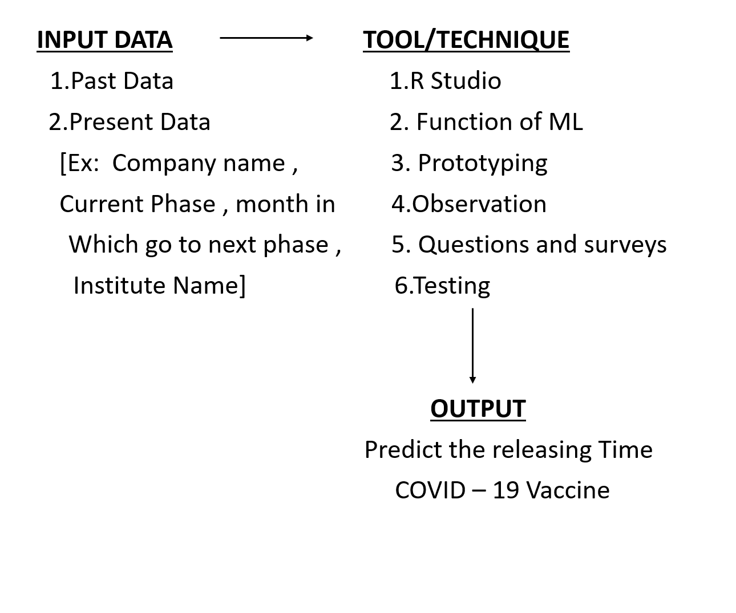

# Approach/Methodology:

**Procedure :-**

* Building our own data set for training and testing of the predictive model.
* Choosing the best machine learning algorithm on the basis of the analysis of the data set.
* Creating our own machine learning model.
* Training and testing of the machine learning model with the data set we built.
* Creating a web app in R using shiny package in R which will display the outputs of our predictive to the user.

**Tools used:-**

* Rstudio
* Packages like caTools, ggplot2, ElemStatLearn, class, e1701, rpart, randomForest, cluster and other required packages required according the ml algorithm to be chosen.
* Shiny package to create a web app in R.

# Literature Review/Related Works:

Many firms and professors of IIT’s are working on it and many got success

Some of the websites names are :

1. <https://github.com/sllloyd/vaccine_predictions>

**Vaccine Pipeline Modelling**

The model takes data on existing COVID-19 vaccines in various stages of clinical trials and expert opinions as to their likely success and predicts how many vaccines will get proper regulatory approval and on what timescales. The model uses Monte Carlo techniques to randomly decide an outcome given the input paramaters.

1. <https://www.nytimes.com/interactive/2020/science/coronavirus-vaccine-tracker.html>

**Coronavirus Vaccine Tracker**

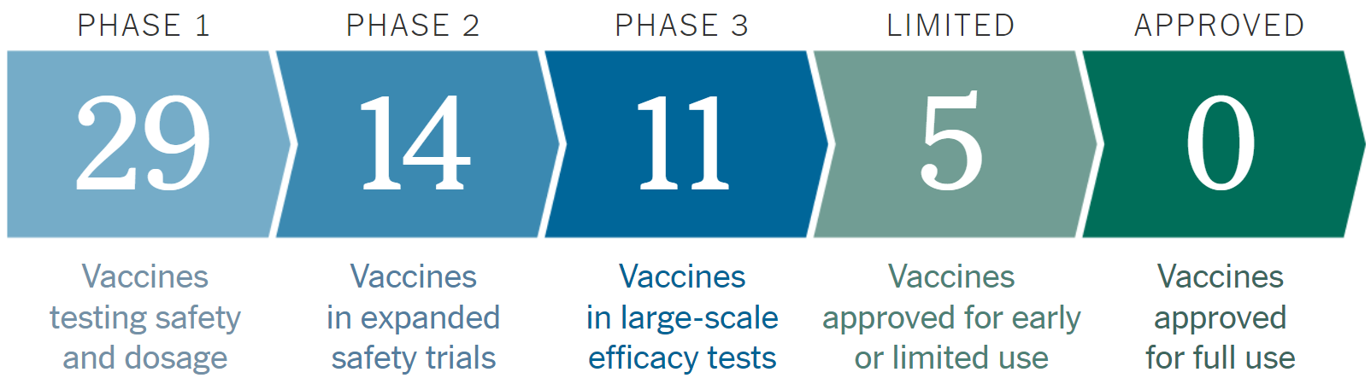

This Website gives us an statistical knowledge with details about Vaccines on Phase 1, Phase 2, Phase 3, Emergency Vaccine and approved one’s.

1. <https://www.raps.org/news-and-articles/news-articles/2020/3/covid-19-vaccine-tracker>

**COVID-19 vaccine tracker**

This website basically tells us about the Cadidate, Mechanism, Sponsor, TrialPhase and Institution. This website has almost every COVID-19 Vaccine with their details given in tabular form.

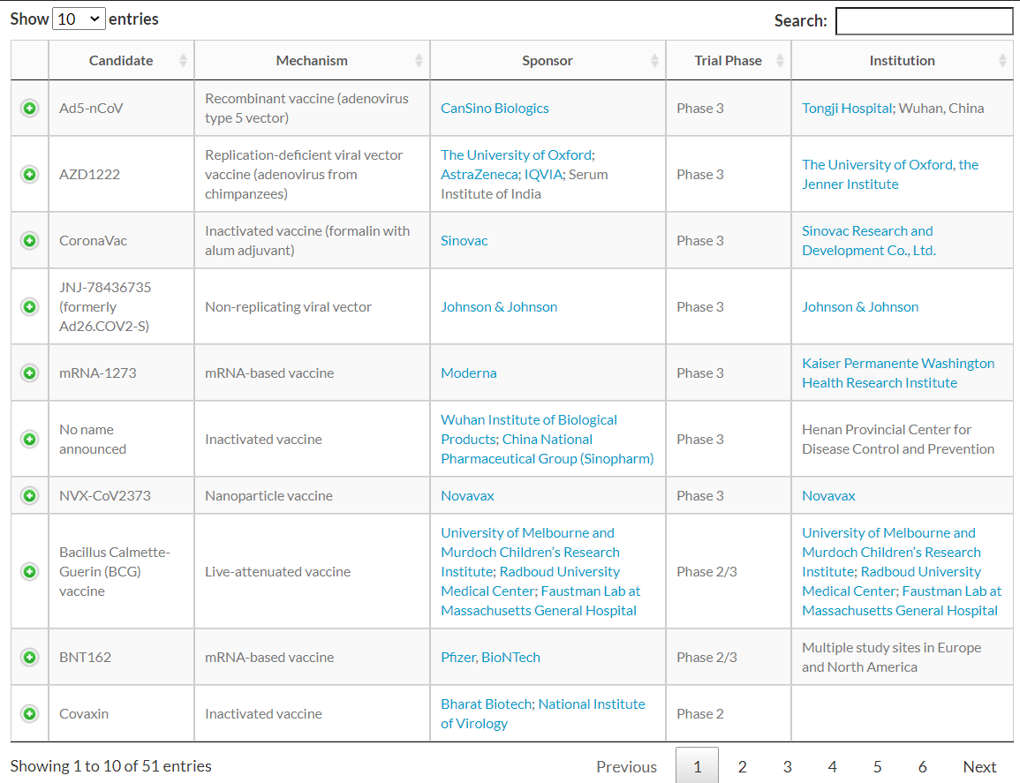

Now the question arises is how is our model different from the models already available on Internet ?

* Our predictive model will take all the past data about that vaccine and will predict the possibility of its approx. manufacturing date and will also predict its failure and delay rate
* There is no app facilitating interactive user interface.
* Our predictive model will let the users to track on all leading pharmaceutical groups, organizations on their progress on developing vaccine for SARS-CoV-2.

Our model will serve as a relief to the people by giving them an option to use the model to track COVID-19 vaccine and predict its release date with high precision.

# Scope and Limitations:

**Scope :-**

There are many approaches to scope a problem. Scoping process is fairly iterative and the scope gets refined both during the scoping process as well as during the project.

**Step 1:** Goals – Define the goal(s) of the project which is let the users to track on all leading pharmaceutical groups, organizations, medical research institutes, biotechnological companies like Novavax, Bharat Biotech, Moderna, Johnson and Johnson, CanSino Biologics,etc. on their progress on developing vaccine for SARS-CoV-2.

**Step 2**: Actions – Actions/interventions that this project will inform - Register name, company's name and various details of vaccine. Analyze the data of all trials and make a prediction for release date.

**Step 3:** Data and its Analysis – Our model will produce outputs such as ranked list of the organizations, which will also mention vaccine name, mechanism used, sponsor of the vaccine, Trial Phase, Institution name, predicted release date, announced release date, side effects till now (if human trials have started), effectiveness of the vaccine, etc. Also our model will produce plots such as plot on progress versus time of different organizations, vaccine effectiveness versus organization names,etc.

**Limitations :-**

* Our app is a predictive model and will consider the past outliers and fluctuation in pattern of progress of companies and accordingly will create future predicted possible delays corresponding to different companies. Thus, accuracy will might be compromised a bit due to possible less, none or more delay.

# Significance of project:

Our project is significant because in the current situation of COVID-19 pandemic, individuals do think every now and then that when this all will be over and everything gets back to normal with a launch and distribution of a COVID-19 vaccine, our project will serve as a solution which can be used by developers or groups like us designing an app in R using it.

There do not exist any such app out there which provides solution to the mentioned problem with enough precision and with a interactive user interface in R.

There do not exist any such project written in R.

# References:

* <https://github.com/sllloyd/vaccine_predictions>
* <https://www.nytimes.com/interactive/2020/science/coronavirus-vaccine-tracker.html>
* <https://www.raps.org/news-and-articles/news-articles/2020/3/covid-19-vaccine-tracker>
* <https://shiny.rstudio.com/tutorial/>
* <https://www.frontiersin.org/articles/10.3389/frai.2020.00065/full>
* <https://opentextbc.ca/projectmanagement/chapter/chapter-9-scope-planning-project-management/>
* https://brainly.in/question/8272055
* http://www.datasciencepublicpolicy.org/home/resources/data-science-project-scoping-guide/