Introduction Of Gstreamer :
GStreamer is a framework for creating streaming media applications.The GStreamer framework is designed to make it easy to write applications that handle audio or video or both.Gstreamer support a very wide variety of formats, including MP3, Ogg/Vorbis, MPEG-1/2, AVI.The framework is based on plugins that will provide the various functionality. The plugins can be linked and arranged in a pipeline. This pipeline defines the flow of the data.The Gstreamer core function is to provide a framework for plugins, data flow and media type handling/negotiation. It also provides an API to write applications using the various plugins.

Specifically, GStreamer provides :
• an API for multimedia applications
• a plugin architecture
• a pipeline architecture
• a mechanism for media type handling/negotiation
• over 150 plug-ins
• a set of tools

GStreamer plug-ins could be classified into
• sources: for audio and video (involves protocol plugins) (udpsrc,v4l2src,filesrc,etc.)
• formats: parsers, formaters, muxers, demuxers, metadata, subtitles (mux,oggdemux)
• codecs: coders and decoders (decodebin,mpg123audiodec,avdec_h264,etc.)
• filters: converters, mixers, effects, (agingtv,videobalance,videoflip,etc.)
• sinks: for audio and video (udpsink,autoaudiosink,ximagesink,autovideosink,alsasink)

GStreamer is packaged into
• gstreamer: the core package
filesrc,tee,queue

• gst-plugins-base: an essential exemplary set of elements
audiotestsrc,alsasink,audioconvert,videoconvert,audioresample,oggdemux,videoscale,glimagesink

• gst-plugins-good: a set of good-quality plug-ins under LGPL
v4l2src,mpegaudioparse,mpg123audiodec,udpsrc,updsink,videobalance,agingtv,videoflip,goom

• gst-plugins-ugly: a set of good-quality plug-ins that might pose distribution problems
x264enc

• gst-plugins-bad: a set of plug-ins that need more quality
wavescope,waylandsink,tsdemux,h264parse

• gst-python: the python bindings
• a few others packages

Design principles :
Clean and Powerfull - The programmer can use an extensive set of powerful tools to create media pipelines without writing a single line of code. Performing complex media manipulations becomes very easy.
Allow binary only plugins - Plugins are shared libraries that are loaded at runtime. Since all the properties of the plugin can be set using the GObject properties, there is no need (and in fact no way) to have any header files installed for the plugins.
High performance - extremely light-weight links between plugins. Data can travel the pipeline with minimal overhead. Data passing between plugins only involves a pointer dereference in a typical pipeline.providing a mechanism to directly work on the target memory. A plugin can for example directly write to the X server’s shared memory space. Buffers can also point to arbitrary memory, such as a sound card’s internal hardware buffer.dedicated streaming threads, with scheduling handled by the kernel.
Provide a framework for codec experimentation - GStreamer also wants to be an easy framework where codec developers can experiment with different algorithms, speeding up the development of open and free multimedia codecs like Theora(.ogg) and Vorbis.

Initializing Gstreamer :
When writing a GStreamer application, you can simply include gst/gst.h to get access to the library functions.
Before the GStreamer libraries can be used, gst_init() has to be called from the main application. This call will perform the necessary initialization of the library as well as parse the Gstreamer-specific command line options.It is also possible to call the gst_init function with two NULL arguments. Use gst_version() API or use the GST_VERSION_MAJOR, GST_VERSION_MINOR and GST_VERSION_MICRO macros to
get the GStreamer version you are building against.

Elements :
An element is the most important class of objects in GStreamer. You will usually create a chain of elements linked together and let data flow through this chain of elements.An element has one specific function, which can be the reading of data from a file, decoding of this data or outputting this data to your sound card (or anything else).Elements together forms a pipeline and it is made with help of gst_pipeline_new().
The most important object in GStreamer for the application programmer is the GstElement.Every decoder, encoder, demuxer, video or audio output is in fact a GstElement.
Following is a flow of pipleline/elements :

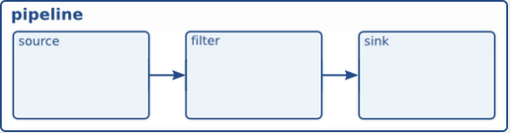

The simplest way to create an element is to use gst_element_factory_make(). Arg1(factory name),Arg2(Element Name).You can pass NULL as the name argument to get a
unique, default name.When you don’t need the element anymore, you need to unref it using gst_object_unref () .An element has a refcount of 1 when it gets created, after unref this count is decreased.
Gobject APIs widely used with Gstreamer for better performance he usual GObject
methods to query, set and get property values.Tools like gst-inspect-1.0 will provide some generic information about an element.
GStreamer knows four element states :
GST_STATE_NULL - This state will deallocate all resources held by the element.
GST_STATE_READY - This state will allocated all of its global resources (buffers).
GST_STATE_PAUSED - PAUSED is the same as PLAYING but without a running clock.
GST_STATE_PLAYING – In this state Element has opened the stream, but is not actively processing it. An element is allowed to modify a stream’s position, read and process data.
You can change the state of an element using the function gst_element_set_state ().
The problem here is our code will only runs once here and we want to run our code in loop so contineously stram our data, for that we are using g_main_loop there are some APIs which are used with respect to g_main loop ,like g_main_loop_new() to init mainloop After adding the initial event sources, g_main_loop_run() is called. This continuously checks for new events from each of the event sources and dispatches them .To stop this main loop use g_main_loop_quit(). We can also use gst_bus_timed_pop_filtered() which will wait until end of a stream or error.

Bins :
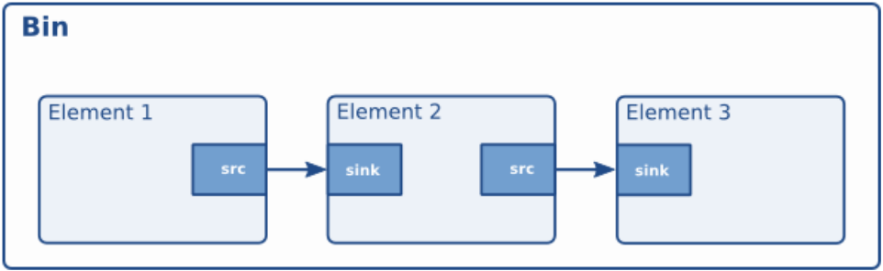

A bin is a container element. You can add elements to a bin. Since a bin is an element itself, a bin can be Fhandled in the same way as any other element.It is very powerful when you are going to construct complex pipelines since it allows you to break up the pipelinein smaller chunks.
Bins can forward bus messages from their contained children (such as error messages, tag messages or EOS messages).
you must add elements to a bin or pipeline before linking them, since adding an element to a bin will disconnect any already existing links. Also, you cannot directly link elements that are not in the same bin or pipeline
Bins are created in the same way that other elements are created, i.e. using an element factory. There are also convenience functions available like gst_bin_add_many(). Note that the bin that you add an element to will take ownership of that element. If you destroy the bin, the element will be dereferenced with it.If you want a list of all elements in a bin use gst_bin_get_list () API.

Pads :
Pads are element’s input and output, where you can connect other elements. They used to negotiate links and data flow between elements in GStreamer.Links are only allowed between two pads when the allowed data types of the two pads are compatible. Data types are negotiated between pads using a process called caps negotiation. Data types are described as a GstCaps .
GStreamer defines two pad directions source pads and sink pads.There are three types of pads 1.always pads always exist, sometimes pad exist only in certain cases (and can disappear randomly), and on-request pads appear only if explicitely requested by applications.
Dynamic pads are pad which form a pad for element at run time with respect to source.
We can connect 2 different pad by some APIs like g_signal_connect() with this command we can connected to the pad added signal in this call a callback and in callback with gst_element_get_static_pad() we can create pad for 2nd element and by gst_pad_link() we can link 2 pad with each other.
A ghost pad is a pad from some element in the bin that can be accessed directly from the bin as well. Using ghost pads on bins, the bin also has a pad and can transparently be used as an element in other parts of your code.Create a bin with gst_bin_new() add a element into bin with gst_bin_add() and A ghostpad is created using the function gst_ghost_pad_new ().

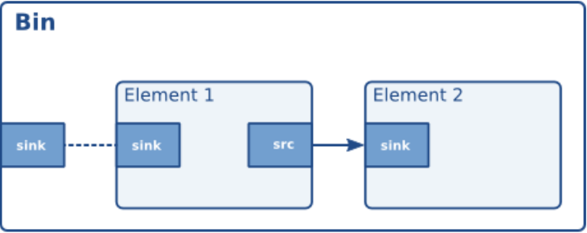

Capabilities of a pad :
Since the pads play a very important role in how the element is viewed by the outside world, a mechanism is implemented to describe the data that can flow or currently flows through the pad by using capabilities.

BUS :
A bus is a simple system that takes care of forwarding messages from the pipeline threads to an application.Every pipeline contains a bus by default, so applications do not need to create a bus or anything, The only thing applications should do is set a message handler on a bus, which is similar to a signal handler to an object.
When the mainloop is running, the bus will periodically be checked for new messages, and
the callback will be called when any message is available.
We can init our bus with gst_pipeline_get_bus() and with the help of gst_bus_add_watch () we can call callback function and then dont forgot to free memory with gst_object_unref(). In handler by using micros like GST_MESSAGE_TYPE_NAME () , GST_MESSAGE_TYPE() we can get the information about message like GST_MESSAGE_ERROR , GST_MESSAGE_EOS.
Messages : GStreamer has a few pre-defined message types that can be passed over the bus.All messages have a message source, type and timestamp. The message source can be used to see which
element emitted the message.
There are different types of messages like Error, warning and information notifications were error are fatal and may terminate program,warnings are not fatal bus cause some issue, information is no problem notification.All those messages contain a Gerror,debug string, we can extract them with gst_message_parse_error () , _parse_warning () and _parse_info () . Both error and debug string should be free’ed after use.
With the help of gst_message_parse_tag () we can get th metadata of stream like bitrate,samplerate,name of song etc. To free it use gst_tag_list_free (). gst_message_parse_state_changed () can be used to parse the old and new state of this transition.
When we are deailing on network we must use gst_message_get_structure () to get buffer percent.

Position tracking and seeking :
If we want to show a slider showing the progress in the song, and usually also a label
indicating stream length. Transcoding applications will want to show a progress bar on how much
percent of the task is done. GStreamer has built-in support for doing all this using a concept known as querying & Seeking is done using the concept of events which is similar like tracking.
Querying is defined as requesting a specific stream-property related to progress tracking. This includes getting the length of a stream (if available) or getting the current position. Those stream properties can be retrieved in various formats such as time, audio samples, video frames or bytes. The function most commonly used for this is gst_element_query () , although some convenience wrappers are provided as well (such as gst_element_query_position () and gst_element_query_duration () ). You can generally query the pipeline directly, and it’ll figure out the internal details for you, like which element to query.
Events work in a very similar way as queries. Dispatching, for example, works exactly the same for events (and also has the same limitations), and they can similarly be sent to the toplevel pipeline and it interact using events, This is done using the seek-event. A seek-event
contains a playback rate, a seek offset format (which is the unit of the offsets to follow, e.g. time, audio samples, video frames or bytes), optionally a set of seeking-related flags (e.g. whether internal buffers should be flushed), a seek method (which indicates relative to what the offset was given), and seek offsets. The first offset (cur) is the new position to seek to, while the second offset (stop) is optional and specifies a position where streaming is supposed to stop. Usually it is fine to just specify GST_SEEK_TYPE_NONE and -1 as end_method and end offset. The behaviour of a seek is also wrapped in the gst_element_seek () .

Buffer :
Buffers contain the data that will flow through the pipeline you have created. A source element will typically create a new buffer and pass it through a pad to the next element in the chain. When using the GStreamer infrastructure to create a media pipeline you will not have to deal with buffers yourself; the elements will do that for you. A buffer consists, amongst others, of:
• A pointer to a piece of memory.
• The size of the memory.
• A timestamp for the buffer.
• A refcount that indicates how many elements are using this buffer. This refcount will be used to
destroy the buffer when no element has a reference to it.
• Buffer flags.

Events :
Events are control particles that are sent both up- and downstream in a pipeline along with buffers. Downstream events notify fellow elements of stream states. Possible events include seeking, flushes, end-of-stream notifications and so on. Upstream events are used both in application-element interaction as well as element-element interaction to request changes in stream state, such as seeks. gst_element_send_event() is used for this purpose.

Metadata :
Metadata gives user idea about some properties of frames like weidth , height, framerate etc. Stream information can most easily be read by reading them from a GstPad also Tag reading is done through a bus in Gstreamer is way to access metadata.

Interfaces :

URI Interface : In order to get the source or sink element supporting a particular URI, use gst_element_make_from_uri () , with the URI type being either GST_URI_SRC for a source element, or GST_URI_SINK for a sink element.
Mixer Interface : The mixer interface provides a uniform way to control the volume on a hardware (or software) mixer.The interface is primarily intended to be implemented by elements for audio inputs and outputs that talk directly to the hardware (e.g. OSS or ALSA plugins e.g. osssrc, osssink, ossmixer , alsasrc, alsasink and alsamixer)
The Tunnner Interface : The tuner interface is a uniform way to control inputs and outputs on a multi-input selection device. This is primarily used for input selection on elements for TV- and capture-cards.This interface is currently only implemented by the Video4linux and Video4linux2 elements.
Color Balance Interface : The colorbalance interface is a way to control video-related properties on an element, such as brightness, contrast and so on.The colorbalance interface is implemented by several plugins, including xvimagesink and the Video4linux and Video4linux2 elements.
X Overlay Interface : The X Overlay interface was created to solve the problem of embedding video streams in an application window. The application provides an X-window to the element implementing this interface to draw on, and the element will then use this X-window to draw on rather than creating a new toplevel window. This is useful to embed video in video players. This interface is implemented by, amongst others, the Video4linux and Video4linux2 elements and by ximagesink, xvimagesink and sdlvideosink.

Clocks in Gstreamer :
To maintain sync in pipeline playback (which is the only case where this really matters), GStreamer uses clocks. Clocks are exposed by some elements, whereas other elements are merely clock slaves. The primary task of a clock is to represent the time progress according to the element exposing the clock, based on its own playback rate. If no clock provider is available in a pipeline, the system clock is used instead.
Some part of the pipeline requires to know the current clock time, it will be requested from the clock through gst_clock_get_time () . The clock-time does not need to start at 0. The pipeline, which contains the global clock that all elements in the pipeline will use, in addition has a “base time”, which is the clock time at the the point where media time is starting from zero. This timestamp is subctracted from the clock time, and that value is returned by _get_time () .
Dynamic Controllable Parameters :
The controller subsystem offers a lightweight way to adjust gobject properties over stream-time. It works by using time-stamped value pairs that are queued for element-properties. At run-time the elements continously pull values changes for the current stream-time. This subsystem is contained within the gstcontroller library (gst/controller/gstcontroller.h) with gst_controller_init () we can initialize the controller.
The first step is to select the parameters that should be controlled. This returns a controller object that is needed to further adjust the behaviour. controller gst_object_control_properties() Next we can select an interpolation mode. This mode controls how inbetween values are determined. The controller subsystem can e.g. fill gaps by smoothing parameter changes. Each controllable Gobject property can be interpolated differently. gst_controller_set_interpolation_mode();
Finally one needs to set control points. These are time-stamped GValues. The values become active when the timestamp is reached. They still stay in the list. If e.g. the pipeline runs a loop (using a segmented seek), the control-curve gets repeated as well. gst_controller_set ().

Threads :
GStreamer is inherently multi-threaded, and is fully thread-safe. Most threading internals are hidden from the application, which should make application development easier. However, in some cases, applications may want to have influence on some parts of those. GStreamer allows applications to force the use of multiple threads over some parts of a pipeline.
In many situations threads are used like Data buffering, for example when dealing with network streams or when recording data from a live stream such as a video or audio card. Short hickups elsewhere in the pipeline will not cause data loss also threads used in Synchronizing output devices, e.g. when playing a stream containing both video and audio data. By using threads for both outputs, they will run independently and their synchronization will be better.
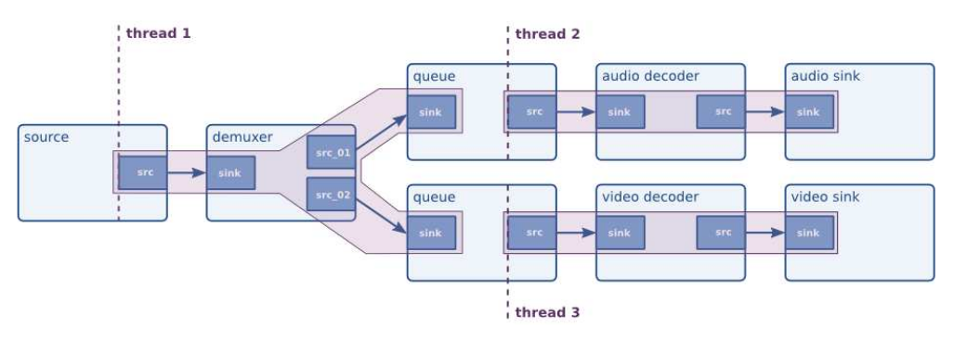

Autoplugging :
If you want to build an application that can automatically detect the media type of a stream and automatically generate the best possible pipeline by looking at all available elements in a system then you must use Autoplugging feature in gstreamer.
For this firstly we want to find a type of a input media Once the typefind element has found a type, the application can use this to plug together a pipeline to decode the media stream.Usually it is done by elements like playbin and decodebin.

