MQTT : (Message Queue Telementry Transport)
referance : https://mosquitto.org/ & https://mosquitto.org/api/files/mosquitto-h.html
Summary : The MQTT protocol provides a lightweight method of carrying out messaging using a publish/subscribe model. This makes it suitable for Internet of Things messaging such as with low power sensors or mobile devices such as phones, embedded computers or microcontrollers.

Components : Publisher(sender like senors) , Broker(Mediator) , Subscriber(reciver like data base).
Methods : Connect , Disconnect , Publis , Subscribe.
Topic : Topic is routing path (home/hall/temp)
Wildcard : Send all subscriber data have temp (home/+/temp) <- single level wildcard
Send all data respect to home to all subscriber (home/#) <- multi-level wildcard
Flow of execution :
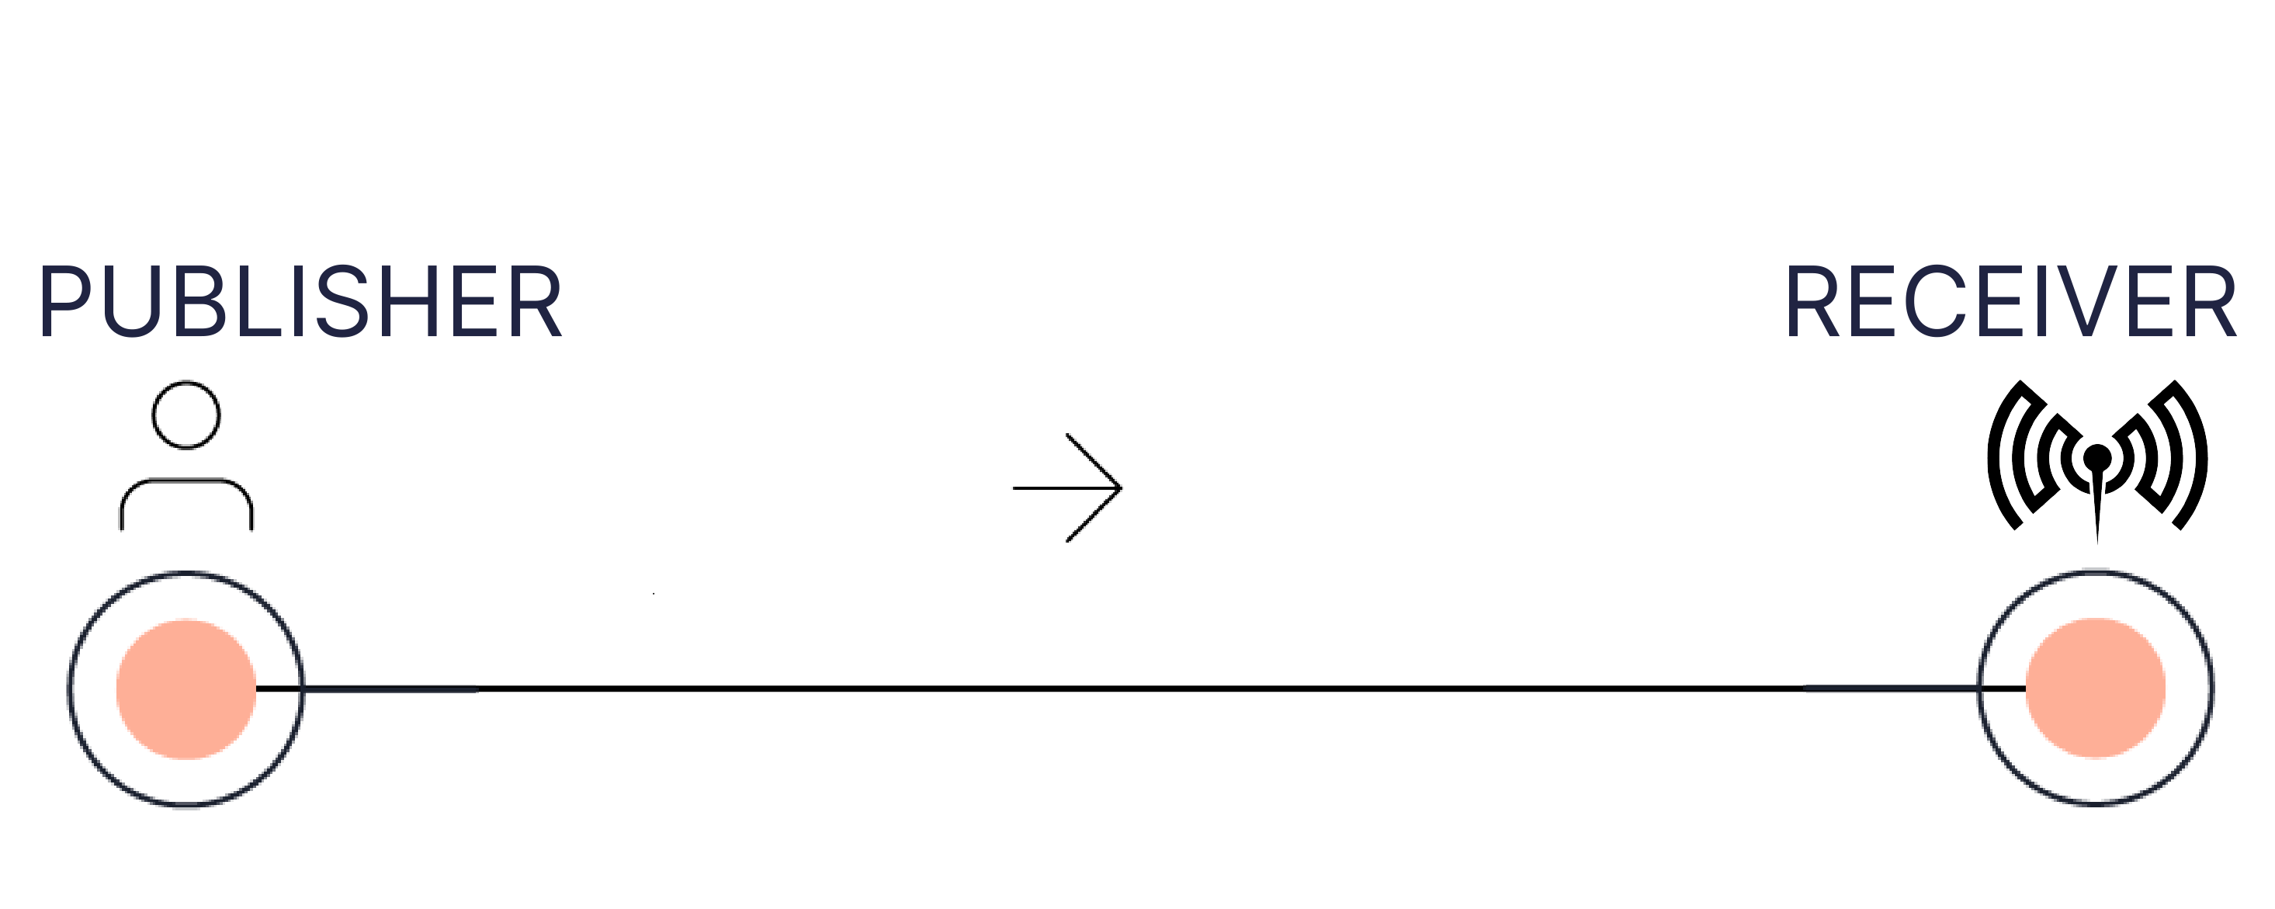
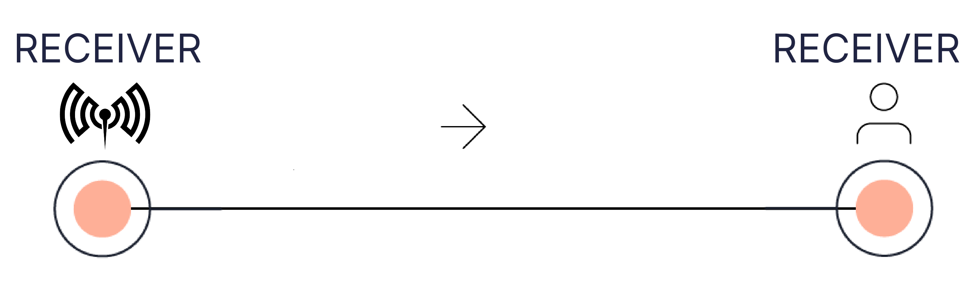

There is no alternative for clients (publishers and subscribers) to communicate via MQTT than to connect to a broker.
The broker is the central entity All packets go through the broker, get checked for specific properties, and are, then sent by the broker to the subscribers The broker covers most of the workload. Hence, the client device only has to do only minimal processing.
Overall it's possible to send up to 256MB in each Payload. Clients can subscribe to any topic they want when a broker is without enabled security.In some cases, no level of security might be without risk. But it's always the end user who has to decide what level of security has to be chosen and how to implement it.Usually, the broker supports common security measurements, e.g., TLS. Still, the end-user has to ensure that the chosen measurements fit the security environment the broker is part of, The default secured MQTT broker port is 8883. The standard unsecured port is 1883.
TCP embeds TLS (Transport Layer Security), the successor of SSL (Secure Sockets Layer), and allows MQTT packets to be transmitted via encrypted pipes.The broker can identify the client on three different pieces of information given. The clientId, a username, and password, or a client's certificate.

Pre-Installation : sudo apt-get install mosquitto
sudo apt-get install mosquitto-clients
sudo apt-get install libmosquitto-dev
Paho : https://www.eclipse.org/paho/index.php?page=downloads.php
Commands to execute :
mosquitto -v //Establish server
gcc mqtt_pub.c -o mqttpub -lmosquitto //compile a code
mosquitto_sub -t test/t1
sudo ufw allow 1883
mosquitto_pub -p 1883 -h 127.0.0.1 -t 'test/topic' -m 'helloWorld'
mosquitto_sub -p 1883 -h 127.0.0.1 -t 'test/topic'

