**A Project Report**

**On**

**ATM Management System**

Submitted in partial fulfilment of the requirements for the award of degree of

**Bachelor of Business Administration (Computer Application)**

**Submitted By:**

**B-72 Dhiraj Jadhav**

**&**

**B-65 Sarthak Pasalkar**

Academic Year: 2023– 2024

**Submitted to:**

**Savitribai Phule Pune University**



Shree Chanakya Education Society

**Indira College of Commerce and Science, Pune**

**Vice Principal & (H.O.D) Guided By**

**Prof. Shivendu Bhushan Prof. Shubhangi Chavan**

**Index**

|  |  |  |  |
| --- | --- | --- | --- |
| Sr. No |  | Particulars | Page No. |
| 1 |  | Abstract | 4 |
| 2 |  | Introduction | 5 |
|  | 2.1 | Motivation |  |
|  | 2.2 | Problem statement |  |
|  | 2.3 | Purpose/Objectives/goals |  |
|  | 2.4 | Literature survey |  |
|  | 2.5 | Project Scope and Limitations |  |
| 3 |  | System Analysis |  |
|  | 3.1 | Existing System |  |
|  | 3.2 | Scope and Limitation of existing system |  |
|  | 3.3 | Project perspective, features, stakeholders |  |
|  | 3.4 | Requirement Analysis |  |
|  | 3.4.1 | Functional Analysis |  |
|  | 3.4.2 | Performance Analysis |  |
|  | 3.4.3 | Security Analysis |  |
| 4 |  | System Design |  |
|  | 4.1 | Design constraints |  |
|  | 4.2 | System Model |  |
|  | 4.2.1 | Data Flow Diagram |  |
|  | 4.2.2 | Data Model |  |
|  | 4.3 | User Interface |  |
| 5 |  | Implementation Details |  |
|  | 5.1 | Software and hardware specifications |  |
| 6 |  | Output and Report Testing |  |
|  | 6.1 | Test Plan |  |
|  | 6.2 | Black Box Testing |  |
|  | 6.3 | White Box Testing |  |
| 7 |  | Conclusion and Recommendation |  |
| 8 |  | Future Scope |  |
| 9 |  | Bibliography and References |  |

**Acknowledgement**

We would like to express our sincere and heartfelt gratitude to our institution” Indira College of Commerce and Science” which provided us with excellent opportunity to achieve our most cherished goal in life to become Bachelor degree in BBA-CA.

We are extremely grateful to our respected Vice Principal and HOD Dr, Shivendu Bhushan for providing excellent academic environment which has made this endeavour possible.

We take this opportunity to express our deep sense of gratitude to our guide Shubhangi Chavan for their resplendent idea and constant encouragement in making this project unmitigated success. Their thoughtfulness and understanding were vast and thoroughly helpful in successful completion of project. Our sincere thanks to all our faculties and non-teaching staff for them at most co-operation.

Finally, we proudly thank our parents and friends for their constant support and priceless guidance in throughout this endeavour.

**1)Abstract**

The ATM Management System is an application for maintaining a person's account in a bank. In this project We tried to show the working of a banking account system and cover the basic functionality of an ATM Management System. To develop a project for solving financial applications of a customer in banking environment in order to nurture the needs of an end banking user by providing various ways to perform banking tasks. Also, to enable the user’s work space to have additional functionalities which are not provided under a conventional banking project.

The ATM Management System undertaken as a project is based on relevant technologies. The main aim of this project is to develop software for Bank Account Management System. This project has been developed to carry out the processes easily and quickly, which is not possible with the manuals systems, which are overcome by this software. This project is developed using Java language. Creating and managing requirements is a challenge of IT, systems and product development projects or indeed for any activity where you have to manage a contractual relationship. Organization needs to effectively define and manage requirements to ensure they are meeting needs of the customer, while proving compliance and staying on the schedule and within budget.

The impact of a poorly expressed requirement can bring a business out of compliance or even cause injury or death. Requirements definition and management is an activity that can deliver a high, fast return on investment. The project analyses the system requirements and then comes up with the requirements specifications. It studies other related systems and then come up with system specifications. The system is then designed in accordance with specifications to satisfy the requirements. The system design is then implemented with Java. The system is designed as an interactive and content management system. The content management system deals with data entry, validation confirm and updating whiles the interactive system deals with system interaction with the administration and users. Thus, above features of this project will save transaction time and therefore increase the efficiency of the system

**2) Introduction**

The “ATM Management System” project is a model Internet Banking Site. This site enables the customers to perform the basic banking transactions by sitting at their office or at homes through PC or laptop. The system provides the access to the customer to create an account, deposit/withdraw the cash from his account, also to view reports of all accounts present. The customers can access the banks website for viewing their Account details and perform the transactions on account as per their requirements. Thus, today's banking is no longer confined to branches. E-banking facilitates banking transactions by customers round the clock globally.

The primary aim of this “ATM Management System” is to provide an improved design methodology, which envisages the future expansion, and modification, which is necessary for a core sector like banking. This necessitates the design to be expandable and modifiable and so a modular approach is used in developing the application software.

Anybody who is an Account holder in this bank can become a member of ATM

Management System. He has to fill a form with his personal details and Account Number.

Bank is the place where customers feel the sense of safety for their property. In the bank, customers deposit and withdraw their money. Transaction of money also is a part where customer takes shelter of the bank. Now to keep the belief and trust of customers, there is the positive need for management of the bank, which can handle all this with comfort and ease.

Smooth and efficient management affects the satisfaction of the customers and staff members, indirectly. And of course, it encourages management committee in taking some needed decision for future enhancement of the bank.

Now a day’s, managing a bank is tedious job up to certain limit. So software that reduces the work is essential. Also, today’s world is a genuine computer world and is getting faster and faster day-by-day. Thus, considering above necessities, the software for bank management has become necessary which would be useful in managing the bank more efficiently. All transactions are carried out online by transferring from accounts in the same Bank . The software is meant to overcome the drawbacks of the manual system.

**Objective**

**1. Moto-** Our moto is to develop a software program for managing the entire bank process related to Administration accounts customer accounts and to keep every track about their property and their various transaction processes efficiently.

Hereby, our main objective is the customer’s satisfaction considering today’s faster in the world.

**2. Customer Satisfaction**: Client can do his operations comfortably without any risk or losing of his privacy. Our software will perform and fulfil all the tasks that any customer would desire.

**3. Saving Customer Time**: Client doesn't need to go to the bank to do small operation.

**4. Protecting the Customer:** It helps the customer to be satisfied and comfortable in his choices, this protection contains customer’s account, money and his privacy.

**5. Transferring Money:** Help client transferring money to/or another bank or country.

**3) System Analysis:**

**3.1) EXISTING SYSTEM**

In the manual system, firstly the bank manager and its staff have to manage

information regarding the accounts and transaction of all the customers manually

Doing this manual transaction was really tedious job. Secondly information

regarding accounts and transactions of customers were to be maintained. This

process is time consuming and it requires a great manual effort.

* **Disadvantages Of Existing System:**

1. More time is consumed.

2. More hard work to maintain all records.

3. Bulk of paper is to be searched for a single search.

**3.2) PROPOSED** **SYSTEM**

Many of us lead busy lives. Some of us are up before the crack of dawn, getting ourselves prepared so we can in turn get our families ready for the day. We rush to work, rush to get the kids to school, and at the end of the day we rush home only to brace ourselves for the next day. After a hectic day, the last thing you want to do is spend time waiting in line at the bank, or even the post office. That's where Online Banking comes in. Many of the benefits of doing our banking online are obvious:

* **Advantages of Proposed System:**

1.You don't have to wait in line.

2.You don't have to plan your day around the bank's hours.

3.You can look at your balance whenever you want, not just when you get a statement.

4.Quick, simple, authenticated access to accounts via the web application.

**Feasibility Study**

* Econmical Feasible:-

The cost of converting from manual system to new automatic computerized system is not probably more. For construction of the new system, the rooms and its facilities are available so it does not require any extra resource, only the software requirement is there.

* Technical Feasible:-

In our proposed system we use operating system as ‘Microsoft Windows’ that can be available all the time. In this system we used back end software as ‘Microsoft Acces’ which is available on microsoft windows. In proposed system we have hardwares like LCD monitor,normal keybord and compatible mouse which are available on every pc’s. To run our system we required Visual basic 6.0 as front-end software which is also easily available on internet.

* Operational Feasible:-

Operational feasibility deals with study prospectus of the system. This system operationally eliminates all the tensions of the tensions of the admin and effectively tracking the project process. This kind of automation will surely reduce time and energy, which previously consumed in manual work. Based on the study, the system is provided to be operationally feasible. Processed feasibility is beneficial only it meet the user requirement. This system will certainly be supported since it produces good results lots of work

**Function Specification: -**

Here, there are two types of modules. This module is the main module which performs all the main operations in the system. The major operations in the system are:

**Admin Module:**

Admin can access this project there is an authorization process. If you login as an Admin then you will be redirected to the Admin Home Page and if you are a simple user you will be redirected to your Account Home Page. This performs the following functions: Create

Individual Accounts, manage existing accounts, View all transactions, Balance enquiry,

Delete/close account etc.

1- Admin login

2- Add/delete/update account

3- Withdrawal/deposit/statements transaction

4- Account Information

5- User details list

6- Active/Inactive account

7- View transaction histories

**User Module:**

A simple user can access their account and can deposit/withdraw money from their account.

User can also transfer money from their account to any other bank account. User can see their transaction report and balance enquiry too.

1- User login, use PIN system

2- Creating/open new account registration

3- Funds transfer (local/international/domestic)

4- View statements transaction

5- User account details

6- Change Password and Pin

**4) System Design**

**4.1) Design constraints**

# 1.Bank

|  |  |  |  |  |
| --- | --- | --- | --- | --- |
| Sr. No | Field name | Datatype | Width | Constraint |
| 1 | Pin | varchar | 10 | Not null |
| 2 | Date | varchar | 50 | Not null |
| 3. | type | varchar | 20 | Not null |
| 4. | amount | varchar | 20 | Not null |

# 2.Login

|  |  |  |  |  |
| --- | --- | --- | --- | --- |
| Sr. No | Field name | Datatype | Width | Constraint |
| 1 | formno | Varchar | 20 | Not null |
| 2 | cardnumber | Varchar | 25 | Not null |
| 3 | pin | Varchar | 10 | Not null |

# 3.Signup

|  |  |  |  |  |
| --- | --- | --- | --- | --- |
| Sr. No | Field name | Datatype | Width | Constraint |
| 1 | formno | Varchar | 20 | Not null |
| 2 | name | Varchar | 20 | Not null |
| 3 | father_name | Varchar | 20 | Not null |
| 4 | dob | Varchar | 20 | Not null |
| 5 | gender | Varchar | 20 | Not null |
| 6 | email | Varchar | 30 | Not null |
| 7 | martial_status | Varchar | 20 | Not null |
| 8 | address | Varchar | 40 | Not null |
| 9 | city | Varchar | 25 | Not null |
| 10 | pincode | Varchar | 20 | Not null |
| 11 | state | Varchar | 25 | Not null |

4.Signuptwo

|  |  |  |  |  |
| --- | --- | --- | --- | --- |
| Sr. No | Field name | Datatype | Width | Constraint |
| 1 | formno | Varchar | 20 | Not null |
| 2 | religion | Varchar | 20 | Not null |
| 3 | category | Varchar | 20 | Not null |
| 4 | income | Varchar | 20 | Not null |
| 5 | education | Varchar | 20 | Not null |
| 6 | occupation | Varchar | 20 | Not null |
| 7 | pan | Varchar | 20 | Not null |
| 8 | aadhar | Varchar | 20 | Not null |
| 9 | seniorcitizen | Varchar | 20 | Not null |
| 10 | exisitingaccount | Varchar | 20 | Not null |

5.Signupthree

|  |  |  |  |  |
| --- | --- | --- | --- | --- |
| Sr. No | Field name | Datatype | Width | Constraint |
| 1 | formno | Varchar | 20 | Not null |
| 2 | accountType | Varchar | 40 | Not null |
| 3 | cardnumber | Varchar | 25 | Not null |
| 4 | pin | Varchar | 10 | Not null |
| 5 | facility | varchar | 100 | Not null |

**B) ERP**

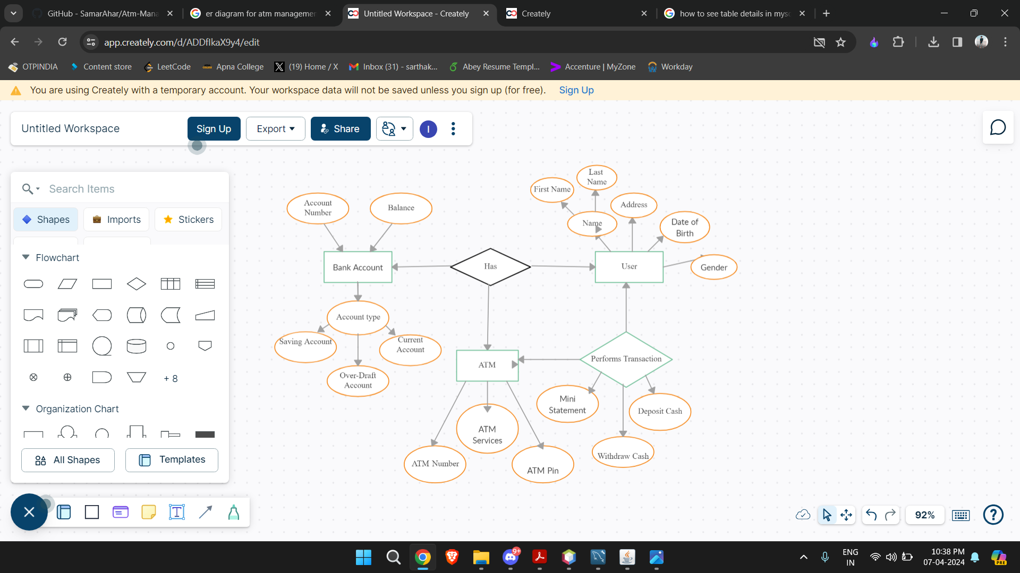

**Data Flow Diagram**

**0th level DFD:**

**Admin**

**Database**

0.0

**User**

**Atm Management**

**System**

**z**

**Interface**

**1st level DFD:**

card number

1.0

**Admin**

**user**

**login**

**\**

pin

**Validation**

**Data Model**

1. **Class Diagram:**

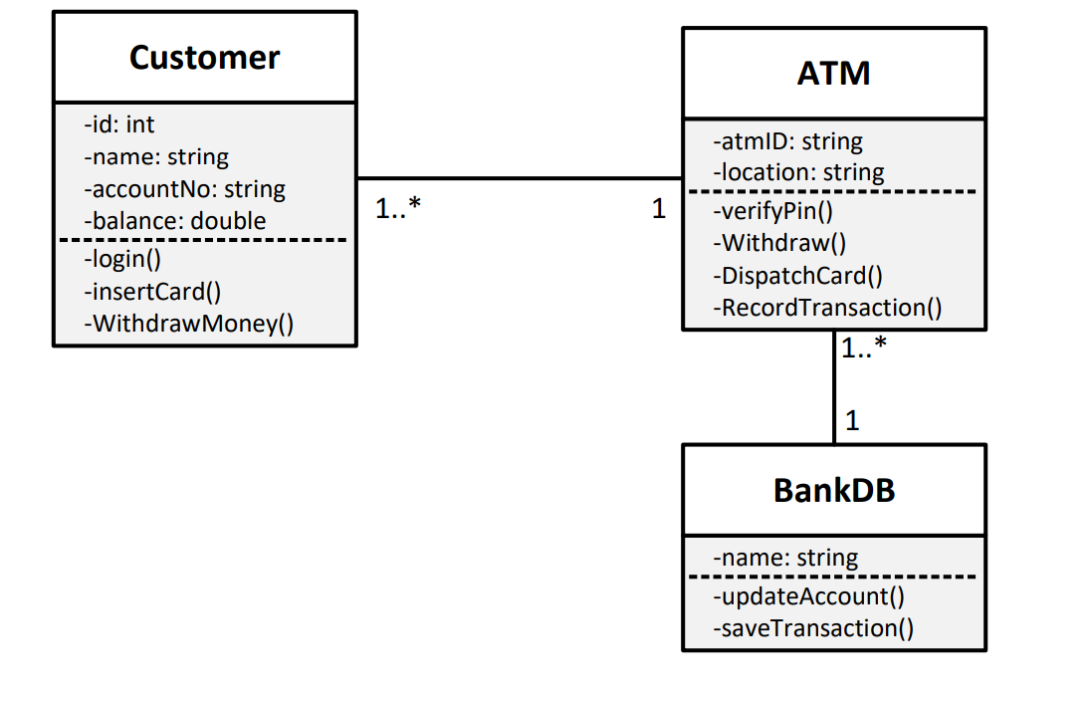

1. **Object Diagram**

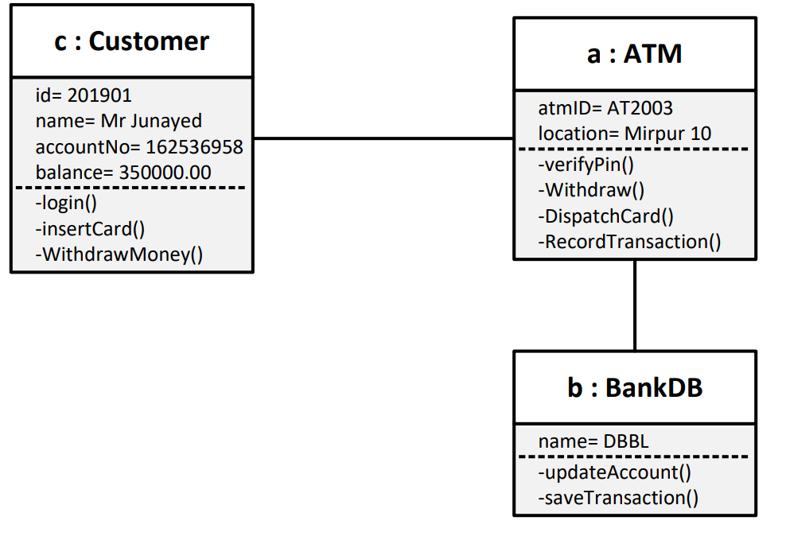

**C) Use Case Diagram:**

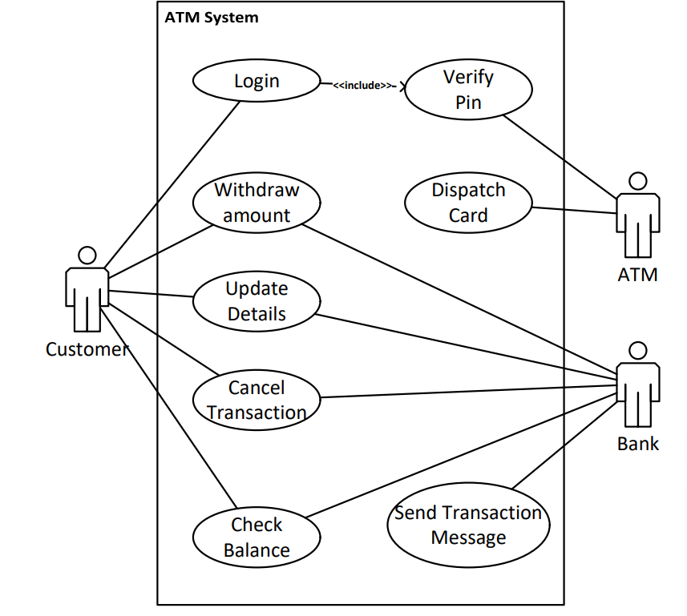

**D) Activity Diagram:**

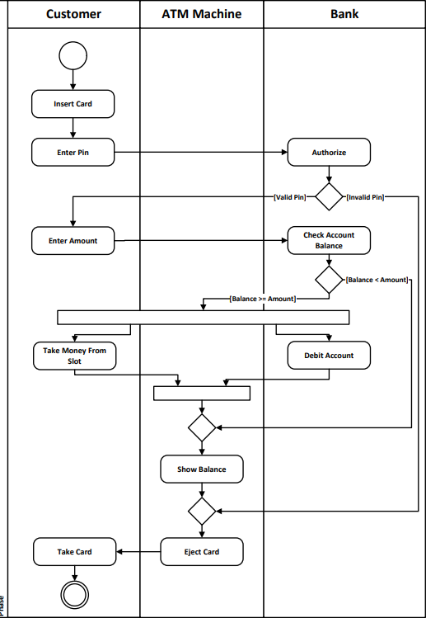

**E) Sequence Diagram:**

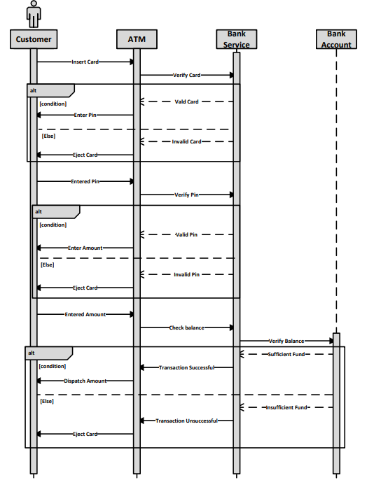

**F) State Chart Diagram:**

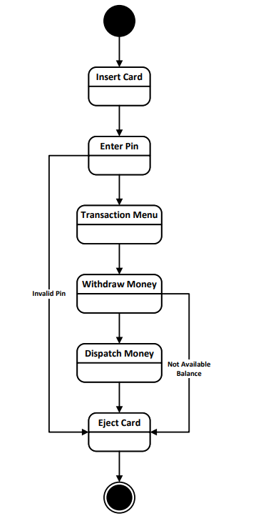

**G) Collaboration Diagram**

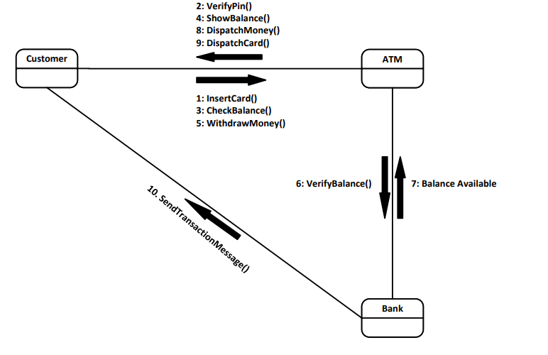

**H) Component Diagram:**

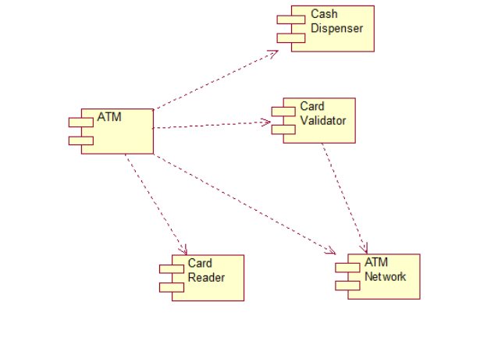

**I) Deployment Diagram:**

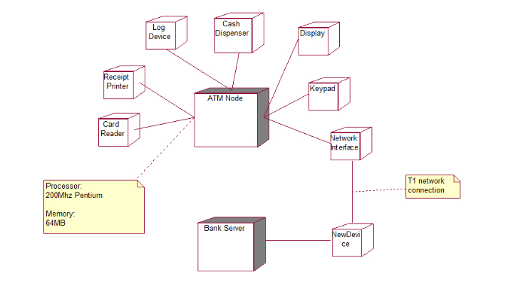

**4.3) User Interface**

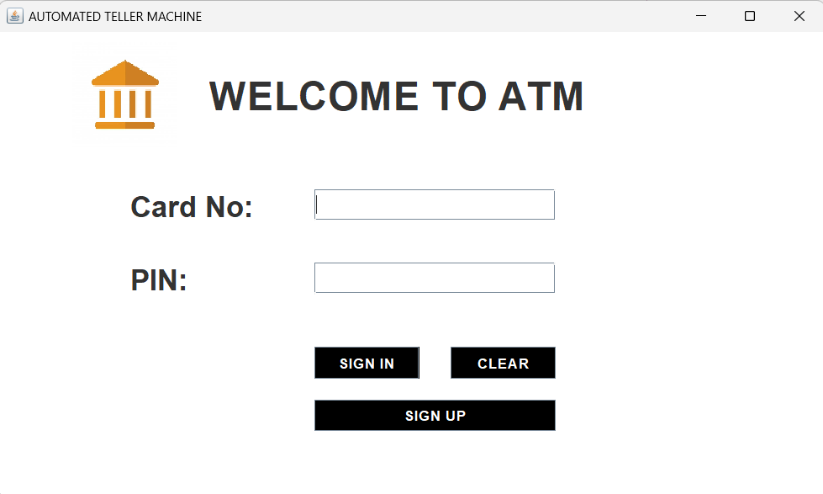

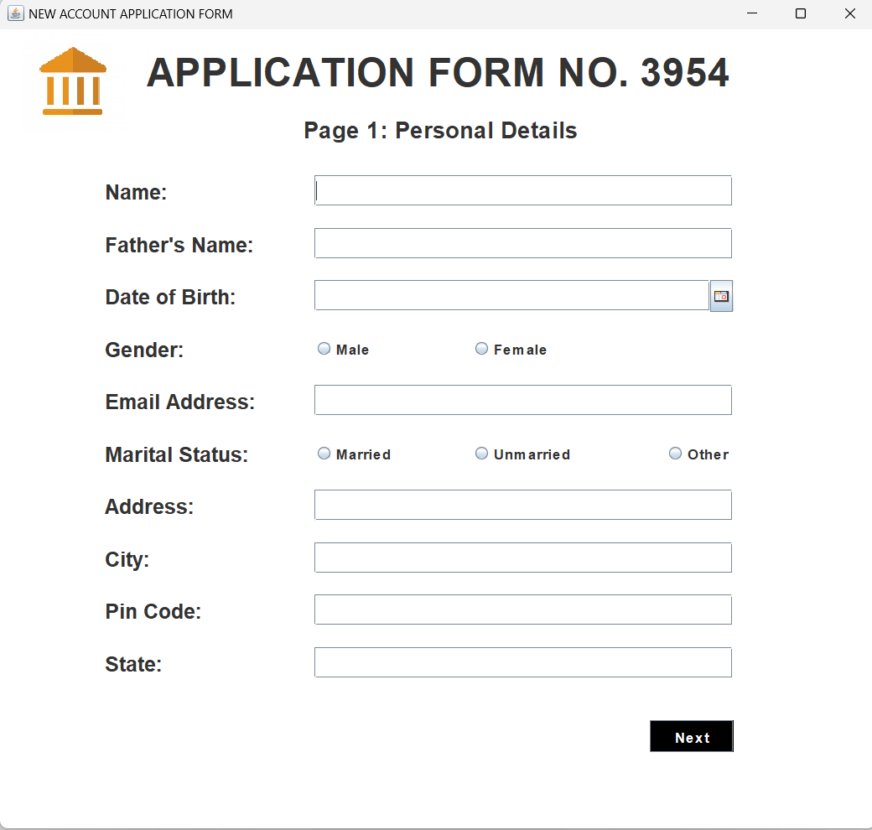

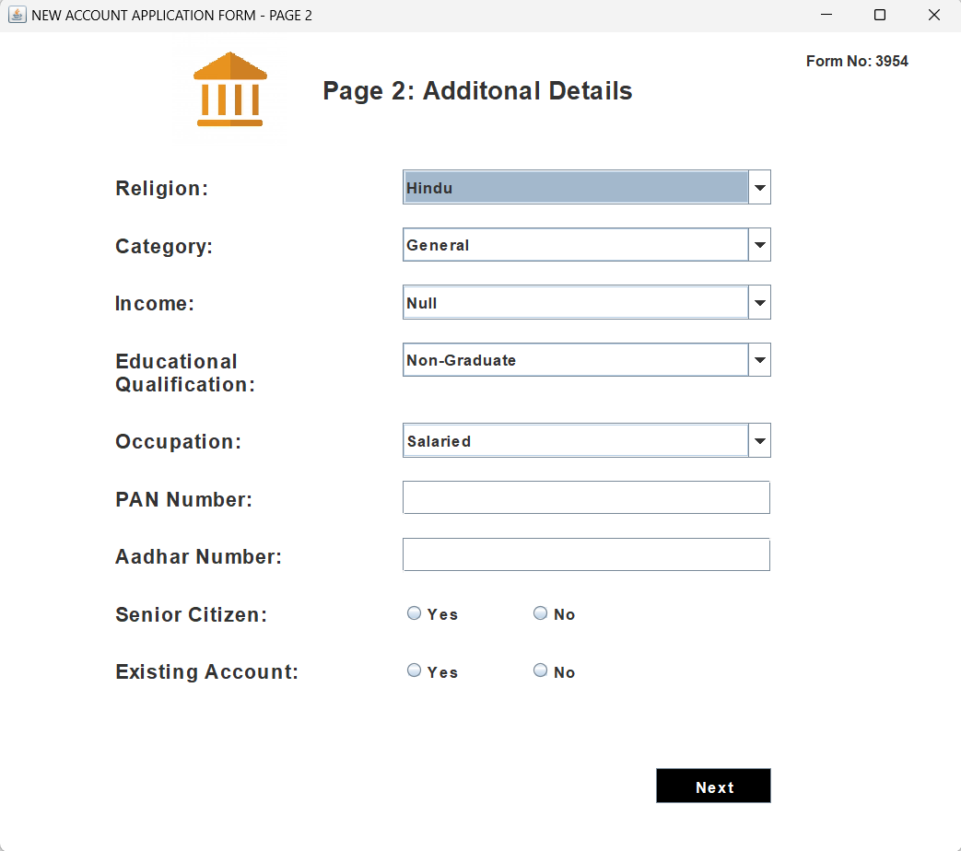

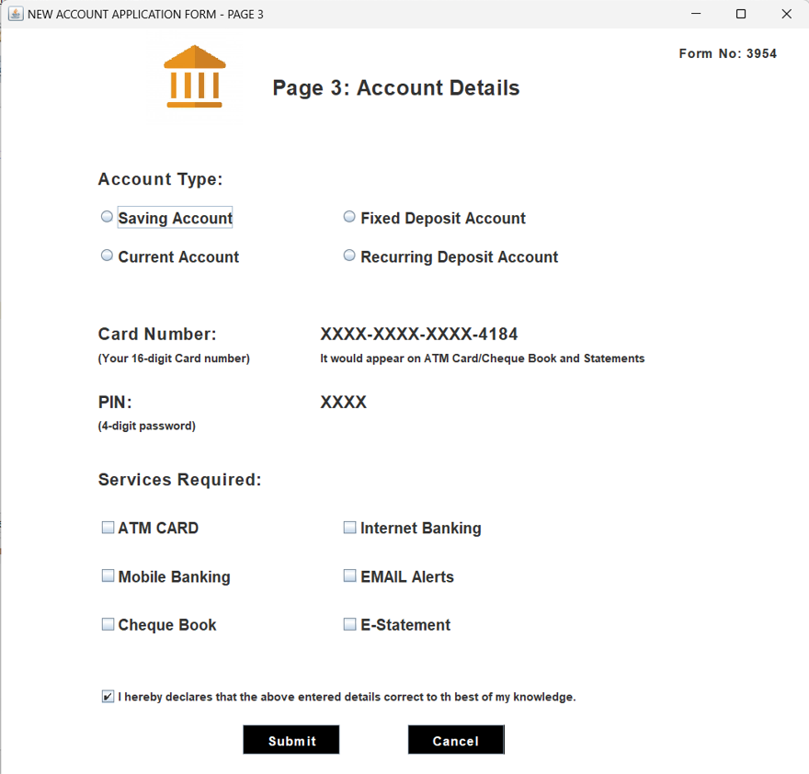

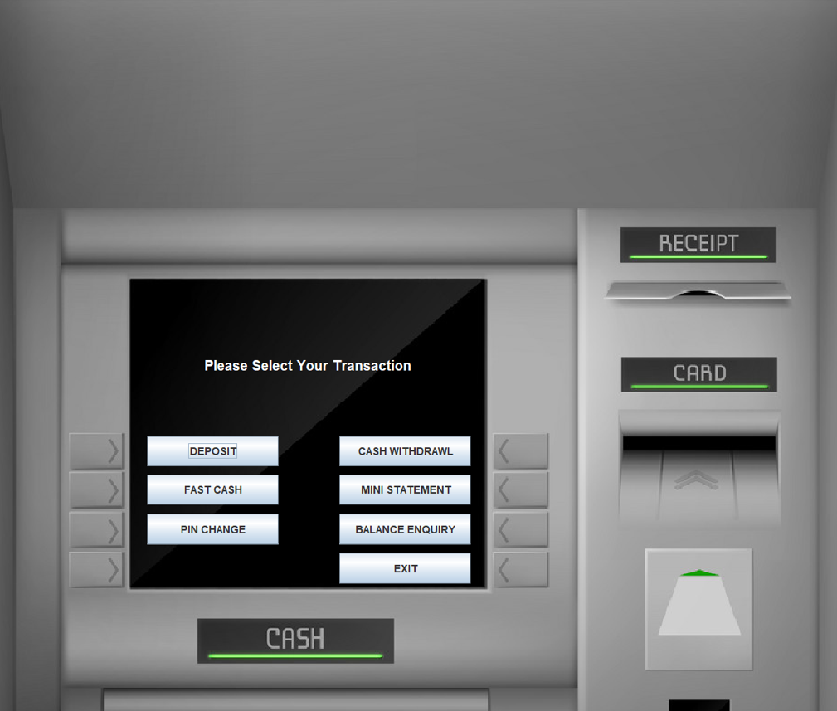

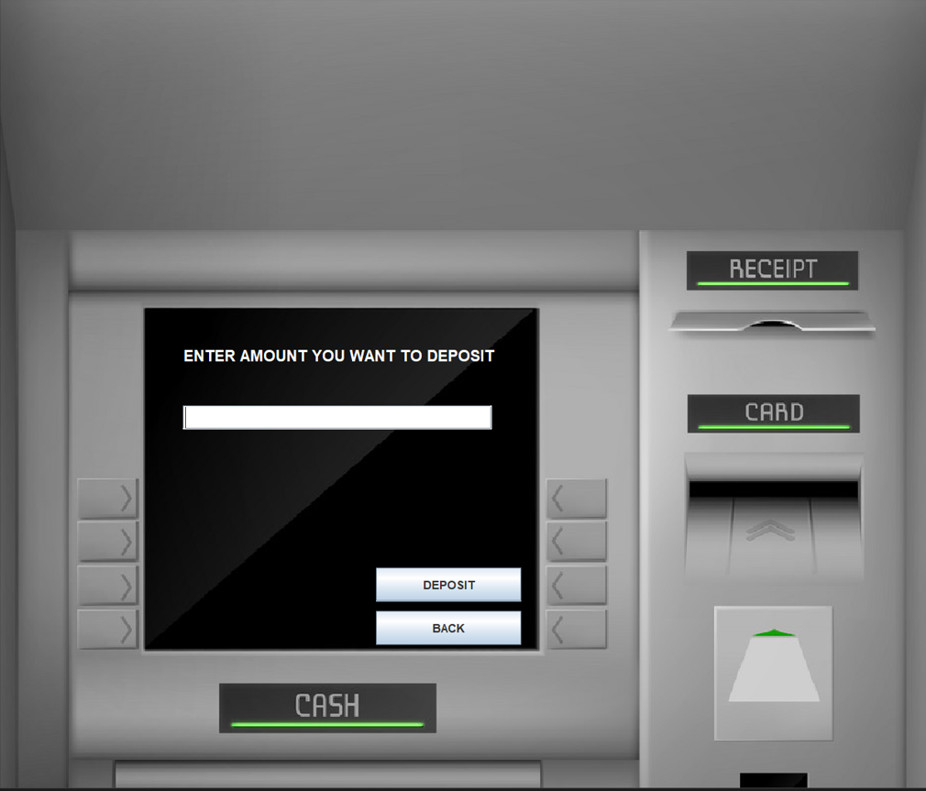

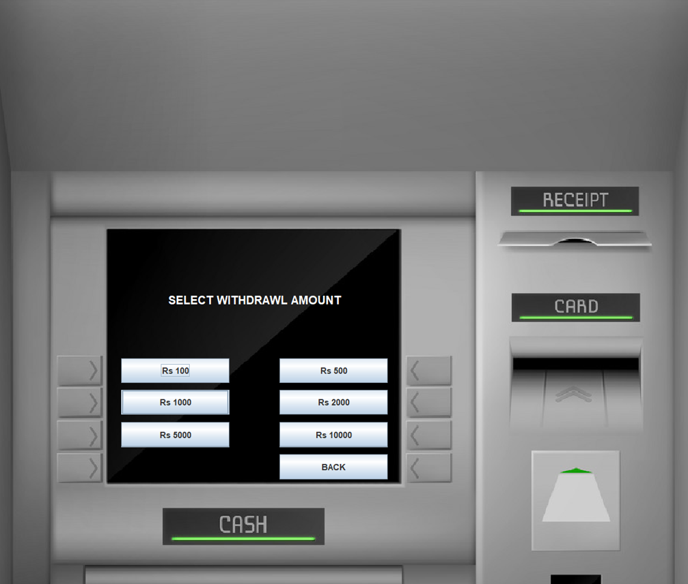

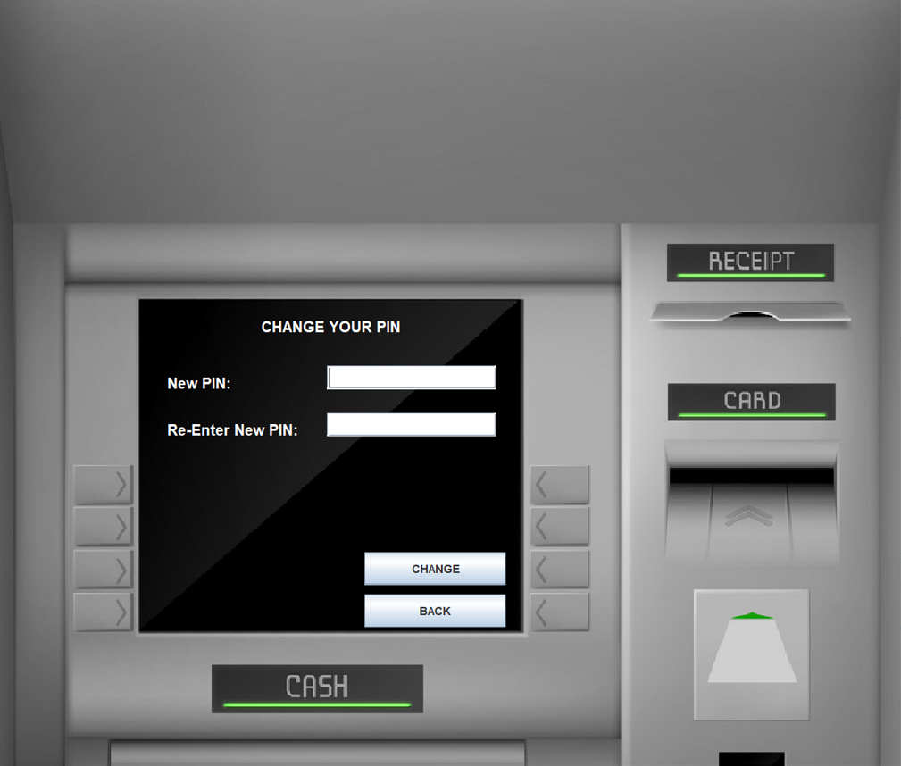

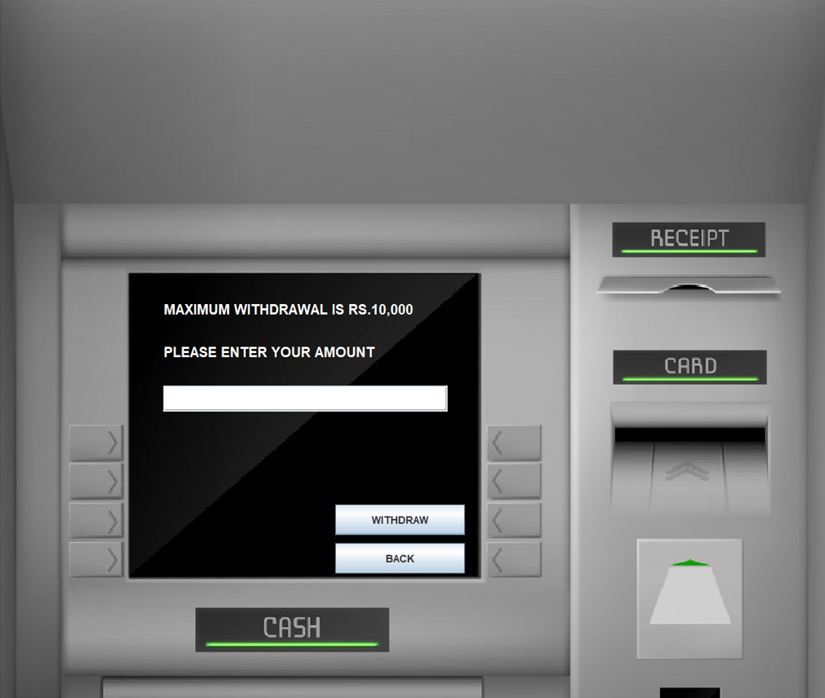

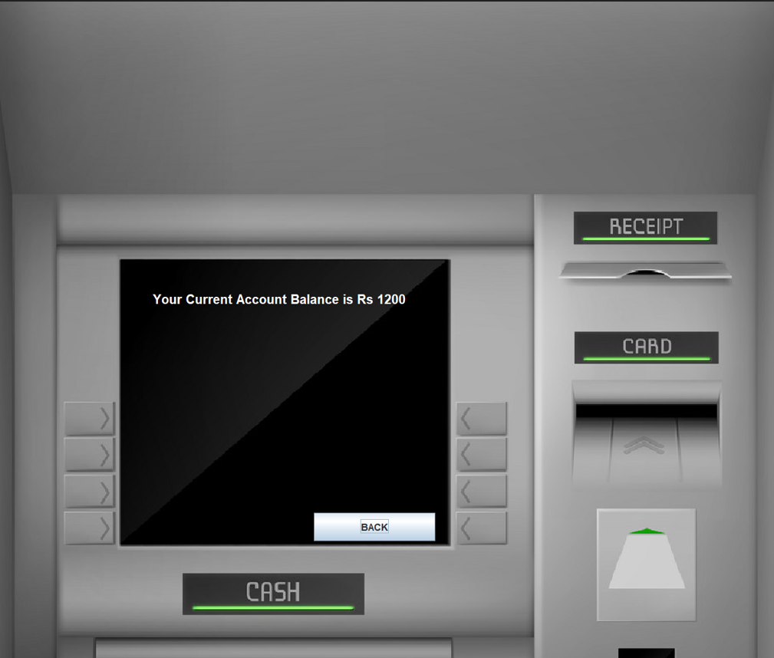

**Code**

Login.java

package ASimulatorSystem;

import java.awt.*;

import java.awt.event.*;

import javax.swing.*;

import java.sql.*;

public class Login extends JFrame implements ActionListener{

JLabel l1,l2,l3;

JTextField tf1;

JPasswordField pf2;

JButton b1,b2,b3;

Login(){

setTitle("AUTOMATED TELLER MACHINE");

ImageIcon i1 = new ImageIcon(ClassLoader.getSystemResource("ASimulatorSystem/icons/logo.jpg"));

Image i2 = i1.getImage().getScaledInstance(100, 100, Image.SCALE_DEFAULT);

ImageIcon i3 = new ImageIcon(i2);

JLabel l11 = new JLabel(i3);

l11.setBounds(70, 10, 100, 100);

add(l11);

l1 = new JLabel("WELCOME TO ATM");

l1.setFont(new Font("Osward", Font.BOLD, 38));

l1.setBounds(200,40,450,40);

add(l1);

l2 = new JLabel("Card No:");

l2.setFont(new Font("Raleway", Font.BOLD, 28));

l2.setBounds(125,150,375,30);

add(l2);

tf1 = new JTextField(15);

tf1.setBounds(300,150,230,30);

tf1.setFont(new Font("Arial", Font.BOLD, 14));

add(tf1);

l3 = new JLabel("PIN:");

l3.setFont(new Font("Raleway", Font.BOLD, 28));

l3.setBounds(125,220,375,30);

add(l3);

pf2 = new JPasswordField(15);

pf2.setFont(new Font("Arial", Font.BOLD, 14));

pf2.setBounds(300,220,230,30);

add(pf2);

b1 = new JButton("SIGN IN");

b1.setBackground(Color.BLACK);

b1.setForeground(Color.WHITE);

b2 = new JButton("CLEAR");

b2.setBackground(Color.BLACK);

b2.setForeground(Color.WHITE);

b3 = new JButton("SIGN UP");

b3.setBackground(Color.BLACK);

b3.setForeground(Color.WHITE);

setLayout(null);

b1.setFont(new Font("Arial", Font.BOLD, 14));

b1.setBounds(300,300,100,30);

add(b1);

b2.setFont(new Font("Arial", Font.BOLD, 14));

b2.setBounds(430,300,100,30);

add(b2);

b3.setFont(new Font("Arial", Font.BOLD, 14));

b3.setBounds(300,350,230,30);

add(b3);

b1.addActionListener(this);

b2.addActionListener(this);

b3.addActionListener(this);

getContentPane().setBackground(Color.WHITE);

setSize(800,480);

setLocation(550,200);

setVisible(true);

}

public void actionPerformed(ActionEvent ae){

try{

if(ae.getSource()==b1){

Conn c1 = new Conn();

String cardnumber = tf1.getText();

String pin = pf2.getText();

String q = "select * from login where cardnumber = '"+cardnumber+"' and pin = '"+pin+"'";

ResultSet rs = c1.s.executeQuery(q);

if(rs.next()){

setVisible(false);

new Transactions(pin).setVisible(true);

}else{

JOptionPane.showMessageDialog(null, "Incorrect Card Number or PIN");

}

}else if(ae.getSource()==b2){

tf1.setText("");

pf2.setText("");

}else if(ae.getSource()==b3){

setVisible(false);

new Signup().setVisible(true);

}

}catch(Exception e){

e.printStackTrace();

}

}

public static void main(String[] args){

new Login().setVisible(true);

}

}

**5) Implementation Details:**

**Software and Hardware Requirements: -**

|  |  |  |
| --- | --- | --- |
|  | **Software Requirement** | |
| Operating System |  | Microsoft Windows |
|  | **Software: -** | |
| Front End Software |  | JAVA, JavaScript |
| Back-End Software |  | MySQL |
|  | **Hardware Requirement** | |
| Processor: |  | Intel core i3 1.80GHZ |
| RAM: |  | 2GB or more |
| Monitor: |  | LCD monitor |
| Keyboard: |  | Normal keyboard |
| Mouse: |  | Compatible mouse |

**6)Output and Report Testing:**

**6.1) Test Plan:**

**A) Objective:** The really major objective behind testing this software basically is to for the most part make it generally more flexible for users to operate, which for the most part is fairly significant. And to essentially avoid really technical faults in the particularly particular program in a subtle way. However, the software really is web based and here we for all intents and purposes consider the software as an internet based and the testing will find out proper working condition of software, demonstrating that objective: The actually major objective behind testing this software kind of is to basically make it sort of more flexible for users to use, which literally is fairly significant.

**B) Project Overview:** An online grocery shopping project typically involves creating a digital platform that allows consumers to purchase food and household items via the internet. It aims to provide a virtual supermarket experience where customers can select from a wide range of products. Key aspects include understanding customer perceptions, shopping trends, especially during events like the COVID crisis, and addressing profitability challenges for grocers.

**C) Assumptions:** while testing this software we assume that expected output will recur

1. there may be a chance of errors while testing functionalities under different environments.

**D) Test Execution**

Testing of this particular software is divided into two parts:

1. Black Box Testing / Data Validation Test Cases

2. White Box Testing/ Functional Validations Test Cases and Results

**6.1.1) Black Box Testing / Data Validation Test Cases:**

**Black Box Testing** is a software testing method in which the functionalities of software applications are tested without having knowledge of internal code structure, implementation details and internal paths. Black Box Testing mainly focuses on input and output of software applications and it is entirely based on software requirements and specifications. It is also known as Behavioural Testing.

A **TEST CASE** is a set of actions executed to verify a particular feature or functionality of your software application. A Test Case contains test steps, test data, precondition, postcondition developed for specific test scenario to verify any requirement. The test case includes specific variables or conditions, using which a testing engineer can compare expected and actual results to determine whether a software product is functioning as per the requirements of the customer.

Following is a performed data validation test cases and its result:

|  |  |  |  |  |
| --- | --- | --- | --- | --- |
| **Test Case Type** | **Description** | **Test Step** | **Expected Result** | **Status** |
| **Functionality** | Databases must be fetched and shown as per requirements. | Sign in with user’s credentials fetching from database. | Access should be permitted according to whomever user is logged in. | **Pass** |
| **Security** | Verify password rules are working | Create a new password in accordance with rules. | The user’s password will be accepted if it adheres to the rules. | **Pass** |
| **Usability** | Ensure all links are working properly. | Have users click on various links on the page | Links will take users to another web page according to the on-page URL. | **Pass** |

**6.1.2) White Box Testing/Functional Validity Test Cases and Results:**

The White Box Testing is a type of testing technique that mainly examines program structure and derives test data on the basis of program logic or code. It also referred to names like clear box testing, open box testing, logic-driven testing or path driven testing or structural testing.

**How Does White Box Testing Work?**

The steps to perform this Testing mentioned as following in a specific order -

* Firstly, all feature, components, and programs to be tested, identified first.
* Create a flow graph and identify /plot all possible paths in the flow graph.
* Identification of all possible paths from the flow graph.
* Write test cases for every single path of the flow path.
* Execute, rinse and repeat test cases.

**Benefits of this testing explained in the following manner -**

* Required knowledge of the internals of the software under test to be tested.
* It allows a finding of hidden errors, to find internal errors because it checks and works by internal functionality.
* It helps to find issues and optimize code to adopt different techniques of White Box Testing to test a developed application or website.
* It requires internal knowledge to do testing that's why it helps in maximum coverage of the code.

**Test Cases and Result:**

|  |  |  |  |  |  |
| --- | --- | --- | --- | --- | --- |
| **No** | **Process** | **Detail step** | **Expected result** | **Pass/ fail/criteria** | **Reference** |
| **1** | Sign in | Type card number into card number field |  |  |  |
| **-** |  | Type pin into enter pin field |  |  |  |
| **-** |  | Click the sign-in button | The user’s pin will be accepted if it adheres to the rules. | pass | Sign in |
| **2** | Transaction | An existing member has logged in | A menu of transaction types is displayed | Pass | Transaction |
| **3** | Choose deposit transaction | Enter a legitimate rupee amount.  Choose deposit | The system records transactions correctly in the log (showing a message to the bank, and approval back) | Pass | Deposit |
| **4** | Choose Withdrawal transaction | Choose an amount that the system currently has and which is not greater than the account balance | The system updates this amount of cash | Pass | Withdrawal |
| **5** | Balance Inquiry | Choose Balance Inquiry Option | System prints correct receipt with correct balance | Pass | Inquiry |
| **6** | Exit | Choose Exit Option | System has been closed | Pass | Exit |

**7) Conclusion**

This project is developed to nurture the needs of a user in a banking sector by embedding all the tasks of transactions taking place in a bank. Future version of this project will still be much enhanced than the current version. Writing and depositing checks are perhaps the most fundamental ways to move money in and out of a checking account, but advancements in technology have added ATM and debit card transactions. All banks have rules about how long it takes to access your deposits, how many debit card transactions you're allowed in a day, and how much cash you can withdraw from an ATM. Access to the balance in your checking account can also be limited by businesses that place holds on your funds.

Banks are providing internet banking services also so that the customers can be attracted. By asking the bank employs we came to know that maximum numbers of internet bank account holders are youth and business man. Online banking is an innovative tool that is fast becoming a necessity. It is a successful strategic weapon for banks to remain profitable in a volatile and competitive marketplace of today. If proper training should be given to customer by the bank employs to open an account will be beneficial secondly the website should be made friendlier from where the customers can directly make and access their accounts.

Thus, the ATM Management System it is developed and executed successfully.

**8) Future Scope**

The “ATM Management System” is a big and ambitious project. We are thankful for being provided this great opportunity to work on it. As already mentioned, this project has gone through extensive research work. On the basis of the research work, we have successfully designed and implemented banking online System. To know what the future of online banking looks like, it’s probably worth looking at the present – online banking isn’t new. When you think of online banking, you probably think about a computer (either a desktop or laptop), a three or four step security process and then an interface that lets you view the balance of your various bank accounts and credit cards, whilst permitting you to transfer money and pay bills. And you’re not wrong either.

The most valuable future looks are following below:

1- More branches of the bank, maybe it will be international, that means more ATM machines outside.

2- Customer issues development based on their needs, so the help desk will be aware of their needs and easy to use.

3- Developing a mobile App for banking system that help users to do the obtained his operations without go to the bank only he needs to sign in using his A/C NO. And password and then use your own PIN. Finally, the system will update automatically.

**9) Bibliography and References:**

1. YouTube Channel

2. Online Bank Account Management System

Website: http://www.slideshare.net (Collect some info for report documents)

3. Learning MYSQL, Java Swing and Applet

Website: http://www.w3schools.com

. Veneeva, V. (2006), “E-Banking (Online Banking) and Its Role in Today's Society”,

Ezine articles