End-to-End Azure Data Engineering Pipeline

Building an End-to-End Azure Data Engineering Pipeline for Amazon Product Review Analytics
Dataset Overview :

Content
Dataset Name :
Helpful Sentences from Reviews
Source :
Amazon Science Public Dataset
Dataset Description :
The dataset contains individual sentences extracted from Amazon customer product reviews. Each sentence is assigned a helpfulness score indicating how useful that sentence is to other customers. The dataset is designed for natural language processing (NLP), text analytics, and information retrieval tasks.
Raw DataSet :

Project Overview :

train.csv
This project presents an end-to-end Azure Data Engineering solution for analyzing Amazon product review helpfulness. The pipeline follows the Medallion Architecture consisting of Bronze, Silver, and Gold layers. Azure Data Factory is used for data ingestion, Azure Data Lake Storage Gen2 serves as the storage

layer, Azure Databricks performs data transformation and feature engineering, Azure Synapse Analytics provides the analytical serving layer, and Power BI is used to create interactive business dashboards.

Problem Statement :
E-commerce platforms such as Amazon receive millions of customer reviews for a wide range of products. These reviews contain valuable information that helps customers make informed purchasing decisions and enables businesses to understand customer opinions. However, manually processing and analyzing such a large volume of review data is time-consuming, inefficient, and prone to errors.
The objective of this project is to design and implement a scalable Azure Data Engineering pipeline that automates the ingestion, transformation, storage, and analysis of Amazon product review data. The solution leverages the Medallion Architecture (Bronze, Silver, and Gold layers) to ensure data quality, efficient processing, and business-ready analytics. The processed data is finally served through Azure Synapse Analytics and visualized in Power BI to provide meaningful insights into review helpfulness.

Project Objectives :
The primary objectives of this project are:
- To build an end-to-end Azure Data Engineering pipeline using Azure cloud services.
- To ingest raw Amazon product review data into Azure Data Lake Storage Gen2 using Azure Data Factory.
- To implement the Medallion Architecture consisting of Bronze, Silver, and Gold layers.
- To perform data cleansing, validation, and feature engineering using Azure Databricks and PySpark.
- To improve data quality by handling null values, duplicate records, and invalid data.
- To derive business metrics such as sentence length, word count, and helpfulness bands.

- To generate analytical KPIs using Azure Synapse Analytics.
- To expose business-ready datasets through Synapse SQL Views.
- To develop interactive dashboards in Power BI for business reporting and decision-making.
- To demonstrate a scalable and industry-standard Azure Data Engineering solution.

Project Architecture :
This project follows a modern Medallion Architecture to process Amazon product review data in a scalable and organized manner. The complete pipeline consists of three layers: Bronze, Silver, and Gold. Azure Data Factory is responsible for data ingestion, Azure Data Lake Storage Gen2 stores the data, Azure Databricks performs data transformation and feature engineering, Azure Synapse Analytics provides the analytical serving layer, and Power BI is used to build interactive dashboards.
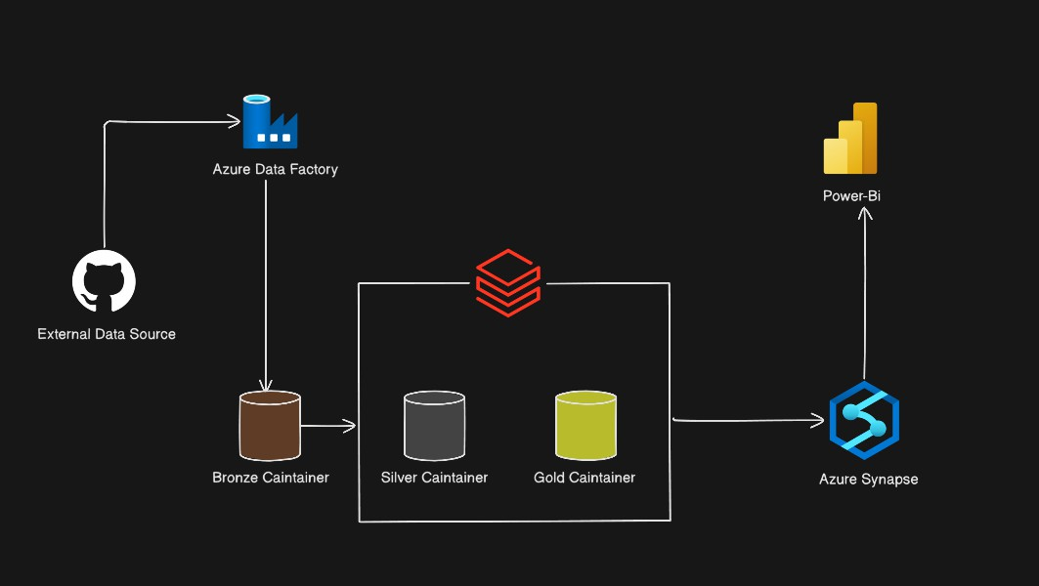
The architecture ensures that raw data is preserved in the Bronze layer, cleaned and enriched data is stored in the Silver layer, and business-ready datasets are generated in the Gold layer for reporting and decision-making.

Architecture Components :

Component | Description
Source Dataset | Amazon Product Review dataset containing review sentences and helpfulness scores.
Azure Data  Factory | Ingests raw data into the Bronze layer.
Bronze Layer  (ADLS Gen2) | Stores raw CSV data without any transformation.
Azure  Databricks | Cleans, validates, transforms data and creates derived columns.
Silver Layer  (Delta) | Stores cleaned and enriched data in Delta format.
Azure Synapse  Analytics | Reads Silver/Gold data using Serverless SQL and exposes analytical views.
Gold Layer | Stores business-ready KPIs for reporting.
Power BI | Builds interactive dashboards and business reports from Synapse views.

Phase I: Data Ingestion and Bronze Layer

Data Ingestion using Azure Data Factory :
Azure Data Factory (ADF) was used to automate the ingestion of the Amazon Product Review dataset into Azure Data Lake Storage Gen2. A static Copy Data pipeline was created to transfer the dataset from the source location to the Bronze container without applying any transformations, ensuring that the raw data remained unchanged.
Figure 1: Azure Data Factory Copy Data Pipeline Linked Service

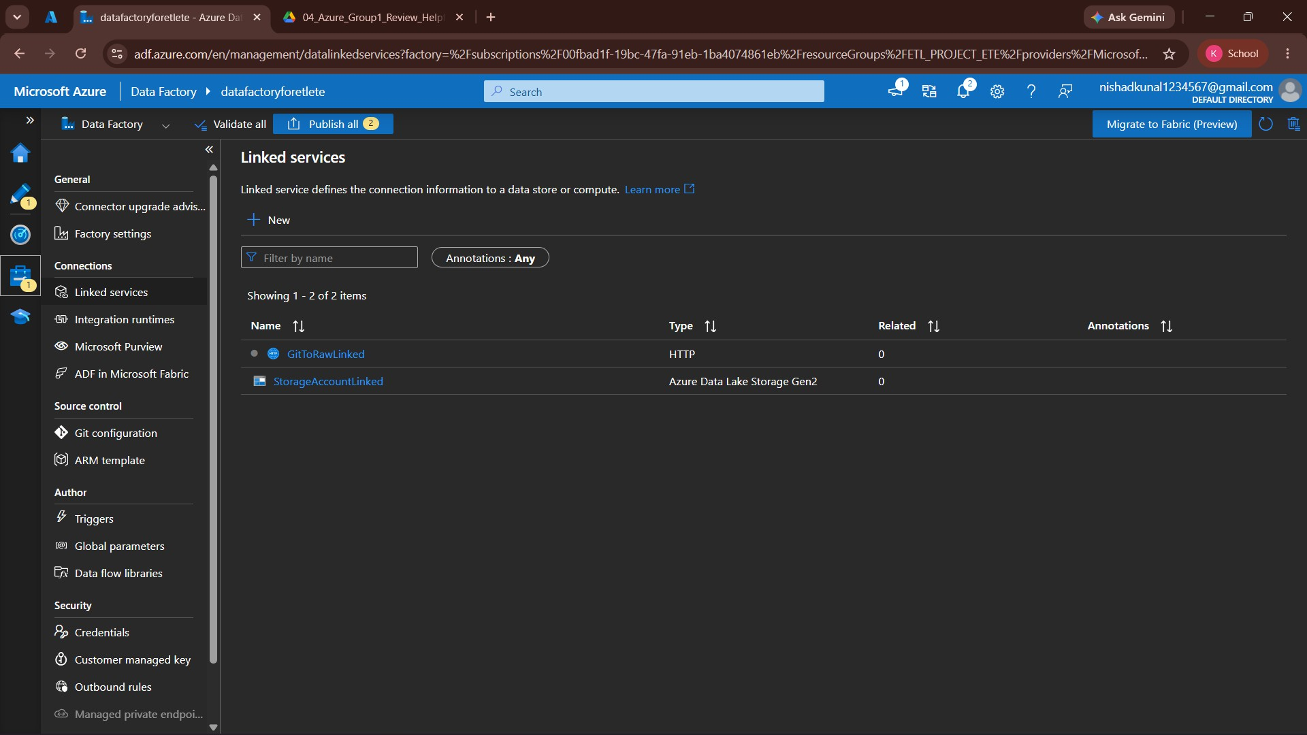

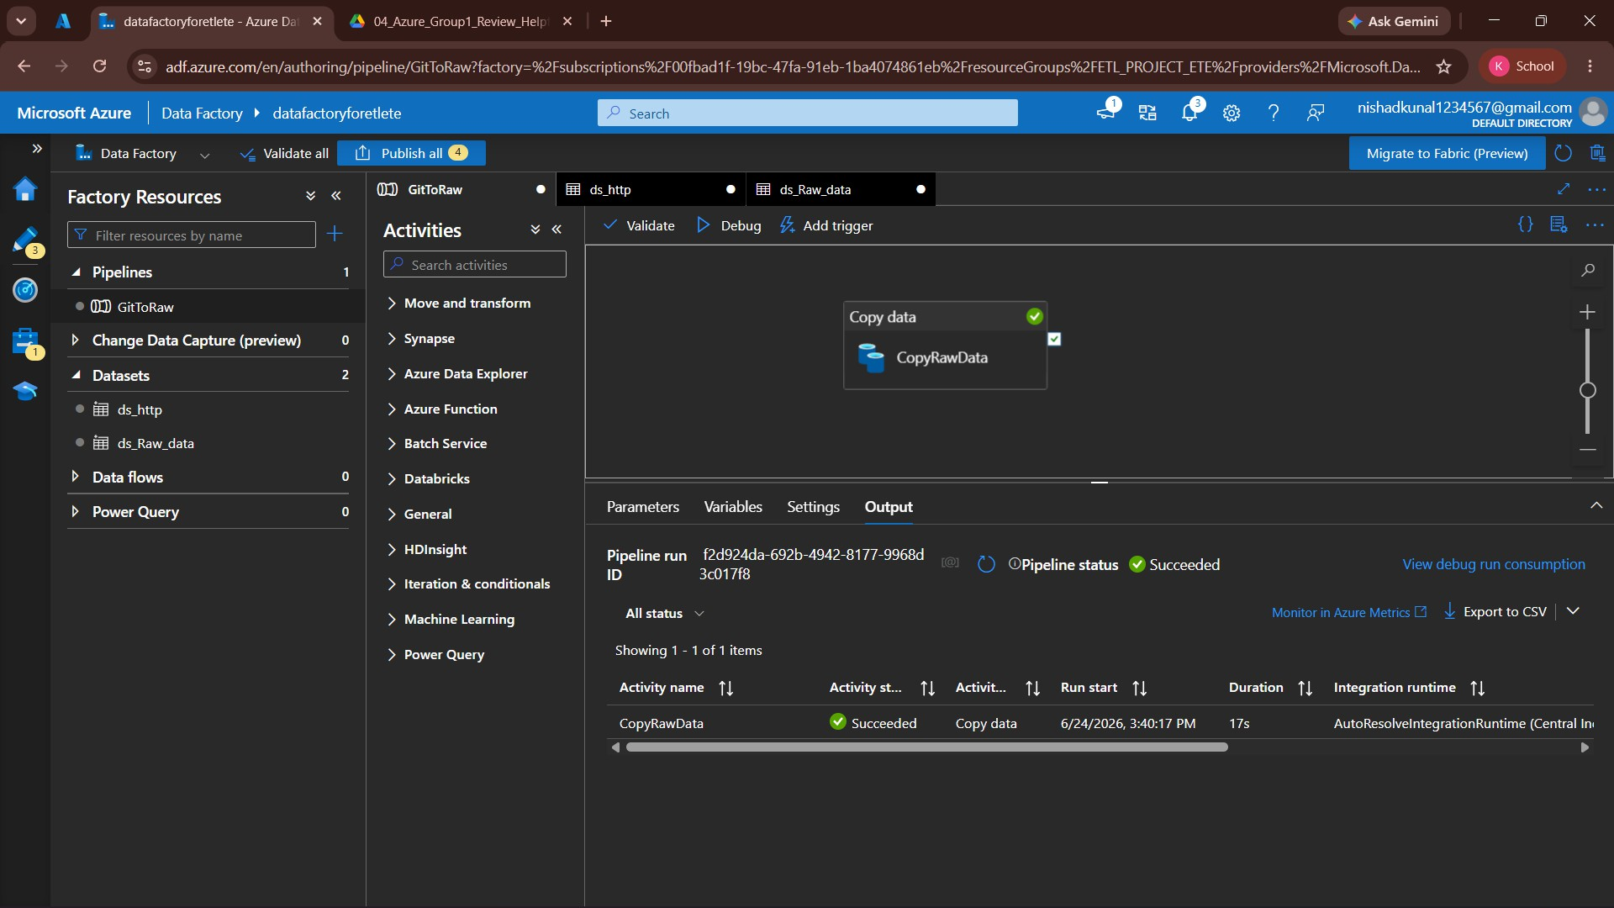
Figure 2: Successful Pipeline Execution

Bronze Layer :

The Bronze layer stores the raw dataset exactly as received from the source. The data is maintained in CSV format without any modifications, serving as the single source of truth for downstream processing.

Bronze Layer Characteristics :

Feature | Description
Storage Format | CSV
Data State | Raw
Transformations | None
Purpose | Preserve original data
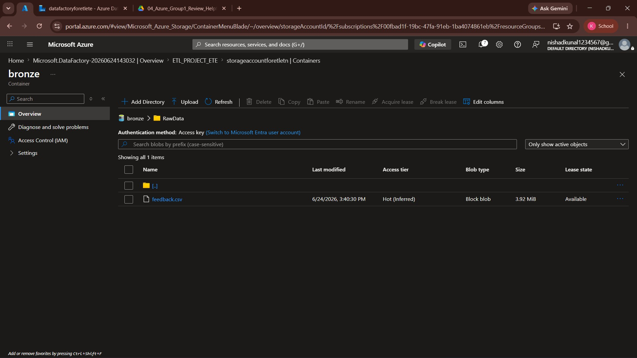
Figure 3: Bronze Layer Storage in Azure Data Lake Storage Gen2

Phase II: Data Transformation using Azure Databricks

Azure Databricks Environment :
Azure Databricks was used to process and transform the raw data stored in the Bronze layer. PySpark notebooks were used to perform data cleaning, validation,

feature engineering, and prepare the curated Silver layer.
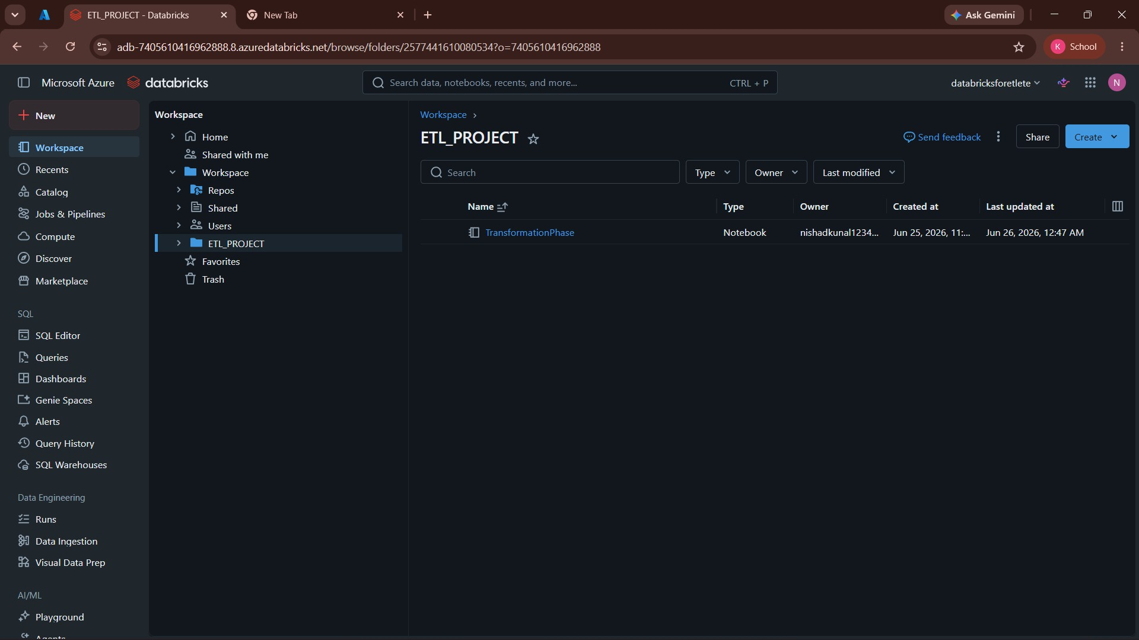
Figure 4: Azure Databricks Workspace

Data Transformation :
The raw CSV dataset was loaded from the Bronze layer into Azure Databricks. Multiple transformations were applied to improve data quality and prepare the dataset for analytical reporting.

Transformations Performed :
- Renamed columns for better readability.
- Converted data types.
- Removed null and empty records.
- Trimmed unnecessary spaces.
- Created derived columns.
- Categorized helpfulness scores into bands.
- Added ingestion metadata.

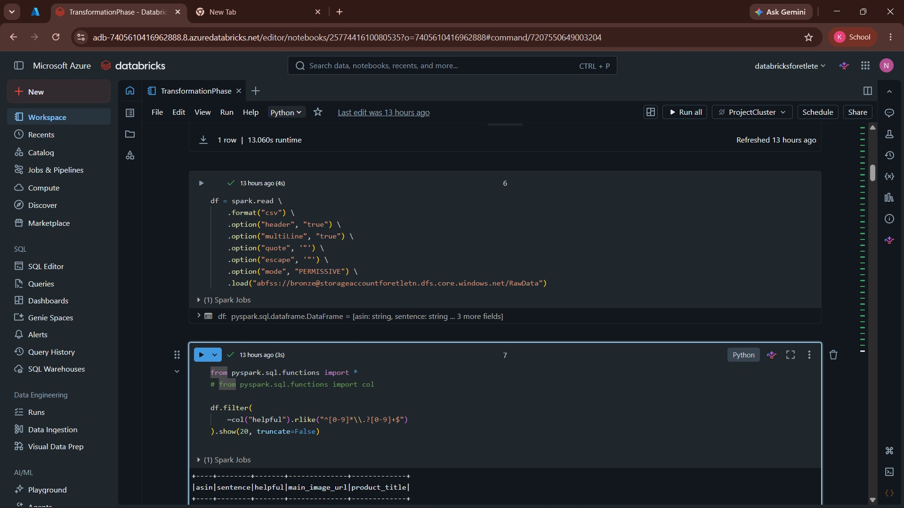
Figure 5: Reading Bronze Layer Data

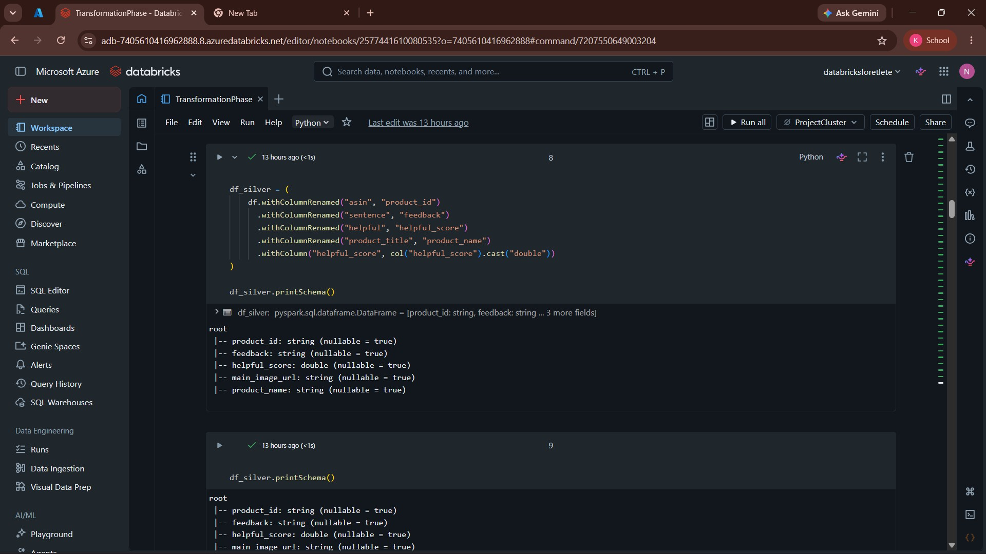
Figure 6: Column Renaming using PySpark

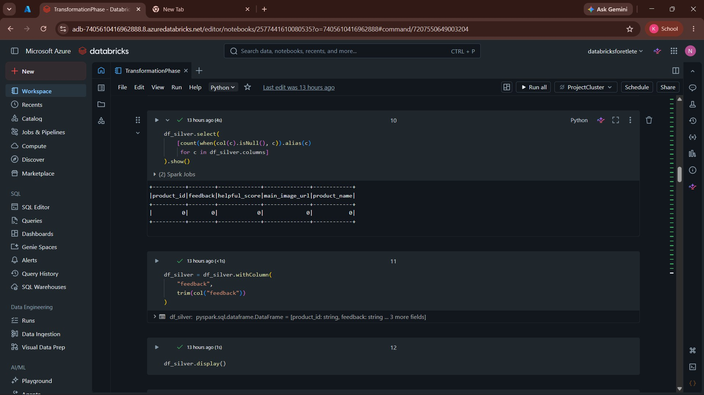
Figure 7: Data Cleaning Process

Feature Engineering :
To improve the analytical capability of the dataset, several derived and metadata columns were created during the transformation process. These columns support business analysis, data quality validation, and efficient reporting.

Column Name | Description
product_id | Renamed from asin to improve readability.
feedback | Renamed from sentence , containing the customer review sentence.
helpful_score | Renamed from helpful ; stores the numerical helpfulness score.
product_name | Renamed from product_title .
sentence_length | Total number of characters in the feedback sentence.
word_count | Total number of words in the feedback sentence.
ingestion_source | Indicates the data ingestion source (e.g., Batch).
ingestion_timestamp | Stores the timestamp when the record was processed.

Column Name | Description
helpfulness_band | Categorizes reviews into Low, Medium, and High based on the helpfulness score.
score_flag | Flags records with valid or invalid helpfulness scores for data quality monitoring.
feedback_hash | SHA-256 hash of the feedback text used for duplicate detection.
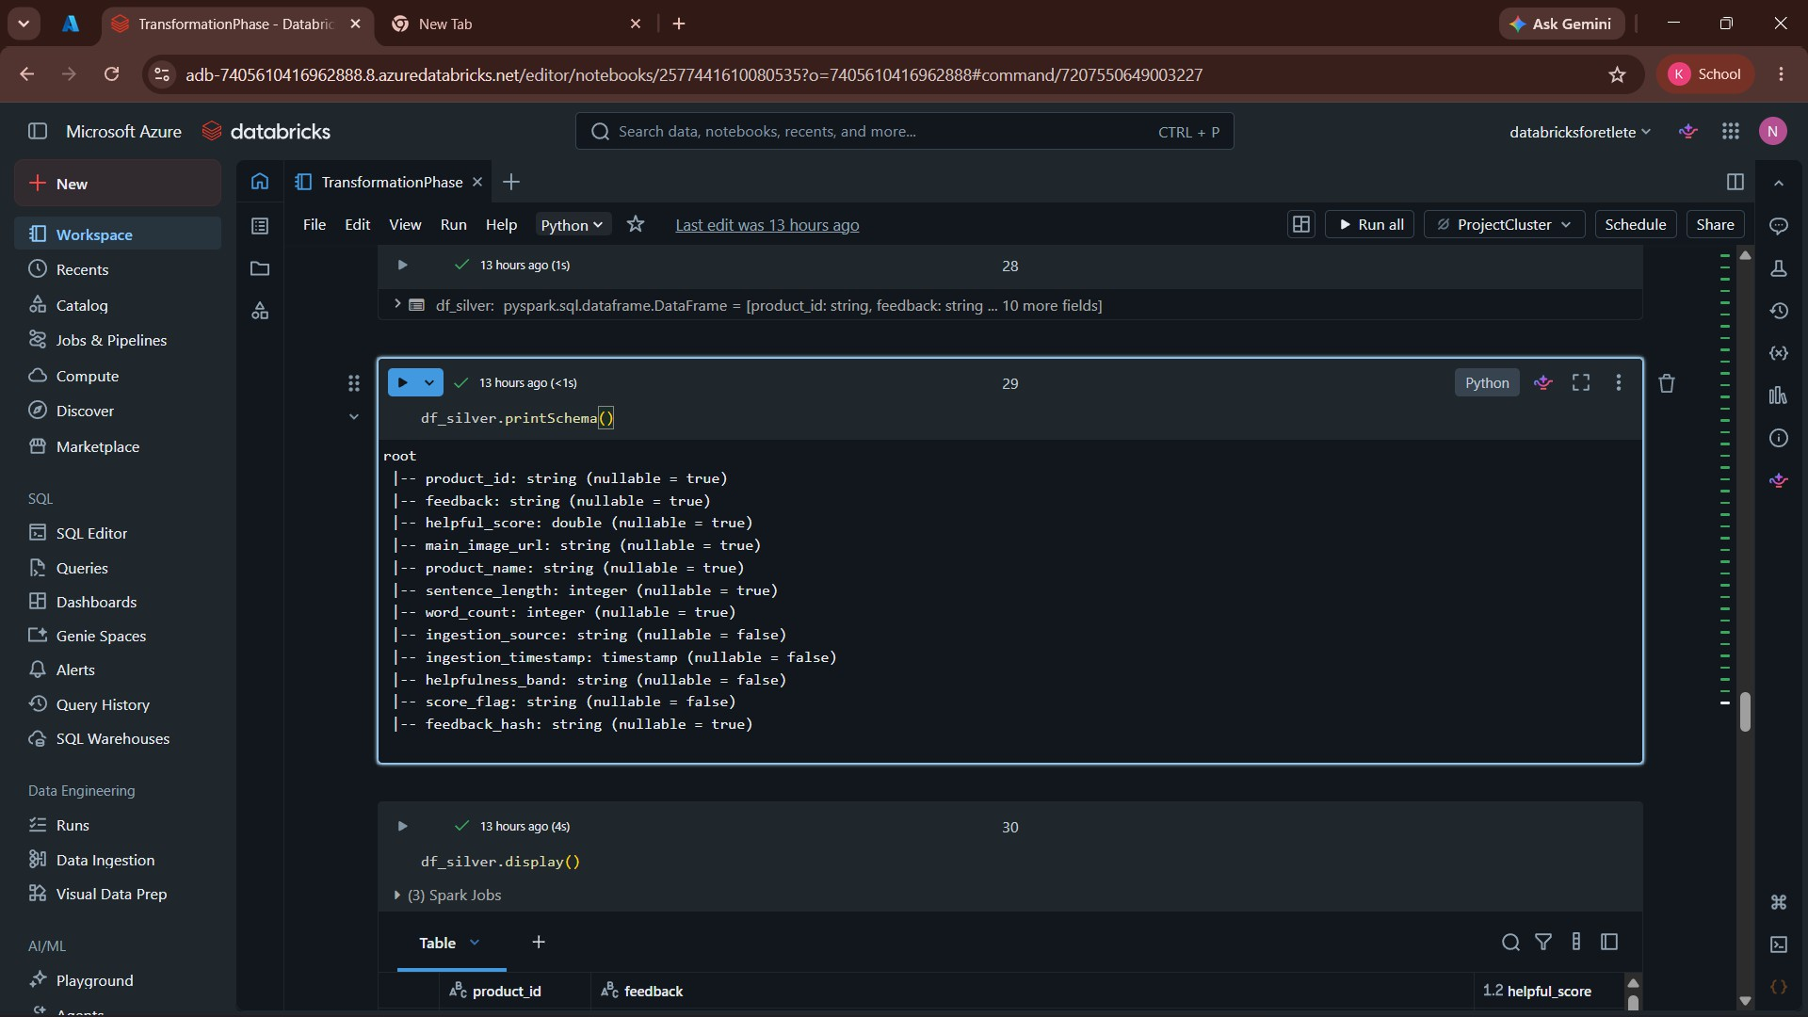
Figure 8: Engineering using PySpark

Data Quality Checks :
Data quality validation was performed before storing the processed data in the Silver layer to ensure consistency and reliability.

Checks Performed
- Null value validation
- Empty feedback removal
- Helpfulness score range validation
- Duplicate record removal

- Row count reconciliation

Silver Layer :
Silver Layer Characteristics

Feature | Description
Format | Delta
Status | Cleaned & Enriched
Purpose | Analytics-ready dataset
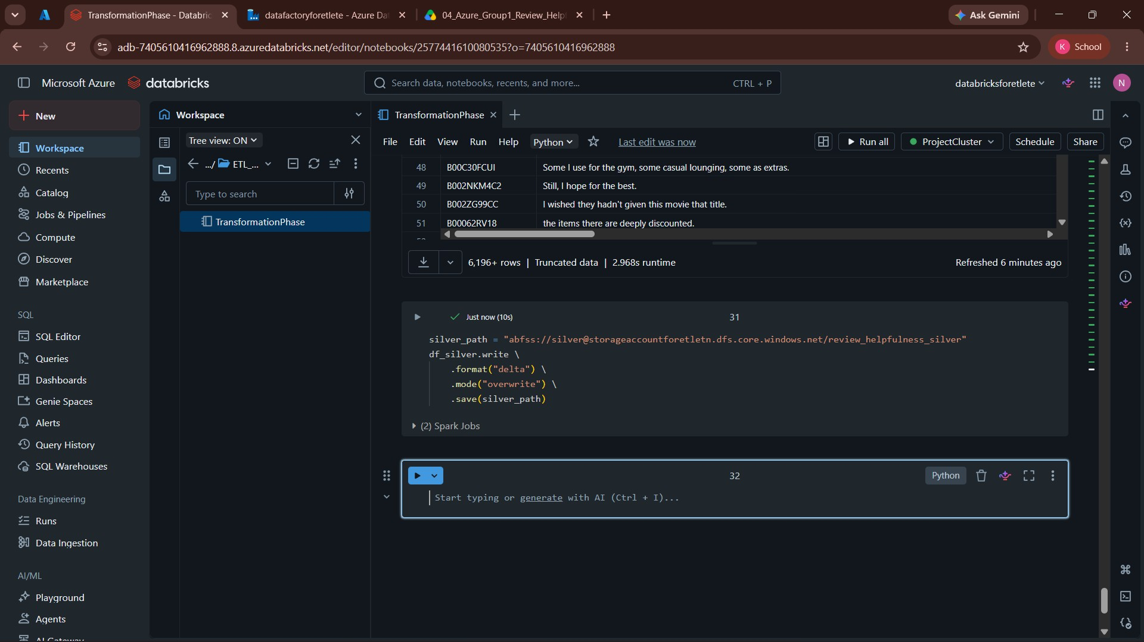
Figure 9: Silver Layer Stored in Delta Format

Figure 10: Curated Silver Dataset Preview

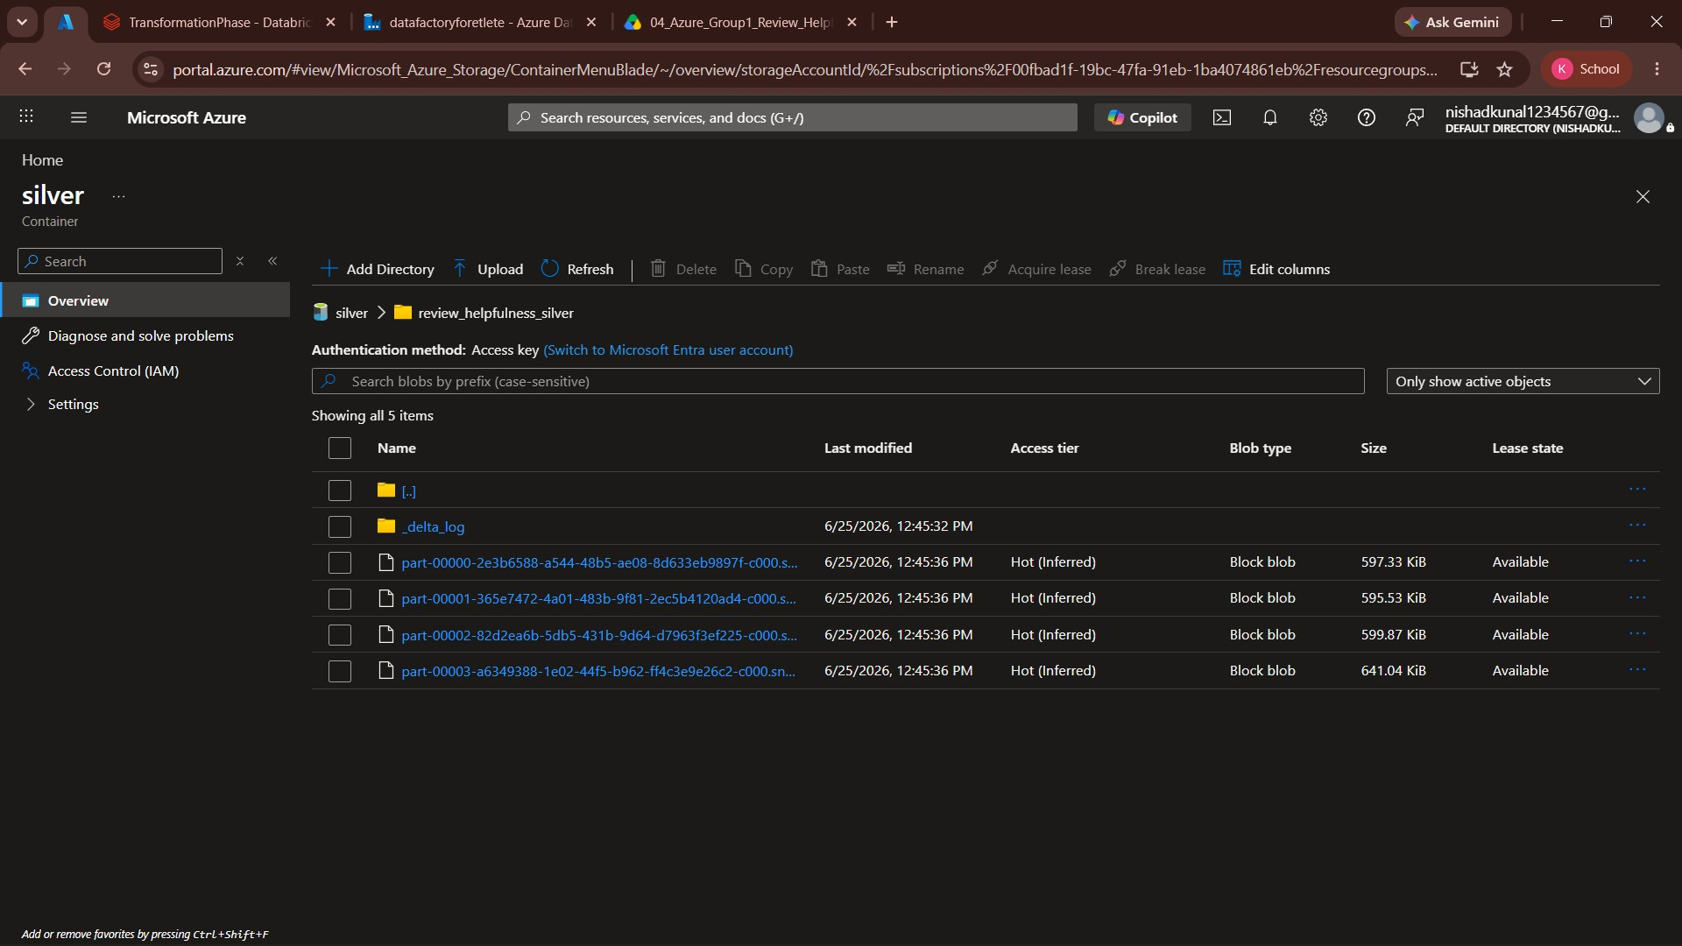

Phase III: Gold Layer, Azure Synapse Analytics and Power BI
The Gold layer contains business-ready datasets generated from the curated Silver layer. Key Performance Indicators (KPIs) were created to support business reporting and decision-making. These datasets were stored in Delta format and made available for analytical querying through Azure Synapse Analytics.

Gold Layer Outputs :

KPI Dataset | Purpose
HelpfulnessSegments | Analyzes review distribution across helpfulness bands.
LowHelpfulnessDrivers | Identifies characteristics of low-helpfulness reviews.
RealtimeIntakeTrend | Monitors review ingestion trends over time.
Figure 11: Gold Layer Stored in Delta Format

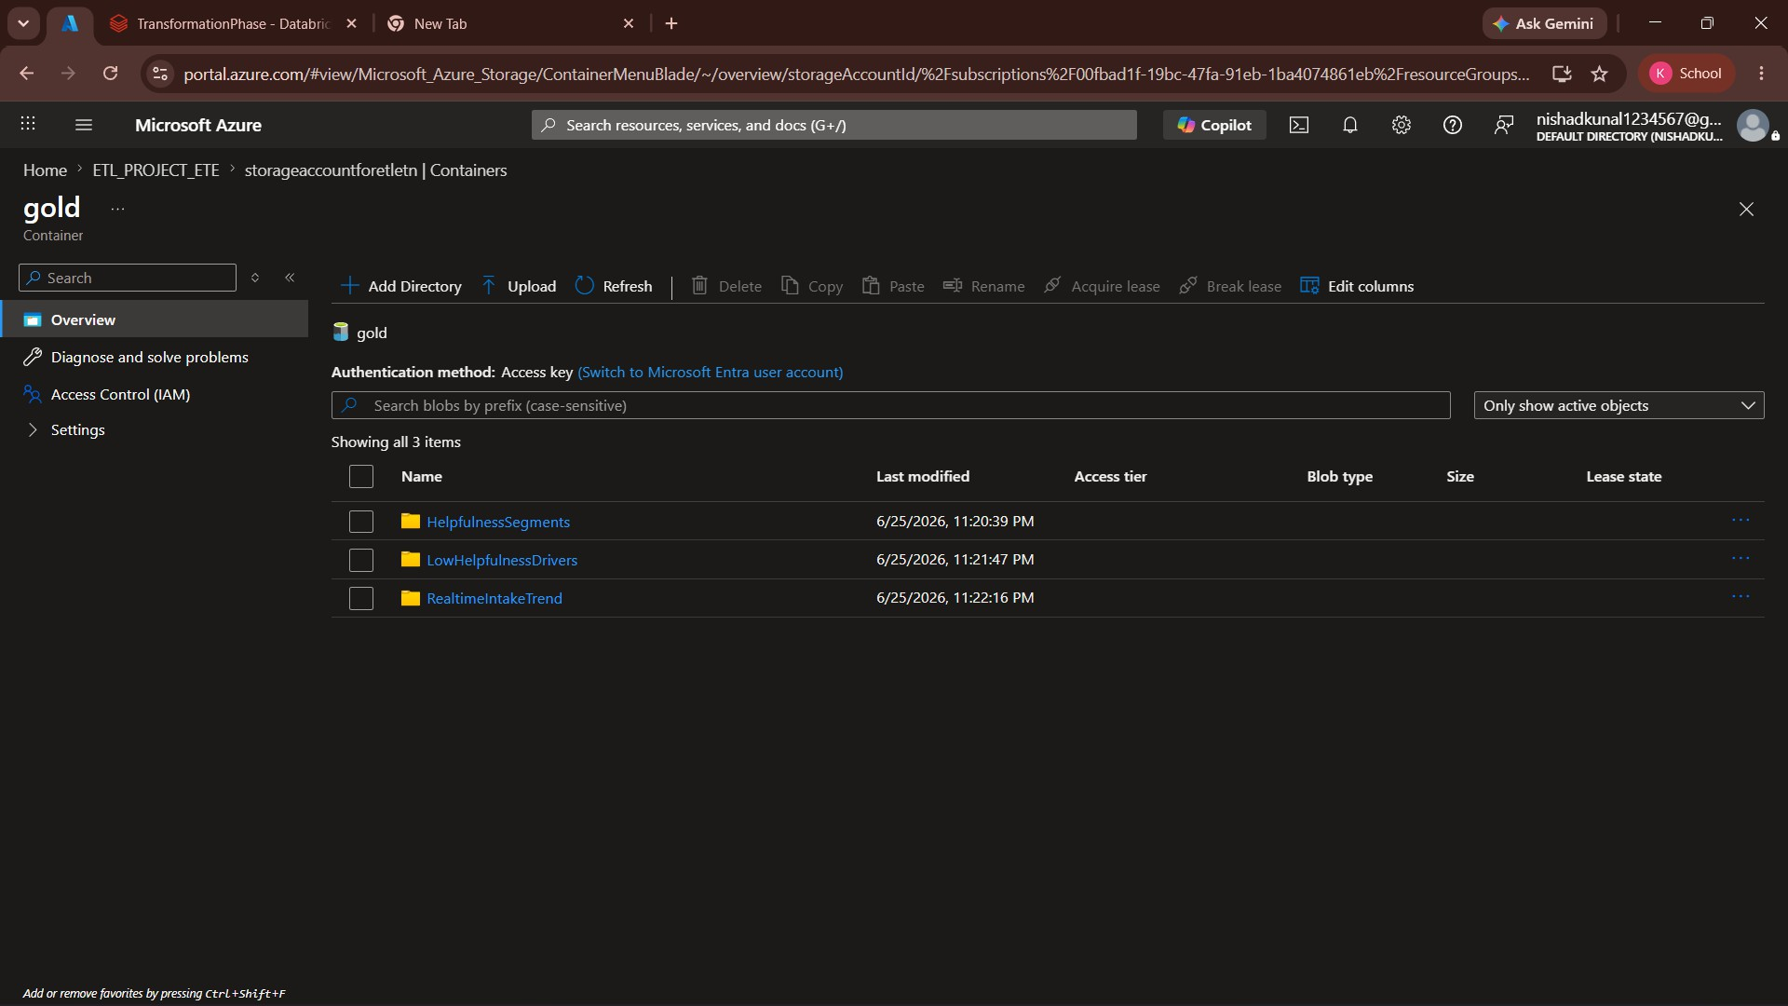

Azure Synapse Analytics :
Azure Synapse Analytics (Serverless SQL Pool) was used as the analytical serving layer. The Gold datasets were exposed through SQL views, enabling efficient querying and seamless integration with Power BI.

Views Created :

View Name | Description
gold.HelpfulnessSegments | Business summary of review helpfulness.
gold.LowHelpfulnessDrivers | Analysis of factors contributing to low helpfulness.
gold.RealtimeIntakeTrend | Daily review ingestion trend and average helpfulness score.
Figure 12: Gold Layer Stored in Delta Format

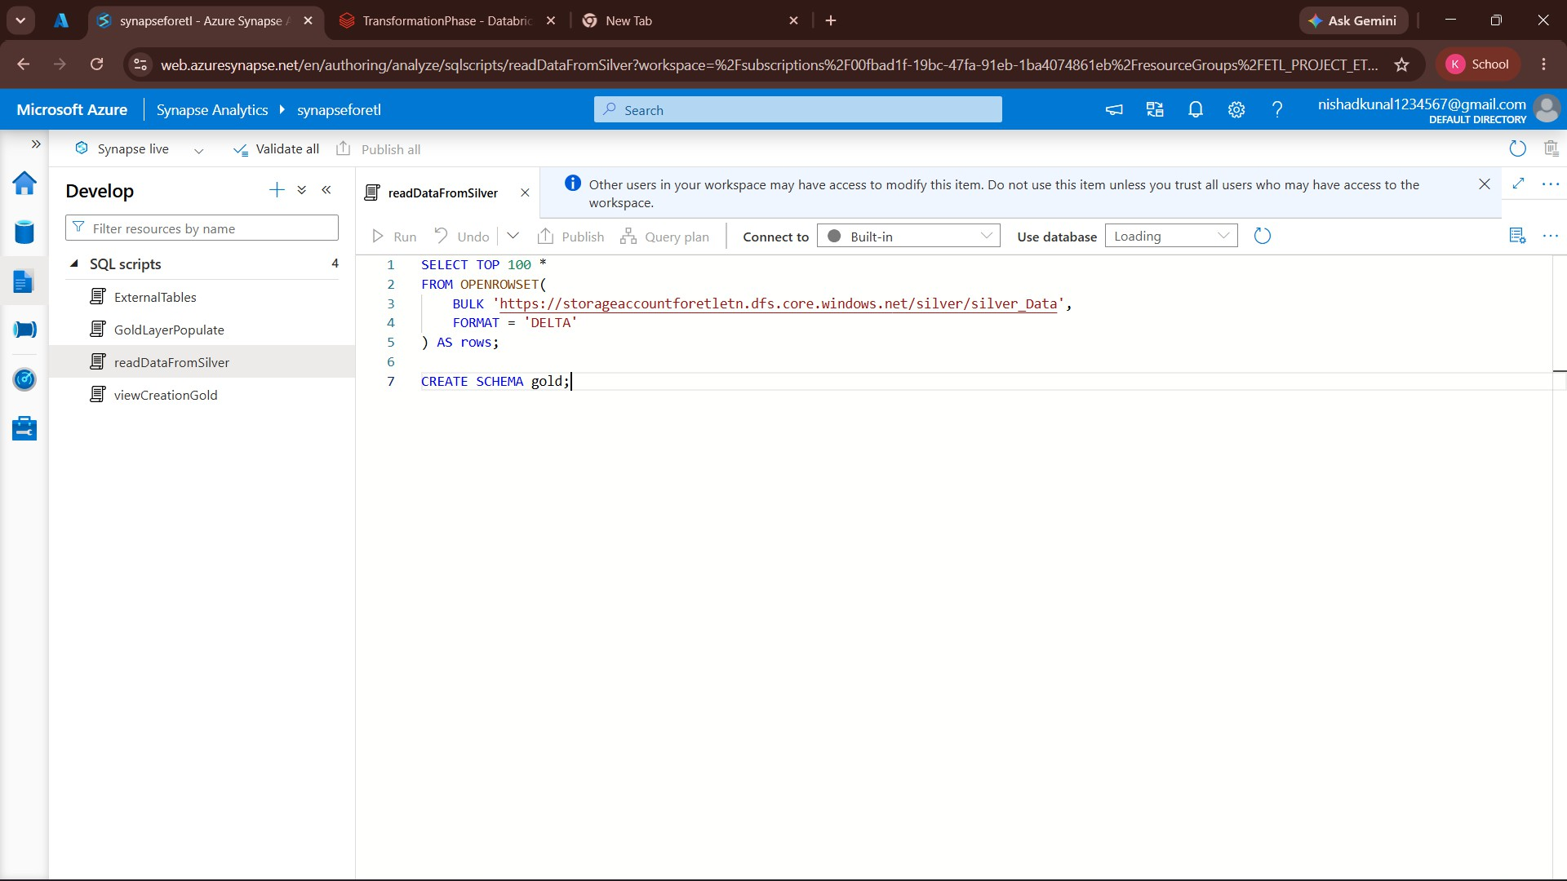

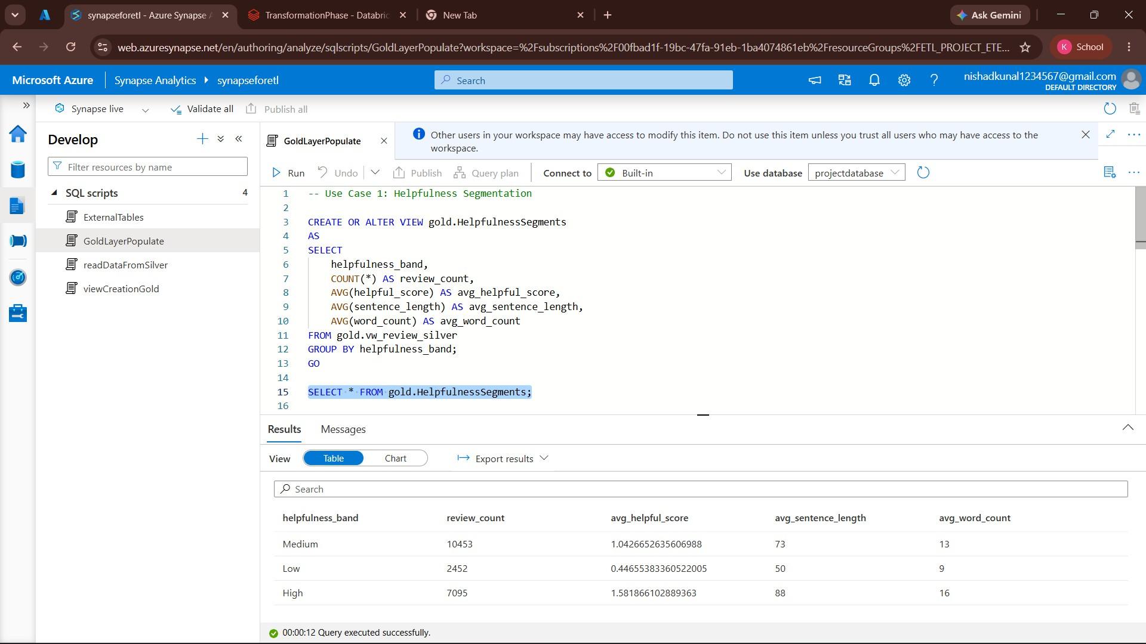
Figure 13: HelpfulnessSegments View Output

Figure 14: LowHelpfulnessDrivers View Output

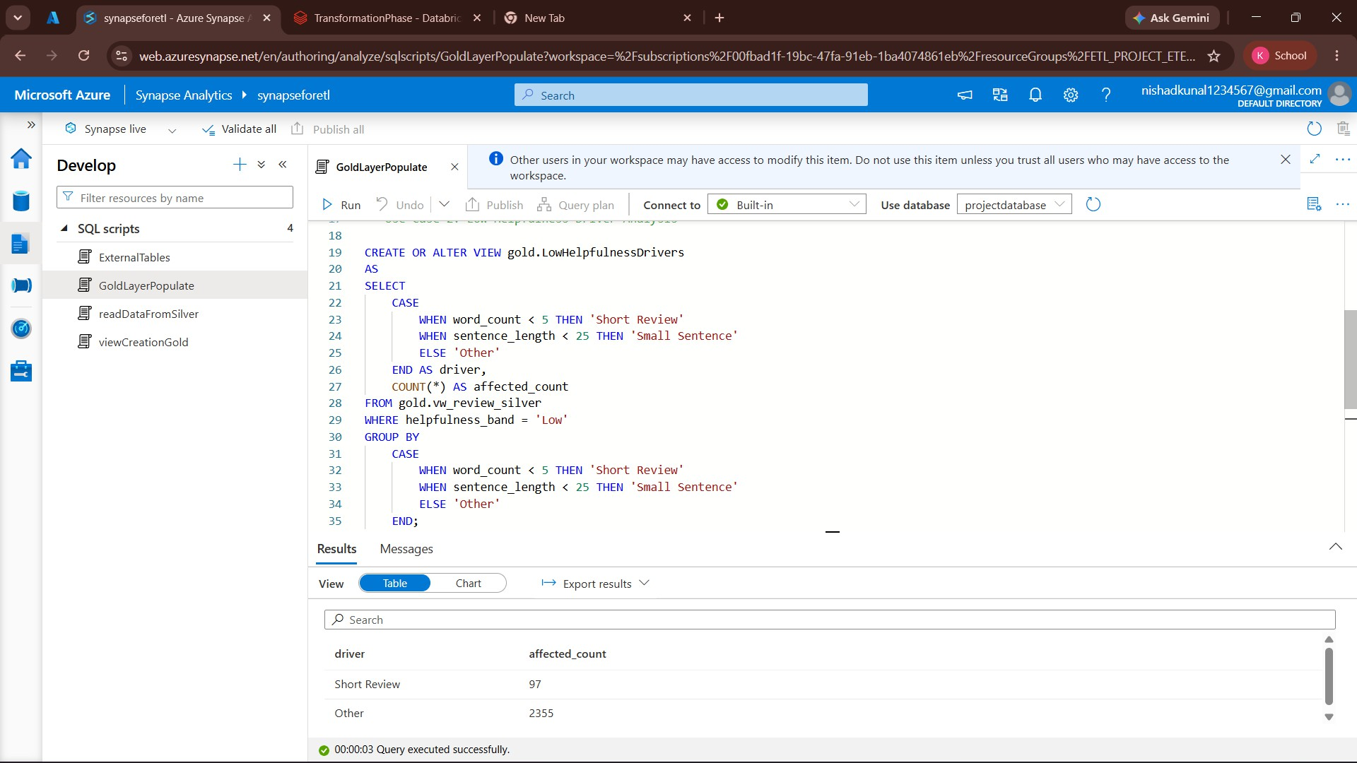

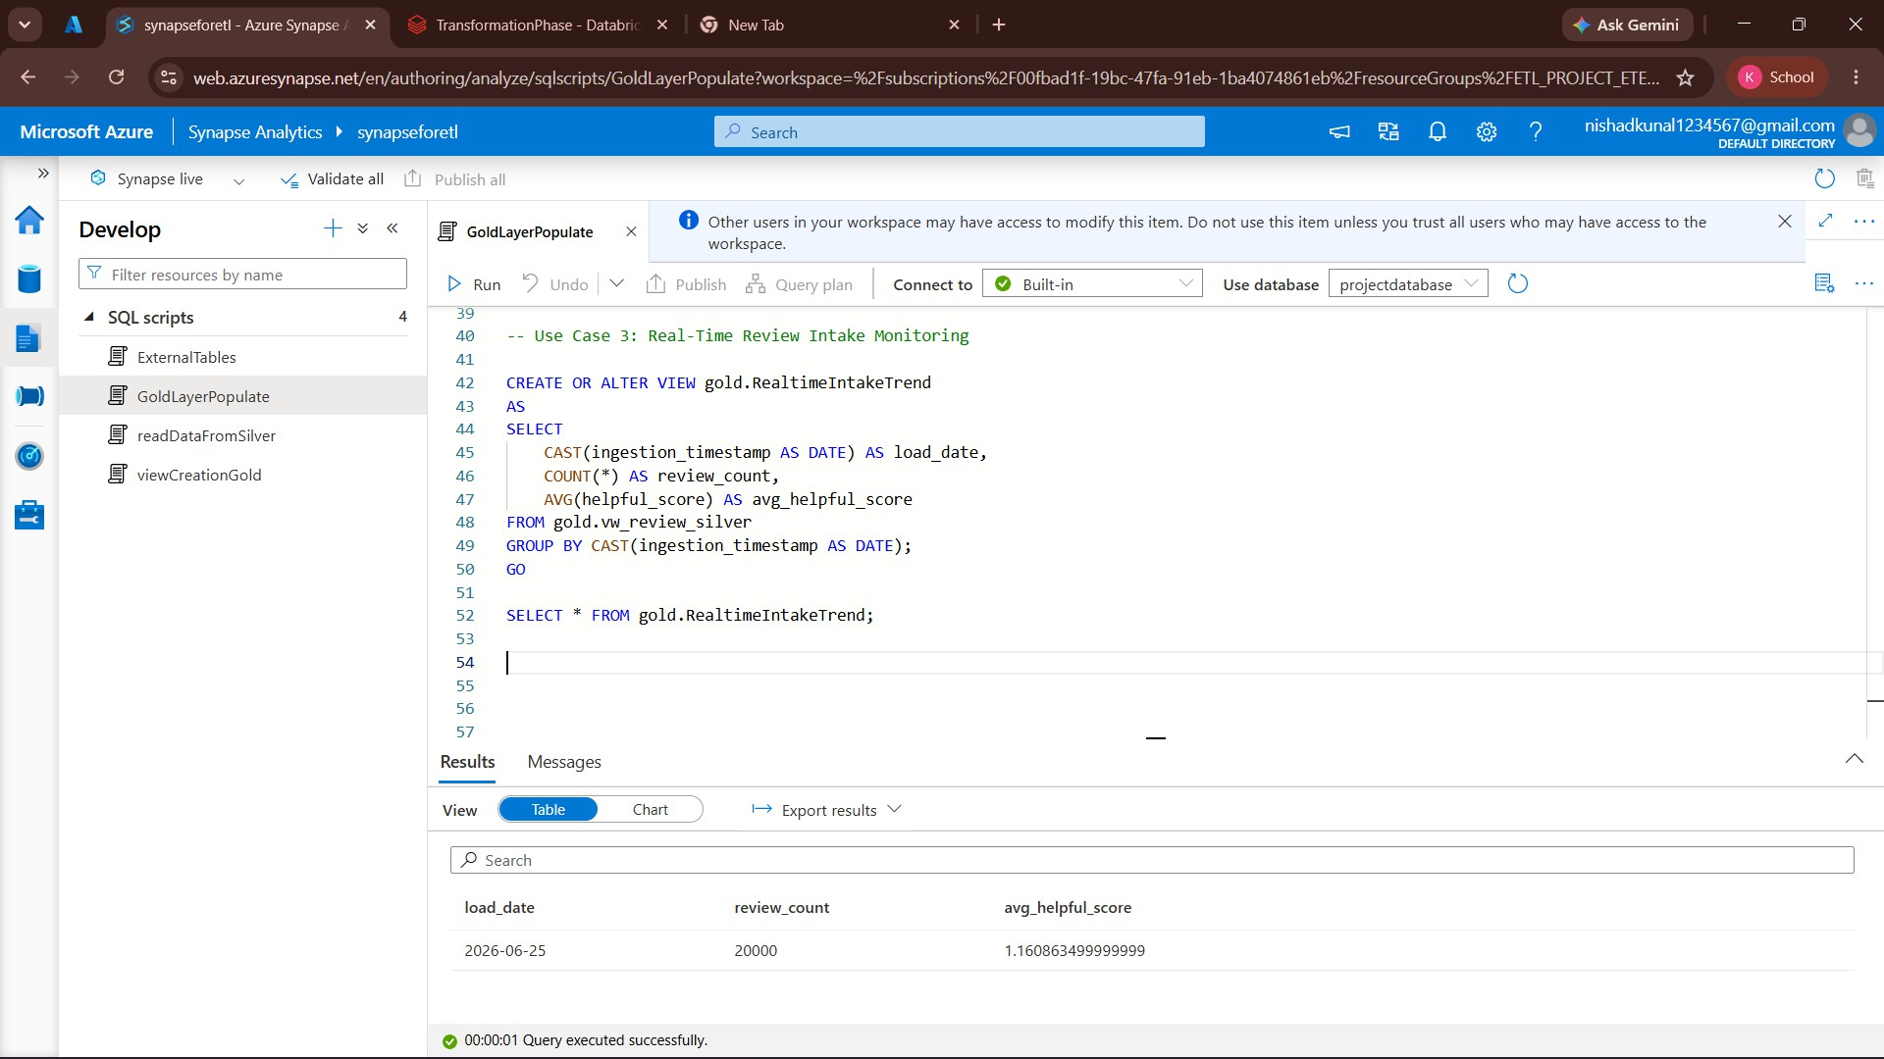
Figure 15: RealtimeIntakeTrend View Output

Power BI Dashboard :

Power BI was connected to Azure Synapse Analytics to visualize business insights from the Gold layer. Interactive dashboards were created to monitor review helpfulness, identify low-helpfulness patterns, and analyze review trends.

Dashboard Pages :

Dashboard | Description
Executive  Summary | Overall review statistics and helpfulness metrics.
Helpfulness  Analysis | Distribution of reviews across helpfulness bands.
Low Helpfulness Analysis | Drivers contributing to low helpfulness reviews.
Review Trend  Analysis | Review count and average helpfulness score over time.
Figure 16: Helpfulness Analysis Dashboard
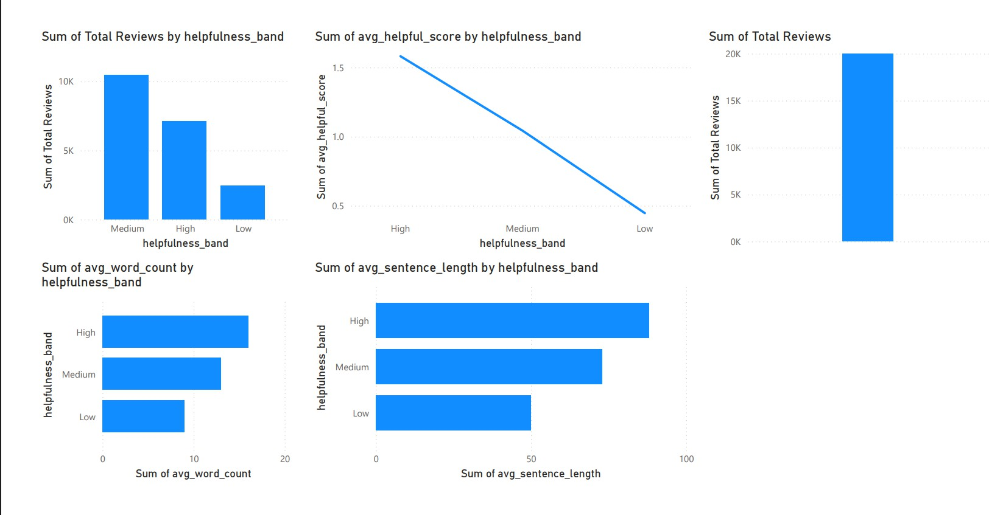

Figure 17: Low Helpfulness Driver Dashboard

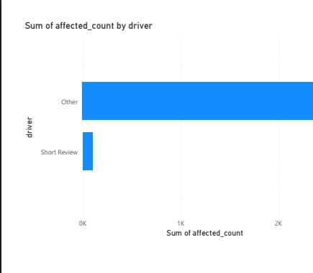

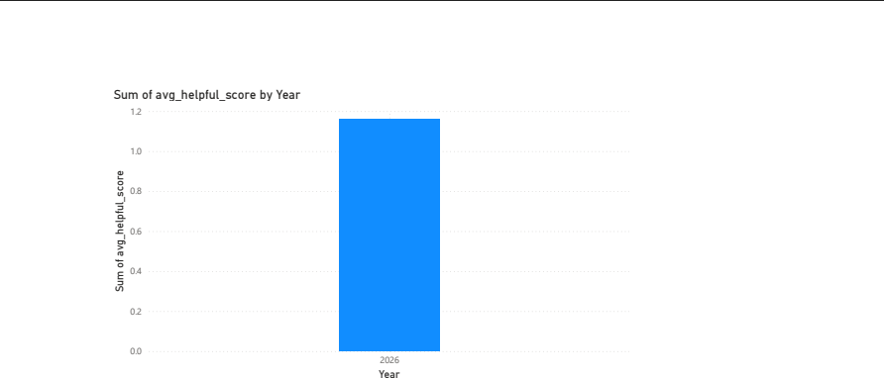
Figure 18: Review Intake Trend Dashboard

Conclusion :

This project successfully implemented an end-to-end Azure Data Engineering pipeline using the Medallion Architecture. The solution automated data ingestion, transformation, storage, analytics, and visualization by integrating Azure Data Factory, Azure Data Lake Storage Gen2, Azure Databricks, Azure Synapse Analytics, and Power BI. The final dashboards provide actionable insights into Amazon product review helpfulness, demonstrating a scalable and industry-standard cloud data engineering solution.

Learning Outcomes :
Through the successful completion of this project, the following learning outcomes were achieved:
- Gained hands-on experience in designing an end-to-end Azure Data Engineering pipeline.
- Learned to automate data ingestion using Azure Data Factory.
- Understood the implementation of the Medallion Architecture (Bronze, Silver, and Gold).
- Performed data cleaning, transformation, and feature engineering using Azure Databricks and PySpark.
- Implemented data quality checks, including null validation, duplicate detection, and score validation.
- Worked with Delta Lake for reliable and optimized data storage.
- Learned to expose analytical datasets using Azure Synapse Analytics and Serverless SQL.
- Developed business-ready KPIs and SQL views for reporting and analysis.
- Connected Azure Synapse Analytics with Power BI to build interactive dashboards.
- Improved practical knowledge of Azure cloud services and modern data engineering best practices.

