Hospital Resource Allocation - Results and Conclusion

Problem Overview
The goal was to optimize hospital resource allocation across 15 departments, using Linear Programming to maximize total benefit (objective function) under limited availability of Nurses, Beds, Medical Equipment, and Doctor Time. TORA software was used to compute the optimal allocation.

Optimized Objective Value
Maximum Achieved Objective Value (Z): 10620

Top Performing Departments
Dept 1 received the largest share of resources due to its high benefit per unit and critical importance, contributing nearly 79% of the total objective value. Other departments made modest contributions as follows:
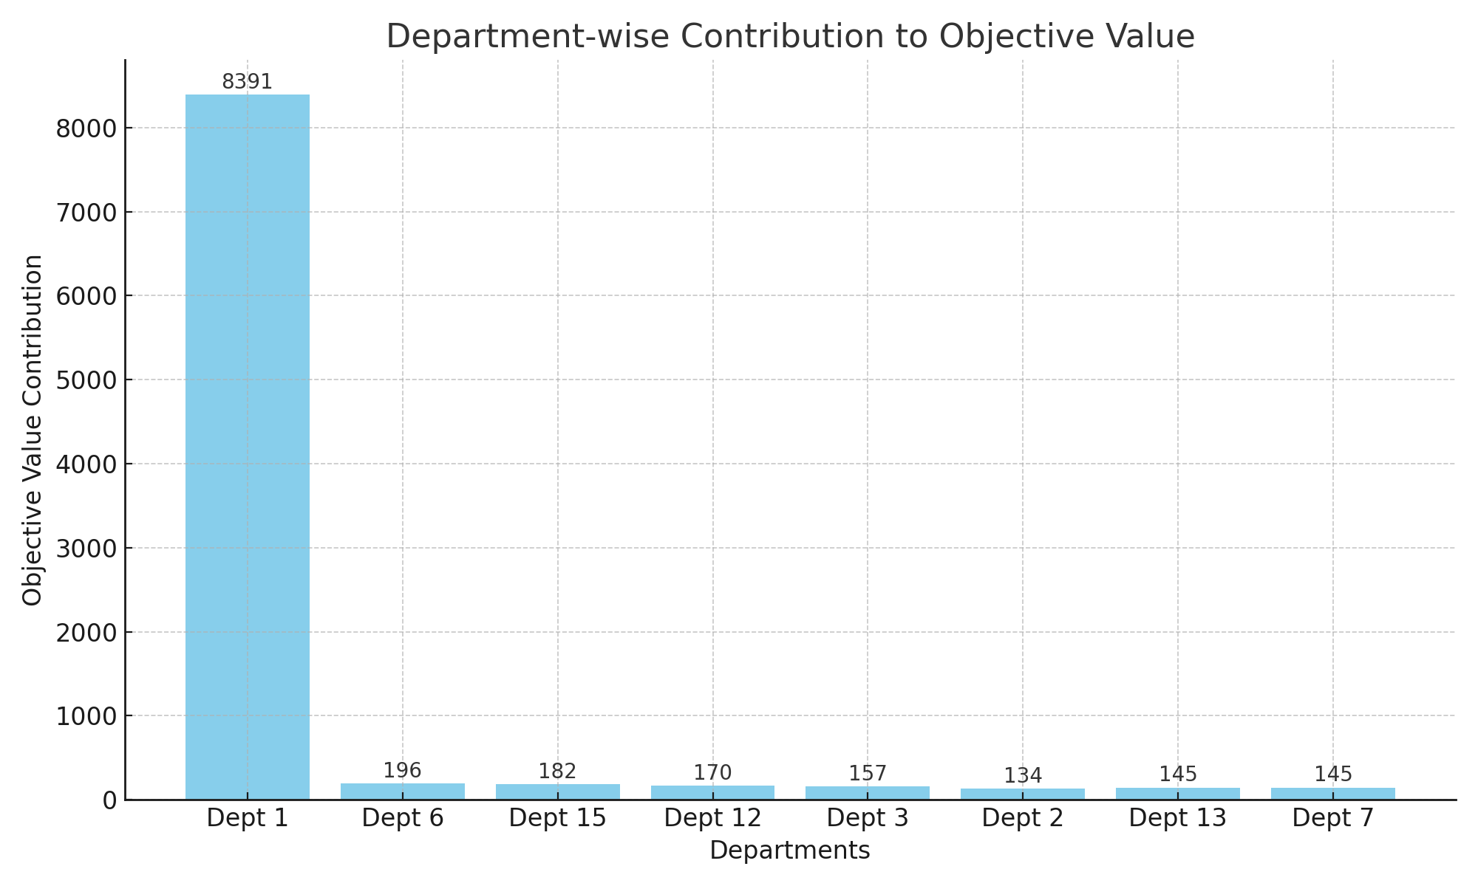

Total Resource Utilization
All resource constraints were fully utilized, indicating optimal allocation. The model ensured no wastage and respected all resource limits.
- Nurses: 500
- Beds: 1000
- Equipment: 200
- Doctor Time: 720

Interpretation & Strategic Insights
The LP model prioritizes high-impact departments and ensures efficient use of resources. It aids in planning during critical situations like pandemics or budget constraints.

Conclusion
The linear programming model successfully distributed resources across departments to maximize the healthcare delivery impact. This approach supports data-driven decisions and improves hospital resource planning.

